Business Requirements Document (BRD)

# Project Title

Process Automation for Retail Loan Disbursement – Unity Bank

# Prepared By

Business Analyst Team

# Date

August 2025

# 1. Objective

The objective of this project is to streamline and automate Unity Bank’s retail loan disbursement process, reducing manual intervention, improving processing speed, enhancing customer experience, and ensuring regulatory compliance. The project will focus on digitizing customer onboarding, automating e-KYC, credit scoring, AML checks, and enabling end-to-end processing through an integrated system.

# 2. Background

Currently, Unity Bank’s retail loan disbursement process is predominantly manual, requiring physical document submission, in-person verification, and multiple handovers between departments. This results in delays, increased operational costs, and a higher risk of human error. The proposed automation solution will enable a digital-first approach, allowing customers to apply online or at the branch, with most verifications completed automatically via integrated APIs.

# 3. Scope

## In-Scope

1. Online and branch-based loan application submission
2. Automated Aadhaar-based e-KYC verification
3. Automated credit score fetching from CIBIL
4. Automated AML checks
5. Digital agreement signing using Aadhaar OTP or DigiLocker
6. Automated loan approval workflow and sanction letter generation
7. Dashboard for Loan Officers, KYC Analysts, Credit Analysts, Risk Analysts, and Bank Managers
8. Notifications to customers at key decision points

## Out-of-Scope

1) Corporate loan processing  
2) Mortgage loan processing

3) Integration with external marketing platforms  
4) Mobile banking app redesign (beyond loan module)  
5) Third-party loan aggregation platforms

# 4. Assumptions

1) Customers provide valid and accurate data for verification.  
2) All required APIs (CIBIL, Aadhaar e-KYC, AML database) are available and functional.  
3) Users have access to internet and required devices for online application.  
4) Branch staff are trained to use the new system.  
5) Regulatory requirements remain consistent during the project timeline.

# 5. Constraints

- Dependency on external APIs (Aadhaar, CIBIL) for verification.  
- Regulatory compliance requirements may affect timelines.  
- Limited budget for advanced AI/ML features.

# 6. Risks

- API downtime affecting verification.  
- Resistance from staff to adopt new system.  
- Cybersecurity threats targeting sensitive customer data.

# 7. Stakeholders

**Primary Stakeholders**

1. **Customer** – Initiates loan application, submits required documents, completes e-KYC, and digitally signs agreements.
2. **Loan Officer** – Assists customers in completing applications, reviews submissions, and coordinates communication between departments.
3. **KYC Analyst** – Verifies customer identity through e-KYC and manual checks if required.
4. **Credit Analyst** – Evaluates credit scores and income-to-loan ratio, flags high-risk applications for review.
5. **Risk Analyst** – Performs AML checks and ensures compliance with regulatory requirements.
6. **Bank Manager** – Approves or rejects loan applications based on analyst reports and compliance checks.
7. **Loan Processing Officer** – Executes final loan disbursement after approval.

**Secondary Stakeholders**

1. **IT Support Team** – Maintains system functionality, resolves technical issues, and ensures integration with APIs (CIBIL, e-KYC, AML).
2. **Compliance Officer** – Ensures adherence to legal, regulatory, and audit requirements.
3. **Project Manager** – Oversees project progress, ensures deliverables meet deadlines, and coordinates between teams.
4. **Operations Team** – Supports back-office processing, document storage, and record management.

# 8. Current Process (As-Is)

Currently, customers visit the branch to submit a loan application with required documents. Loan Officers collect and forward documents to KYC Analysts for manual verification. After KYC, Credit Analysts assess the customer’s creditworthiness using manual CIBIL requests. Risk Analysts perform AML checks manually, and the Bank Manager provides the final decision. The process is time-consuming and prone to delays.

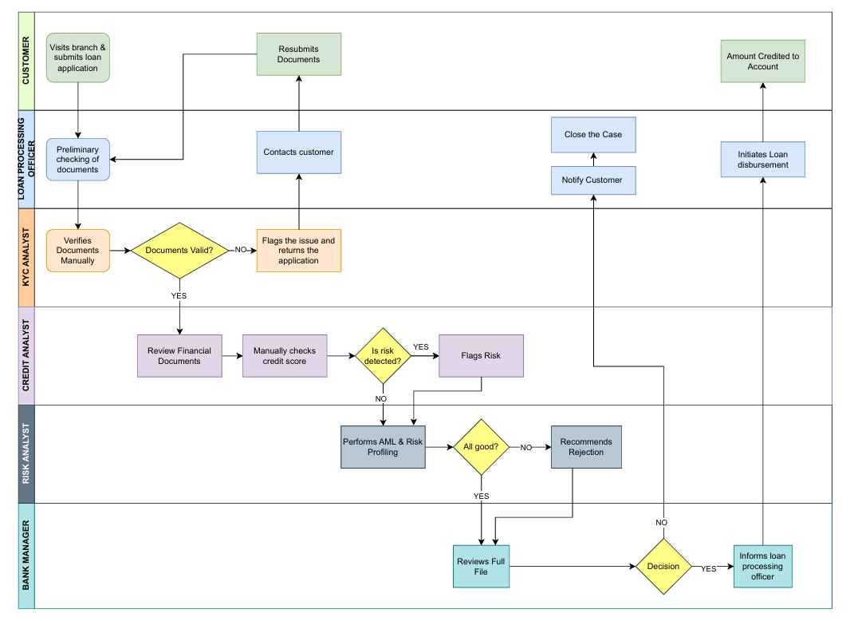

# 9. Proposed Process (To-Be)

Customers can apply for loans online or at the branch. The system automatically triggers Aadhaar e-KYC, fetches CIBIL credit scores, and performs AML checks via integrated APIs. If all verifications pass, the Bank Manager approves the loan, and the system generates a sanction letter. Customers digitally sign the agreement, and the Loan Officer disburses the amount. Notifications are sent at key decision points.

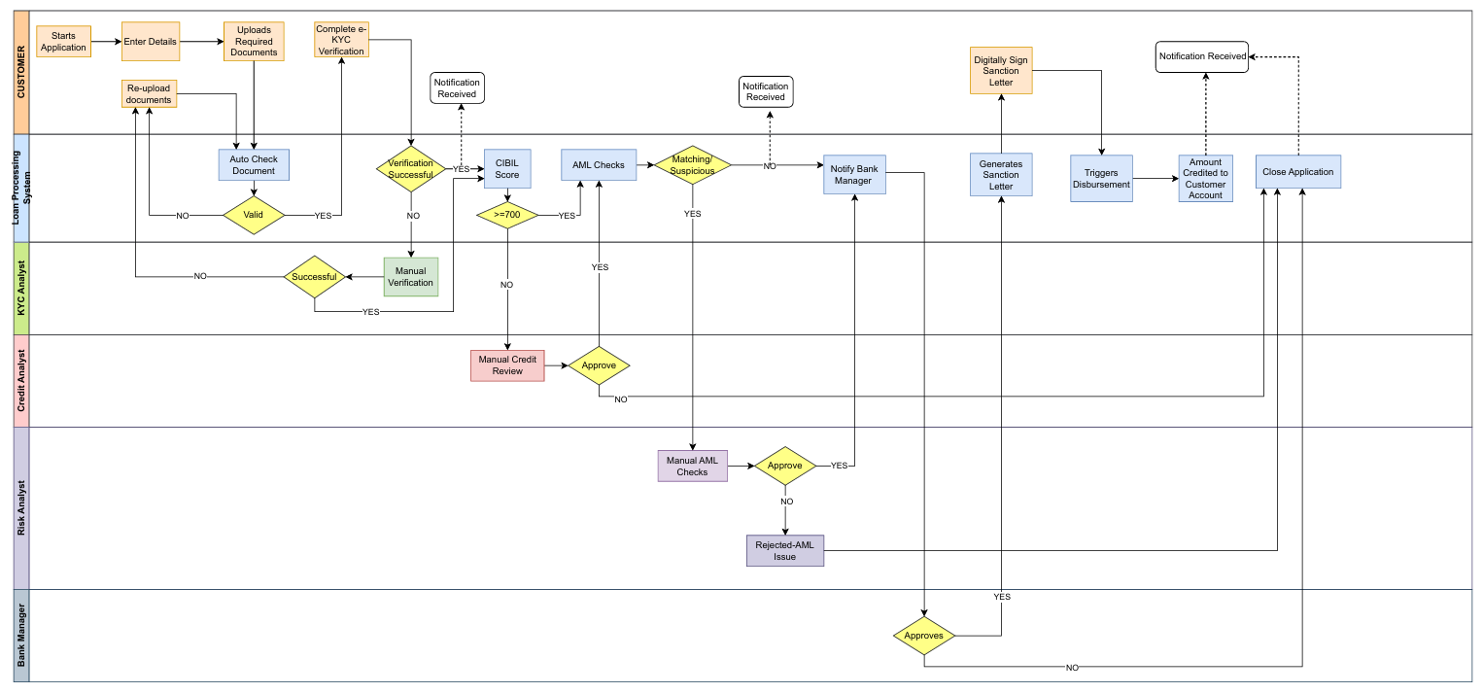

# 10. High-Level Requirements

Functional Requirements:  
1) Allow customers to submit loan applications online/branch.  
2) Aadhaar-based e-KYC verification.  
3) Automated credit score fetching from CIBIL.  
4) AML checks against central blacklists.  
5) Digital agreement signing.  
6) Role-based dashboards.  
7) Automated notifications.  
  
Non-Functional Requirements:  
1) System uptime of 99.9%  
2) Response time under 3 seconds for form submissions  
3) Data encryption in transit and at rest  
4) Compliance with RBI guidelines

NOTE: Detailed requirement descriptions and acceptance criteria are documented in the Functional Requirements Document (FRD).

# 11. Glossary

* KYC – Know Your Customer
* AML – Anti-Money Laundering
* CIBIL – Credit Information Bureau (India) Limited
* API – Application Programming Interface
* OTP – One-Time Password
* UI – User Interface