SQL-Based CRM Performance Evaluation & AI Lead Prioritization

1. INTRODUCTION

1.1 Objective
The purpose of this SQL analysis is to evaluate the current performance of the CRM system (AS-IS state) before implementing AI-driven enhancements.
The analysis focuses on:
• Understanding lead distribution across different stages
• Measuring overall conversion and loss rates
• Identifying bottlenecks in the sales pipeline
• Detecting inefficiencies in early-stage lead handling
This baseline analysis establishes measurable performance metrics that will later be used to evaluate the impact of AI-based lead scoring and prioritization.

1.2 Data Preparation & Model Enhancement

1.2.1 Status Handling and Data Structuring
The CRM system initially stored lead status changes in a separate lead_status_history table, where multiple records existed for each lead to track status transitions over time.
For reporting and analytical simplicity, a current_status column was introduced in the leads table. This column represents the most recent status of each lead.
The latest status was derived from the status history table based on the most recent status date for each lead.
Purpose of This Enhancement:
• Ensure one record per lead for reporting
• Reduce query complexity during analysis
• Improve performance of aggregation queries
• Maintain historical tracking while enabling simplified current-status analysis.
This enhancement enabled efficient calculation of key performance metrics such as conversion rate, loss rate, and pipeline distribution.

2. AS-IS ANALYSIS

2.1 Leads by Current Status

Objective
To understand the current distribution of leads across different stages of the sales pipeline.

Method
Leads were grouped based on the current_status field to determine how many leads are present in each stage.

SQL Query
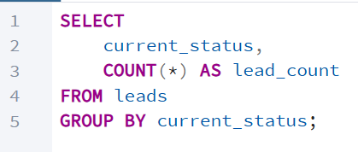

Result
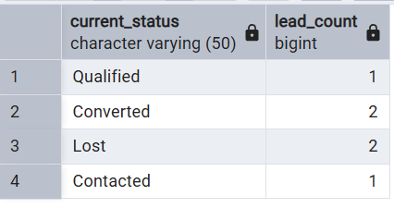

Interpretation
The analysis shows the current pipeline distribution:
- A portion of leads have been successfully converted.
- An equal portion has been lost.
- The remaining leads are in intermediate stages such as Contacted and Qualified.
This distribution indicates that while leads are progressing through the funnel, a significant number are not converting successfully. The presence of leads in mid-stages suggests potential inefficiencies in early-stage qualification and prioritization.
This insight establishes the foundation for deeper performance analysis and highlights the need for improved lead handling strategies.

2.2 Overall Conversion Rate

Objective
To measure the overall effectiveness of the sales process by determining the percentage of total leads that resulted in successful conversions.

Method
The overall conversion rate was calculated as:
Converted Leads / Total leads * 100
This metric evaluates performance across the entire sales funnel.

Query
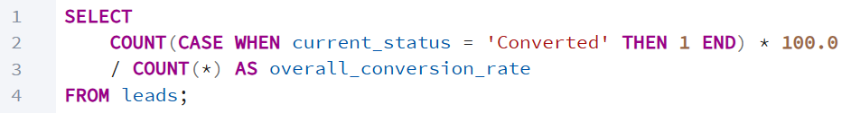

Result
The overall conversion rate was 33%.
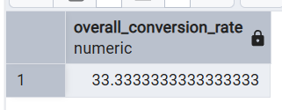

Interpretation
An overall conversion rate of 33% indicates that only one-third of generated leads are successfully converted into customers.
This suggests that while some leads are being successfully closed, there may be inefficiencies in the qualification and prioritization process earlier in the pipeline.
This metric serves as the baseline performance indicator prior to implementing AI-driven lead scoring.

2.3 Close Rate

Objective
To measure the effectiveness of the sales team at the final decision stage of the pipeline.

Method
The close rate was calculated as:
Converted leads / (Converted + lost leads) * 100
This metric evaluates performance only among leads that reached a final outcome (either converted or lost).

Query
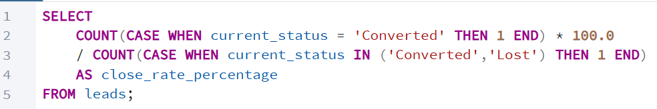

Result
The close rate was 50%.
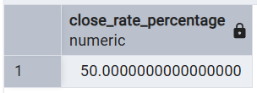

Interpretation
A close rate of 50% indicates that once leads reach the final decision stage, half of them are successfully converted.
This suggests that the sales team demonstrates reasonable effectiveness in closing deals. However, when compared to the overall conversion rate (33%), it becomes evident that the primary inefficiencies likely occur in earlier stages of the pipeline, particularly in lead qualification and prioritization.
This insight supports the need for AI-driven lead scoring to improve early-stage filtering and engagement.

3. KEY OBSERVATIONS
• The overall conversion rate is 33%, indicating that only one-third of total leads are successfully converted.
• The close rate is 50%, suggesting that once leads reach the final decision stage, the sales team performs moderately well.
• The gap between overall conversion (33%) and close rate (50%) indicates inefficiencies occurring in early stages of the sales funnel.
Leads are not being intelligently segmented based on potential value, resulting in:
• Inefficient allocation of sales effort
• Time spent on low-probability leads
• Reduced overall conversion performance
This establishes the need for a data-driven prioritization mechanism to improve early-stage efficiency.

4. AI-Based Lead Scoring (TO-BE Enhancement)

4.1 Objective
To improve early-stage lead qualification and prioritization by introducing a rule-based AI scoring mechanism that evaluates lead quality based on measurable attributes.

4.2 Design Approach
To address inefficiencies identified in the AS-IS analysis, additional attributes were incorporated into the CRM system:
• Lead Source
• Budget
Each lead was assigned a numerical score based on predefined business rules.

4.3 Scoring Logic
The lead score was calculated using the following rule-based structure:
Source-Based Scoring
- Referral → 40 points
- Website → 30 points
- Property Portal → 20 points
- Facebook → 10 points
Budget-Based Scoring
- Budget > 12,000,000 → 40 points
- Budget between 6,000,000 and 12,000,000 → 25 points
- Budget below 6,000,000 → 10 points
Total Lead Score = Source Score + Budget Score
This resulted in scores ranging between 20 and 80.

4.4 Priority Classification
Based on the total score, leads were classified into three priority levels:
AI-Prioritized → Score ≥ 45
Non-Prioritized → Score < 45
The threshold was selected after reviewing the score distribution to ensure meaningful segmentation between higher and lower probability leads.
Query
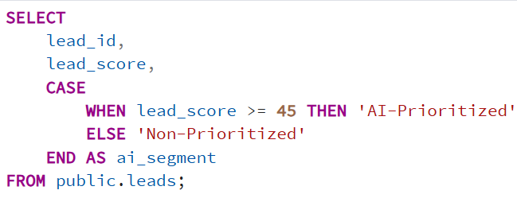
Result
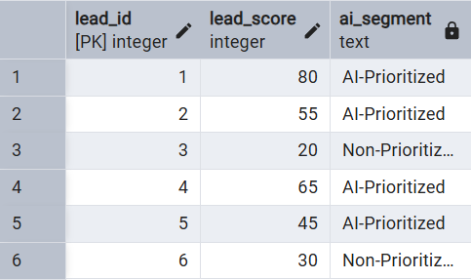
Interpretation
Out of 6 total leads, 4 leads were classified as AI-Prioritized and 2 leads were classified as Non-Prioritized.
This segmentation enables comparison of conversion performance between higher-scoring and lower-scoring leads to evaluate the potential impact of AI-driven prioritization.

5. AI IMPACT ASSESSMENT

5.1 Objective
To evaluate the effectiveness of the AI-based lead scoring model by comparing conversion performance before and after implementing prioritization.

5.2 Baseline Performance (Before AI)
The overall conversion rate was calculated to establish the baseline CRM performance prior to introducing AI-based prioritization.
The overall conversion rate was 33%.
Only one-third of total leads were successfully converted, indicating inefficiencies in the overall funnel. This serves as the baseline performance metric.

5.3 Conversion Performance by Priority Level (After AI Scoring)
After introducing rule-based lead-scoring, leads were categorized into High, Medium, and Low priority levels.
Conversion performance was evaluated per priority segment.
Query
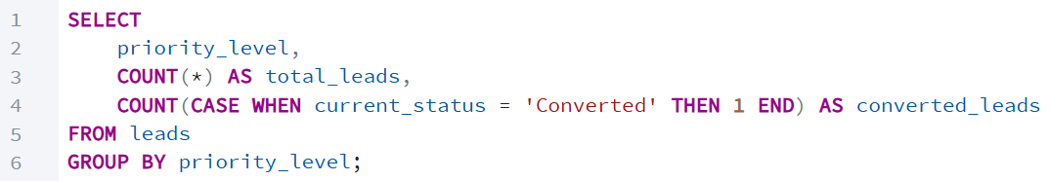
Result
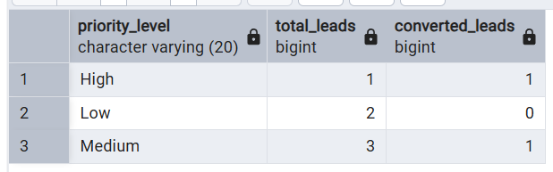
Observed Results
- High Priority – 100% Conversion
- Medium Priority – 33% Conversion
- Low Priority – 0% Conversion
Interpretation
The result clearly demonstrates that high-priority leads have significantly higher conversion potential compared to medium and low-priority leads. This validates the effectiveness of the scoring logic in differentiating lead quality.

5.4 Prioritized Strategy Simulation
To simulate practical implementation, a scenario was evaluated where the sales team focuses on High and Medium priority leads first.
Query
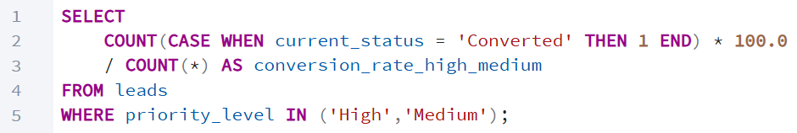
Result
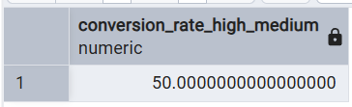
The conversion rate under prioritized focus increased to 50%.

5.5 Impact Analysis
By implementing AI-based lead scoring and prioritizing high-potential leads:
• Conversion rate improved from 33% to 50%.
• Sales effort is redirected toward higher-probability opportunities.
• Time spent on low-conversion leads is reduced.
• Early-stage inefficiencies are addressed.
This represents a 17%-point improvement in conversion performance.
The scoring model does not eliminate lower-budget leads but prioritizes higher-value opportunities to optimize sales resource allocation while maintaining visibility across all segments.

6. CONCLUSION
This project analyzed the current CRM performance using SQL based metrics to identify inefficiencies in the lead management process.
The analysis revealed that:
• The overall conversion rate was 33%
• The close rate was 50%
• The primary bottleneck existed in early-stage lead qualification and prioritization
While the sales team demonstrated reasonable effectiveness at the final closing stage, the gap between overall conversion and close rate indicated inefficiencies earlier in the pipeline.
To address the issue, a rule-based AI lead scoring model was introduced using measurable attributes such as lead source and budget. Leads were segmented into High, Medium, and Low priority categories to optimize sales effort allocation.
The impact assessment demonstrated that:
• High-priority leads showed significantly higher conversion performance
• A prioritized sales strategy improved conversion from 33% to 50%
This represented a 17% point improvement in overall conversion efficiency.
The findings validate that data-driven prioritization can enhance resource allocation, reduce inefficiencies, and improve overall CRM performance.
This case study demonstrates how SQL-based analysis can be leveraged to diagnose operational challenges and how AI-driven enhancements can be strategically implemented to deliver measurable business impact.

