Database Management Systems

P.R.POTE (PATIL)EDUCATION & WELFARE TRUST’S GROUP OF INSTITUTIONS,

COLLEGE OF ENGINEERING& MANAGEMENT,

AMRAVATI.

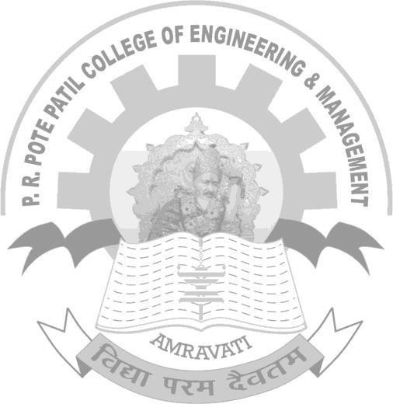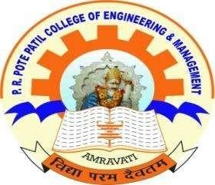

COMPUTER SCIENCE ANDENGINEERING

Year :3rd Semester: 6

SUBJECT: EMERGING TECHNOLOGY(ET)

NAME OF LABORATORY: (5KS07)ET LAB

PRPCEM, Amravati

Data Analyasis And Algorithm

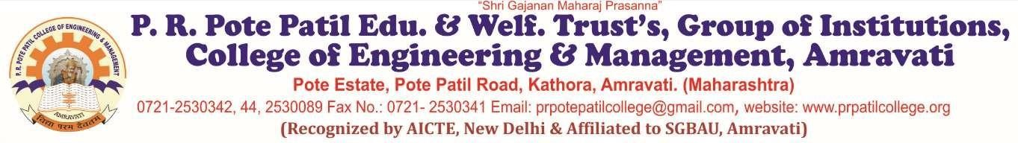

**Department of Computer Science & Engineering**

Certificate

This is to certify that Ms. **Vaishnavi Vijayrao Deshmukh**

of 6th Semester of Bachelor of Engineering in Computer Engineering of P. R. Pote Patil College of Engineering & Management,

Amravati, has completed the term work satisfactory in subject **ET** for the academic year 2022- 2023 as prescribed in the curriculum.

**Place:- Amravati Roll No: 367**

Date:- 15/05/2022

**Subject Teacher Head of Department**

PRPCEM, Amravati