**ASSIGNMENT NO 1**

Name :- Vaishnavi Vijayrao Deshmukh

Roll No :- 367

Section :-A

**Arithmetic Operators :**

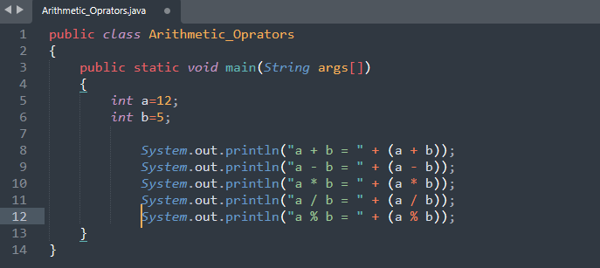

**Output** :

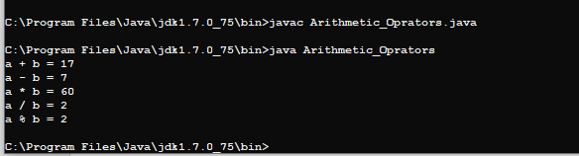

**Logical Operator**

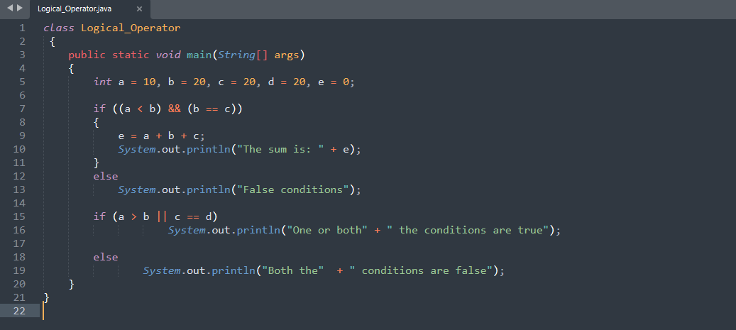

**Output :-**

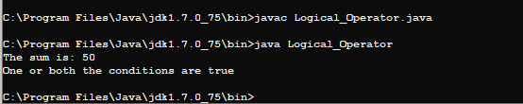

**if statement :**

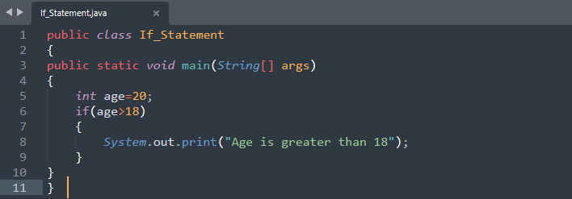

**Output** :

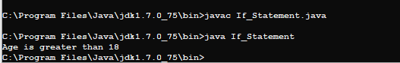

**If Else Statement :**

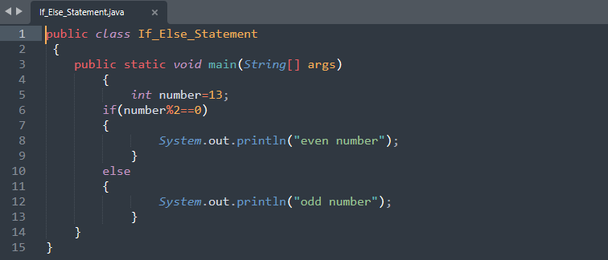

**Output :**

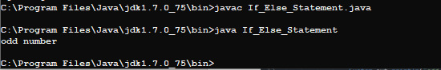

**Nested_If_Statement :**

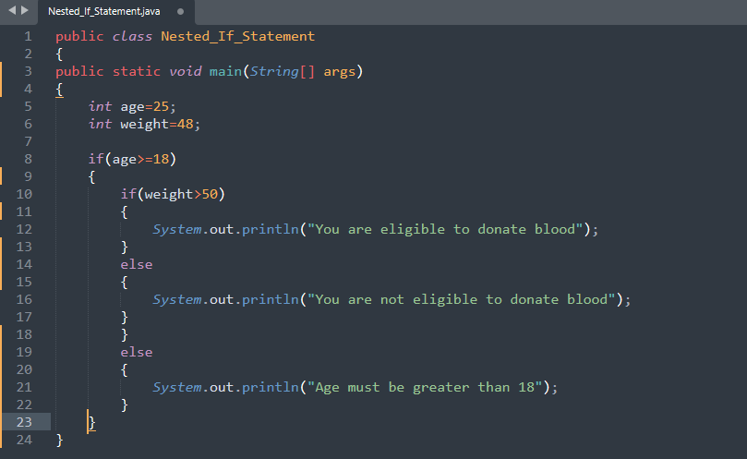

**sOutput :**

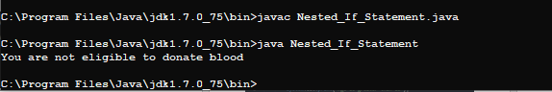

**If Else If statement** :

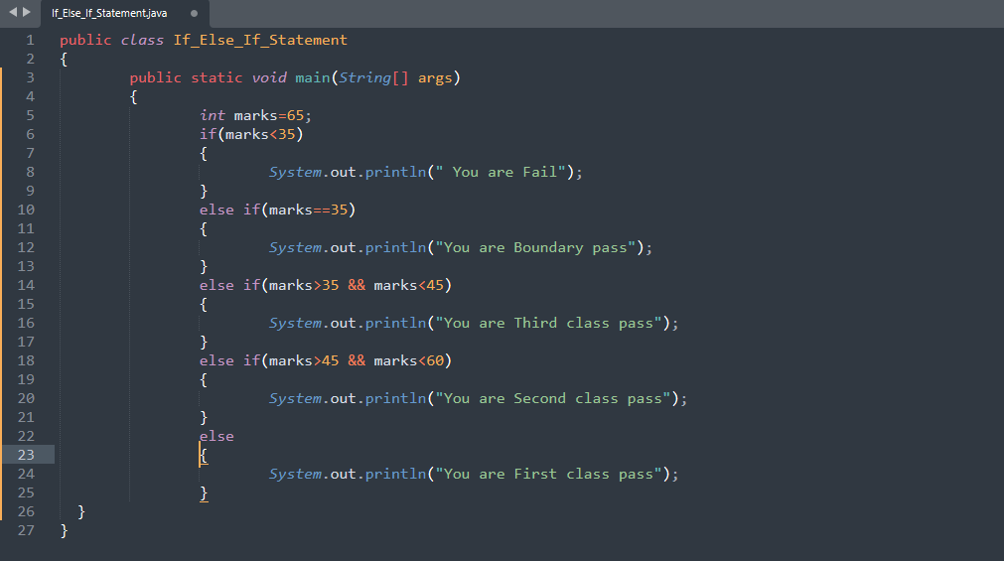

Output :

