**Seminar**

**on**

**“VersoAugumented Reality”**

**Submitted to**

**Sant Gadge Baba Amravati University, Amravati**

in partial fulfillment of the requirement for the award of degree of

Bachelor of Engineering in Computer Science & Engineering

**Submitted by**

**Miss. Vaishnavi .V. Deshmukh**

**Under the guidance of**

**Prof. S.R.Sontakke**

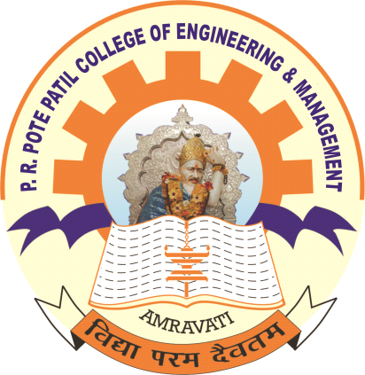

**Department of Computer Science & Engineering**

**P. R. Pote (Patil) College of Engineering & Management, Amravati**

**2022-23**

**CERTIFICATE**

This is to certify that the seminar entitled

**“VersoAugumented Reality”**

is a bonafide work and it is submitted to the

**Sant Gadge Baba Amravati University, Amravati.**

Submitted by

**Mr./ Miss. Vaishnavi .V.Deshmukh**

in the partial fulfillment of the requirement for the award of degree of Bachelor of Engineering in Computer Science and Engineering during the academic year of 2022– 23

**Prof. S.R.Sontakke Dr. V. B. Kute**

Guide HOD, CSE



**Department of Computer Science & Engineering**

**P. R. Pote (Patil) College of Engineering & Management, Amravati**

**2022-23**

**DECLARATION**

I hereby declare that the seminar , ***“*VersoAugumented Reality”**was carried out and written by me under the guidance of **Prof.S.R.Sontakke**, Dept. of Computer Science and Engineering, P. R. Pote (Patil) College of Engineering & Management, Amravati. This work has not been previously formed the basis for the award of any degree or diploma or certificate nor has been submitted elsewhere for the award of any degree or diploma.

Place: Amravati **Miss.Vaishnavi.V.Deshmukh**

Date: Final Year (CSE)

**ACKNOWLEDGEMENT**

It is my utmost duty and desire to express acknowledgement to the various torchbearers, who have rendered valuable guidance during the preparation of my seminar. First of all, I extend my deepest gratitude to respected Principal, **Dr. D. T. Ingole** without whose support, my seminar could not have been transformed into present form.

I am grateful to **Dr. V. B. Kute** Head, Computer Science and Engineering Department, and my guide **Prof.S.R.Sontakke** for providing immense support and guidance. I am beholden for guiding me at every step in the seminar. He/she has honestly guided me throughout, never leaving me unanswered for any of my doubts. It was his/her constant persuasion, encouragement, inspiration and able guidance that helped me in completing my seminar successfully.

**Miss.Vaishnavi.V.Deshmukh**