**Pyspark installation on Linux**













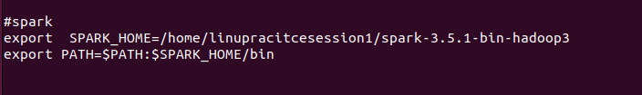





# **PySpark DataFrame Operations and Outputs**

Includes five example PySpark DataFrame operations with their outputs for demonstration purposes.

# 





