To bypass that hypervisor crash, your teammate needs to do two things: Enable Nested Virtualization at the cloud level, and tweak the Android Emulator settings to run without demanding physical hardware acceleration.
Here is the exact blueprint to make Android Studio emulators work smoothly inside a cloud VM.

Step 1: Fix the Cloud Infrastructure (The "Hypervisor" Error)
Because a cloud desktop is already a virtual machine, trying to boot an Android Emulator creates a "VM inside a VM." The cloud provider blocks this by default. Your teammate must change their VM instance type or settings to allow Nested Virtualization.

If they are on Microsoft Azure:
They must change the VM size to a series that supports nested hypervisors (look for a lowercase "v3" or newer in the name, like Dv3, Dv4, Ev3, or Ev4 sizes).
- Shut down the VM.
- In the Azure portal, go to Size, select a compatible series, and click Resize.

If they are on AWS (EC2):
- Shut down the instance.
- Go to the EC2 Console -> Instance Settings -> Change CPU options.
- Under Nested Virtualization, select Enable and save. (Note: AWS supports this on modern virtualized instances like C8i, M8i, and R8i).

Step 2: Turn on Windows Hyper-V Features
Once the cloud provider allows it, Windows needs to be told to handle the virtualization. Inside the Windows Virtual Desktop:
- Click the Windows Start menu, type Turn Windows features on or off, and open it.
- Check the box for Hyper-V (ensure both Hyper-V Management Tools and Hyper-V Platform are ticked).
- Check the box for Windows Hypervisor Platform.
- Click OK, let Windows install the files, and restart the virtual machine.

Step 3: Create a Cloud-Friendly Emulator in Android Studio
Now that the hypervisor error is handled, create a specific type of Virtual Device that uses Software Rendering instead of hardware graphics (since cloud VMs usually lack dedicated GPUs).
- Open Android Studio and launch the Device Manager.
- Click Create Virtual Device and choose a tablet profile (like the Nexus 9).
- When selecting a System Image (Android Version), choose an x86_64 image (do NOT use ARM/Google Play system images, as they run too slowly on VMs).
- On the final confirmation screen (Verify Configuration), look for the Graphics dropdown.
- Change Graphics from Automatic/Hardware to Software - GLES 2.0.
- Click Finish.

Step 4: Launching it without a GUI Crash
If clicking the standard "Play" button in Android Studio still causes a stutter or crash, your teammate can bypass the Android Studio UI entirely and force-start the emulator via the command line with headless optimizations.
Have them open Command Prompt or PowerShell and run:
DOS
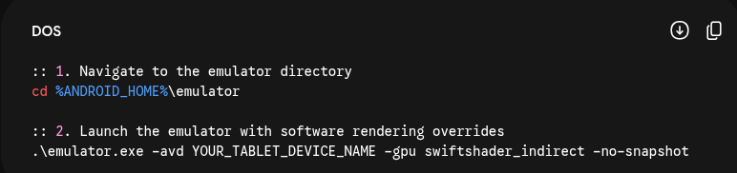
:: 1. Navigate to the emulator directory
cd %ANDROID_HOME%\emulator

:: 2. Launch the emulator with software rendering overrides
.\emulator.exe -avd YOUR_TABLET_DEVICE_NAME -gpu swiftshader_indirect -no-snapshot

(Replace YOUR_TABLET_DEVICE_NAME with the exact name of the device they created, using underscores instead of spaces, e.g., Nexus_9_API_33).

Step 5: Verify the Link to Appium
Once the emulator boots up on the virtual desktop screen, they just need to open a fresh terminal in VS Code and run your usual verification:
Bash
adb devices
As long as it lists the emulator (e.g., emulator-5554 device), their local Appium server (npx appium) will be able to target the device, push the application package, and run the layout test suite flawlessly!

