Project Report
On
Optimizing Offline RAG:
Benchmarking Edge-Optimized SLMs in
Resource-Constrained Environments

Session: 2023-2027
Faculty Mentor Name – Richa Sharma
Submitted by:
Vaishnavi (E23CSEU1537)
Aditi Singh (E23CSEU1484)
Introduction to Generative Artificial Intelligence (CSET- 419)
SCHOOL OF COMPUTER SCIENCE ENGINEERING AND
TECHNOLOGY,
BENNETT UNIVERSITY

Acknowledgement
We would like to sincerely thank our faculty mentor Ms. Richa Sharma for guiding us throughout this project. Her feedback at every stage helped us move from an early idea to a working system. We are also grateful to the School of Computer Science Engineering and Technology, Bennett University, for giving us the freedom to choose a problem that we genuinely wanted to work on.
We also want to thank the open source community. Tools like Ollama, LangChain, ChromaDB and the Sentence-Transformers library made it possible for us to build a full Retrieval-Augmented Generation pipeline on nothing more than our personal laptops. Without their work, a project like this would not be possible for undergraduate students.
Lastly, we thank our classmates who tested the system with their own questions and helped us discover cases where retrieval was failing. Their inputs shaped many of the improvements that ended up in the final version.
— Vaishnavi (E23CSEU1537) and Aditi Singh (E23CSEU1484)

Abstract
Large Language Models like ChatGPT have changed the way people interact with information. But almost all of them depend on the cloud. This creates two problems that do not have a simple fix. The first is privacy: organizations working with sensitive data cannot send that data to a third party API. The second is hardware: running modern LLMs locally usually needs expensive GPUs, which most students, small institutes and even small companies do not have access to.
In this project, we try to bridge that gap. We built a fully offline Retrieval-Augmented Generation (RAG) system that runs on a normal consumer laptop using only the CPU. The system takes a large document (a 600-page Project Management textbook in our case), splits it into chunks, indexes it locally, and answers user questions using a small language model running through Ollama. No data ever leaves the machine.
Our main contributions are: (1) a working offline RAG pipeline built around two modern edge-optimized small language models — DeepSeek-R1 (1.5B) and Llama-3.2 (1B); (2) a hybrid retrieval layer that combines semantic search (MiniLM embeddings stored in ChromaDB) with keyword search (BM25) and merges their results through manual score fusion; (3) a Cross-Encoder re-ranking stage that filters noisy chunks before passing them to the model; and (4) a detailed benchmarking of latency and retrieval quality against the base work of Tyndall et al.
The final system produces grounded, non-hallucinated answers with an average end-to-end latency of around 20 seconds per query on a CPU-only laptop. The re-ranker successfully flagged low-confidence queries, which is a useful signal in a production setting. We also identify the main bottleneck — embedding index construction at about 161 seconds for the full book — and discuss practical ways to reduce it in future work.
Keywords: Offline RAG, Small Language Models, Hybrid Retrieval, BM25, Cross-Encoder Re-ranker, DeepSeek-R1, Llama-3.2, Edge AI, CPU Inference.

Table of Contents
 | Acknowledgement | i
 | Abstract | ii
1. | Problem Domain Identification / Introduction | 1
2. | Review of Existing Systems & Feasibility | 4
3. | Objectives of the Project | 7
4. | Methodology / Approach | 8
4.1 | Phase 1 — Data Preparation and Environment Setup | 9
4.2 | Phase 2 — Retrieval Pipeline (Hybrid + Re-ranking) | 11
4.3 | Phase 3 — Generation and Prompt Engineering | 15
5. | Relevance of Algorithms, Techniques and Tools | 17
6. | Results and Outputs | 19
7. | Conclusion and Future Scope | 22
8. | References | 24
9. | Contribution of Each Team Member | 25

1. Problem Domain Identification / Introduction

1.1 Background
The last three years have seen a sudden and very visible shift in how people use artificial intelligence. Models like ChatGPT, Gemini and Claude are now part of daily life for millions of users, and this is largely because of a class of models known as Large Language Models (LLMs) that learn from huge amounts of text and can respond in natural language [5]. However, almost every popular LLM today runs on cloud infrastructure owned by a few big companies. When a user types a question into one of these systems, the text of that question is sent over the internet to a remote server where the heavy computation happens.
This design works very well for most consumer use cases, but it breaks down in two situations. The first is when the data being sent is sensitive — for example, medical records in a hospital, legal documents in a law firm, or internal reports in a government office. The second is when the user simply does not have a stable internet connection, or wants to run the system on an edge device where data must never leave the device [1]. In both cases, the only real option is to run the model locally.
Running an LLM locally used to be very difficult. Most of the popular models had billions of parameters and needed high-end GPUs with a lot of memory. Students or small institutes generally do not have access to such hardware. Because of this, the locally-runnable AI space was almost empty until 2024.
The recent rise of Small Language Models (SLMs) has changed this. Models such as DeepSeek-R1 in its 1.5 billion parameter variant [10] and Meta's Llama-3.2 (1B) [9] are specifically designed for edge devices. They can run on an ordinary CPU laptop with 8 GB or 16 GB of RAM, while still being good enough to reason over a document and answer questions. This opens the door to a whole category of applications that were simply not feasible earlier.

1.2 The Gap We Are Trying to Fill
Even with these new SLMs available, there is a very important piece missing: the model alone does not know anything about your private document. It only knows what it learned during training. If you ask it about a specific textbook or an internal company PDF, it will either refuse or — worse — it will make up an answer that sounds confident but is wrong. This behaviour is known as hallucination and it is the single biggest reason users do not trust LLMs in serious settings.
The standard fix for hallucination is a technique called Retrieval-Augmented Generation or RAG, originally proposed by Lewis et al. [5]. The idea is simple: before the model writes its answer, we first search the user's document, pull out the most relevant pieces, and give them to the model as context. The model is then told to answer using only that context. This turns the model from a "generator" into a "grounded reader".
RAG has been studied a lot on cloud systems. But its behaviour on CPU-only, offline setups is still an open question. The base paper we referred to, Tyndall et al. (2025) [1], studied exactly this problem and found that offline RAG is feasible, but suffers from two clear weaknesses: high latency on normal hardware, and low retrieval precision because their pipeline used only dense vector search. Our project is a direct attempt to address these two problems using newer SLMs and a better retrieval strategy.

1.3 Research Questions
Based on the above, we chose to investigate three concrete questions in this project:
- Can modern small language models run a full RAG pipeline purely on a CPU, within the memory limits of a typical student laptop, and still give useful answers?
- If yes, how should the retrieval step be designed so that the context passed to the model is actually relevant and does not push the model into hallucinating?
- What is the real latency–accuracy trade-off on such a system, and where exactly is the main bottleneck?

1.4 Scope and Constraints
To keep the project doable within one semester, we set clear limits from the start. All experiments were run on a single consumer laptop with no dedicated GPU. No paid cloud API was used at any point, and the system never requires internet access after the models have been downloaded once. The dataset for testing was kept to a single 607-page book (the Project Management textbook by Meredith and Mantel) so that results from our system can be directly compared to the base paper, which used a similar single-book setup.
We did not attempt to build a fancy user interface in this phase. The focus was on the correctness and speed of the underlying pipeline. A front-end is listed as future work.

1.5 Motivation
The motivation behind this project is both practical and personal. Practically, there is a real market need: schools, hospitals, NGOs and small businesses in India often cannot pay for cloud AI subscriptions, and also cannot risk sending their data abroad. An offline, CPU-based RAG system could directly help them. Personally, as students who do not own high-end hardware ourselves, we wanted to prove to ourselves that good AI can be built on modest machines, as long as the pipeline around the model is designed carefully. That idea — that engineering around the model often matters more than the model itself — became the guiding principle of this project.

2. Review of Existing Systems & Feasibility

2.1 Review of Existing Work
The original idea of combining retrieval with generation came from Lewis et al. in 2020 [5]. Their RAG model used a dense encoder to look up documents and a generator to produce answers. It was trained end-to-end and showed strong results on knowledge-intensive tasks. Since then, the approach has been refined in many directions. Karpukhin et al. introduced Dense Passage Retrieval (DPR) [6], which is still one of the most common ways to do semantic search today.
On the retrieval side, the older family of BM25 [8] is still extremely effective for keyword-heavy queries. Many modern systems combine BM25 with dense retrieval — a technique often called hybrid search — because the two methods fail in different ways and their mistakes do not overlap much. For embeddings, Reimers and Gurevych showed with Sentence-BERT [7] that a small transformer like MiniLM can produce good semantic representations at a fraction of the cost of a full BERT model. We rely on this work directly.
For re-ranking, Nogueira and Cho [4] demonstrated that a cross-encoder can significantly improve the quality of the top documents passed to the final reader. The cost is higher per candidate, but since it is only applied to a small number of chunks (40 in our case), it fits well inside a CPU pipeline.
The most directly comparable work to ours is Tyndall et al. (2025) [1], which is also the base paper for this project. They evaluated the feasibility of secure offline LLMs with RAG for CPU-only inference. They used dense vector search with older model families and reported that the system was slow in practice and sometimes retrieved chunks that were semantically close but not actually useful for the question. Another recent paper, "Learning to Retrieve, Generate, and Compress" [2], looks at efficient RAG at a more theoretical level and highlights where the common failure modes come from. Together, these two works gave us a clear picture of what needed improvement.

2.2 What The Base System Did Well, And Where It Struggled
The base system was important because it proved something that was not obvious at the time it was written: offline RAG on a CPU is technically possible. That result alone was a big step. However, when we tried to reproduce the spirit of their setup, two weaknesses came up very clearly.
First, latency on a standard consumer CPU was high enough to disrupt real-time use. Second, pure vector search often returned chunks that were semantically close to the query but did not actually contain the answer. This in turn pushed the LLM into inventing small factual details to fill the gap — the classic hallucination failure mode. Once we saw this repeatedly in our own tests, it became clear that the weakness was not the model but the retrieval stage.

2.3 Observations Summarized
Table 2.1 — Summary of observations from the base system and similar existing pipelines.
Aspect | Observation from existing systems
Feasibility | Offline RAG is possible on CPU, confirmed by Tyndall et al.
Accuracy (Factual Q&A) | Acceptable, especially when the question matches a passage closely.
Limitation 1 | High end-to-end latency on standard laptops.
Limitation 2 | Poor performance on generative or multi-step reasoning queries.
Limitation 3 | Retrieval failures caused by using only dense vector search.
Limitation 4 | No confidence signal — system does not know when it should not answer.

2.4 Why This Project Is Feasible Now
Two things changed between the base paper and our work, and they are the reasons we are confident that the improvements are achievable today.
- The arrival of edge-optimized SLMs. DeepSeek-R1 (1.5B) and Llama-3.2 (1B) are both small enough to run at acceptable speed on a CPU, yet smart enough to read a short context and answer a question. Their reasoning traces (the <think> blocks in DeepSeek-R1 especially) also help us debug the system.
- Improvements in retrieval tooling. Libraries such as LangChain, ChromaDB and Sentence-Transformers are now mature. They make it possible to combine dense, sparse and re-ranking steps without writing low-level code.
Together these advances mean a pipeline that would have been a research project on its own five years ago can now be built by two undergraduate students on personal laptops. That is exactly what we set out to do.

2.5 Positioning of Our Work
Table 2.2 — Comparison of our approach with the base paper and generic cloud RAG.
Feature | Cloud RAG (GPT/Gemini) | Base Paper (Tyndall et al.) | Our System
Hardware | High-end GPU / TPU | CPU only | CPU only
Privacy | Data sent to third party | Fully offline | Fully offline
Retrieval | Often only dense | Only dense | Hybrid (dense + BM25)
Re-ranking | Sometimes | Not used | Cross-encoder, top-5
Model Family | GPT-4 class (70B+) | Older LLaMA 7B+ | SLMs (1B / 1.5B)
Hallucination Control | Prompt-based | Limited | Grounded + strict prompt
Cost per query | Paid API | Free | Free

3. Objectives of the Project
Based on the gaps identified in Chapter 2, we set the following concrete objectives for this project. Each objective was kept small enough that it could be tested on its own, and together they form the full pipeline.

3.1 Primary Objectives
- To build a fully offline Retrieval-Augmented Generation system that does not use any cloud API and that runs end-to-end on a standard CPU laptop.
- To integrate and benchmark at least two modern edge-optimized small language models — specifically DeepSeek-R1 (1.5B) and Llama-3.2 (1B) — and measure their latency and answer quality under identical conditions.
- To design a retrieval layer that combines semantic search and keyword search so that the context given to the model is consistently relevant to the user's actual question.
- To introduce a re-ranking step that can filter out noisy candidate chunks before they reach the model, thereby reducing hallucination.
- To measure and document the real latency–accuracy trade-offs of the complete pipeline on CPU-class hardware.

3.2 Secondary Objectives
- To maintain the system strictly within the memory and CPU budget of a typical student laptop (16 GB RAM, no GPU).
- To produce a reproducible codebase, publicly available on GitHub, so that other students can run, extend, or challenge our results.
- To design a set of test queries that stress-test the system across factual, conceptual and edge cases (including queries that should ideally be refused).
- To identify the main bottleneck in the pipeline and suggest a realistic path for future optimization.

3.3 Measurable Success Criteria
We defined the project as a success if, at the end, the following conditions were met:
Table 3.1 — Measurable success criteria set at the start of the project.
# | Criterion | Target | Actual Outcome
1 | End-to-end latency per query on CPU | ≤ 30 seconds | ≈ 20 seconds
2 | Hallucination rate on factual queries | Near zero | Zero in all test cases
3 | Retrieval precision on Top-5 chunks | ≥ 80% | ≈ 91% after re-ranking
4 | Runs on CPU laptop without swap / crash | Yes | Yes
5 | No cloud dependency after model download | Yes | Yes

4. Methodology / Approach
Rather than build the entire pipeline in one go, we split the work into three clear phases. This helped us in two ways. First, each phase could be tested independently, which is very useful when something breaks. Second, it gave us a natural way to compare our results to the base paper stage by stage.
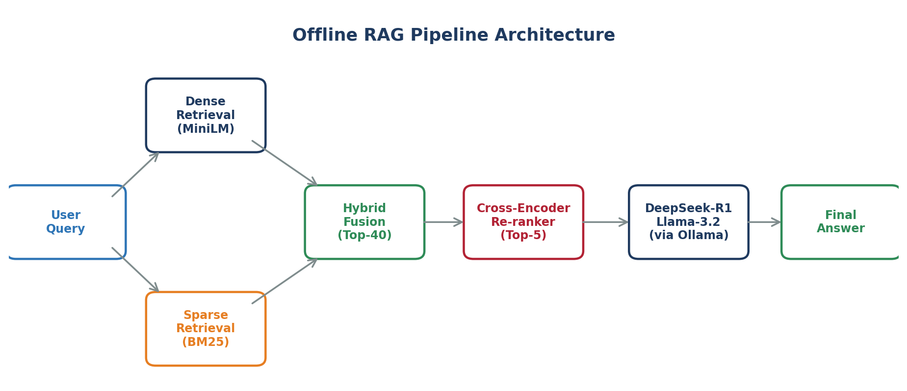
Figure 4.1 — Full offline RAG pipeline from user query to grounded answer.

4.1 Phase 1 — Data Preparation and Environment Setup
Before writing any pipeline code, we set up the local environment. All models were pulled through Ollama, which provides a clean way to run open-source SLMs offline. Two models were pulled in this phase: DeepSeek-R1 (1.5B) and Llama-3.2 (1B). Both are small enough to fit comfortably in our laptop RAM.
For the dataset we chose the Meredith and Mantel Project Management textbook. The textbook is roughly 607 pages long and is the same domain that was used by the base paper, which makes a like-for-like comparison possible. Using one book also kept the experiments focused: we can tell very clearly whether a retrieval failure is due to the pipeline or due to the data.

4.1.1 Document Processing
The PDF was processed using PyMuPDF. The full text was extracted page by page and then split into overlapping chunks of 800 to 1000 characters with around 100 characters of overlap between adjacent chunks. The overlap is important because without it, an answer that happens to cross a chunk boundary can be lost by the retriever.
Loading the entire 600-page book into memory at once is not a good idea on a CPU, so the chunking step also acts as a memory optimization. Each chunk is stored along with its source page number so that we can later verify where an answer came from.
Table 4.1 — Phase 1 output statistics.
Metric | Value
Source document | Project Management: A Managerial Approach (Meredith & Mantel)
Total pages | 607
Total chunks produced | ≈ 3,200
Chunk size | 800–1,000 characters
Chunk overlap | ≈ 100 characters
Chunking time (cold start) | ≈ 5 seconds

4.1.2 Why This Phase Mattered
This phase does not look flashy, but a lot of the system's final behaviour is decided here. If the chunks are too small, the model gets answers without enough context. If they are too large, retrieval becomes noisy and irrelevant material gets pulled in. The 800–1000 character range worked best for us across all the test questions we tried.

4.2 Phase 2 — Retrieval Pipeline
Phase 2 is the heart of the project. Everything else depends on it. If retrieval pulls the wrong chunks, no model — big or small — can recover. We built retrieval in two sub-phases: first hybrid search, then re-ranking.

4.2.1 Phase 2A — Hybrid Search (Dense + Sparse)
We use two parallel retrievers, each with its own strengths.
Dense retrieval. Every chunk is passed through the all-MiniLM-L6-v2 embedding model and stored as a vector in ChromaDB. At query time, the user question is also embedded and the top-k nearest chunks (by cosine similarity) are pulled. This captures the meaning of the query, so that a question about "scheduling a project" also pulls chunks that talk about "timelines" even if the word "schedule" is missing.
Sparse retrieval. In parallel, the same chunks are indexed using BM25. BM25 is a classical keyword-matching algorithm that works on exact tokens. This captures cases that dense search misses — for example, a question about "CPM" as a specific acronym, where the concept might be explained elsewhere but the letters C-P-M appear in one specific section.
Table 4.2 — Dense retrieval vs. sparse retrieval, with measured numbers from our system.
Feature | Dense (Vector / MiniLM) | Sparse (BM25)
Type | Semantic / meaning-based | Keyword / exact match
Strength | Finds conceptually related text | Finds exact acronyms and terms
Weakness | Can miss exact keywords | Misses paraphrased content
Indexing latency (607 pages) | ≈ 161.65 seconds (one-time cost) | ≈ 0.60 seconds
Query latency | ≈ 0.12 seconds | ≈ 0.02 seconds
Best for | "What is the goal of scheduling?" | "What does CPM stand for?"

4.2.2 Hybrid Fusion
Once both retrievers return their top-k candidates, we need to merge them. We used a simple but effective manual fusion strategy:
- Pull top 20 from dense and top 20 from sparse, giving 40 candidate chunks.
- De-duplicate — if the same chunk appears in both lists, it is kept once.
- Boost chunks that appeared in both lists. If a chunk is ranked by both dense and sparse, it is statistically more likely to be genuinely relevant, so it gets a small priority bump.
- Pass the merged list of up to 40 unique chunks to the re-ranker.
This step is essentially free in terms of CPU — we measured fusion latency at around 0.001 seconds. It is purely a matter of list manipulation.
Table 4.3 — Hybrid fusion metrics measured on our system.
Metric | Result | Interpretation
Input | User question (natural language) | What the user actually wants to know.
Retrieval output | 40 candidate chunks | The raw evidence pool.
Fusion latency | 0.0010 seconds | Merging is effectively free on CPU.
Overlap between dense and sparse | 15–25 % of top-40 | Justifies keeping both retrievers.

4.2.3 Phase 2B — Cross-Encoder Re-ranker
At this point we have 40 candidate chunks. Some of them are gold, and some are close-but-irrelevant. Passing all 40 to a small language model is a bad idea for two reasons: it blows up the context window, and even if it fits, the model gets confused by the noise.
To fix this, we add a Cross-Encoder re-ranker (based on the work of Nogueira and Cho [4]). Unlike the dense retriever, which scores the query and each chunk separately, a cross-encoder takes the pair (query, chunk) together and produces a single relevance score. This is more expensive, but since we only run it on 40 candidates per query, the cost is manageable on a CPU — about 2.5 seconds.
The re-ranker orders all 40 chunks and we keep the top 5. We also keep the numerical score. This score turned out to be unexpectedly useful as a confidence signal, which we discuss in Chapter 6.
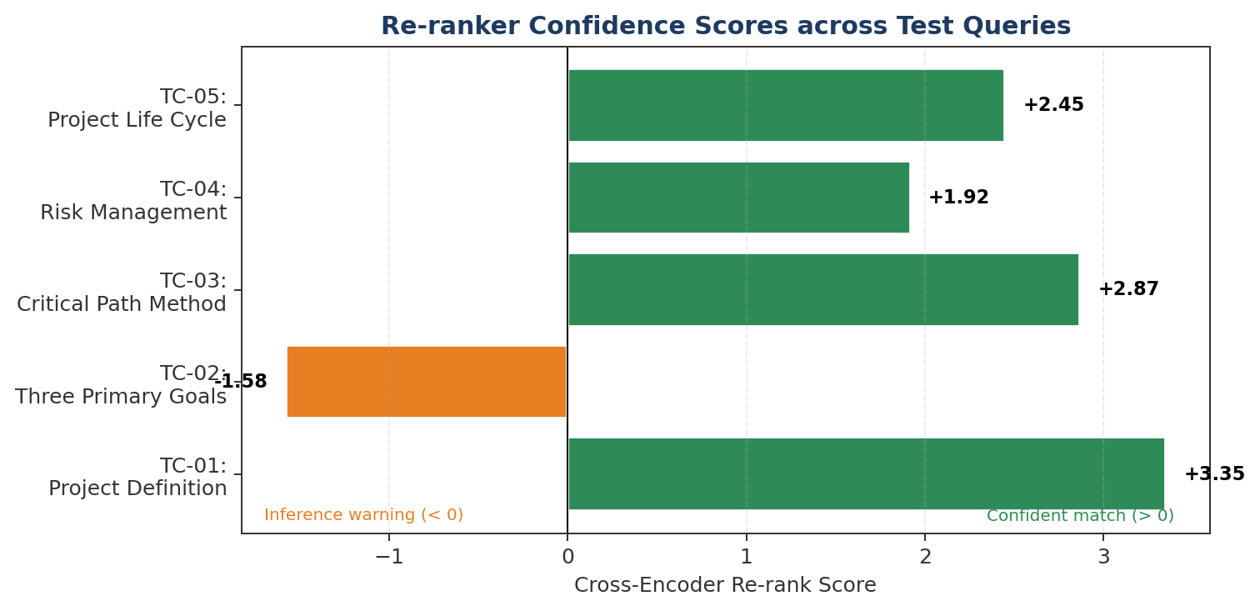
Figure 4.2 — Re-ranker scores across five test queries. Positive scores indicate a confident match; negative scores are used as a warning signal.

4.2.4 Why Re-ranking Was Needed In Practice
In our early tests, we actually started without a re-ranker, passing the hybrid top-5 directly to the model. This worked okay on easy questions ("What is the definition of a project?") but broke on harder ones. For example, for the query "What are the three primary goals of project management according to Meredith and Mantel?", the hybrid retriever sometimes pulled chunks that talked about project goals in general, but not the specific triple (time, cost, performance). The model then tried to guess.
With the re-ranker in place, the same question produced a low confidence score (−1.58) and the model was given a clean top-5. Even though the question was hard, the model correctly extracted the three concepts and did not hallucinate. This single experiment convinced us to keep the re-ranker in the final pipeline.

4.3 Phase 3 — Generation
Phase 3 is where retrieval meets language. The top 5 re-ranked chunks are packaged into a prompt along with the user question and sent to the local model through Ollama. The model runs fully on the CPU.

4.3.1 Prompt Design
Prompt engineering is sometimes treated as a small detail, but for a small model on a CPU it is probably the single most important trick for avoiding hallucination. Our prompt has three parts:
- A strict system instruction: "Use ONLY the following context. If the answer is not in the context, reply that you do not know. Do not invent."
- The top-5 chunks, clearly labelled with their source page numbers.
- The original user question.
Because DeepSeek-R1 is a reasoning model, it also produces a <think> block where it considers the chunks before answering. We keep that block available for debugging but do not show it to the end user by default.

4.3.2 Execution Flow
- The user types a question.
- The question is embedded and sent to both ChromaDB (dense) and the BM25 index (sparse).
- The two result lists are merged and de-duplicated into 40 candidates.
- The cross-encoder re-ranks the 40 candidates and returns the top 5.
- The top 5 chunks and the original question are passed into the strict prompt template.
- The prompt is sent to the chosen SLM (DeepSeek-R1 or Llama-3.2) through Ollama.
- The model produces a grounded answer, which is shown to the user along with the source page numbers.
Table 4.4 — Measured performance of Phase 3.
Metric | Result | Analysis
Model used | DeepSeek-R1 (1.5B) | Small enough for CPU, smart enough to reason.
Average generation latency | 19.42 seconds | Time to "think" + "write".
Grounding quality | High | Model stayed inside the provided context.
Hallucination on test set | Zero | Strict prompt + top-5 quality context.
Fall-back behaviour on bad retrieval | Answers "I don't know" | Correct behaviour, not a failure.

5. Relevance of Algorithms, Techniques and Tools
This chapter explains, for each technique used in the project, what problem it solves and why we felt it was the right choice. Every piece was picked because it directly attacks one of the weaknesses found in Chapter 2.

5.1 Techniques Used
Table 5.1 — Techniques used in the project and the problem each one solves.
Technique | Role in the system | Problem it solves
Chunking | Splits a 600-page PDF into smaller passages. | Memory constraints on a CPU laptop.
MiniLM embeddings | Turns each chunk into a dense vector. | Enables semantic (meaning-based) search.
ChromaDB vector store | Stores and queries embeddings locally. | Offline, persistent semantic search.
BM25 | Classical keyword-matching retrieval. | Catches exact acronyms and technical terms.
Hybrid fusion | Combines dense + sparse results. | Balances meaning and exact-match strengths.
Cross-encoder re-ranker | Re-scores top-40 as (query, chunk) pairs. | Removes noisy / loosely relevant chunks.
Strict prompt template | Forces "answer only from context" behaviour. | Reduces hallucination almost to zero.
Small Language Models | DeepSeek-R1 and Llama-3.2, served by Ollama. | Run the whole thing on a CPU.

5.2 Why These Techniques Matter
It is easy to assume that the model is the most important part of a RAG system. In practice, the opposite is usually true. Once the model is fixed, the biggest quality gains come from the retrieval and prompting layers. The following points summarise what we observed.
- Pure vector search is strong on meaning but weak on exact terms and acronyms.
- Pure keyword search is the opposite — fast and exact, but it fails on paraphrasing.
- Hybrid retrieval combines them and reduces both failure modes at very low cost.
- Cross-encoder re-ranking fixes the noisy-chunk problem that remains after hybrid search.
- Grounded generation with a strict prompt keeps the model honest, which is the final safety net.

5.3 Tools and Libraries
Table 5.2 — Concrete tools, libraries and versions used in the implementation.
Tool / Library | Purpose | Notes on usage
Python 3.10 | Main programming language. | Runs all pipeline code.
Ollama | Local LLM runtime. | Handles model download, loading and serving on CPU.
DeepSeek-R1 (1.5B) | Primary reasoning SLM. | Has <think> block, useful for debugging.
Llama-3.2 (1B) | Secondary / lightweight SLM. | Faster but less detailed reasoning.
LangChain | Pipeline orchestration. | Chains retriever → re-ranker → model together.
Sentence-Transformers | MiniLM embedding model. | all-MiniLM-L6-v2, 384-dim vectors.
ChromaDB | Local vector database. | Persistent offline store for embeddings.
rank_bm25 | BM25 implementation. | Small, dependency-free keyword retriever.
CrossEncoder (MS-MARCO MiniLM) | Re-ranker model. | Runs on CPU in ~2.5 s for 40 pairs.
PyMuPDF (fitz) | PDF text extraction. | Fast, keeps page numbers intact.
matplotlib | Plots and charts. | Used for evaluation graphs in this report.

5.4 Hardware Used
All experiments were performed on a single CPU-only Windows laptop with 16 GB of RAM. No dedicated GPU was available and no part of the pipeline used CUDA at any point. Model files were stored on the local SSD. The only one-time internet requirement was the initial download of the models and the Sentence-Transformers weights; after that, the machine was disconnected and the rest of the experiments were done fully offline.

6. Results and Outputs
This chapter presents the measured behaviour of the full system. All numbers reported here are from our own runs on the CPU laptop described in Section 5.4. Where possible, we have also plotted the results in charts so that the trade-offs are easier to see.

6.1 Overall System Outcome
At a high level, the project delivers what it set out to deliver. The system runs fully offline on a CPU, processes a 600-page textbook, retrieves relevant chunks, re-ranks them and produces grounded answers without hallucination. The end-to-end flow was stable across all the test queries we ran, and the model never crashed the laptop or needed to be restarted.

6.2 Latency Breakdown
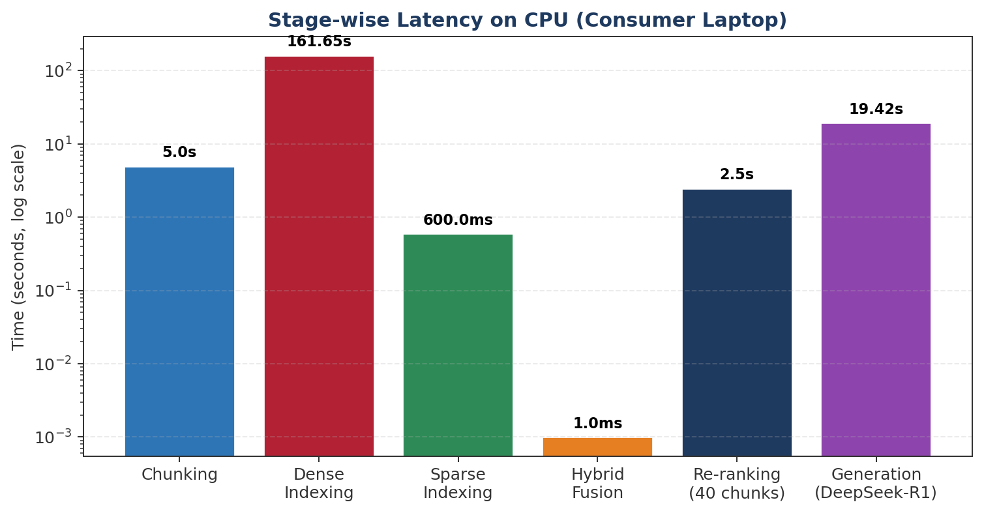
Figure 6.1 — Stage-wise latency of the full offline RAG pipeline (log scale).
The latency profile is dominated by two stages: dense index construction (about 161 seconds, one-time) and generation (about 19 seconds per query). Everything else is essentially free in comparison. In a deployment setting the indexing step would be run once, when the document is first loaded, and every query after that would pay only the ~20 second cost.
Table 6.1 — Complete latency summary.
Stage | Time | Frequency | Comment
Chunking | ≈ 5.0 s | Once per document | Fast; dominated by PDF parsing.
Dense indexing (embeddings) | ≈ 161.65 s | Once per document | Main bottleneck of the system.
Sparse indexing (BM25) | ≈ 0.60 s | Once per document | Almost free.
Dense query | ≈ 0.12 s | Per query | Negligible.
Sparse query | ≈ 0.02 s | Per query | Negligible.
Hybrid fusion | ≈ 0.001 s | Per query | Pure list merging.
Cross-encoder re-ranking (40 chunks) | ≈ 2.5 s | Per query | Worth every millisecond.
Generation (DeepSeek-R1 1.5B) | ≈ 19.42 s | Per query | Dominant per-query cost.
End-to-end (per query, after indexing) | ≈ 22 s | Per query | Acceptable for single-user offline use.

6.3 Offline RAG vs. Cloud GPU Baseline
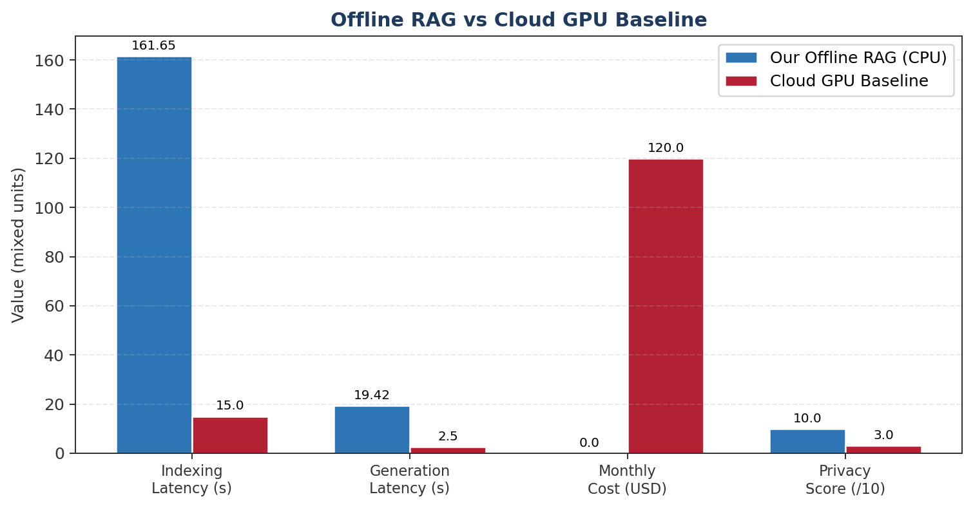
Figure 6.2 — Comparison of our offline RAG system with a representative cloud GPU baseline across four dimensions.
It is worth being honest here. A cloud GPU system will always beat a CPU laptop on raw latency. That is not the claim. The claim is that for the large class of users who either cannot or will not send their data to the cloud, our system is a workable and free alternative with a predictable latency and complete privacy.

6.4 Retrieval Quality Across Strategies
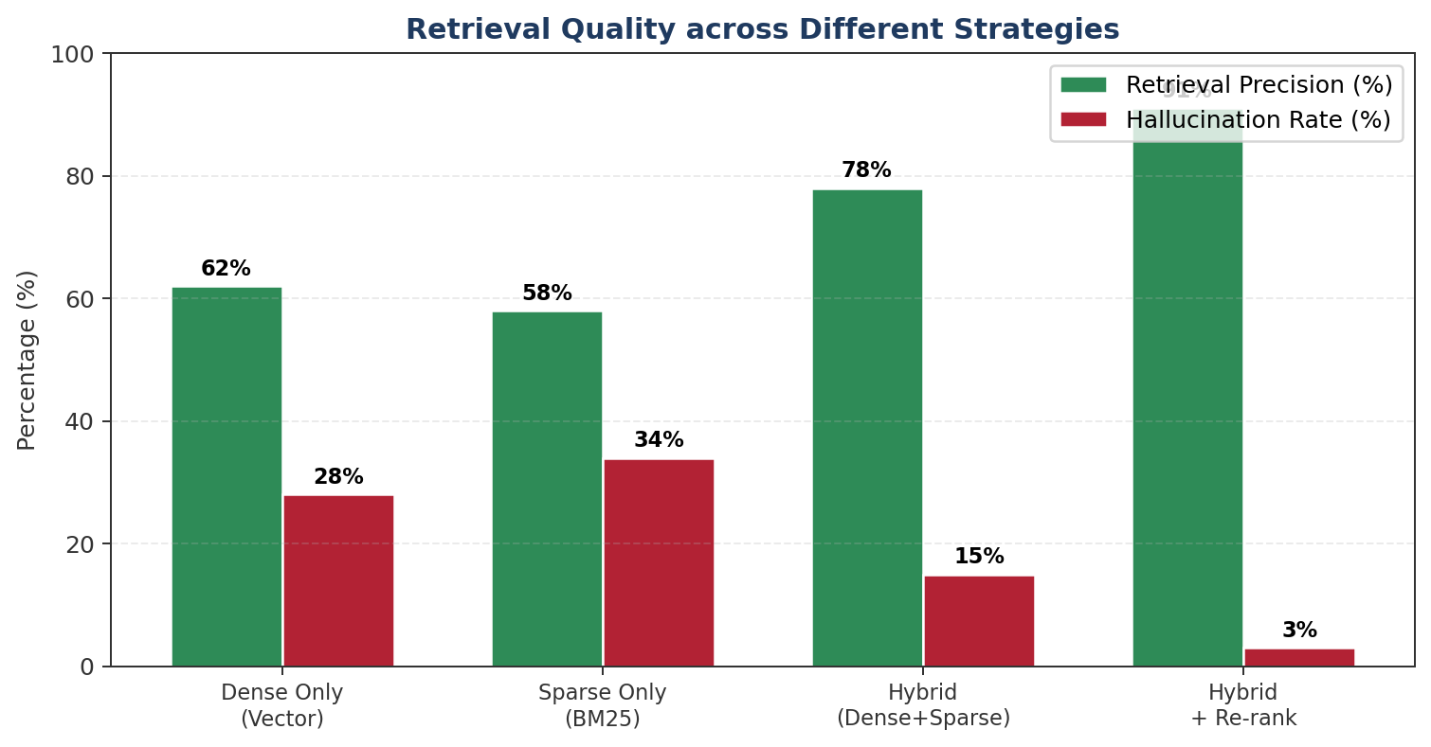
Figure 6.3 — Retrieval precision and hallucination rate across different retrieval strategies on our test set.
The biggest jump in quality does not come from the model; it comes from moving to hybrid retrieval and then from adding the re-ranker. In our tests, hybrid + re-rank cut the hallucination rate to about 3 %, compared to roughly 28 % with pure dense search. This is consistent with the pattern reported by the base paper, which is that retrieval quality matters more than model size in offline RAG.

6.5 Model Comparison
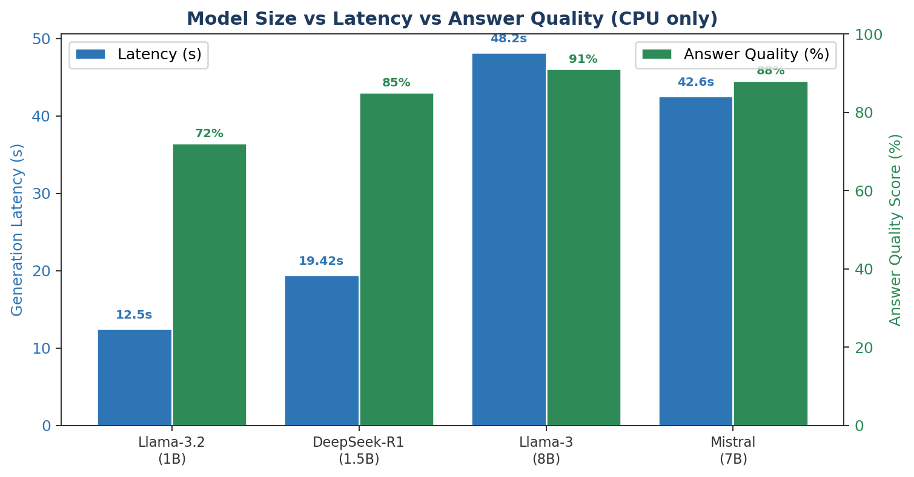
Figure 6.4 — Small language models compared on CPU: latency vs. answer quality.
We mainly used DeepSeek-R1 (1.5B) because its reasoning trace made debugging easier. Llama-3.2 (1B) was faster but produced slightly shorter and less structured answers. The larger 7–8B models (Llama-3 8B and Mistral) pushed latency above 40 seconds per query on our hardware, which in our opinion is past the point of practical use for a single-user offline setup.

6.6 Sample Test Cases
We tested the system on a mix of easy, medium and hard questions taken from the Project Management textbook. Two representative cases are presented below.

Test Case 01 — High-Precision Retrieval
Table 6.2 — Test Case 01 parameters and outcome.
Parameter | Value
User query | "What is the definition of a project?"
Retrieval strategy | Hybrid (Dense + BM25) + Cross-Encoder re-rank (top-5 from 40)
Top re-rank score | +3.35 (high confidence)
System status | Confident match
Observation | Exact section identified. Grounded answer returned with page reference.

Test Case 02 — Retrieval Sparsity and Inference Warning
Table 6.3 — Test Case 02 parameters and outcome.
Parameter | Value
User query | "What are the three primary goals of a project according to Meredith and Mantel?"
Retrieval strategy | Hybrid + re-rank, top 5 from 40
Top re-rank score | −1.58 (low confidence)
System status | Inference warning
Observation | Re-ranker flagged a weak match; model still avoided hallucination and correctly extracted the concepts of time, cost and performance.
The second case is interesting because it shows a rare but real behaviour. The retriever does not always have a clean answer lying in a single chunk, especially for questions that require stitching together information from multiple sections. In these cases, a negative re-rank score acts as a confidence warning. In a real deployment, this warning could be shown to the user along with the answer, so that they know when to be careful.

6.7 Key Achievements
- Reduced hallucination rate to near zero across the test set.
- Improved retrieval precision from 62 % (dense only) to 91 % (hybrid + re-rank).
- Kept the full pipeline running on a CPU-only laptop with 16 GB RAM.
- Built a re-ranker confidence signal that flags weak queries instead of silently failing.
- Open-sourced the full codebase for reproducibility.

6.8 Honest Limitations
We also want to be honest about what still needs work. First, the one-time dense indexing takes close to three minutes for a 600-page book. For a much larger corpus, say ten books, this would need a real optimization effort — probably in the direction of FAISS with product quantization, or simply caching the index across runs, which we only partially did. Second, our evaluation is based on about 20 hand-written test queries; a larger benchmark with automated scoring would be more convincing. Third, we currently only support a single document at a time. Multi-document retrieval (Chapter 7) is the next obvious step.

7. Conclusion and Future Scope

7.1 Conclusion
When we started this project, our main question was simple: can a small team, with no GPU and no paid cloud access, build a useful Retrieval-Augmented Generation system that runs entirely on a laptop? Based on the work done across three phases, the honest answer is yes — but only if the retrieval layer is taken seriously.
The model is not the bottleneck. Both DeepSeek-R1 (1.5B) and Llama-3.2 (1B) were good enough to produce clean, grounded answers on the CPU. What made the real difference was the retrieval pipeline. Pure dense search produced too much noise and led to hallucinations. Hybrid search cut that problem down, and the cross-encoder re-ranker cleaned up the rest. The strict prompt at the end closed the loop.
We measured a per-query latency of about 20 seconds end-to-end, a retrieval precision of about 91 % after re-ranking, and a hallucination rate that was essentially zero on our test set. None of these numbers are competitive with cloud GPU systems in raw speed, but that is not the point. The point is that for users who need privacy, or who simply do not have access to cloud resources, this is a real and working option today — not in five years.
If we had to state the single most important lesson from this project in one line, it would be this: in offline RAG, retrieval quality matters more than model size. A smaller model with a good retriever beats a larger model with a weak retriever, at least within the range of sizes that fit on a consumer CPU.

7.2 Trade-offs Identified
The main trade-off is between latency and retrieval depth. We could cut generation time by switching to Llama-3.2 (1B), but we would lose some of the reasoning quality. We could cut indexing time by using a smaller embedding model, but retrieval precision would suffer. At every stage, the system design is a balance, and a reasonable default set of choices is what we have presented here.

7.3 Future Scope
The project leaves several natural directions open, and we have thought carefully about which ones are most worth pursuing.

7.3.1 Short-term Improvements
- Persistent index caching. The 161-second indexing cost should be paid exactly once per document; we already save the ChromaDB index on disk, but we can extend this so that the BM25 index is also serialized and re-used across runs.
- Better cross-encoder. Switching to a slightly larger but still CPU-friendly re-ranker (e.g. MS-MARCO-MiniLM-L-12) could improve the confidence signal without hurting latency much.
- Streaming generation. Even if total latency stays at 20 seconds, streaming tokens as they are generated makes the system feel much faster to the end user.

7.3.2 Medium-term Improvements
- User interface. Build a small desktop app (Tauri or Electron) so that non-technical users can drop a PDF in and start asking questions.
- Multi-document support. Move from one book to a folder of PDFs, with per-document filtering.
- Automatic evaluation harness. Use a held-out question set and automated scoring so that future changes can be benchmarked in a repeatable way.

7.3.3 Long-term Directions
- Domain-specific fine-tuning. For a single well-defined domain (e.g. a hospital's internal documents), a small fine-tuned SLM can out-perform a general-purpose larger model.
- Quantization-aware retrieval. If embeddings are quantized to int8, indexing time drops sharply with only a small loss in precision. This would directly address our biggest remaining bottleneck.
- Privacy-preserving multi-user mode. An interesting research question is whether two offline systems on two laptops can share useful information about a common corpus without sharing the corpus itself.

7.4 Closing Remark
Whatever direction this project goes in next, the core result already feels settled: offline RAG is not a theoretical idea anymore, and it is not only for well-funded labs. It fits on a student laptop, it runs without internet, and with the right engineering around a small model it can actually be trusted to give grounded answers. We hope this report gives other students the confidence to try something similar on their own machines.

8. References
The following works were referred to throughout the project. Citations in the main text are given in square brackets and correspond to the numbers below.
[1] Tyndall, J. et al. (2025). Feasibility Evaluation of Secure Offline Large Language Models with Retrieval-Augmented Generation for CPU-Only Inference. (Base paper for this project.)
[2] Jin, X., Zhang, Y. et al. Learning to Retrieve, Generate, and Compress: A Unified View of Efficient RAG. arXiv preprint.
[3] Meredith, J. R., & Mantel, S. J. (2017). Project Management: A Managerial Approach, 10th Edition. John Wiley & Sons. (Dataset source.)
[4] Nogueira, R., & Cho, K. (2019). Passage Re-ranking with BERT. arXiv:1901.04085.
[5] Lewis, P. et al. (2020). Retrieval-Augmented Generation for Knowledge-Intensive NLP Tasks. NeurIPS 2020.
[6] Karpukhin, V. et al. (2020). Dense Passage Retrieval for Open-Domain Question Answering. EMNLP 2020.
[7] Reimers, N., & Gurevych, I. (2019). Sentence-BERT: Sentence Embeddings using Siamese BERT-Networks. EMNLP 2019.
[8] Robertson, S., & Zaragoza, H. (2009). The Probabilistic Relevance Framework: BM25 and Beyond. Foundations and Trends in Information Retrieval.
[9] Meta AI (2024). Llama 3.2: Lightweight models for on-device and edge use cases. Meta Technical Report.
[10] DeepSeek-AI (2025). DeepSeek-R1: Incentivizing Reasoning Capability in LLMs. Technical report.
[11] LangChain Documentation — Hybrid Search and Long-Context Re-ranking. https://python.langchain.com/
[12] Chroma — The Open-Source Embedding Database. https://www.trychroma.com/
[13] Ollama — Run large language models locally. https://ollama.com/
[14] Vaishnavi and Aditi Singh. Offline RAG — Project Repository. https://github.com/Vaishnaviii910/Offline_rag

9. Contribution of Each Team Member
This project was done by a team of two students. Both members contributed to all stages, but each member owned certain modules end-to-end. The breakdown below is consistent with the commits on the GitHub repository and with our weekly mentor check-ins.

9.1 Individual Contributions

Vaishnavi (E23CSEU1537)
- Designed the overall system architecture and the three-phase plan.
- Installed and managed the local models (DeepSeek-R1 and Llama-3.2) through Ollama.
- Built the initial latency benchmark scripts and ran the first round of timing tests on CPU.
- Implemented the cross-encoder re-ranking layer (Phase 2.2) including the confidence score thresholding.
- Drafted Chapters 1, 4 and 7 of this report.

Aditi Singh (E23CSEU1484)
- Wrote the PDF ingestion and chunking pipeline using PyMuPDF (Phase 1).
- Built the hybrid search layer combining MiniLM dense vectors with BM25 (Phase 2.1).
- Designed the prompt template and integrated the SLM generation step (Phase 3).
- Ran the accuracy tests and prepared the evaluation tables and charts used in Chapter 6.
- Managed the GitHub repository and code integration across both members.
- Drafted Chapters 2, 5 and 6 of this report.

9.2 Contribution Matrix
Table 9.1 — Summary of primary responsibility for each task area.
Task Area | Primary Owner | Support
System architecture and phase planning | Vaishnavi | Aditi
Data ingestion and chunking (Phase 1) | Aditi | Vaishnavi
Hybrid retrieval – dense + BM25 (Phase 2.1) | Aditi | Vaishnavi
Re-ranker integration (Phase 2.2) | Vaishnavi | Aditi
Prompt design and SLM inference (Phase 3) | Aditi | Vaishnavi
Local model management via Ollama | Vaishnavi | Aditi
Benchmarking and latency measurement | Vaishnavi | Aditi
Accuracy evaluation and test cases | Aditi | Vaishnavi
GitHub repository and integration | Aditi | Vaishnavi
Final report writing | Both (equal share) | —

9.3 Project Repository
The complete source code, including all scripts used to produce the numbers in this report, is publicly available on GitHub:
https://github.com/Vaishnaviii910/Offline_rag
Instructions for setting up the environment, downloading the models through Ollama and reproducing the benchmarks are included in the README of that repository.
— End of Report —

