AWS YouTube Analytics ETL Pipeline
1. Project Overview
This project involved building an end-to-end data engineering pipeline on AWS to ingest, process, and analyze YouTube trending data. The pipeline automates raw data ingestion, transformation, schema management, and preparation of an analytics-ready reporting layer that can be queried efficiently and used for dashboards.
2. Problem Statement & Data Context
- Raw YouTube trending data (CSV video statistics by region and nested JSON category reference data) was stored in Amazon S3 but not analytics-ready.
- Challenges included nested JSON structures, inconsistent schemas, and expensive joins and casting during querying.
- The goal was to build a scalable AWS ETL pipeline that cleans, catalogs, and prepares a reporting layer usable in Athena and BI tools like QuickSight.
3. Architecture & Tools Used
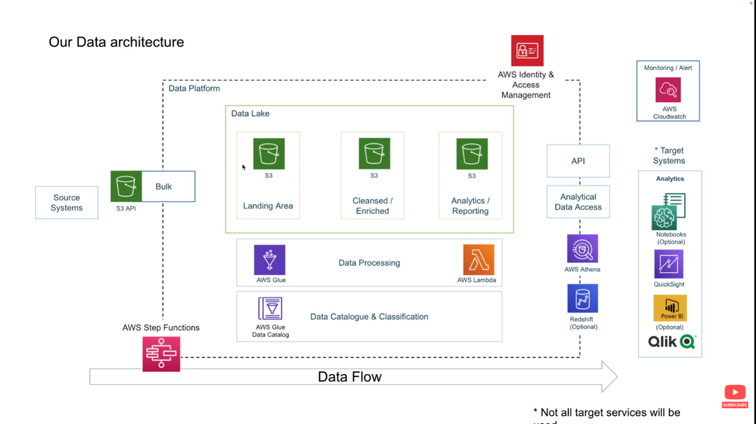

4. End-to-End Data Flow & What Was Implemented
- Uploaded raw CSV and JSON datasets to an S3 raw layer, organized by region to support partitioning.
- Created Glue Crawlers to catalog raw CSV data and validate region-based partitions for efficient Athena queries.
- Built a Lambda-based process to flatten nested JSON category data and store it in Parquet format in a clean S3 layer.
- Queried raw and clean tables in Athena to validate joins between video statistics and category metadata.
- Developed Glue ETL jobs using PySpark to convert CSV data to Parquet, enforce consistent schemas, and write partitioned outputs.
- Built a final Glue Studio ETL pipeline to join cleaned datasets and generate a reporting/analytics layer in a separate S3 bucket.
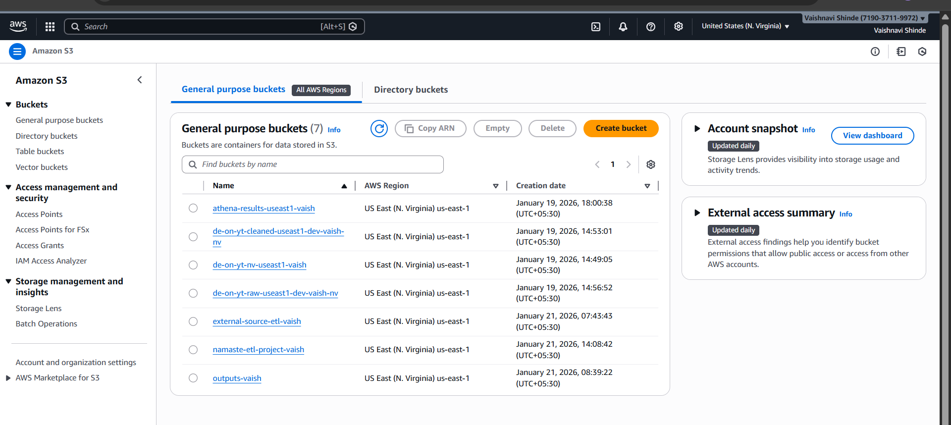

4. End-to-End Data Flow & What Was Implemented
- Uploaded raw CSV and JSON datasets to an S3 raw layer, organized by region to support partitioning.
- Created Glue Crawlers to catalog raw CSV data and validate region-based partitions for efficient Athena queries.
- Built a Lambda-based process to flatten nested JSON category data and store it in Parquet format in a clean S3 layer.
- Queried raw and clean tables in Athena to validate joins between video statistics and category metadata.
- Developed Glue ETL jobs using PySpark to convert CSV data to Parquet, enforce consistent schemas, and write partitioned outputs.
- Built a final Glue Studio ETL pipeline to join cleaned datasets and generate a reporting/analytics layer in a separate S3 bucket.

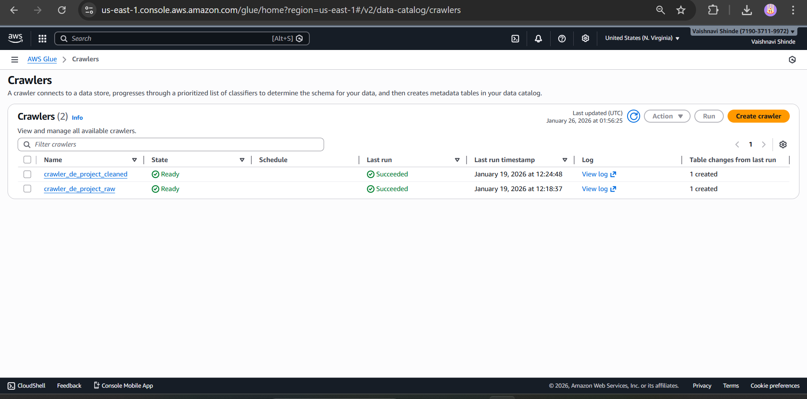

5. Challenges Faced
- Raw CSV tables were partitioned by region, but joins with category metadata initially caused query issues due to schema and datatype mismatches.
- Joining category_id (integer) from statistics data with id (string) from category JSON produced Athena errors and required casting.
- Attempting to fix the datatype only in the Glue Data Catalog caused Parquet compatibility errors because Parquet stores schema metadata within the file itself.
- Glue ETL jobs failed during initial runs due to multilingual and Unicode text that Spark could not process reliably.
- Consistent partitioning across raw, clean, and analytics layers was required to ensure performance and cost efficiency.
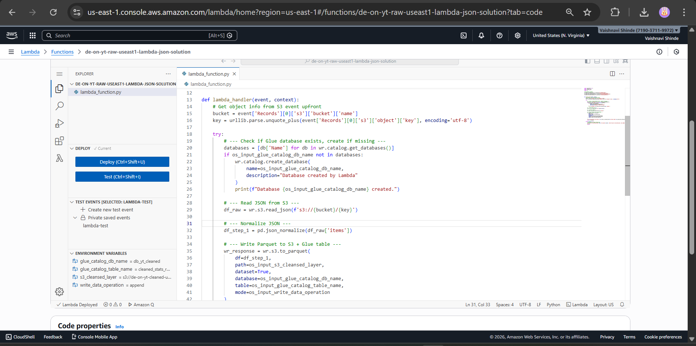

6. How the Issues Were Solved
- Addressed datatype mismatch properly instead of relying on CAST in SQL: although casting fixed the query temporarily, it was inefficient at scale. The datatype was corrected at the data layer instead.
- Identified that changing the Glue Catalog schema alone does not update the Parquet file schema, which caused incompatible Parquet errors.
- Resolved this by deleting Parquet files written with the old schema and re-running the Lambda JSON processing so newly written Parquet matched the updated datatype.
- Handled Glue ETL failures caused by multilingual data by filtering data to selected regions (CA, GB, US) using predicate pushdown logic to validate the ETL pipeline first.
- Updated Glue ETL jobs to write partitioned output (by region and later by category_id), ensuring efficient Athena scans.
- Used CloudWatch logs extensively to debug Lambda and Glue failures and confirm successful pipeline execution.

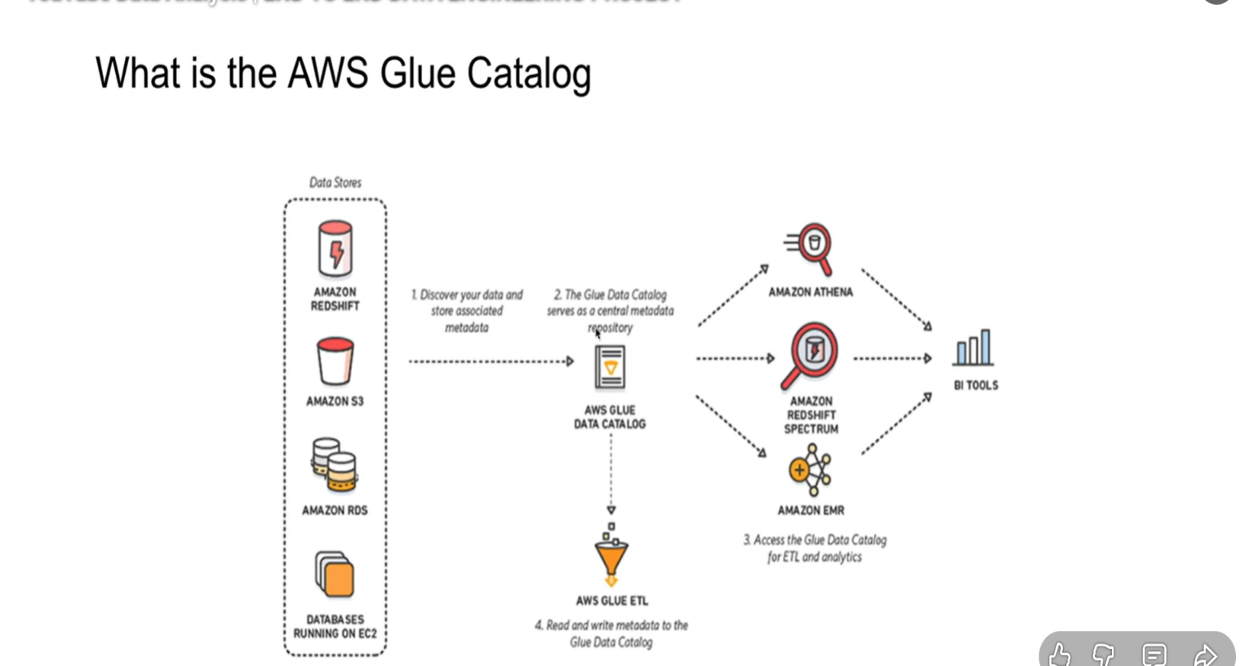

7. Outcomes / Results (Transcript-Based)
- Created a fully queryable raw data layer in Athena by crawling CSV data and validating region-based partitions, allowing region-specific queries without scanning the entire dataset.
- Produced a clean data layer where nested JSON category data was flattened, converted to Parquet, and successfully joined with video statistics using category_id.
- Built a reporting/analytics layer by joining cleaned statistics and category metadata using Glue Studio and writing optimized, partitioned Parquet outputs to a dedicated analytics bucket.
- Enabled BI and visualization use cases by connecting Amazon QuickSight to Athena and creating example analyses such as category-wise views/likes and region-wise distribution, demonstrating that the reporting layer is ready for dashboards and insights.
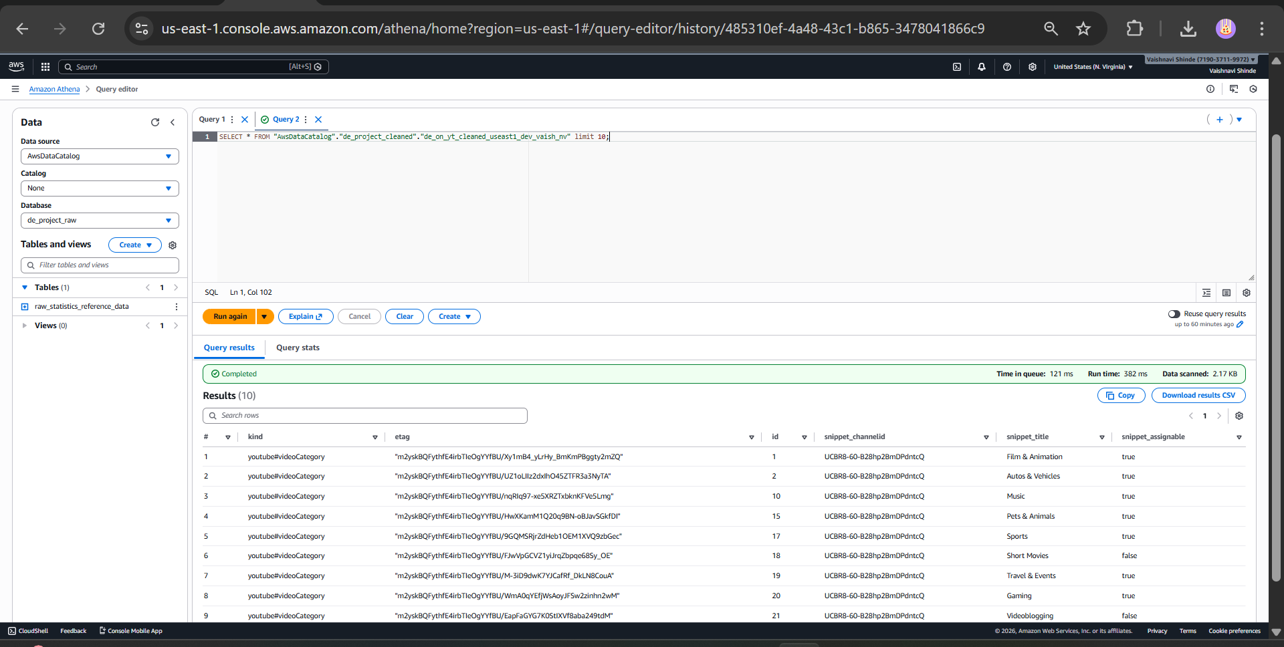
8. Key Learnings
- Partitioning strategy (region/category) significantly improves Athena performance and reduces scan cost.
- Fixing schemas at the data layer is better than repeatedly casting in SQL queries.
- Glue Catalog schema changes do not override Parquet file schemas; data must be rewritten after datatype updates.
- Predicate pushdown and controlled filtering help validate Glue ETL pipelines before scaling to all regions.
- Building a reporting layer simplifies analytics by eliminating repeated joins and complex queries.
