**NAME :- VAISHNAVI K**

**USN :- 1NT19IS195**

**Pipeline**

**Creating a database and inserting records**

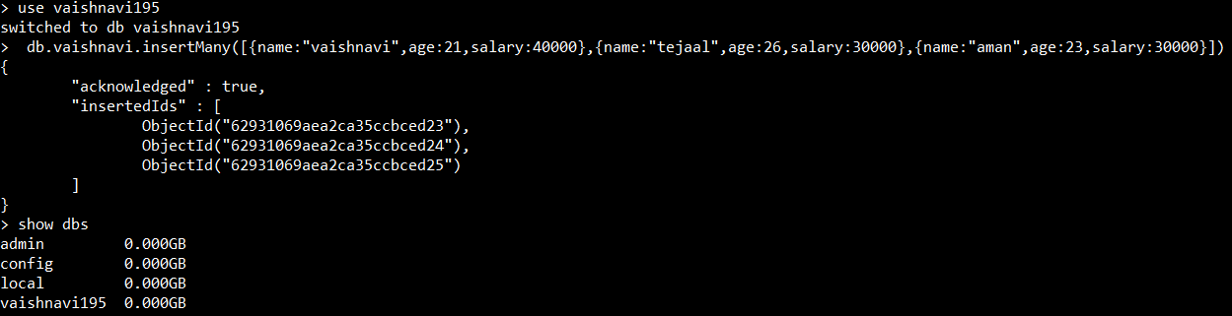

**Displaying the inserted records**

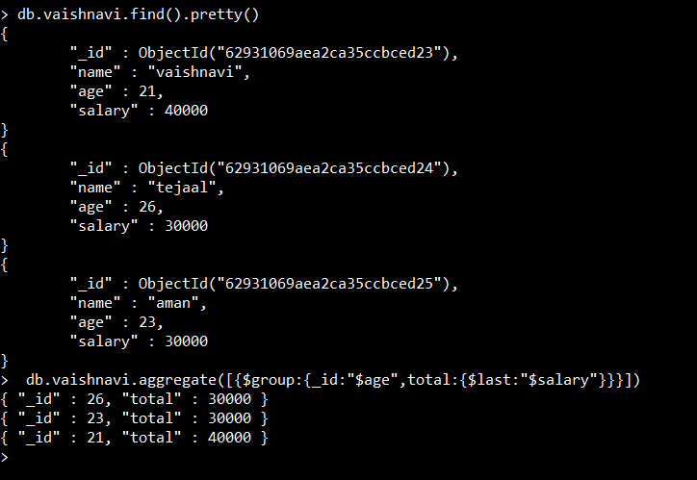

**Using Group**



**Using Match**



**Using Minimum and Maximum**



**Using** **Sum and Average**

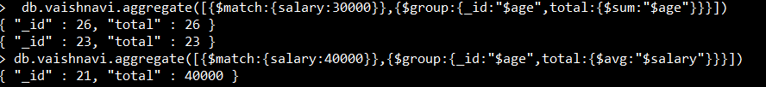

**Using First and Last**

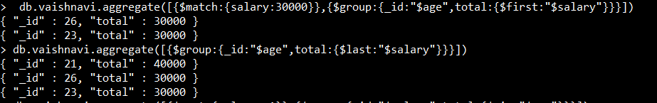

**Using Sort**

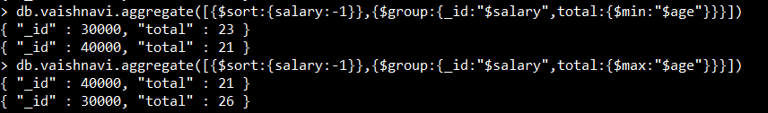

**Map Reduce**

