BIG DATA LAB

Vaishnavi K

1NT19IS195

**Experiment 2**

Check hadoop version

$ hadoop version

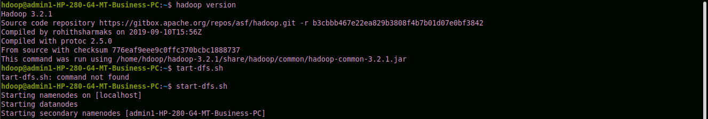

Start hadoop

$ start-dfs.sh



1. Creating a directory

$ hdfs dfs -mkdir /vaishu



1. Listing all directories

$ hdfs dfs -ls /

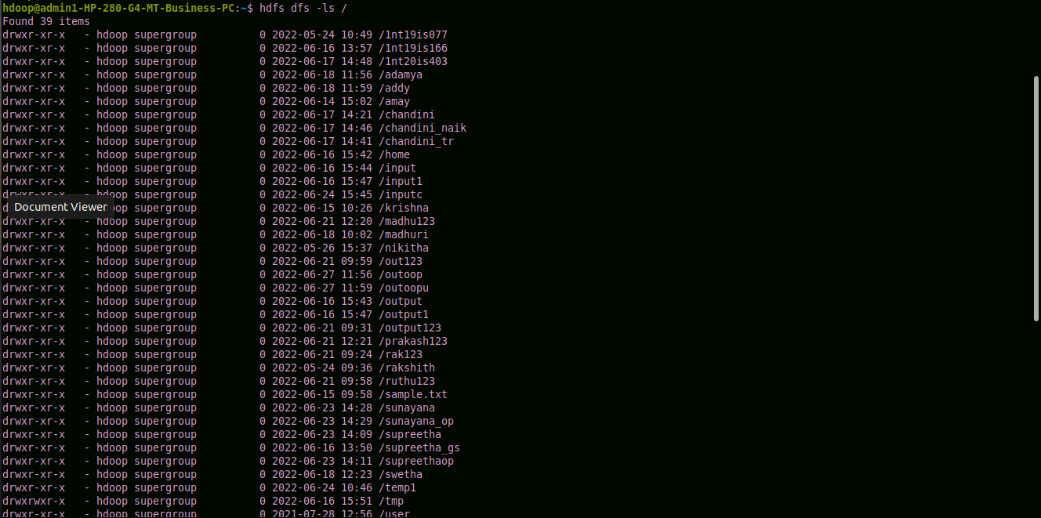

1. Add two empty files into directory

$ hdfs dfs -touchz /vaishu/vk.txt

$ hdfs dfs -touchz /vaishu/vk1.txt

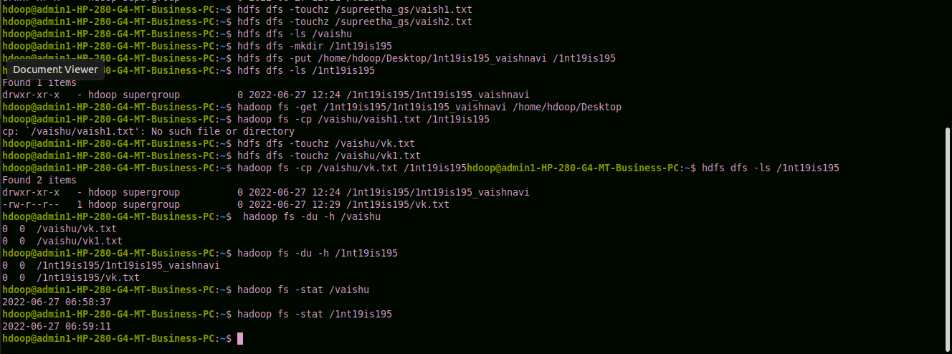

1. Listing all the files in the directory that was created

$ hdfs dfs -ls /vaishu



1. Moving file from local to hadoop using put command

$ hdfs dfs -mkdir /1nt19is195

$ hdfs dfs -put /home/hdoop/Desktop/1nt19is195_vaishnavi /1nt19is195



Checking file at destination

$ hdfs dfs -ls /1nt19is195



1. Moving from hadoop to local

$ hadoop fs -get /1nt19is195/1nt19is195_vaishnavi /home/hdoop/Desktop



File moved to local

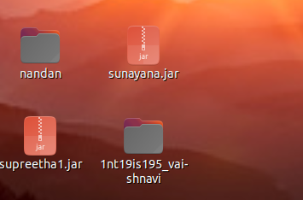

1. Moving file within hadoop

$ hadoop fs -cp /vaishu/vk1.txt /1nt19is195



8. Displaying the size of files in directory

$ hadoop fs -du -h /vaishu

$ hadoop fs -du -h /1nt19is195



Using stat command

$ hadoop fs -stat /vaishu

$ hadoop fs -stat /1nt19is195

