VAISHNAVI

1NT19IS195

BDLAB

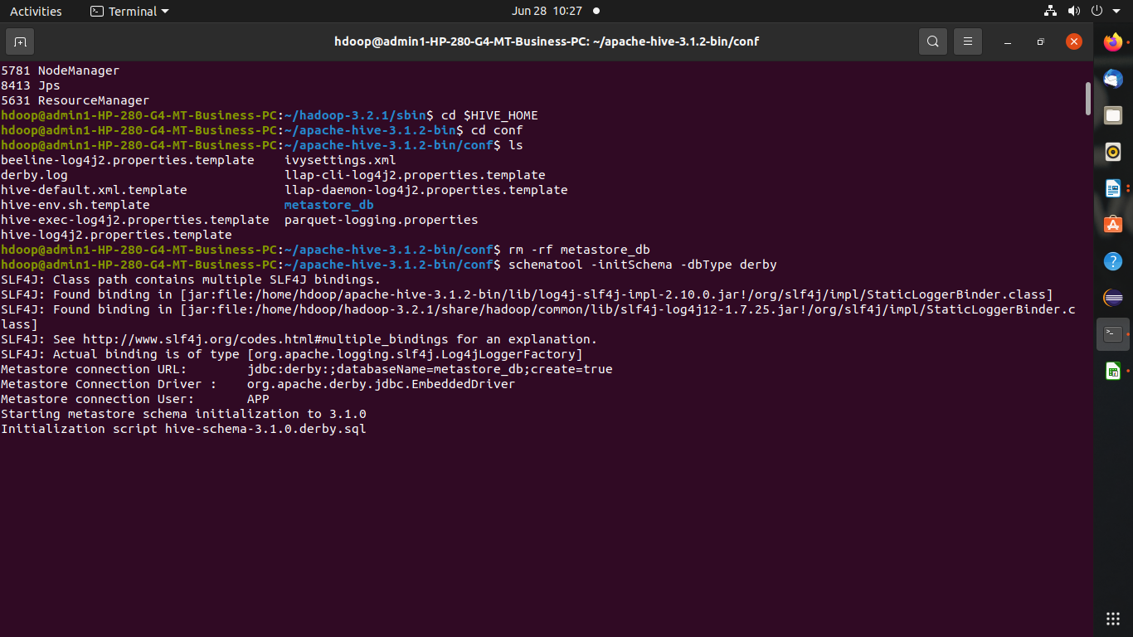HIVE INSTALLIATION:

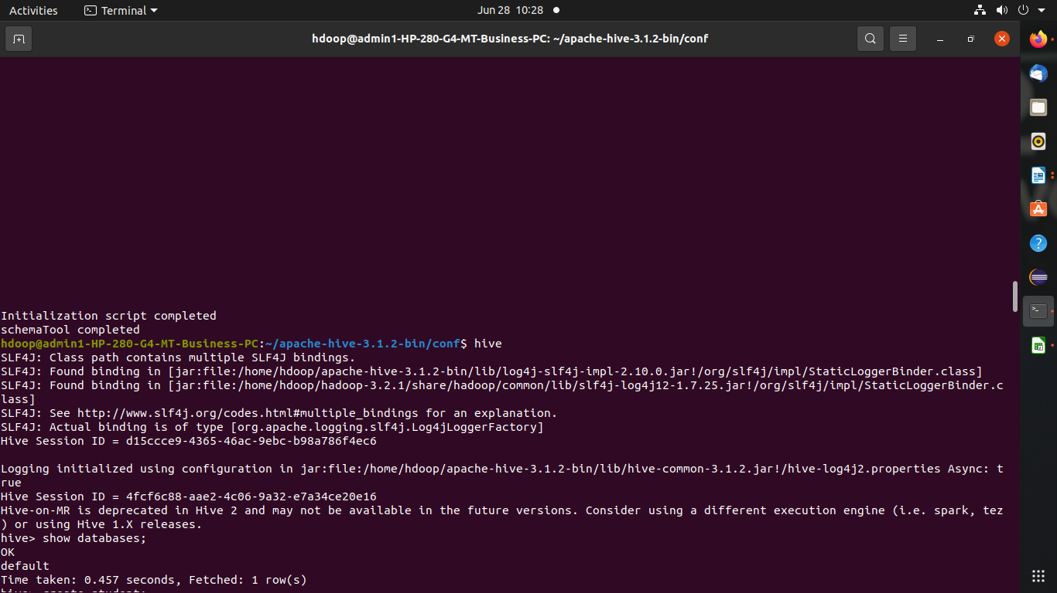

1) Create and Drop databases

hive> create database data;

OK

Time taken: 0.035 seconds

hive> use data;

OK

Time taken: 0.014 seconds

hive> drop database data;

OK

Time taken: 0.122 seconds



2)Create ,Alter ,Drop table

Create :

hive> create table std(usn int,name string,age int);

OK

Time taken: 0.442 seconds

hive> desc std;

OK

usn int

name string

age int

Time taken: 0.113 seconds, Fetched: 3 row(s)

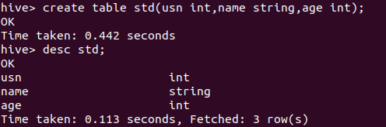

drop table s;

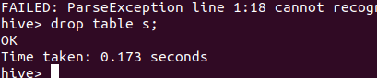

operations:

created new table bank:

create table bank(slno int, cname string, custname string, amount int)

> row format delimited

> fields terminated by "," ;

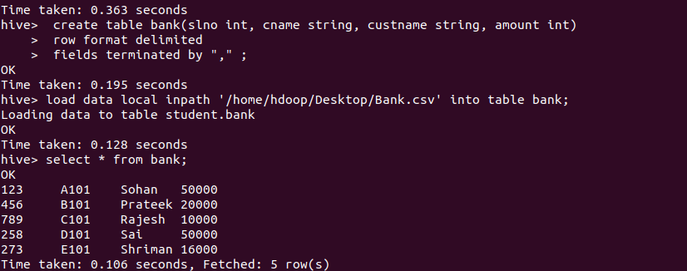

load csv file into table:

load data local inpath '/home/hdoop/Desktop/Bank.csv' into table bank;

and display the data

select \* from bank;



MIN, MAX AVG Operations:

select max(amount) from bank;

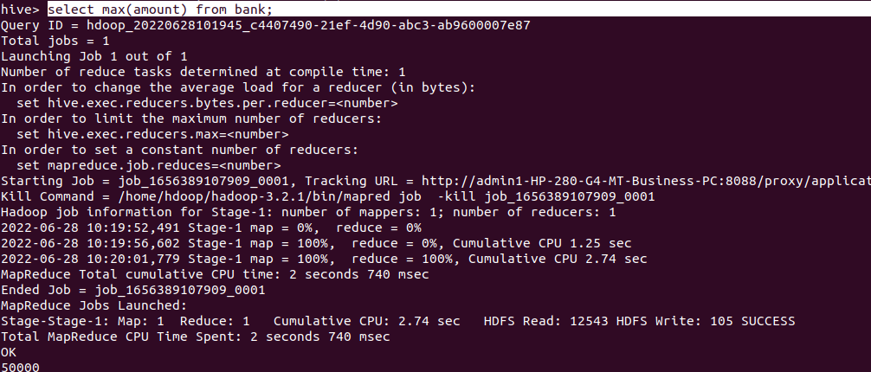

select min(amount) from bank;

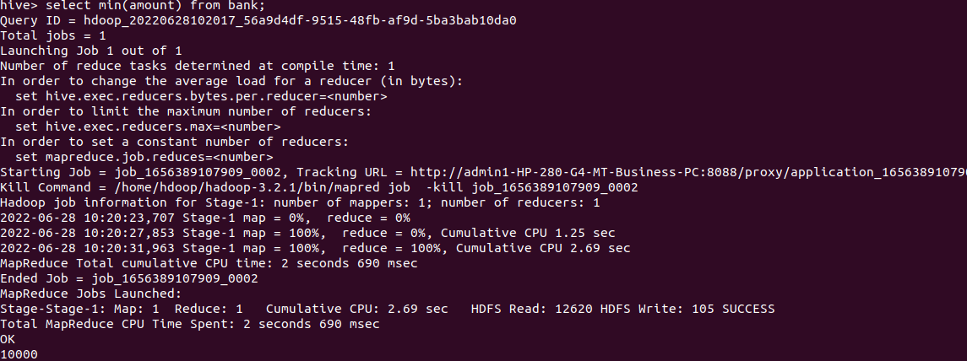

select avg(amount) from bank;

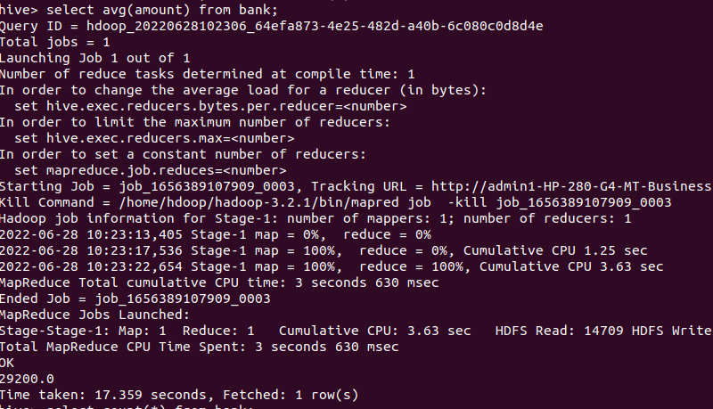

select count(\*) from bank;

