**NAME- VAISHNAVI K**

**USN-1NT19IS195**

**BATCH-C3**

use vaishnavi_employeedb



**1)Inserting the records**

var data=[

{

"id": 1,

"name": "vaishnavi",

"mname": "k",

"lname": "konduru",

"age": 18,

"sal": 25000,

"designation": "PR",

"role": "manager"

},

{

"id": 2,

"name": "padma",

"mname": "m",

"lname": "konduru",

"age": 28,

"sal": 55000,

"designation": "EA",

"role": "UI developer"

},

{

"id": 3,

"name": "prateek",

"mname": "k",

"lname": "konduru",

"age": 38,

"sal": 95000,

"designation": "AC",

"role": "UX developer"

},

{

"id": 4,

"name": "nagesh",

"mname": "rao",

"lname": "konduru",

"age": 48,

"sal": 45000,

"designation": "HR",

"role": "Team lead"

},

{

"id": 5,

"name": "tejaal",

"mname": "rao",

"lname": "mupalla",

"age": 38,

"sal": 25000,

"designation": "ED",

"role": "Manager"

},

{

"id": 6,

"name": "diya",

"mname": "d",

"lname": "mupalla",

"age": 38,

"sal": 25000,

"designation": "AC",

"role": "Associate Manager"

},

{

"id": 7,

"name": "madhavi",

"mname": "m",

"lname": "sai",

"age": 38,

"sal": 5000,

"designation": " AC",

"role": "Accountant"

},

{

"id": 8,

"name": "ramya",

"mname": "d",

"lname": "surya",

"age": 38,

"sal": 95000,

"designation": "PR",

"role": "Assistant Manager"

},

{

"id": 9,

"name": "Varun",

"mname": "m",

"lname": "sandeep",

"age": 68,

"sal": 150000,

"designation": "Ac",

"role": "CEO"

},

{

"id": 10,

"name": "Sindhu",

"mname": "k",

"lname": "sillava",

"age": 38,

"sal": 15000,

"designation": "EA",

"role": "HR"

},

{

"id": 11,

"name": "Nishitha",

"mname": "k",

"lname": "Raghunath",

"age": 18,

"sal": 75000,

"designation": "AC",

"role": "Electrical engineer"

},

{

"id": 12,

"name": "Abhiram",

"mname": "kr",

"lname": "Sinukunar",

"age": 19,

"sal": 55000,

"designation": "ED",

"role": "R&D head"

},

{

"id": 13,

"name": "Vani",

"mname": "p",

"lname": "Venkatesh",

"age": 58,

"sal": 75000,

"designation": "AC",

"role": "Software engineer"

},

{

"id": 14,

"name": "Meghala",

"mname": "r",

"lname": "Kannan",

"age": 28,

"sal": 107000,

"designation": "EDA",

"role": "Senior manager"

},

{

"id": 15,

"name": "Bharath",

"mname": "Kumar",

"lname": "sai",

"age": 18,

"sal": 75000,

"designation": "AC",

"role": "Manager"

}]

db.Employee.insert(data);

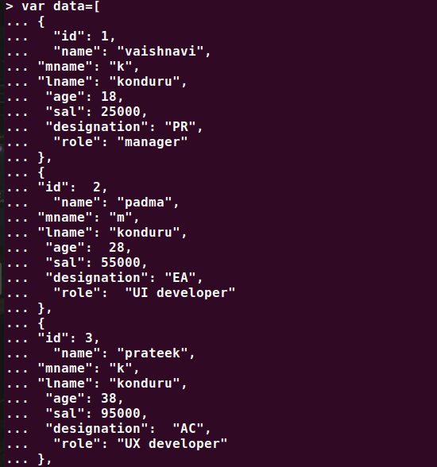

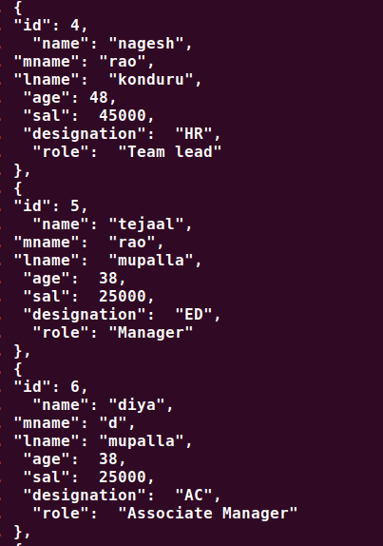

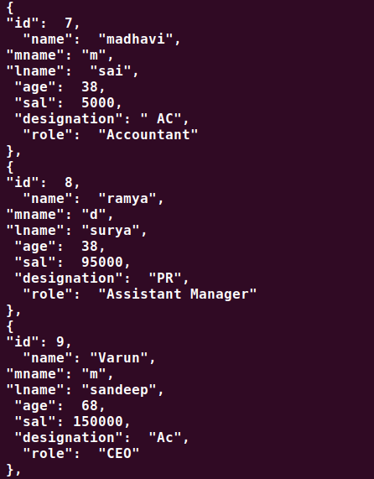

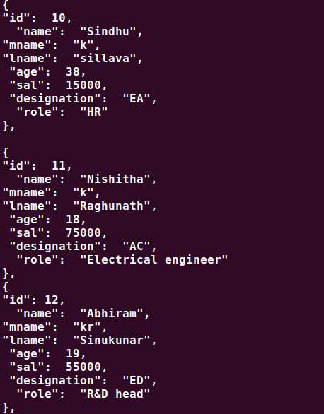

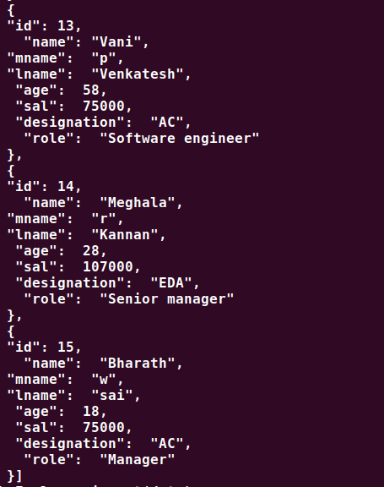

**1)Displaying the records**

> db.Employee.find().pretty()

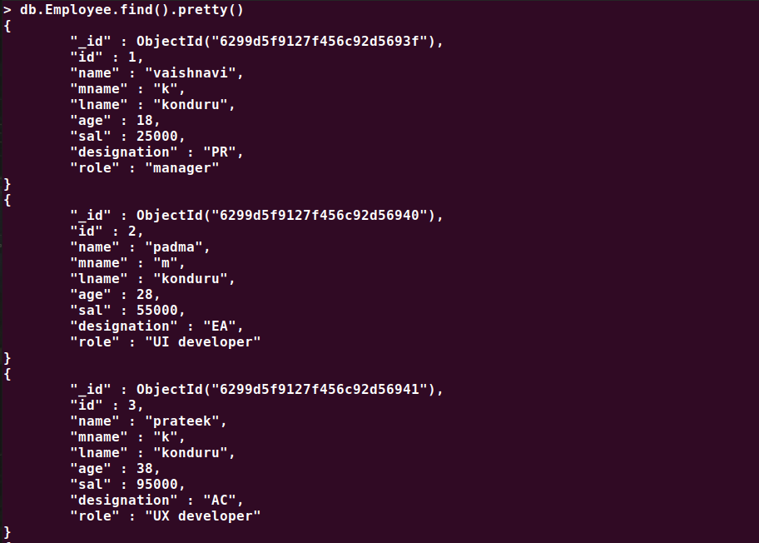

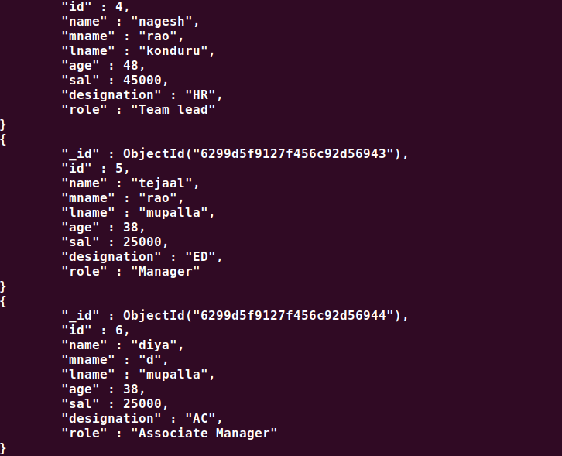

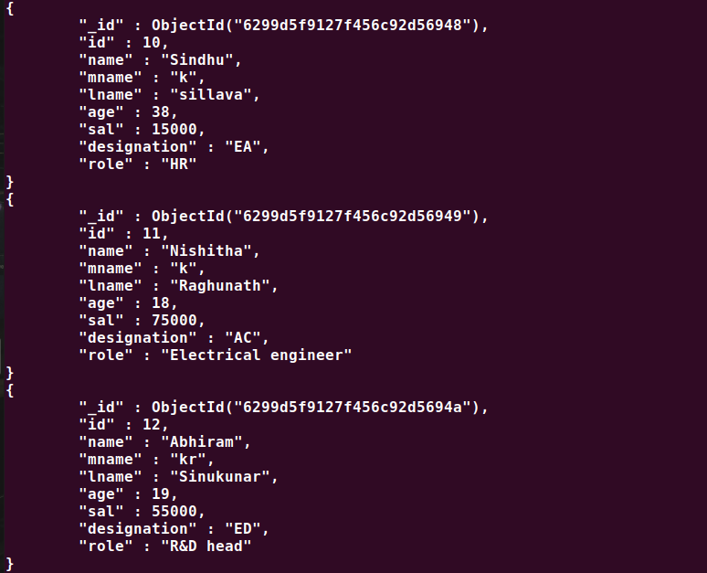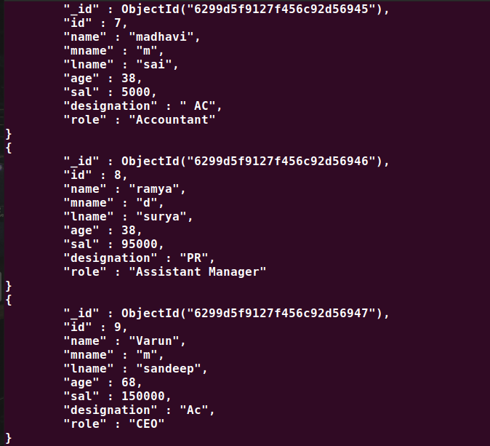

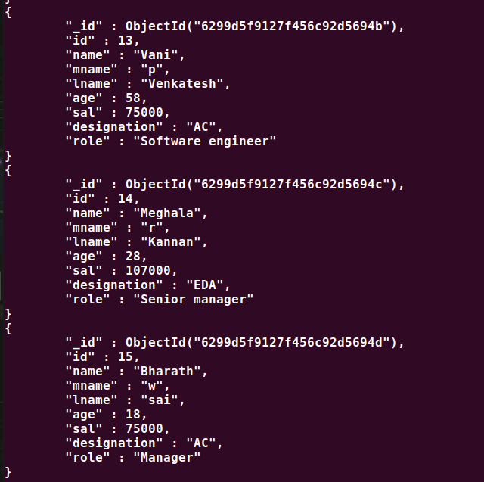

**2. List all the records having salary in the range of 20000 – 35000**

> db.Employee.find({sal:{$gt:20000,$lt:35000}}).pretty()

db.Employee.find({sal:{$gt:20000,$lt:35000}}).pretty()

{

"_id" : ObjectId("6299d5f9127f456c92d5693f"),

"id" : 1,

"name" : "vaishnavi",

"mname" : "k",

"lname" : "konduru",

"age" : 18,

"sal" : 25000,

"designation" : "PR",

"role" : "manager"

}

{

"_id" : ObjectId("6299d5f9127f456c92d56943"),

"id" : 5,

"name" : "tejaal",

"mname" : "rao",

"lname" : "mupalla",

"age" : 38,

"sal" : 25000,

"designation" : "ED",

"role" : "Manager"

}

{

"_id" : ObjectId("6299d5f9127f456c92d56944"),

"id" : 6,

"name" : "diya",

"mname" : "d",

"lname" : "mupalla",

"age" : 38,

"sal" : 25000,

"designation" : "AC",

"role" : "Associate Manager"

}

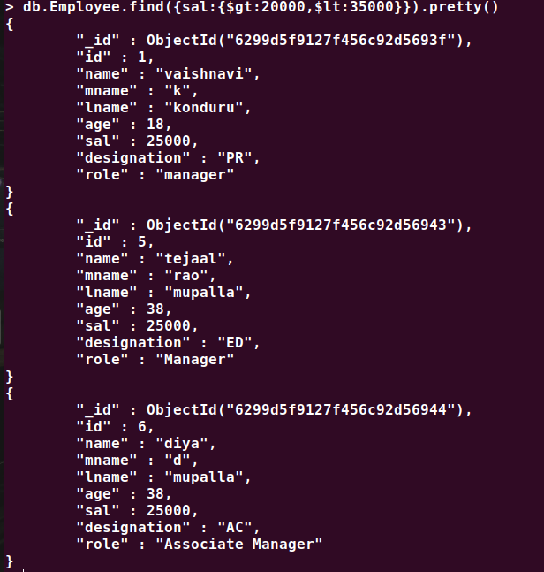

**3. List all the Employee whose Middle name is "Rao".**

db.Employee.find({"name.mname": "k")

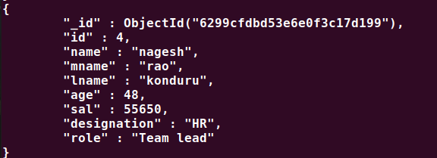

**4.Count the number of Employees who has a role "Manager" in the Role field**

> db.Employee.find({"role":"Manager"}).count()

2



**5.Find out all the documents who have age < 35 and salary in the range of**

**20000-35000**

> db.Employee.find({sal:{$gt:20000,$lt:35000},age:{$lt:35}}).pretty()

{

"_id" : ObjectId("6299d5f9127f456c92d5693f"),

"id" : 1,

"name" : "vaishnavi",

"mname" : "k",

"lname" : "konduru",

"age" : 18,

"sal" : 25000,

"designation" : "PR",

"role" : "manager"

}

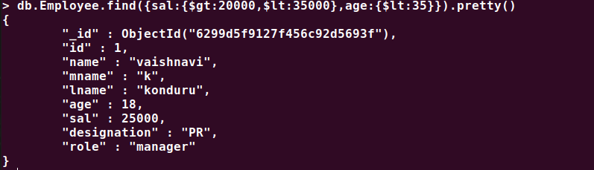

**6. Delete an Employee whose "Firstname" is "Varun" and having the**

**designation as "CEO"**

> db.Employee.deleteOne({"name":"Varun"},{"designation":"CEO"})

{ "acknowledged" : true, "deletedCount" : 1 }



**7. Update all the Employees whose role is "Team Lead" with a salary of**

**55650 INR**

> db.Employee.updateMany({role:"Team lead"},{$set:{sal:55650}})

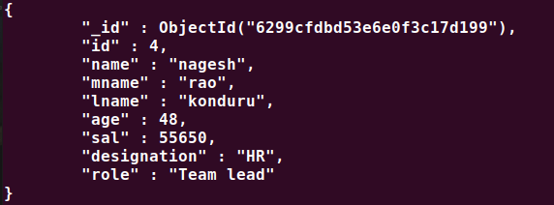

**8. Group all the Employees by their age(common age should be there)**

**and calculate the average salary obtained in the each group**

> db.Employee.aggregate([{$group:{_id:"$age",total:{$avg:"$sal"}}}])

{ "_id" : 28, "total" : 81000 }

{ "_id" : 38, "total" : 43333.333333333336 }

{ "_id" : 68, "total" : 150000 }

{ "_id" : 58, "total" : 75000 }

{ "_id" : 18, "total" : 58333.333333333336 }

{ "_id" : 48, "total" : 55650 }

{ "_id" : 19, "total" : 55000 }

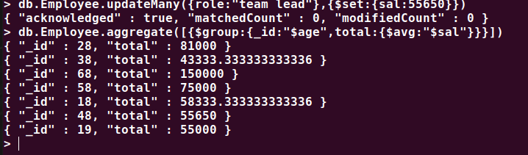

**9. Apply the map-reduce to perform the above operation and obtain the results**

> var mapfunction=function(){emit(this.age,this.sal)}

> var reducefunction=function(key,values){return Array.avg(values)}

> db.Employee.mapReduce(mapfunction,reducefunction,{'out':'result'})

{ "result" : "result", "ok" : 1 }

> db.result.find()

{ "_id" : 68, "value" : 150000 }

{ "_id" : 38, "value" : 43333.333333333336 }

{ "_id" : 48, "value" : 55650 }

{ "_id" : 18, "value" : 58333.333333333336 }

{ "_id" : 28, "value" : 81000 }

{ "_id" : 19, "value" : 55000 }

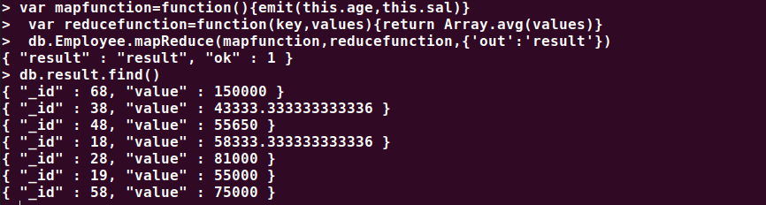{ "_id" : 58, "value" : 75000 }