NAME :-VAISHNAVI K
USN :-1NT19IS195

Creating a new database
> use vaishnavi195
switched to db vaishnavi195
> db
vaishnavi195
$mongo –command to enter into mongoDB
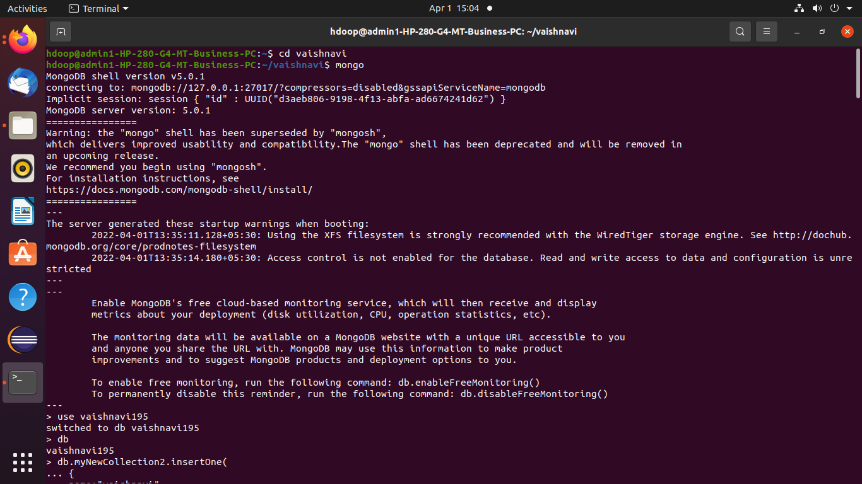

Insertion of one value
> db.myNewCollection2.insertOne( { name:"vaishnavi", age:18, gender:"female",areaofinterest:"cloud computing" })
{
"acknowledged" : true,
"insertedId" : ObjectId("6246ba3c2ea1551316a0d9a9")
}

Displaying the content

> db.myNewCollection2.find()
{ "_id" : ObjectId("6246ba3c2ea1551316a0d9a9"), "name" : "vaishnavi", "age" : 18, "gender" : "female", "areaofinterest" : "cloud computing" }
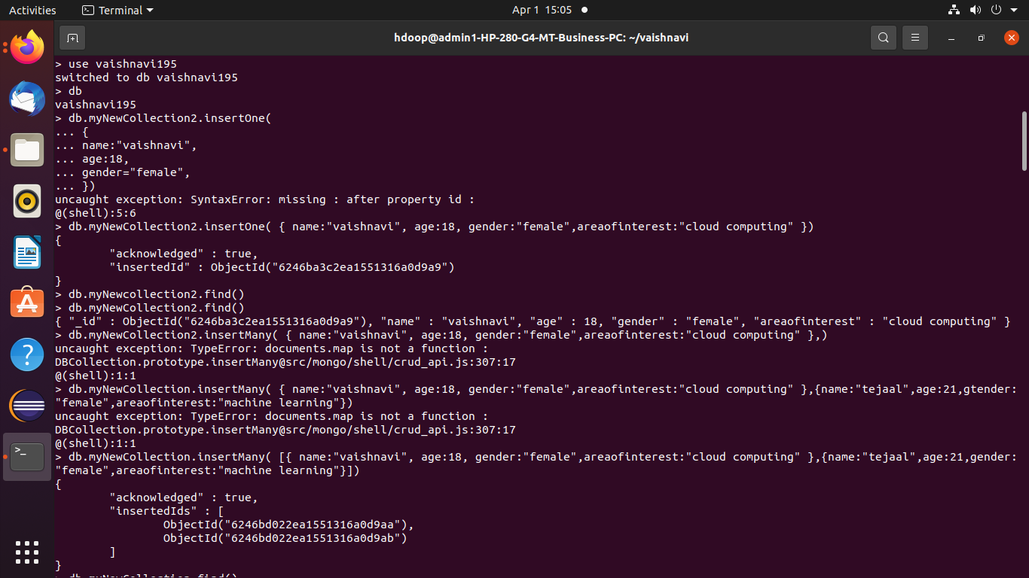

Insertion of many values

> db.myNewCollection.insertMany( [{ name:"vaishnavi", age:18, gender:"female",areaofinterest:"cloud computing" },{name:"tejaal",age:21,gender:"female",areaofinterest:"machine learning"}])
{
"acknowledged" : true,
"insertedIds" : [
ObjectId("6246bd022ea1551316a0d9aa"),
ObjectId("6246bd022ea1551316a0d9ab")
]
}

Displaying the content

> db.myNewCollection.find()
{ "_id" : ObjectId("6246bd022ea1551316a0d9aa"), "name" : "vaishnavi", "age" : 18, "gender" : "female", "areaofinterest" : "cloud computing" }
{ "_id" : ObjectId("6246bd022ea1551316a0d9ab"), "name" : "tejaal", "age" : 21, "gender" : "female", "areaofinterest" : "machine learning" }

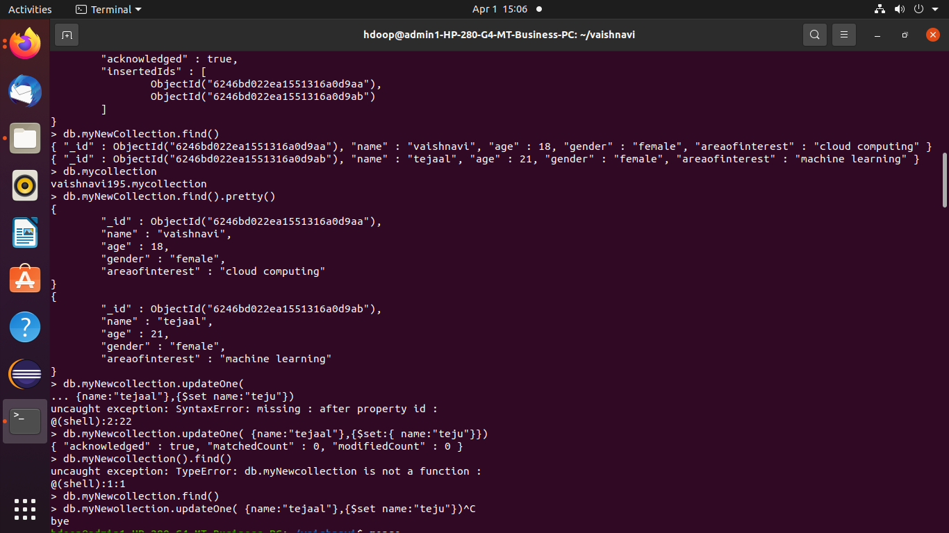

Displays the collections in database
> db.mycollection
vaishnavi195.mycollection

Pretty() helps to displays the content in well-spaced manner
> db.myNewCollection.find().pretty()
{
"_id" : ObjectId("6246bd022ea1551316a0d9aa"),
"name" : "vaishnavi",
"age" : 18,
"gender" : "female",
"areaofinterest" : "cloud computing"
}
{
"_id" : ObjectId("6246bd022ea1551316a0d9ab"),
"name" : "tejaal",
"age" : 21,
"gender" : "female",
"areaofinterest" : "machine learning"
}

Updating one value (using set)

> db.myNewCollection.updateOne( {name:"tejaal"},{$set:{ name:"teju"}})
{ "acknowledged" : true, "matchedCount" : 1, "modifiedCount" : 1 }

> db.myNewCollection.find()
{ "_id" : ObjectId("6246bd022ea1551316a0d9aa"), "name" : "vaishnavi", "age" : 18, "gender" : "female", "areaofinterest" : "cloud computing" }
{ "_id" : ObjectId("6246bd022ea1551316a0d9ab"), "name" : "teju", "age" : 21, "gender" : "female", "areaofinterest" : "machine learning" }
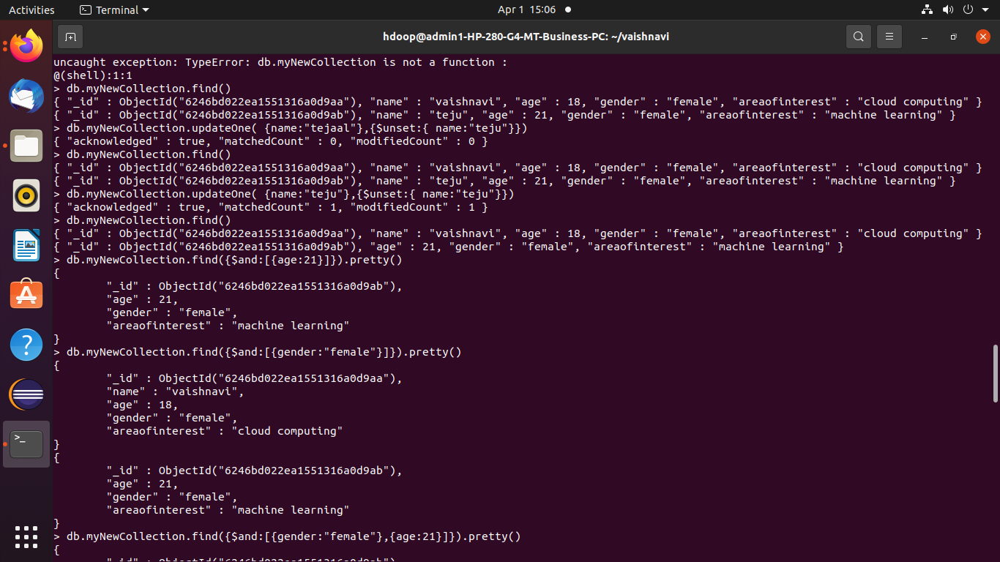

Updating one value (using unset)

> db.myNewCollection.updateOne( {name:"teju"},{$unset:{ name:"teju"}})
{ "acknowledged" : true, "matchedCount" : 1, "modifiedCount" : 1 }

> db.myNewCollection.find()
{ "_id" : ObjectId("6246bd022ea1551316a0d9aa"), "name" : "vaishnavi", "age" : 18, "gender" : "female", "areaofinterest" : "cloud computing" }
{ "_id" : ObjectId("6246bd022ea1551316a0d9ab"), "age" : 21, "gender" : "female", "areaofinterest" : "machine learning" }

Making use AND operator
> db.myNewCollection.find({$and:[{gender:"female"},{age:21}]}).pretty()
{
"_id" : ObjectId("6246bd022ea1551316a0d9ab"),
"age" : 21,
"gender" : "female",
"areaofinterest" : "machine learning"
}

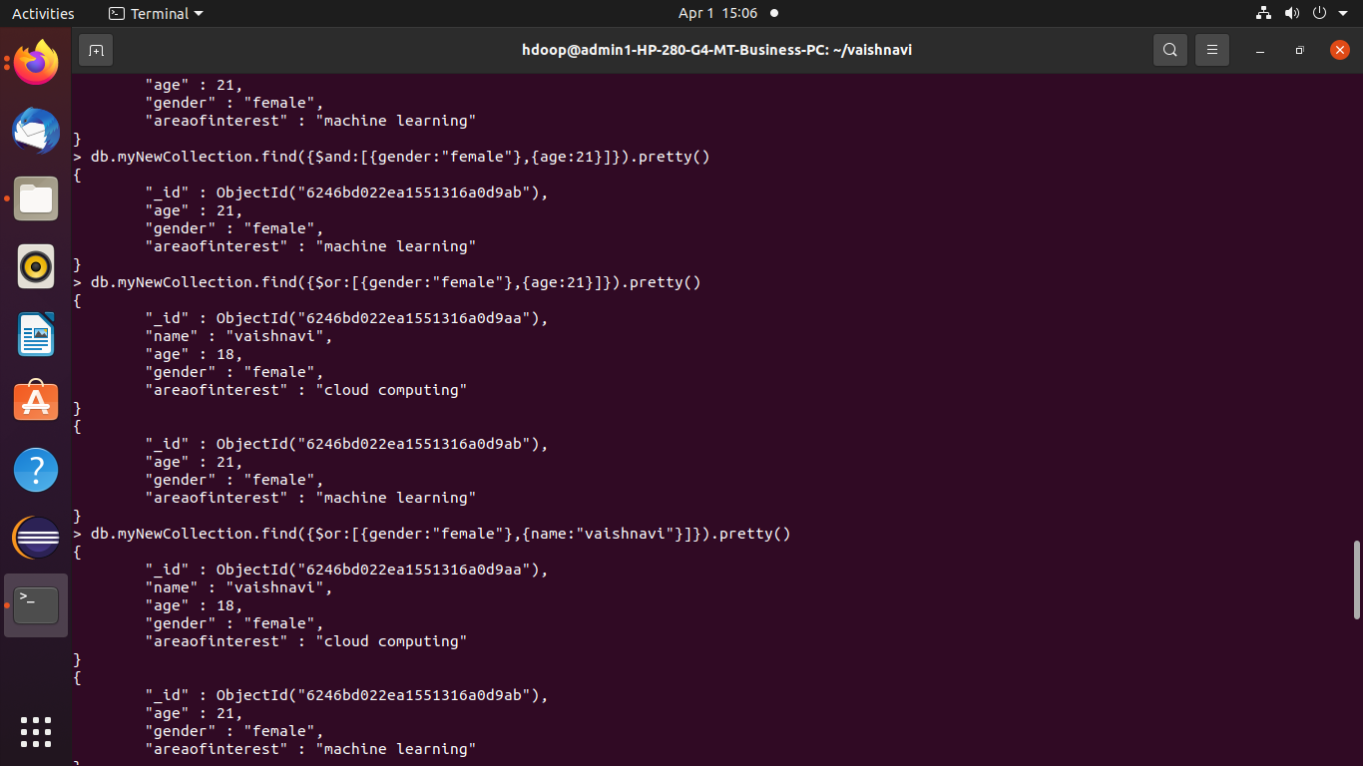

Making use OR operator

> db.myNewCollection.find({$or:[{gender:"female"},{name:"vaishnavi"}]}).pretty()
{
"_id" : ObjectId("6246bd022ea1551316a0d9aa"),
"name" : "vaishnavi",
"age" : 18,
"gender" : "female",
"areaofinterest" : "cloud computing"
}
{
"_id" : ObjectId("6246bd022ea1551316a0d9ab"),
"age" : 21,
"gender" : "female",
"areaofinterest" : "machine learning"
}

Updating many values

> db.myNewCollection.updateMany({age:{ $gt: 17 }},{$set:{age:'20'}})
{ "acknowledged" : true, "matchedCount" : 2, "modifiedCount" : 2 }
> db.myNewCollection.find().pretty()
{
"_id" : ObjectId("6246bd022ea1551316a0d9aa"),
"name" : "vaishnavi",
"age" : "20",
"gender" : "female",
"areaofinterest" : "cloud computing"
}
{
"_id" : ObjectId("6246bd022ea1551316a0d9ab"),
"age" : "20",
"gender" : "female",
"areaofinterest" : "machine learning"
}

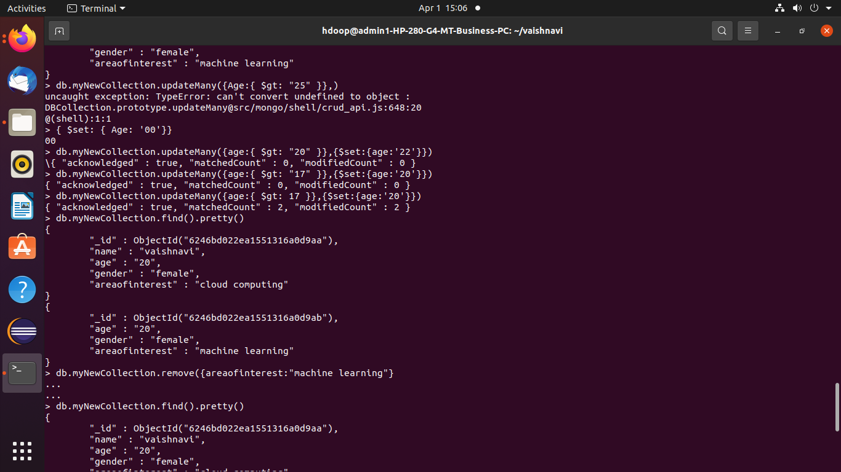

Deletion
> db.myNewCollection.remove({areaofinterest:'machine learning'})
WriteResult({ "nRemoved" : 1 })
> db.myNewCollection.find().pretty()
{
"_id" : ObjectId("6246bd022ea1551316a0d9aa"),
"name" : "vaishnavi",
"age" : "20",
"gender" : "female",
"areaofinterest" : "cloud computing"
}

