**Username and Email:**

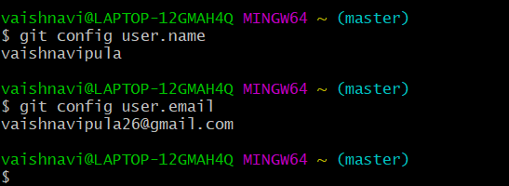

**Question-1:**

**Describe the usage of the git stash command by using an example and also state the process by giving the screenshot of all the commands written in git bash.**

**Git Stash:**

Stash is a Git command to locally store your recent changes in a separate area so you can fetch those changes later. Stash uses “stack” data structure. After taking a snapshot of your local files, it resets the state of your workspace to the previous commit state. You can save multiple stashes on your local computer and you can apply back any of the stashes at a later stage.

Using “git init” I have initialized a repository and created files file1 and file2 in the directory. I made changes to both files and file1 is added to staged area and file2 is just modified.

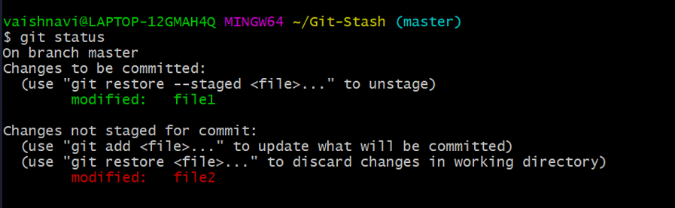

**git stash:** git stash is used to stash changes.

**git stash list:** It is used to show the stash list in the first in last out manner (Stack data structure).

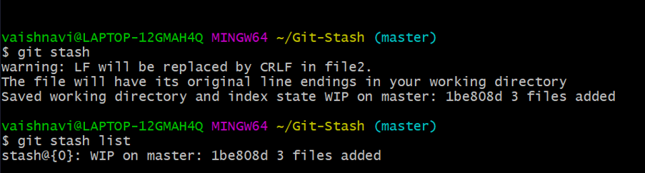

**git stash push:** It is used to push changes to stash. Git stash applies default push .In git stash push we have to enter message.

Modified file3 and pushed to stash.

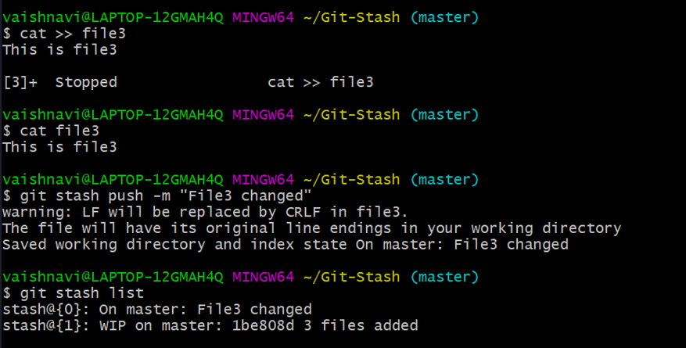

Modified file1 and file4 and changes pushed to stash

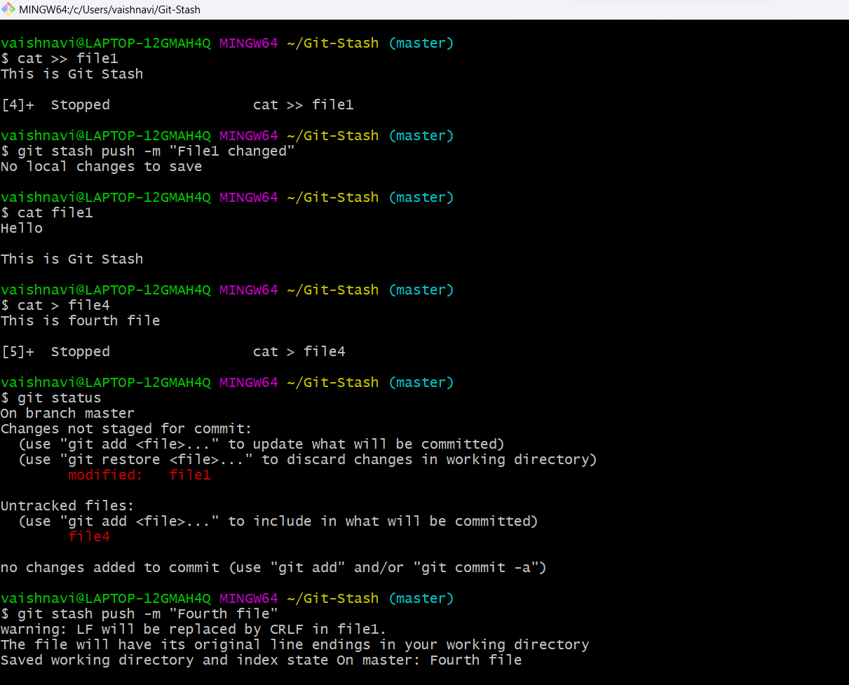

**git stash apply:** It applies the changes back to file in working directory. We have to mention index of stash in list.

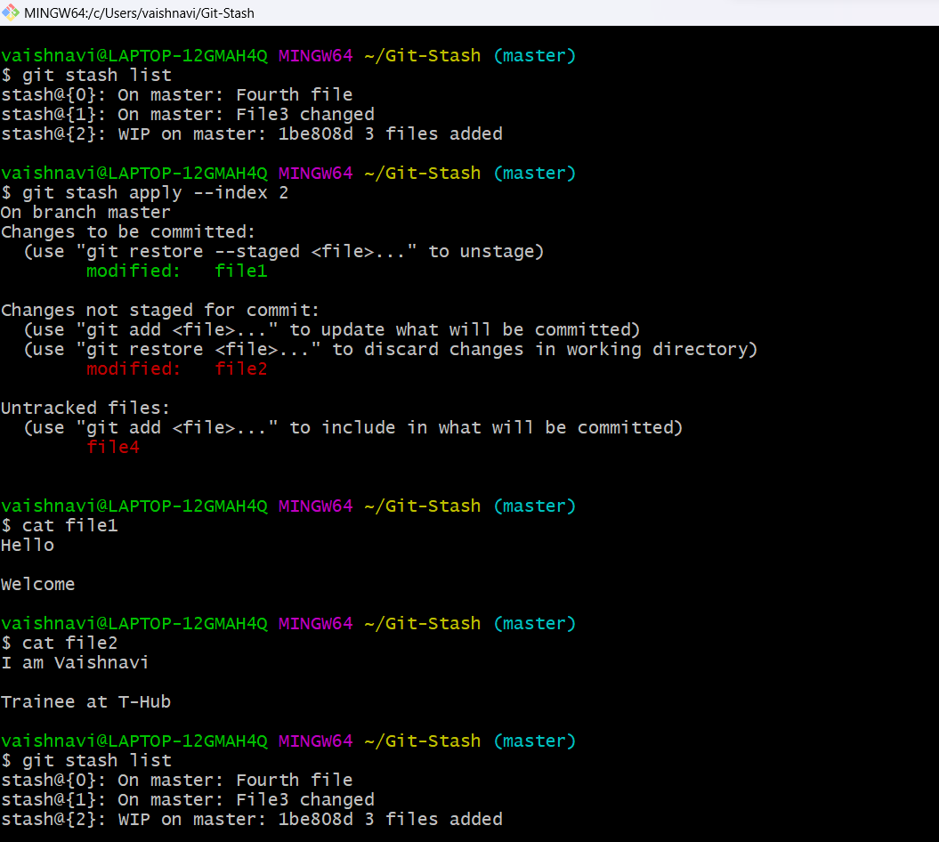

**git stash show:** It is used to show the changes made.It indicates files and number of insertions.

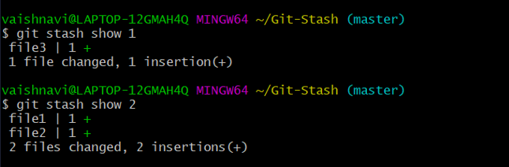

**git stash pop:** It is used to remove specified stash from the list. Changes made at particular stash will be removed if not applied before pop.

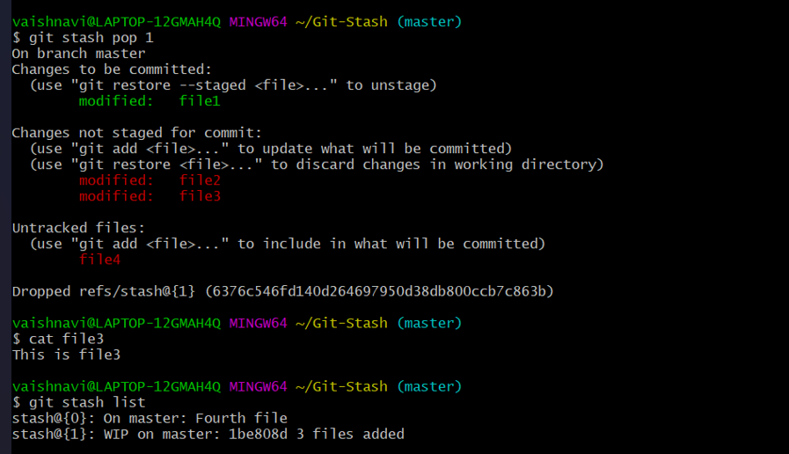

**git stash clear:** It clears entire stash list.

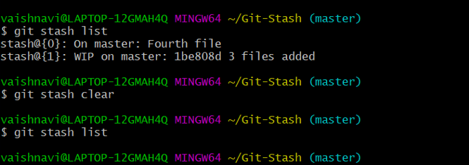

**Question-2:**

**By using a sample example of your choice, use the git fetch command and also use the git merge command and describe the whole process through a screenshot with all the commands and their output in git bash.**

**Git fetch:** It fetches all the changes from the remote repository and stores it in a separate branch in your local repository. You can reflect those changes in your corresponding branches by merging.

**git fetch URL**

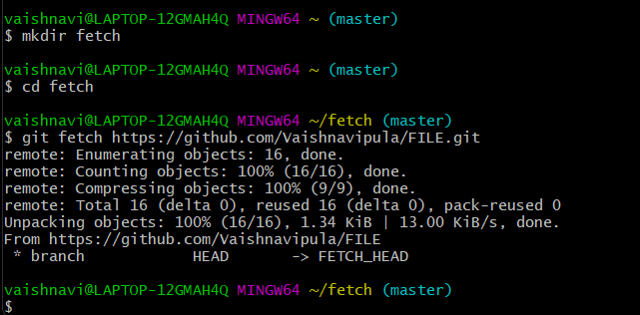

**git fetch URL branch_name**

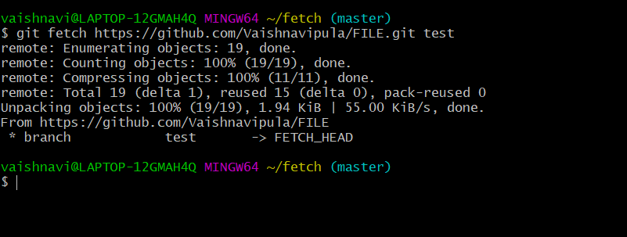

**git fetch --all**

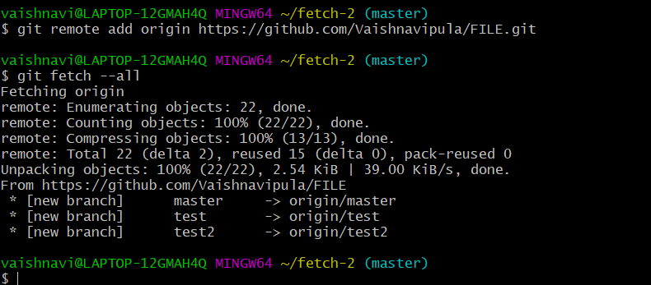

**Let us create a repository in Github and add files in it.**

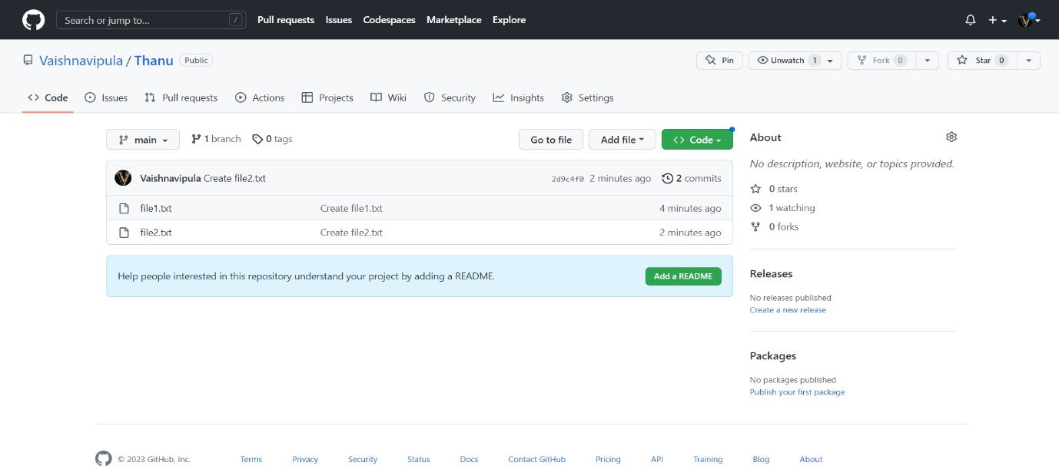

**Let us clone the repository from remote to local using “git clone URL”**

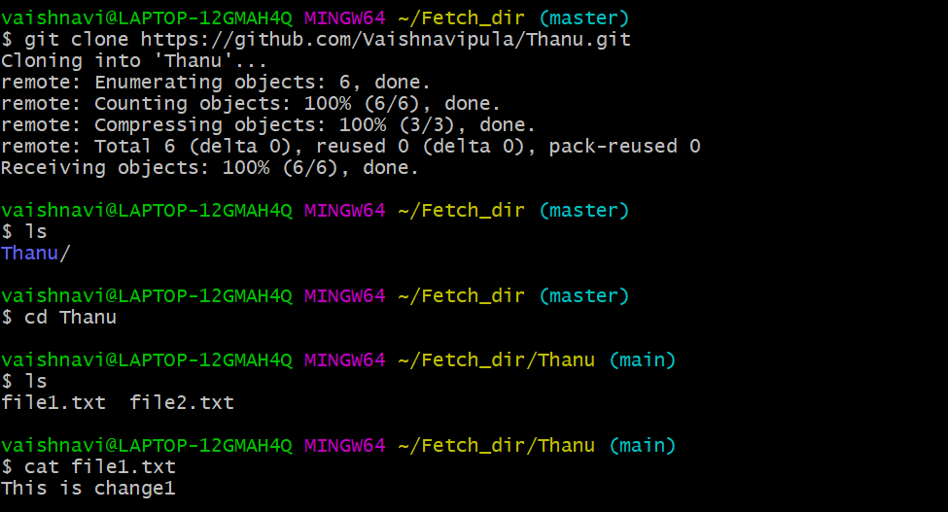

**Now make a change in any file in remote repository**

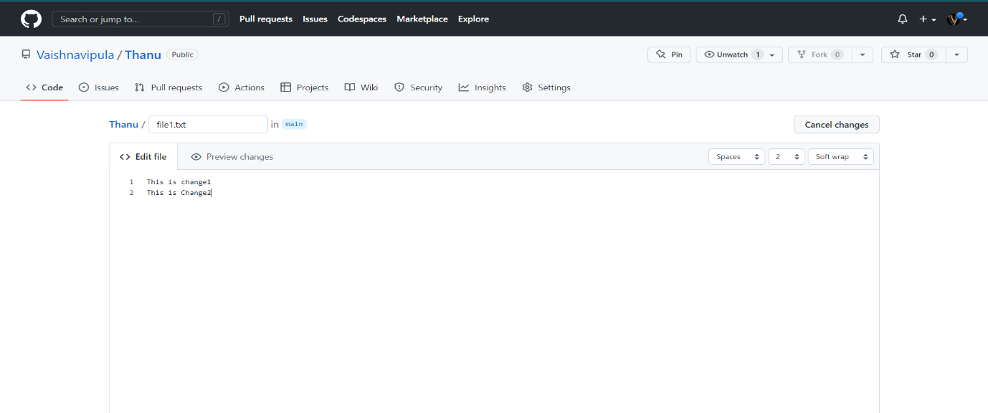

**Use git fetch:** When we use fetch ,the changes made in remote file won’t reflect in local files .We just get the details of changes made.

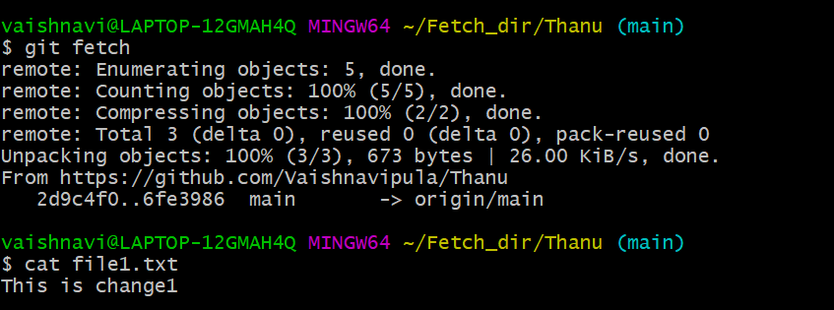

**Use git merge:** After using git merge the changes made in remote repository files will be reflected in local files.

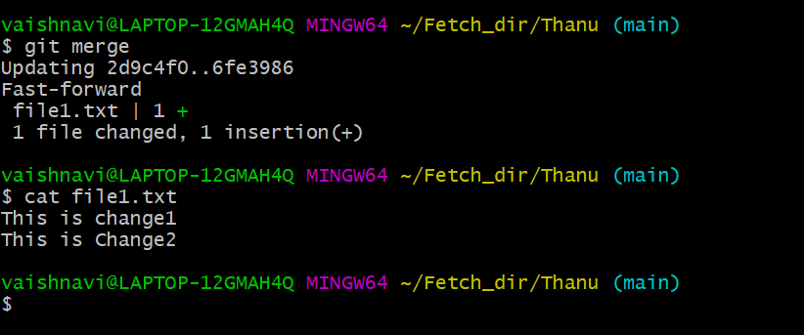

**Question-3:**

**State the difference between git fetch and git pull by doing a practical example in your git bash and attach a screenshot of all the processes.**

**Git fetch:** It fetches the changes made in remote repository to local repository.When we use fetch there is no file transfer.

**Git Pull:** It Pulls the changes made in remote repository to local repository.When we apply Pull , file transfer takes place from remote to local.

**We have 2 files in repository named “Thanu”.**

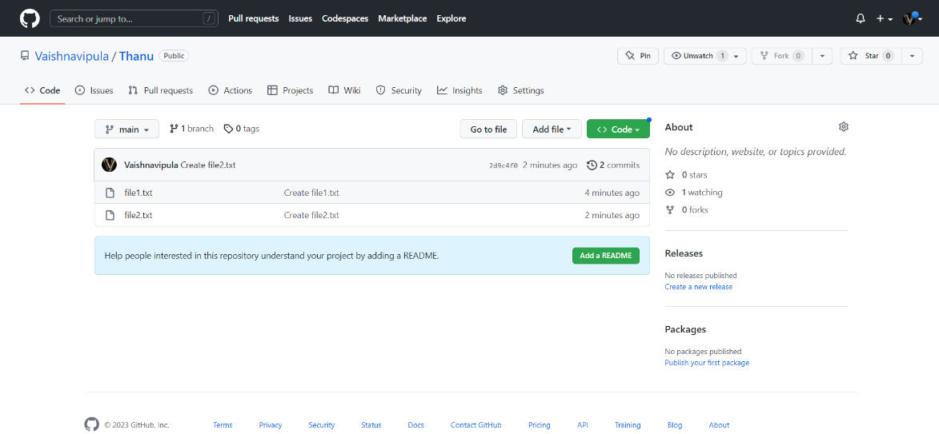

**After cloning we will have the files in local repository.**

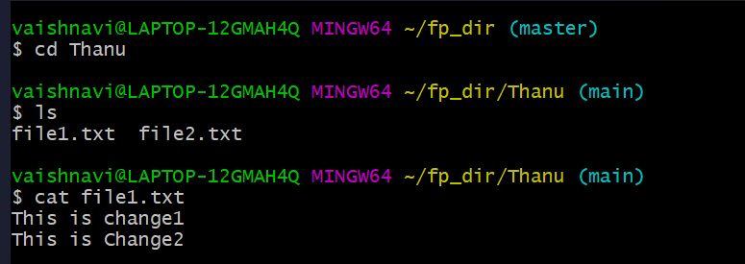

**Now make changes to files in Remote Repository.**

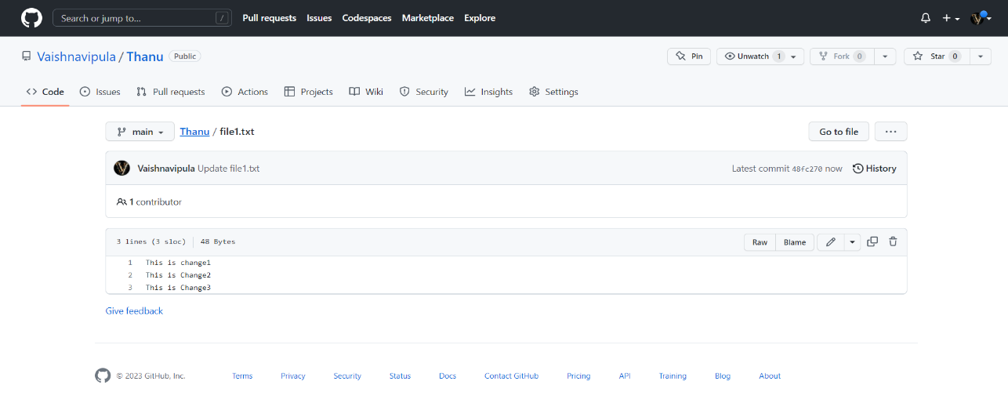

**Use git fetch in git bash.**

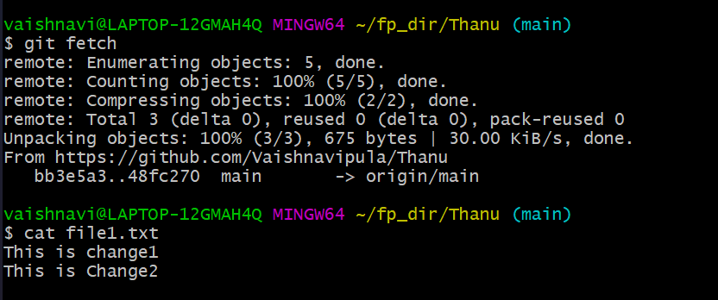

**After using git pull , changes made in Remote Repository will be reflected in Local Repository.**

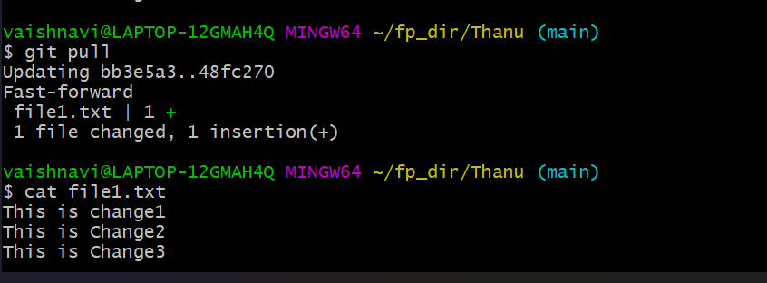

**git pull:** It will do the work done by both Fetch and Merge.

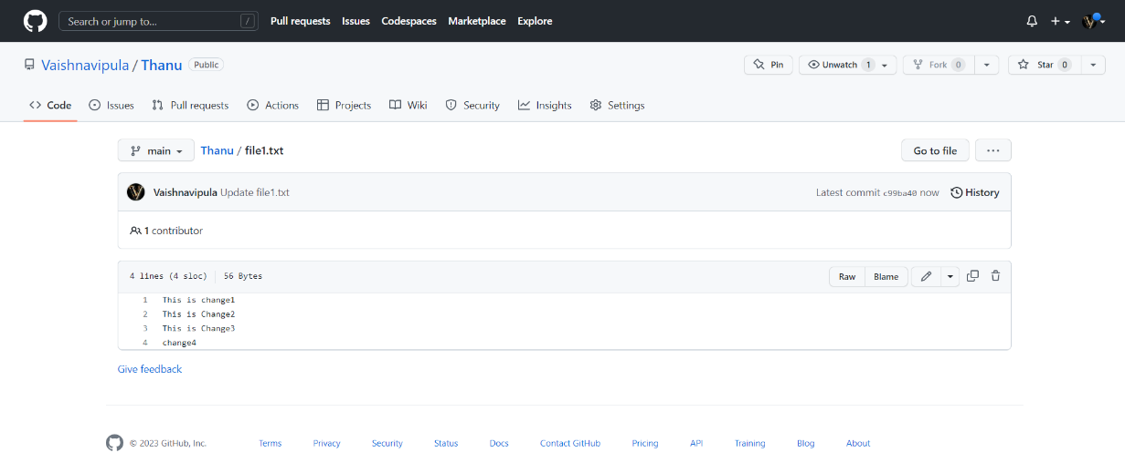

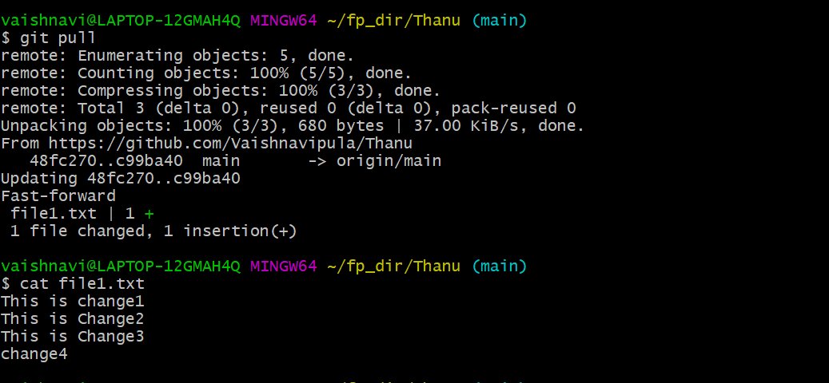

**Question-4:**

**Try to find out about the awk command and use it while reading a file created by yourself. Also, make a bash script file and try to find out the prime number from the range 1 to 20.**

**The whole process should be carried out and by using the history command, give the screenshot of all the processes being carried out.**

**Awk Command:**

Awk is mostly used for pattern scanning and processing. It searches one or more files to see if they contain lines that matches with the specified patterns and then perform the associated actions.

Let us create a file and apply Awk command. The following syntaxes are used to get required columns.

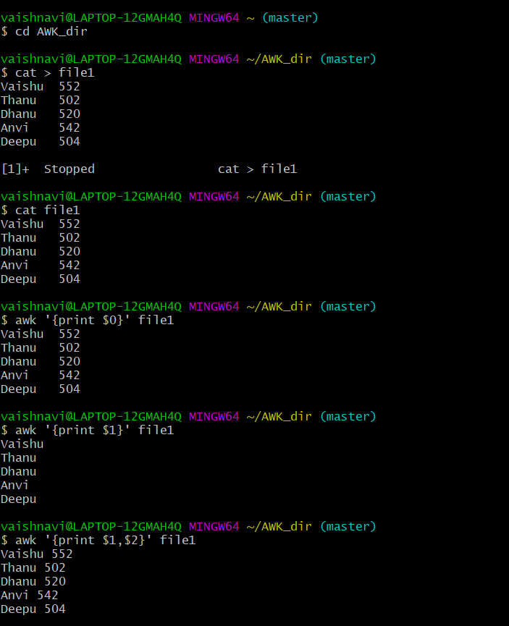

The following awk commands are used to print serial number along with the required column and prints last column.

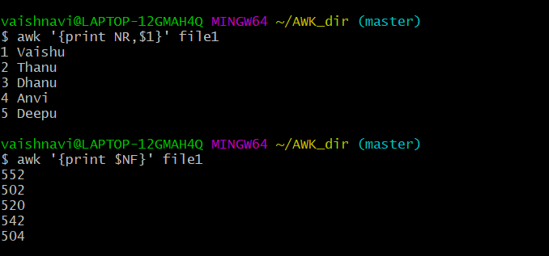

The following commands are used to print specified line in required column.

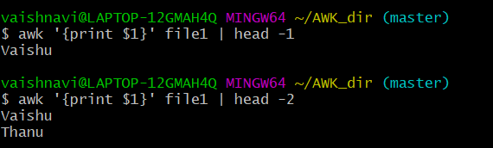

The following commands are used to print the pattern matching lines.

^D prints lines that start with ‘D’ and 0$ prints the lines that end with ‘0’ .

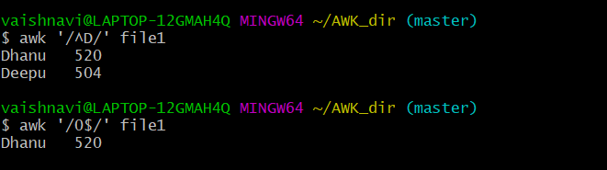

**Using Bash Script:**

**Create a file using vi editor with “.sh” extension and write bash script for printing the prime numbers from the range 1 to 20.**

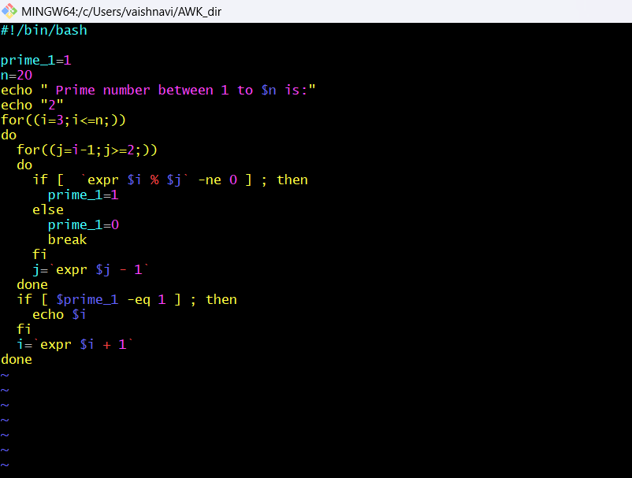

**Use “./filename.sh“ to run bash script file.**

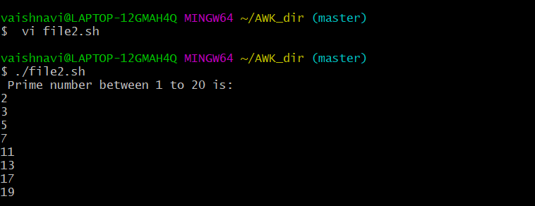

**History command:** History command is used to show the list of commands used till now.

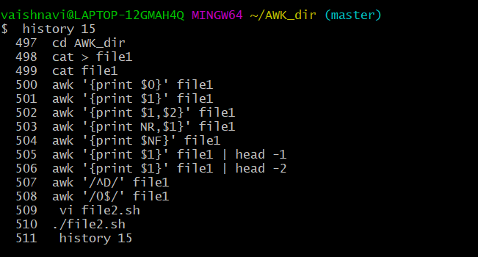

**Question-5:**

**Set up a container and run a Ubuntu operating system. For this purpose, you can make use of the docker hub and run the container in interactive mode.**

**All the processes pertaining to this should be provided in a screenshot for grading.**

In Docker to run the Ubuntu operating system first we need to pull it from the Docker Hub and then run it by creating a container.

**Docker pull**: If image is already available then pull updates the image ,otherwise it downloads .

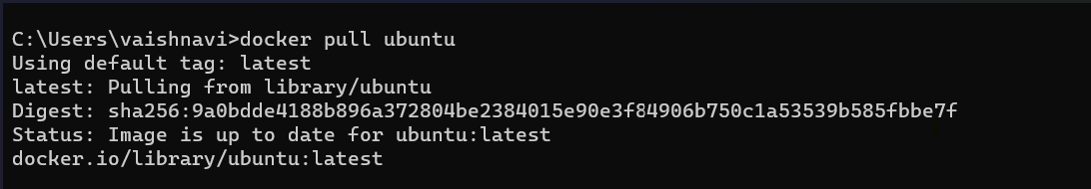

**Docker Create:** Used to create Containers.

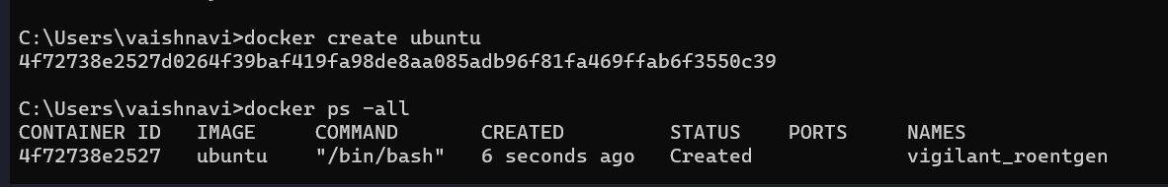

**Docker Run:** It is used to run the image.To run Ubuntu in interactive mode we have to use “ docker run -it ubuntu ” .To exit the process use exit command in interactive mode of ubuntu.

