IR Remote Controlled Bulb Using Arduino

This project allows you to control a bulb (or any device) using an IR remote control and an Arduino.   
It demonstrates the use of an IR receiver sensor and relay module to toggle electrical appliances wirelessly.

# Features

* • Turn a bulb ON/OFF using an IR remote button
* • Relay module safely controls 230V devices
* • IR receiver detects and decodes signals from any standard IR remote
* • Serial monitor outputs received IR codes for easy debugging
* • Easily extendable to multiple buttons/devices

# Components Used

|  |  |
| --- | --- |
| Component | Quantity |
| Arduino UNO | 1 |
| IR Receiver (e.g., TSOP1738) | 1 |
| IR Remote Control | 1 |
| Relay Module | 1 |
| Bulb & Holder | 1 |
| Breadboard + Jumper Wires | As needed |
| 230V AC Power (Caution!) | 1 |

# Circuit Diagram

Below is a simple schematic representation of the IR bulb control circuit.

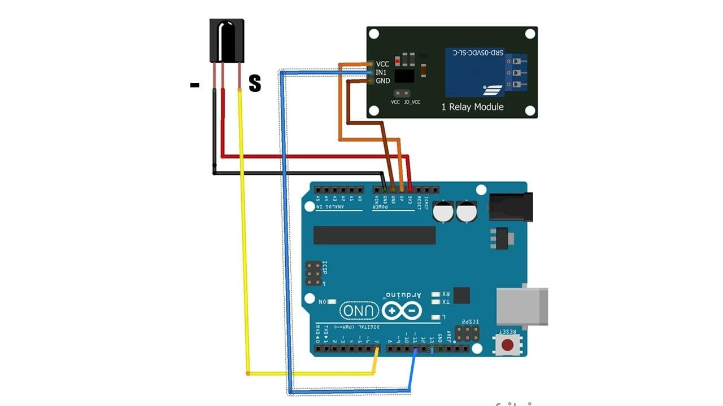

# How It Works

The IR receiver detects IR signals from the remote. Each button on the remote sends a unique hexadecimal code.  
The Arduino reads the code and checks if it matches the pre-defined value. If it matches the ON/OFF button,   
it toggles the bulb state using the relay. The status is shown on the serial monitor.

# Arduino Code

The main logic is in the IR_Remote_Bulb_Control.ino file uploaded to the GitHub repository.

# IR Code Configuration

To find the real code:  
- Open Serial Monitor in Arduino IDE  
- Press buttons on your IR remote  
- Note the values printed

# Safety Warning

If you're using a 230V AC bulb:  
- Ensure proper isolation using a relay module  
- Never touch live wires  
- Work under supervision if you’re a beginner

# Future Enhancements

* • Control multiple appliances
* • Add LCD/LED display for status
* • Integrate with Wi-Fi (e.g., ESP32) for mobile app control
* • Use EEPROM to save bulb state after power loss

# Author

K. Vaishnavi  
Electronics & Communication Engineer  
Passionate about Embedded Systems and Automation Projects