**Secure Check: A Python-SQL Digital Ledger for Police Post Logs**

**Purpose Tools/Techniques**

1   Data storage & schema: PostgreSQL, SQLAlchemy, Render

2   Data cleaning: Python, pandas

3   Database design: SQL

4   Dashboard & analytics: Streamlit, Plotly, SQLAlchemy

**Define SQL Schema for Police Stop Records**

`stop_id`, `stop_date`, `stop_time`, `county_name`, `driver_gender`, `driver_age`, `driver_race`, `search_conducted`, `drugs_related_stop`, `stop_duration`, `vehicle_number`, `violation`, `stop_outcome`,

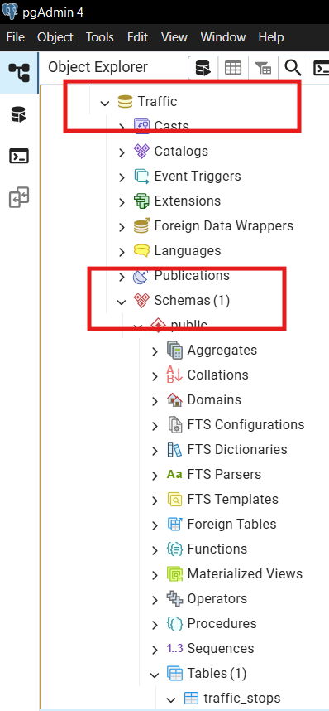

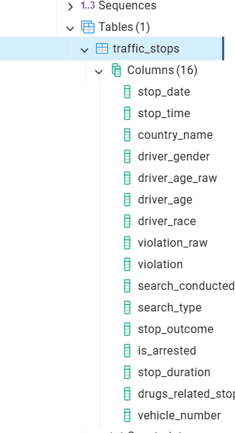

**SQL table creation:**

1. Use Python (pandas, sqlalchemy) to Insert and Query Data
2. Use `pandas` to process data in Python.
3. Use `sqlalchemy` to connect Python to your SQL database.
4. Connecting Render cloud platform with SQL for accessing DB for anywhere.

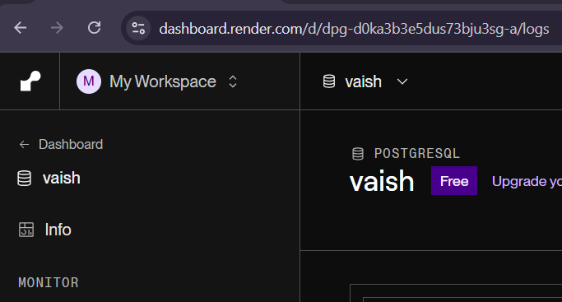

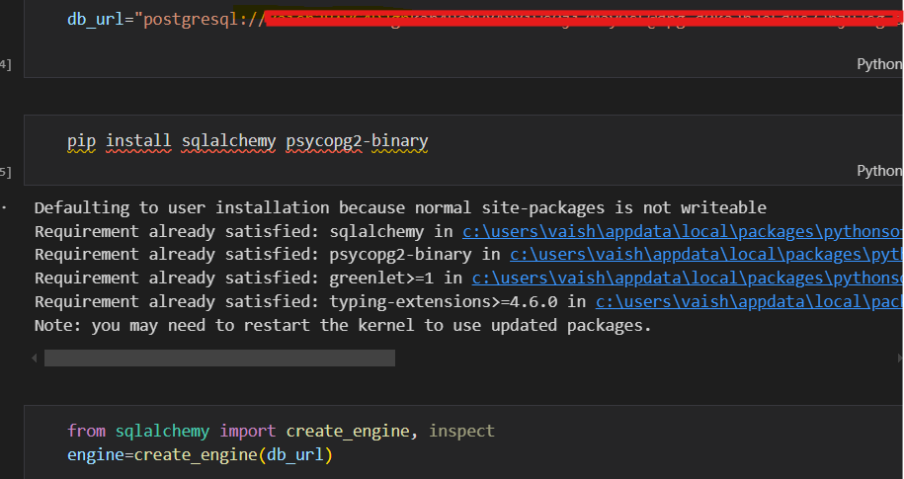

**Python for Data Processing**

1.Remove Columns That Only Contain Missing Values

2.Handle the NaN Values

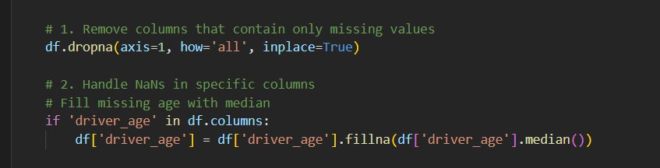

**Streamlit Dashboard**

**a. Display Vehicle Logs, Violations, and Officer Reports**

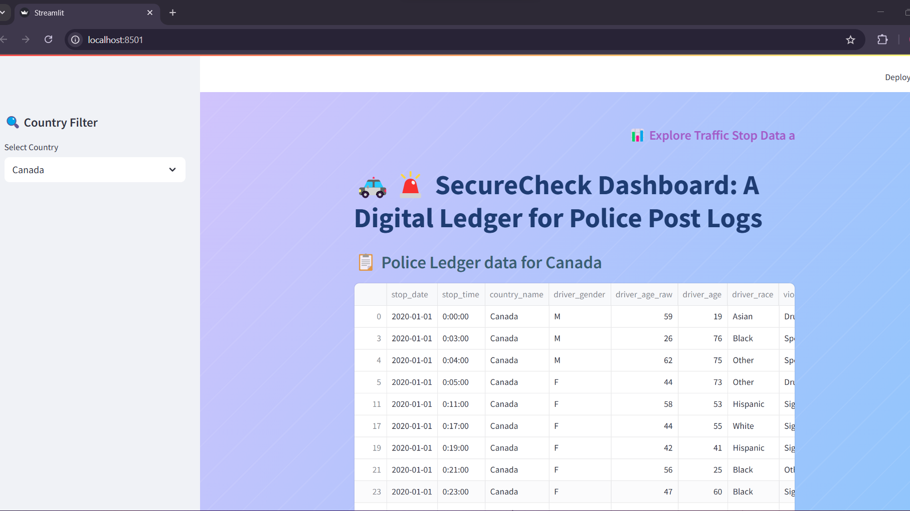

**b. Implement SQL-Based Search Filters for Quick Lookups**

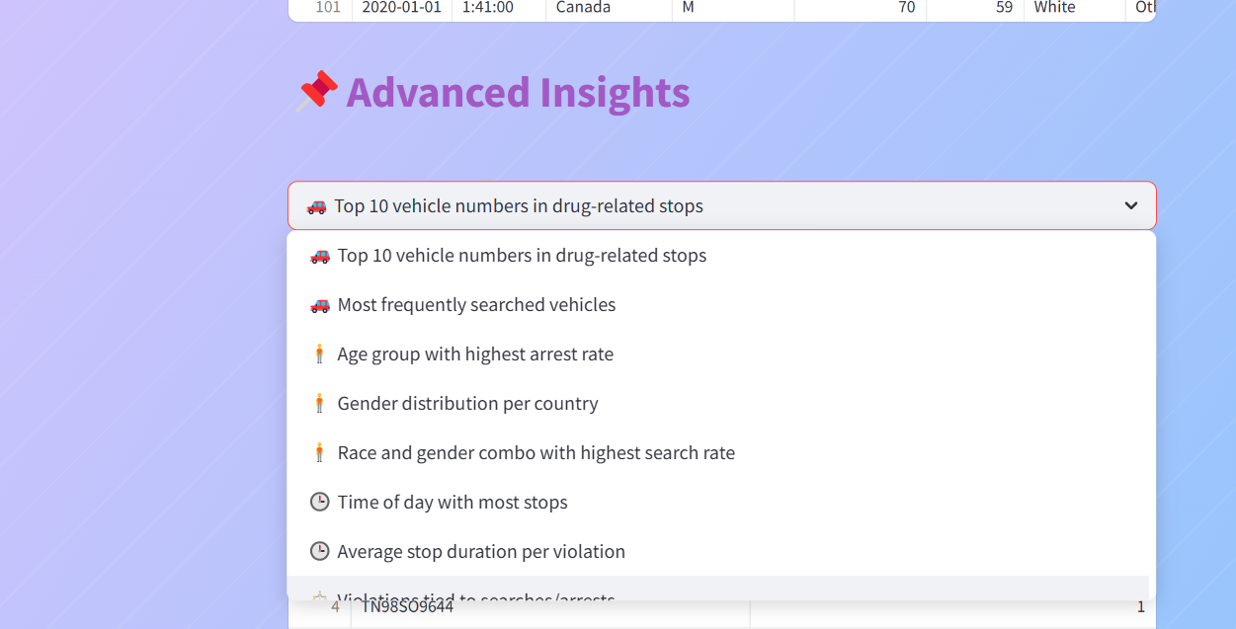

**c. Generate Analytics and Trends (e.g., High-Risk Vehicles)**

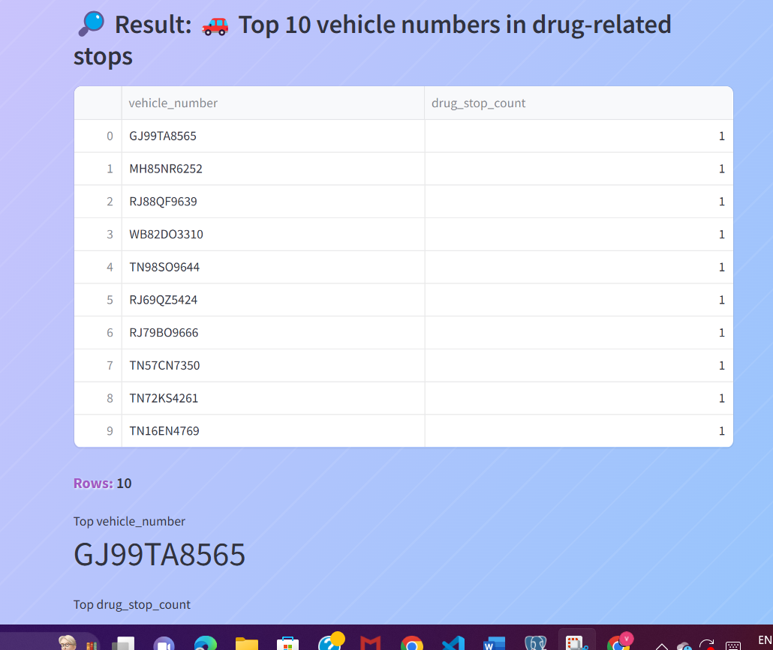

**Prediction Violation Output:**

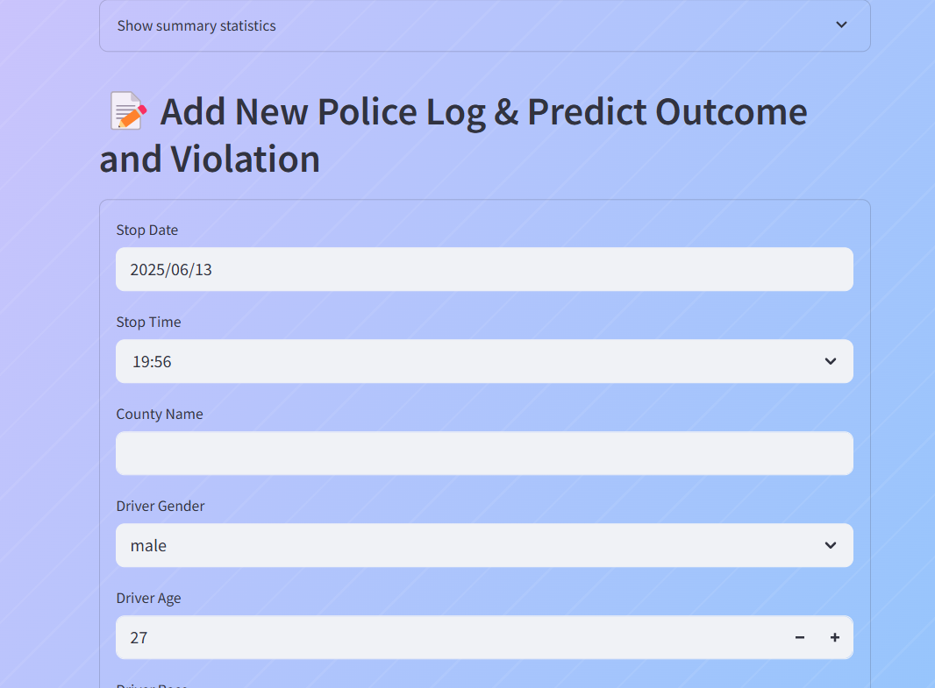

**Prediction outcome snapshot:**

