**Concepts of Operating System**

**Assignment 2**

**Part A**

What will the following commands do?

**echo "Hello, World!"**

This command print hello world.

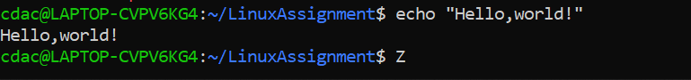

**name="Productive"**

This command store “Productive” string int name variable.

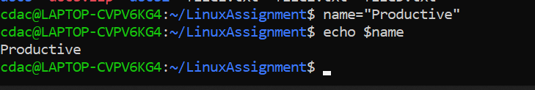

**touch file.txt**

**This command creats file .txt file**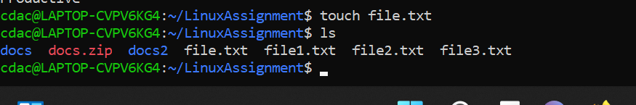

**ls -a**

**This commands list out all files including hidden files.**

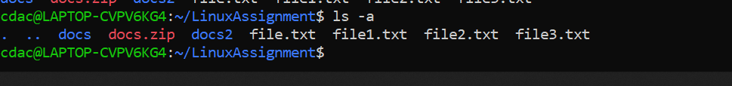

**rm file.txt**

**This command removes files from directories.**

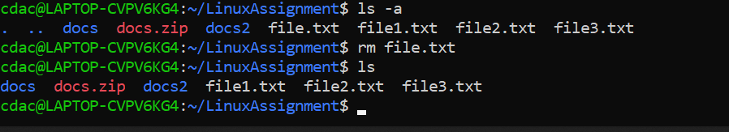

**cp file1.txt file2.txt**

**This command copy contents of file1.txt to file2.txt. If file2.txt is not created it will create file.**

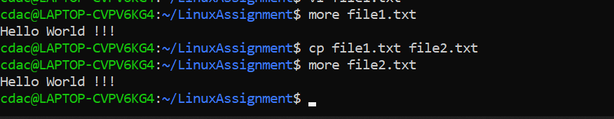

**mv file.txt /path/to/directory/**

**Moves the file into specified path.**

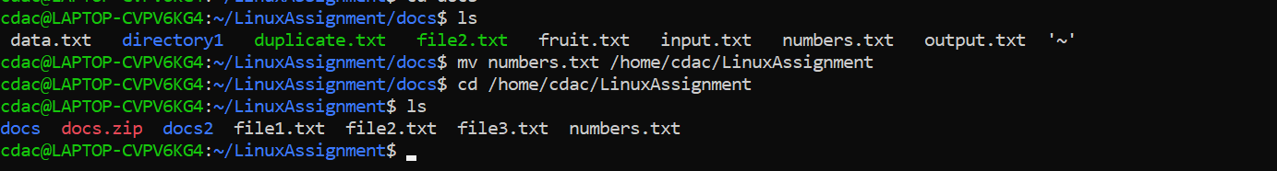

**chmod 755 script.sh**

**This commands gives the write,execute and read permissions to owner.**

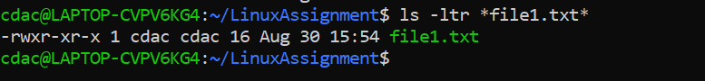

**grep "pattern" file.txt**

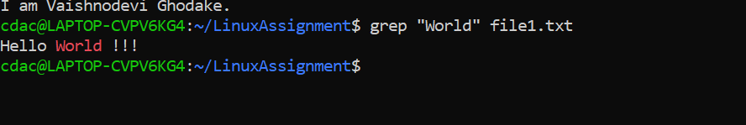

**kill PID**

It is used to terminate the process by their process ID.

**mkdir mydir && cd mydir && touch file.txt && echo "Hello, World!" > file.txt && cat file.txt**

This command is creating mydir directory and in that directory file.txt file is creating and output of echo "Hello, World!" is stored into file.txt.



**ls -l | grep ".txt"**

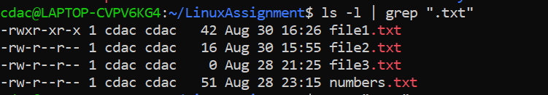

**cat file1.txt file2.txt | sort | uniq**

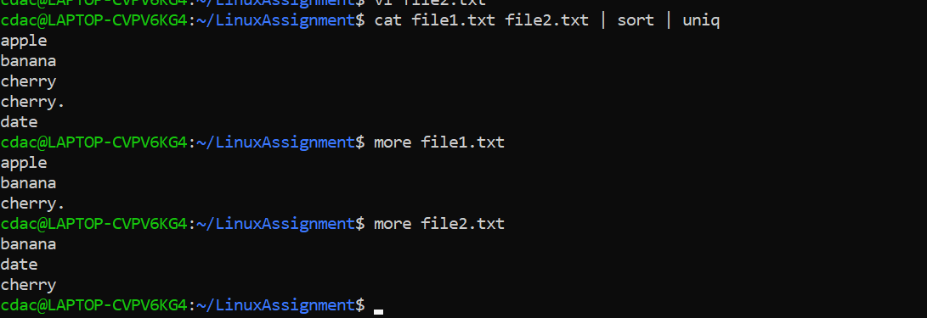

**ls -l | grep "^d"**

**Listing out the all the files which is starting from d.**

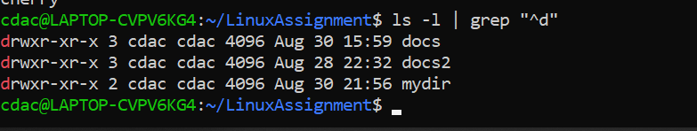

**grep -r "pattern" /path/to/directory/**

**This command will search for the pattern within the directory and subdirectory recursively**

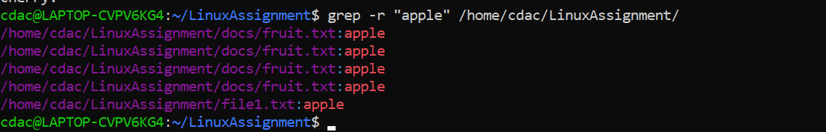

**cat file1.txt file2.txt | sort | uniq –d**

**Cat command concatenate two files and sort command arrange the lines in alphabetical order.**

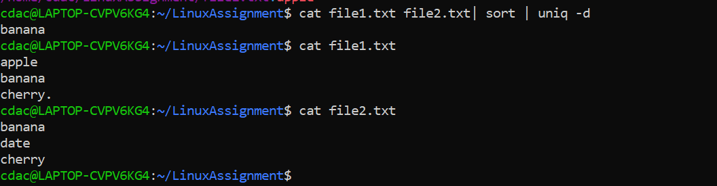

**chmod 644 file.txt**

**This command will give permissions to owner - 4(read)+2(write) and to group- 4(read) and to other - 4(read)**

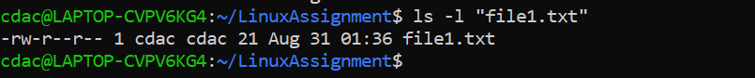

**cp -r source_directory destination_dire**

**Copies the source dir to destination dir with sub directories of source dir**

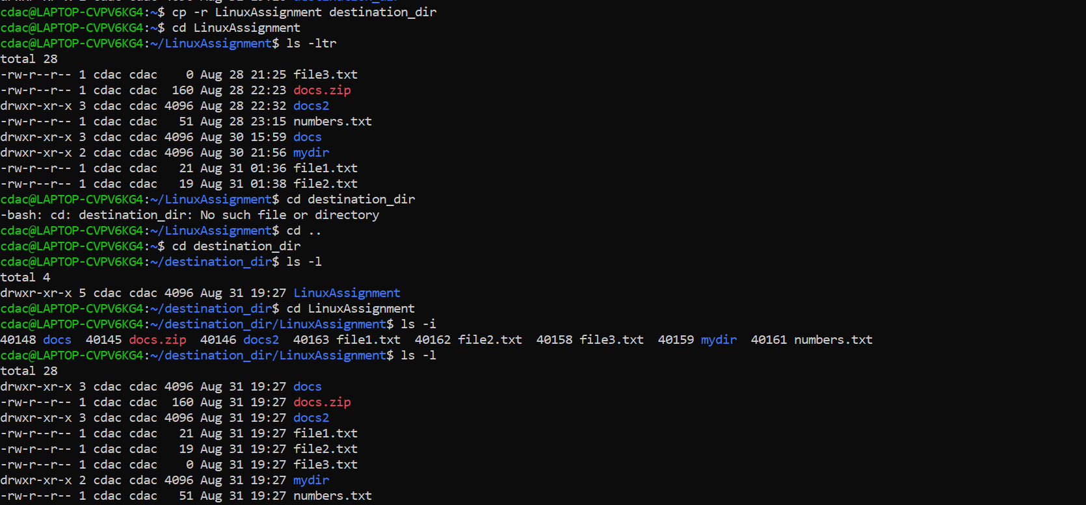

**Part B**

Identify True or False:

1. ls is used to list files and directories in a directory.

True

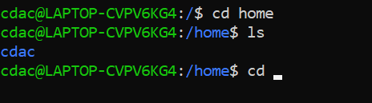

2. mv is used to move files and directories.

True

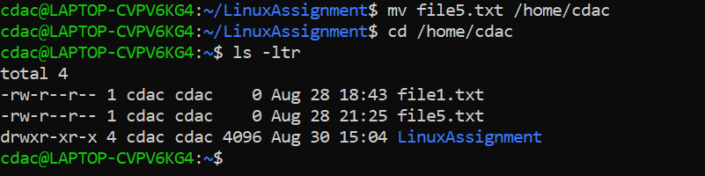

3. cd is used to copy files and directories.

False. Cd is used to change the directories

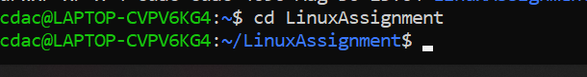

4. pwd stands for "print working directory" and displays the current directory.

True

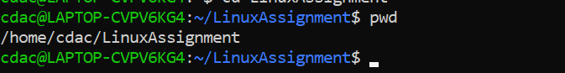

5. grep is used to search for patterns in files.

True

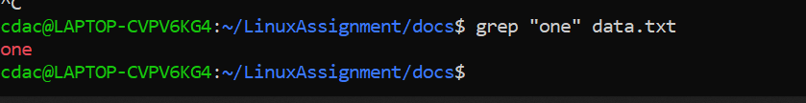

6. chmod 755 file.txt gives read, write, and execute permissions to the owner, and read and execute permissions to group and others.



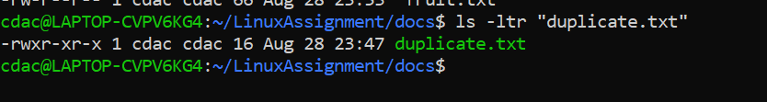

7. mkdir -p directory1/directory2 creates nested directories, creating directory2 inside directory1

if directory1 does not exist.

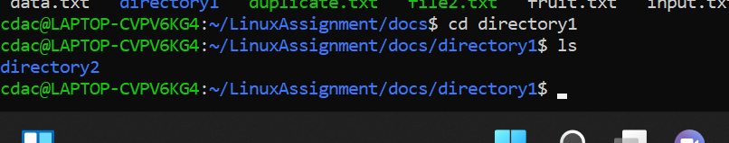

8. rm -rf file.txt deletes a file forcefully without confirmation.

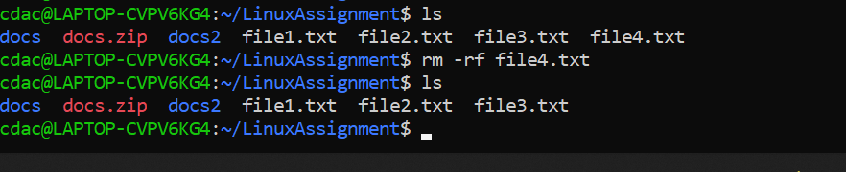

Identify the Incorrect Commands:

1. chmodx is used to change file permissions.

This is incorrect. Chmod is correct command.

2. cpy is used to copy files and directories.

This is incorrect. cp is used to copy files and directories.

3. mkfile is used to create a new file.

This is incorrect.touch command isused to create file.

4. catx is used to concatenate files.

This incorrect. Cat command is correct.

5. rn is used to rename files.

This is incorrect. mv is used to rename files.

Part C

Question 1: Write a shell script that prints "Hello, World!" to the terminal.

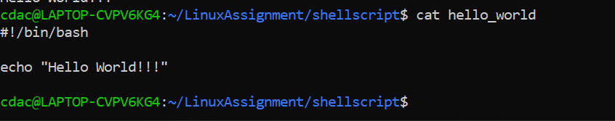

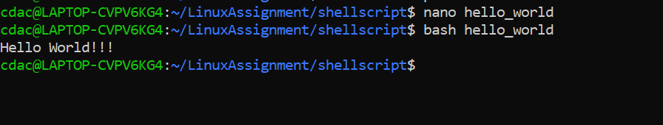

Question 2: Declare a variable named "name" and assign the value "CDAC Mumbai" to it. Print thevalue of the variable.

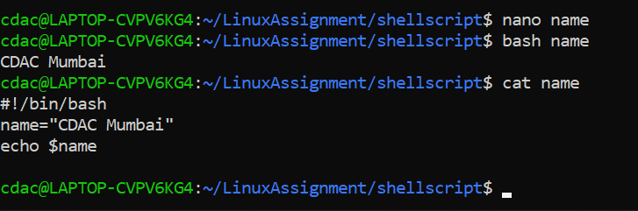

Question 3: Write a shell script that takes a number as input from the user and prints it.

\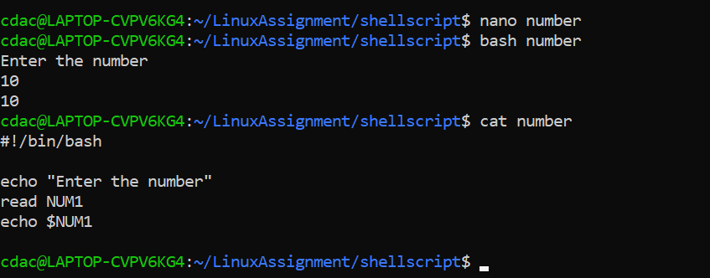

Question 4: Write a shell script that performs addition of two numbers (e.g., 5 and 3) and prints the result.

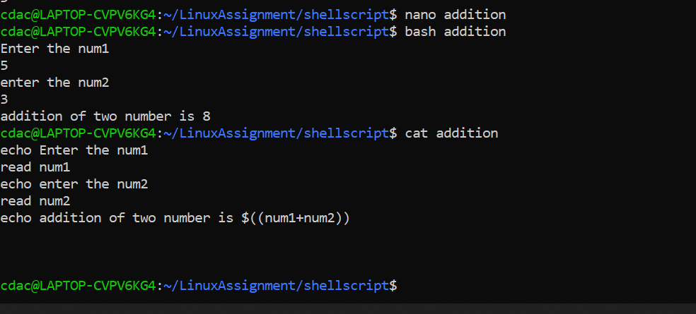

Question 5: Write a shell script that takes a number as input and prints "Even" if it is even, otherwise prints "Odd".

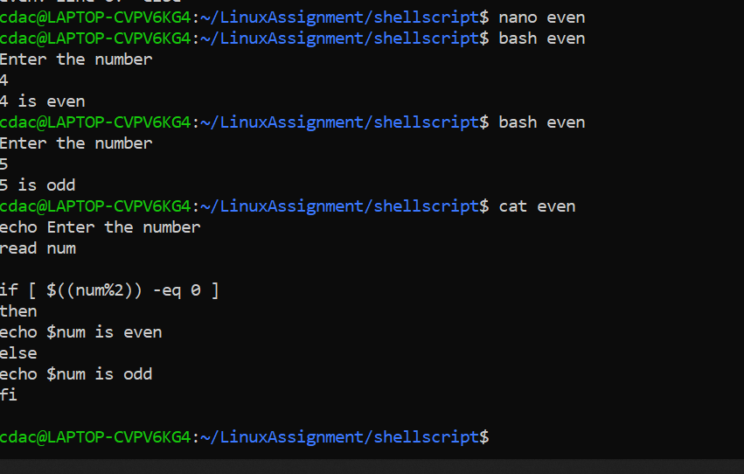

Question 6: Write a shell script that uses a for loop to print numbers from 1 to 5.

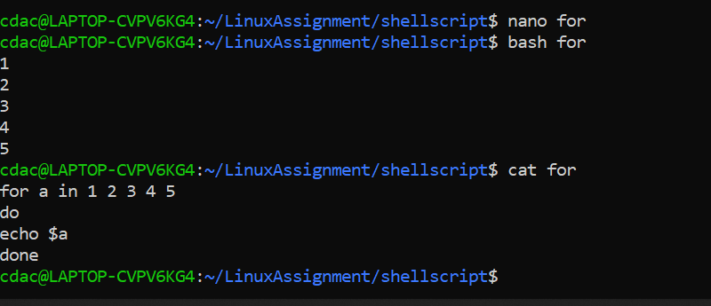

Question 7: Write a shell script that uses a while loop to print numbers from 1 to 5.

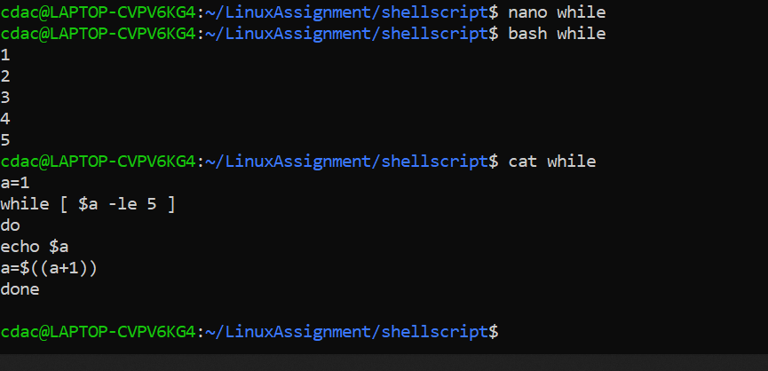

Question 8: Write a shell script that checks if a file named "file.txt" exists in the current directory. If it does, print "File exists", otherwise, print "File does not exist".

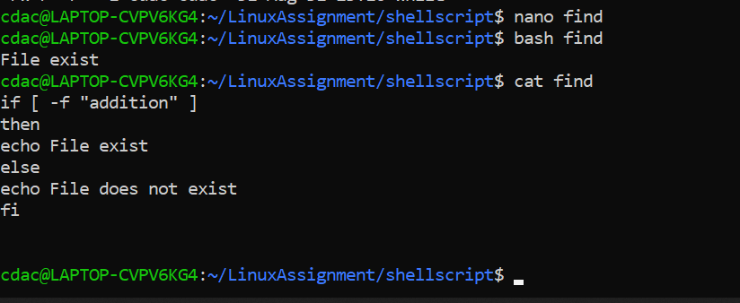

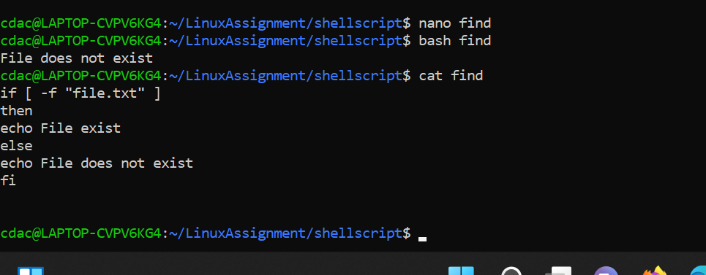

Question 9: Write a shell script that uses the if statement to check if a number is greater than 10 and prints a message accordingly.

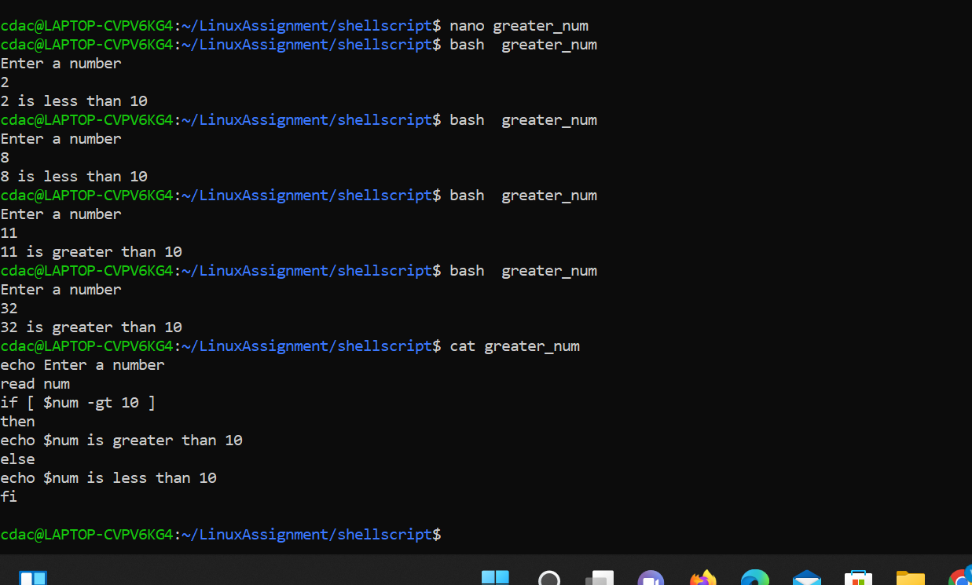

Question 10: Write a shell script that uses nested for loops to print a multiplication table for numbers from 1 to 5. The output should be formatted nicely, with each row representing a number and each column representing the multiplication result for that number.

