Q-1]

<!Doctype html>

<html lang="en">

<meta charset="UTF-8">

<meta name="viewport" content="width=device-width initial-scale=1.0">

<body>

<p id="myPara">

It is rightly said that being disciplined is essential in life. When a person leads a disciplined life, they set an easy path to success. They will develop an approach to happiness and a beautiful future ahead. Being disciplined is the practice of having a scheduled daily routine which helps an individual to be punctual and hard-working. An individual is taught what being disciplined means from the time they are young. Even though discipline takes a lot of effort, the advantages of a disciplined life make it a worthwhile endeavour.

</p>

<button type="submit" id="myButton">click here</button>

<script>

const myPara =document.getElementById('myPara');

const myButton = document.getElementById('myButton');

myButton.addEventListener('click',function() {

myPara.style.color ='blue';

myPara.style.fontSize ='40px';

})

</script>

</body>

</html>

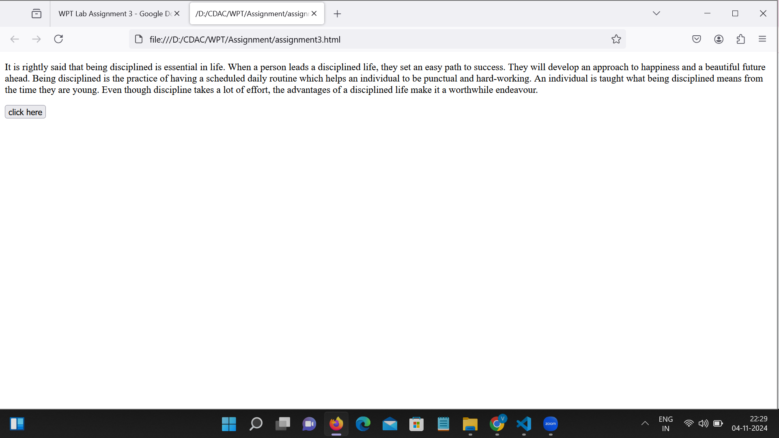

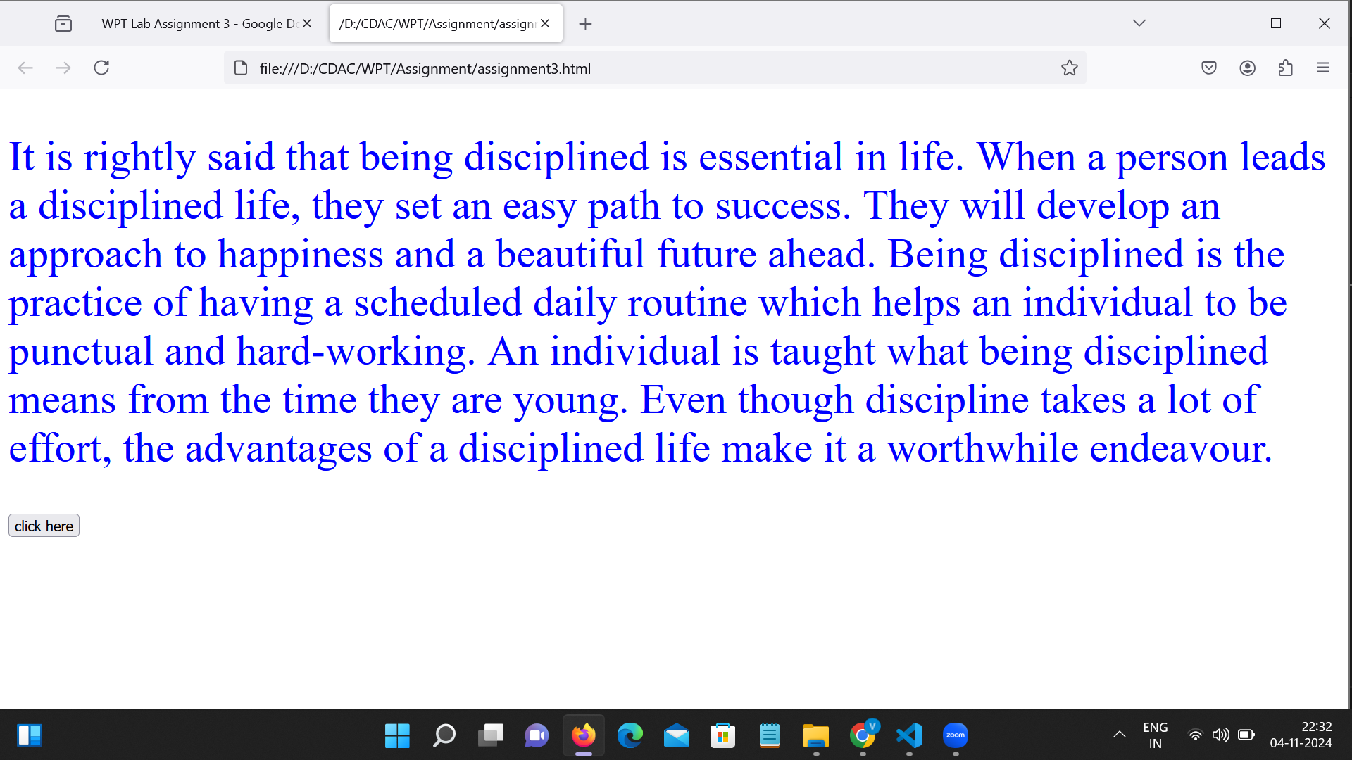

Q-2]

<!DOCTYPE html>

<html lang="en">

<body>

<form>

<p>

<label for="fname">First Name</label>

<input type="text" id="fname" placeholder="First Name">

</p>

<p>

<label for="lname">Last Name</label>

<input type="text" id="lname" placeholder="Last Name">

</p>

<p>

<label for="mobileNum">Mobile Number</label>

<input type="text" id="mobileNum" placeholder="Mobile Number">

</p>

<p>

<label for="Email">Email</label>

<input type="email" id="Email" placeholder="Email">

</p>

<button type="button" id="myButton" >Submit</button>

</form>

<script>

const fname = document.getElementById('fname');

const lname = document.getElementById('lname');

const mobileNum = document.getElementById('mobileNum');

const Email = document.getElementById('Email')

const myButton = document.getElementById('myButton')

myButton.addEventListener('click',function() {

console.log("First Name: "+fname.value);

console.log("Last Name: "+lname.value);

console.log("Mobile Number: "+mobileNum.value);

console.log("Email: "+Email.value);

});

</script>

</body>

</html>

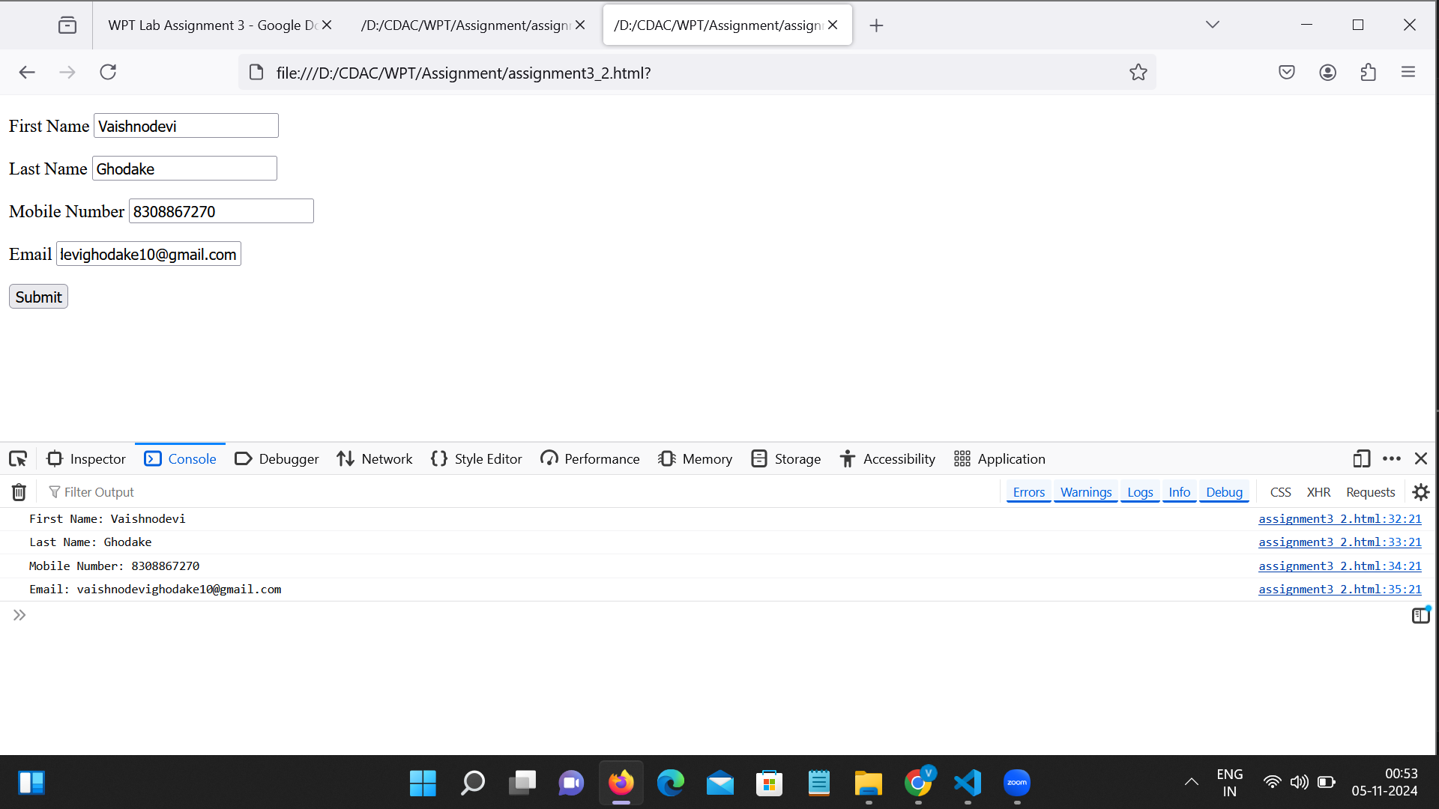

Q-3]

<!DOCTYPE html>

<html lang="en">

<body>

<select id="dropdown">

<option>Option1</option>

<option>Option2</option>

<option>Option3</option>

<option>Option4</option>

</select>

<button type="button" id="myButton">click here</button>

<script>

var dropdown = document.getElementById('dropdown');

var myButton = document.getElementById('myButton');

myButton.addEventListener('click', function() {

dropdown.remove(dropdown.selectedIndex);

})

</script>

</body>

</html>

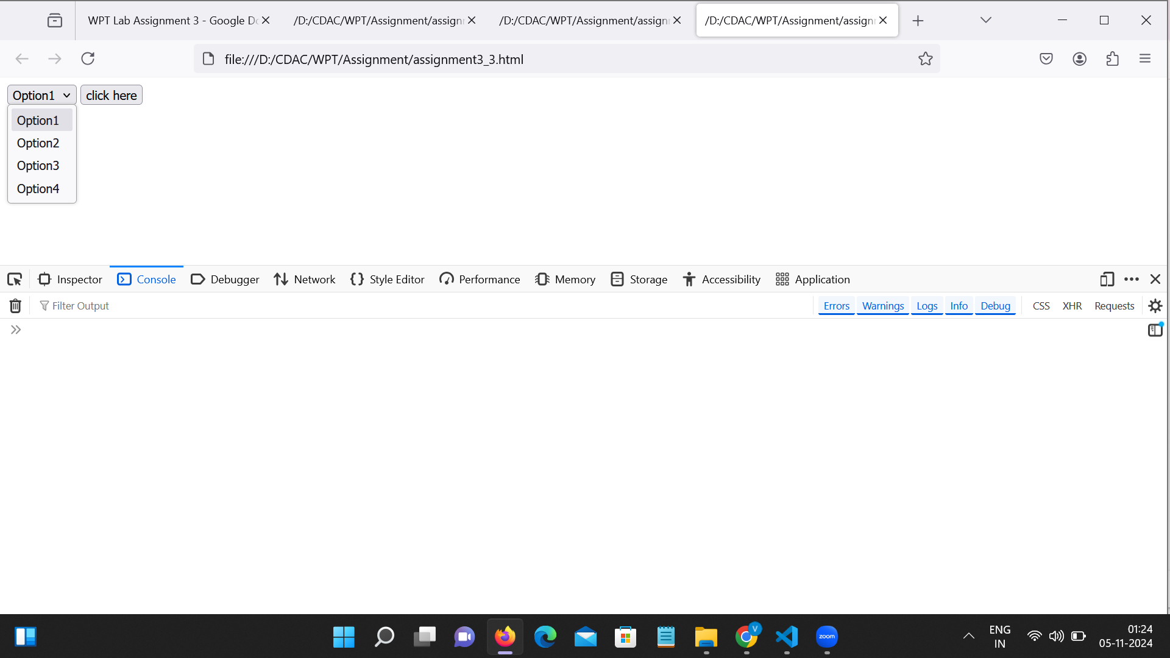

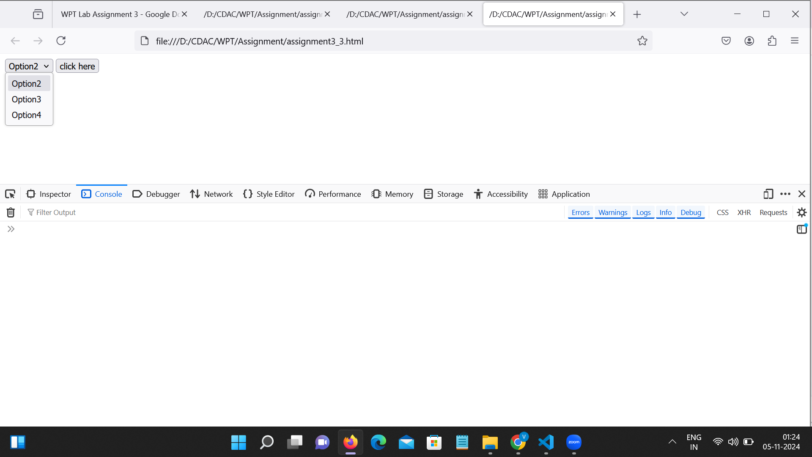

Q-4]

<!DOCTYPE html>

<html lang="en">

<meta charset="UTF-8">

<body>

<p>[<a href="#" onMouseOver="highlight()" onMouseOut="return_normal()">On mouse over here bold words of the following paragraph will be highlighted</a></a>] </p>

<p><strong>We</strong> have just started <strong>this</strong> section for the users (<strong>beginner</strong> to intermediate) who <strong>want</strong> to work with <strong>various</strong> JavaScript <strong>problems</strong> and write scripts online to <strong>test</strong> their JavaScript <strong>skill</strong>.</p>

<script>

var bold_items;

window.onload = getBold_items;

function getBold_items()

{

bold_items = document.getElementsByTagName('strong');

}

function highlight()

{

for(var i=0;i<bold_items.length;i++)

{

bold_items[i].style.color='blue';

}

}

function return_normal()

{

for(var i=0;i<bold_items.length;i++)

{

bold_items[i].style.color='black';

}

}

</script>

</body>

</html>

