Unsupervised STructural EMbedding for Stance Detection (STEM)

BACHELOR OF TECHNOLOGY
in
COMPUTER SCIENCE AND ENGINEERING

Submitted by :
BANGARU RAJU CHEERAPA (N170599)
VAISHNAVI DHULIPUDI(N170367)




`
DEPARTMENT OF COMPUTER SCIENCE ENGINEERING
Rajiv Gandhi University of Knowledge Technologies – Nuzvid,
Eluru(D.t), Andhra Pradesh – 521202.

TABLE OF CONTENTS  ABSTRACT  CHAPTER 1  PROJECT INTRODUCTION  - Objective of the project  - Word Embeddings  - Disadvantages  CAPTER 2  LITERATURE SURVEY  2.1 Node Embeddings  2.2 Random walk  2.3 Cosine Similarity  CHAPTER 3  PROPOSED MODEL  3.1 Construction of Conversation Tree  3.2 conversion from conversation tree to graph  3.3 Two-Core Reduction  3.4 SDP  CHAPTER 4  RESULTS  Requirements  Test Cases  Code  Result Screenshots  CHAPTER 5  CONCLUSION  REFERENCES | 3  4  5-6  5  5  5-6  7-9  7-8  8-9  9  10-11  10  10  11  11  12  12  12-16  16-21  22-23  24  24  24

ABSTRACT

We introduce an innovative approach to detect the stance of a discussion: STEM (Structural Embeddings), which can do the stance detection based on the structure of the graph. Our project is domain-independent and unsupervised, so we achieve stance detection without relying on text and domain. Firstly, the claim and multiparticipant discussion is given, and then we construct the tree or discussion thread. Then we convert that tree into a graph to give it a structural representation and using 2 core reduction we make a dense graph. After that ,the graph is split into two stances using the max-cut and SDP algorithms. Here Our main assumption is if speaker 1 replies to speaker2 then speaker1 and speaker2 hold opposite stances.

CHAPTER 1

PROJECT INTRODUCTION

Objective of the Project

Main aim of the project is to find a stance of the claim without relying on text. Here we proposed

structural embeddings based on graphs and texts

1.2 Word Embeddings:

A word embedding serves as a means of representing a word, and it finds its use in text analysis.

The usual form of this representation is a vector with real number values, which captures the essence

of the word's meaning. It follows that words that are closer together in the vector space are deemed

to have similar meanings.

Techniques for learning word embeddings are Word2Vec, GloVe, and other neural

network-based approaches that train on an NLP task such as language modeling or document

Classification

And a bag-of-words model, or BoW for short, is a way of extracting features from text for use in

modeling, such as with machine learning algorithms.

1.3 Disadvantages

Contextual information: Stance detection often requires an understanding of the broader context in

which a statement is made, such as the speaker's background, the topic being discussed, and the

intended audience. Word embeddings may not capture this contextual information, making it

difficult to accurately detect stance.

Word embeddings can struggle with ambiguity, as different words can have multiple meanings

depending on the context in which they are used. This can make it difficult to accurately represent

the stance of a speaker or writer, especially if they use ambiguous language.

CHAPTER 2

LITERATURE SURVEY

2.1 Node embeddings

Node embeddings are a class of techniques used in graph analysis and machine learning to represent nodes in a graph as vectors in a high-dimensional space. The goal of node embeddings is to capture the structural and semantic relationships between nodes in the graph, which can then be used to perform various tasks, such as link prediction, node classification, and clustering.
The basic idea behind node embeddings is to learn a low-dimensional vector representation for each node in the graph, such that nodes that are close to each other in the graph are also close to each other in the vector space. This is achieved by using various algorithms, such as random walk, deep learning, and matrix factorization, to extract features from the graph and map them to vector representations.
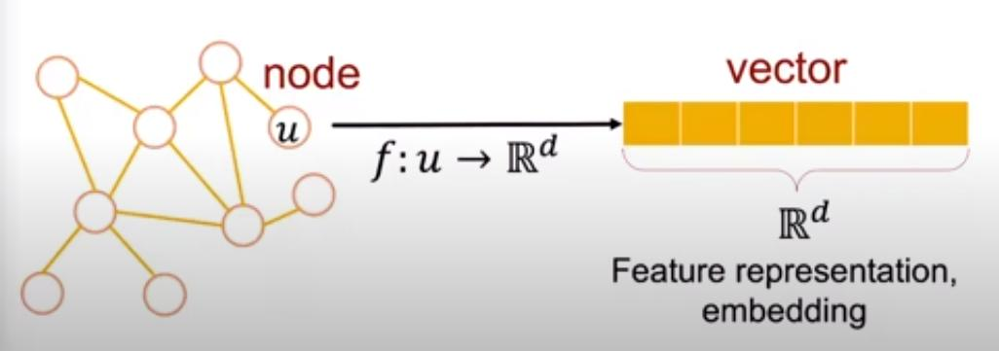
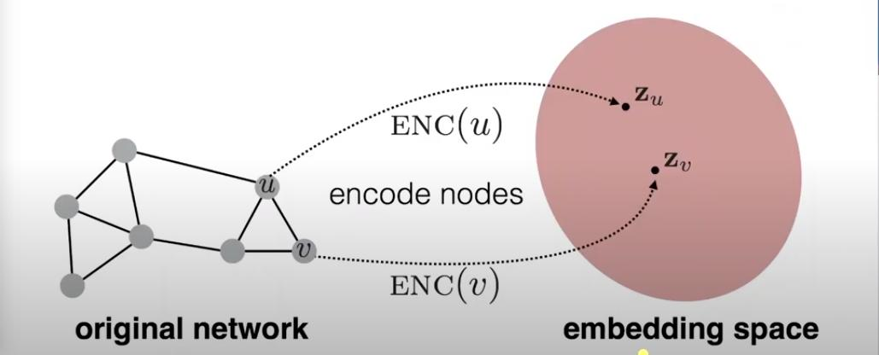
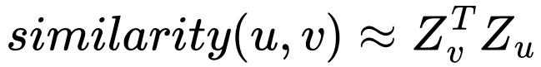
Where u,v are nodes in original network and,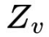,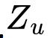are corresponding vector representations in embedding space

2.2 Random walk:

Random walk is a technique used in node embeddings to learn vector representations of nodes in a graph. In a random walk, starting from a particular node, we move to one of its neighboring nodes at random, and then repeat the process for the next node, and so on. By doing this repeatedly for a large number of iterations, we can generate a large number of random walks that traverse different paths in the graph. These random walks can then be used to learn vector representations of nodes using techniques such as Skip-Gram or GloVe.
The idea behind this approach is that nodes that are close to each other in the graph will have similar vector representations, as they are likely to appear in similar contexts in the random walks. By representing nodes as vectors in a high-dimensional space, we can perform various graph analysis tasks, such as link prediction, node classification, and clustering.
Random walk-based node embedding techniques have been shown to be effective in a wide range of applications, including social network analysis, recommendation systems, and natural language processing.

2.3 Cosine similarity
Cosine similarity is a widely used measure of similarity between two vectors in a high-dimensional space, and it is commonly used in node embeddings to measure the similarity between the vector representations of nodes in a graph.
In node embeddings, each node is represented as a vector in a high-dimensional space, where the dimensions correspond to different features or characteristics of the node. To calculate the cosine similarity between two nodes, we take the dot product of their vector representations and divide it by the product of their magnitudes. The resulting value ranges from -1 (indicating complete dissimilarity) to 1 (indicating complete similarity), with values closer to 1 indicating greater similarity between the nodes.
Cosine similarity is particularly useful in node embeddings because it allows us to compare the similarity of nodes based on their vector representations in a high-dimensional space, rather than on specific features or characteristics of the nodes themselves. This means that cosine similarity can capture more complex relationships between nodes that may not be apparent from their individual features.

CHAPTER 3

Proposed Model

The detailed information of our algorithm is given in this section. We choose below image to demonstrate the structural embedding process of the proposed method, the processing of image enhancement
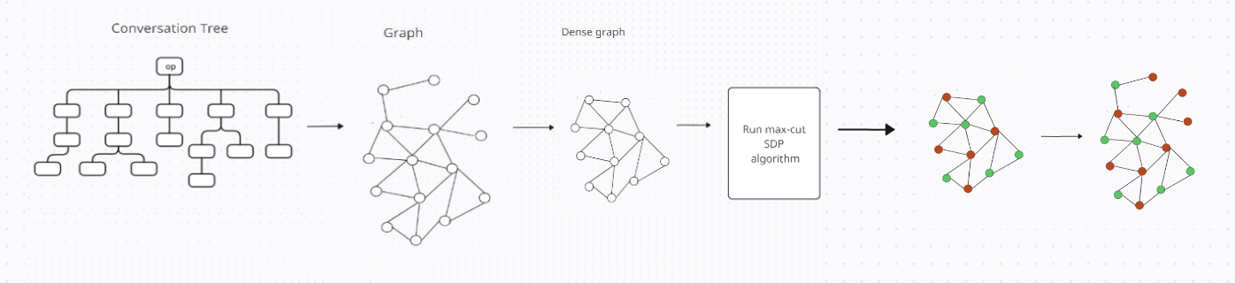

3.1 Construct a conversation tree

A discussion can be represented as a tree structure, with each node representing a comment or post. If a

node, v1, is a direct response to an original post, it is considered a child of that post. Similarly, if a node, v2,

is a direct response to another post, v1, then v1 is considered the parent of v2. Based on these responses, we

can create edges between the nodes in the tree.

3.2 conversion from conversation tree to graph

Instead of treating individual utterances as nodes, an interaction network models speakers as nodes. The

Edge 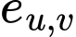 between nodes u and v indicate direct interactions between the speakers, and the edges can be

weighted based on replies and quotes. The weighting function is platform-dependent. For instance, in our

platform, we consider only replies and quotes.

Where and are represented by type of interactions like replies or quotes

On other platforms, like Instagram, we may need to use a different equation to calculate edge weights, for

instance consider below equation .

Where , , and represented by types of interactions such as replies, retweets, likes, and messages,

respectively,

3.3 Two core reduction of the graph

The 2-core of a graph is a maximal subgraph in which every vertex has at least degree 2. In

other words, the 2-core is a subgraph that remains after recursively removing vertices of degree less than 2

until no more such vertices remain. The 2-core reduction algorithm removes all vertices that are not part of

the 2-core, resulting in a simplified graph that retains only the most densely connected regions.

3.4 semi definite program

Semi-Definite Programming (SDP) is a powerful optimization technique utilized to solve optimization

problems involving matrices, extending the principles of linear programming. SDP finds application across

diverse fields such as control theory, combinatorial optimization, and machine learning. One such problem

often addressed using SDP is Max-Cut, a fundamental combinatorial optimization problem focused on

dividing the nodes of a graph into two sets to maximize the total weight of edges between them.

CHAPTER 4

RESULT
4.1 Requirements :
4.1.1 System Requirements
1. Operating System : Windows, macOS, and Linux.
2. Programming Language: Python or java
3. Libraries and Dependencies: pandas, networkx, cvxpy, numpy, Matplotlib.

4.1.2 Hardware Requirements
1. Processor: Intel(R) Core(TM) i5-12500H.
2. RAM: 20GB

4.1.3 Funcitonal Requirements
1. Data Preprocessing: Prepare raw data from discussions for analysis.
2. Network Construction: Create networks to represent interactions between speakers.
3. Topological Embedding: Convert interaction networks into mathematical representations for each speaker.
4. Speaker Partitioning: Group speakers based on their views or stances.
5. Stance Classification: Determine speakers' stances based on their groupings

4.1.4 Non-Funcitonal Requirements
1. Efficiency: The framework works quickly and doesn't waste resources.
2. Scalability: It can handle both small and large datasets.
3. Robustness: Deal well with noisy or incomplete data and adapt to different topics.
4. Interpretability: Provide clear explanations of how the framework works.
5. Portability: Enable easy use across different systems and environments.

4.2 Test Cases :

4.2.1: using CreateDebate dataset
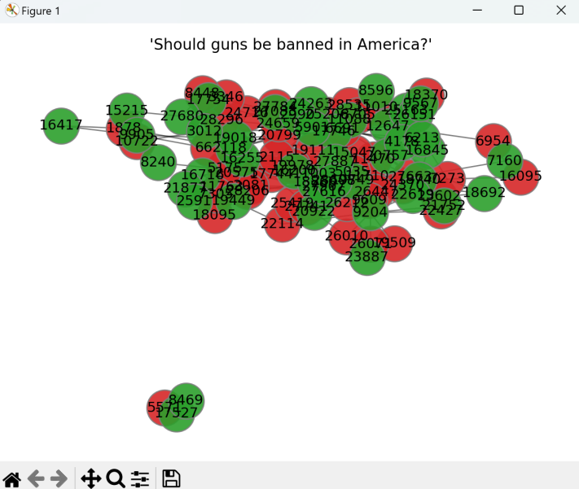

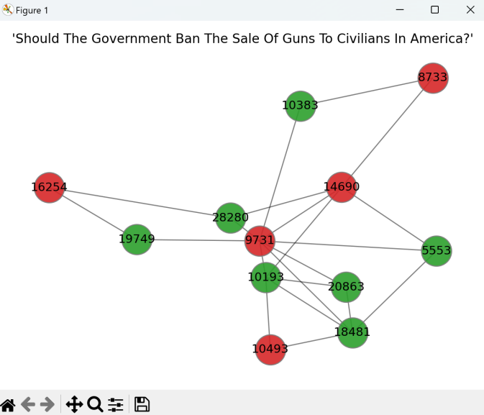

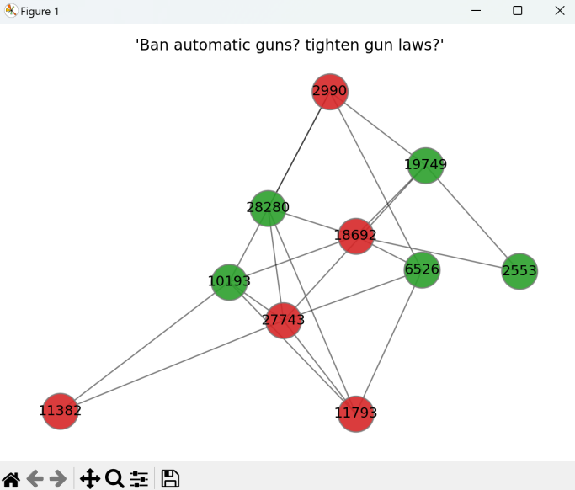

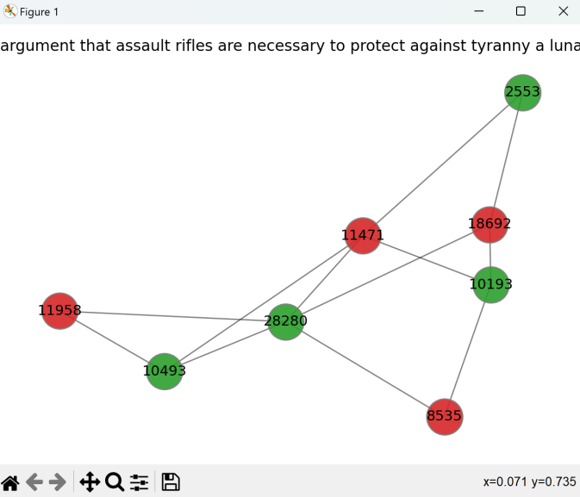

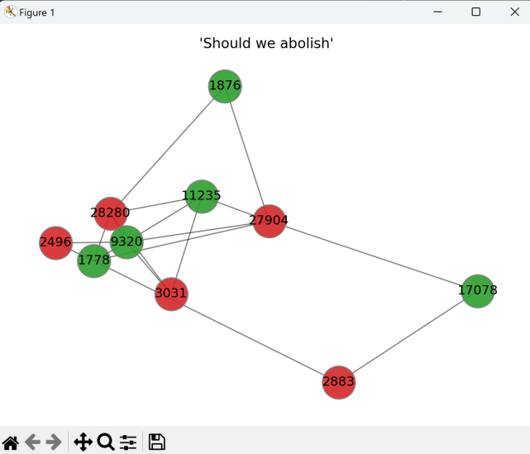

4.2.2: using ConvinceMe datset

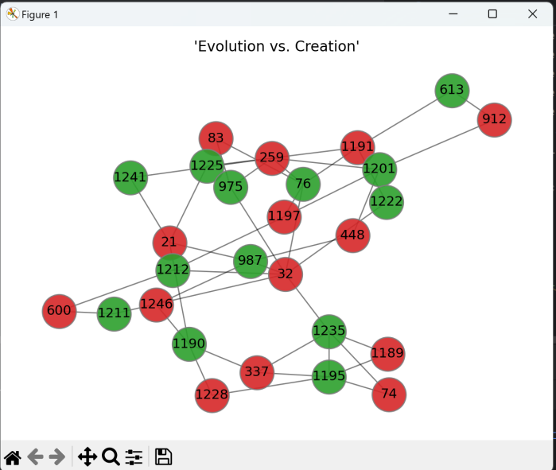

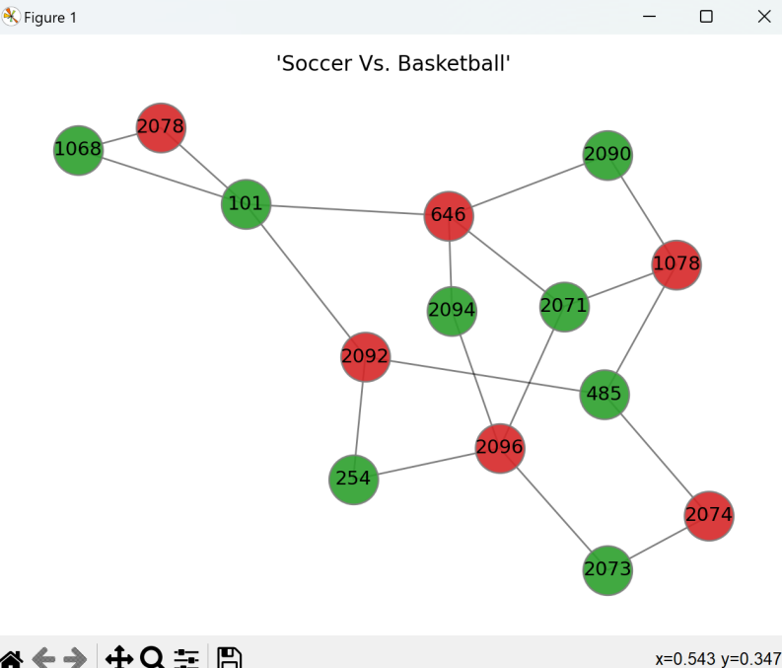

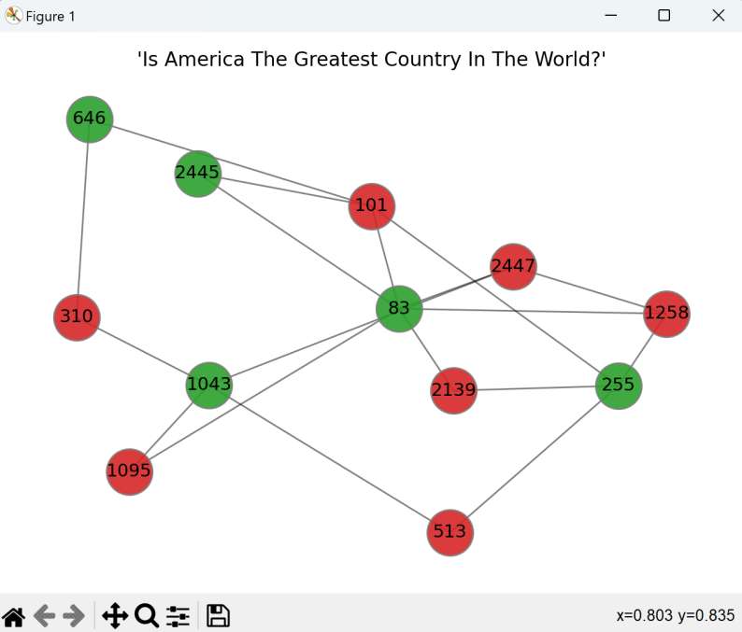

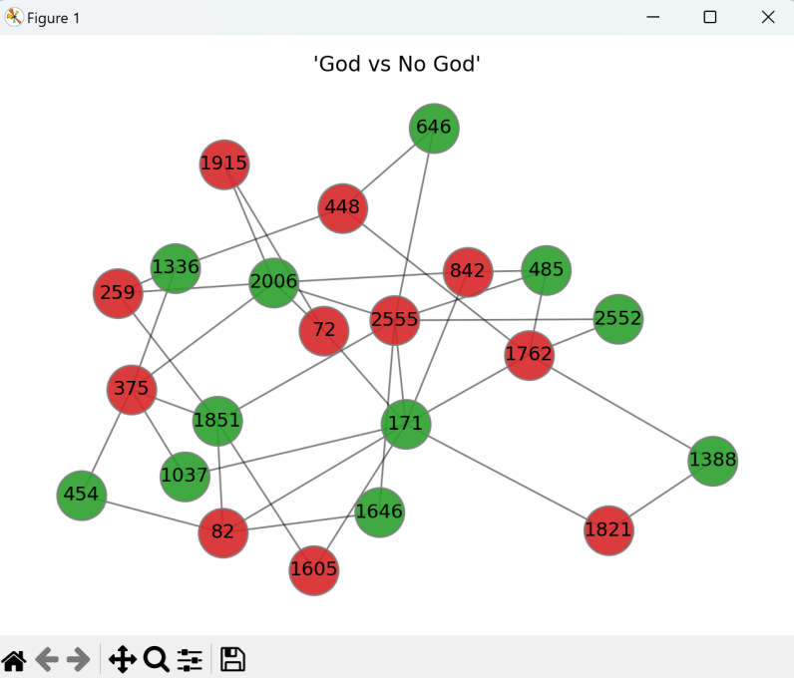
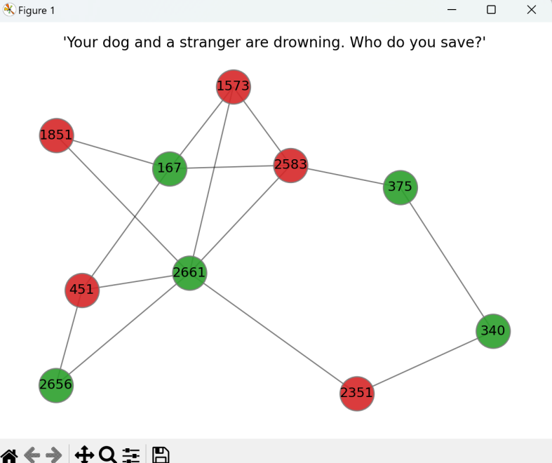

4.3 Code :
4.3.1 : Data preprocessing code
class Author:
def __init__(self, authorId):
"""
Initializes an Author object.

Parameters:
authorId (int): The unique identifier for the author.
"""
self.authorId = authorId

class Discussion:
def __init__(self, discussionId, title, initiatingAuthorId):
"""
Initializes a Discussion object.

Parameters:
discussionId (int): The unique identifier for the discussion.
title (str): The title of the discussion.
initiatingAuthorId (int): The author ID of the author who initiated the discussion.
"""
self.discussionId = discussionId
self.title = title
self.initiatingAuthorId = initiatingAuthorId

class DiscussionStance:
def __init__(self, discussionId, discussionStanceId, discussionStance):
"""
Initializes a DiscussionStance object.

Parameters:
discussionId (int): The unique identifier for the discussion.
discussionStanceId (int): The unique identifier for the discussion stance.
discussionStance (str): The stance of the discussion.
"""
self.discussionId = discussionId
self.discussionStance = discussionStance
self.discussionStanceId = discussionStanceId

class DiscussionTopic:
def __init__(self, discussionId, topicId):
"""
Initializes a DiscussionTopic object.

Parameters:
discussionId (int): The unique identifier for the discussion.
topicId (int): The unique identifier for the topic.
"""
self.discussionId = discussionId
self.topicId = topicId

class Post:
def __init__(self, discussionId, authorId, postId, parentPostId, responseType=""):
"""
Initializes a Post object.

Parameters:
discussionId (int): The unique identifier for the discussion.
authorId (int): The unique identifier for the author of the post.
postId (int): The unique identifier for the post.
parentPostId (int): The parent post ID if this post is a response to another post.
responseType (str): The response type of the post.
"""
self.discussionId = discussionId
self.authorId = authorId
self.postId = postId
self.parentPostId = parentPostId
if not np.isnan(self.parentPostId):
self.parentPostId = int(parentPostId)
self.responseType = responseType

class Quote:
def __init__(self, discussionId, postId, sourcePostId):
"""
Initializes a Quote object.

Parameters:
discussionId (int): The unique identifier for the discussion.
postId (int): The unique identifier for the post that contains the quote.
sourcePostId (int): The unique identifier for the post being quoted.
"""
self.discussionId = discussionId
self.postId = postId
self.sourcePostId = sourcePostId

class Topic:
def __init__(self, topicId, topic):
"""
Initializes a Topic object.

Parameters:
topicId (int): The unique identifier for the topic.
topic (str): The topic.
"""
self.topicId = topicId
self.topic = topic

class TopicStance:
def __init__(self, topicId, topicStanceId, stance):
"""
Initializes a TopicStance object.

Parameters:
topicId (int): The unique identifier for the topic.
topicStanceId (int): The unique identifier for the topic stance.
stance (str): The stance of the topic.
"""
self.topicId = topicId
self.topicStanceId = topicStanceId
self.stance = stance

4.3.2 : Main code
from src.Service.LoadInput import LoadInput # Importing LoadInput class from LoadInput module
from src.Service.ConversationTree import ConversationTree # Importing ConversationTree class from ConversationTree module
from src.Model.Discussion import Discussion # Importing Discussion class from Discussion module
from typing import Dict # Importing Dict type from typing module

class ConversationForest:
"""
Represents a forest of conversation trees.
"""

def __init__(self, loadInputObject: LoadInput):
"""
Initializes a ConversationForest object.

Parameters:
loadInputObject (LoadInput): An instance of LoadInput class.
"""
self.loadInputObject = loadInputObject
self.conversationTrees: Dict[str, ConversationTree] = {} # Dictionary to store conversation trees

def buildConversationTrees(self):
"""
Builds conversation trees from loaded input data.
"""
discussionRecords = self.loadInputObject.discussionRecords
for key, value in discussionRecords.items():
self.conversationTrees[key] = self.buildConversationTree(value)

def buildConversationTree(self, discussion: Discussion):
"""
Builds a conversation tree from a discussion.

Parameters:
discussion (Discussion): The discussion object.

Returns:
ConversationTree: A conversation tree object.
"""
initiatedAuthorId = discussion.initiatingAuthorId
discussionId = discussion.discussionId
discussionTitle = discussion.title
posts = {}
for post in self.loadInputObject.postRecords.values():
if post.discussionId == discussionId:
posts[str(post.postId)] = post
conversationTree = ConversationTree(initiatedAuthorId, discussionId, discussionTitle, posts)
return conversationTree

def getAllConversationTrees(self):
"""
Gets all conversation trees.

Returns:
Dict[str, ConversationTree]: Dictionary of conversation trees.
"""
return self.conversationTrees

from typing import Dict
from src.Model.Post import Post
import networkx as nx
import matplotlib.pyplot as plt
import numpy as np

class ConversationTree:
"""
Represents a conversation tree.
"""

def __init__(self, initiatedAuthorId: int, discussionId: int, discussionTitle: str, posts: Dict[str, Post]):
"""
Initializes a ConversationTree object.

Parameters:
initiatedAuthorId (int): The ID of the author who initiated the discussion.
discussionId (int): The ID of the discussion.
discussionTitle (str): The title of the discussion.
posts (Dict[str, Post]): Dictionary of posts in the discussion.
"""
self.initiatedAuthorId = initiatedAuthorId
self.discussionId = discussionId
self.discussionTitle = discussionTitle
self.tree = {} # Dictionary to represent the tree structure
self.originalPost = str(initiatedAuthorId) + "_" + str(discussionTitle) # Identifier for the original post
self.tree[self.originalPost] = [] # Initialize the original post in the tree
self.posts = posts # Posts in the discussion
self.buildConversationTree() # Build the conversation tree

def buildConversationTree(self):
"""
Builds the conversation tree from posts.
"""
for post in self.posts.values():
if post.discussionId == self.discussionId:
if np.isnan(post.parentPostId):
self.tree[self.originalPost].append(str(post.postId))
elif str(post.parentPostId) not in self.tree.keys():
self.tree[str(post.parentPostId)] = []
self.tree[str(post.parentPostId)].append(str(post.postId))
else:
self.tree[str(post.parentPostId)].append(str(post.postId))

def showConversationTree(self):
"""
Shows the conversation tree.
"""
diGraph = nx.DiGraph()
for node in self.tree.keys():
diGraph.add_node(str(node))
for node in self.tree.keys():
for reply in self.tree[node]:
diGraph.add_edge(str(reply), str(node))
nx.draw(diGraph, with_labels=True)
plt.show()

def getConversationTree(self):
"""
Gets the conversation tree.

Returns:
Dict[str, List[str]]: The conversation tree.
"""
return self.tree

4.4 Reuslt screenshots :

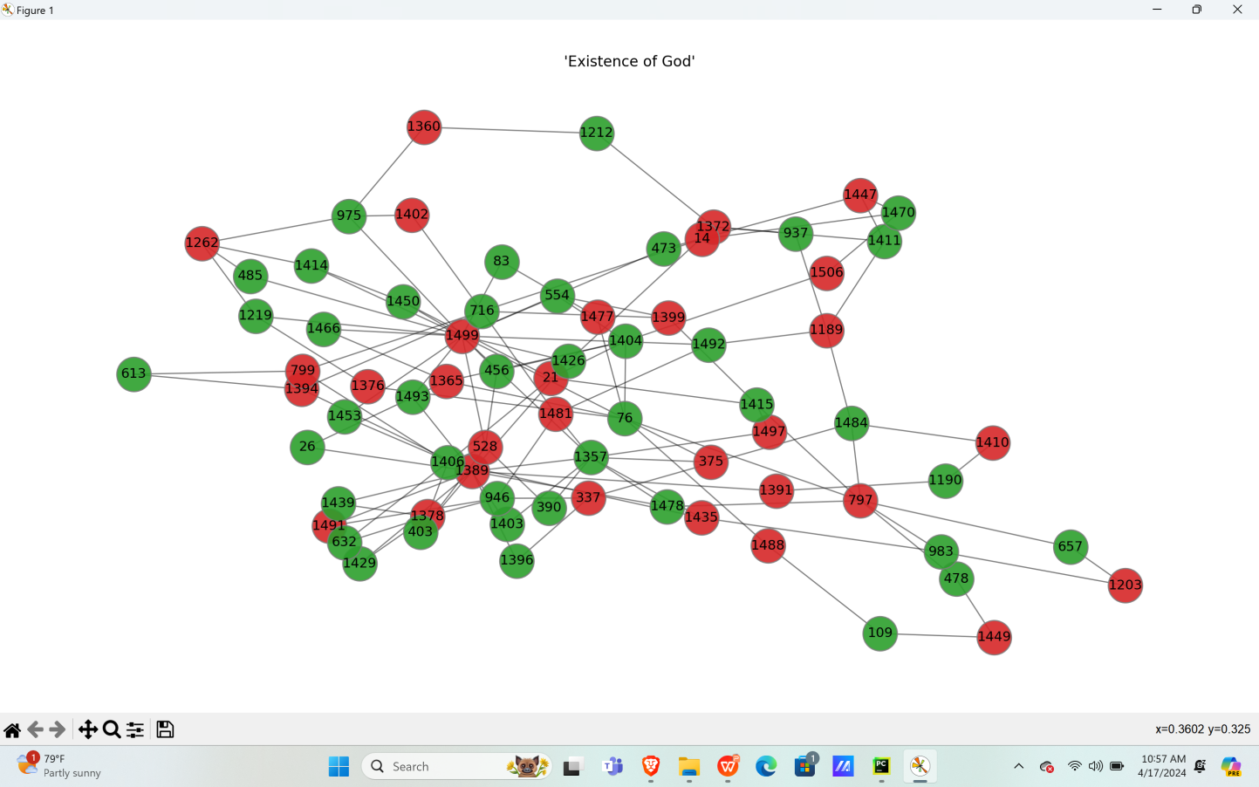

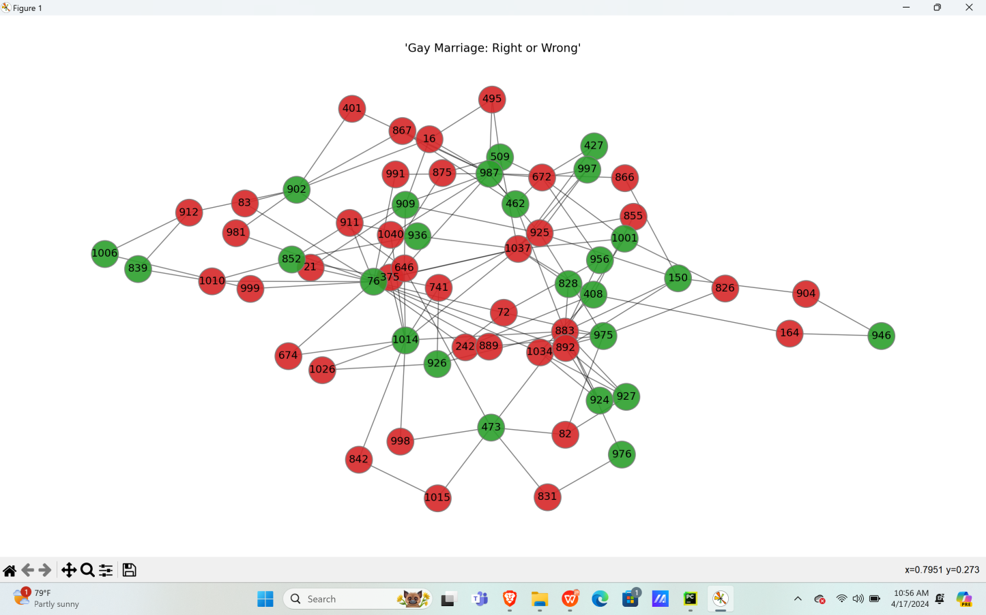

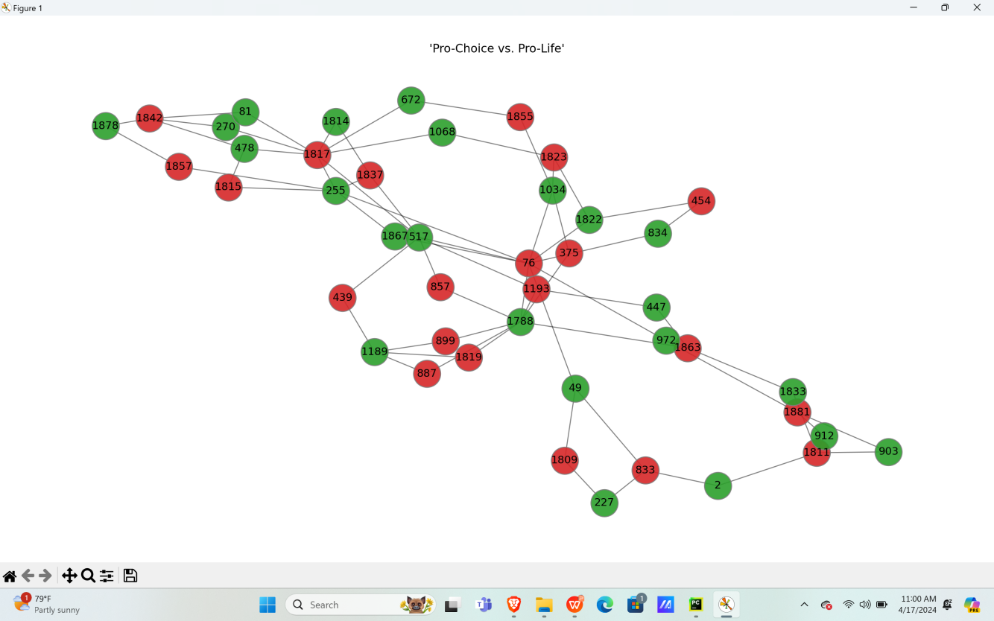

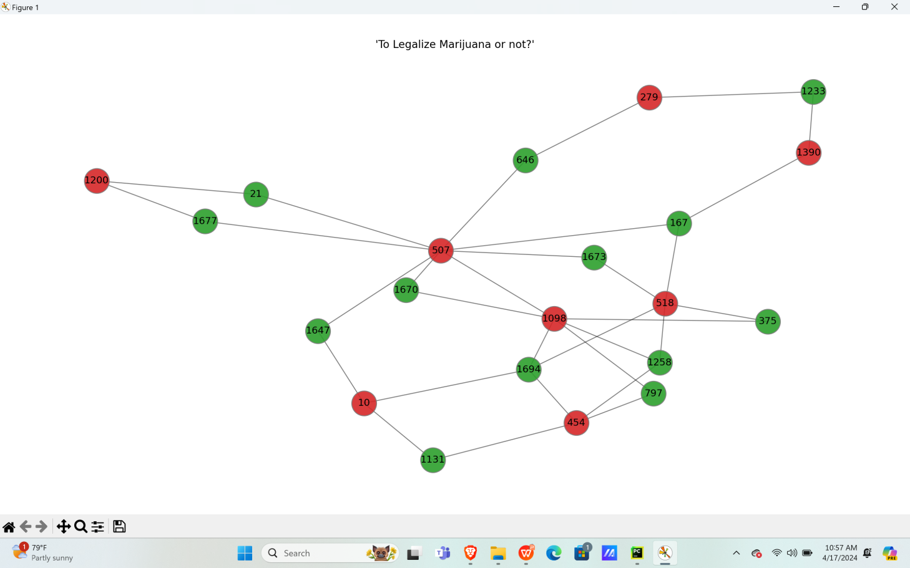

By using structural embeddings, we are able to identify the stances of the speakers and show whether

their stance is towards or against the claim.

CHAPTER 5

CONCLUSION

We present an unsupervised and domain-independent approach to stance detection, leveraging the
conversation structure to compute a useful speaker embedding. This approach was evaluated on two datasets. Our findings show that this approach yields improved accuracy compared to existing methods. Furthermore, we have demonstrated how the speaker embedding can be used to detect the speaker's stance in a conversation, allowing for more accurate and efficient stance detection. We believe that this work contributes to the advancement of the field by introducing an effective, unsupervised approach to stance detection.

REFERENCES

- STEM: Unsupervised STructural EMbedding for Stance Detection. Ron Korenblum Pick, Vladyslav
Kozhukhov, Dan Vilenchik, Oren Tsur
2. Optimal solutions and ranks in the max-cut sdp Daniel Hong, Hyunwoo Lee, and Alex Wei

