Olist E-Commerce Dataset
Customer Clustering and Product Analysis Report
Prepared for Data Analysis Internship Submission

This report presents an end-to-end customer clustering and product performance analysis using the full available Olist relational dataset: customers, orders, order items, products, sellers, payments, reviews, geolocation, and product category translations. The analysis follows an industry-style workflow: data profiling, cleaning, analytical dataset construction, feature engineering, customer segmentation, product/category performance analysis, and business recommendations.

Executive Summary
Delivered orders analysed | 96,478
Unique customers clustered | 93,358
Products analysed | 32,216
Product categories analysed | 74
Total payment value analysed | 15,422,605
Total item revenue analysed | 13,221,498
Average review score | 4.16/5
Average delivery duration | 12.6 days

- Revenue is concentrated geographically: SP is the largest customer state by revenue with 37.4% of delivered-order payment value.
- The leading category is health_beauty, contributing 9.3% of product revenue in delivered orders.
- Customer behavior is highly skewed toward one-time purchase patterns, so customer_unique_id was used instead of customer_id to avoid treating repeat buyers as unrelated customers.
- Customer clusters show different action paths: retention for high-value multi-order customers, reactivation for dormant buyers, and service recovery for low-satisfaction customers.
- Product portfolio performance is dominated by a small set of revenue-driving categories and products, while a large long tail requires careful inventory and catalog governance.

1. Scope, Objective and Analytical Approach
Objective: identify actionable customer segments and product portfolio patterns that can support marketing, retention, merchandising, logistics, and customer experience decisions.
Analytical grain: customer analysis is performed at customer_unique_id level; product analysis is performed at product_id and category level; order analysis is restricted mainly to delivered orders for reliable sales, delivery, review, and payment interpretation.
Why delivered orders were used: cancelled and unavailable orders do not represent completed demand and can distort revenue, delivery time, review, and product performance metrics. They are still kept in the cleaned enriched order file for auditability.
Table 1. Raw Dataset Profiling Summary
Dataset | Rows | Columns | Duplicate Rows | Missing Cells | Missing Pct
customers | 99,441 | 5 | 0 | 0 | 0.0
orders | 99,441 | 8 | 0 | 4,908 | 0.6
order_items | 112,650 | 7 | 0 | 0 | 0.0
payments | 103,886 | 5 | 0 | 0 | 0.0
reviews | 99,224 | 7 | 0 | 145,903 | 21.0
products | 32,951 | 9 | 0 | 2,448 | 0.8
sellers | 3,095 | 4 | 0 | 0 | 0.0
category_translation | 71 | 2 | 0 | 0 | 0.0
geolocation | 1,000,163 | 5 | 261,831 | 0 | 0.0

2. Data Cleaning and Preparation
- Removed exact duplicate records where applicable and de-duplicated master tables using primary keys such as customer_id, order_id, product_id, and seller_id.
- Converted purchase, approval, carrier, delivery, estimated delivery, review, and shipping-limit columns into datetime fields.
- Translated product category names from Portuguese to English using the category translation table; missing translations/categories were retained as unknown instead of being dropped.
- Aggregated payment records to order level because one order can have multiple payment rows.
- Aggregated review records to order level because some orders can contain duplicate or multiple review records.
- Aggregated order item rows to order level for customer clustering and retained line-level order-item records for product analysis.
- Aggregated geolocation at zip-code-prefix level using median latitude/longitude to avoid many-to-many duplication in the customer/order base.
- Created delivery, lateness, freight ratio, order value, category diversity, and review satisfaction features.

3. Customer Clustering Analysis
The clustering model uses behavioral and operational features: recency, frequency, monetary value, average order value, number of items, category diversity, review score, delivery duration, late delivery rate, installments, freight-to-sales ratio, and credit-card share. Numeric outliers were winsorized at the 1st and 99th percentiles, skewed variables were log-transformed, and all features were standardized before K-Means clustering.
Model selection note: K values from 3 to 7 were tested using silhouette score and business interpretability. The selected solution uses 5 clusters because it produced distinct, explainable commercial segments. Inertia values on a 5,000-customer sample were: k=3: 47,106, k=4: 38,181, k=5: 31,303, k=6: 28,999, k=7: 27,447. Silhouette was not used in the final report because this dataset is dominated by one-time customers, making business interpretability more reliable than a purely geometric score.
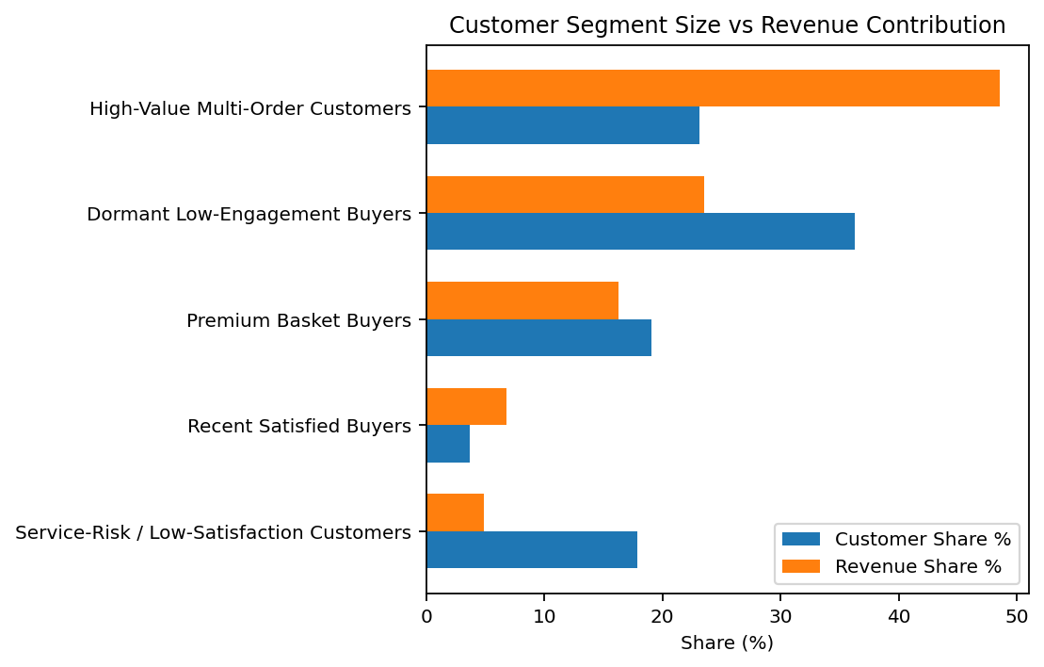
Table 2. Customer Segment Profile
Segment | Customers | Customer Share Pct | Total Revenue | Revenue Share Pct | Recency Days | Frequency | Monetary | Avg Order Value | Avg Review Score | Late Delivery Rate
High-Value Multi-Order Customers | 21,594 | 23.1 | 7,489,044.85 | 48.6 | 234.00 | 1.00 | 346.81 | 346.81 | 3.68 | 0.18
Dormant Low-Engagement Buyers | 33,828 | 36.2 | 3,626,115.10 | 23.5 | 204.00 | 1.00 | 107.19 | 107.19 | 4.53 | 0.01
Premium Basket Buyers | 17,769 | 19.0 | 2,510,091.04 | 16.3 | 226.00 | 1.00 | 141.26 | 141.26 | 4.21 | 0.08
Recent Satisfied Buyers | 3,480 | 3.7 | 1,043,076.51 | 6.8 | 198.00 | 1.90 | 299.73 | 168.76 | 3.97 | 0.06
Service-Risk / Low-Satisfaction Customers | 16,687 | 17.9 | 754,277.73 | 4.9 | 224.00 | 1.00 | 45.20 | 45.20 | 4.00 | 0.12

Customer Segment Interpretation and Actions

High-Value Multi-Order Customers
Size: 21,594 customers (23.1% of customers) | Revenue share: 48.6% | Avg monetary value: 346.81 | Avg review: 3.68/5.
- Prioritize loyalty offers, early access to high-performing categories, and personalized cross-sell campaigns.
- Protect service quality for this group because small retention improvements have disproportionate revenue impact.

Dormant Low-Engagement Buyers
Size: 33,828 customers (36.2% of customers) | Revenue share: 23.5% | Avg monetary value: 107.19 | Avg review: 4.53/5.
- Use low-cost reactivation campaigns rather than heavy discounting.
- Suppress from frequent paid campaigns if response remains low to protect marketing ROI.

Premium Basket Buyers
Size: 17,769 customers (19.0% of customers) | Revenue share: 16.3% | Avg monetary value: 141.26 | Avg review: 4.21/5.
- Promote bundles, warranty/service add-ons, and premium product recommendations.
- Monitor freight costs because higher basket value can hide logistics inefficiency.

Recent Satisfied Buyers
Size: 3,480 customers (3.7% of customers) | Revenue share: 6.8% | Avg monetary value: 299.73 | Avg review: 3.97/5.
- Trigger second-purchase campaigns within 15-45 days of delivery.
- Recommend adjacent categories based on first purchase category and review positivity.

Service-Risk / Low-Satisfaction Customers
Size: 16,687 customers (17.9% of customers) | Revenue share: 4.9% | Avg monetary value: 45.20 | Avg review: 4.00/5.
- Run service recovery actions: apology coupon, faster support, proactive delivery updates.
- Investigate categories/sellers linked to low review scores and late delivery.
Table 3. Top States Within Each Customer Segment
Segment | State | Customers | Monetary
Dormant Low-Engagement Buyers | SP | 17,176 | 1,747,900.96
Dormant Low-Engagement Buyers | MG | 4,080 | 450,704.75
Dormant Low-Engagement Buyers | RJ | 3,980 | 446,651.29
High-Value Multi-Order Customers | SP | 6,769 | 2,392,528.63
High-Value Multi-Order Customers | RJ | 3,259 | 1,062,567.82
High-Value Multi-Order Customers | MG | 2,532 | 865,780.63
Premium Basket Buyers | SP | 7,799 | 1,006,551.33
Premium Basket Buyers | MG | 2,045 | 296,525.21
Premium Basket Buyers | RJ | 1,987 | 285,066.50
Recent Satisfied Buyers | SP | 1,500 | 410,909.34
Recent Satisfied Buyers | RJ | 494 | 157,706.41
Recent Satisfied Buyers | MG | 411 | 119,816.96
Service-Risk / Low-Satisfaction Customers | SP | 5,906 | 214,113.33
Service-Risk / Low-Satisfaction Customers | RJ | 2,193 | 103,523.16
Service-Risk / Low-Satisfaction Customers | MG | 1,928 | 86,397.64

4. Product and Category Analysis
Product analysis was built from delivered order items and enriched with product master data, seller data, delivery outcomes, and review scores. The analysis uses product revenue, units sold, orders, sellers, freight burden, average price, review score, delivery speed, dimensions, and content attributes.
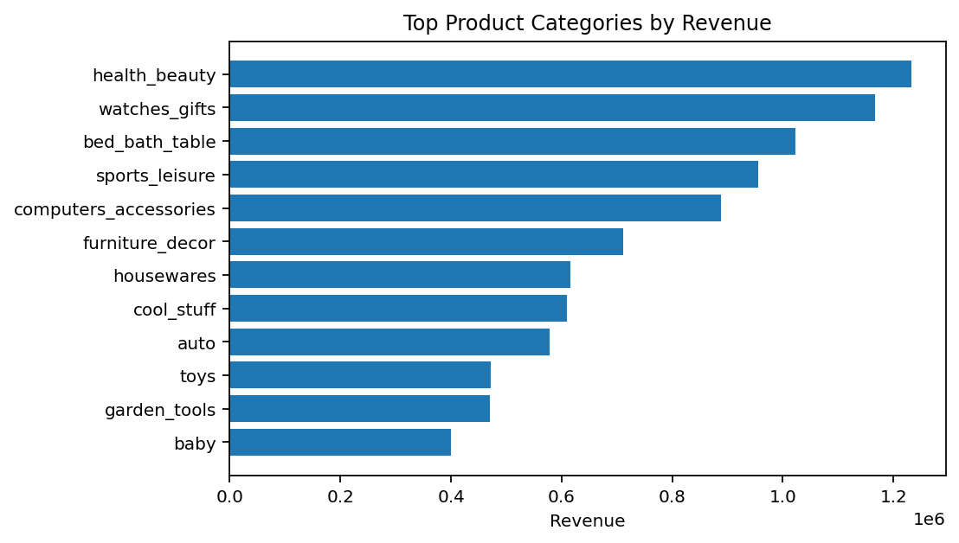
Table 4. Top Categories by Revenue
Category | Units Sold | Orders | Products | Sellers | Revenue | Revenue Share Pct | Avg Price | Avg Review Score | Late Delivery Rate
health_beauty | 9,465 | 8,647 | 2,397 | 479 | 1,233,131.72 | 9.3 | 130.28 | 4.19 | 0.09
watches_gifts | 5,859 | 5,495 | 1,300 | 95 | 1,166,176.98 | 8.8 | 199.04 | 4.07 | 0.08
bed_bath_table | 10,953 | 9,272 | 2,991 | 189 | 1,023,434.76 | 7.7 | 93.44 | 3.92 | 0.08
sports_leisure | 8,431 | 7,530 | 2,822 | 466 | 954,852.55 | 7.2 | 113.25 | 4.17 | 0.07
computers_accessories | 7,644 | 6,530 | 1,600 | 279 | 888,724.61 | 6.7 | 116.26 | 3.99 | 0.08
furniture_decor | 8,160 | 6,307 | 2,593 | 352 | 711,927.69 | 5.4 | 87.25 | 3.95 | 0.08
housewares | 6,795 | 5,743 | 2,282 | 452 | 615,628.69 | 4.7 | 90.60 | 4.11 | 0.06
cool_stuff | 3,718 | 3,559 | 770 | 259 | 610,204.10 | 4.6 | 164.12 | 4.19 | 0.07
auto | 4,140 | 3,810 | 1,853 | 371 | 578,966.65 | 4.4 | 139.85 | 4.12 | 0.08
toys | 4,030 | 3,804 | 1,373 | 242 | 471,286.48 | 3.6 | 116.94 | 4.21 | 0.07
garden_tools | 4,268 | 3,448 | 725 | 227 | 470,495.28 | 3.6 | 110.24 | 4.08 | 0.08
baby | 2,982 | 2,809 | 890 | 240 | 400,421.84 | 3.0 | 134.28 | 4.08 | 0.09

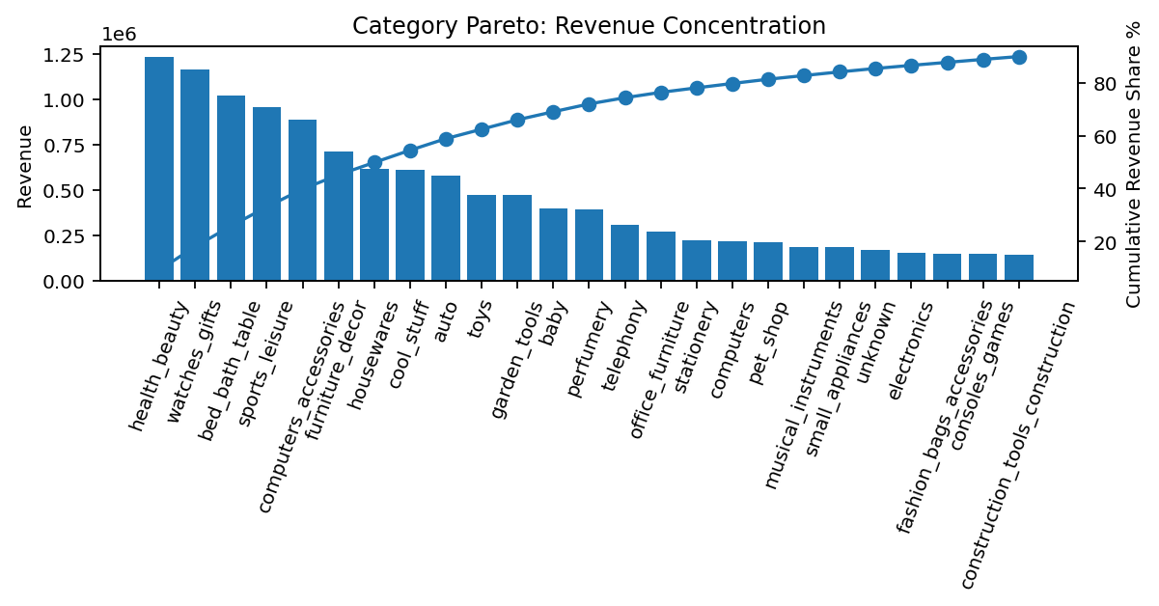

Product Segmentation
Products were segmented using business rules based on revenue, units sold, average price, freight-to-revenue ratio, and review score. This makes the segmentation easy to explain to non-technical stakeholders and directly usable for merchandising decisions.
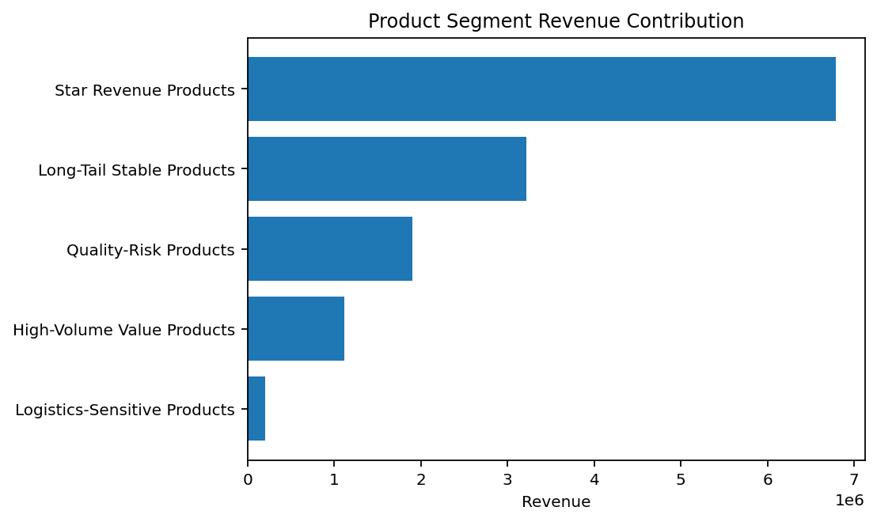
Table 5. Product Segment Summary
Product Segment | Products | Units Sold | Revenue | Avg Price | Avg Review Score | Freight To Revenue Ratio
Star Revenue Products | 4,472 | 40,733 | 6,784,618.08 | 391.45 | 4.58 | 0.14
Long-Tail Stable Products | 14,348 | 25,192 | 3,216,210.09 | 118.84 | 4.67 | 0.20
Quality-Risk Products | 4,708 | 10,095 | 1,903,162.92 | 187.95 | 2.13 | 0.19
High-Volume Value Products | 4,127 | 28,311 | 1,115,319.50 | 39.12 | 4.02 | 0.51
Logistics-Sensitive Products | 4,561 | 5,866 | 202,187.52 | 32.82 | 4.07 | 0.81

Top Product-Level Opportunities
Table 6. Top Products by Revenue
Product Id | Category | Product Segment | Units Sold | Orders | Revenue | Avg Price | Avg Review Score | Freight To Revenue Ratio
bb50f2e236e5eea0100680137654686c | health_beauty | Star Revenue Products | 194 | 186 | 63,560.00 | 327.63 | 4.24 | 0.06
6cdd53843498f92890544667809f1595 | health_beauty | Star Revenue Products | 153 | 148 | 53,652.30 | 350.67 | 4.36 | 0.08
d6160fb7873f184099d9bc95e30376af | computers | Star Revenue Products | 33 | 33 | 45,949.35 | 1,392.40 | 4.67 | 0.03
d1c427060a0f73f6b889a5c7c61f2ac4 | computers_accessories | Star Revenue Products | 332 | 313 | 45,620.56 | 137.41 | 4.28 | 0.29
99a4788cb24856965c36a24e339b6058 | bed_bath_table | Long-Tail Stable Products | 477 | 456 | 42,049.66 | 88.15 | 3.93 | 0.19
3dd2a17168ec895c781a9191c1e95ad7 | computers_accessories | Star Revenue Products | 272 | 253 | 40,782.80 | 149.94 | 4.22 | 0.17
25c38557cf793876c5abdd5931f922db | baby | Quality-Risk Products | 38 | 38 | 38,907.32 | 1,023.88 | 2.68 | 0.04
5f504b3a1c75b73d6151be81eb05bdc9 | cool_stuff | Star Revenue Products | 63 | 63 | 37,733.90 | 598.95 | 4.56 | 0.11
53b36df67ebb7c41585e8d54d6772e08 | watches_gifts | Star Revenue Products | 321 | 304 | 37,454.63 | 116.68 | 4.20 | 0.06
aca2eb7d00ea1a7b8ebd4e68314663af | furniture_decor | Star Revenue Products | 520 | 425 | 37,104.30 | 71.35 | 4.05 | 0.19
e0d64dcfaa3b6db5c54ca298ae101d05 | watches_gifts | Long-Tail Stable Products | 193 | 193 | 31,621.82 | 163.84 | 3.80 | 0.11
d285360f29ac7fd97640bf0baef03de0 | watches_gifts | Long-Tail Stable Products | 119 | 118 | 30,573.91 | 256.92 | 3.76 | 0.06
7a10781637204d8d10485c71a6108a2e | watches_gifts | Star Revenue Products | 141 | 140 | 30,044.50 | 213.08 | 4.11 | 0.08
f1c7f353075ce59d8a6f3cf58f419c9c | bed_bath_table | Star Revenue Products | 153 | 149 | 29,792.36 | 194.72 | 4.38 | 0.11
f819f0c84a64f02d3a5606ca95edd272 | watches_gifts | Star Revenue Products | 44 | 44 | 28,451.58 | 646.63 | 4.16 | 0.05

- health_beauty: strong revenue category with 9.3% share; maintain availability, improve search visibility, and monitor review/late delivery patterns.
- watches_gifts: strong revenue category with 8.8% share; maintain availability, improve search visibility, and monitor review/late delivery patterns.
- bed_bath_table: strong revenue category with 7.7% share; maintain availability, improve search visibility, and monitor review/late delivery patterns.
- sports_leisure: strong revenue category with 7.2% share; maintain availability, improve search visibility, and monitor review/late delivery patterns.
- computers_accessories: strong revenue category with 6.7% share; maintain availability, improve search visibility, and monitor review/late delivery patterns.

5. Geography, Payment and Operational Insights
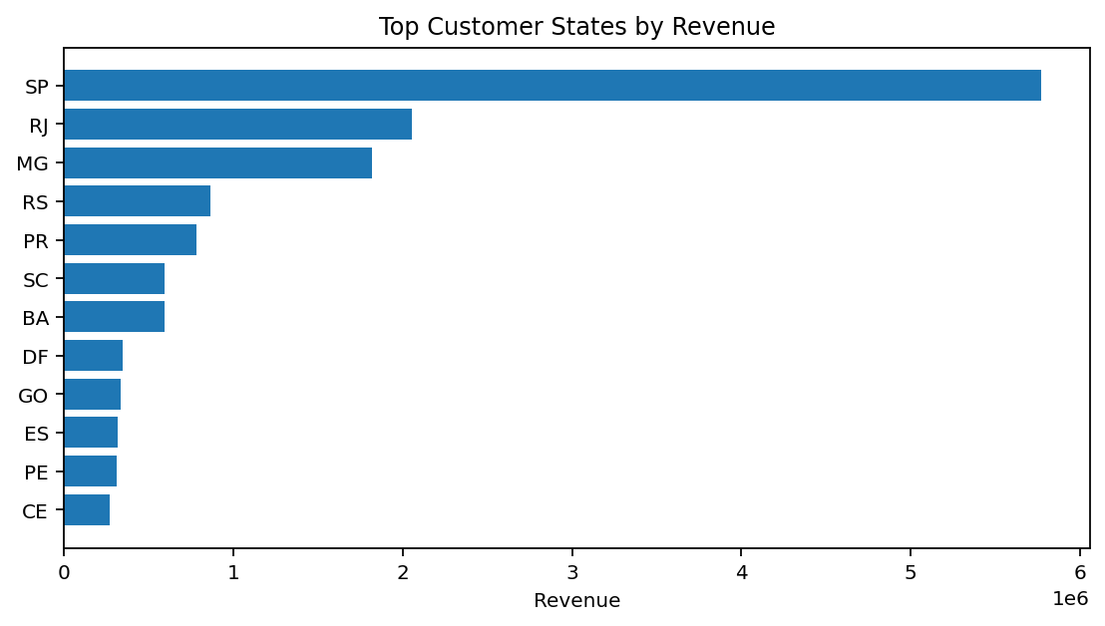
Table 7. Customer State Summary
Customer State | Customers | Orders | Revenue | Revenue Share Pct | Avg Order Value | Avg Review Score | Late Delivery Rate
SP | 39,156 | 40,501 | 5,770,409.65 | 37.4 | 142.48 | 4.25 | 0.06
RJ | 11,917 | 12,350 | 2,055,690.45 | 13.3 | 166.45 | 3.97 | 0.13
MG | 11,001 | 11,354 | 1,819,277.61 | 11.8 | 160.23 | 4.19 | 0.06
RS | 5,168 | 5,345 | 861,802.40 | 5.6 | 161.24 | 4.19 | 0.07
PR | 4,769 | 4,923 | 781,919.55 | 5.1 | 158.83 | 4.24 | 0.05
SC | 3,449 | 3,546 | 595,208.40 | 3.9 | 167.85 | 4.13 | 0.10
BA | 3,158 | 3,256 | 591,270.60 | 3.8 | 181.59 | 3.93 | 0.14
DF | 2,019 | 2,080 | 346,146.17 | 2.2 | 166.42 | 4.13 | 0.07
GO | 1,895 | 1,957 | 334,294.22 | 2.2 | 170.82 | 4.10 | 0.08
ES | 1,928 | 1,995 | 317,682.65 | 2.1 | 159.24 | 4.08 | 0.12
PE | 1,551 | 1,593 | 309,074.59 | 2.0 | 194.02 | 4.08 | 0.11
CE | 1,258 | 1,279 | 266,463.97 | 1.7 | 208.34 | 3.94 | 0.15

Table 8. Payment Method Summary
Payment Type | Transactions | Payment Value | Payment Share Pct
credit_card | 76,795 | 12,542,084.19 | 78.3
boleto | 19,784 | 2,869,361.27 | 17.9
voucher | 5,775 | 379,436.87 | 2.4
debit_card | 1,529 | 217,989.79 | 1.4
not_defined | 3 | 0.00 | 0.0

Table 9. Order Status Distribution
Order Status | Orders | Share Pct
delivered | 96,478 | 97.0
shipped | 1,107 | 1.1
canceled | 625 | 0.6
unavailable | 609 | 0.6
invoiced | 314 | 0.3
processing | 301 | 0.3
created | 5 | 0.0
approved | 2 | 0.0

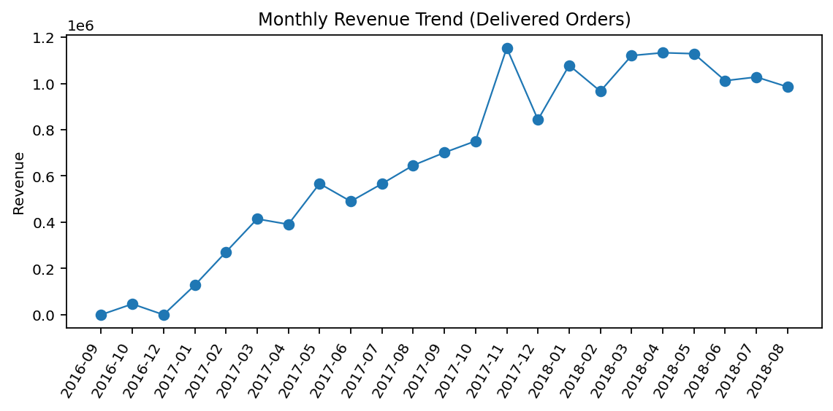

6. Business Recommendations
Table 10. Prioritized Recommendations
Area | Recommendation
Customer Retention | Create separate lifecycle campaigns for high-value multi-order customers, recent satisfied buyers, and dormant buyers. Avoid one generic campaign for all customers.
Service Recovery | Build a service-risk workflow for customers with low review scores and late delivery. Prioritize cases linked with high-value customers and high-revenue categories.
Merchandising | Protect stock depth for star revenue products and leading categories; use high-volume value products for acquisition and basket-building promotions.
Pricing and Freight | Monitor products with high freight-to-revenue ratios. These products may need shipping-fee optimization, regional seller matching, or bundle thresholds.
Catalog Governance | Improve missing product category/content/dimension completeness because these fields support search quality, recommendation performance, and logistics estimation.
Regional Growth | Use SP as the benchmark region, then identify underpenetrated high-population states with acceptable delivery performance for expansion campaigns.
Seller Management | For categories with low reviews or late deliveries, review seller-level SLA, product packaging, and carrier performance before scaling paid promotion.

7. Limitations and Next Steps
- The dataset ends in 2018, so findings are historical and should be used for internship/project analytics rather than current market decisions.
- Customer demographic attributes such as age, gender, income, and marketing campaign exposure are not available; clustering is therefore behavior-based, not demographic.
- Profit or margin data is not provided; revenue-driving products may not be the most profitable products.
- Geolocation was aggregated by zip-code-prefix, which is appropriate for regional analysis but not exact customer-location analysis.
- Future work can add CLTV modeling, churn prediction, cohort retention, market-basket analysis, and seller scorecards using this cleaned analytical base.

Appendix A. Analytical Data Dictionary
Output File | Description
customer_clustering_output.csv | One row per customer_unique_id with RFM, review, delivery, payment, freight and cluster label features.
customer_cluster_profile.csv | Segment-level summary table used for interpretation and recommendations.
product_analysis_output.csv | One row per product_id with sales, reviews, freight, logistics and product segment fields.
category_summary.csv | Category-level unit, order, seller, product, revenue and service metrics.
cleaned_orders_enriched.csv | Order-level enriched dataset joining customers, orders, items, payments, reviews and geolocation aggregates.
state_summary.csv | Customer-state level revenue, orders, customers and service metrics.
monthly_summary.csv | Monthly orders, revenue and customer counts for delivered orders.

