OOPS in Python (Object-Oriented Programming System)
OOP (Object-Oriented Programming) is a programming paradigm based on the concept of "objects". Objects can contain data (attributes/variables) and functions (methods) to operate on the data.

Class and Object Example in Python

What is a Class?
A class is a blueprint for creating objects.
It defines attributes (variables) and methods (functions).

What is an Object?
An object is an instance of a class.
Through the object, we can access the variables and methods of the class.
Constructor:
A constructor is a unique function that gets called automatically when an object is created of a class. (def __init__(self): constructor) create a instance of object automatically call (not mandatory to call).
The main purpose of a constructor is to initialize or assign values to the data members of that class.
Self:
Self(self) denotes current object (used)
Self-keyword used to object refers
The self-keyword is used to refer to the instance of the class, allowing access to its variables and methods.
The self-keyword refers to the object itself."

Class (Variables and Types):
Instance Variable
Class Variable
Instance Variable
Instance variables are unique to each instance of a class. They are defined within methods and are prefixed with the self-keyword. These variables store data that is specific to an instance, making them essential for object-oriented programming (OOP) principles like encapsulation.
Self is object instance.
Self used like, self.brand,self.price, self.ram this is called instance variable
Eg.
class phone():
def __init__(self,brand,price,ram):
self.brand=brand
self.price=price
self.ram=ram
def display(self):
print("Brand: ",self.brand)
print("Price: ",self.price)
print("RAM: ",self.ram)
oppo=phone("Oppo","15000","16gb")
oppo.display()

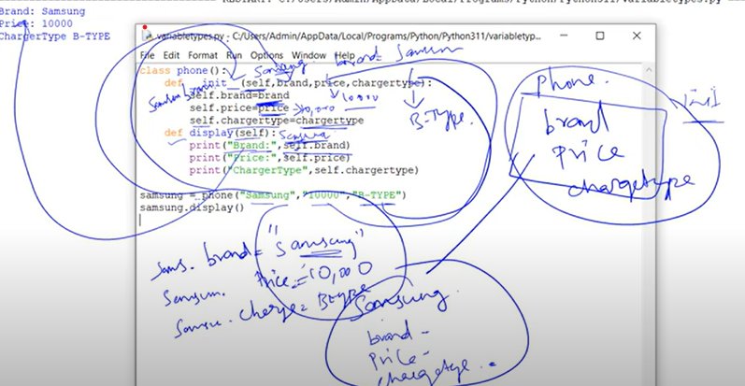

Class Variable
In contrast, class variables are shared among all instances of a class. Class variables store data that is common to all instances, making them a powerful tool for managing shared state and settings.
Eg.
class phone():
chargetype="C-TYPE"
def __init__(self,brand,price):
self.brand=brand
self.price=price
def display(self):
print("\nBrand: ",self.brand)
print("Price: ",self.price)
print("ChargeType: ",self.chargetype)
phone.chargetype="B-TYPE "
oppo=phone("Oppo","15000")
oppo.display()
redmi=phone("Redmi","10000")
redmi.display()
vivo=phone("vivo","5000")
vivo.display()

Types of Methods in Python Class
In Python, methods inside a class are mainly of three types:
Instance Method
Definition:
These methods work with a specific object (instance) of the class.
How:
- First parameter is always 'self' (refers to the object calling the method).
- Can access and change both object’s data and class data.
Use:
Used when you want to perform actions related to one particular object.
Example:
class Student:
def show(self):
print("This is an instance method")
Class Method
Definition:
These methods work with the class itself, not with objects.
How:
- First parameter is always 'cls' (refers to the class itself).
- Use '@classmethod' decorator.
- Can access and change class-level data, but not object data directly.
Use:
Used to create alternative constructors or modify class-level information.
Example:
class Student:
@classmethod
def info(cls):
print("This is a class method")
Static Method
Definition:
These are just like normal functions inside a class. They don't use class data or object data.
How:
- No 'self' or 'cls' needed.
- Use '@staticmethod' decorator.
Use:
Used for utility/helper functions that relate to the class but don’t need any class or object information.
Example:
class Student:
@staticmethod
def greet():
print("Welcome to Python!")
Inheritance in Python (Simple Definition)
Inheritance is a feature in Python where a child class can access the properties and methods of a parent class. It is mainly used for code reusability and helps in creating relationships between classes.

Types of Inheritance in Python (Short Definitions)

Single Inheritance:
A child class inherits from one parent class.

Multiple Inheritance:
A child class inherits from multiple parent classes.

Multilevel Inheritance:
Inheritance occurs through multiple levels (grandparent → parent → child).

Hierarchical Inheritance:
One parent class is inherited by multiple child classes.

Hybrid Inheritance:
A combination of two or more types of inheritance.

Inheritance
Inheritance allows us to define a class that inherits all the methods and properties from another class.
Parent class is the class being inherited from, also called base class.
Child class is the class that inherits from another class, also called derived class.
Single Inheritance:
Single inheritance enables a derived class to inherit properties from a single parent class, thus enabling code reusability and the addition of new features to existing code.

Diagram
+-------------+
| Parent |
|-------------|
| method1() |
+-------------+
↓
+-------------+
| Child |
|-------------|
| method2() |
+-------------+
Eg.
#Single Inheritance
#base class
class dad():
def phone(self):
print("Dad's phone")
#derived class
class son(dad):
def laptop(self):
print("Son's Laptop")
ram=son()
#ram.laptop()
ram.phone()

Multiple Inheritance:
When a class can be derived from more than one base class this type of inheritance is called multiple inheritances. In multiple inheritances, all the features of the base classes are inherited into the derived class.
Diagram
+-------------+ +-------------+
| Parent1 | | Parent2 |
|-------------| |-------------|
| method1() | | method2() |
+-------------+ +-------------+
\ /
\ /
\ /
+-----------------+
| Child |
|-----------------|
| method1(), method2() |
+-----------------+
Eg.
#Multiple Inheritance
#base class1
class dad():
def phone(self):
print("Dad's phone")
#base class2
class mom():
def sweet(self):
print("Mom's Sweet")
class son(dad,mom):
def laptop(self):
print("Son's Laptop")
ram=son()
#ram.laptop()
ram.phone()
ram.sweet()

Multilevel Inheritance:
In multilevel inheritance, features of the base class and the derived class are further inherited into the new derived class. This is similar to a relationship representing a child and a grandfather.

Diagram
Grandparent(home) (Base Class)
↓
Parent (car) (Derived from grandparent)
↓
Child (bike) (Derived from Parent)

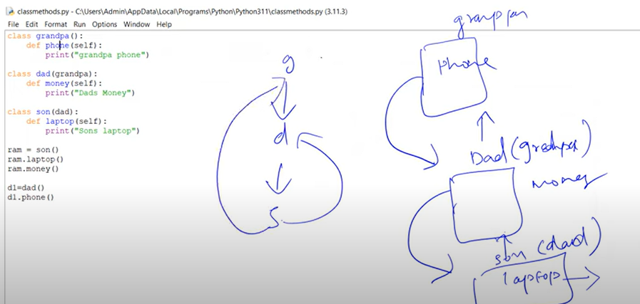
Hierarchical Inheritance
Hierarchical Inheritance is a type of inheritance in Python where multiple child classes inherit from the same single parent class.
Diagram
Parent
/ \ \
Child1 Child2 Child3

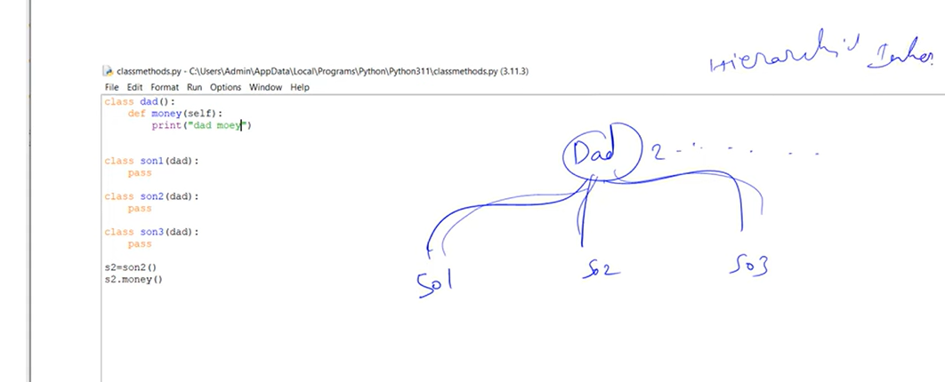

Hybrid Inheritance
Hybrid Inheritance is a combination of two or more types of inheritance (single, multiple, multilevel, hierarchical) in a single program.
It helps in building complex class relationships where a class might inherit features from multiple parent classes in different ways.
Diagram

Parent
/ \
Child1 Child2
\ /
Child3

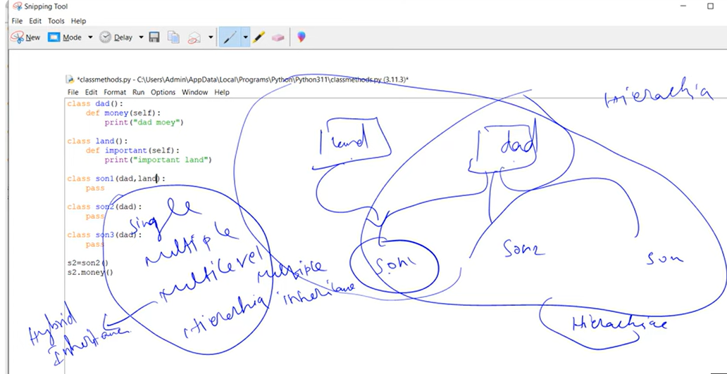

Super class:
The super keyword in Python is a powerful tool used in object-oriented programming to refer to the superclass or parent class of a derived or subclass.
It allows you to access and invoke methods and attributes defined in the superclass from within the subclass.
By using super, you can effectively override or extend methods inherited from the superclass while still retaining their original functionality.
It provides a way to maintain the existing behavior of the superclass while adding or modifying specific functionality in the subclass.
The syntax for using super is as follows: super().method_name(arguments). This invokes the method method_name from the superclass, allowing you to perform actions defined in the superclass before or after adding your own modifications in the subclass.
The super keyword is particularly useful in scenarios where you want to augment the behavior of a method rather than completely replace it.
It helps maintain code consistency and prevents duplication by leveraging the existing implementation in the superclass.
Additionally, super can be used to access superclass attributes or variables. This enables you to reuse and modify values defined in the superclass without having to redefine them in the subclass.
Overall, the super keyword in Python serves as a valuable mechanism for achieving method overriding, extending functionality, and maintaining code reuse and consistency in object-oriented programming.
super() Keyword in Python
Definition:
The super() keyword in Python is used to give access to methods and properties of a parent class. It is commonly used in inheritance to call a method from the parent class inside the child class.
Why Use super()?
- To reuse the parent class methods.
- To avoid directly referring to the parent class name, which makes the code more maintainable.
- Useful in multiple inheritance scenarios to ensure proper method resolution.

Syntax:
super().method_name(arguments)

Example 1: Calling Parent Class Method Using super()
class Parent:
def show(self):
print("This is the Parent class method.")

class Child(Parent):
def show(self):
super().show()
print("This is the Child class method.")
obj = Child()
obj.show()
Output:
This is the Parent class method.
This is the Child class method.

Example 2: Using super() with __init__ Constructor
class Person:
def __init__(self, name):
self.name = name
print(f"Person name is {self.name}")
class Student(Person):
def __init__(self, name, grade):
super().__init__(name) # Call parent class constructor
self.grade = grade
print(f"Grade is {self.grade}")
s1 = Student("Alice", "A")

Output:
Person name is Alice
Grade is A

Advantages of super()
Makes code shorter and cleaner.
Ensures proper method resolution order (MRO) in multiple inheritance.
Avoids hardcoding the parent class name.

When to Use:
- Inside constructors (__init__)
- Inside overridden methods
- When extending or enhancing parent class functionality
Polymorphism:
The word polymorphism means having many forms. In programming, polymorphism means the same function name (but different signatures) being used for different types. The key difference is the data types and number of arguments used in function.
Types of Polymorphism in Python:
Benefits of Polymorphism:
- Increases code flexibility
- Supports scalability
- Reduces coupling between classes
- Makes code more readable and maintainable
What is Polymorphism?
Polymorphism means "many forms".
In Python, it refers to the ability of different objects to respond to the same function or method name in different ways, depending on their class.

What is Duck Typing in Polymorphism (Python)?
Duck Typing is a concept in dynamic typing languages like Python. It is based on the saying:
"If it looks like a duck, swims like a duck, and quacks like a duck, then it must be a duck."
In polymorphism, Duck Typing means:
- We don't care about the type of an object.
- We only care whether the object behaves as expected (i.e., implements required methods or attributes).
Duck Typing in Polymorphism: Explained
Polymorphism allows objects of different classes to be treated as if they are of the same type if they implement the same behavior (methods).
With duck typing, Python lets us use any object in place of another as long as it supports the expected operations.
Example:
class Dog:
def speak(self):
return "Woof!"
class Cat:
def speak(self):
return "Meow!"
def animal_sound(animal):
print(animal.speak())
# Duck typing in action:
d = Dog()
c = Cat()
animal_sound(d) # Output: Woof!
animal_sound(c) # Output: Meow!
animal_sound() doesn't care whether it's a Dog or a Cat. It just expects the object to have a .speak() method.
Why Duck Typing Is Useful
- Flexible: No need for strict type hierarchies (like interfaces).
- Reduces boilerplate: No need to inherit from a base class.
- Powerful for polymorphism in dynamic typing languages.
💡 Summary
Concept | Meaning
Duck Typing | Type is determined by behavior (methods/attributes), not  inheritance
Inheritance Polymorphism | Objects of different classes can be used interchangeably if they implement the expected methods

2. Operator Overloading
Definition:
Operator overloading lets you define custom behavior for standard operators (+, -, *, etc.) based on the object type.
Explanation:
Python allows classes to override special methods like __add__, __sub__, etc., to change the behavior of operators when used on their objects.
Example:
class Point:
def __init__(self, x, y):
self.x = x
self.y = y
def __add__(self, other):
return Point(self.x + other.x, self.y + other.y)
def __str__(self):
return f"({self.x}, {self.y})"
p1 = Point(2, 3)
p2 = Point(4, 5)
result = p1 + p2 # Calls p1.__add__(p2)
print(result) # Output: (6, 8)

//p1 = Point(2, 3)
p2 = Point(4, 5)
result = p1 + p2 # This means: result = p1.__add__(p2)

# self = p1 (2, 3)
# other = p2 (4, 5)
# return Point(2+4, 3+5) => Point(6, 8)//

3. Method Overloading (Simulated in Python)
Definition:
Method Overloading is having multiple methods with the same name but different parameters.
Python does not support true method overloading like Java or C++. But it can be simulated using default arguments or *args.

Example:
class Greet:
def hello(self, name=None):
if name:
print(f"Hello, {name}")
else:
print("Hello")
g = Greet()
g.hello() # Output: Hello
g.hello("Alice") # Output: Hello, Alice

4. Method Overriding (Inheritance-Based)
Definition:
Method Overriding occurs when a child class provides its own implementation of a method that is already defined in its parent class.
Example:
class Animal:
def speak(self):
print("Animal speaks")
class Dog(Animal):
def speak(self): # Overriding the parent method
print("Dog barks")
a = Animal()
a.speak() # Output: Animal speaks
d = Dog()
d.speak() # Output: Dog barks
Type | Description | Python Support | Example Area
Duck Typing | Based on behaviour, not inheritance/type | ✅ Yes | Same method name across classes
Operator Overloading | Redefining operators for custom classes | ✅ Yes | __add__, __sub__, etc.
Method Overloading | Same method name with different arguments (simulated) | Partially | Default arguments / *args
Method Overriding | Child class redefines method of parent class | ✅ Yes | Inheritance

Exercises (Python OOP)
- Method Overriding (Inheritance-based Polymorphism)
Create a parent class Vehicle with a method describe().
Create two child classes Car and Bike, both overriding the describe() method.
- Write code to call describe() for each object.

- Duck Typing
Create two classes:
- Laptop with a method process()
- Human with a method process()
Write a function use_device(obj) that accepts any object and calls its process() method. Show how this function works with both Laptop and Human.

- Operator Overloading (Numbers)
Create a class Point to represent (x, y) coordinates.
- Overload the + operator to add two Point objects.
- Example:
p1 = Point(1, 2)
p2 = Point(3, 4)
p3 = p1 + p2 # Should give Point(4, 6)

- Operator Overloading (Strings Representation)
Create a class Book with attributes: title and pages.
- Overload the + operator to combine pages when two Book objects are added.
- Example: book1 + book2 should return total pages.

- Polymorphism through Functions
Write a function area(shape) which calls shape.area().
- Define two classes: Circle and Rectangle with an area() method.
- Show how the same function works with different objects.

  - Polymorphism via Abstract Base Class
Use abc module.
- Create an abstract class Animal with abstract method make_sound().
- Implement Dog and Cat classes with their versions of make_sound().

7. Method Overriding with Super()
Create a class Person with a method display().
Create a subclass Employee that overrides display() but also calls the parent display() using super().

8. Polymorphism with Built-in Functions
Explain with code how len() behaves differently for:
- a list
- a string
- a dictionary

9. Overloading Comparison Operators
Create a class Box with length attribute.
Overload > operator to compare two Box objects based on their length.

10. Polymorphism in Collections
Store different objects (Dog, Cat, Bird) in a list. Each object should have a method speak().
Iterate through the list and call speak() on each object.

Encapsulation
Encapsulation in Python is the process of hiding the internal details of a class and restricting direct access to its data.
It protects the data by allowing access only through methods (functions).
Access Specifiers:
Public, Private
Eg.
class Person:
def __init__(self, name, age):
self.name = name # Public
self.__age = age # Private (encapsulated)
def show(self):
print(f"Name: {self.name}, Age: {self.__age}")
p = Person("John", 25)
p.show()
# print(p.__age) # Cannot access directly (Encapsulated)

Simple Explanation
Encapsulation is one of the fundamental principles of Object-Oriented Programming (OOP). It refers to bundling the data (variables) and the methods (functions) that operate on the data into a single unit — a class. It also restricts direct access to some
components of an object, which is a way of protecting the internal state of the object.
Key Features of Encapsulation in Python:
Feature | Description
Data Hiding | Prevents direct access to variables from outside the class.
Access Modifiers | Uses _protected and __private naming conventions.
Getter and Setter Methods | Used to safely access and update private variables.
Why Use Encapsulation?
- To protect object data from unwanted external modification.
- To control access to variables and methods.
- To increase modularity and maintainability.

Example:
class Student:
def __init__(self):
self.__name = None # private variable

def set_name(self, name):
self.__name = name # setter method

def get_name(self):
return self.__name # getter method

# Object creation
s1 = Student()
s1.set_name("Vaishnavi")
print(s1.get_name()) # Output: Vaishnavi

# Trying to access private variable directly
print(s1.__name) # Error: AttributeError

Access Modifiers in Python:
Modifier | Syntax | Access Level
Public | Var | Accessible from anywhere
Protected | _var | Shouldn't be accessed directly (by convention)
Private | __var | Not accessible directly outside the class
Encapsulation with Protected and Private Attributes:
class BankAccount:
def __init__(self, balance):
self._balance = balance # protected
self.__pin = 1234 # private
def show_balance(self, pin):
if pin == self.__pin:
print("Balance:", self._balance)
else:
print("Incorrect PIN!")
account = BankAccount(5000)
account.show_balance(1234) # Correct PIN
account.show_balance(9999) # Incorrect PIN
# Direct access
print(account._balance) # Allowed but not recommended
print(account.__pin) # Error: AttributeError
Summary:
Term | Meaning
Encapsulation | Wrapping data and methods in one unit (class)
Private Members | Prevent outside access to sensitive data
Getter/Setter | Provide controlled access to private data

Getter and Setter in Python – Explained Simply
In Python, getter and setter methods are used to access and update the value of private (or protected) variables from outside a class while maintaining encapsulation and control over data.

Why Use Getters and Setters?
Reason | Explanation
Controlled access | Prevents direct access/modification of sensitive variables.
Validation logic | Add checks before changing or returning values.
Security and debugging | Keep class variables secure and easier to trace.
Private Variable Example Without Getter/Setter:
class Student:
def __init__(self):
self.__name = "Vaishnavi"
s = Student()
print(s.__name) # Error: AttributeError
Using Getter and Setter Methods:
class Student:
def __init__(self):
self.__name = None # private variable
# Setter method to update value
def set_name(self, name):
self.__name = name
# Getter method to access value
def get_name(self):
return self.__name
# Usage
s = Student()
s.set_name("Vaishnavi") # using setter
print(s.get_name()) # using getter → Output: Vaishnavi

How It Works:
Method Type | Purpose | Example Syntax
Setter | To set/update the value of a variable | def set_name(self, name):
Getter | To retrieve/read the value | def get_name(self):

Example with Validation:
class Employee:
def __init__(self):
self.__salary = 0
def set_salary(self, amount):
if amount > 0:
self.__salary = amount
else:
print("Invalid salary!")
def get_salary(self):
return self.__salary
e1 = Employee()
e1.set_salary(30000) # valid
print(e1.get_salary()) # Output: 30000
e1.set_salary(-5000) # invalid input

Getter/Setter vs Direct Access
Feature | Direct Access | Getter/Setter
Encapsulation | ❌ Broken | ✅ Maintained
Validation | ❌ Not possible | ✅ Easily added
Debugging/Logging support | ❌ Harder to trace | ✅ Easy to log/debug

Abstraction
Abstraction means hiding the complex details and showing only the essential features to the user.

Simple Example:
Think of a TV remote —
You press a button to change the channel, but you don’t know how the remote works internally.
That’s abstraction — you only see what you need to use.

The @abstractmethod is a built-in decorator in Python used to define abstract methods inside an abstract class.
It’s part of the abc (Abstract Base Class) module and is used in Object-Oriented Programming (OOP) to enforce that certain methods must be implemented in subclasses.
Key Points:
- An abstract method is a method without implementation.
- Any class containing abstract methods cannot be instantiated.
- All abstract methods must be implemented in child classes.

