Image Deconvolution by Learning Gradient Descent Optimization Techniques

Image Deconvolution, which aims to sharpen blurry images, can be approached by learning optimized gradient descent techniques. Instead of relying on manually designed image priors or noise level assumptions, we are employing deep learning methods to learn a universal gradient descent optimizer. This involves incorporating convolutional neural networks (CNNs) into a gradient descent scheme, allowing the network to learn an implicit image prior and a dynamic update rule.

In propose work introducing gradient based Convolution Neural Network algorithm called Gradient Descent Optimization Network (GDON) to de-blur images from blur or blind images. The propose GDON algorithm will compute gradient features and then optimize blur images to get de-blur images. A hyper-parameter-free update unit shared across steps is used to generate updates from the current estimates, based on a convolutional neural network. By training on diverse examples, the GDON learns an implicit image prior and a universal update rule through recursive supervision. The learned optimizer can be repeatedly used to improve the quality of diverse degenerated observations. The proposed method possesses strong interpretability and high generalization. Extensive experiments on synthetic benchmarks and challenging real-world images demonstrate that the proposed deep optimization method is effective and robust to produce favourable results as well as practical for real-world image deblurring applications.

GDON is based on DNN architecture derived from gradient descent optimization methods. The GDON iteratively updates the unknown variable x using a universal image updating unit, which mimics the gradient descent optimization process. To achieve this, added parameterize which learn a universal gradient descent optimizer, which can be repeatedly used to update x based on its previous updates.

To de-blur blur images we have used PASCAL-VOC dataset which contains blur and de-blur images and then GDON algorithm get trained on this dataset and then this model can be applied on any blur images to get de-blur image.

To implement this project we have designed following modules

1. Upload Blur-Deblur Dataset: using this module we will upload dataset to application
2. Generate & Load Image Deconvolution Model: this module will read dataset of blur and de-blur images and then build CNN model by optimizing features from de-blur to blur images by computing gradient descendent values. Gradient descent computation refers to improve the quality of any object and here it will improve image quality by analysing features from blur and de-blur dataset and in simple terms it will replace weak intensity pixel of images with high intensity pixels. Loaded model will be applied on test original image and predicted Deblur image to compute PSNR and SSIM between original image and de-blur generated image
3. Upload Blur Image & Get Deblur Output: using this module we will input blur image and then apply GDON model to get de-blur image.

In below screen we are showing code to compute gradient descent using GDON model

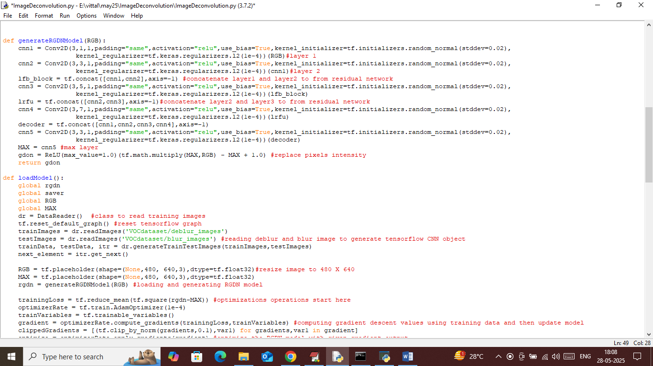

In above screen read red colour comments to know about gradient descent based optimization implementation

SCREE SHOTS

To run project double click on ‘run.bat’ file to get below screen

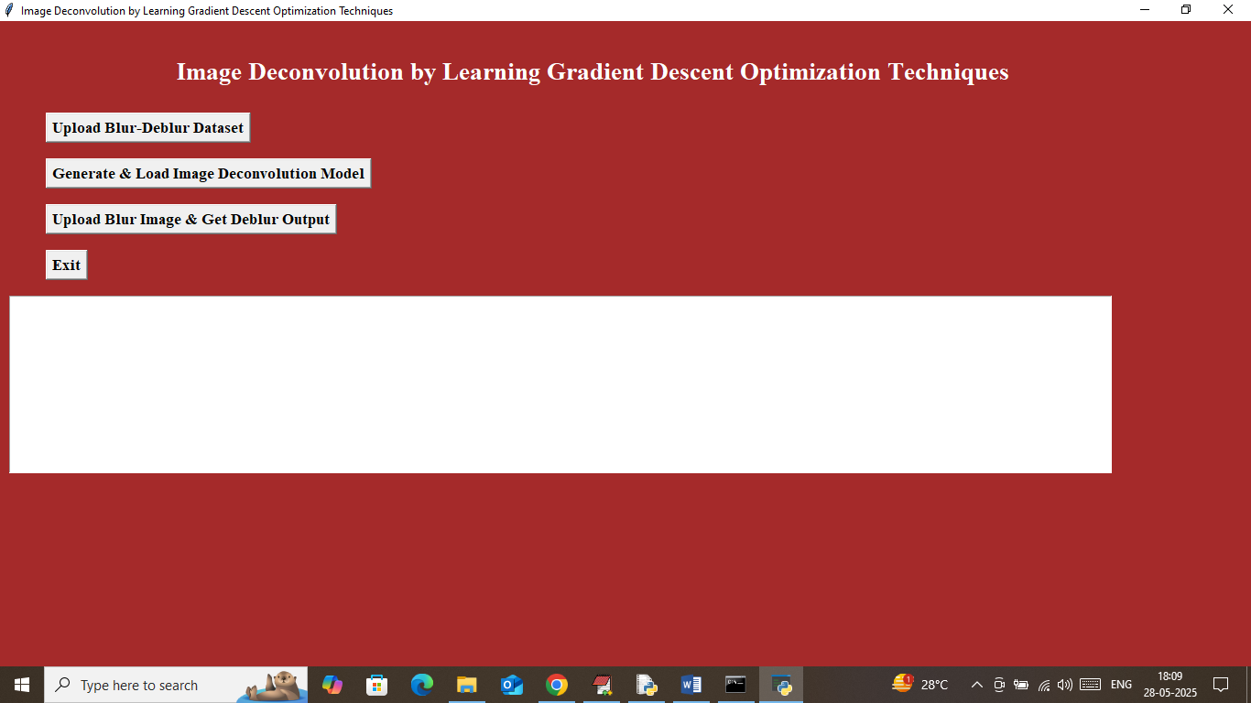

In above screen click on ‘Upload Blur-Deblur Dataset’ button to upload dataset and get below output

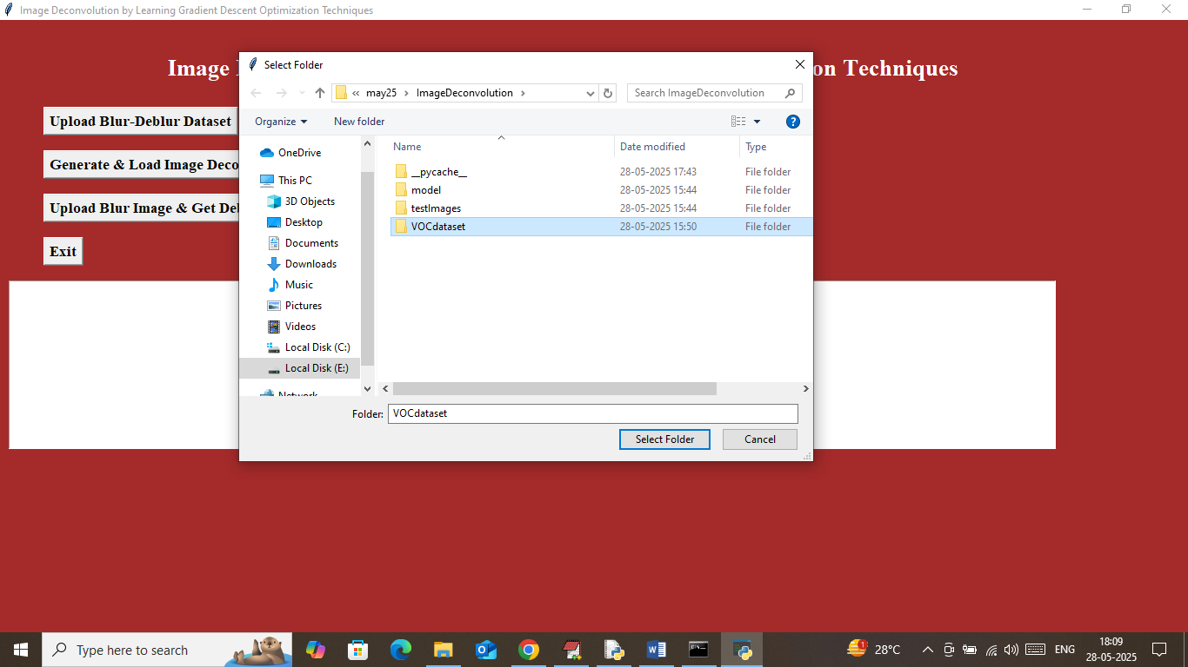

In above screen selecting and uploading ‘Pascal VOC’ dataset and then click on ‘Select Folder’ button to get below output

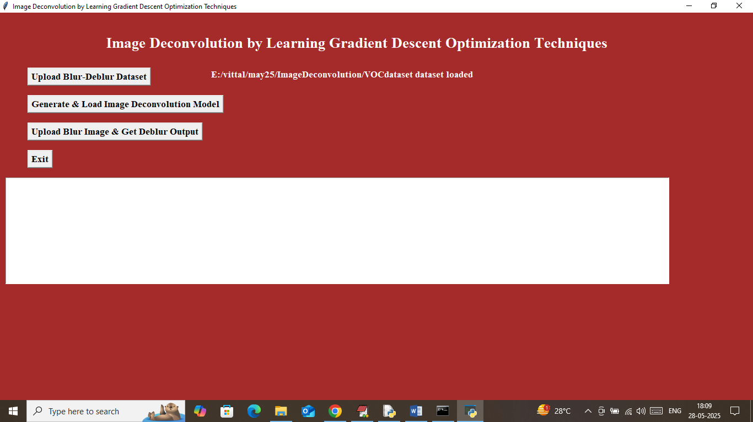

In above screen in white colour text we can see dataset loaded and now click on ‘Generate & Load Image Deconvolution Model’ button to generate and load GDON model and get below output

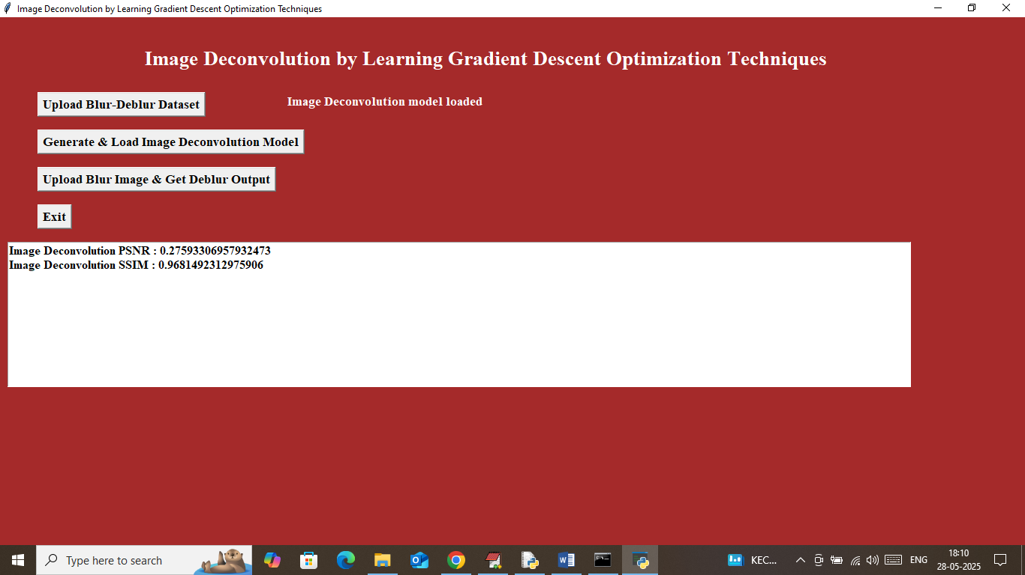

In above screen in white colour text we can see model is loaded and in text area can see Propose model can Deblur image with PSNR (signal noise ratio) as 0.27% and Generated image having SSIM (structural similarity image) as 96%. Now click on ‘Upload Blur Image & Get Deblur Output’ button to upload blur image and get below output

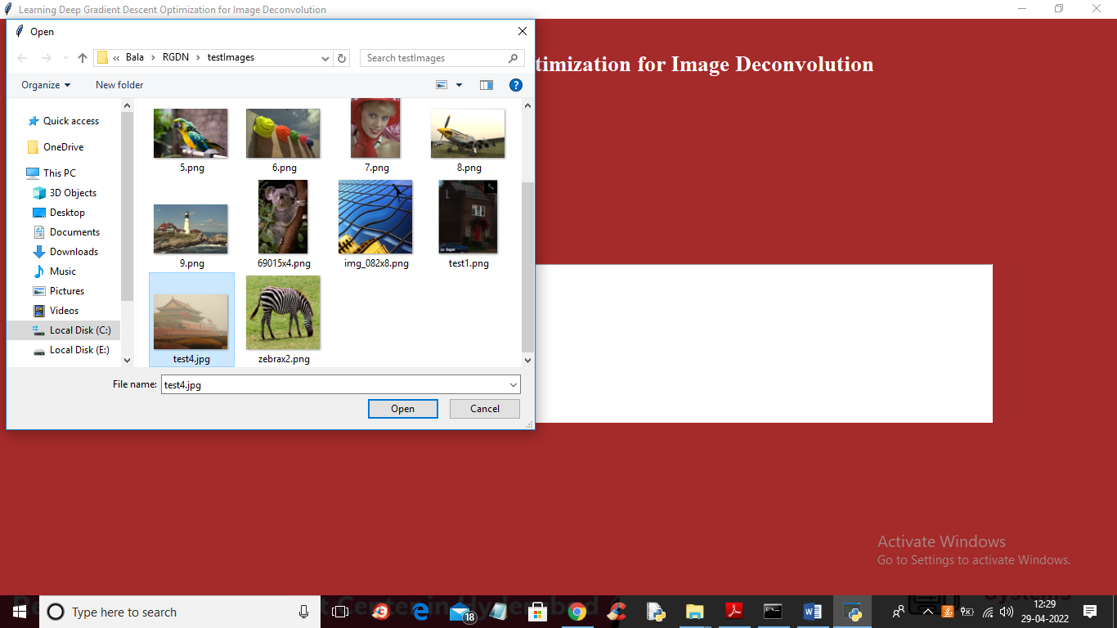

In above screen selecting and uploading ‘2.jpg’ file which contains blur and after applying GDON model will get below output

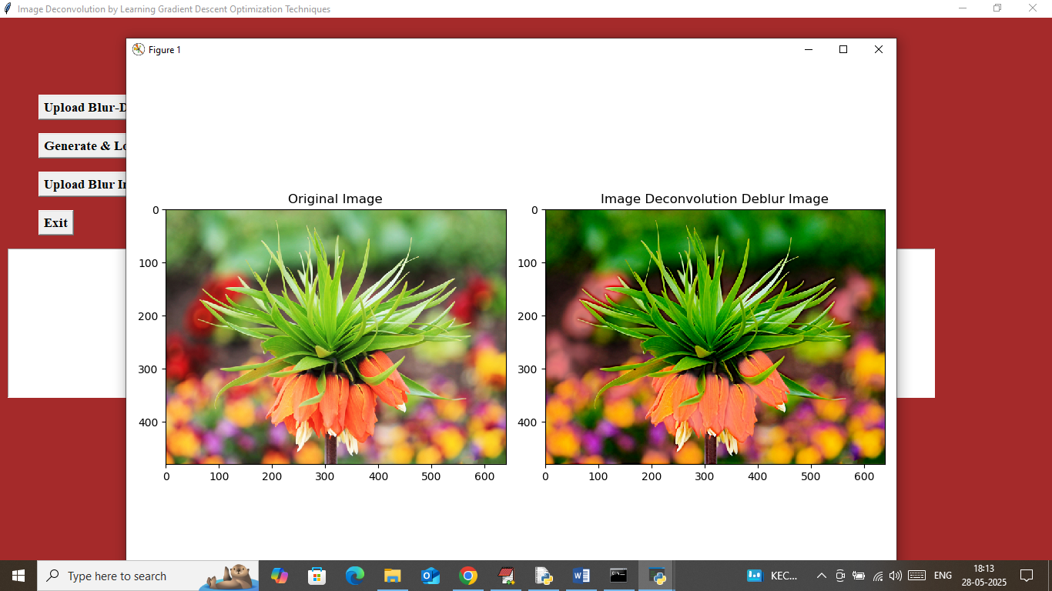

In above screen first image is the original image and second image is de-blur image obtained from GDON model and can see Deblur image from propose algorithm contains clear image compare to original image. Similarly you can upload and test any other images. Now in below screen showing some other test images

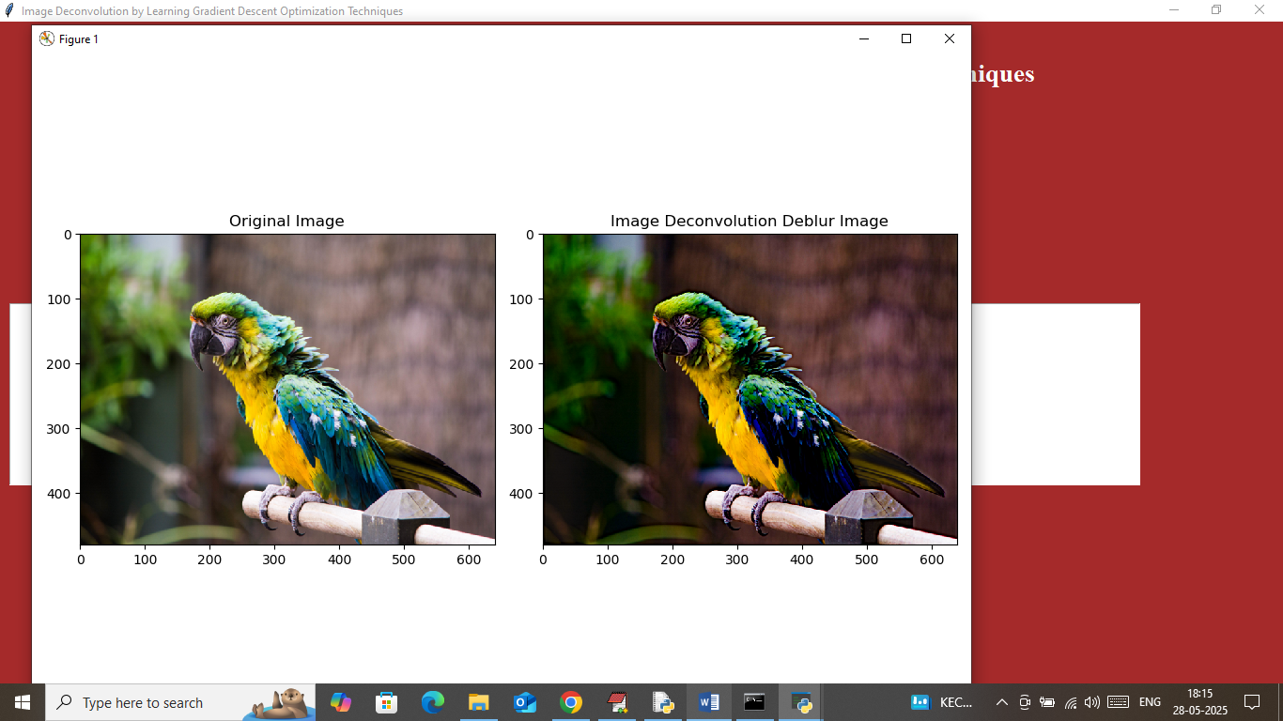

Above can see original and GDON Deblur image output in second image

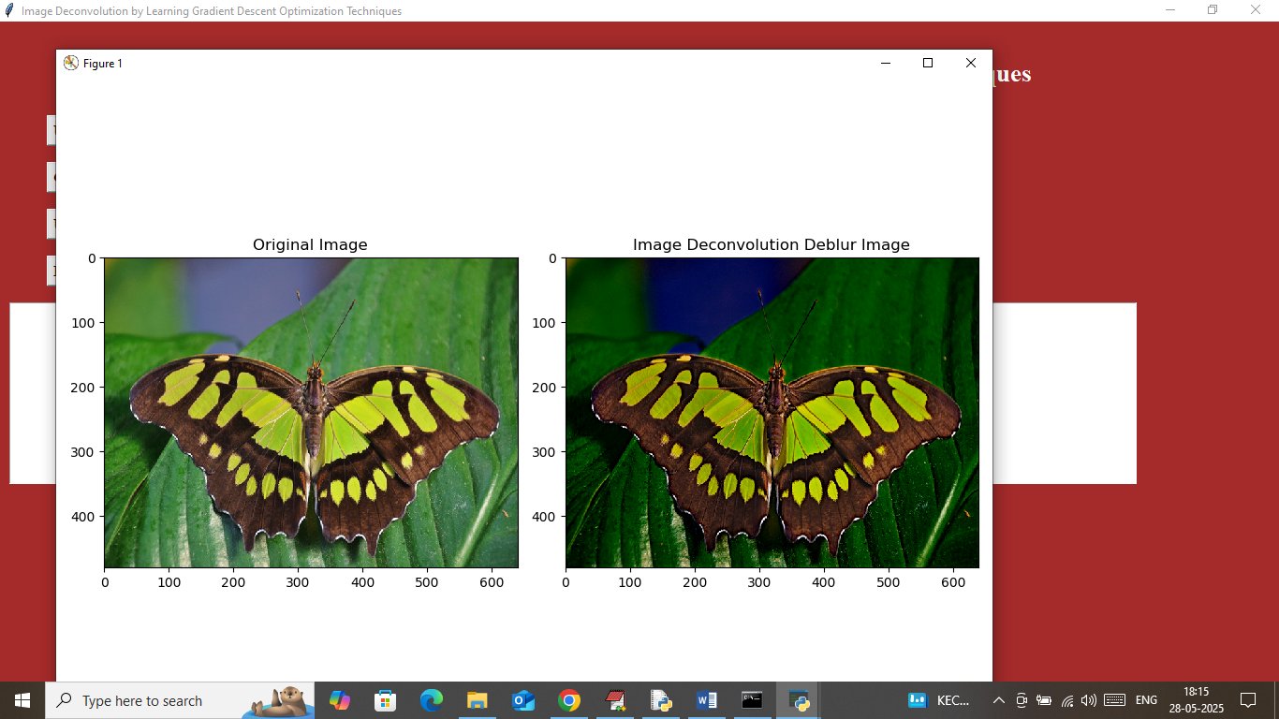

Above is another test output

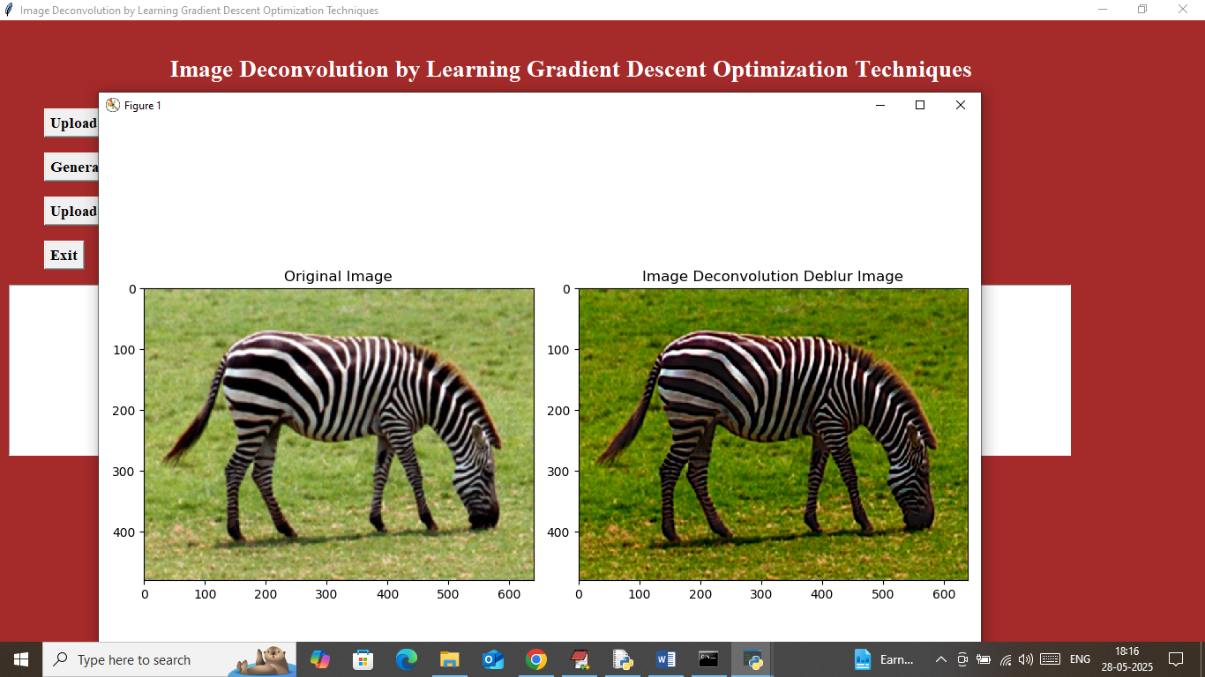

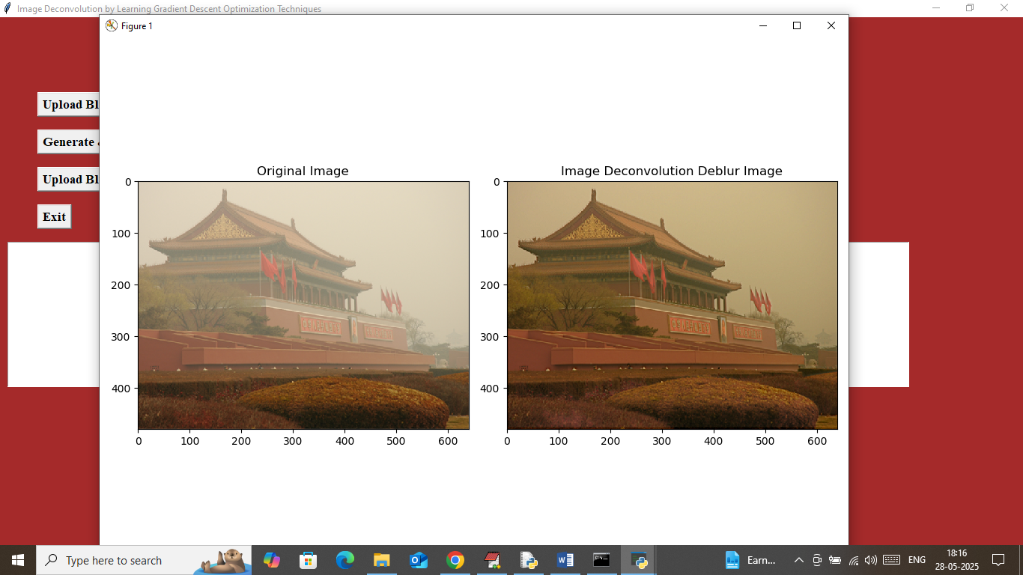

Above is another test output