The Four Vs of Big Data and Real-World Use Cases
Exploring Volume, Velocity, Variety, and Veracity

Introduction

Big Data refers to extremely large datasets that cannot be easily managed or processed using traditional tools. To understand Big Data, experts often refer to the Four Vs: Volume, Velocity, Variety, and Veracity. These dimensions describe the scale, speed, diversity, and reliability of data. In this document, we explore each V with real-world examples and use cases.
Reference Infographic:

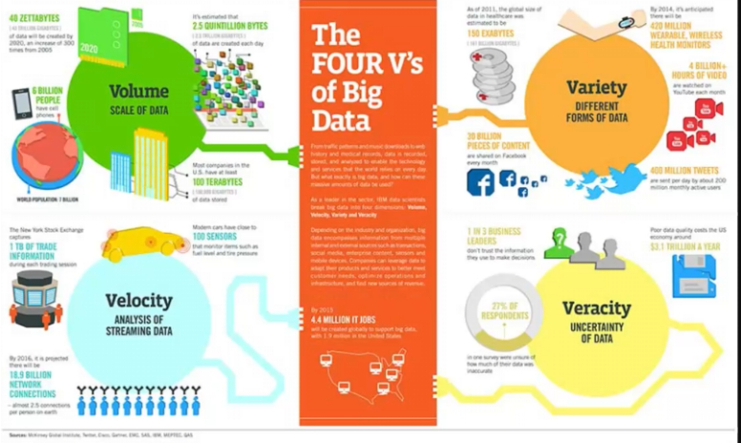

Volume: Scale of Data

Volume refers to the sheer amount of data generated every second. Organizations deal with terabytes to petabytes of data from various sources. Examples include social media platforms generating billions of posts, IoT sensors streaming data, and financial institutions processing millions of transactions daily.
Use Cases:
• Healthcare: Patient records and medical imaging data for predictive analytics.
• Retail: Customer purchase history for personalized recommendations.
• Finance: Transaction logs for fraud detection and compliance.

Velocity: Speed of Data Processing

Velocity refers to the speed at which data is generated and processed. Real-time data streams require immediate analysis for timely decisions. Examples include stock market feeds, live video streaming, and sensor data from autonomous vehicles.
Use Cases:
• Banking: Real-time fraud detection during transactions.
• Transportation: Autonomous vehicles processing sensor data instantly.
• Media: Streaming platforms analyzing viewer behavior in real time.

Variety: Different Forms of Data

Variety refers to the diversity of data types—structured, semi-structured, and unstructured. Sources include text, images, audio, video, and sensor readings. Managing and integrating these formats is a major challenge for organizations.
Use Cases:
• Social Media: Text posts, images, and videos for sentiment analysis.
• Healthcare: Combining structured patient data with unstructured doctor notes.
• E-commerce: Product images, customer reviews, and transaction data.

Veracity: Uncertainty of Data

Veracity refers to the trustworthiness and quality of data. Inaccurate or incomplete data can lead to poor decisions. Organizations must implement data validation and cleansing processes to ensure reliability.
Use Cases:
• Banking: Ensuring accurate credit scores for loan approvals.
• Healthcare: Validating patient data for correct diagnosis.
• Government: Maintaining integrity in census and demographic data.

