BANK CUSTOMER CHURN PREDICTION
& RETENTION ANALYTICS
Data Analytics with AI | Internship Project Report
Prepared by Vaishnavi Metkar
October 2026

Abstract
This project investigates bank customer attrition using 10,000 customer records. It includes data quality checks, exploratory data analysis (EDA), five classification model families, and a validation-selected decision threshold for a Gradient Boosting model. On 2,000 held-out test customers, lowering the threshold from 0.50 to 0.325 increased recall from 48.16% to 58.72% while reducing accuracy from 85.80% to 83.85%. The result demonstrates a transparent trade-off between identifying more churners and generating more false-positive retention alerts.

1. Problem Statement and Objectives
Customer churn represents customers leaving the bank. Retention teams may benefit from a model that prioritizes customers for further review, but false positives consume outreach resources. The project therefore considers recall, precision and F1-score in addition to accuracy.
- Understand the structure, quality and class balance of the dataset.
- Explore observed churn rates by customer segments.
- Compare five classification model families with leakage-safe preprocessing.
- Select a retention-focused probability cutoff using validation data, not the test set.
- Translate predictive results into appropriately qualified business recommendations.

2. Dataset and Data Quality
The supplied Churn_Modelling.csv contains 10,000 rows and 14 columns. The target is Exited, where 1 indicates churn. There are 2,037 churned customers (20.37%) and 7,963 retained customers (79.63%). The executed notebook found zero missing values and zero exact duplicate rows. The original public source URL was not recorded in the notebook and must be confirmed before final submission.
Category | Columns / purpose
Identifiers (excluded) | RowNumber, CustomerId, Surname
Demographics | Geography, Gender, Age
Banking characteristics | Tenure, Balance, NumOfProducts, HasCrCard, IsActiveMember
Other predictors | CreditScore, EstimatedSalary
Target | Exited (1 = churn, 0 = retained)

3. Exploratory Data Analysis
The notebook examines the churn distribution, geography, gender, active membership, number of products and age. Observed churn rates are 26.85% among inactive customers and 14.27% among active customers. Geography-level churn rates are 16.15% in France, 32.44% in Germany and 16.67% in Spain. Female customers have 25.07% observed churn versus 16.46% for male customers. These are descriptive associations and cannot establish causality.

4. Data Preparation and Splitting
A stratified split produces 6,000 training rows, 2,000 validation rows and 2,000 held-out test rows (random_state=42). The target and three identifier columns are excluded from features. Numeric fields are median-imputed and standardized; categorical fields are most-frequent-imputed and one-hot encoded. These transformations are fitted within scikit-learn pipelines using training data only, reducing preprocessing leakage. No fictitious withdrawal or transaction-frequency features are engineered from unrelated customer rows.

5. Classification Models
The notebook compares Logistic Regression, Decision Tree, Random Forest, Histogram-based Gradient Boosting and scikit-learn MLP. All five are compared on the validation set at a probability cutoff of 0.50. The MLP is a scikit-learn neural network; the Gradient Boosting model uses HistGradientBoostingClassifier.
Validation model | Accuracy | Recall | F1 | ROC-AUC
Gradient Boosting | 86.15% | 46.68% | 57.84% | 0.8589
Random Forest | 85.95% | 43.00% | 55.47% | 0.8543
Neural Network (MLP) | 85.30% | 43.73% | 54.77% | 0.8475
Decision Tree | 84.50% | 34.15% | 47.28% | 0.8335
Logistic Regression | 80.90% | 21.38% | 31.30% | 0.7566

6. Validation-Based Threshold Tuning
Gradient Boosting is the retention-focused candidate. The notebook evaluates validation thresholds from 0.150 to 0.650 in steps of 0.025. Among thresholds meeting illustrative minimum validation recall of 0.55 and accuracy of 0.82, it chooses the maximum validation F1-score; if none qualify, it falls back to maximum validation F1. The selected threshold is 0.325. At that threshold, validation accuracy is 85.10%, recall 64.13%, precision 63.20% and F1-score 63.66%. No test-set metric is used to choose the threshold.

7. Final Held-Out Test Results
Metric | Threshold 0.50 | Threshold 0.325
Accuracy | 85.80% | 83.85%
Precision | 72.86% | 60.66%
Recall | 48.16% | 58.72%
F1-score | 57.99% | 59.68%
ROC-AUC | 0.8533 | 0.8533
True negatives | 1,520 | 1,438
False positives | 73 | 155
False negatives | 211 | 168
True positives | 196 | 239

On the 2,000-row test set (407 churned customers), the tuned threshold detects 43 additional actual churners, reduces missed churners by 43, and produces 82 additional false-positive alerts. Recall improves by 10.57 percentage points (rounded), while accuracy falls by 1.95 percentage points. The preferred operating threshold depends on the relative costs of outreach and missed churn.
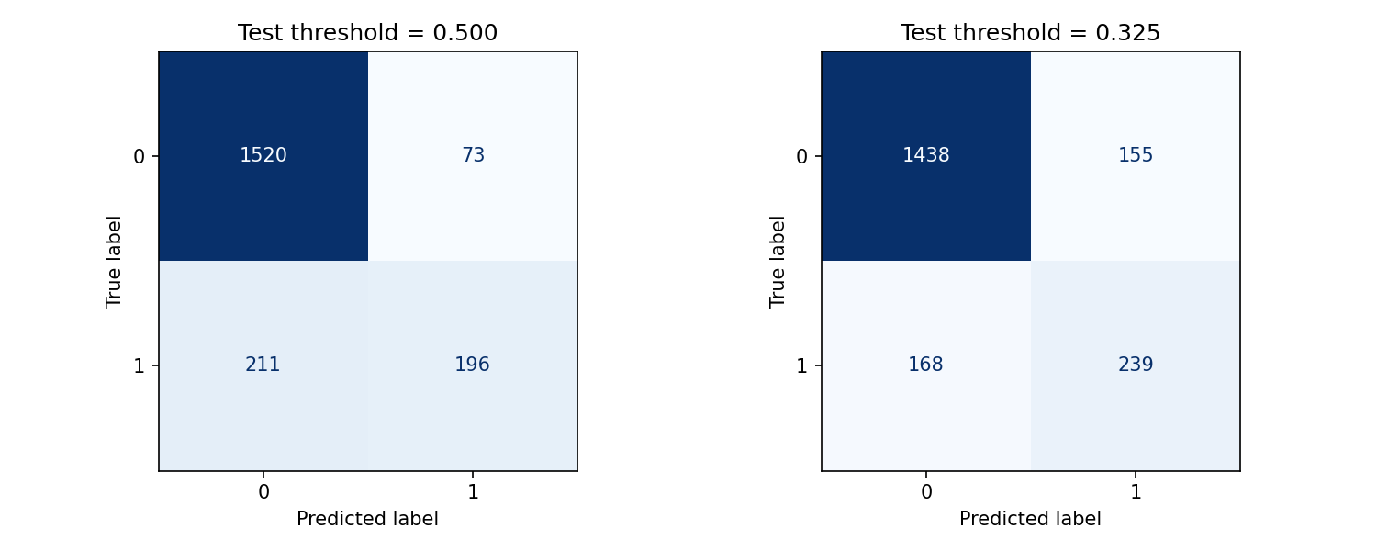
Figure 1. Held-out test confusion matrices at default and validation-selected thresholds.

8. Business Recommendations
- Prioritize higher-risk customers for human review rather than treating model labels as certainties.
- Evaluate outreach costs against the value of detecting additional churners.
- Investigate inactivity and geography patterns using further evidence before intervening.
- Pilot retention actions in controlled experiments and measure outcomes, not just predicted risk.
- Check probability calibration, subgroup fairness and data drift before any deployment.

9. Limitations and Future Work
- No transaction-level history, retention campaign data, intervention outcomes or ROI measurements are available.
- Observed segment-level differences are associations rather than proven causes.
- Threshold constraints are illustrative and do not represent a bank-approved cost policy.
- A separate temporal or external dataset would be useful for further validation.
- Dataset source (Kaggle): https://www.kaggle.com/datasets/louishgy/churn-modelling. The project author supplied this dataset page as the source for Churn_Modelling.csv.

10. Conclusion
The project demonstrates an end-to-end, reproducible analytics workflow and explains why a single accuracy figure is insufficient for an imbalanced churn problem. Validation-based threshold tuning increased held-out recall while clearly documenting additional false positives and lower precision. The model should be treated as a learning and decision-support prototype, not a production banking decision system.

11. Deliverables and References
Code: Vaishnavi_BankCustomerChurn.ipynb. Dataset: Churn_Modelling.csv. Dependencies: requirements.txt. Repository instructions: README.md. Output files: validation model comparison, threshold results, final test comparison, confusion matrices and fitted model.
References: scikit-learn documentation (https://scikit-learn.org/stable/); Pandas documentation (https://pandas.pydata.org/docs/); Matplotlib documentation (https://matplotlib.org/stable/). Dataset source: https://www.kaggle.com/datasets/louishgy/churn-modelling.

