|  |  |
| --- | --- |
| **VISVESVARAYA TECHNOLOGICAL UNIVERSITY**    **BELAGAVI – 590018, Karnataka**  **INTERNSHIP REPORT**  **ON**  **“Chatbot For Healthcare System Using AI”**  ***Submitted in partial fulfilment for the award of degree(21CSI85)***    **BACHELOR OF ENGINEERING IN**  **Computer Science & Engineering**  ***Submitted by:***  **SUSHMA S**  **1AK21CS096**    Conducted at  **Compsoft Technologies**        **AKSHAYA INSTITUTE OF TECHNOLOGY**  **Department of Computer Science**  **Approved by AICTE, New Delhi, Affiliated to VTU, Belgaum,**  **Recognized by Govt. of Karnataka. Obalapura Post, Lingapura, Koratagere Road, Tumakuru - 572 106,** | 1 |

**AKSHAYA INSTITUTE OF TECHNOLOGY**

**Department of Computer Science**

**Approved by AICTE, New Delhi, Affiliated to VTU, Belgaum,**

**Recognized by Govt. of Karnataka**

# Obalapura Post, Lingapura, Koratagere Road, Tumakuru - 572 106



# CERTIFICATE

This is to certify that the Internship titled **“Chatbot For Healthcare System Using AI”** carried out by **SUSHMA S** a bonafide student of Akshaya Institute of Technology, in partial fulfilment for the award of **Bachelor of Engineering**, in **BRANCH** under

Visvesvaraya Technological University, Belagavi, during the year 2023-2024. It is certified that all corrections/suggestions indicated have been incorporated in the report.

The project report has been approved as it satisfies the academic requirements in respect of Internship prescribed for the course Internship / Professional Practice (21****)

|  |  |  |  |  |
| --- | --- | --- | --- | --- |
| **Signature of Guide** |  |  | **Signature of**  **HOD External Viva:** | **Signature**  **of Principal** |
| Name of the Examiner |  |  |  | Signature with Date |

1)

2) ___________________

**D E C L A R A T I O N**

I**, SUSHMA S,** first/final year student of Branch, College Name - 560 082, declare that the Internship has been successfully completed, in **Compsoft Technologies Pvt Ltd**. This report is submitted in partial fulfillment of the requirements for award of Bachelor Degree in Branch name, during the academic year 2022-2023.

Date :06/12/2023 :

Place : Tumkur

USN : 1AK21CS096

NAME :SUSHMA S

## OFFER LETTER PROVIDED BY THE COMPANY

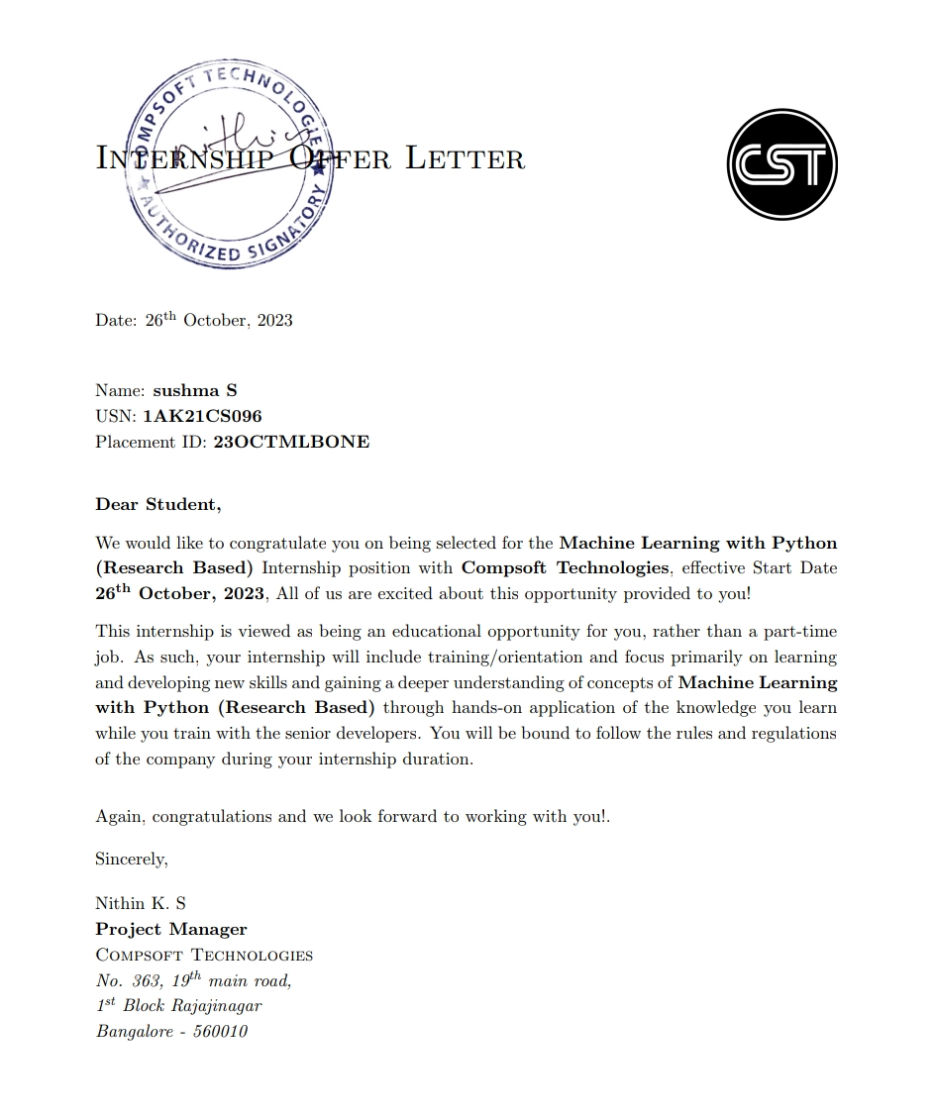

# A C K N O W L E D G E M E N T

This Internship is a result of accumulated guidance, direction and support of several important persons. We take this opportunity to express our gratitude to all who have helped us to complete the Internship.

We express our sincere thanks to our Principal, for providing us adequate facilities to undertake this Internship.

We would like to thank our Head of Dept – branch code, for providing us an opportunity to carry out Internship and for his valuable guidance and support.

would like to thank our (Lab assistant name) Software Services for guiding us during the period of internship.

We express our deep and profound gratitude to our guide, Guide name, Assistant/Associate Prof, for her keen interest and encouragement at every step in completing the Internship.

We would like to thank all the faculty members of our department for the support extended during the course of Internship.

We would like to thank the non-teaching members of our dept, for helping us during the Internship.

Last but not the least, we would like to thank our parents and friends without whose constant help, the completion of Internship would have not been possible.

**NAME:SUSHMA S**

**USN:1AK21CS096**

## ABSTRACT

Complex, unreliable, and unsustainable is the new healthcare delivery system. The use of machine learning (ML) to improve system performance has revolutionised the way businesses and individuals collect and analyse data. It is possible to use machine learning algorithms for the analysis of structured, unstructured and semi-structured data. A virtual assistant can communicate with patients in their native language to understand their symptoms, provide physician advice, and monitor health indicators. To further analyse customer reviews, natural language processing algorithms and deep learning analytics are employed. Deep bilinear similarity models are proposed in the architecture to enhance SQL queries used in algorithms and predictions. BERT and SQLOVA models are used to train the system's data collection algorithm.

**Learning Objectives/Internship Objectives**

* Internships are generally thought of to be reserved for college students looking to gain experience in a particular field. However, a wide array of people can benefit from Training Internships in order to receive real world experience and develop their skills.

* An objective for this position should emphasize the skills you already possess in the area and your interest in learning more

* Internships are utilized in a number of different career fields, including architecture, engineering, healthcare, economics, advertising and many more.

* Some internship is used to allow individuals to perform scientific research while others are specifically designed to allow people to gain first-hand experience working.

* Utilizing internships is a great way to build your resume and develop skills that can be emphasized in your resume for future jobs. When you are applying for a Training Internship, make sure to highlight any special skills or talents that can make you stand apart from the rest of the applicants so that you have an improved chance of landing the position.

#### 

#### **COMPANY PROFILE**

*A Brief History of Compsoft Technologies*

Compsoft Technologies, was incorporated with a goal ”To provide high quality and optimal

Technological Solutions to business requirements of our clients”. Every business is a different and has a unique business model and so are the technological requirements. They understand this and hence the solutions provided to these requirements are different as well. They focus on clients requirements and provide them with tailor made technological solutions. They also understand that Reach of their Product to its targeted market or the automation of the existing process into e-client and simple process are the key features that our clients desire from Technological Solution they are looking for and these are the features that we focus on while designing the solutions for their clients.

Sarvamoola Software Services. is a Technology Organization providing solutions for all web design adevelopment, MYSQL, PYTHON Programming, HTML, CSS, ASP.NET andLINQ. Meeting the ever increasing automation requirements, Sarvamoola Software Services. specialize in ERP, Connectivity, SEO Services, Conference Management, effective web promotion and tailor-made software products, designing solutions best suiting clients requirements

Compsoft Technologies, strive to be the front runner in creativity and innovation in software development through their well-researched expertise and establish it as an out of the box software development company in Bangalore, India. As a software development company, they translate this software development expertise into value for their customers through their professional solutions.

They understand that the best desired output can be achieved only by understanding the clients demand better. Compsoft Technologies work with their clients and help them to defiine their exact solution requirement. Sometimes even they wonder that they have completely redefined their solution or new application requirement during the brainstorming session, and here they position themselves as an IT solutions consulting group comprising of high caliber consultants.

##### **ABOUT THE COMPANY**



Compsoft Technologies is a Technology Organization providing solutions for all web design and development, MYSQL, PYTHON Programming, HTML, CSS, ASP.NET and LINQ. Meeting the ever increasing automation requirements, Compsoft Technologies specialize in ERP, Connectivity, SEO Services, Conference Management, effective web promotion and tailormade software products, designing solutions best suiting clients requirements. The organization where they have a right mix of professionals as a stakeholders to help us serve our clients with best of our capability and with at par industry standards. They have young, enthusiastic, passionate and creative Professionals to develop technological innovations in the field of Mobile technologies, Web applications as well as Business and Enterprise solution.

Motto of our organization is to “Collaborate with our clients to provide them with best bring a cascading a positive effect in their business shape as well”. Providing a Complete suite of technical solutions is not just our tag line, it is Our Vision for Our Clients and for Us, We strive hard to achieve it

*Products of CompSoft Technologies.*

Android Apps

It is the process by which new applications are created for devices running the Android operating system. Applications are usually developed in Java (and/or Kotlin; or other such option) programming language using the Android software development kit (SDK), but other development environments are also available, some such as Kotlin support the exact same Android APIs (and bytecode), while others such as Go have restricted API access.

The Android software development kit includes a comprehensive set of development tools. These include a debugger, libraries, a handset emulator based on QEMU, documentation, sample code, and zutorials. Currently supported development platforms include computers running Linux (any modern desktop Linux distribution), Mac OS X 10.5.8 or later, and Windows 7 or later. As of March 2015, the SDK is not available on Android itself, but softwaredevelopment is possible by using specialized Android applications.

Web Application

It is a client–server computer program in which the client (including the user interface and client- side logic) runs in a web browser. Common web applications include web mail, online

retail sales, online auctions, wikis, instant messaging services and many other functions. web applications use web documents written in a standard format such as HTML and JavaScript,which are supported by a variety of web browsers. Web applications can be considered as a specifific variant of client–server software where the client software is downloaded to the client machine when visiting the relevant web page, using standard procedures such as HTTP. The Client web software updates may happen each time the web page is visited. During the session, the web browser interprets and displays the pages, and acts as the universal client for any web application. The use of web application frameworks can often reduce the number of errors in a program, both by making the code simpler, and by allowing one team to concentrate on the framework while another focuses on a specifified use case. In applications which are exposed to constant hacking attempts on the Internet, security- related problems can be caused by errors in the program.

Frameworks can also promote the use of best practices such as GET after POST. There are some who view a web application as a two-tier architecture. This can be a “smart” client that performs all the work and queries a “dumb” server, or a “dumb” client that relies on a “smart” server. The client would handle the presentation tier, the server would have the database

*Services provided by Compsoft Technologies.*

* Core Java and Advanced Java
* Web services and development
* .Dot Net Framework
* Event Management Service
* On The Job Training
* Selenium Testing
* Dot Net Framework
* Python
* Academic Project Guidance
* Software Training

**INTRODUCTION**

Through chatbots one can communicate with text or voice interface and get reply through artificial intelligence. Typically, a chat bot will communicate with a real person. Chat bots are used in applications such as ecommerce customer service, call centres and Internet gaming. Chatbots are programs built to automatically engage with received messages. Chatbots can be programmed to respond the same way each time, to respond differently to messages containing certain keywords and even to use machine learning to adapt their responses to fit the situation. A developing number of hospitals, nursing homes, and even private centres, presently utilize online Chatbots for human services on their sites. These bots connect with potential patients visiting the site, helping them discover specialists, booking their appointments, and getting them access to the correct treatment. In any case, the utilization of artificial intelligence in an industry where individuals’ lives could be in question, still starts misgivings in individuals. It brings up issues about whether the task mentioned above ought to be assigned to human staff. This healthcare chatbot system will help hospitals to provide healthcare support online 24 x 7, it answers deep as well as general questions. It also helps to generate leads and automatically delivers the information of leads to sales. By asking the questions in series it helps patients by guiding what exactly he/she is looking for.

**Modules:**

The system comprises of 3 major modules with their sub-modules as follows:

1. **User:**

* **Registration:** user need to register to get credentials.
* **Login:** user can login using credentials
* **Homepage:** user can view the webpage
* **Hospital Details:** user can see the hospital details
* **Doctor Details:** user can view the available doctors.
* **Chat with Bot:** user can chat with the bot regarding the query

1. **Admin:**

* **Login:** Admin can login by using credentials.
* **Manage Question & Answer:** Admin can arrange questions and answers.
* **View Users:** Admin can also view the users.
* **Manage Hospital Details:** Admin can update hospital details.
* **Manage Doctor Details:** Admin can update details of available doctors.

##### **Project Lifecycle:**

##### **Description**

The waterfall Model is a linear sequential flow. In which progress is seen as flowing steadily downwards (like a waterfall) through the phases of software implementation. This means that any phase in the development process begins only if the previous phase is complete. The waterfall approach does not define the process to go back to the previous phase to handle changes in requirement. The waterfall approach is the earliest approach that was used for software development.

* **Hardware Requirement:**
* i3 Processor Based Computer or higher
* Memory: 1 GB
* Hard Drive: 50 GB
* Monitor
* Internet Connection
* **Software Requirement:**
* Windows 7 or higher
* WAMP Server
* Notepad++
* My SQL 5.6
* Google Chrome Browser
* **Advantages**
* Save time and money
* Generate new leads
* Guide users
* It provides support 24 x 7
* **Limitation**
* It requires active internet connection.
* Not all business can use chatbot.
* **Application**
* This system can be used by the multiple peoples to get the counselling sessions online.
* **Reference**
* <https://shsu-ir.tdl.org/shsu-ir/bitstream/handle/20.500.11875/1164/0781.pdf?sequence=1>
* <https://ieeexplore.ieee.org/document/6208293/>
* <https://ieeexplore.ieee.org/document/4679917/>

**CODING**

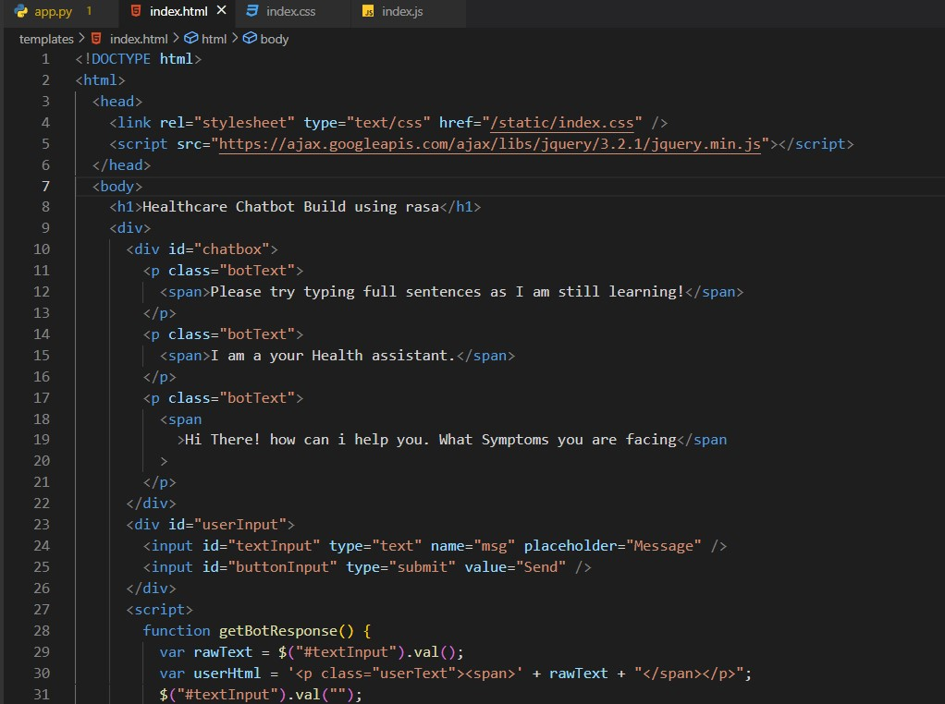

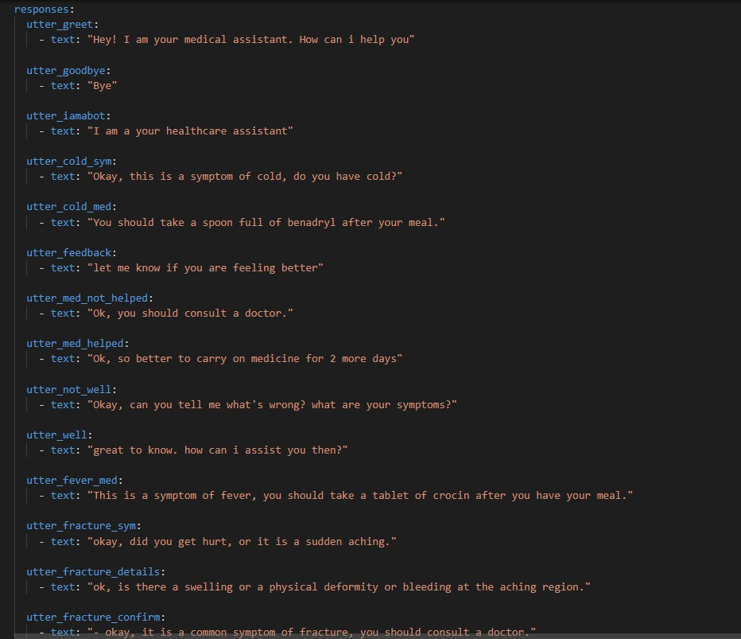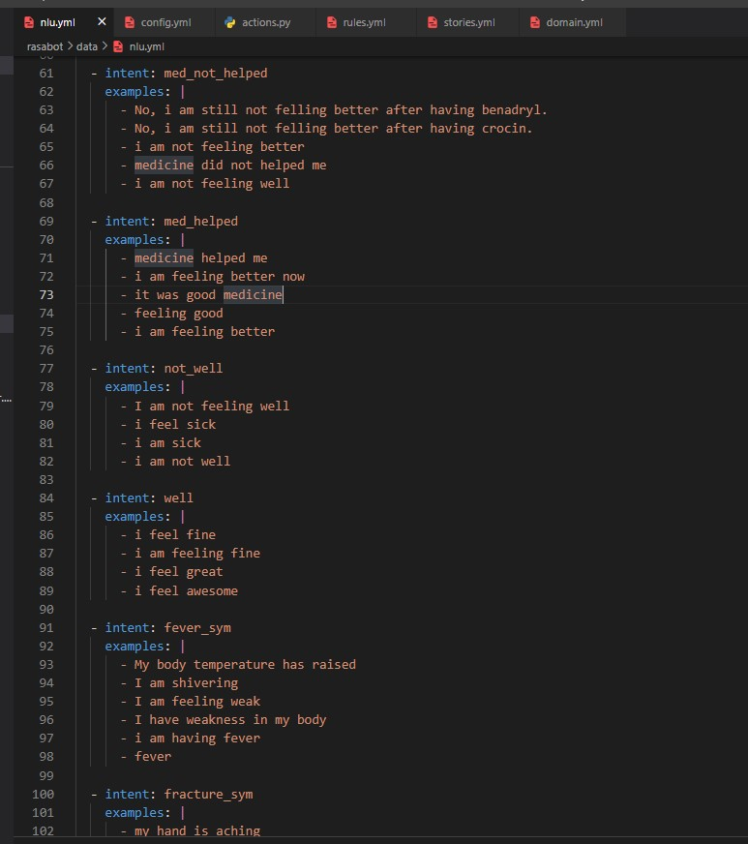

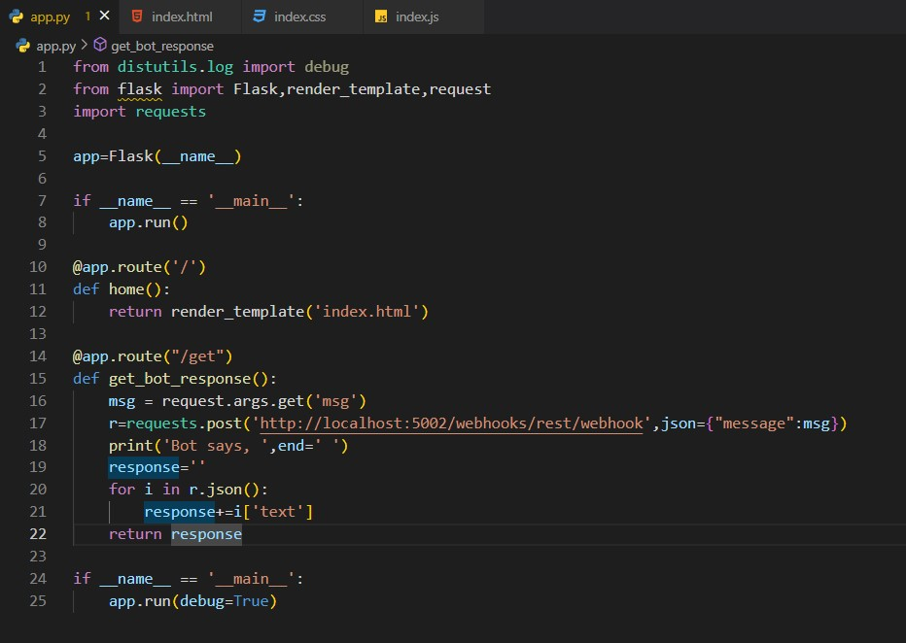

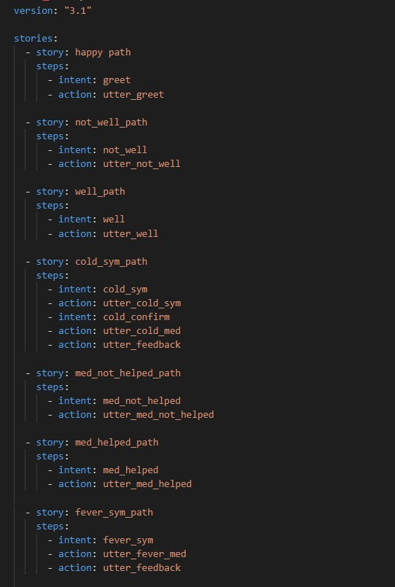

**CHATBOT**

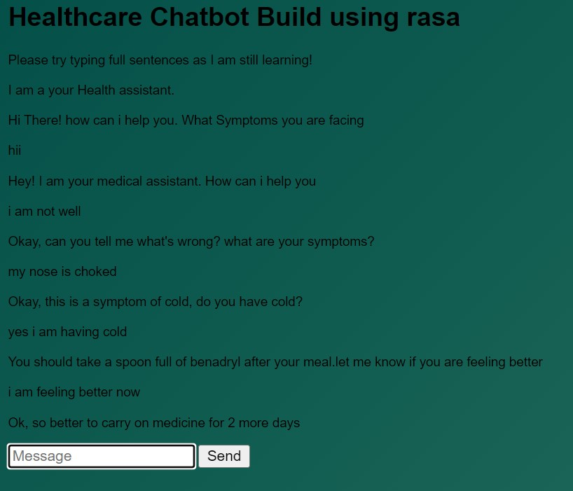  
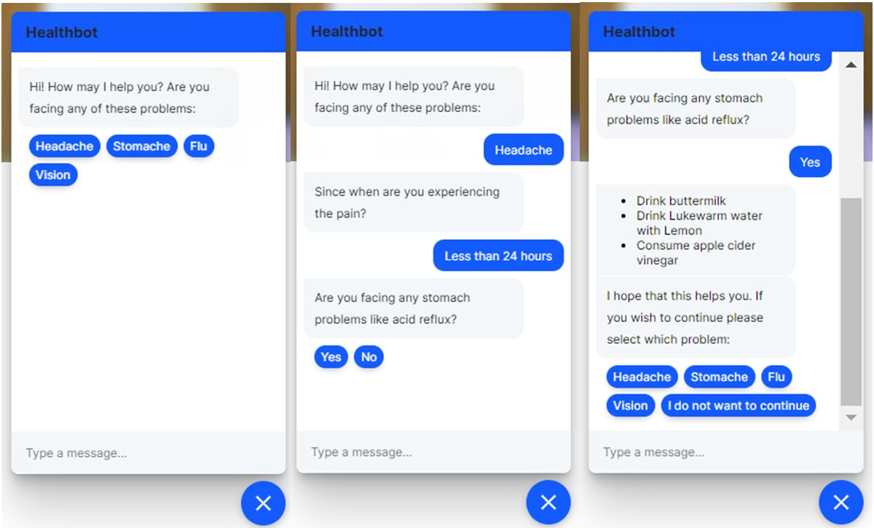

**Description:** Ai technology (AI) is a device that makes marketers to create highly personalized consumer encounters, increase company response, and resolve customer issues. In this article, the chatbot is investigated as an ai - based platform in marketing, and even its current application and potential value in the aforementioned sector. In total, 60 survey participants were surveyed about their views, habits, and opinions when utilizing various information exchange, with an emphasis on bots and potential advantages and disadvantages in comparison to conventional communication channels. The findings suggested that the greatest value of employing automation in business solutions was when offering simple, precise data, but they also suggested respondents' worry of chatbots providing erroneous information. Chatbots should be explored by organization’s, particularly if they are experiencing connectivity issues with their clients, but also if they wish to stay up with their customers' changing lives.

**The Potential of Chatbots: Analysis of Chatbot Conversations**

**Description:** The concept of using machines to answer questions has been around since the introduction of these programmers. The first algorithms to achieve this goal were developed in the early 1960s. Chatbots have grown in popularity in a range of businesses in recent years. They are recognized as important instruments for improving client interactions with in area of business applications. This article investigates a telecoms company's chatbot to determine how well these communications could have been used to measure a) users' concerns and b) user happiness. Text mining algorithms analyse user inputs to represent chat messages as a chain of actions. As per the study's findings, users' public conversational contributions can reveal useful information about their desires and well-being. If the chatbot does not respond quickly, the bulk of people will abandon the conversation. As a result, the themes of discourse frequently overlap. As we learned in our research study, organization’s that use chatbots should carefully review the data they acquire in order to truly comprehend their clients' desires. According to our findings, they could increase customer loyalty by offering personalized service and incorporating real-time reviews.

# 

# SYSTEM ARCHITECTURE DIAGRAM

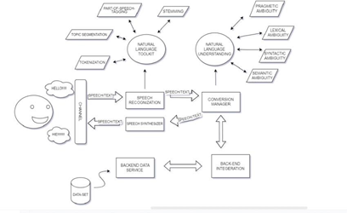

**SYSTEM**

**Module:**

Module 1: Press the button for voice input.

Module 2: We need to give our question or query to system.

Module 3: System will recognize the speech.

Module 4: Recognize the query using Speech Recognition Module and convert to text using text Conversion.

Module 5: Translate the query using translator.

Module 6: Match the query in database (Use NLP).

Module 7: Response to query by translating in quick way.

# CONCLUSION

In order to make it easier to profit from the market, we created the platform. The portal is currently under construction, and our primary focus is on making it as user-friendly as possible. In the same way that there is no compelling reason to wait for the answer, pressing the catch to select the option offers no compelling incentive. A combination of voice recognition software, sound-to-information conversion, and a language interpreter module is being used in this application. Using a chatbot service provider, you can have a customer support representative for a wide range of businesses, institutions, and fields, or even a

receptionist for anyone on the planet. Chatbots created on our site will also help you remember a wide variety of products. As a result, numerous businesses will be better able to persuade customers from all over the world. It can be used to enlighten and entertain those who are simply passing the time. Profitability is the most important consideration when developing a project that will simultaneously serve millions of customers. Based on the findings of the study and the answers given in the background, the recommended remedy was found to be correct.

# REFERENCES

[1]Augello A. Saccone G. Gaglio S. Pilato G., Humorist Bot: Bringing Computational Humour in a Chat-Bot System. Proceedings of the International Conference on “Complex, Intelligent and Software Intensive Systems (CISIS)”, 4-7 March 2018, Barcelona, Spain, pp.703- 708.

1. Gambino O. Augello A. Caronia A. Pilato G. Pirrone R. Gaglio S., Virtual conversation with a real talking head. Proceedings of the Conference on “Human System Interactions”, 25-27 May 2018,Kraow, Poland, pp. 263-268.
2. Vojtko J. Kacur J. Rozinaj G., The training of Slovak speech recognition system based on Sphinx 4 for GSM networks. Proceedings of International Symposium “EL, MAR (Electronics in Marine) focused on Mobile Multimedia”, 12-14 Sept. 2017, Zadar, Croatia, pp. 147-150.
3. Sun Microsystems, Developer resources for JAVA technology. [Online] [http://java.sun.com (](http://java.sun.com/)Accessed: 30 Oct. 2018)
4. The Apache Software Foundation, The Apache HTTP Server Project. [Online] [http://www.apache.org](http://www.apache.org/) (Accessed: 30 Oct.

2018)

1. Sun Microsystems, MySQL: The world’s most popular open source database. [Online] http://www.mysql.com(Accessed: 30 Oct. 2018)