

**A project Report on**

**FLIPKART WEBSITE USING AUTOMATION TOOL SELENIUM WEBDRIVER WITH JAVA.**

**By**

**SRIVAISHNAVI G**

**Batch-EON (2021-5533)**

**Under the Guidance of,**

**Amruta Deore Kachole**

**(Technical Trainer)**

**EduBridge India Pvt. Ltd.**

**Introduction:**

* This Project aims to do overall testing like functional testing, GUI testing on Flipkart website to check quality of application using selenium web driver. It helps to improve quality of website and saves time for manually doing this testing.
* In this Project our main focus is to test the Fashion Module. Fashion Module contains Mens and Womens clothes and Footwear.In order to Purchase Womens footwear, First we have to login in to flipkart website,then we have to search in the search bar,filter the product, select the product,check the review,add to cart,check the cart,wishlist,title and Icon of the Flipkart website.

**Software Requirements:**

* Operating System : Windows 10
* Browser : Latest version of Google Chrome
* Platform : Eclipse IDE
* Automation Tool and Language: Selenium WebDriver, Java
* Files : JDK, Selenium Jar files, Common IO file

**1.FASHION MODULE**

**TC01:** Launch the browser and Flipkart website

**Selenium WebDriver Test Script:**

System.*setProperty*("webdriver.chrome.driver","C:\\SeleniumWebDriver\\Chromedriver\\chromedriver.exe);

WebDriver driver = **new** ChromeDriver();

driver.get("https://www.flipkart.com/");

System.***out***.println("Browser launched and site opened");

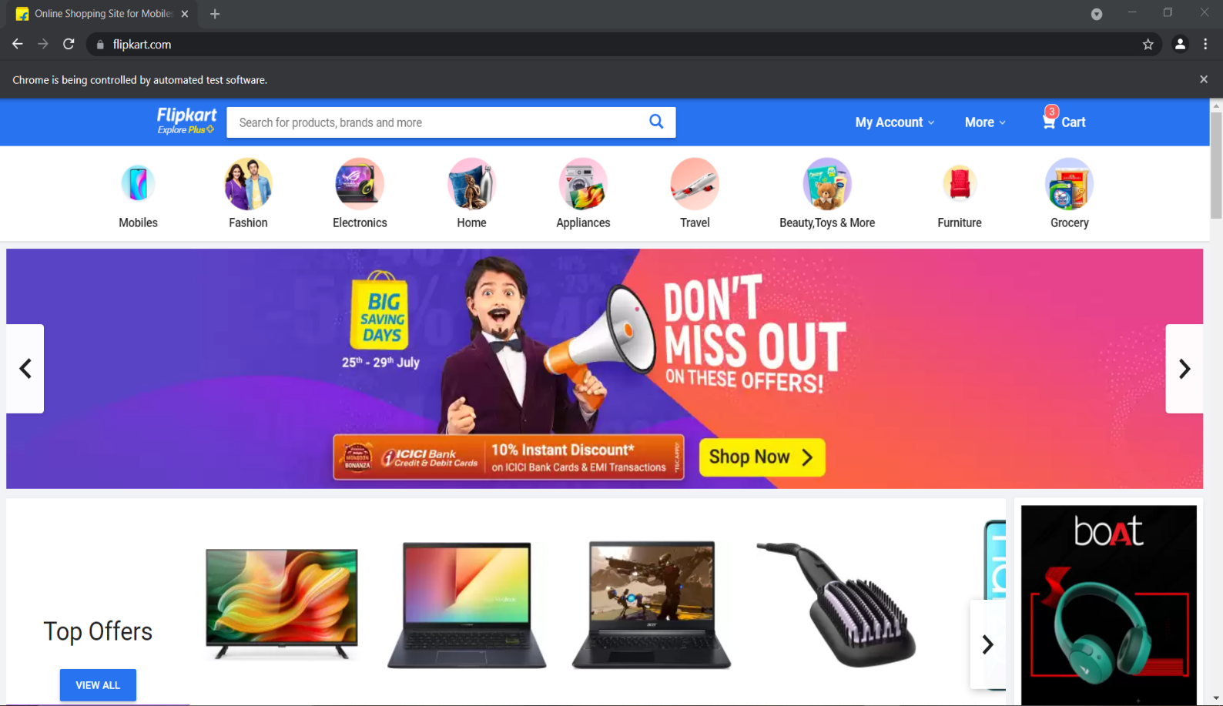

**TC02:** Maximize the window

**Selenium WebDriver Test Script:**

driver.manage().window().maximize();

System.***out***.println("Maximizing Window");

**TC03:** To verify Login

**Selenium WebDriver Test Script:**

driver.findElement(By.*xpath*("/html/body/div[2]/div/div/div/div/div[2]/div/form/div[1]/input")).sendKeys("9940588616");

System.***out***.println("Username done");

driver.findElement(By.*xpath*("/html/body/div[2]/div/div/div/div/div[2]/div/form/div[2]/input")).sendKeys("Vaishu@99");

System.***out***.println("Password done");

driver.findElement(By.*xpath*("/html/body/div[2]/div/div/div/div/div[2]/div/form/div[4]/button/span")).click();

System.***out***.println("Successfully Logged In");

**TC04:** To verify Title Check

**Selenium WebDriver Test Script:**

String ActualTitle ="Online Shopping Site for Mobiles, Electronics, Furniture, Grocery, Lifestyle, Books & More. Best Offers!";

String ExpectedTitle = driver.getTitle();

Assert.*assertEquals*(ActualTitle, ExpectedTitle);

System.***out***.println("Title checked");

**TC05:** To verify Icon Check

**Selenium WebDriver Test Script:**

WebElement Icon= driver.findElement(By.*xpath*("//body/div[@id='container']/div[1]/div[1]/div[1]/div[2]/div[1]/div[1]/a[1]/img[1]"));

Assert.*assertEquals*(**true**, Icon.isDisplayed());

System.***out***.println("Icon Displayed");

**TC06:** To verify Searching Box

**Selenium WebDriver Test Script:**

WebElement search = driver.findElement(By.*name*("q"));

search.sendKeys("Womens Heels");

search.sendKeys(Keys.***ENTER***);

System.***out***.println("Women Heels");

**TC07:** To verify and display Window Handling

**Selenium WebDriver Test Script:**

String Mainwindow = driver.getWindowHandle();

Set<String> s1 = driver.getWindowHandles();

Iterator<String> i1 = s1.iterator();

**while**(i1.hasNext())

{

String childwindow = i1.next();

**if**(!Mainwindow.equalsIgnoreCase(childwindow))

{

driver.switchTo().window(childwindow);

}

System.***out***.println("Handling multiple window");

}

**TC08:** To verify and display Scroll Down

**Selenium WebDriver Test Script:**

JavascriptExecutor js= (JavascriptExecutor)driver;

js.executeScript("window.scrollBy(0,400)");

System.***out***.println("ScrollDown done");

**TC09:** To verify and display Scroll Up

**Selenium WebDriver Test Script:**

JavascriptExecutor js1 = (JavascriptExecutor)driver;

js1.executeScript("window.scrollBy(0,-20)");

System.***out***.println("ScrollUp Done");

**TC10:** To verify and display Brand is Selected

**Selenium WebDriver Test Script:**

WebElement brand = driver.findElement(By.*xpath*("//div[contains(text(),'Brand')]"));

Actions act = **new** Actions(driver);

brand.click();

System.***out***.println("Mouse over Brand Webelement");

WebElement brandselect = driver.findElement(By. *xpath*("//body/div[@id='container']/div[1]/div[3]/div[1]/div[1]/div[1]/div[1]/div[1]/section[5]/div[2]/div[1]/div[6]/div[1]/label[1]/div[1]"));

brandselect.click();

System.***out***.println("brand is selected");

**TC11:** To verify and display Discount Range is Selected

**Selenium WebDriver Test Script:**

JavascriptExecutor js2= (JavascriptExecutor)driver;

js2.executeScript("window.scrollBy(0,400)");

System.***out***.println("ScrollDown done");

WebElement discount = driver.findElement(By.*xpath*("//div[contains(text(),'Discount')]"));

discount.click();

System.***out***.println("Mouse over discount done");

WebElement discount_range = driver.findElement(By.*xpath*("//body/div[@id='container']/div[1]/div[3]/div[1]/div[1]/div[1]/div[1]/div[1]/section[8]/div[2]/div[1]/div[6]/div[1]/label[1]/div[1]"));

discount_range.click();

Thread.*sleep*(4000);

System.***out***.println("Discount range is done");

**TC12:** To verify that Product is Selected

**Selenium WebDriver Test Script:**

WebElement product = driver.findElement(By.*xpath*("//body/div[@id='container']/div[1]/div[3]/div[1]/div[2]/div[4]/div[1]/div[3]/div[1]/a[1]/div[1]/div[1]/div[1]/div[1]/img[1]"));

Thread.*sleep*(4000);

product.click();

System.***out***.println("Product Selected");

String Mainwindow1 = driver.getWindowHandle();

Set<String> s2 = driver.getWindowHandles();

Iterator<String> i2 = s2.iterator();

**while**(i2.hasNext())

{

String childwindow1 = i2.next();

**if**(!Mainwindow1.equalsIgnoreCase(childwindow1))

{

driver.switchTo().window(childwindow1);

}

System.***out***.println("Handling multiple window");

}

**TC13:** To verify that Footwear size is Selected

**Selenium WebDriver Test Script:**

JavascriptExecutor js4= (JavascriptExecutor)driver;

js4.executeScript("window.scrollBy(0,1000)");

System.***out***.println("ScrollDown done to see Review");

WebElement size1= driver.findElement(By.*xpath*("//*[@id=\"swatch-3-size\"]/a"));

act.contextClick(size1);

System.***out***.println("Selected size");

**TC14:** To verify that mouse over is working on webelement

**Selenium WebDriver Test Script:**

WebElement electronic = driver.findElement(By.*xpath*("//*[@id=\"container\"]/div/div[2]/div/div/span[1]"));

act.moveToElement(electronic).build().perform();

Thread.*sleep*(2000);

System.***out***.println("Mouse over Electronics");

WebElement Application = driver.findElement(By.*xpath*("//*[@id=\"container\"]/div/div[2]/div/div/span[2]"));

act.moveToElement(Application).build().perform();

Thread.*sleep*(2000);

System.***out***.println("Mouse over Application & TV");

WebElement Men = driver.findElement(By.*xpath*("//*[@id=\"container\"]/div/div[2]/div/div/span[3]"));

act.moveToElement(Men).build().perform();

Thread.*sleep*(2000);

System.***out***.println("Mouse over Men");

WebElement women = driver.findElement(By.*xpath*("//*[@id=\"container\"]/div/div[2]/div/div/span[4]"));

act.moveToElement(women).build().perform();

Thread.*sleep*(2000);

System.***out***.println("Mouse over Women");

WebElement Baby_Kids = driver.findElement(By.*xpath*("//*[@id=\"container\"]/div/div[2]/div/div/span[5]"));

act.moveToElement(Baby_Kids).build().perform();

Thread.*sleep*(2000);

System.***out***.println("Mouse over Baby and Kids");

WebElement Home_and_Furniture = driver.findElement(By.*xpath*("//*[@id=\"container\"]/div/div[2]/div/div/span[6]"));

act.moveToElement(Home_and_Furniture).build().perform();

Thread.*sleep*(2000);

System.***out***.println("Mouse over home and furniture");

WebElement sports = driver.findElement(By.*xpath*("//*[@id=\"container\"]/div/div[2]/div/div/span[7]"));

act.moveToElement(sports).build().perform();

Thread.*sleep*(2000);

System.***out***.println("Mouse over Sport,Book and More");

WebElement flights = driver.findElement(By.*xpath*("//*[@id=\"container\"]/div/div[2]/div/div/a[1]"));

act.moveToElement(flights).build().perform();

Thread.*sleep*(2000);

System.***out***.println("Mouse over flights");

WebElement offer = driver.findElement(By.*xpath*("//*[@id=\"container\"]/div/div[2]/div/div/a[2]"));

act.moveToElement(offer).build().perform();

Thread.*sleep*(2000);

System.***out***.println("Mouse over Offers");

**TC15:** To Check that product added to cart

**Selenium WebDriver Test Script:**

WebElement cart = driver.findElement(By.*xpath*("//*[@id=\"container\"]/div/div[3]/div[1]/div[1]/div[2]/div/ul/li[1]/button"));

cart.click();

System.***out***.println("Added to cart");

**TC16:** To Check the cart

**Selenium WebDriver Test Script:**

WebElement date = driver.findElement(By.*xpath*("//*[@id=\"container\"]/div/div[1]/div[1]/div[2]/div[5]/div/div/a/span"); act.moveToElement(date).build().perform();

date.click();

System.***out***.println("Checking the cart");

**TC17:** To verify My wishlist

**Selenium WebDriver Test Script:**

WebElement myaccount = driver.findElement(By.*xpath*("//body/div[@id='container']/div[1]/div[1]/div[1]/div[2]/div[3]/div[1]");

myaccount.click();

System.***out***.println("Mouse over Myaccount done");

WebElement wishlist = driver.findElement(By.*xpath*("//*[@id=\"container\"]/div/div[1]/div[1]/div[2]/div[3]/div/div/div[2]/div[2]/div/ul/li[5]/a/div[2]"));

act.moveToElement(wishlist).build().perform();

wishlist.click();

System.***out***.println("Checking Wishlist");

**TC18:** To verify that browser is able to close.

**Selenium WebDriver Test Script:**

driver.close();

System.***out***.println("Closing the browser");

**TC19:** To verify that browser is able to quit

**Selenium WebDriver Test Script:**

driver.quit();

System.***out***.println("Quit the browser");