**DEVI AHILYA VISHVIDYALAYA, INDORE**

**(School of Data Science and Forecasting)**



**A Project Report on**

**Student Result Visualization with Power BI Dashboard**

Course: M.Tech. Data Science and Artificial Intelligence

Semester: VI

Batch: 2021-26

Course Title: Netflix Data Analysis

Guided By: Dr. Prof Nandkishor Buwade

Presented By: Vaishnavi Yadav

Roll No: DS6A2142

**Certificate**

This is certify that **Miss Vaishnavi Yadav**, a student of M.Tech. Data Science, Batch 2021-26 has completed Minor Project Title “**Student Result Visualization with Power BI Dashboard”** under my guidance. This project is submitted for this purpose and fulfils the requirment of the course

**Dr. VB Gupta Dr. Nandkishor Buwade**

(Head, School of Data Science and Forecasting) (Faculty, Data mining)

**Acknowledgement**

The acknowledgement is dedicated to all those indivisuals and faculties who have provided guidance and resourses to complete this project. I would like to express my thanks to **Dr. VB Gupta**  who has given me opportunity to pursue this course.

I would like to give specail thanks to **Dr. Nandkishor Buwade** to taught python in such a simple and aucid way.

Last, but not the least I would like to thank my parents and friends for their motivation and support to complet this project on time.

Date:23/04/2024

**TABLE OF CONTENTS**

|  |  |
| --- | --- |
| **S.No.** | **Title:** |
| 1. | Introduction |
| 2. | What is Power Bi? |
| 3. | What is report? |
| 4. | What is a dashboard? |
| 5. | Dashboards vs. Reports |
| 6. | How to Create a Dashboard/Report on Power BI? |
| 7. | Publishing and Sharing Dashboards |
| 8. | Conclusion |

**Introduction**

In the dynamic world of business intelligence tools, Power BI stands as a frontrunner, offering users a remarkable platform for creating fascinating and customizable visualizations and dashboards. It requires no coding skills which is the beauty of Power BI and hence we can say that along with the data professionals beginners can also access this tool with ease, making it a versatile choice for both.

Developed by Microsoft, Power BI built an interface that particularly would be a great choice for Excel users, coupled with deep integrations with ubiquitous spreadsheet software. However, what truly sets Power BI apart are its advanced features, enabling data transformation, collaborative teamwork at scale, and the establishment of finely-tuned access controls.

Despite all of these great features, Power BI provides the art of turning raw data into insightful, actionable, and visually stunning dashboards. In this article, I will demonstrate the power of Power BI by showing real-world example of Power BI dashboard that covers a variety of topics.

**What is Power BI?**

Power BI, a comprehensive business analytics service offered by Microsoft, empowers users with self-service BI capabilities, enabling them to create reports and dashboards independently. This self-sufficiency eliminates the reliance on IT personnel or database administrators.

According to a survey conducted by Forbes, more than 95% of businesses encounter the challenge of handling unstructured data. In a separate study, over 87% of respondents emphasized the vital importance of data organization. If you find yourself grappling with similar data-related issues, the solution lies in the world of Power BI dashboards.

With Power BI, you gain access to both cloud-based BI services, known as "Power BI Services," and a desktop-based interface called "Power BI Desktop." It encompasses data warehouse capabilities, including data preparation, data discovery, and interactive dashboards. Additionally, Microsoft introduced Power BI Embedded on its Azure cloud platform in March 2016, facilitating report delivery, data analysis, and various ETL (Extract, Transform, Load) operations within Power BI.

The Power BI gateways enable seamless connections to SQL Server databases, Analytical

Services, and a multitude of other data sources for your dashboards. Embedded Power BI reports and dashboards within reporting portals provide a unified and efficient user experience.

**What is report?**

A Power BI report is a multi-perspective view of a dataset, where visualizations convey diverse findings and insights from the data. It can comprise a single visualization or span multiple pages filled with various visual elements. While akin to a dashboard, a Power BI report serves a distinct purpose.

Each visualization within a report encapsulates a valuable piece of information. Unlike static displays, these visualizations are dynamic, allowing users to manipulate data, switch visualization types, and apply filters as they explore the data, seeking meaningful insights and answers to their queries. Much like a dashboard, a Power BI report is known for its high interactivity, extensive customization options, and the ability to adapt visualizations in response to changes in the underlying data.

The image below represents how a sample report looks.

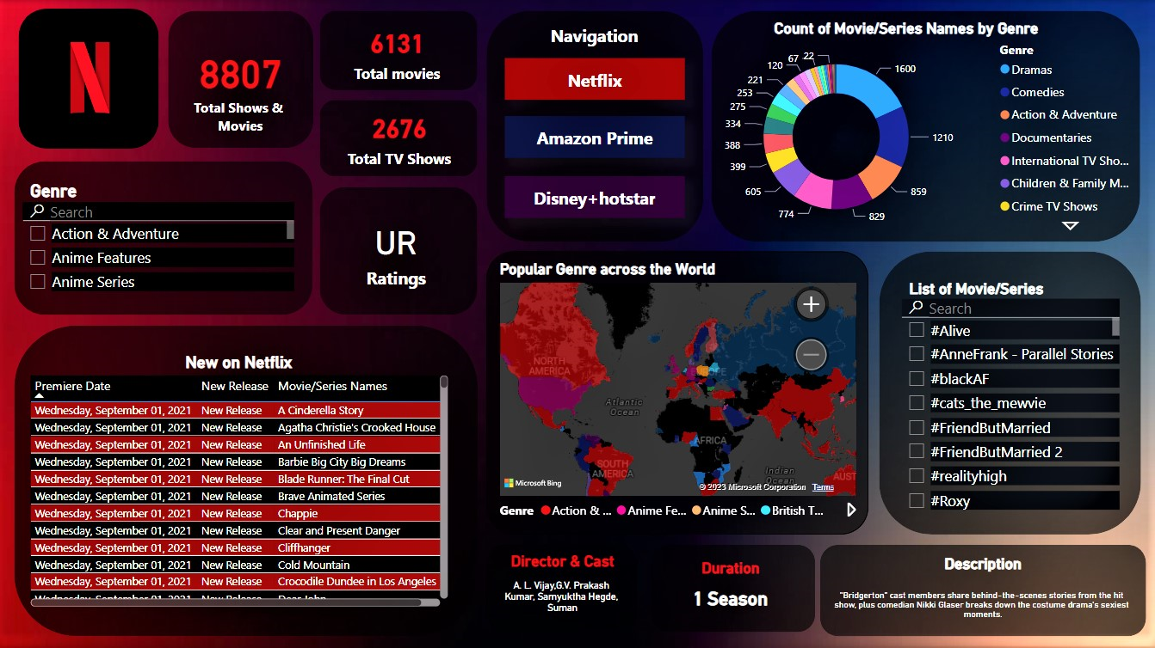

**What is a dashboard?**

The dashboard is a core, defining feature of the Power BI service, offering real-time monitoring of your most critical data. It seamlessly integrates both on-premises and cloud-based data sources, delivering a unified and consolidated view, regardless of data source location. The creation of a Power BI dashboard can be achieved through several methods, and I'll provide a step-by-step guide on how to create a Power BI dashboard.

A Power BI dashboard is more than just an aesthetically pleasing image; it is highly interactive and fully customizable. The ways to work with and interact with a Power BI dashboard are diverse and plentiful, making it impossible for a single article to cover every aspect comprehensively.

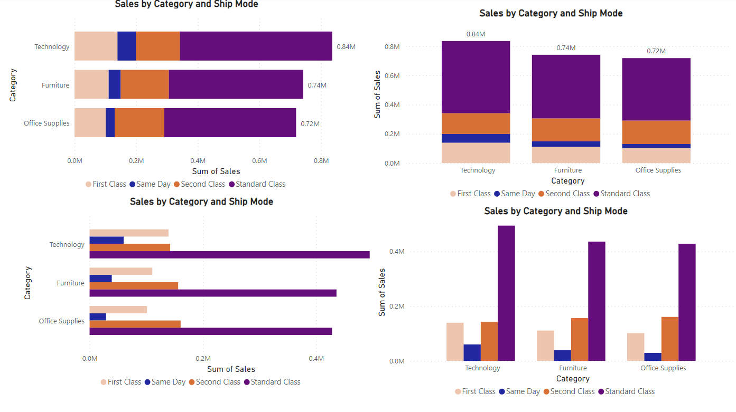

It's a common misconception to equate dashboards with reports, as both comprise canvases filled with visualizations. However, there are notable distinctions between the two. Let's delve into these variances using the following insights.

**Dashboards vs. Reports**

Certainly, here are some additional key distinctions between reports and dashboards:

1. **Structure**:

- Reports are typically organized into multiple pages or sections, allowing for a structured and detailed presentation of data and insights.

- Dashboards are usually single-page displays, offering a concise, high-level overview of critical metrics and KPIs.

2. **Data Exploration**:

- Reports are designed for in-depth data exploration, allowing users to conduct detailed analysis, apply filters, and drill into specific data points.

- Dashboards are intended for quick data consumption, providing a snapshot of key information without the need for extensive exploration.

3. **Real-Time Updates**:

- Reports can offer real-time data updates and dynamic refresh capabilities, ensuring that users always access the latest information.

- Dashboards may provide real-time updates as well, but they often prioritize immediate access to essential, pre-aggregated data.

4. **User Audience**:

- Reports cater to data analysts and professionals who require in-depth insights and have the time for thorough exploration.

- Dashboards target a broader audience, including executives and decision-makers who need quick, easily digestible data summaries.

5. **Design and Layout**:

- Reports allow for more intricate design and layout customization, accommodating a wide range of visualizations and data representations.

- Dashboards prioritize simplicity and user-friendliness, with a focus on clean, intuitive design for quick comprehension.

These differences emphasize that reports and dashboards serve distinct purposes and are tailored to different user needs and scenarios.

**How to Create a Dashboard/Report on Power BI?**

To effectively utilize Power BI, practical application is crucial. Whether you're creating reports for personal use or sharing them with colleagues, understanding how to create and interact with reports is essential.

The Power BI desktop interface features 3 main tabs located in the left-hand corner. The default tab is the "Report" tab, which is where you create your reports. The "Data" tab allows you to view and manage your imported datasets. Additionally, the "Relations" tab provides insight into the relationships between different variables within your dataset, provided they are well-defined. This hands-on approach is key to mastering Power BI and harnessing its capabilities.

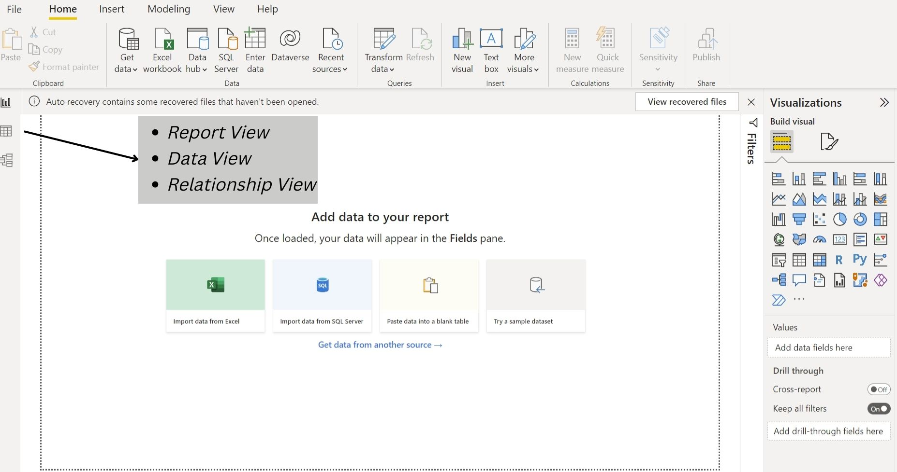

Importing datasets into Power BI is a straightforward process. Begin by clicking on the "Get Data" tab. On the right-hand side of the screen, you'll find the "Visualizations" tab, which offers a variety of visualization options to suit your needs. Adjacent to the "Visualizations" tab is the "Fields" tab, where you can access all the fields present in your dataset. This intuitive interface simplifies the process of working with your data in Power BI.

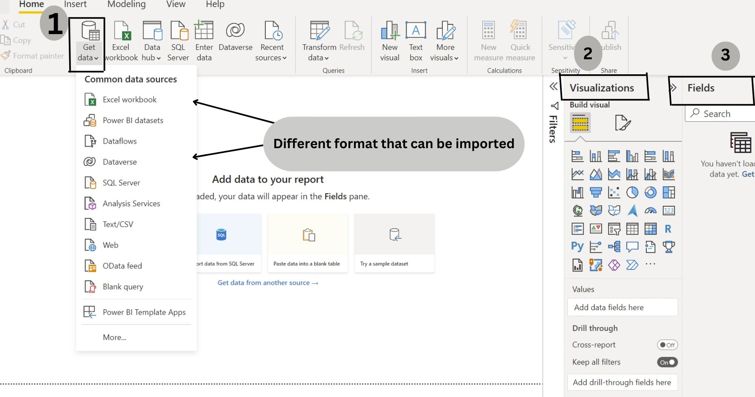

For practice purposes, I'm currently using the dataset of Netflix Data Analysis from by Movie Analysis report; this dashboard will showcases Netflix data from 1925 to 2021, revealing fascinating trends and patterns.

Once you click Load sample data, the interface will allow you to load or edit the data as it is visible in the image below.

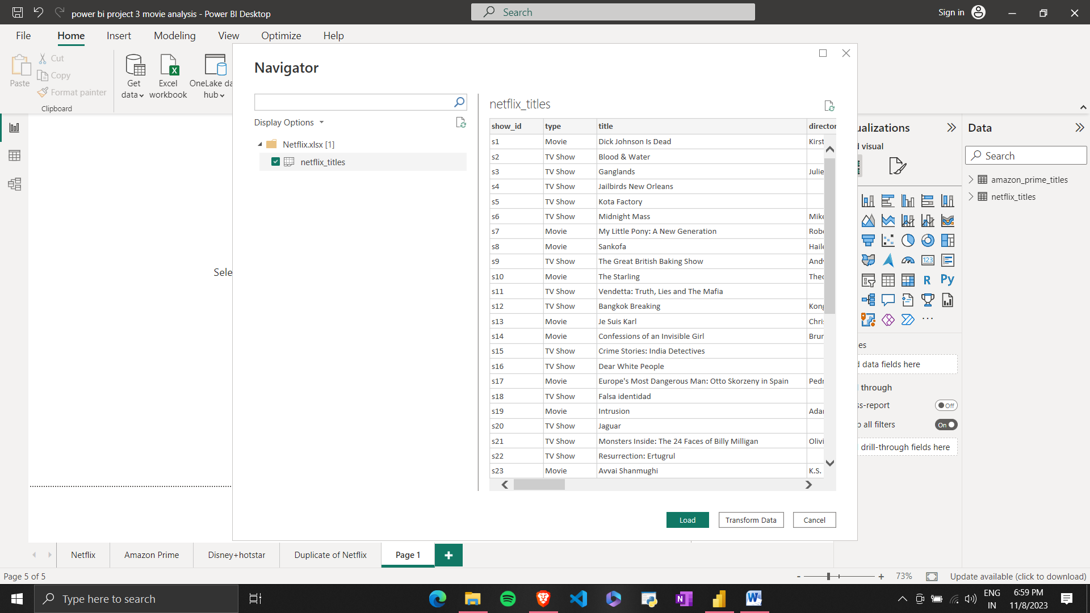

When you reach this screen, it displays the available tables in your data source. Clicking on this table provides you with two primary options: "Load" and "Transform Data." While "Load" allows you to directly load the dataset into Power BI, it's advisable to choose "Transform Data." This option enables you to make various data adjustments, such as changing data types, renaming columns, removing columns, altering table names, and performing other transformations. It also provides a detailed view of your data, including columns and their values. After you've completed your data transformations and are ready to proceed, clicking "Load" will bring your data into the Power BI interface, where you can access all the fields in the field view on the right side.

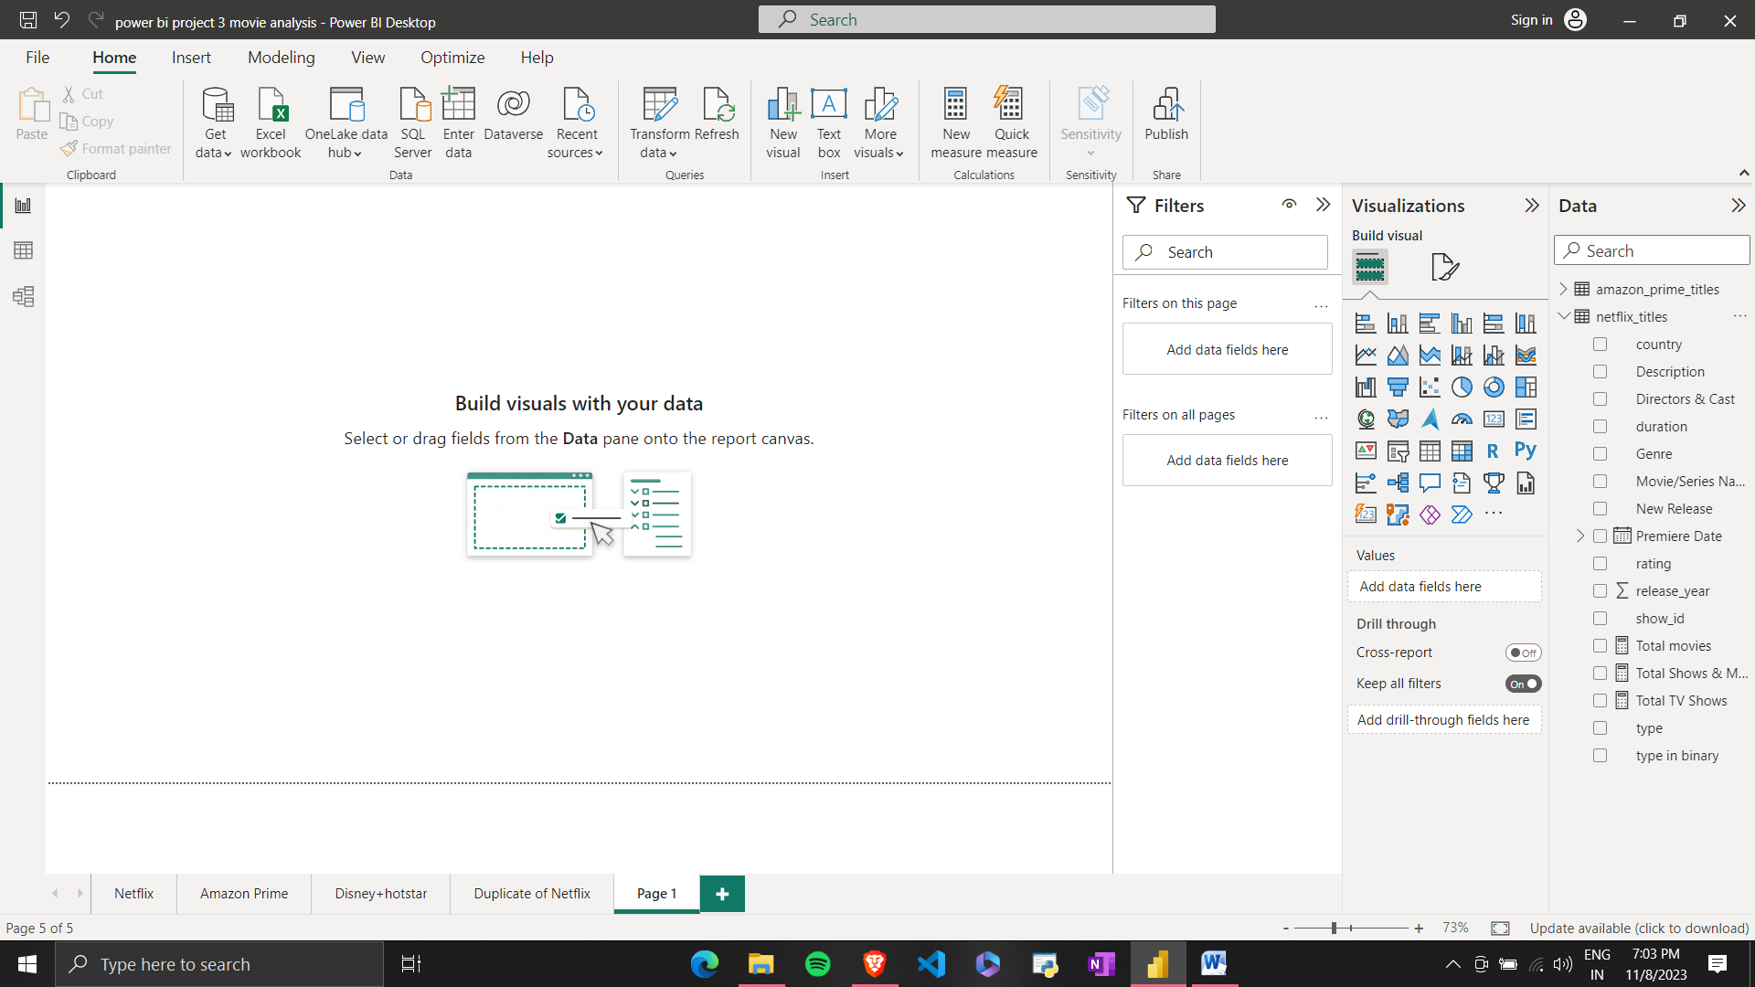

Now, you can easily create visualizations by selecting them and dragging the relevant fields onto the visualization template. When designing a dashboard, remember to follow a left-to-right layout for better user experience. Place filters on the left, key performance indicators (KPIs) at the top, and keep the number of charts to a maximum of six for a clean and visually appealing design. To start, select the "Card" visualization type from the pane and choose the "Sales" value to display the sum of sales.

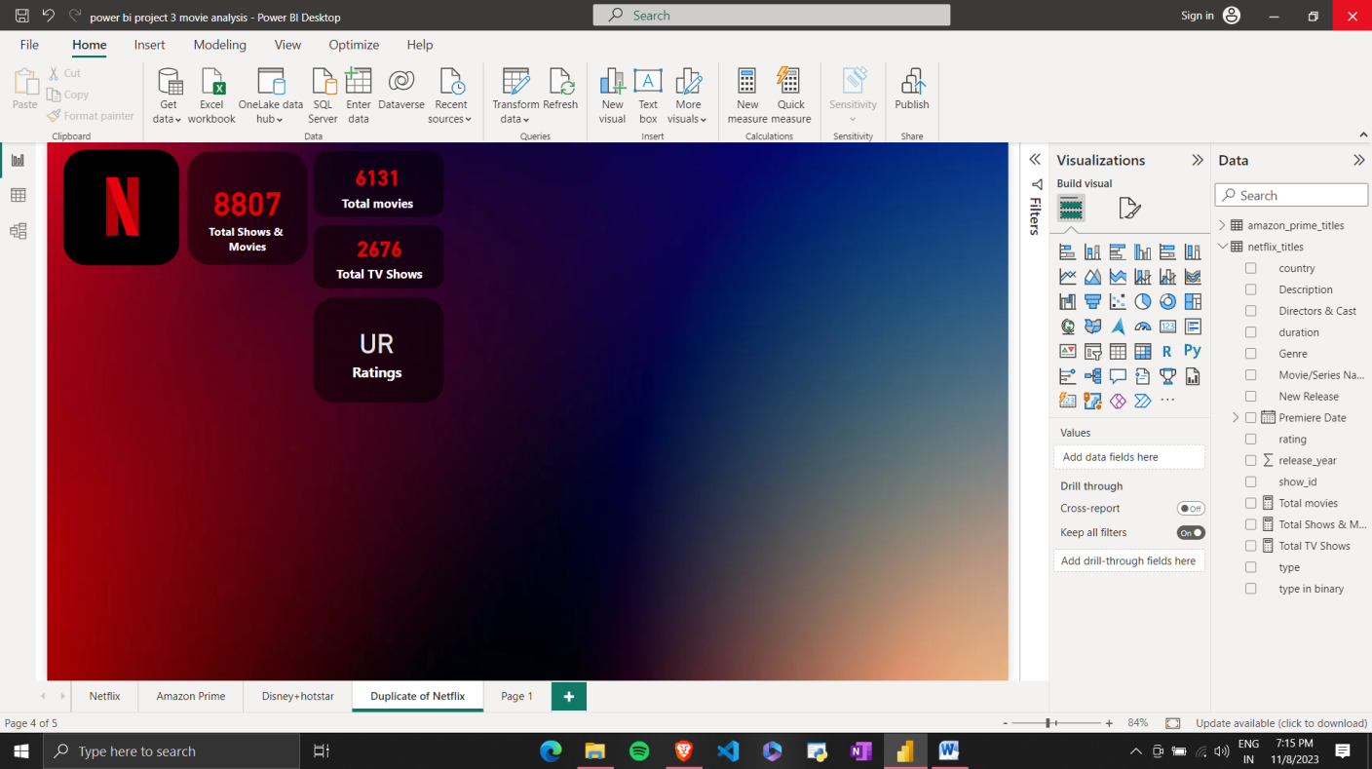

We can also use format option to align KPI's if needed and distribute in horizontal and vertical alignment.

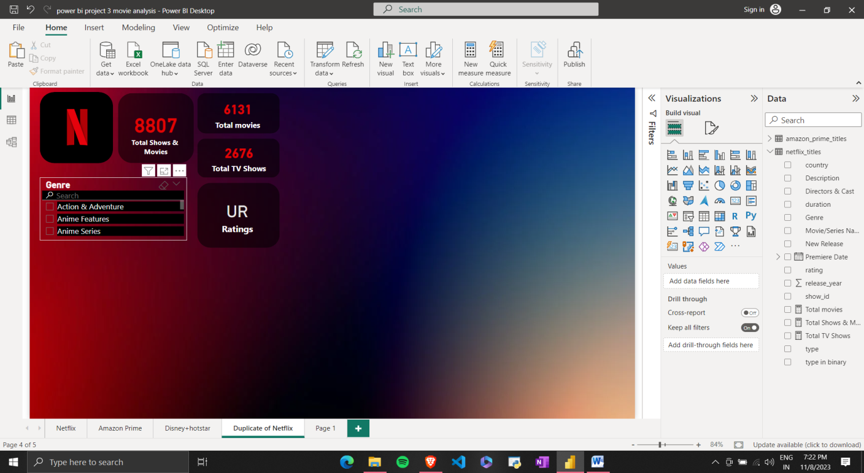

In the image above, you have the flexibility to customize the appearance of your filters. By clicking on the three dots, you can choose between two options: "List" and "Dropdown."

On the right-hand side, you'll find the "Format" page. The area where we are currently working is called the "canvas." Here, you can access various options such as "Canvas Settings" and "Canvas Background."

For each visual, you can customize its formatting using the format pane. Simply select the visual you want to modify and you can make changes to it as per your preferences.

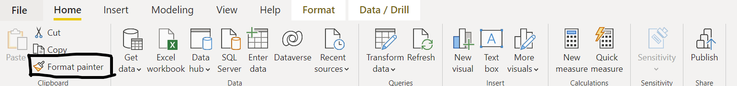

After that, I wanted to show you how you can format with a format painter. Look for the "Format Painter" option under the home tab, and with a single click, you can copy the formatting from one visualization and apply it to another. This is a handy tool for maintaining a consistent style across your dashboard.



In this dashboard, I've used a variety of visualizations, including cards, slicers, maps, table, matrix, pie chart and slicer. To make navigation and data exploration more convenient for other platform (Amazon Prime and Disney+hotstar), I've added 3 button at the top. You can locate this button in the "Buttons" option under the insert pane, next to the home pane. Whenever you want to click the button make sure to press control key along with it.

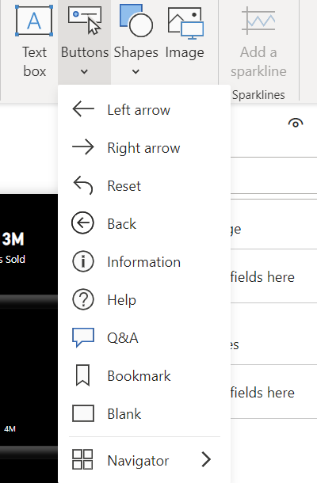

After you get that navigation button you need to set it up. So, for that, you need to go to the view pane and under that you will find bookmarks. Just add the reset button in your bookmarks.

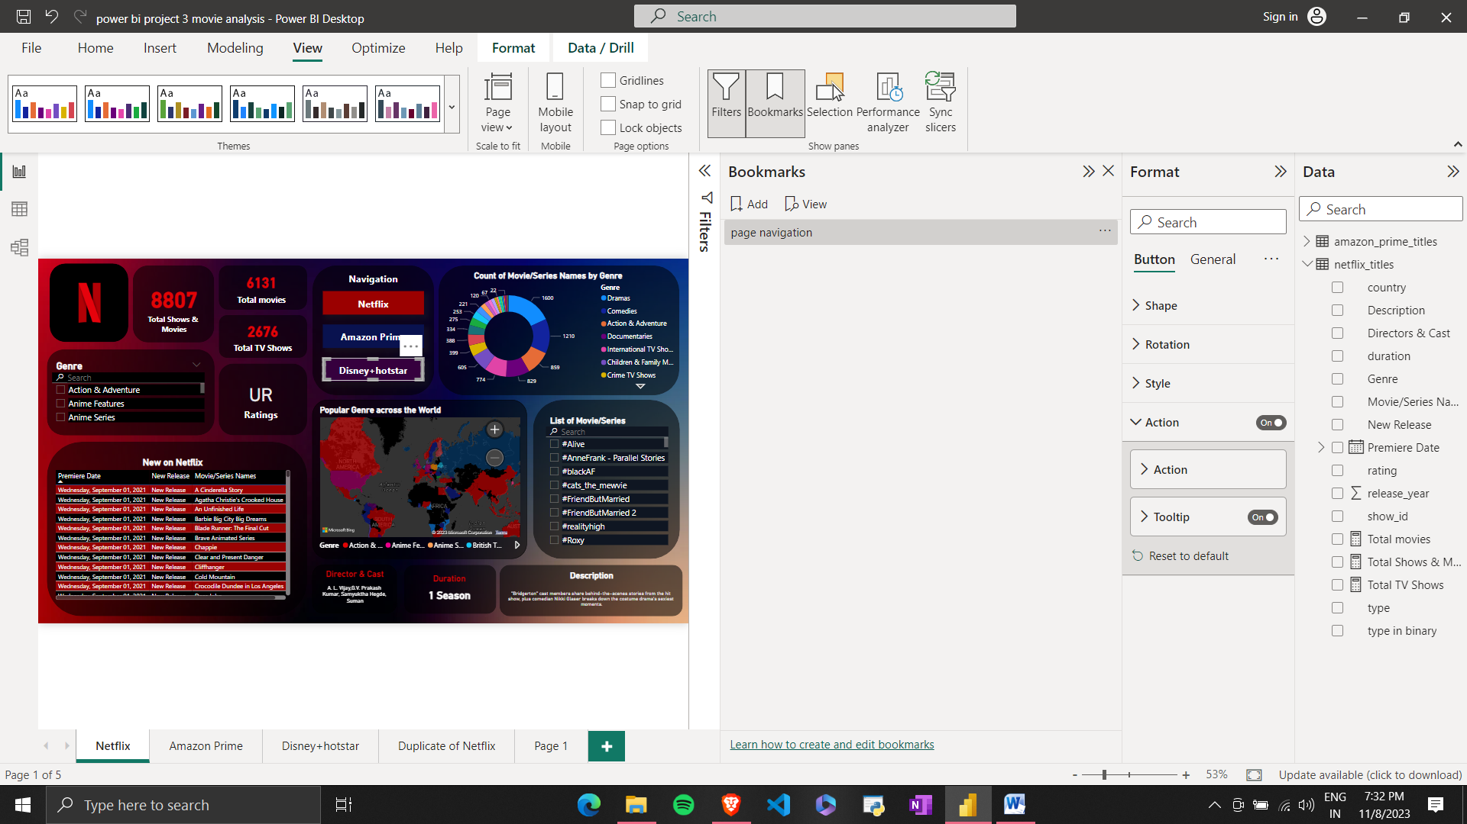

After adding a bookmark, you can go to format under that, just set your action type as bookmark and bookmark as page navigation.

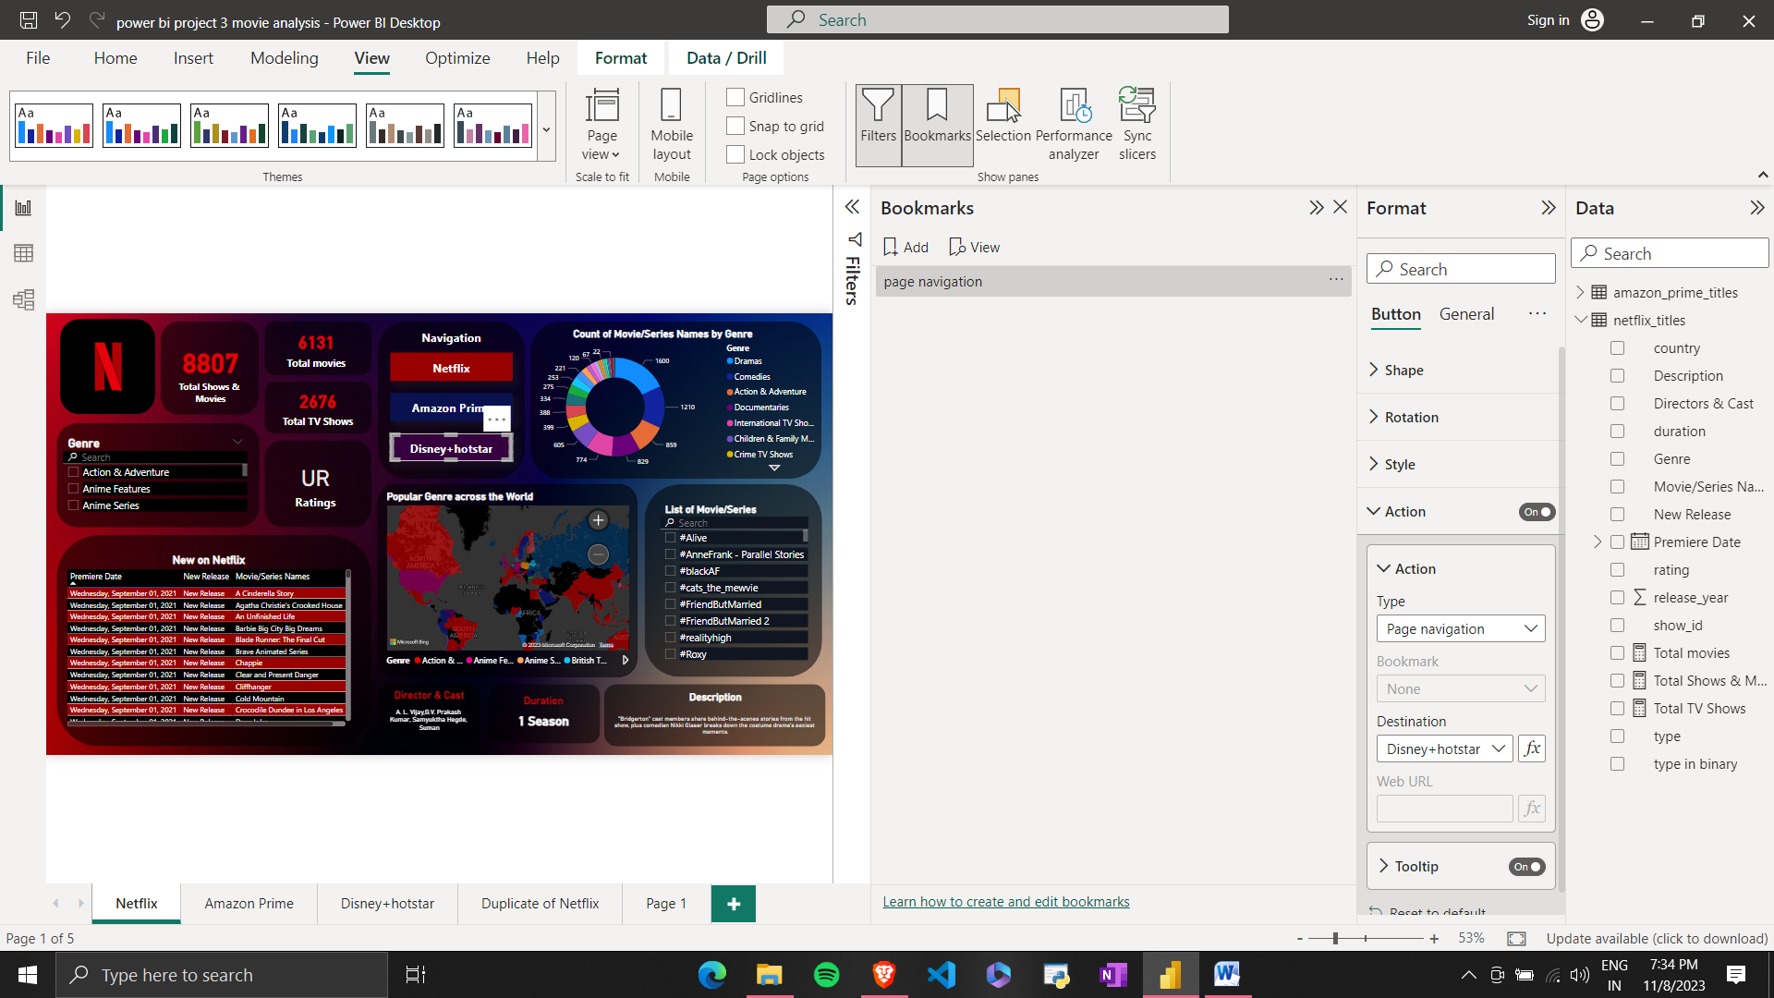

**Publishing and Sharing Dashboards**

Publishing and sharing a Power BI dashboard involves these key steps:

1. **Publish to Power BI Service**: After creating your dashboard in Power BI Desktop, you publish it to the Power BI service by selecting the workspace and report.

2. **Share the Dashboard**: In the Power BI service, choose your report, and then either use "Publish to web" for public sharing or the "Share" option for controlled access.

3. **Customize Permissions**: Specify user or group access levels, including view, edit, or administer permissions.

4. **Embed in Websites or Apps**: Generate an embed code to seamlessly integrate the dashboard into your own websites or applications.

5. **Scheduled Email Subscriptions**: Set up automated email subscriptions for recipients to receive reports via email at regular intervals.

6. **Mobile Access**: Users can access shared dashboards on mobile devices through Power BI's iOS and Android apps.

7. **Collaboration and Feedback**: Encourage collaboration by allowing users to leave comments on specific visualizations within the dashboard.

By following these steps, you can efficiently share your Power BI dashboard with the intended audience, enabling them to access valuable data and insights.

**Conclusion**

In a nutshell, Power BI is like the superhero of data analytics. It is a versatile and user-friendly tool that empowers both seasoned data professionals and beginners to create interactive dashboards and reports. It offers a dynamic canvas where you can transform raw data into insightful visualizations and share your data stories with others. With its numerous features, integrations, and customization options, Power BI equips you to explore data, gain insights, and make data-driven decisions with ease. So, dive into the world of Power BI, and start turning your data into valuable insights today!