Project Title:Forecasting House Prices Accurately Using Smart Regression Techniques in Data Science

GITHUB REPOSITORY LINK:

# Problem Statement:

Accurate prediction of house prices is a critical challenge in the real estate industry, where property values are influenced by numerous factors such as location, size, number of bedrooms, age of the house, and market trends. Traditional pricing models often fall short in capturing complex, non- linear relationships between these features and housing prices. The objective of this project is to develop a robust and intelligent regression-based model using advanced data science techniques to forecast house prices with high accuracy. By leveraging smart regression algorithms—such as regularized linear models (Lasso, Ridge), ensemble methods (Random Forest, Gradient Boosting), and advanced approaches like XGBoost or neural networks—the goal is to build a model that can generalize well across diverse housing datasets.

# Project Objectives:

* 1. **To collect and preprocess real-world housing datasets** containing relevant features such as location, square footage, number of rooms, age, and neighborhood attributes.
  2. **To perform exploratory data analysis (EDA)** to identify patterns, outliers, correlations, and feature importance that influence house prices.

## To implement and compare multiple smart regression techniques such as:

* + - Linear Regression
    - Ridge and Lasso Regression
    - Decision Trees
    - Random Forest Regression
    - Gradient Boosting (including XGBoost, LightGBM)
  1. **To optimize model performance** using hyperparameter tuning, cross-validation, and regularization techniques to avoid overfitting and improve generalization.
  2. **To evaluate model accuracy** using metrics such as Mean Absolute Error (MAE), Mean Squared Error (MSE), and R-squared score (RZ).

1. Flowchart of the project workflow

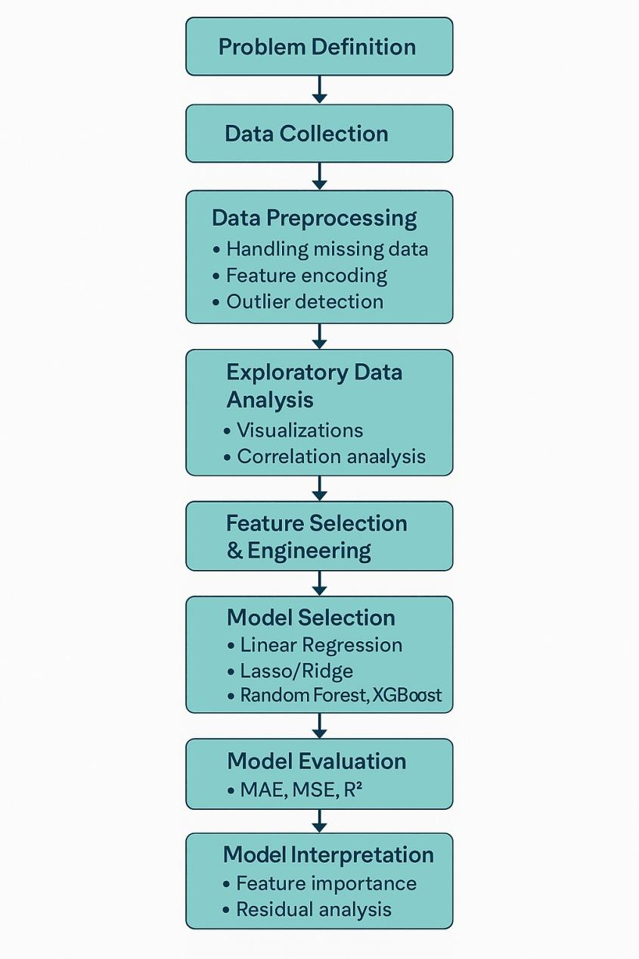

# Data Description

## The dataset used in this project contains various features (independent variables) that influence house prices (the dependent variable). Below is a general description of the key attributes typically found in housing price datasets:

**Feature Name Description**

Id Unique identifier for each house entry SalePrice Final selling price of the house (Target variable) LotArea Lot size in square feet

OverallQual Overall material and finish quality (rated 1–10) OverallCond Overall condition rating (rated 1–10) YearBuilt Year the house was built

YearRemodAdd Year of last remodeling

TotalBsmtSF Total basement area in square feet GrLivArea Above ground (gross living area) square feet GarageArea Size of the garage in square feet GarageCars Number of cars that can fit in the garage FullBath Number of full bathrooms

HalfBath Number of half bathrooms BedroomAbvGr Number of bedrooms above ground level KitchenQual Kitchen quality (e.g., Ex, Gd, TA, Fa)

Neighborhood Physical locations within the city (categorical feature)

HouseStyle Style of dwelling (e.g., 1Story, 2Story)

MSZoning General zoning classification (e.g., RL, RM) Exterior1st Exterior covering on house (e.g., VinylSd, MetalSd) Heating Type of heating system

CentralAir Whether the house has central air conditioning (Y/N)

# Data Preprocessing

## Importing Required Libraries & Loading Data

* + - Use libraries like pandas, numpy, matplotlib, and seaborn to load and explore the dataset.

## Handling Missing Values

* + - **Numerical Features**: Impute with mean/median.
    - **Categorical Features**: Impute with mode or a new category (e.g., 'None').
    - Drop columns with too many missing values if necessary.

## Encoding Categorical Variables

* + - **Label Encoding**: For ordinal data (e.g., quality ratings).
    - **One-Hot Encoding**: For nominal categories (e.g., neighborhoods, house styles).

## Outlier Detection and Removal

* + - Use box plots or Z-scores to detect outliers in features like GrLivArea, SalePrice, etc.
    - Consider removing or capping extreme outliers to avoid model distortion.

## Feature Engineering

* + - Create new features from existing ones, such as:
      * AgeOfHouse = YrSold - YearBuilt
      * TotalBathrooms = FullBath + 0.5 * HalfBath
      * TotalSF = TotalBsmtSF + GrLivArea + GarageArea

# Exploratory Data Analysis (EDA)

EDA helps understand the structure, patterns, and relationships within the housing dataset before building any model. Here are the key steps:

## Data Overview

* + - Display basic info using df.info() and df.describe() to understand:
      * Data types (numeric, categorical)
      * Summary statistics
      * Missing values

## Target Variable Analysis

* + - **Visualize SalePrice (target)**
      * Histogram or KDE Plot: sns.histplot(df['SalePrice'], kde=True)
      * Check distribution (often right-skewed)
      * Apply log transform if highly skewed

## Correlation Analysis

* + - **Correlation matrix**: df.corr()
    - **Heatmap**: Use sns.heatmap() to find features strongly correlated with SalePrice
      * Common high-correlation features: GrLivArea, OverallQual, GarageArea, TotalBsmtSF

## Univariate Analysis

* + - **Numerical Features**:
      * Histograms, boxplots to identify distribution and outliers
      * Example: sns.boxplot(x=df['GrLivArea'])

## Categorical Features:

* + - * Count plots: sns.countplot(x='HouseStyle', data=df)
      * Bar plots: Compare mean SalePrice across categories

## Bivariate Analysis

* + - **Numeric vs Target**:
      * Scatterplots: sns.scatterplot(x='GrLivArea', y='SalePrice', data=df)
      * Linearity and outliers can be checked

## Categorical vs Target:

* + - * Boxplots: sns.boxplot(x='Neighborhood', y='SalePrice', data=df)
      * Helps identify high-value area

# Feature Engineering

Feature engineering improves model accuracy by creating, transforming, or selecting the most informative variables. It’s a critical step in housing price prediction due to the complexity of real estate data.

## Creating New Features

1. **Total Square Footage**: python:

## df['TotalSF'] = df['TotalBsmtSF'] + df['1stFlrSF'] + df['2ndFlrSF']Encoding

* 1. **Categorical Variables**
     + **Label Encoding** (for ordinal features): python:

**from sklearn.preprocessing import LabelEncoder**

**df['KitchenQual'] = LabelEncoder().fit_transform(df['KitchenQual'])**

* 1. **Handling Skewed Features**
     + Apply log transformation to reduce skew: python:

**df['SalePrice'] = np.log1p(df['SalePrice']) df['GrLivArea'] = np.log1p(df['GrLivArea'])**

* 1. **eature Selection**
     + Drop redundant or highly correlated features:

**python:**

**df = df.drop(['GarageCars'], axis=1) # If strongly correlated with GarageArea**

* 1. **Polynomial Features (Optional)**
     + Add interaction or squared terms for linear models:

**python:**

**from sklearn.preprocessing import PolynomialFeatures poly = PolynomialFeatures(degree=2, include_bias=False) X_poly = poly.fit_transform(df[['GrLivArea', 'TotalSF']])**

# Model Building Steps

## Import Required Libraries

**Python:**

**import pandas as pd import numpy as np**

**from sklearn.model_selection import train_test_split, GridSearchCV, cross_val_score from sklearn.linear_model import LinearRegression, Ridge, Lasso**

**from sklearn.ensemble import RandomForestRegressor, GradientBoostingRegressor from xgboost import XGBRegressor**

**from sklearn.metrics import mean_squared_error, mean_absolute_error, r2_score**

* 1. **Model Interpretation**

## Feature Importance:

**python:**

**import matplotlib.pyplot as plt**

**feat_importances = pd.Series(rf.feature_importances_, index=X.columns) feat_importances.nlargest(10).plot(kind='barh')**

**plt.title("Top 10 Feature Importances")**

**plt.show()**

# isualization of results & Model Insights

* 1. **Actual vs Predicted Plot**

Visualizes how well the model is predicting compared to real values. Python:

import matplotlib.pyplot as plt

import seaborn as sns

y_pred = model.predict(X_test)

plt.figure(figsize=(8,6)) sns.scatterplot(x=y_test, y=y_pred) plt.xlabel('Actual Sale Price') plt.ylabel('Predicted Sale Price') plt.title('Actual vs Predicted House Prices')

plt.plot([y_test.min(), y_test.max()], [y_test.min(), y_test.max()], color='red', lw=2) plt.show()

# Tools and Technologies Used:

## Programming Languages:

* + - **Python**: The most widely used language for data science, with libraries like pandas, NumPy, scikit-learn, and statsmodels for regression and analysis.
    - **R**: Another strong option for statistical modeling, with packages like caret, xgboost, and randomForest.

## Data Science Libraries:

* + - **pandas**: For data manipulation and cleaning.
    - **NumPy**: For numerical computations.
    - **scikit-learn**: For machine learning algorithms, including regression models and model evaluation tools.
    - **statsmodels**: For more advanced statistical models like ordinary least squares regression.
    - **XGBoost, LightGBM, CatBoost**: Libraries for powerful boosting algorithms.
    - **Matplotlib, Seaborn**: For data visualization.

## Deep Learning (Optional):

* + - **TensorFlow** or **PyTorch**: For more complex models like neural networks (if the dataset is large and requires deep learning techniques).

## Data Handling:

* + - **SQL**: To query databases and retrieve housing data.
    - **NoSQL (MongoDB, Firebase)**: For unstructured or semi-structured data.

## Cloud Platforms (for Deployment and Scaling):

* + - **AWS** (Amazon Web Services), **Google Cloud**, or **Microsoft Azure**: For hosting models, using managed machine learning services, and storing large datasets.

from google.colab import files uploaded=files.upload()

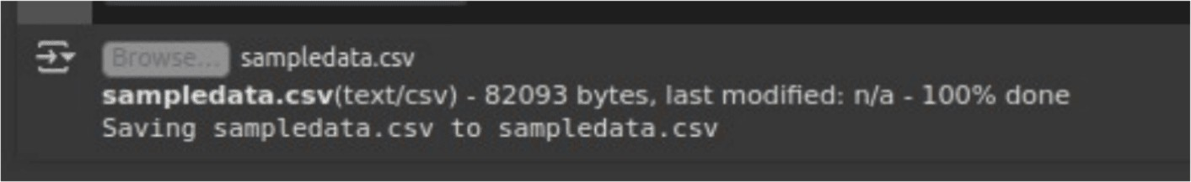

import matplotlib.pyplot as plt import seaborn as sns

# Basic statistics print(df.describe()) # Correlation matrix

plt.figure(figsize=(10, 6))

sns.heatmap(df.corr(), annot=True, cmap='coolwarm') plt.title("Correlation Matrix of Features")

plt.show()

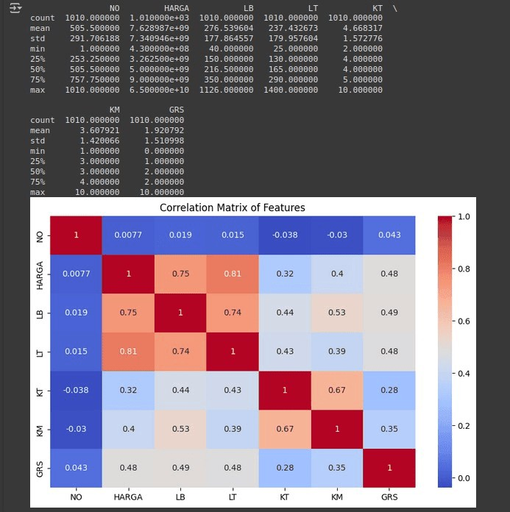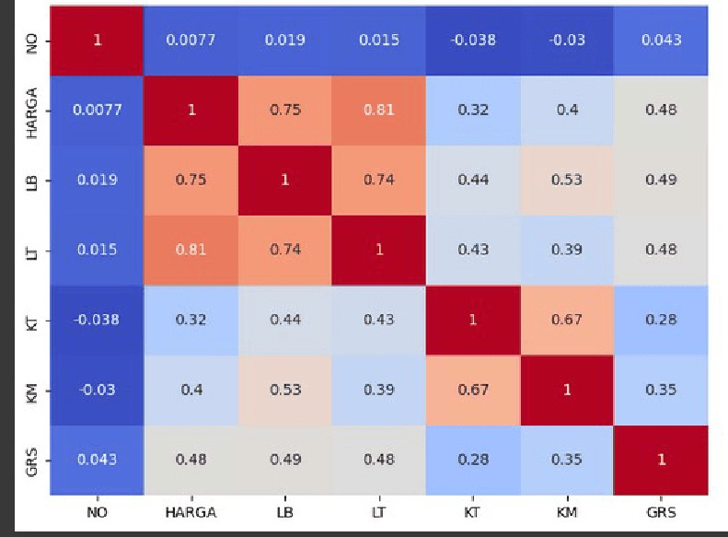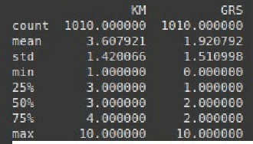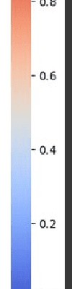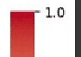

# Boxplot to detect price outliers sns.boxplot(df['HARGA']) plt.title("Boxplot of House Prices") plt.show()

# Remove extreme outliers df_clean = df[df['HARGA'] < df['HARGA'].quantile(0.95)]



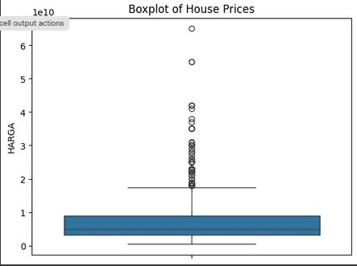

from sklearn.linear_model import LinearRegression import numpy as np

X = df[['LB']] y = df['HARGA']

model = LinearRegression() model.fit(X, y)

print("R^2 Score:", model.score(X, y))



features = ['LB', 'LT', 'KT', 'KM', 'GRS']

X = df[features] y = df['HARGA']

model = LinearRegression() model.fit(X, y)

print("Model coefficients:", model.coef_) print("R^2 score:", model.score(X, y))



from sklearn.preprocessing import PolynomialFeatures from sklearn.pipeline import make_pipeline

poly_model = make_pipeline(PolynomialFeatures(2), LinearRegression()) poly_model.fit(X, y)

print("R^2 score (poly):", poly_model.score(X, y))



from sklearn.model_selection import train_test_split from sklearn.metrics import mean_squared_error

X_train, X_test, y_train, y_test = train_test_split(X, y, test_size=0.2) model = LinearRegression()

model.fit(X_train, y_train) pred = model.predict(X_test)

print("Test RMSE:", np.sqrt(mean_squared_error(y_test, pred)))



from sklearn.ensemble import RandomForestRegressor

rf = RandomForestRegressor(n_estimators=100) rf.fit(X_train, y_train)

print("Random Forest R^2:", rf.score(X_test, y_test))



importances = rf.feature_importances_ sns.barplot(x=features, y=importances)

plt.title("Feature Importances in Predicting House Price") plt.show()

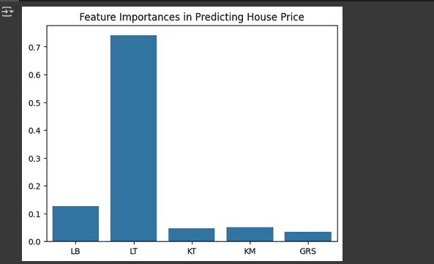

sample = pd.DataFrame({ 'LB': [200],

'LT': [150],

'KT': [4],

'KM': [3],

'GRS': [1]

predicted_price = rf.predict(sample) print("Predicted House Price:", predicted_price[0])

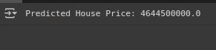

import joblib

joblib.dump(rf, 'house_price_model.pkl') print("Model saved as 'house_price_model.pkl'")

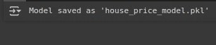

**Team Members and Contributions**

1. **SURENDER-PROBLEM STATEMENT AND PROJECT OBJECTIVES**
2. **SRIDHAR-FLOWCHART OF THE PROJECT WORKFLOW,DATA DESCRIPTION,DATA PREPROCESSING,EXPLORATORYDATA ANALYSIS**
3. **SUNIL-FEATURE ENGINEERING AND MODEL BULIDING**
4. **VATHISH- VISULATION OF RESULTS&MODEL INSIGHTS AND TOOLS&TECHNOLOGIES USED**