Report on the results of the load testing

Creating by Vaitsakhouski Raman

Operating system: **Ubuntu (32-bit).**

Web server: **Apache.**

Relational database management system: **MySQL.**

Runtime: **PHP.**

Content management system: **WordPress.**

Test perform software: **Apache JMeter.**

Conducted stress testing site http://localhost/

Emulated user requests with different number of users and time period.

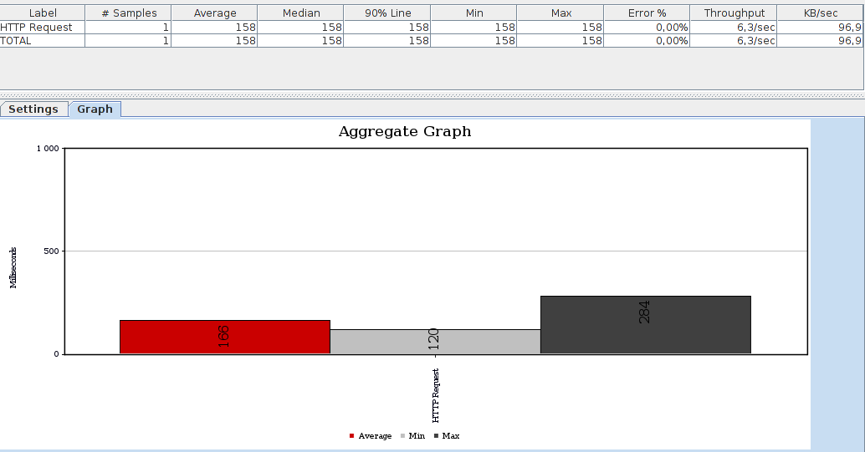

Graph.1(Users - 1; Seconds - 1)

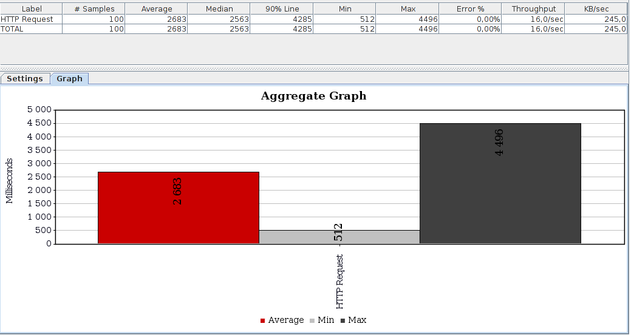

Graph.2(Users - 100; Seconds - 1)

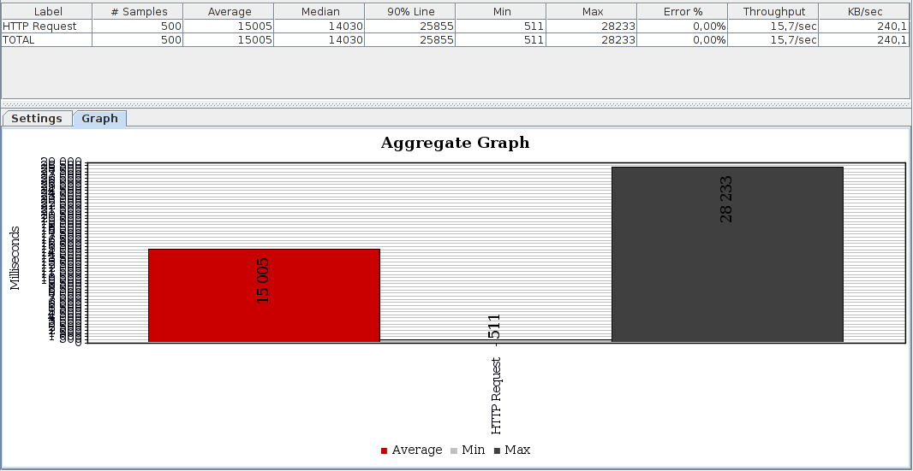

Graph.3(Users - 500; Seconds - 1)

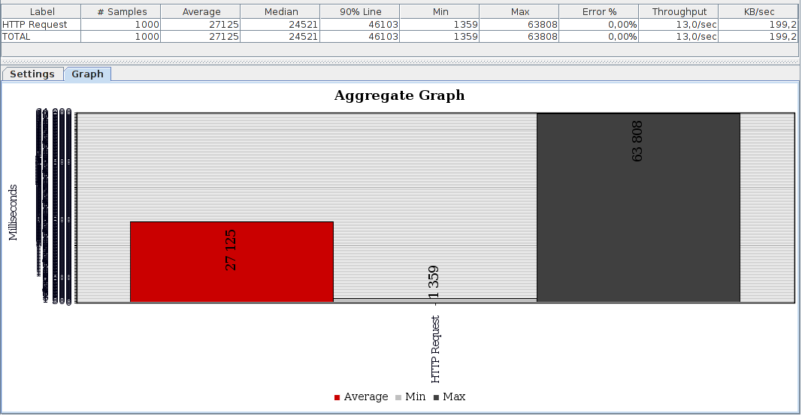

Graph.4(Users - 1000; Seconds - 1)

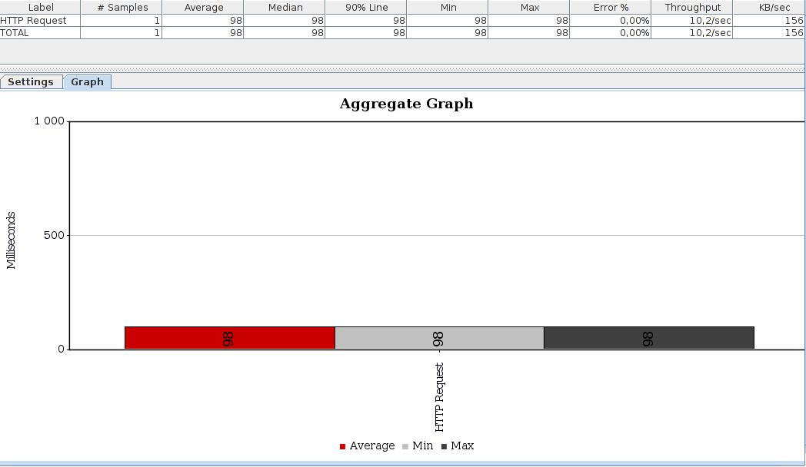

Graph.5(Users - 1; Seconds - 10)

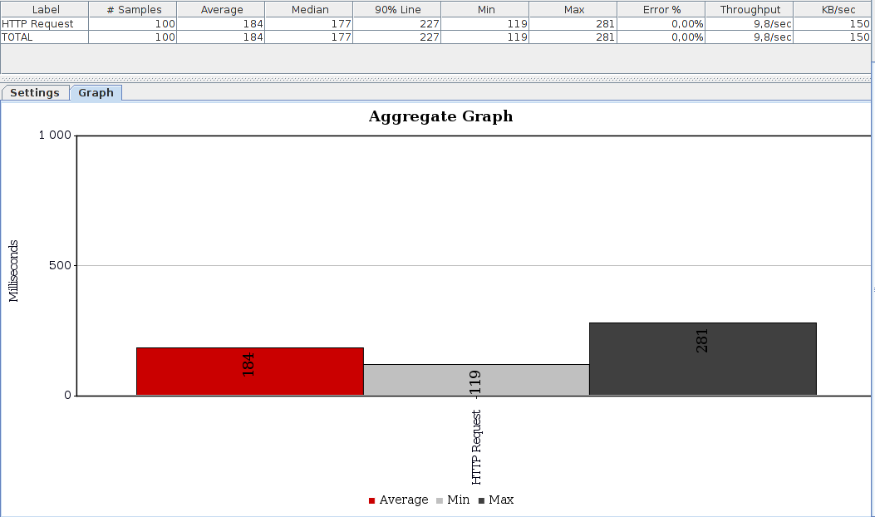

Graph.6(Users - 100; Seconds - 10)

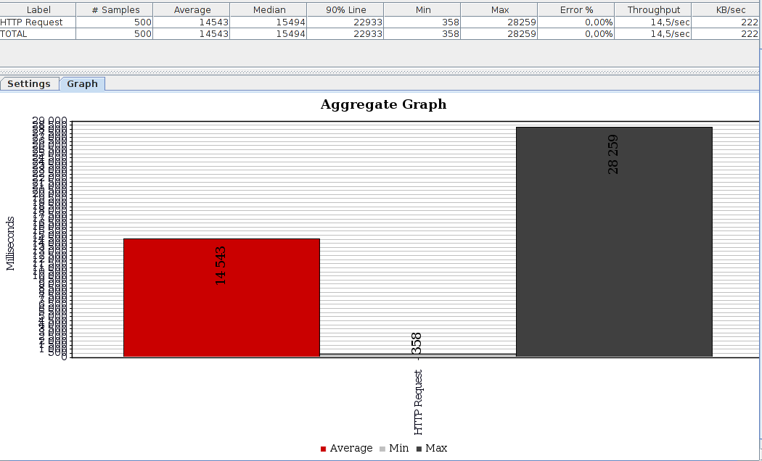

Graph.7(Users - 500; Seconds - 10)

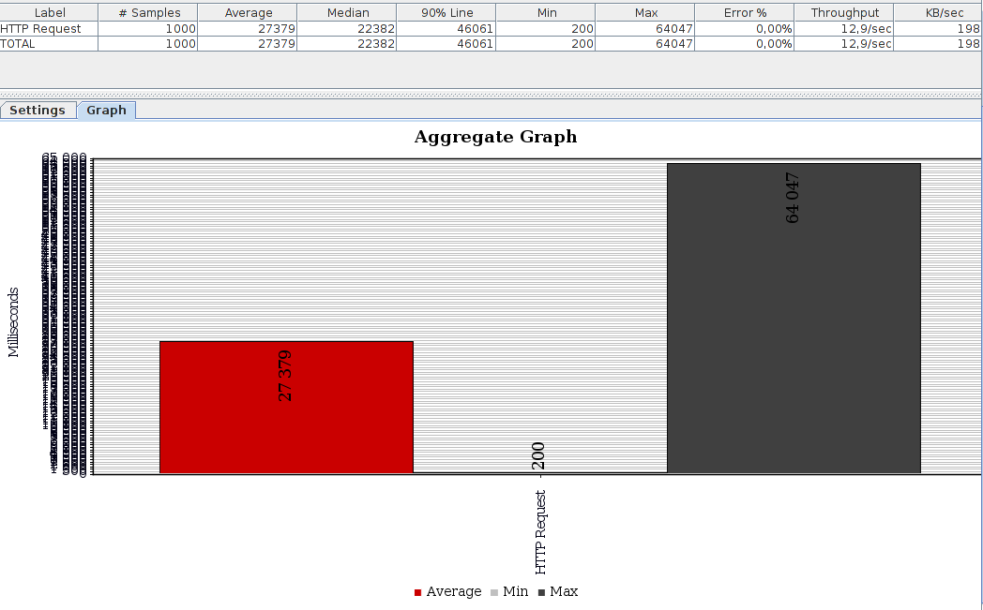

Graph.7(Users - 1000; Seconds - 10)

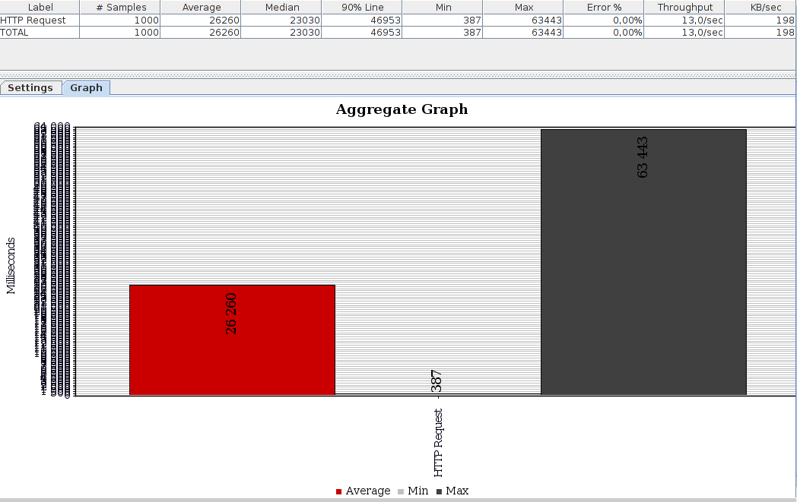

Graph.8(Users - 1000; Seconds - 20)

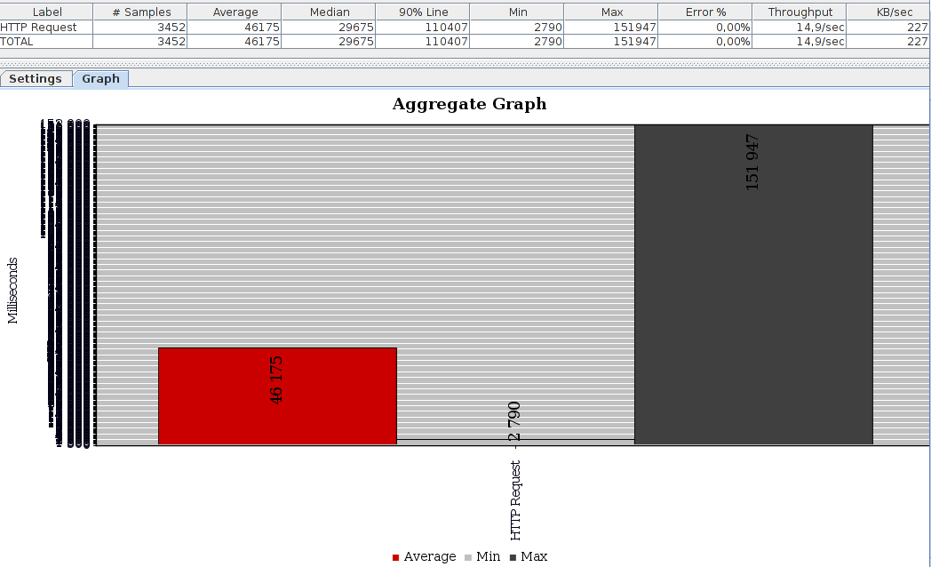

Graph.9(Users - 5000; Seconds - 20)