Week 10
Objective: To Deploy Web App on Elastic Beanstalk
✅ Step 1: Prepare Your Application
- Make sure your PHP file index.php with content as below
?php
// Hello World PHP Project
echo "Hello World";
✅ Step 2: Zip Your Project
- Store this file “index.php” in folder “demo” and make its zip file as “demo.zip”
✅ Step 3: Open Elastic Beanstalk
- Go to AWS Console
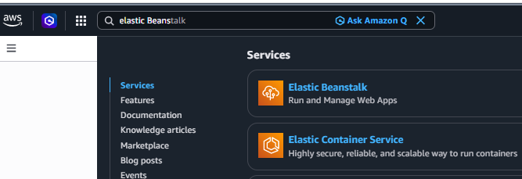

- Search → **Elastic Beanstalk**

- Click **Create Application**

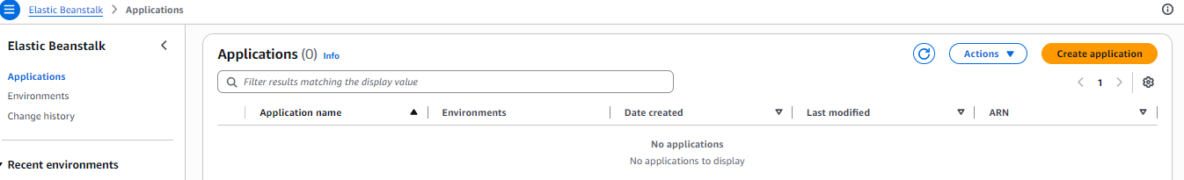
✅ Step 4: Configure Application
Fill in:
- Application name → anything (e.g., “yogita-web-app”)
- Then click on Create

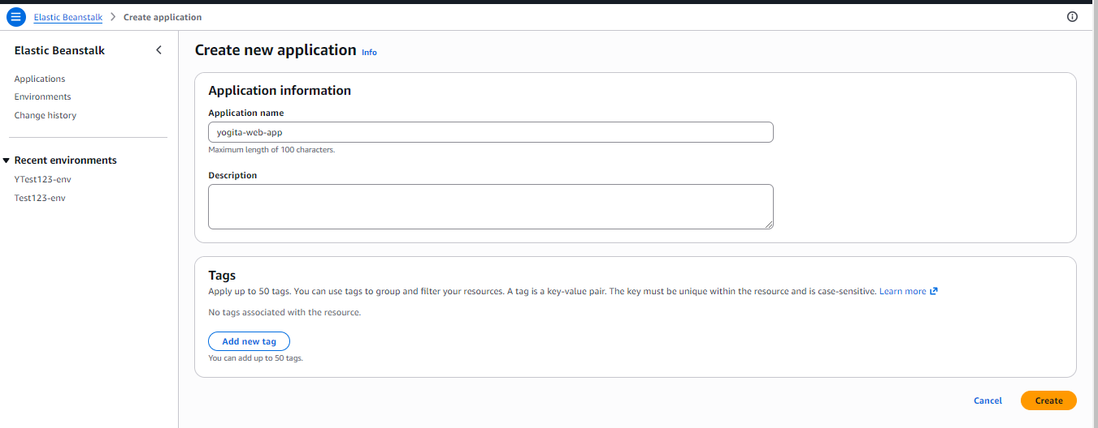
- Click on Create Environment
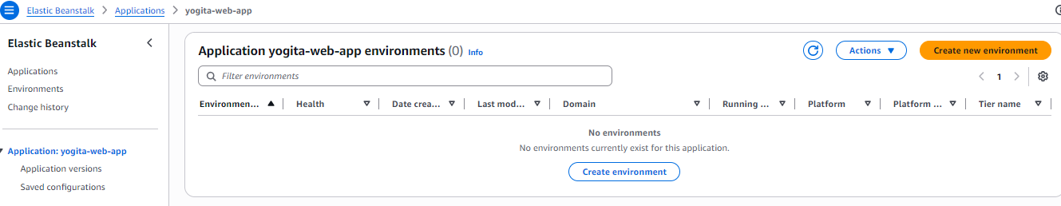
- Environment → Web server environment
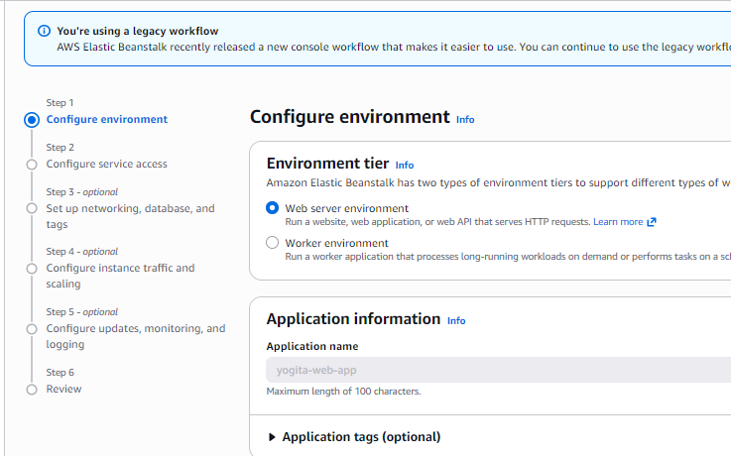
- Platform** → Scroll down and choose your language (PHP.)
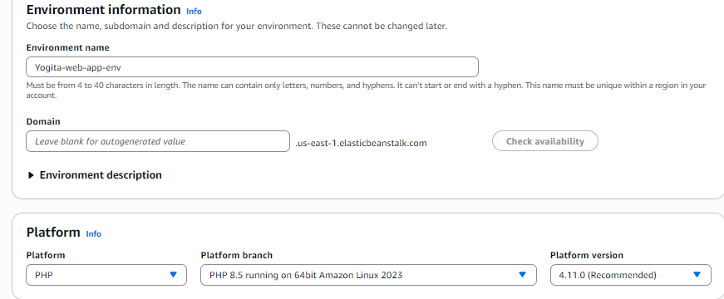

- Keep all default and Click on Next
: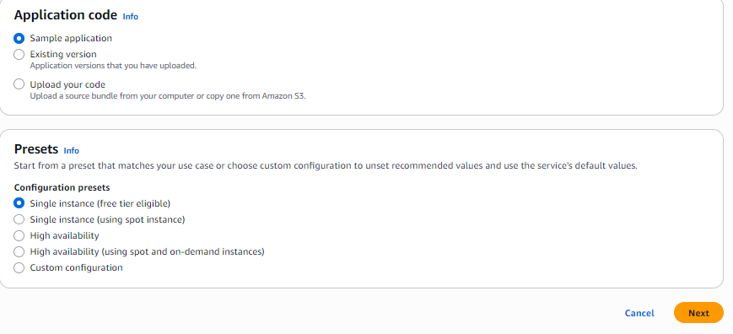
✅ Step 5: Configure service access
- Service role: select LabRole
- EC2 instance profile: select LaInstanceProfile
- EC2 key pair: Already create key you have( eg. ubuntupemkey I created for ubuntu pem key )
- Press Next

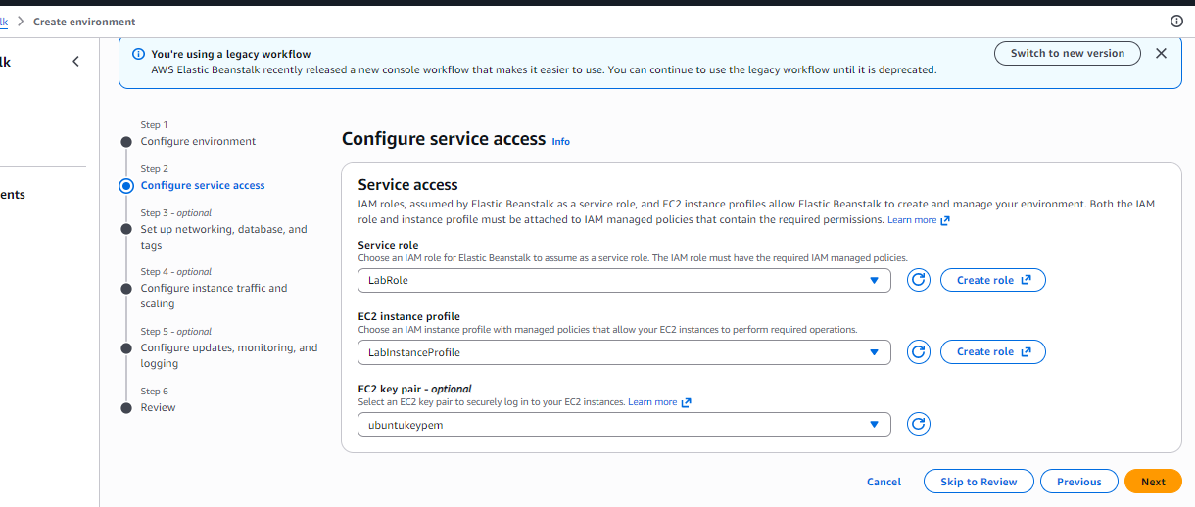
- Keep all default and Click on Skip to Review
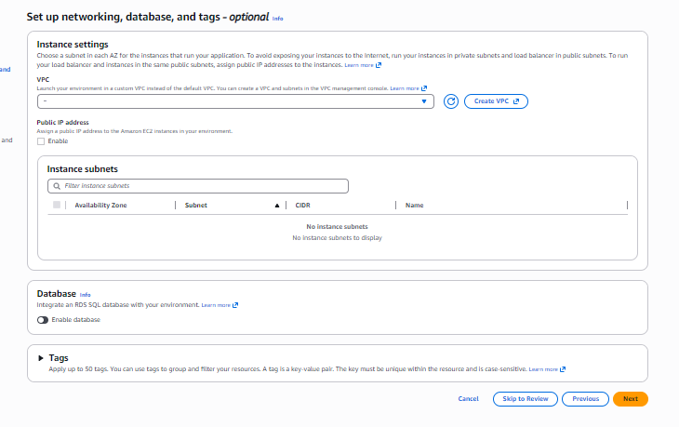
Scroll down and click on create
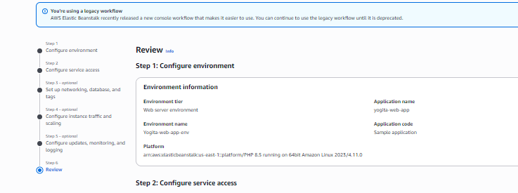
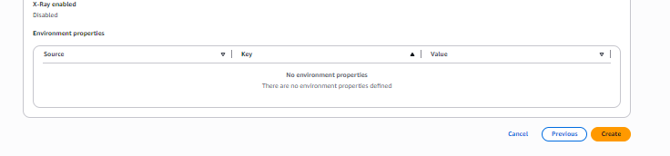
✅ Step 6: Environment “Yogita-web-app-env” launched successfully
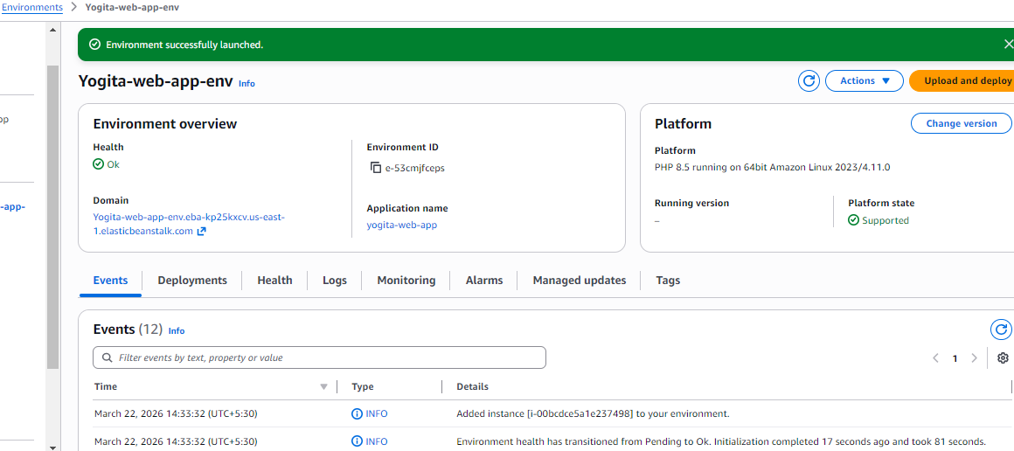

Note: Wait for some time and see all these appear in your created environment
At Health -> Ok in Green must appear
Application name -> yogita-web-app

Domain -> Yogita-web-app-env.eba-kp25kxcv.us-east-1.elasticbeanstalk.com

Platform state -> Supported

Check all Events (10 / 12) have no error in red

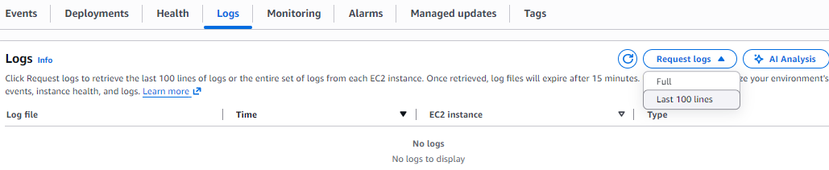
Optional: At Logs press on Request logs. Here you specify Last 100 lines. The download the file appear, and you can open it and see if errors are present. No error no need of this.
✅ Step 7: Access Your App
- You’ll get a URL under Domain :
- Yogita-web-app-env.eba-kp25kxcv.us-east-1.elasticbeanstalk.com
- Click on it / Open it → your app is LIVE

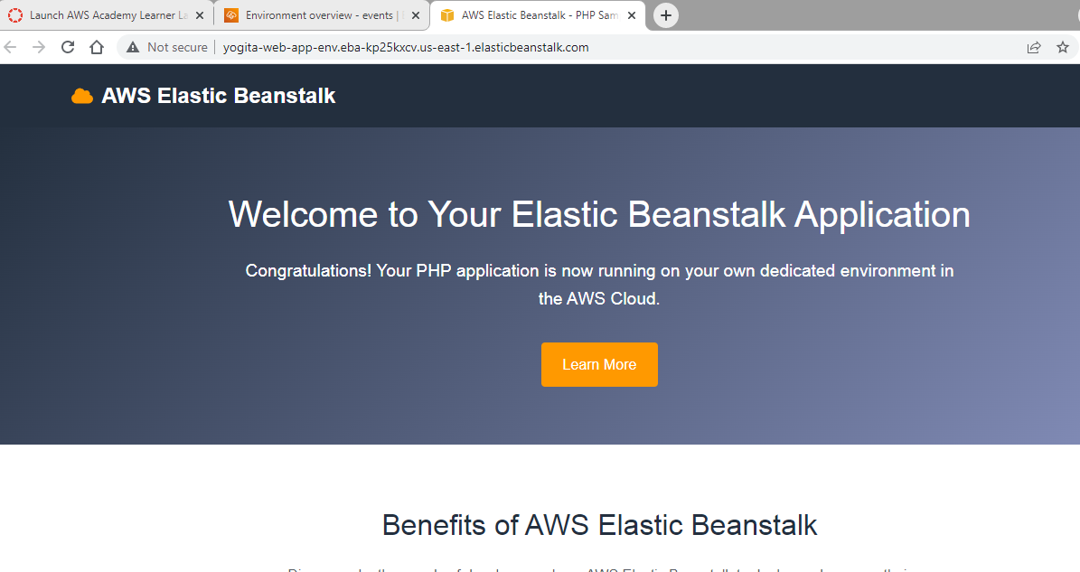
✅ Step 8: Deploy your code
- Click on **Upload and Deploy**
- Choose **Upload your code**
- Select your `.zip` file i.e. “demo.zip” created in Step 2
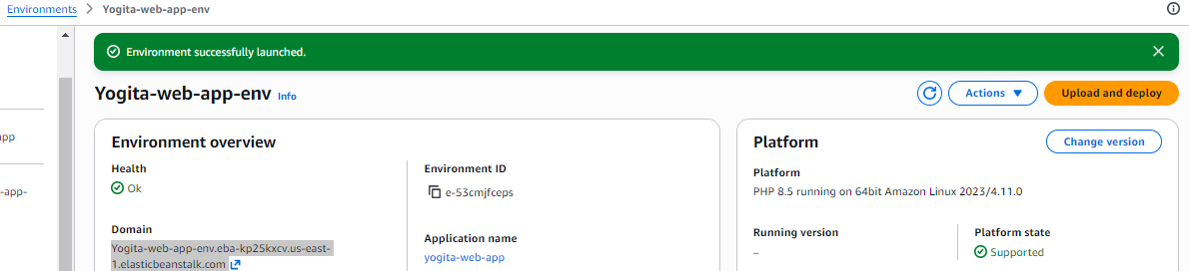
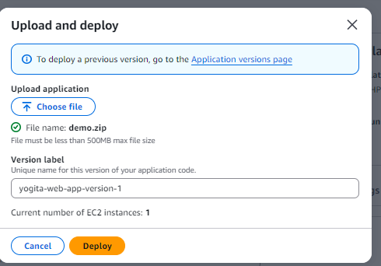
Click on Deploy
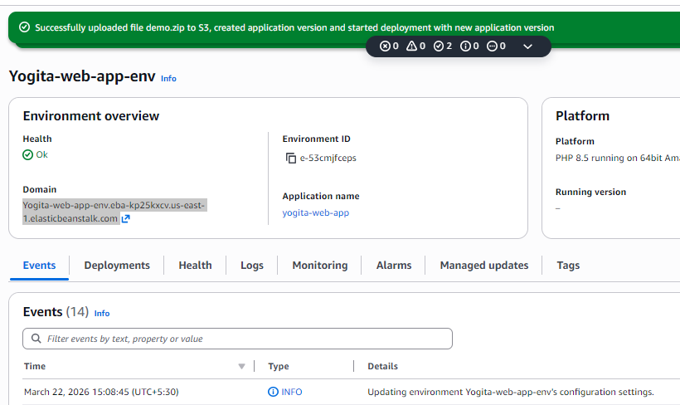
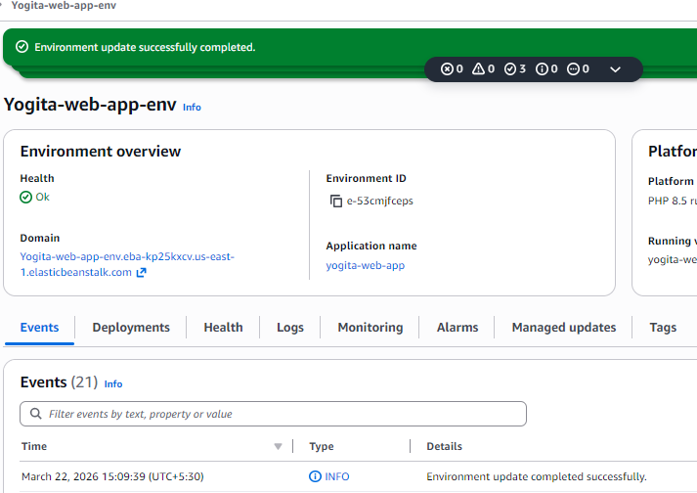

✅ Step 9: Open URL to see deployed code output
- You’ll get a URL under Domain :
- Yogita-web-app-env.eba-kp25kxcv.us-east-1.elasticbeanstalk.com
- Click on it
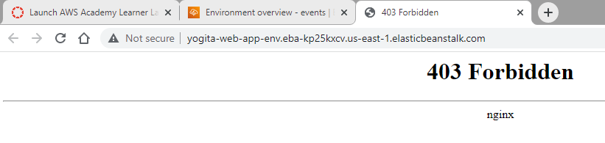
It shows error, so specify path as including /demo
yogita-web-app-env.eba-kp25kxcv.us-east-1.elasticbeanstalk.com/demo
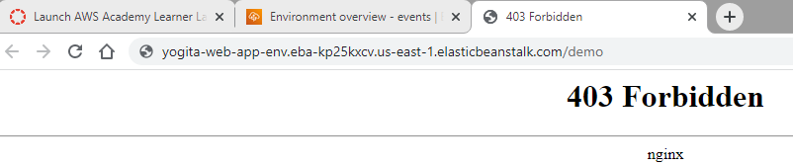
Output appears as below: Hello World
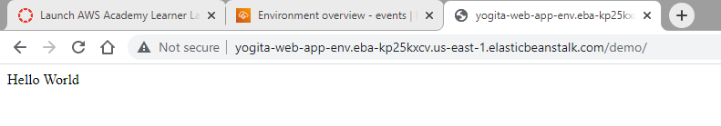
✅ Step 10: Check Logs (if error)
If something fails:
- Go to **Elastic Beanstalk Dashboard**
- Click your environment
- Click **Logs → Request logs**
- Here you specify Last 100 lines.
- The download the file appear, and you can open it and see for errors.
✅ Step 11: Terminate all
Environments-> Actions-> Terminate Environment
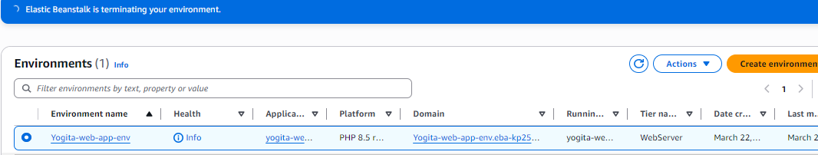
Or here
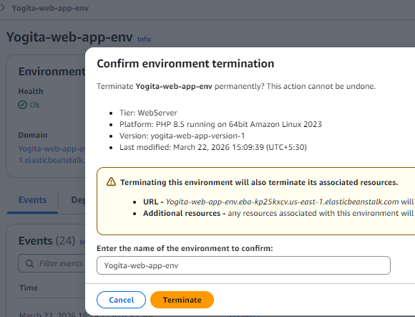
Click on Application, select Action and Delete Application

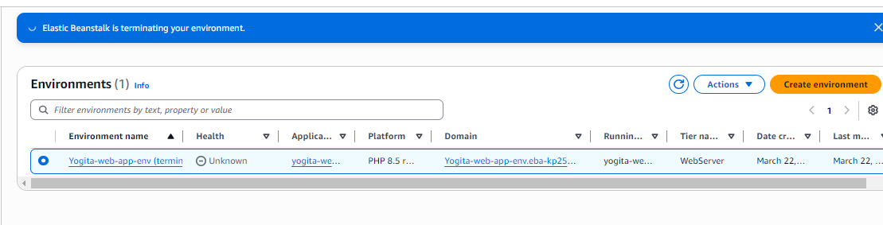
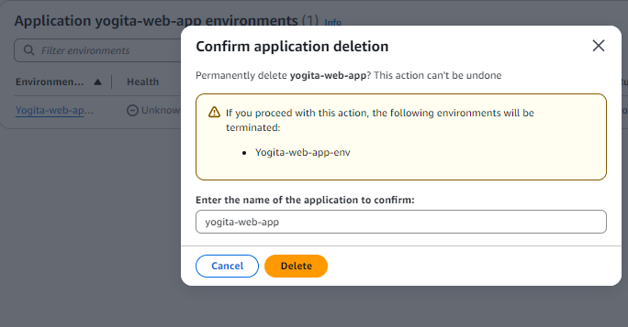

With Answers
Scenario 1: File Not Displaying (404 Error)

You see a 404 error instead of “Hello World.”

**Answer:**

* The `index.php` file is likely inside a subfolder (`demo/`) instead of root.
* Elastic Beanstalk expects `index.php` at the root level.
* Adding `/demo` works because the file exists inside that folder.
* ✅ Fix: Zip the contents directly (not the folder), so `index.php` is at the root.

## 🔹 Scenario 2: Wrong Platform Selected

**Q:** You selected Node.js instead of PHP.

**Answer:**

* The app won’t execute PHP code → may show raw code or error.
* Platform matters because EB installs language-specific runtime.
* ✅ Fix: Create a new environment with PHP (platform cannot be changed easily).

## 🔹 Scenario 3: Application Health Warning (Yellow)

**Q:** Health shows Warning instead of Green.

**Answer:**

* Possible reasons:

* Application errors
* Misconfiguration
* Low request traffic
* Check:

* Events (for errors)
* Logs (for details)
* Low traffic may not confirm health properly.

---

## 🔹 Scenario 4: 4xx Errors in Logs

**Q:** Logs show 100% HTTP 4xx errors.

**Answer:**

* 4xx = client-side errors (bad request, not found, unauthorized).
* Likely causes:

* Wrong URL path (missing `/demo`)
* File not found
* ✅ Verify URL and file location.

---

## 🔹 Scenario 5: Key Pair Issue

**Q:** You didn’t select a key pair.

**Answer:**

* You cannot SSH into EC2 instance.
* Troubleshooting becomes difficult.
* ✅ Fix:

* Recreate environment with key pair
* Or use logs instead of SSH

---

## 🔹 Scenario 6: Deployment Fails

**Q:** Upload and Deploy fails.

**Answer:**

* Possible issues:

* Incorrect zip structure
* Missing `index.php`
* Corrupted zip file
* ✅ Check:

* Logs in EB dashboard
* File structure inside zip

---

## 🔹 Scenario 7: Works Locally but Not on Cloud

**Q:** App works locally but not on Elastic Beanstalk.

**Answer:**

* Causes:

* Different environment configuration
* File permissions
* Path issues
* ✅ Debug:

* Check logs
* Verify file paths and dependencies

---

## 🔹 Scenario 8: Blank Page Output

**Q:** App loads but shows blank page.

**Answer:**

* Causes:

* PHP errors not displayed
* Syntax error in code
* ✅ Fix:

* Enable error reporting in PHP
* Check logs for errors

---

## 🔹 Scenario 9: Domain Not Accessible

**Q:** Domain doesn’t open.

**Answer:**

* Possible reasons:

* Environment still launching
* Deployment failed
* ✅ Check:

* Health status (should be Green)
* Events tab for errors

---

## 🔹 Scenario 10: Forgot to Terminate Environment

**Q:** You didn’t terminate resources.

**Answer:**

* AWS continues charging 💸
* Services still running:

* EC2
* Load balancer
* Storage
* ✅ Fix:

* Go to Environment → Terminate

---

## 🔹 Scenario 11: High Traffic (Scaling)

**Q:** Traffic increases suddenly.

**Answer:**

* Elastic Beanstalk supports auto-scaling.
* Add more EC2 instances automatically.
* ✅ If not configured:

* App may crash or slow down

---

## 🔹 Scenario 12: Updated Code Not Visible

**Q:** Users still see old output.

**Answer:**

* Possible reasons:

* Code not redeployed
* Browser caching
* ✅ Fix:

* Redeploy application
* Hard refresh (Ctrl + F5)

---

# 🎯 Quick Revision Tip

Think of Elastic Beanstalk like this:

* 📦 ZIP → Upload code
* ⚙️ Platform → Runs your language
* 🌐 URL → Access your app
* 📊 Logs → Debug issues
* ❌ Terminate → Save money

