WEEK-11—Amazon LEX

Step 1: Open Amazon Lex
- Login to AWS Console
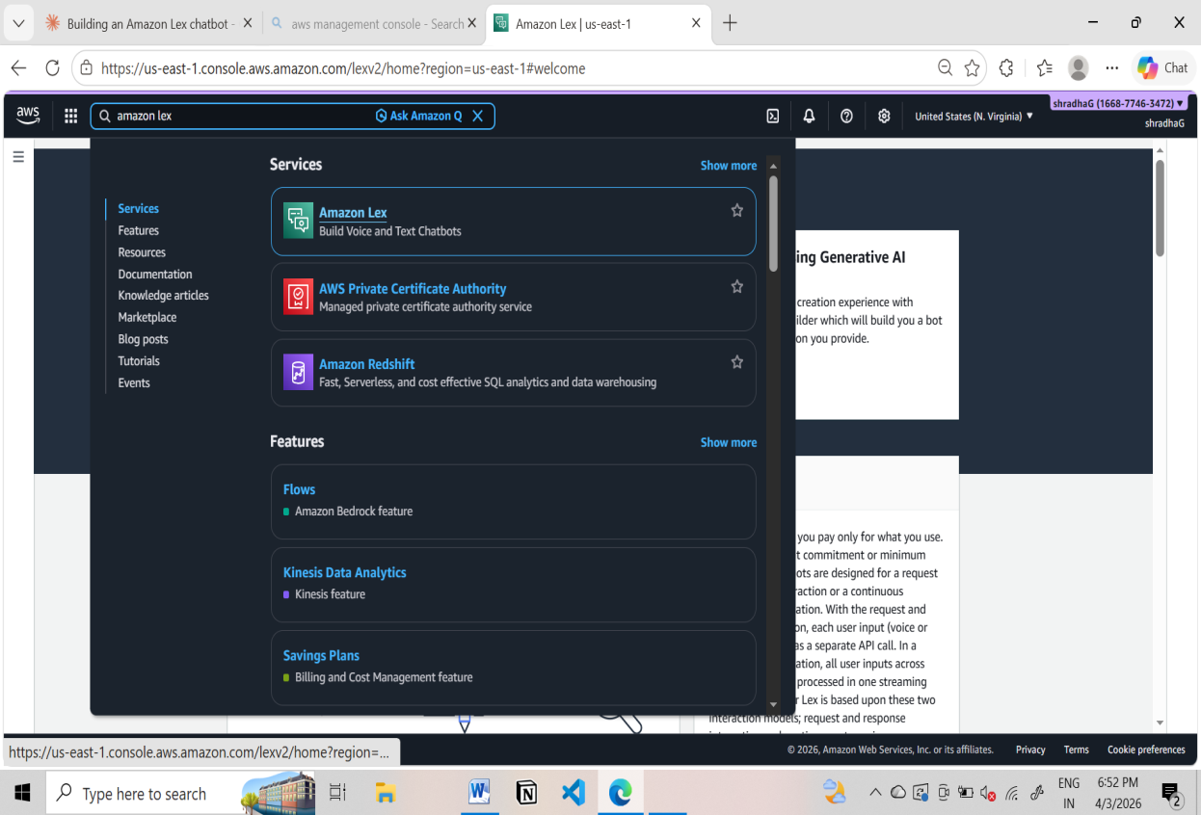

- Search Amazon Lex

- Click Create bot
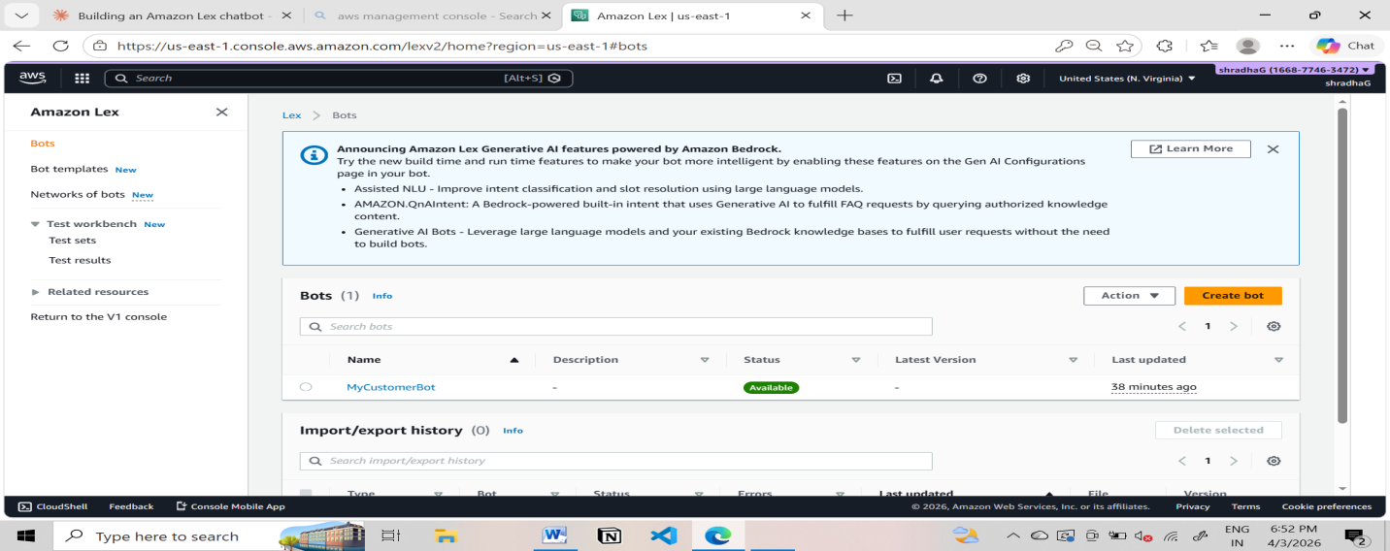

Step 2: Create Bot
- Choose:
  - Create a blank bot
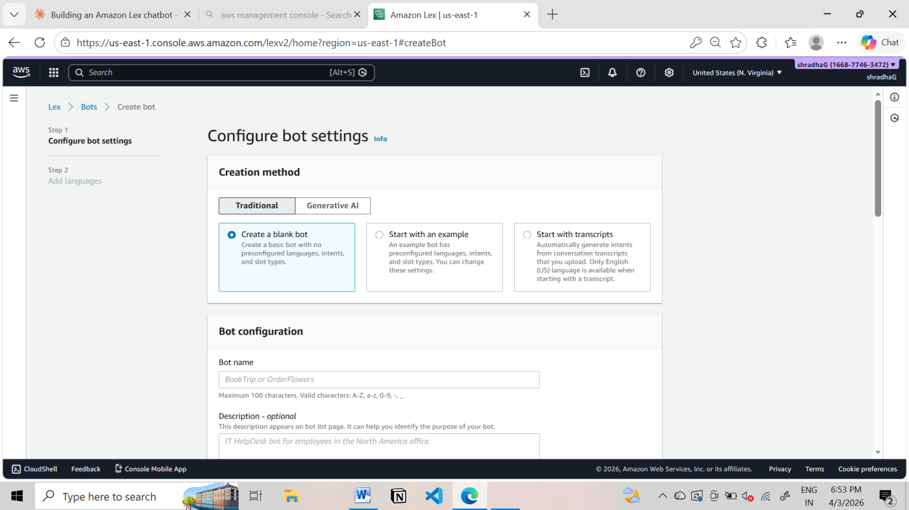

- Enter:
  - Bot name: YogitaHotelBookingBot
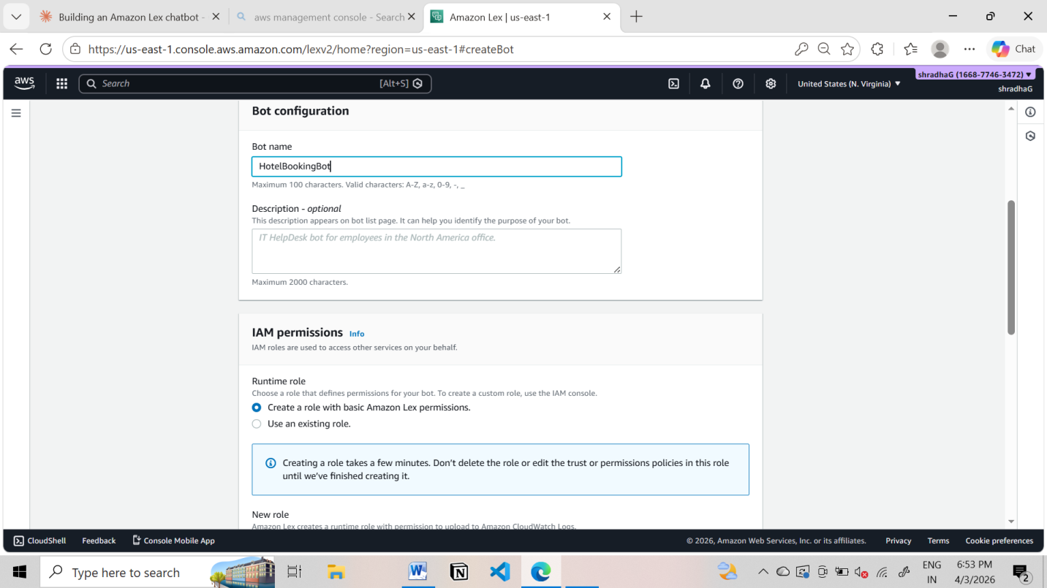

- IAM role → Create new role
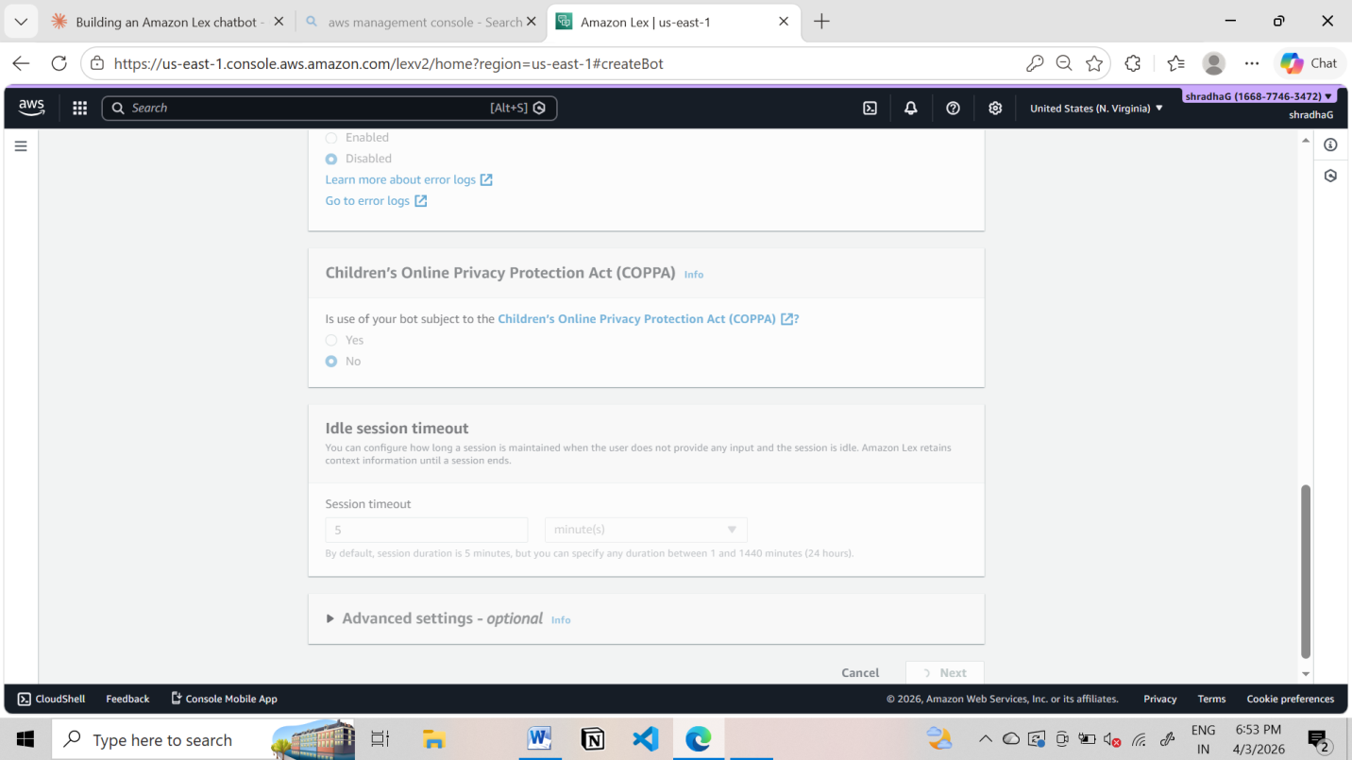

- Remaining defaultnext
- Language: English
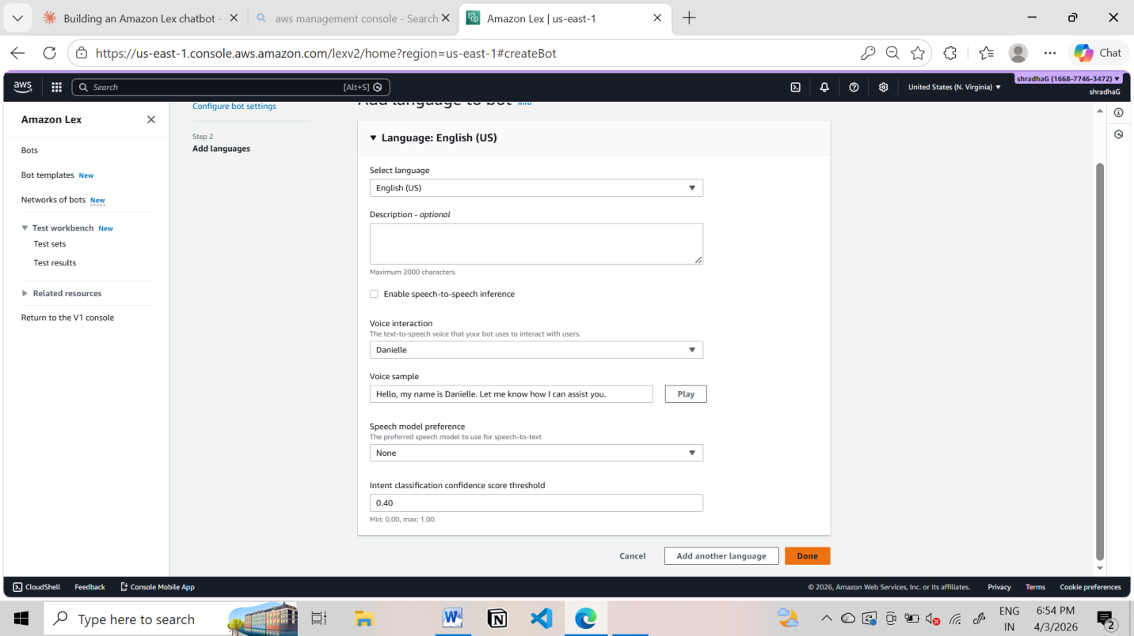
- Voice (optional)
- Click Done

Step 3: Create Intent
- Go to Intents
- Name: BookHotel
- Click Create
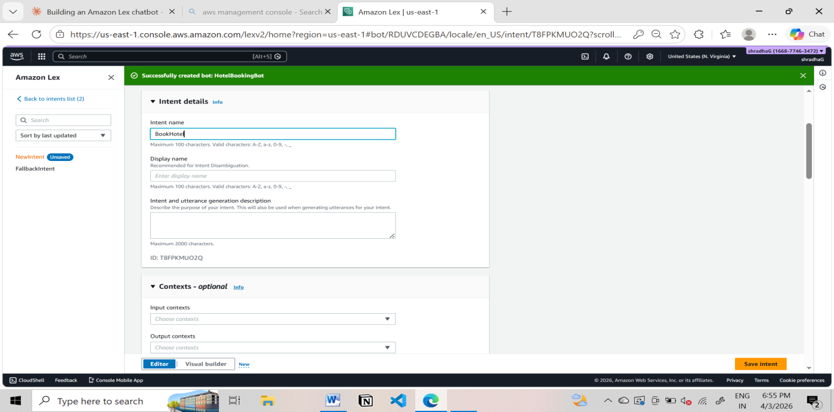

Step 4: Add Sample Utterances
Add user sentences (how user talks):
I want to book a hotel
Book a room
Reserve hotel
I need a room
These are Utterances
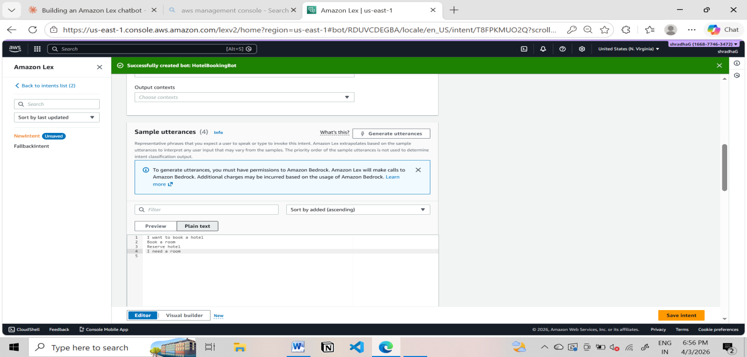

Step 5: Create Slots (User Inputs)
Slots collect user information.
Add Slot
- Click Add slot
- Fill:
  - Slot name: age
  - Slot type: AMAZON.Number
  - Prompt: What is your age?
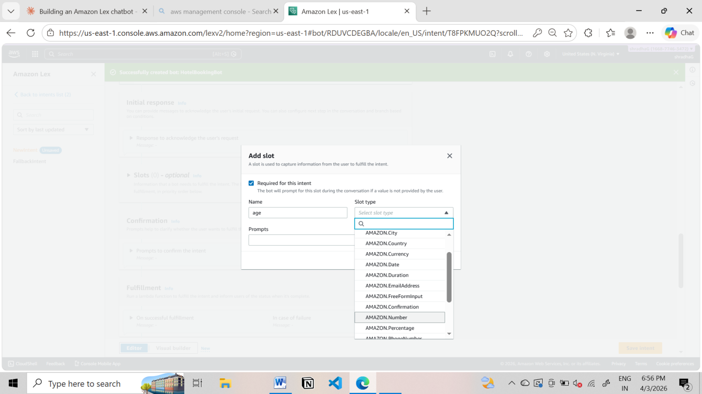
Mark as Required
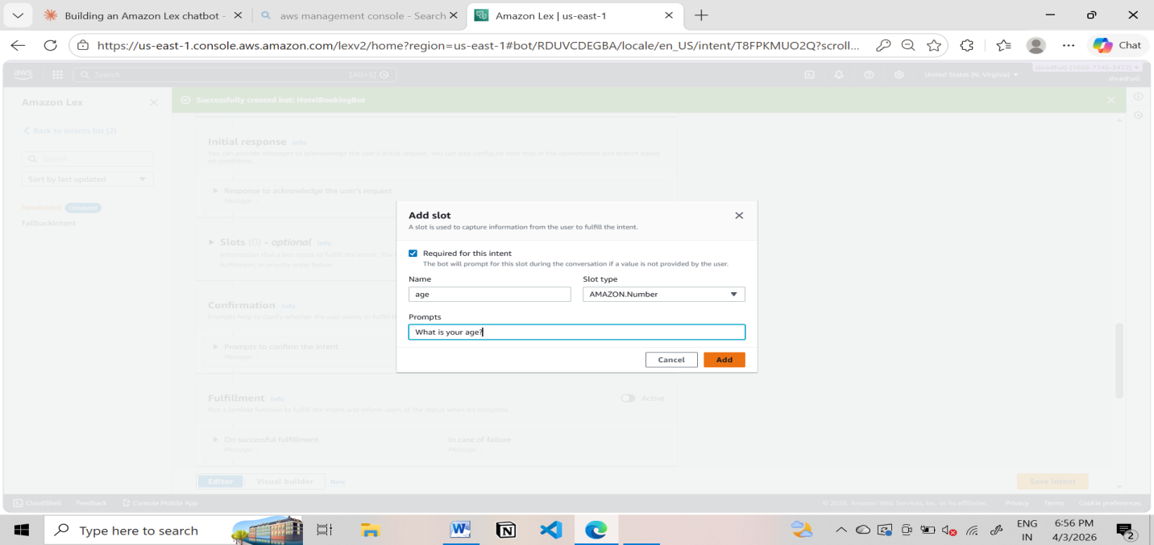
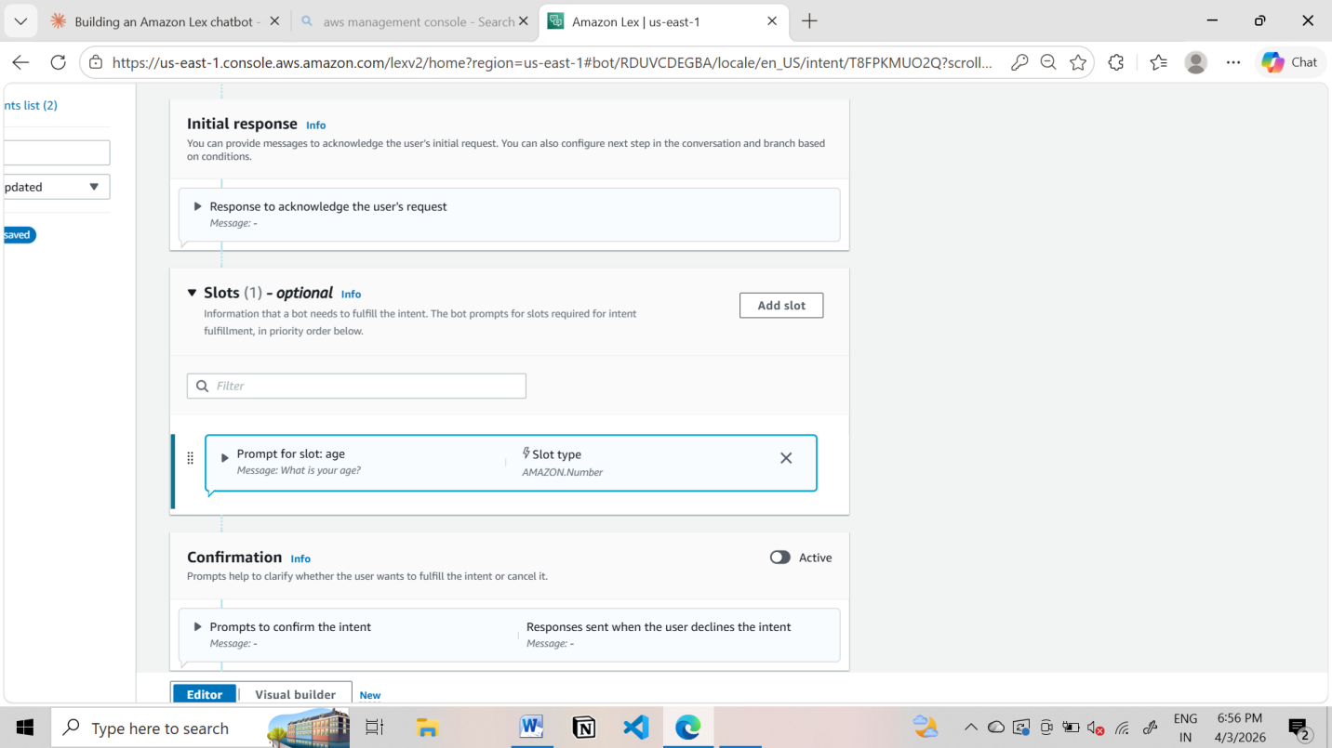
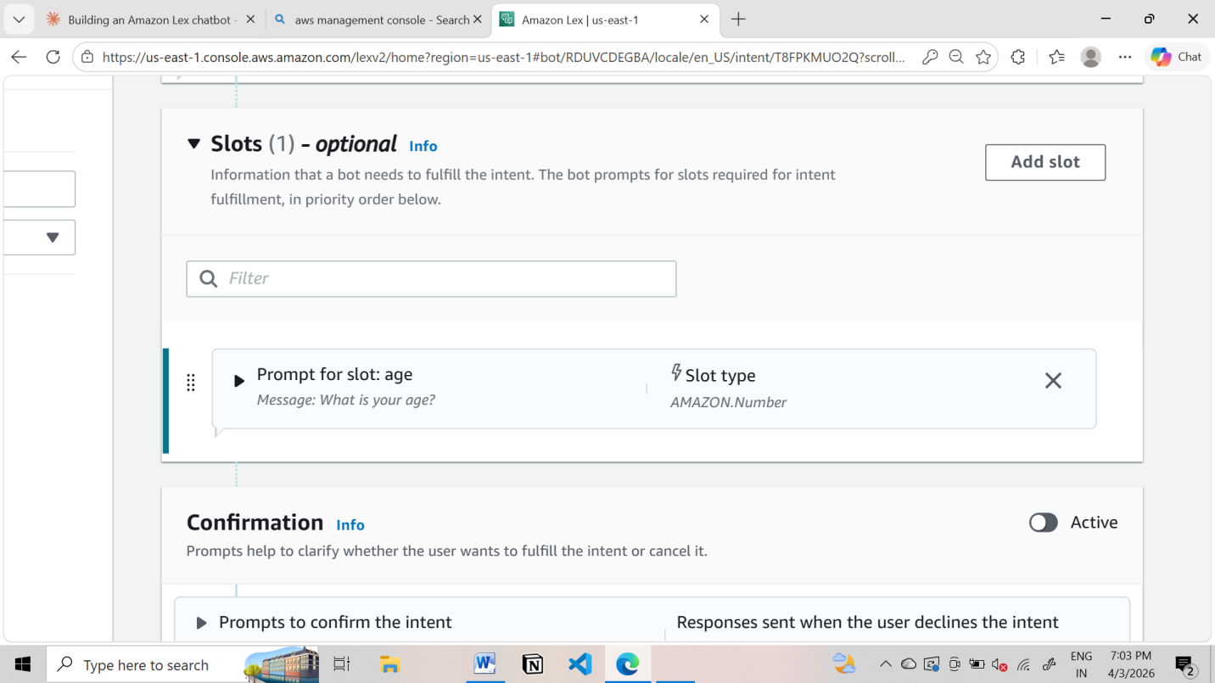
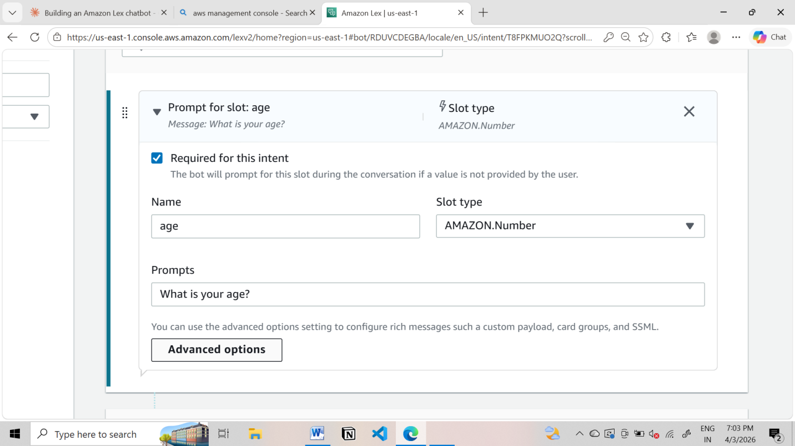
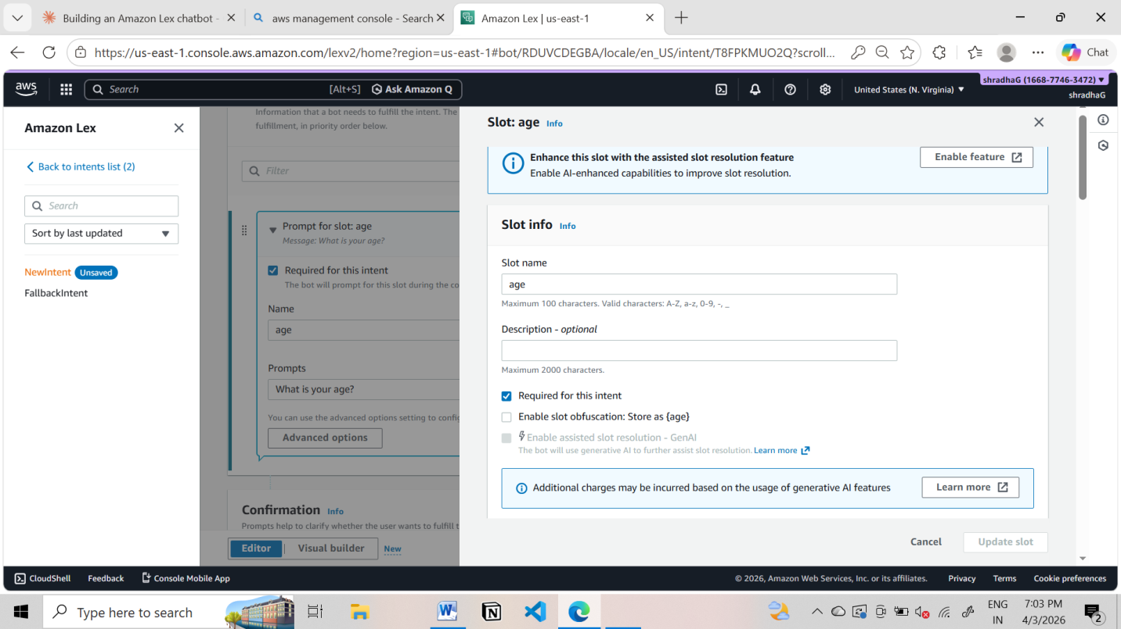
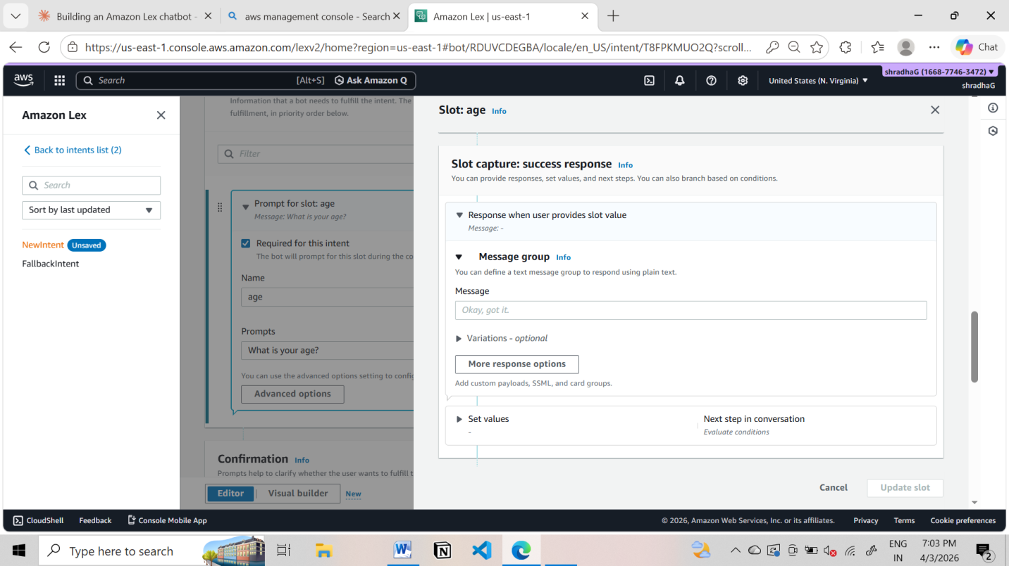

Add IF Conditions (Conditional Logic)
Used to control flow based on slot values

Example Condition:
If {age} < 18
Steps:
- Go to Intent → Slots -> under Advance options
- Scroll to Slot capture: success response ->Conditional branching
- Click Add condition
Example:
Condition:
If {age} < 18
Response:
Your not eligible for hoot booking?
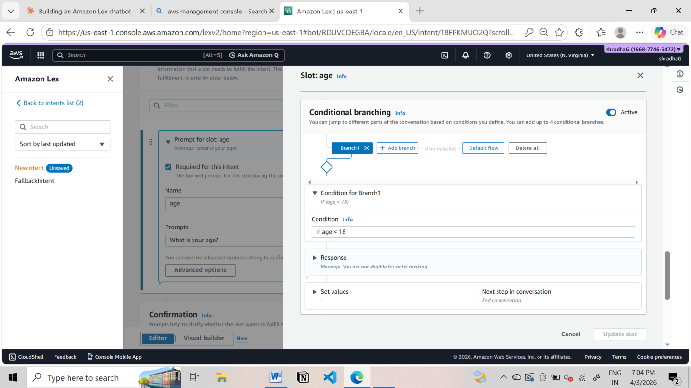

Step 6: Create Slots (User Inputs)
Slots collect user information.
Add Slot
- Click Add slot
- Fill:
  - Slot name: location
  - Slot type: AMAZON.City
  - Prompt: Which city do you want?
- Mark as Required

Repeat for other slots.
- Click Add slot
- Fill details:
  - Slot name: checkin
  - Slot type: AMAZON.Date
  - Prompt:
"What is your check-in date?"
- Mark as Required
(Optional but recommended)
  - Add Retry prompt:
"Please provide a valid date (e.g., 2026-03-25)"
- Click Save

Slot 7: Number of Nights (nights)
Steps:
- Click Add slot again
- Fill details:
  - Slot name: nights
  - Slot type: AMAZON.Number
  - Prompt:
"How many nights will you stay?"
- Mark as Required
- Click Save

Step 7: Create Custom Slot Type

Save intent

Click on Back to intents
If you want custom values:
- Go to Slot Types
- Click Add slot type ->add blank slot type
- Name: RoomType
Add values:
Single
Double
Suite
Save slot type
Now use this in slot: go back to intent
- Slot name: RoomType
- Slot type: RoomType
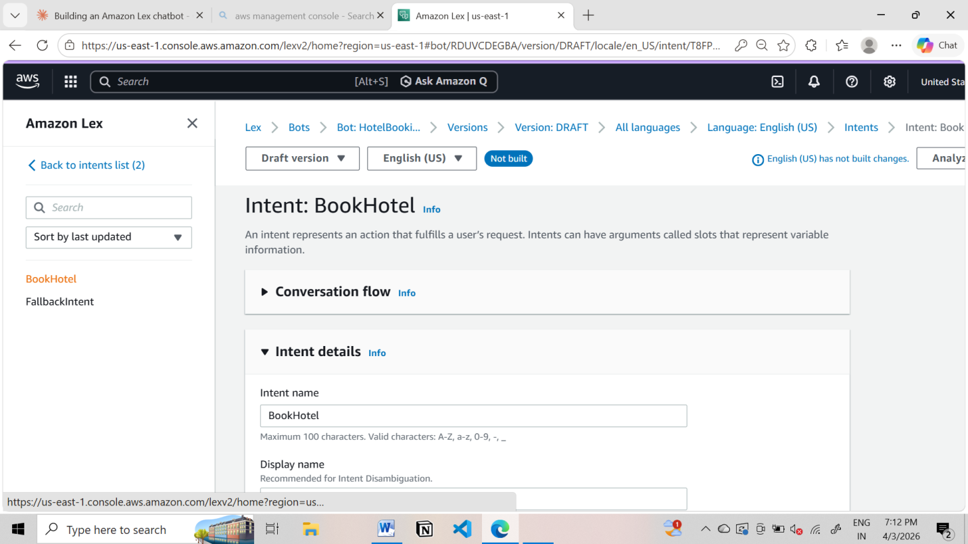
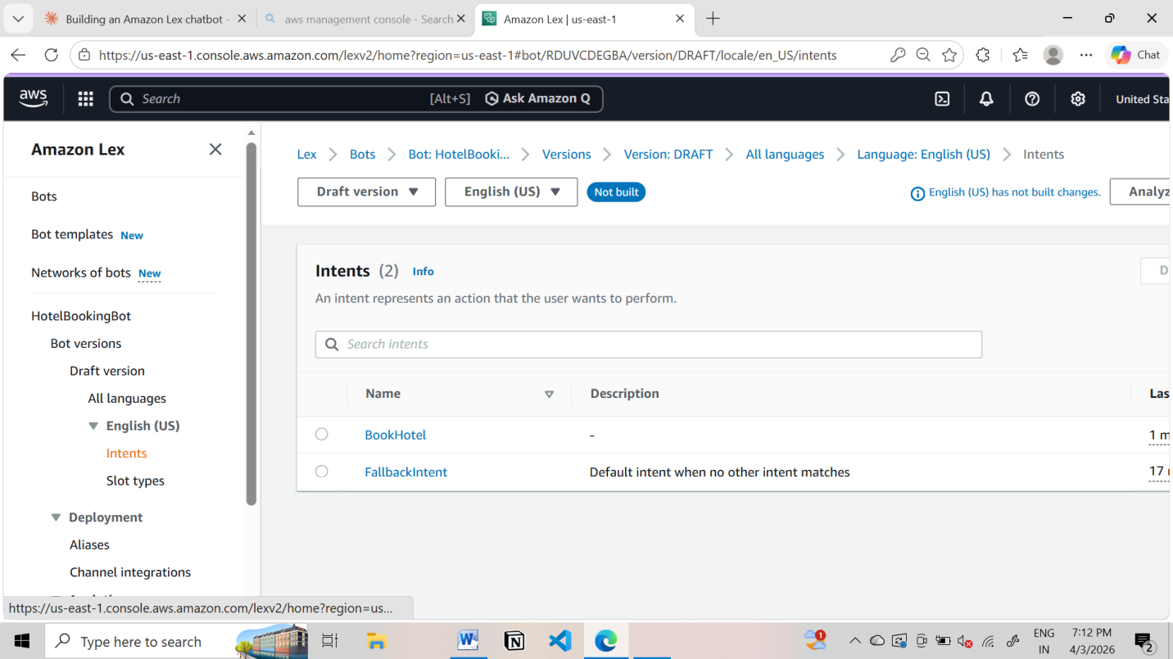

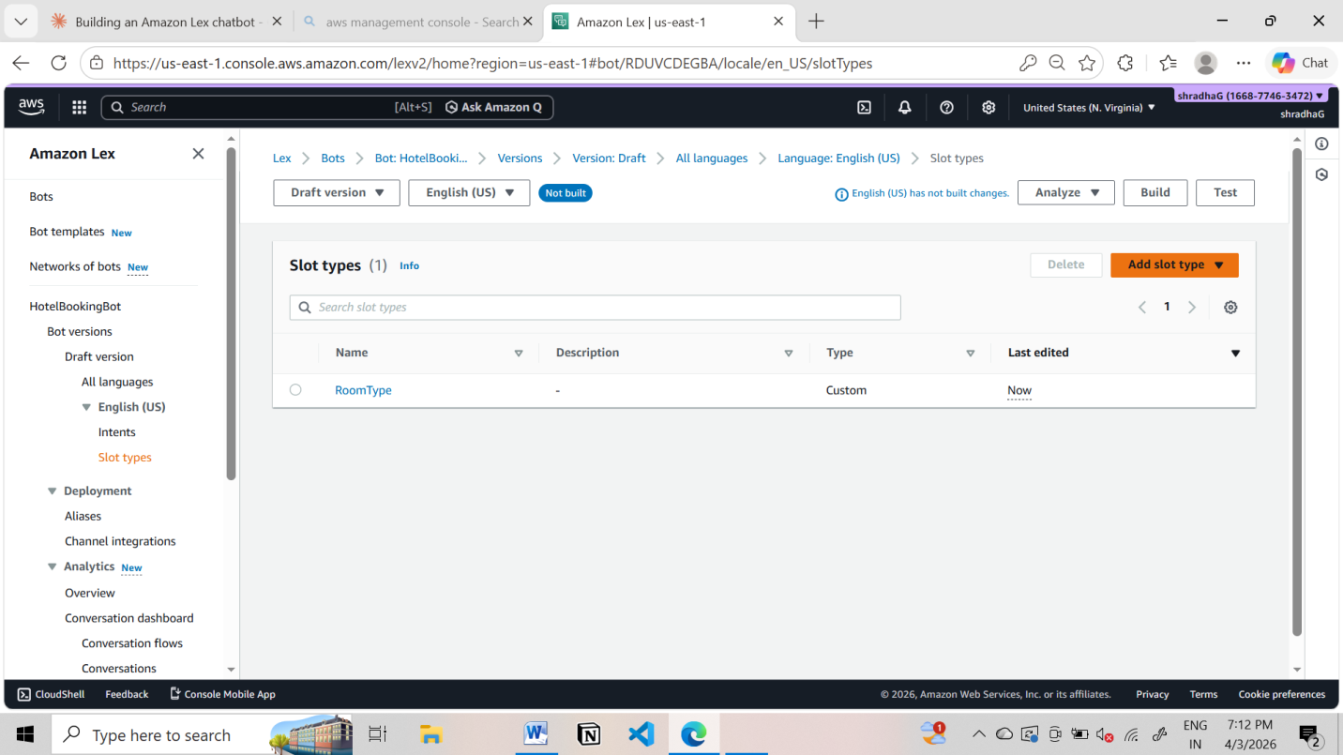
Step 9: Add Response Cards (Card Groups)
Used for buttons (quick replies)
Steps:
- Go to slot prompts -> more prompt options
- Click Add -> add card groups
Example:
Card Title: Select Room Type
click on add Buttons:
- Single → "Single"
- Double → "Double"
- Suite → "Suite"

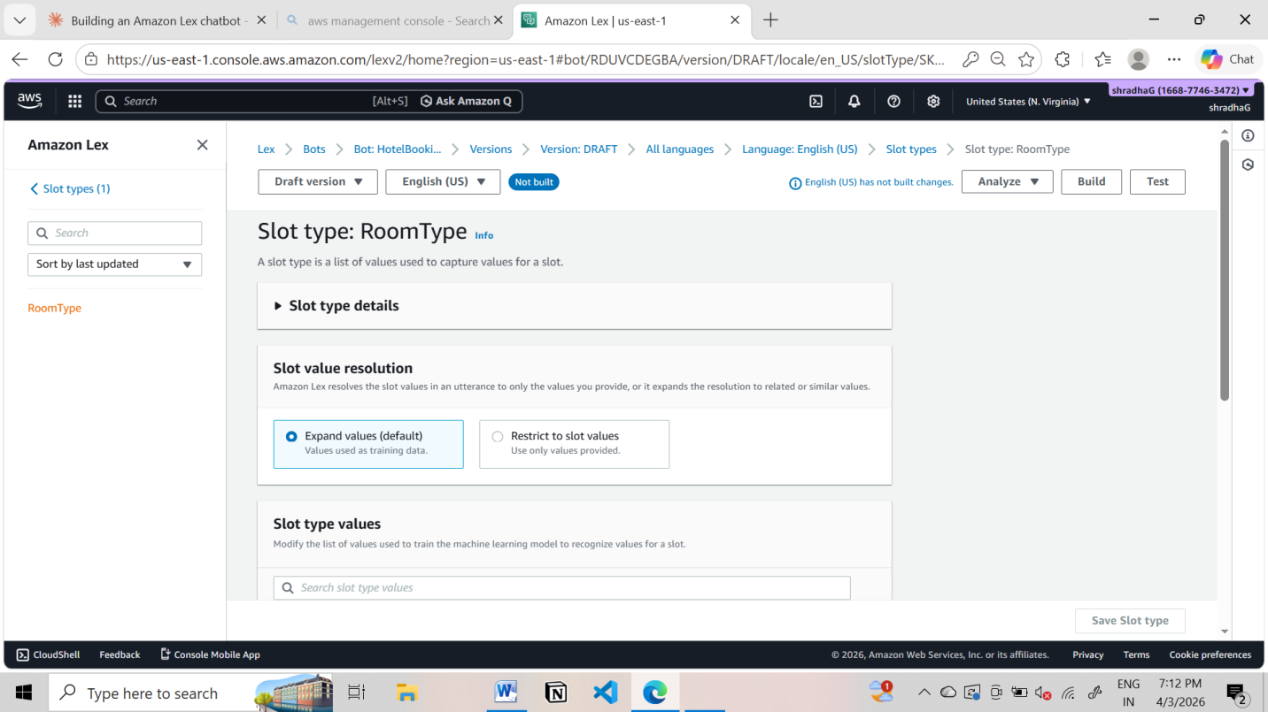

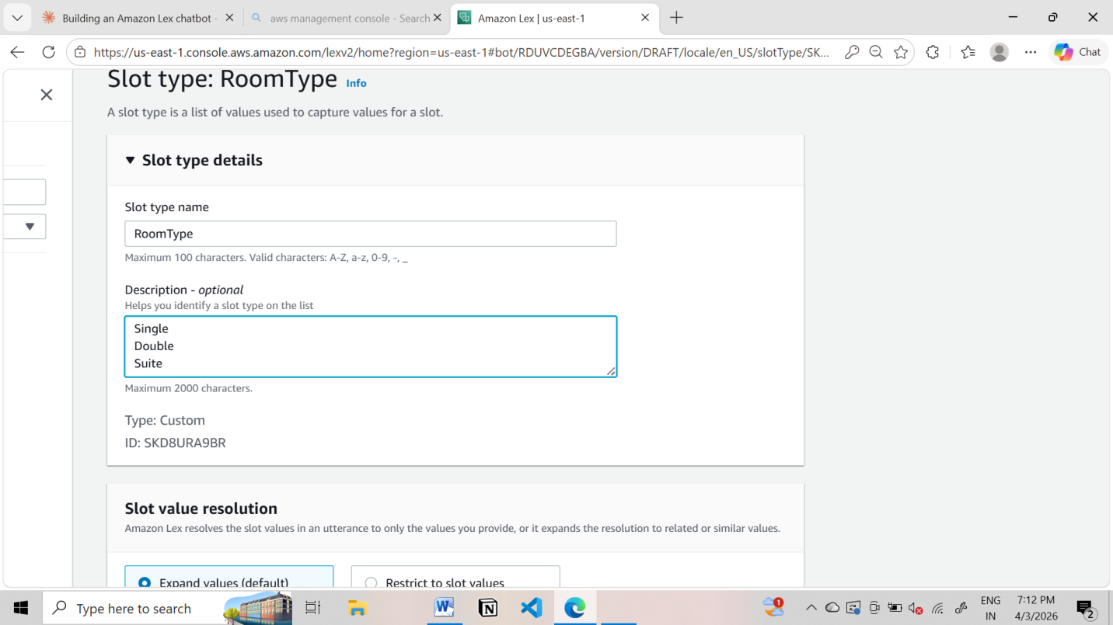

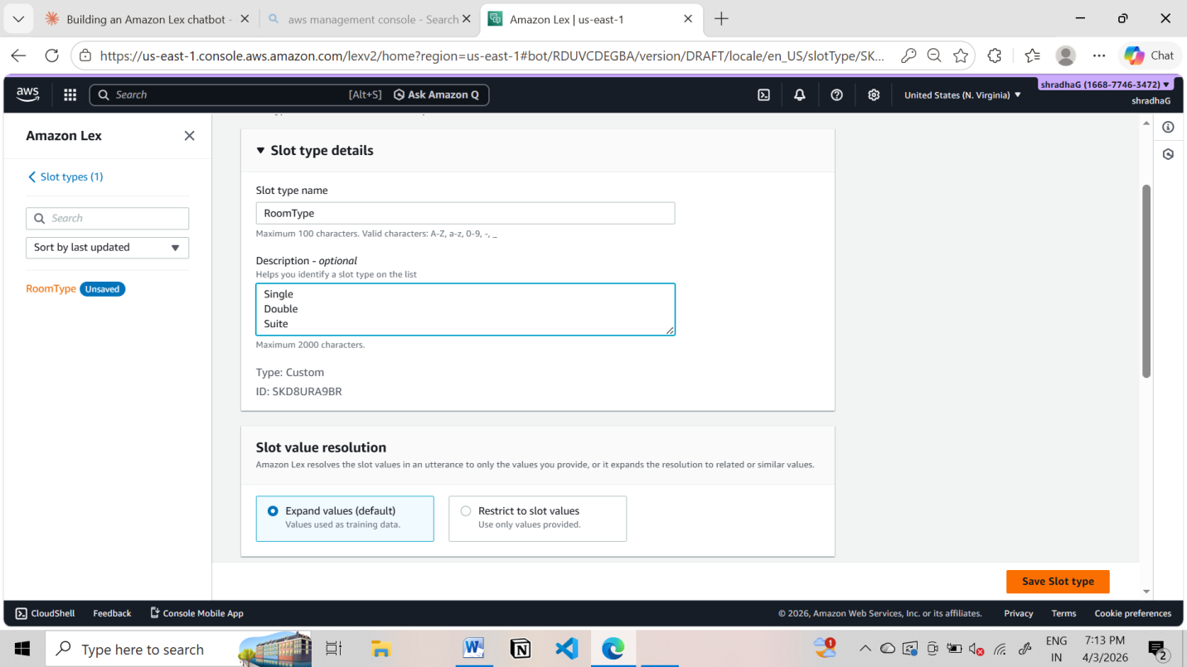

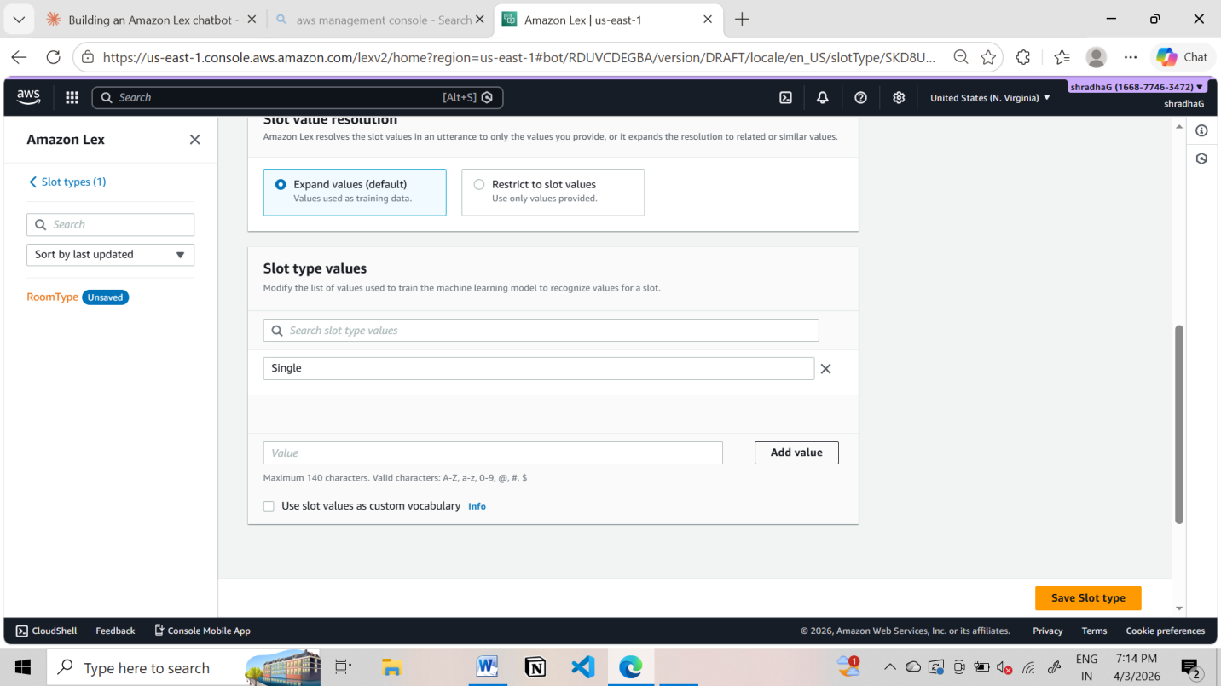
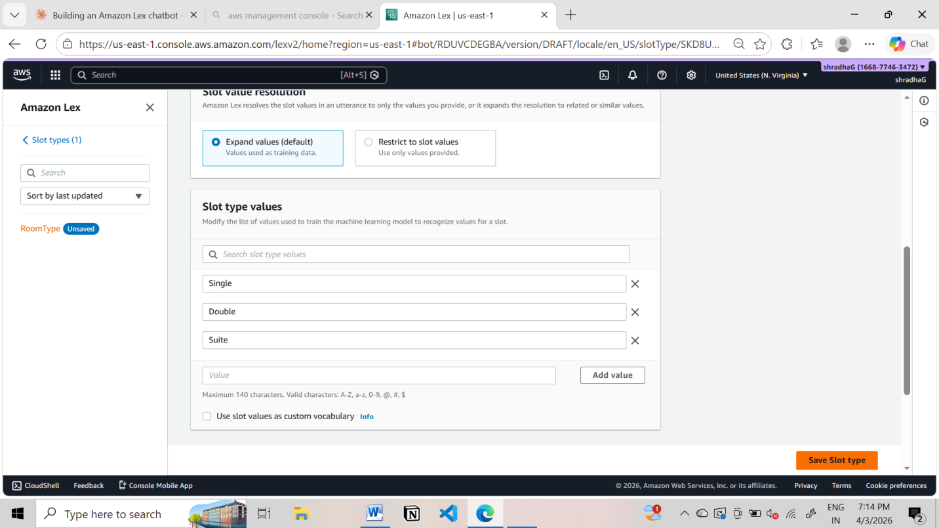
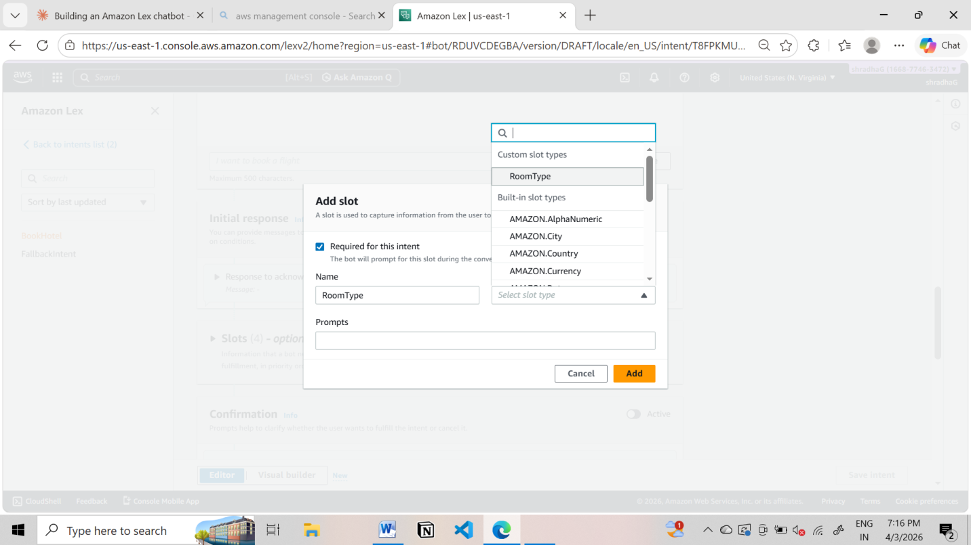

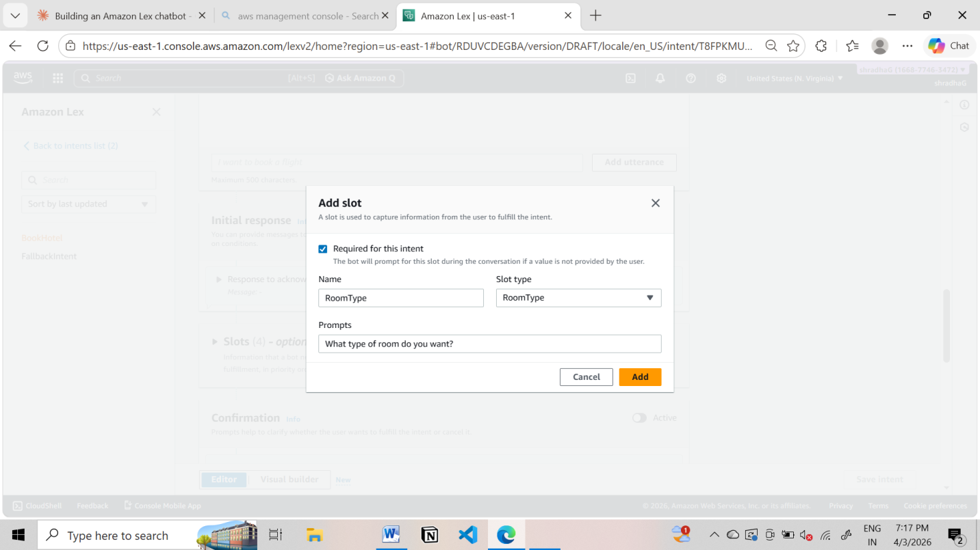

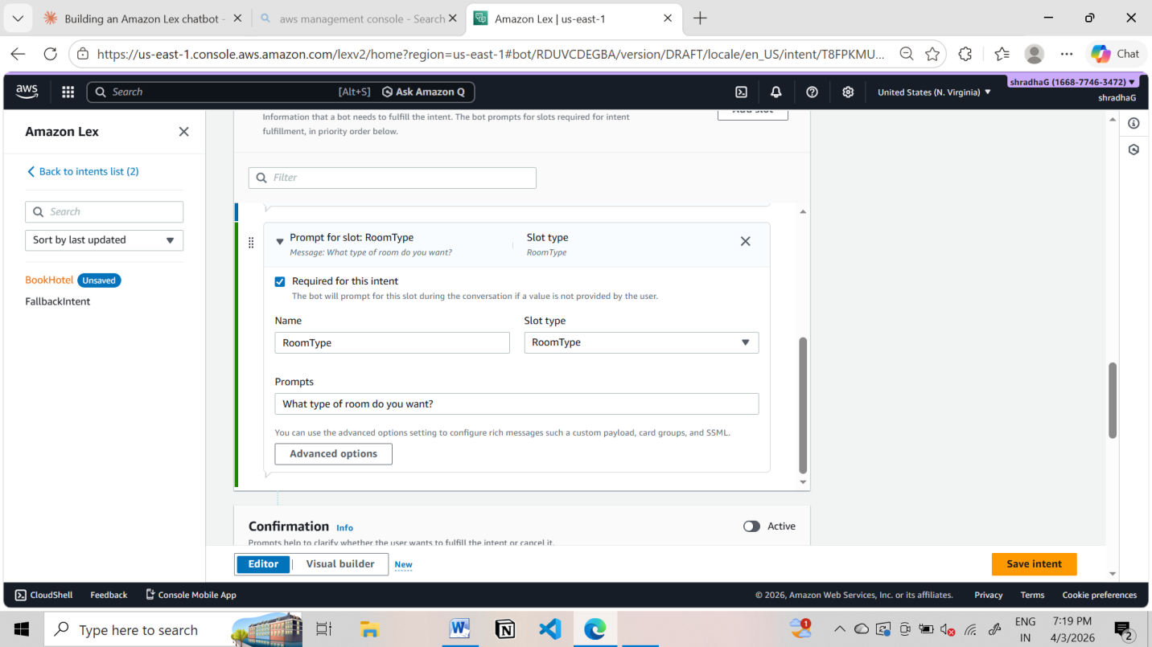

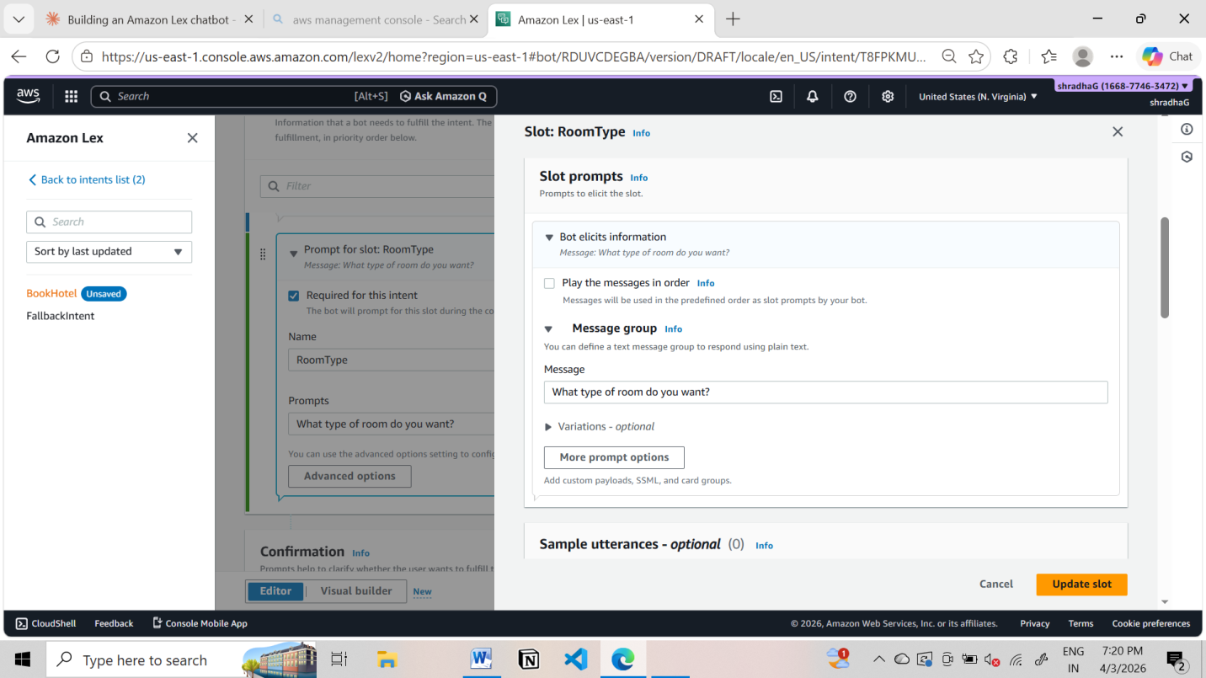

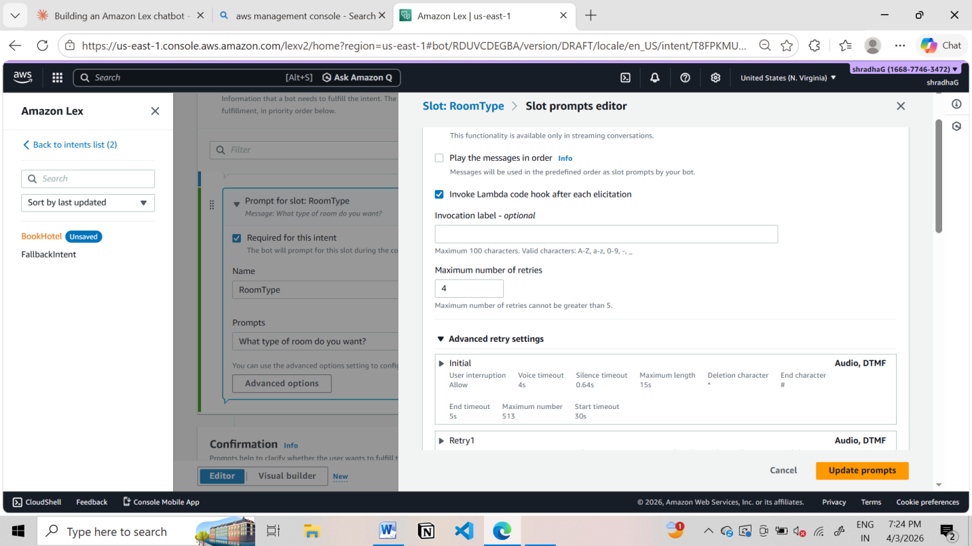
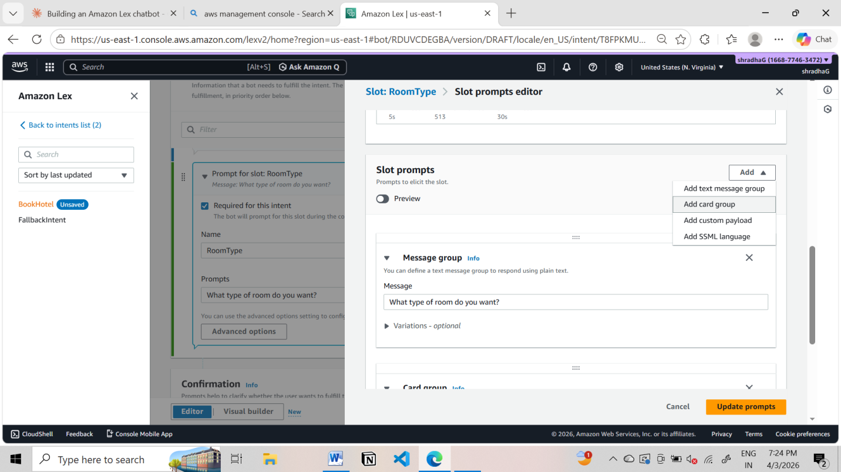

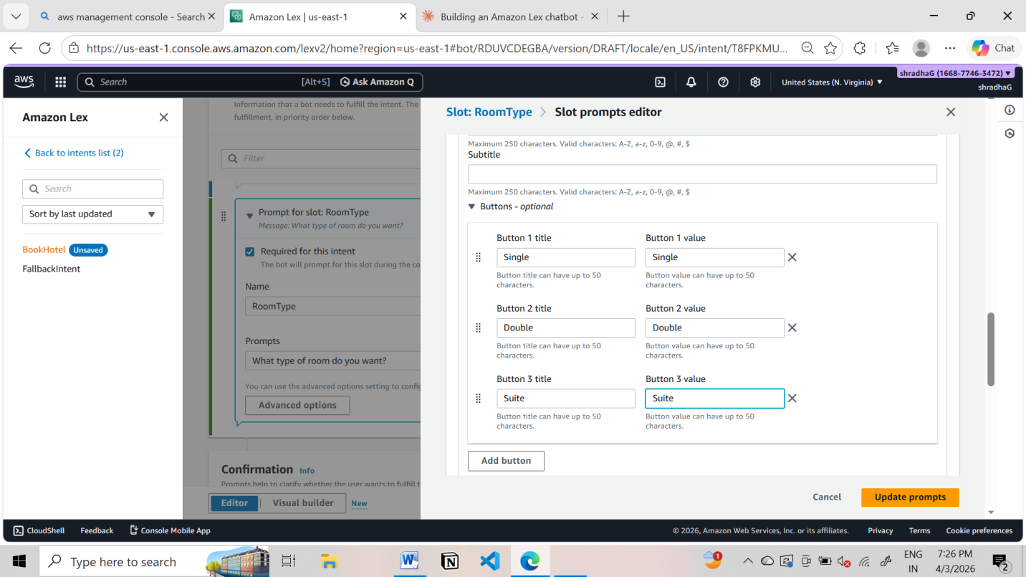

Step 10: Configure Responses
Initial Response:
Welcome to Hotel Booking! What is your name?
Confirmation:
Do you want to confirm booking in {location} for {nights} nights?
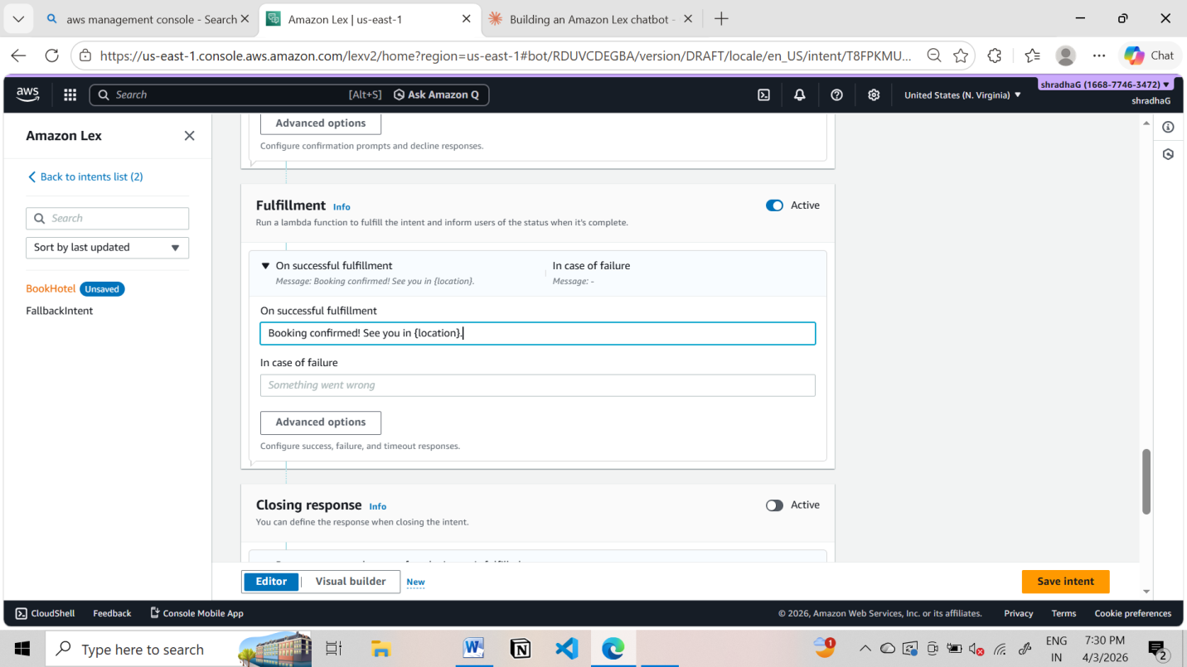

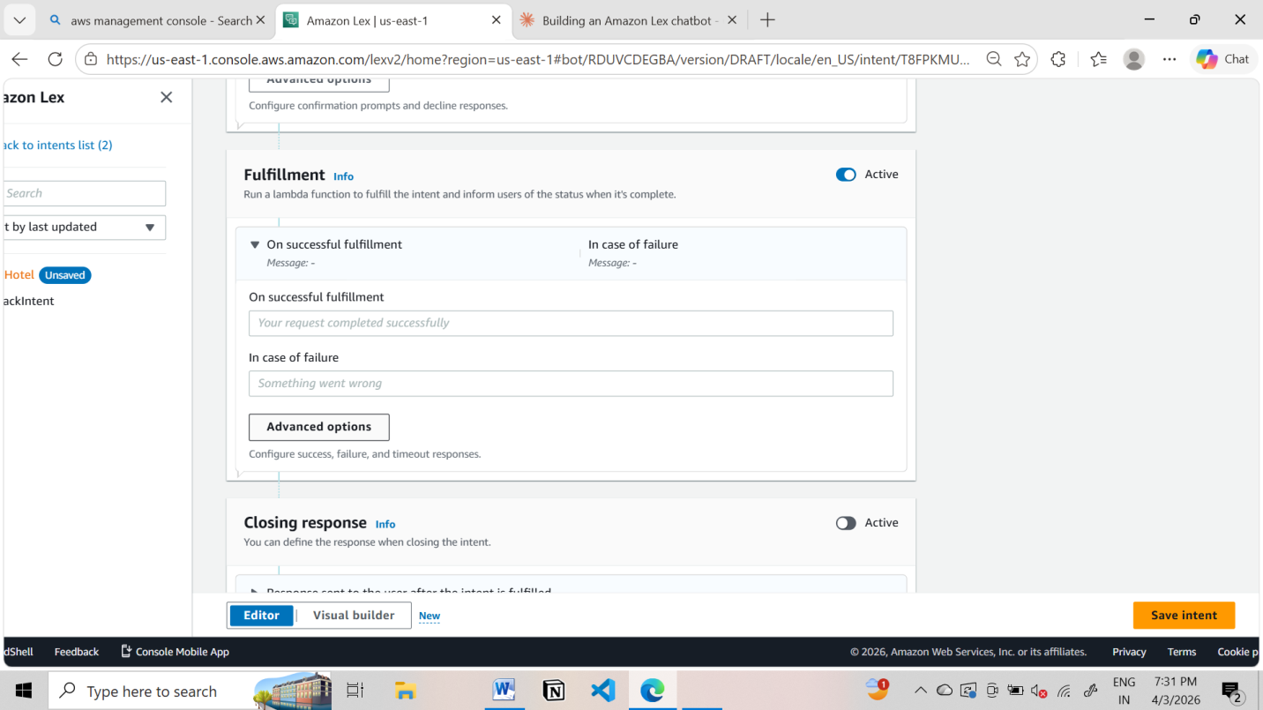
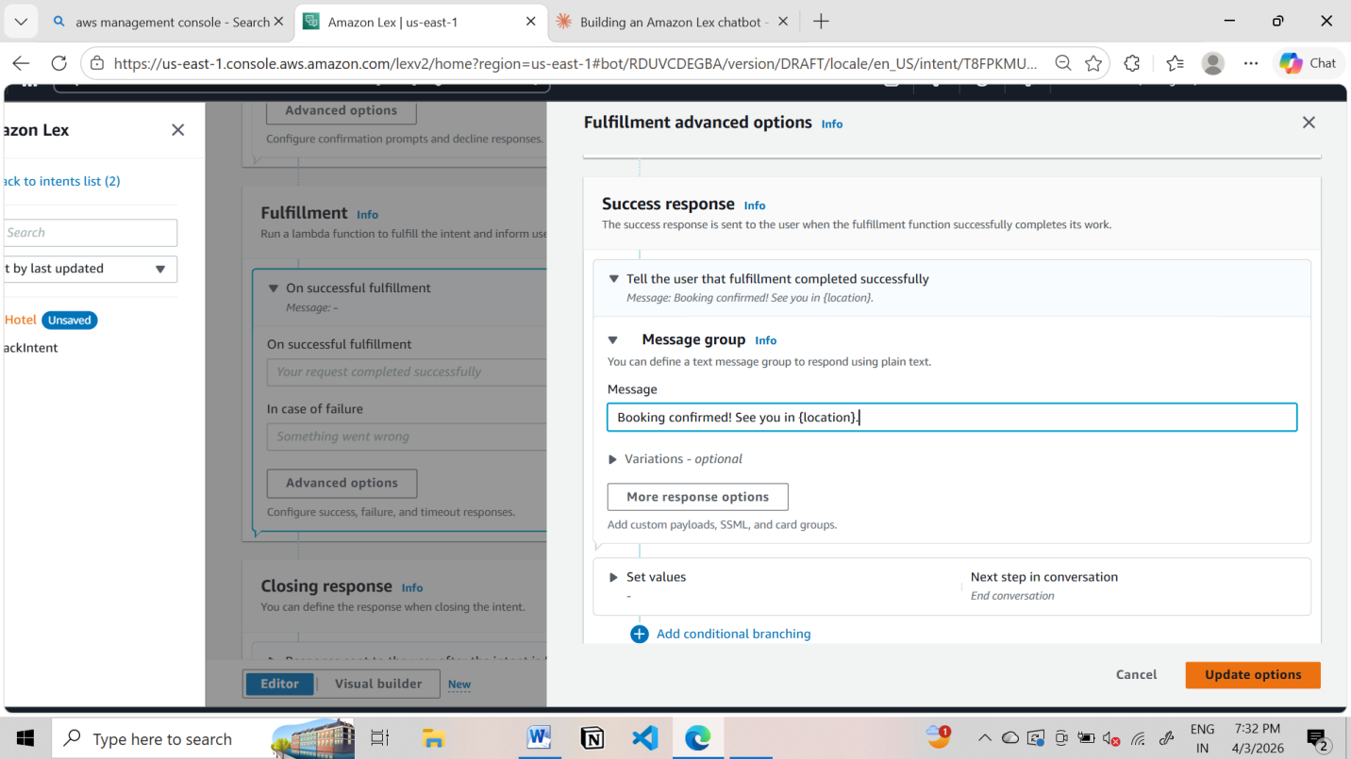

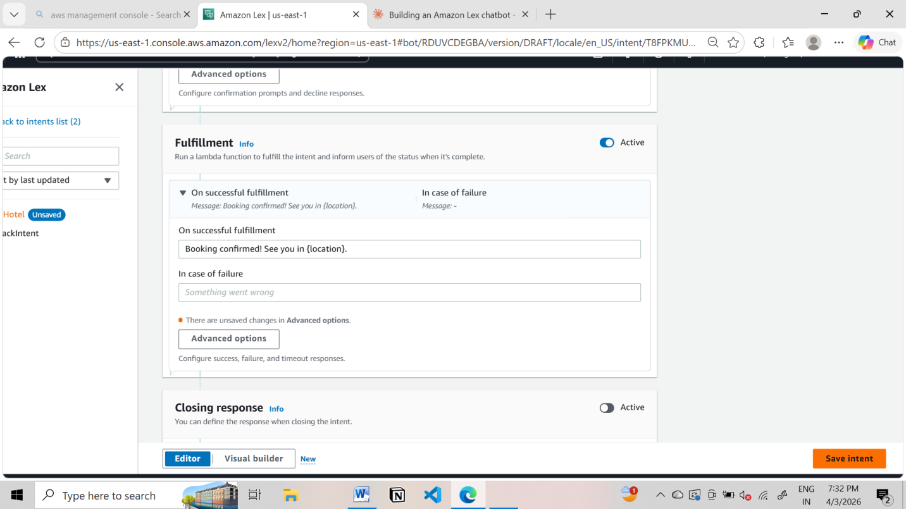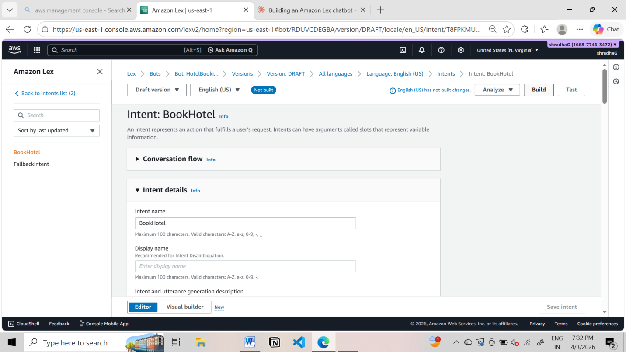

Step 11: Build & Test
- Click Build
- Use Test chatbot panel
- Try:
Book a hotel

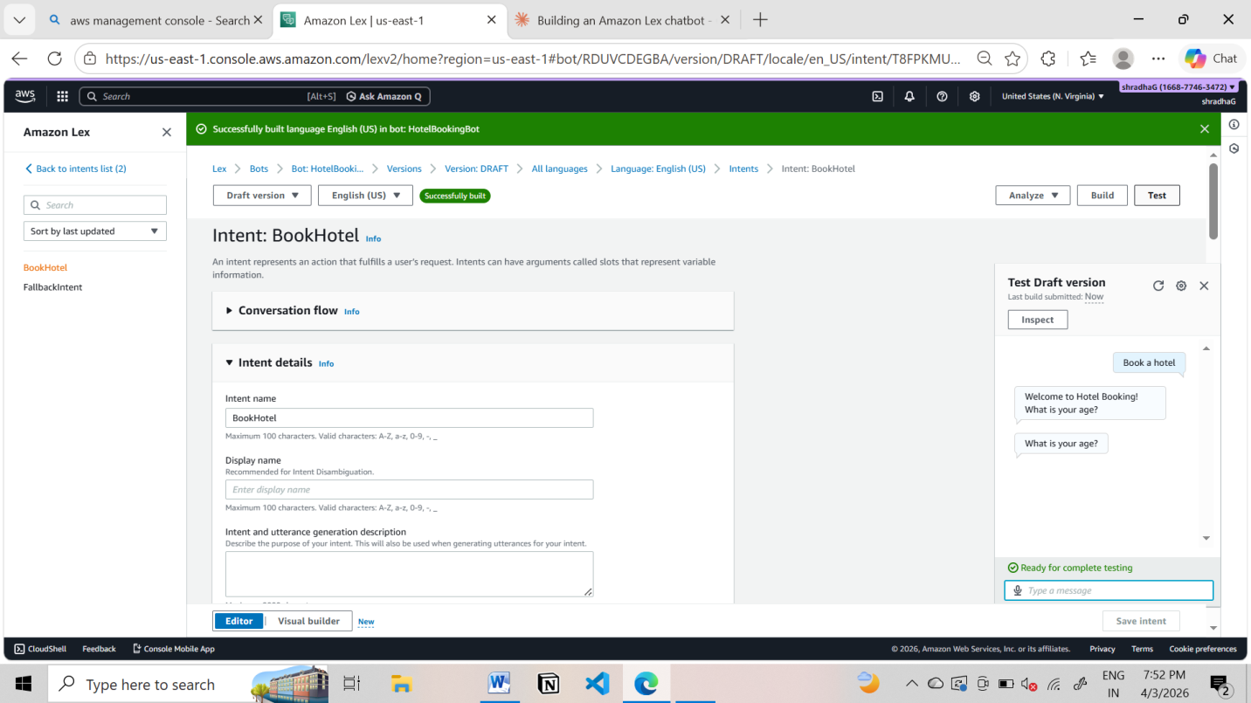

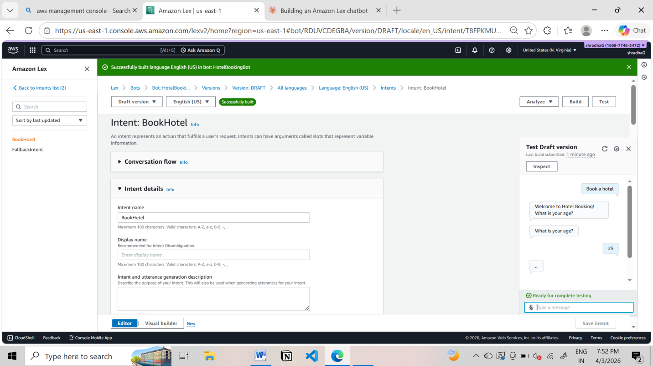

Sample output
User: Book a hotel
Bot: What is your age?
User: 25
Bot: Which city do you want?
User: Hyderabad
Bot: Check-in date?
User: Tomorrow
Bot: Number of nights?
User: 2
Bot: Select room type
User: Double
Bot: Do you want to confirm booking in Hyderabad for 2 nights?
User: Yes
Bot: Booking confirmed.
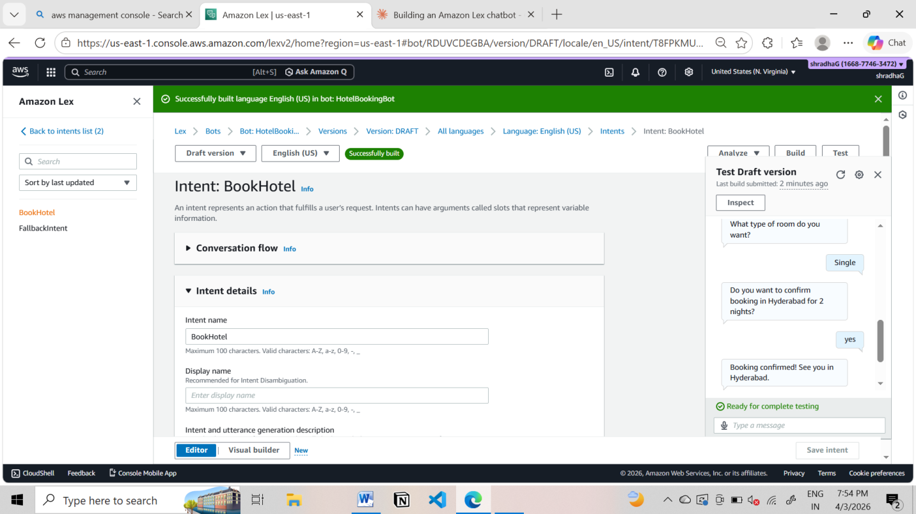

SCENARIO BASED QUESTIONS
Scenario 1: Bot Not Responding
You created a chatbot, but when you test it, the bot does not respond to user input.
- What could be the possible reason for no response?
- Did you build and publish the bot correctly?
- How would you troubleshoot this issue?

Scenario 2: Incorrect Intent Matching
A user types a valid query, but the chatbot responds with the wrong intent.
- What could cause incorrect intent recognition?
- How do utterances affect intent matching?
- How can you improve accuracy?

Scenario 3: Missing Slot Values
The chatbot asks for user input, but fails to capture required slot values.
- What is a slot in Amazon Lex?
- Why might slot values not be captured properly?
- How would you fix slot configuration issues?

Scenario 4: Fulfillment Not Working
The bot collects all user inputs but does not perform the expected action.
- What is fulfillment in Amazon Lex?
- Could Lambda integration be misconfigured?
- How would you verify the backend processing?

Scenario 5: Bot Not Accessible
You created the bot successfully, but users are unable to access it.
- Did you deploy or publish the bot?
- Could permissions or channel integration be missing?
- How would you make the bot accessible to users?

Scenario 6: Wrong Language Understanding
The chatbot fails to understand user queries written in slightly different formats.
- How does Amazon Lex process natural language?
- Why is training with multiple utterances important?
- How can you improve NLP performance?

Scenario 7: Versioning Issue
You updated the bot, but users still experience the old behavior.
- Did you create a new version of the bot?
- Why is alias configuration important?
- How do you ensure users access the latest version?

Scenario 8: Lambda Permission Error
The chatbot is connected to a Lambda function, but it fails during execution.
- What type of permission error might occur?
- How are IAM roles used in this integration?
- How would you fix the permission issue?

Scenario 9: Bot Gives Default Response
The chatbot always gives a fallback/default response instead of proper answers.
- What is a fallback intent?
- Why does the bot fail to match user input?
- How can you improve intent recognition?

Scenario 10: Multi-turn Conversation Issue
The chatbot fails to continue conversation properly after asking follow-up questions.
- What is dialog management in Amazon Lex?
- How are slots used in multi-turn conversations?
- How can conversation flow be improved?

Scenario 11: Integration with Web Application
A company wants to integrate the chatbot into their website.
- How can Amazon Lex be integrated with web applications?
- What services or APIs are required?
- What challenges might occur during integration?

Scenario 12: Performance Issue
The chatbot responds slowly when many users interact simultaneously.
- What could cause performance delays?
- How can scalability be handled in Amazon Lex?
- What AWS services can support high traffic handling?

