

Image source: @balaji cabs

**Problem Statement:**

In, Recent years, City Hotel & Resort Hotel Have Been High Cancellation rates. Each hotel is dealing with a number of issues as a result, including fewer revenues & less than ideal hotel room use. Consequently, lowering cancellation rates for both hotels.

The analysis of hotel booking cancellation as well as other factors that have no bearing on their business & yearly revenue generation are main topics of this project.

**Primary Goal 🎯:**

In order to increase their efficiency in generating revenue & for us to offer thorough business advice to address their problem.

**Assumption That Made:**

1. No unusual occurrences between 2015 & 2017 will have a substantial impact on the data used.
2. The information is still current and can be used to analyze a hotel's possible plans in an efficient manner.
3. There are no unanticipated negatives to the hotel employing any advised technique.
4. The hotels are not currently using any of the suggested solutions.
5. The biggest factor affecting the effectiveness of earning income is booking cancellations.
6. Cancellations result in vacant rooms for the booked length of time.
7. Clients make hotel reservations the same year they make cancellations.

**Key Insights To Find:**

1. What influences hotel reservation cancellation rates?
2. How can hotel operations be optimized to reduce reservation cancellations?
3. How can data and analytics support hotels in developing effective pricing and promotional strategies?

**Hypothesis:**

1. Cancellation rates tend to increase as prices rise.
2. Cancellations may be more frequent when waiting lists are longer.
3. A significant portion of reservations come through offline travel agents.

**Analytical Key Insights:**

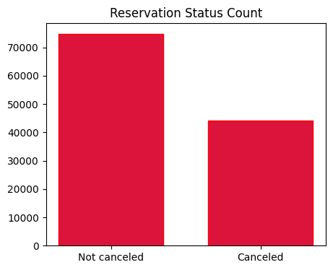

**Fig.1 Reservation Status Count (Not canceled or Canceled)**

Overall, the majority of reservations are not canceled. This is indicated by the larger bar segment representing "Not canceled" reservations, which takes up **62%** of the chart. This suggests that the hotel may be doing a good job of managing its cancellation rates.

There is still a significant number of canceled reservations, however. The 37% of reservations that are canceled represent a noticeable portion of the hotel's business.

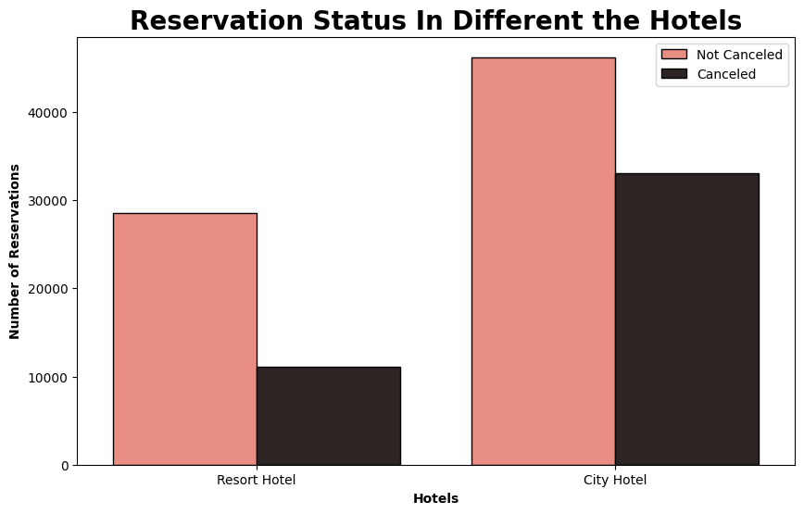

**Fig. 2 Reservation Status In Different Hotels**

City hotels have a higher overall number of reservations compared to the city hotel. This suggests a stronger demand for resort experiences or resort hotels that have more prices than city hotels.

Cancellation rates differ significantly between the two hotel types.

* City hotels have a higher proportion of cancellations (approximately 40% of its reservations).
* Resort hotels have a lower cancellation rate (around 25% of its reservations).
* Resort hotels experience a larger gap between canceled and not canceled reservations. This suggests a more consistent demand and potentially higher revenue potential for the resort.

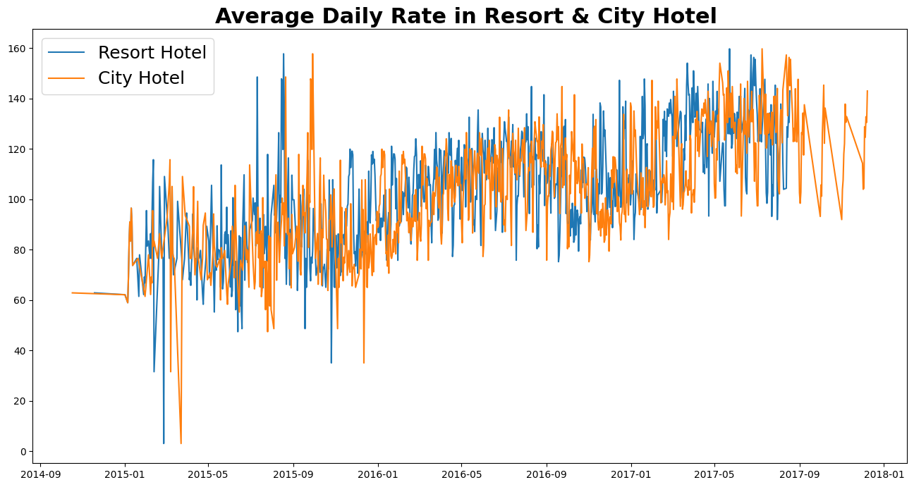

**Fig.3 Average Daily Price Rate In Resort & City Hotels**

**Figure 3** demonstrates that weekdays often see city hotel rates significantly lower than those of resort hotels. However, the gap narrows or even reverses on weekends and holidays, as resort hotel rates typically increase due to higher demand.

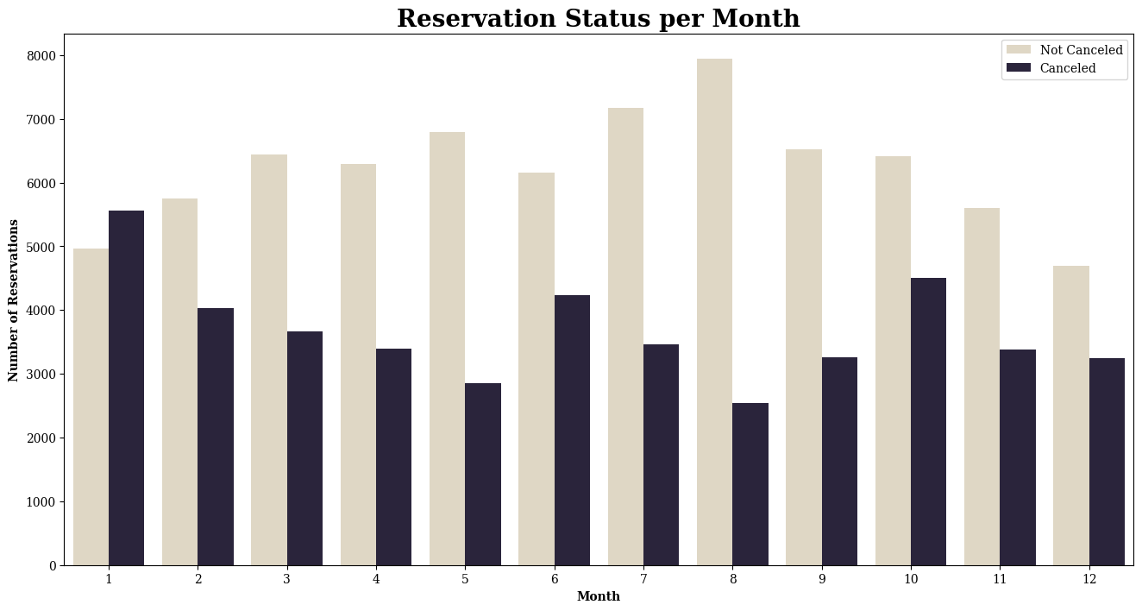

**Fig.4 Reservation Status per Month**

To understand seasonal trends in reservation patterns, we created a grouped bar graph comparing confirmed and canceled reservations across months. August emerged as the busiest month overall, attracting both the highest number of bookings and cancellations. However, January surprisingly witnessed the highest cancellation rate, suggesting potential factors influencing guest decisions during that period.

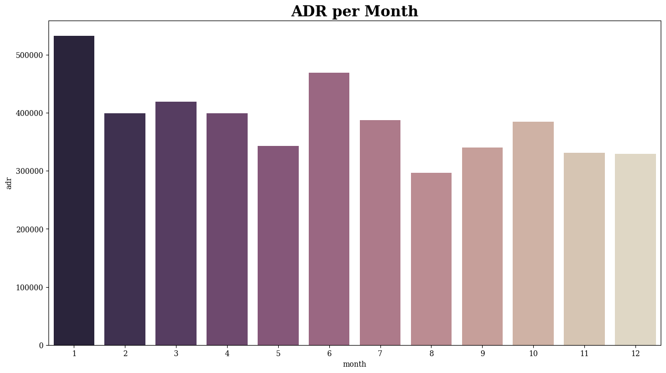

**Fig. 5 ADR per month**

This bar graph suggests a strong correlation between price and cancellation rates. Cancellations are more likely at higher prices and less frequent at lower prices. However, it's important to consider other factors that might influence guest decisions, such as date changes or external events."

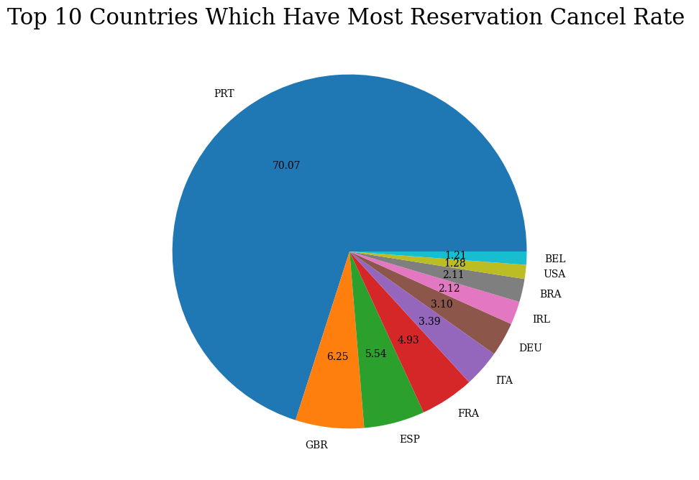

**Fig. 6 Top 10 Countries which have most reservation cancel rate**

**Figure 6** demonstrates the **Top 10** countries which have the most significant cancellation rate of reservation. **Portugal** has a significantly **higher** cancellation rate that is **70.07 %** than other countries whereas **Belarus** has a **lower** cancellation rate among top 10 countries that is **1.21%.**

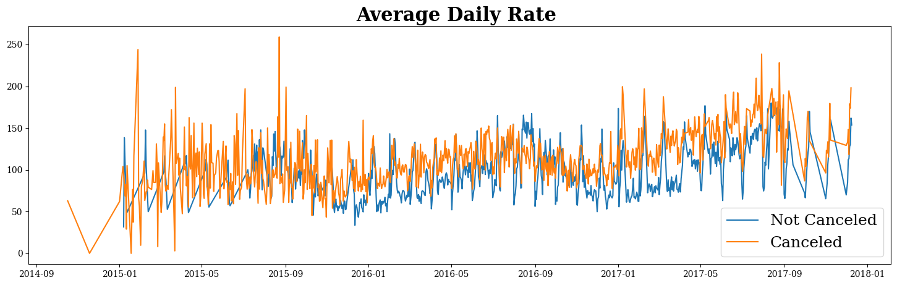

**Fig. 7 Average Daily of Hotels**

This finding in Figure 7 aligns with the earlier analysis suggesting a potential influence of price on cancellations. Further research could help determine the extent and specific reasons behind this correlation.

**Suggestions :**

1. **Dive deeper into cancellations**: Analyze reasons, demographics, lead times, and room types for both hotels. Explore how weekend/holiday pricing and January's anomaly impact cancellations.
2. **Develop targeted solutions:** Segment cancellations and tailor solutions. Offer flexible booking options or targeted promotions based on guest data. Implement cancellation recovery strategies with incentives.
3. **Leverage data and analytics:** Use historical data to predict cancellation risks and proactively engage guests. Track campaign performance and optimize for maximum impact. Integrate with revenue management for optimal pricing and occupancy.
4. **Consider additional factors:** Improve guest experience through better amenities, service, or communication. Monitor external factors like economic trends or events to adjust strategies.