Medical Inventory

Optimization

By Vaka Prasanna



# 360DigiTMG Reviews - 52 Reviews of 360digitmg.com | Sitejabber Contents

* Business Objective
* Business Constraints
* Project Architecture
* Data Collection
* Exploratory Data Analysis
* Data Visualization

2

# Business Problem

* **Business Problem:** Bounce Rate is significantly leading to patient dissatisfaction.
* Hospitals and healthcare facilities constantly struggle to maintain optimal stock levels of medical supplies and medications.
* Running out of essential supplies during procedures can put patients at risk and delay treatment.
* Holding excessive inventory and Poor prediction of demand can cause either stockouts or overstocking.



# Project Overview and Scope

**Project Overview:**

**Project Goal:** Develop and implement a software solution that optimizes medical inventory management for hospitals and healthcare facilities.

**Target Audience:** Hospitals, clinics, and other healthcare institutions of various sizes.

* **Project Scope:**
* Demand Forecasting Module
* Inventory Optimization Module
* Inventory Management Dashboard
* Integration and Implementation

4

# Data Dictionary

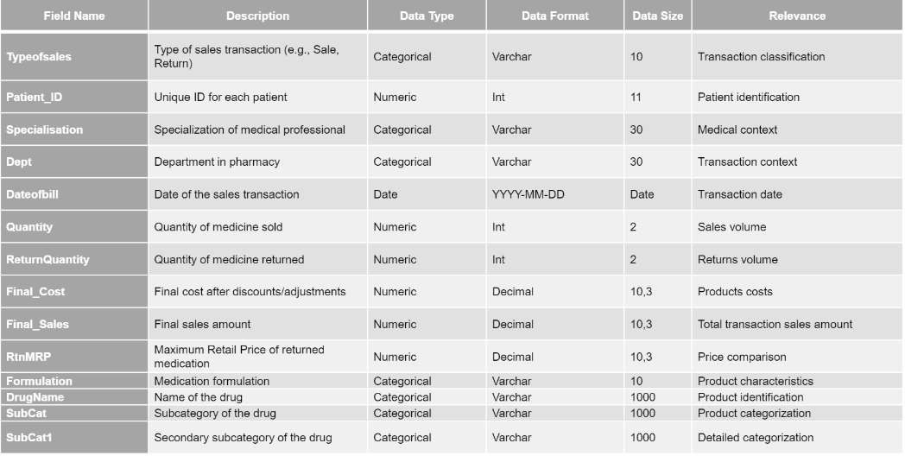

**Exploratory Data Analysis [EDA]**

**Statistical Insights**

* + Historical usage data analysis (mean, median, seasonality)
  + Standard deviation analysis of usage data
  + Cluster analysis to group similar

items based on usage patterns

* + Analyze historical usage data combined with expiry dates.
  + Track order fulfillment times and fill rates from different suppliers.

**Business Insights**

* + Identify predictable fluctuations in demand



* + Quantify the variability in demand

to determine buffer stock needs s

* + Identify opportunities for bulk

purchasing or standardization within categories

* + Identify opportunities for bulk

purchasing or standardization within categories

* + Identify reliable suppliers with

consistent delivery times.

6

# Data Preprocessing

Type casting: Missing values Observation:

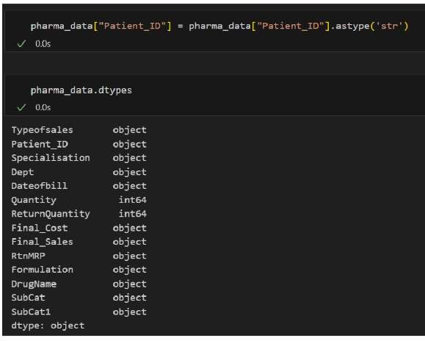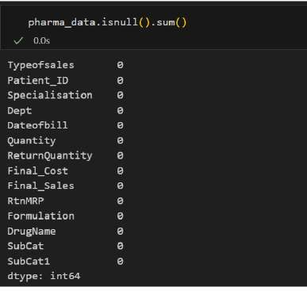



**Data preprocessing:**

**Removing Duplicates: Data manipulation:**

After formatting Quantity Values and Sorting ‘Dateofbill’

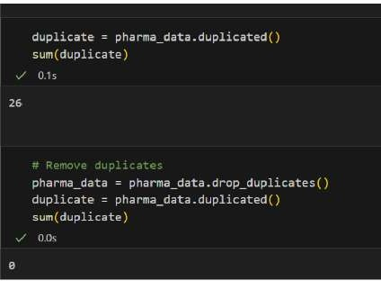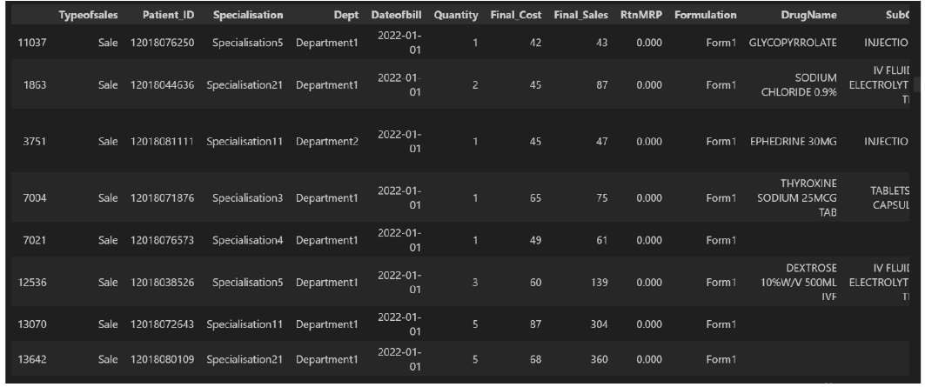

First Moment Business Decision

**Measure of central Tendency**:

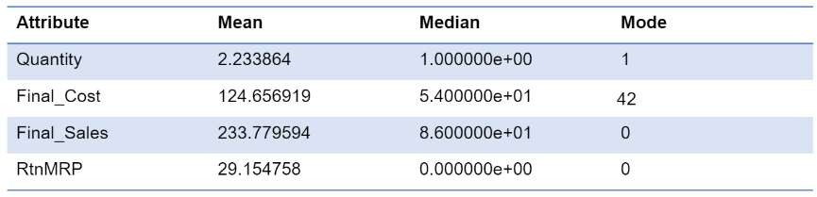

* On average, the quantity of medicines sold per transaction is around 2.23 units.
* Average cost of the medicines sold per transaction is around $124.66.
* Average sales revenue generated per transaction is around $233.78.
* Return value of a medicine, based on the manufacturer's retail price, is around $29.15.
* Median quantity is 1.0 shows that 50% of transactions involve purchasing just 1 unit of a drug.
* Mode of the data is Patient_ID 12018071649 with final cost of 42$.

## Second Moment Business Decision

Measure of Dispersion:

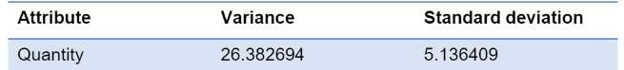

* Variance of approximately 26.38 indicates that there is a notable amount of dispersion in the "Quantity" values. This suggests that the quantities of products sold across transactions show significant differences from the mean.
* The calculated standard deviation of around 5.14 further illustrates the spread of the "Quantity" data.

## Third and fourth Moment Business Decision

**Measure of asymmetry in distribution: Measure of peakedness –represents overall spread in the data:**

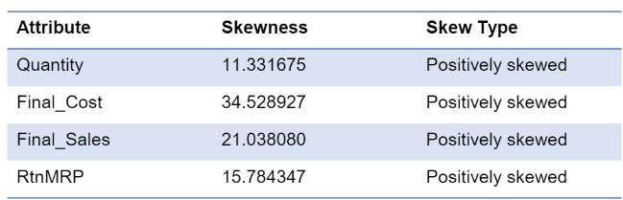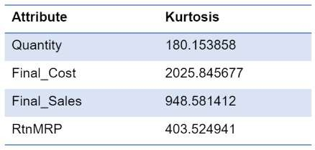

Quantity • 11.33 suggests that the distribution of the data is positively skewed

Final Sales • 21.04 suggests that the distribution of the "Final_Sales" data is positively skewed.

Quantity • 179.85 suggests that the distribution of the data has high positive kurtosis. Final Sales • 949.99 suggests very high positive kurtosis in the data.

# Data Visualization

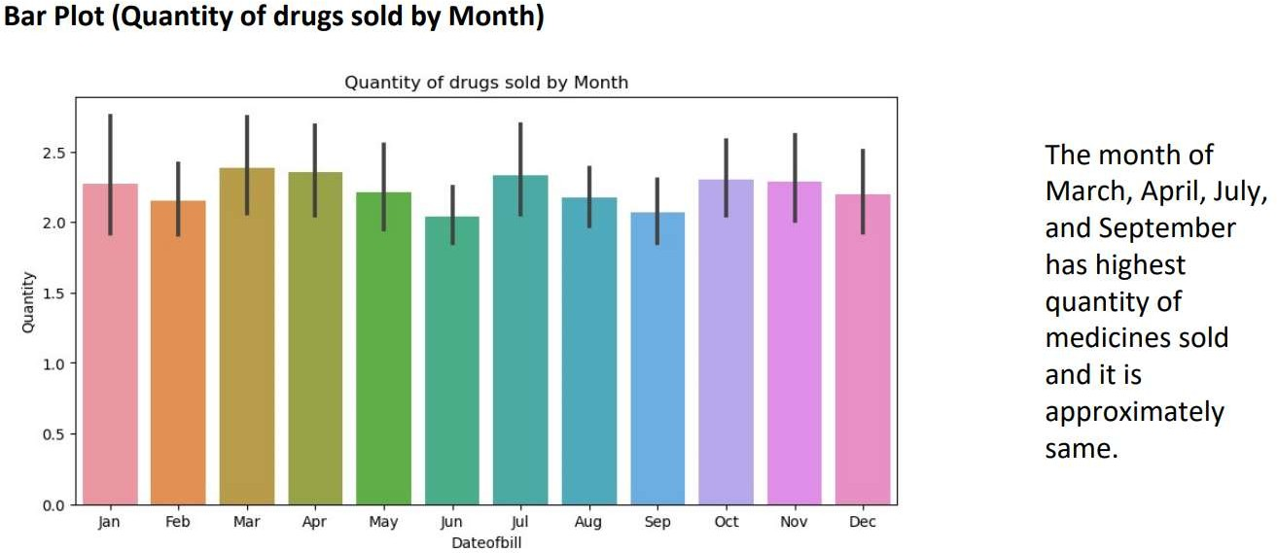



## Data Visualization:

