Name : V V S Sanjeev
Usn: 1NT19IS183
Section:C(Batch 2)

Mongo DB lab

31-03-2022 thursday

use dhoni
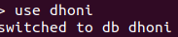

insert one element:
> db.dhoni.insertOne(
... {
... name:"sanjeev",
... age:26,
... status:"pending"
... }
... )
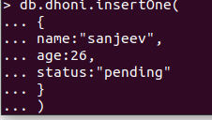

insert many elements:
> db.dhoni.insertMany([
... {name:"vinayak",age:27,status:"active"},
... {name:"ullaas",age:31,status:"single"}
... ])

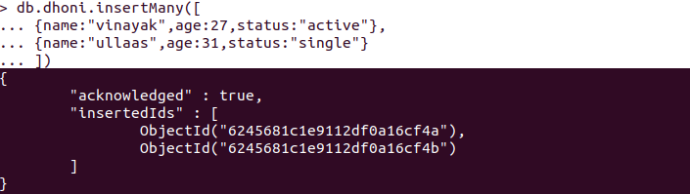
To count how many elements in database:
db.dhoni.count()
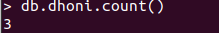

To find:
db.dhoni.find()
To find in pretty() format :

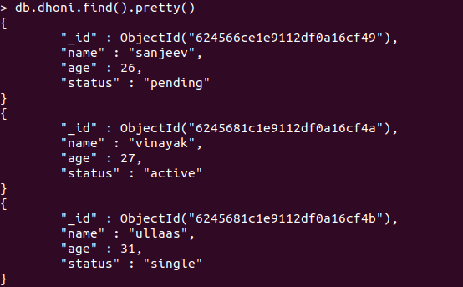

To find sepecific element :

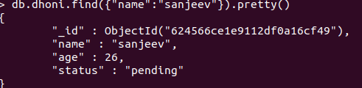

To update one :
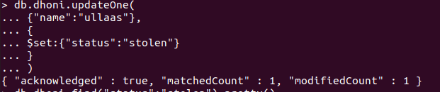
To update many:
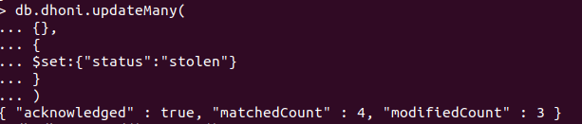

To delete one :
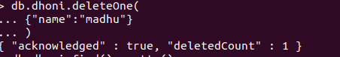

To replace one :

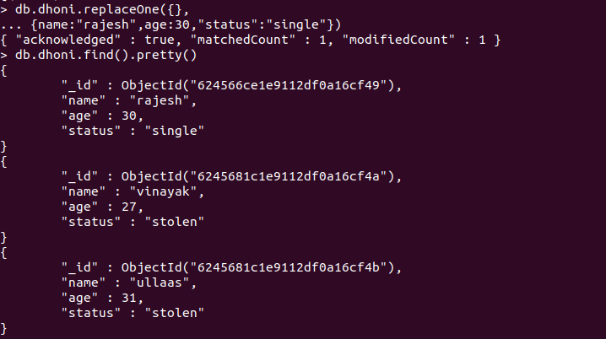

Set conditon:

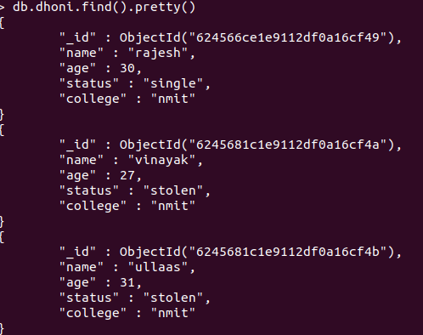

Unset condition :
