EDA la2

Submitted By: Sanjeev V V S(1NT19IS183) & Vinayak P Bhupal(1NT19IS187)

2022-07-03

library(readxl)  
Restaurant_la <- read_excel("C:/Users/Admin/Desktop/Restaurant_la.xlsx")  
View(Restaurant_la)

**Visualizationsa of dataset in BAR Graph**

library(ggplot2)  
ggplot(Restaurant_la,aes(x=Review))+geom_bar()

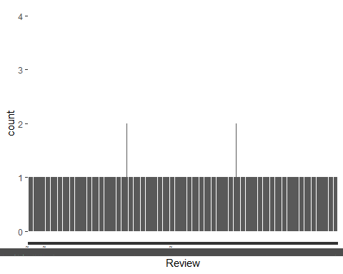 **Visualizations of dataset in BAR Graph**

ggplot(Restaurant_la,aes(x=Liked))+geom_bar()

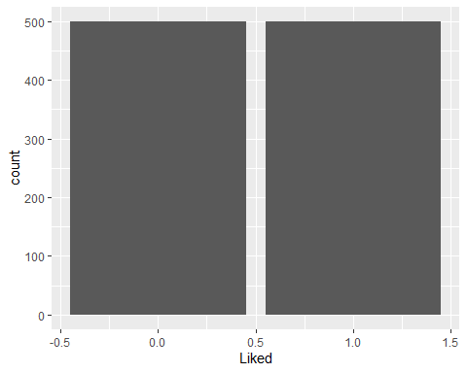

**Visualizations of dataset in histogram Graph**

ggplot(Restaurant_la,aes(x=Liked))+geom_histogram()

## `stat_bin()` using `bins = 30`. Pick better value with `binwidth`.

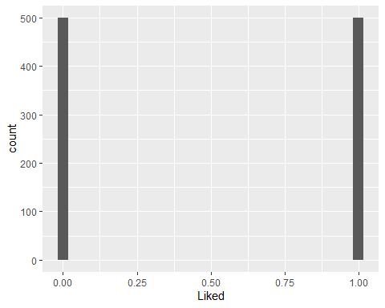 **Visualizations of dataset in ScatterPlot**

ggplot(Restaurant_la,aes(x=Review,y=Liked))+geom_point()

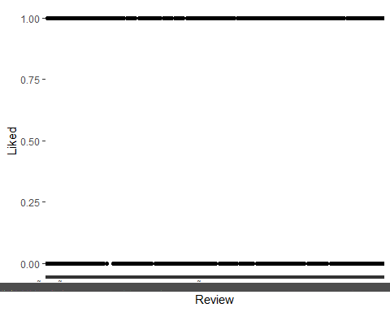

**Visualizations of dataset in Vilion Graph**

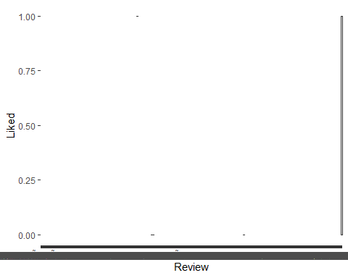

**Visualizations of dataset in Line Graph**

ggplot(Restaurant_la,aes(x=Review,y=Liked))+geom_line()

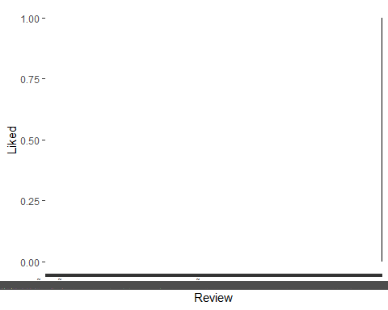 **Visualizations of dataset in Poly_Freq Graph**

ggplot(Restaurant_la,aes(x=Liked))+geom_freqpoly()

## `stat_bin()` using `bins = 30`. Pick better value with `binwidth`.

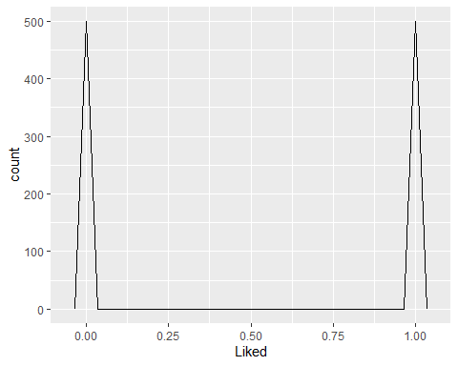

**Visualizations of dataset in Density Graph**

ggplot(Restaurant_la,aes(x=Review,y=Liked))+geom_density()

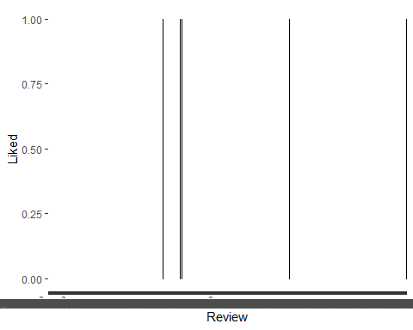 **Density curves with facets**

ggplot(Restaurant_la, aes(x = Liked)) +  
 geom_density() +  
 facet_grid(Liked ~ .)

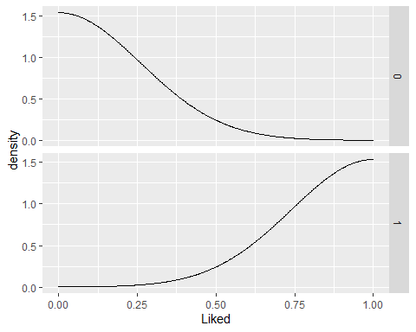 **Density curves overlaid on histograms**

ggplot(Restaurant_la, aes(x = Liked)) +  
 geom_histogram(binwidth = 200, fill = "cornsilk", colour = "grey60",  
 size = .2) +  
 geom_density() +  
 facet_grid(Liked ~ .)

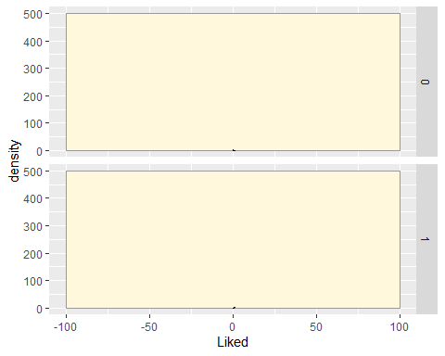

**#Making a Basic Box Plot**

ggplot(Restaurant_la, aes(x = Review,y=Liked)) + geom_boxplot()

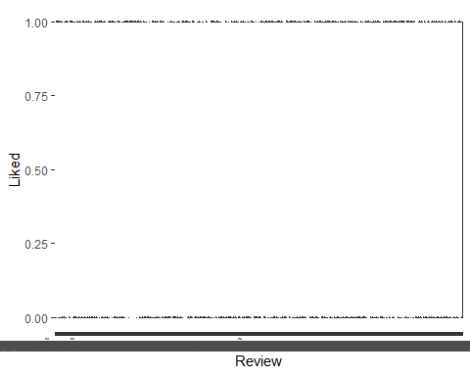 **#Box plot with narrower boxes**

ggplot(Restaurant_la, aes(x = Review, y = Liked)) + geom_boxplot(width = .5)

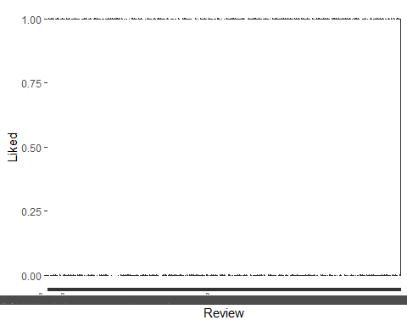

**#Making Multiple Dot Plots**

ggplot(Restaurant_la, aes(x = Review, y = Liked)) +  
 geom_dotplot(binaxis = "y", binwidth = .5, stackdir = "center")

