7BUIS008C.2 Data Mining and Machine Learning

Coursework Two

***Vishvaka Neomal Ranasinghe***

2019677 (IIT)

w1790596 (UOW)

**1st Task:** Data Set Selection and Visualization

**Dataset used:** UCI Heart disease *[link:* [*https://archive.ics.uci.edu/ml/datasets/heart+Disease*](https://archive.ics.uci.edu/ml/datasets/heart+Disease)*]*

**Introduction to the dataset:**

This dataset gives 13 variables along with a target condition of having or not having heart disease.



**The column definitions are as follows:**

* **age**: Age of the patient in years.
* **sex**: 1 = male and 0 = female
* **cp**: Chest pain type

Angina, also known as angina pectoris, is chest pain or pressure, usually due to not enough blood flow to the heart muscle. (Source: [Wikipidia](https://en.wikipedia.org/wiki/Angina))

* + 1 -> Typical Angina
  + 2 -> Atypical Angina
  + 3 -> Non-anginal Pain
  + 4 -> Asymptomatic
* **trestbps**: Resting blood pressure in mm Hg on admission to the hospital
* **chol**: Serum cholesterol in mg/dl
* **fbs**: Fasting blood sugar level greater than 120 mg/dl
  + 0 -> False
  + 1 -> True
* **restecg**: Resting electrocardiographic results
  + 0 -> Normal
  + 1 -> Having ST-T wave abnormality (T wave inversions and/or ST elevation or depression of > 0.05 mV)

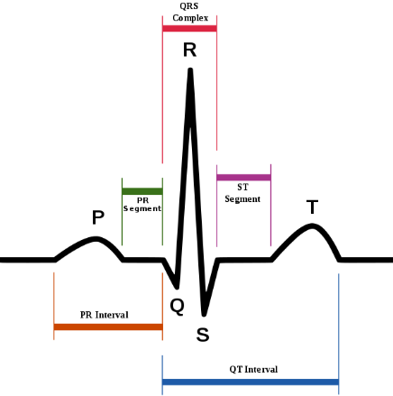

In electrocardiography, the ST segment connects the QRS complex and the T wave and has a duration of 5ms to 150ms.

**Interpretation**

* The normal ST segment has a slight upward concavity.
* Flat, down sloping, or depressed ST segments may indicate coronary ischemia.

(Source: [Wikipidia](https://en.wikipedia.org/wiki/ST_segment))

* + 2 -> Showing probable or definite left ventricular hypertrophy by [Estes’ criteria](https://www.healio.com/cardiology/learn-the-heart/ecg-review/ecg-topic-reviews-and-criteria/left-ventricular-hypertrophy-review).
* **thalach**: Maximum heart rate achieved in beats per minute
* **exang**: Exercise induced angina
  + 0 -> No
  + 1 -> Yes
* **oldpeak**: ST depression induced by exercise relative to rest
* **slope**: The slope of the peak exercise ST segment
  + 1 -> Upsloping
  + 2 -> Flat
  + 3 -> Down sloping
* **ca**: Number of major vessels [0-3] colored by fluoroscopy
* **thal**: Thalium stress test result
  + 1 -> Fixed defect
  + 2 -> Normal
  + 3 -> Reversable defect
* **num**: Diagnosis of heart disease (angiographic disease status)
  + 0 -> Less than 50% diameter narrowing
  + 1 -> Greater than 50% diameter narrowing

str(heart)

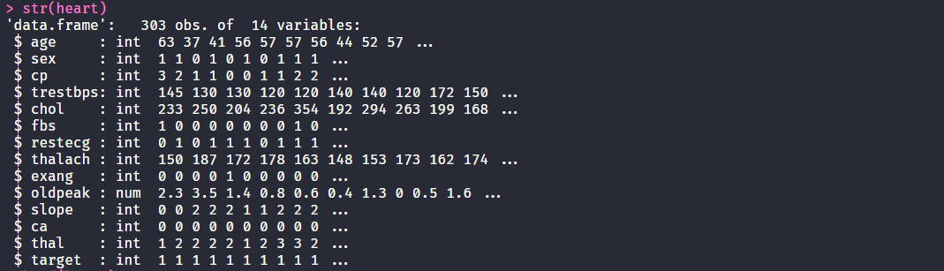

head(heart)

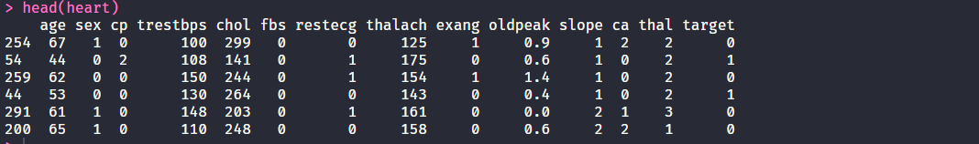

summary(heart)

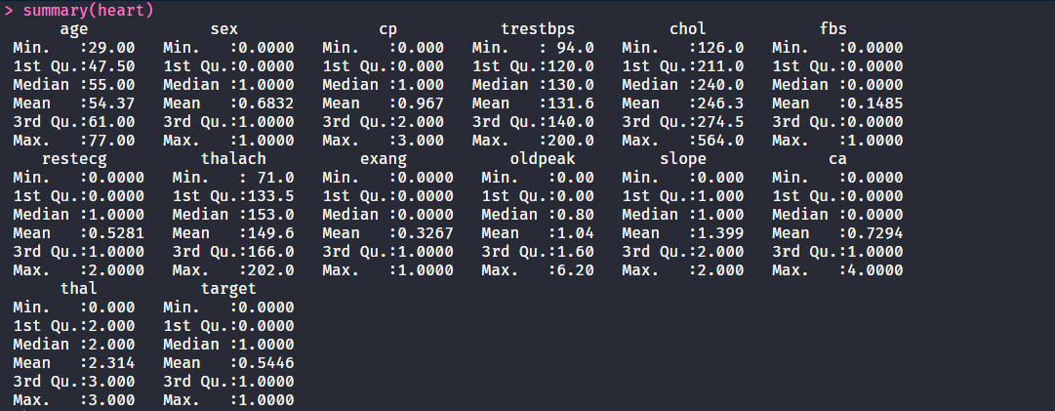

**Age Analysis**

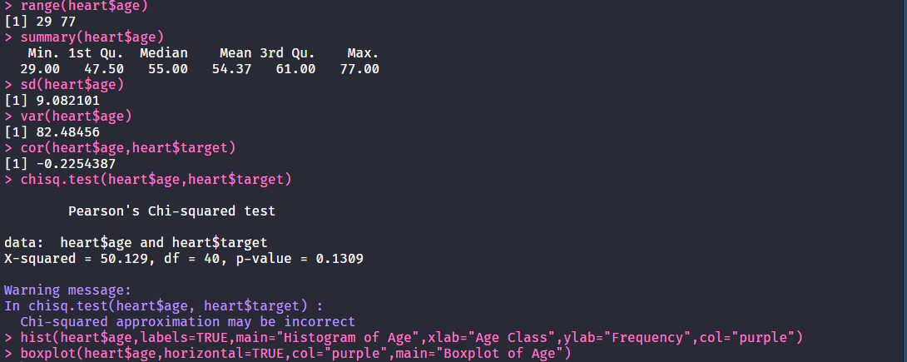

* Minimum age is 29 and maximum age is 77, average age is 54.37. Majority of the population is between age group 55 and 60 years.
* There is negative correlation between age and target. This implies that when get older probability of heart attack is decreasing.
* By observing the curve, we can see that from age 30 to 60 probability of heart attack is decreasing and from 60 again probability is increasing. After 70 chance of heart attack is more.
* Using Chi squared test we get a probability value of 0.13. There for we can conclude that target is independent of the age.

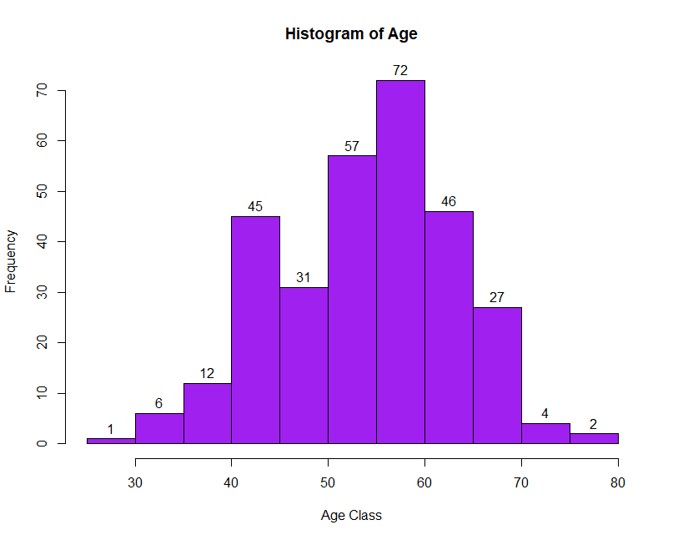

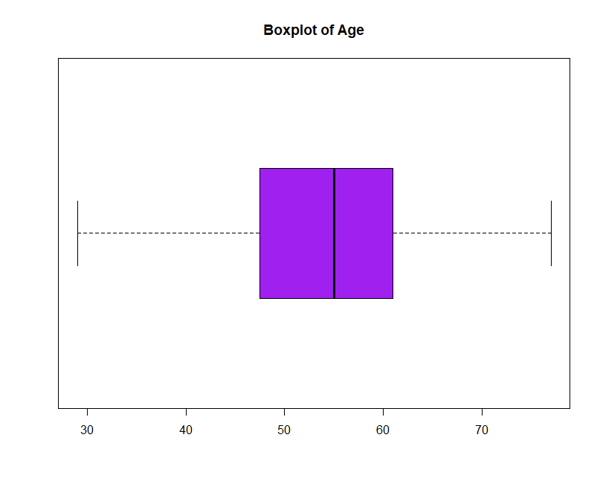

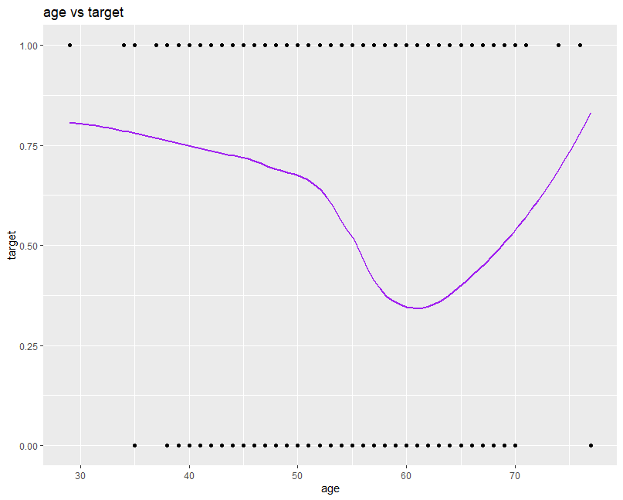

**Gender(sex) Analysis**

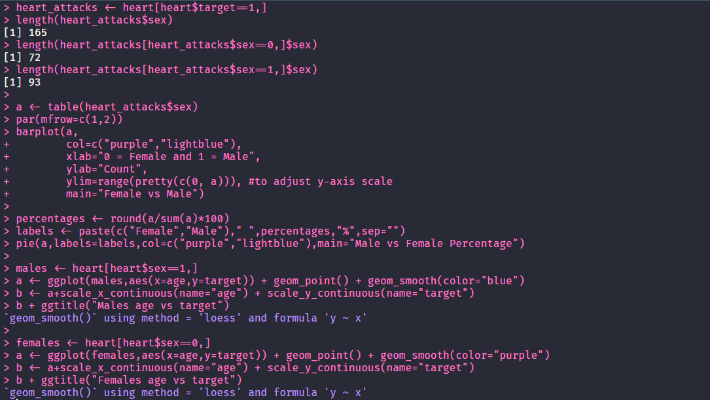

* Out of 165 Heart Attack observations 72 are Female and 93 are male.
* Looking at the barplot we can see that males have a higher proportion when compared to female. Also, in Pie chart we can see that proportion of female is 44% while male is 56%.
* Using “*males age vs target*” plot we can see that there is a significant drop in the probability of a heart attack as males grow older.
* As for females there is a drop of the probability of a heart attack from 46 to 60 years and then rapidly increases as they grow older.

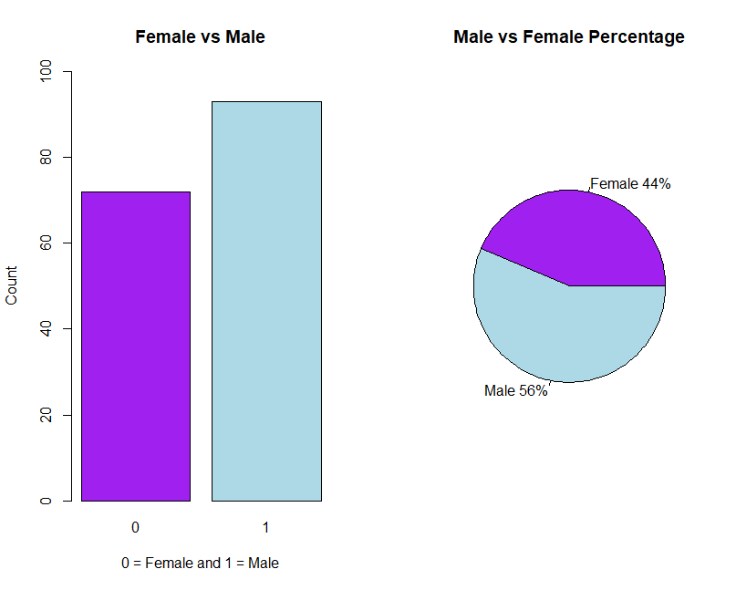

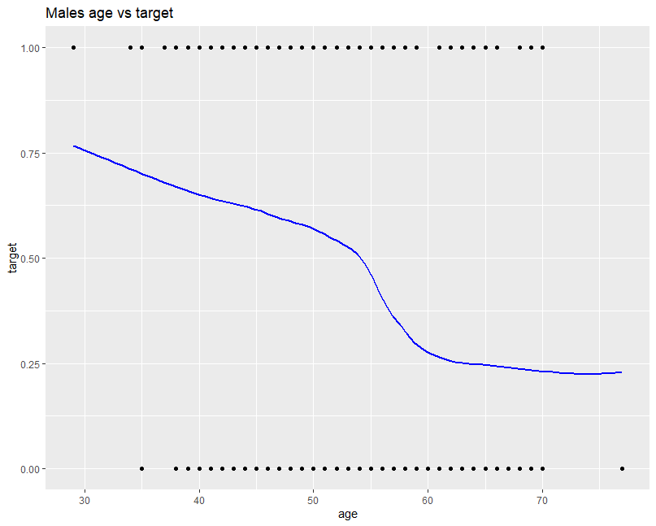

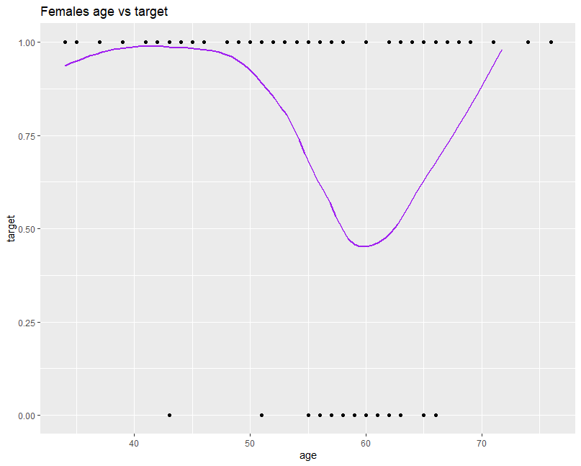

**Chest Pain(cp) Analysis**

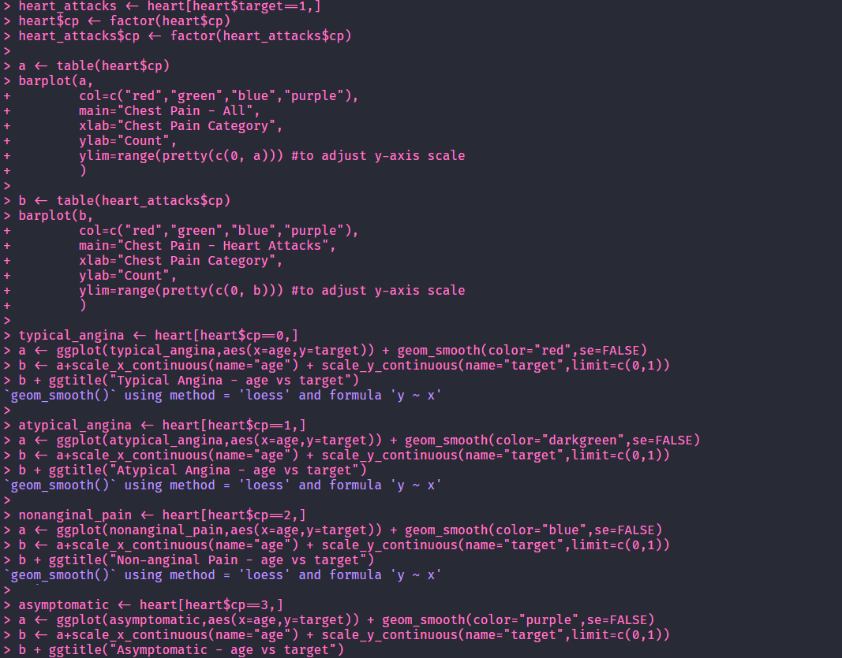

* There is 4 category of Chest pain starting from 0 up to 3.
* 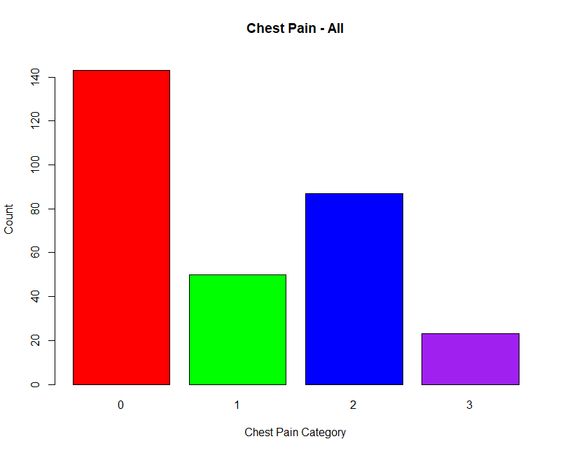From barplot we can observer that, most people have typical angina (Type 0) chest pain, but most of the people who had non-anginal (Type 2) chest pain had a heart attack.

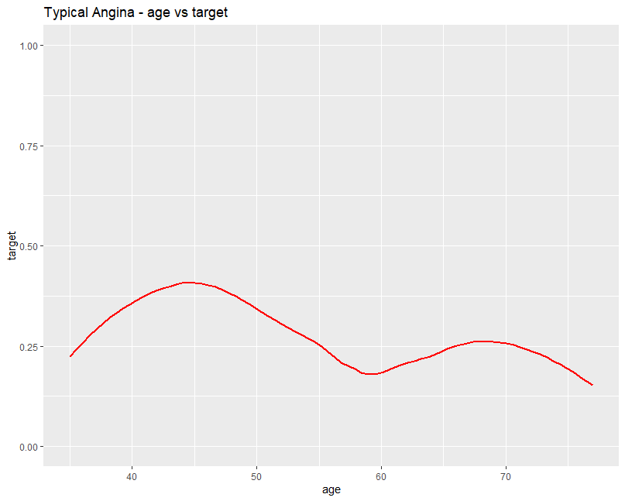

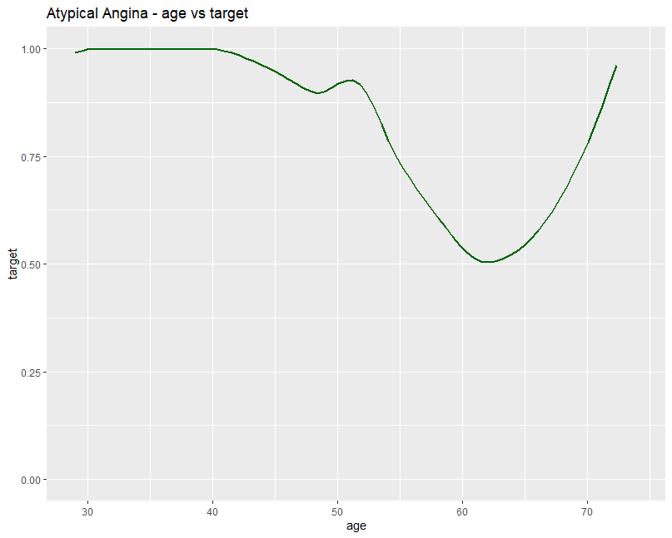

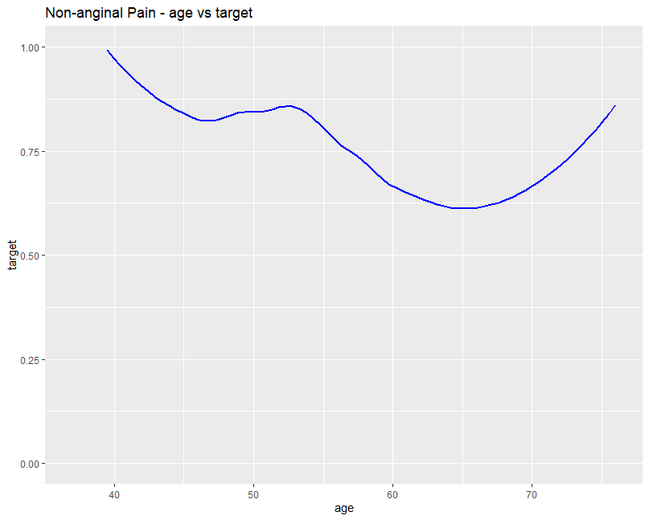

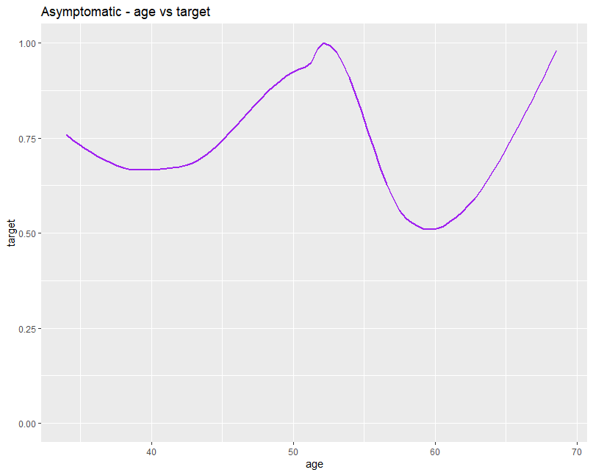

**Rest Blood Pressure(trestbps) Analysis**

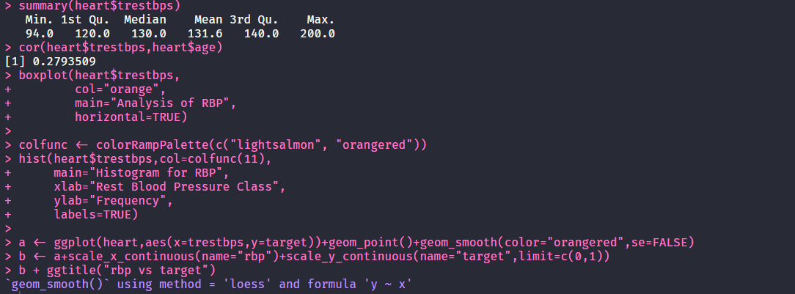

* Minimum resting blood pressure is 94, maximum is 200 and average RBP is 131.6.
* There is low positive correlation between RBP and Target, on increasing resting blood pressure chance of getting heart attack will increase.
* We can clearly see in histogram; Maximum number of Population have Rest Blood Pressure between 120 and 140.
* People having RBP between 95 and 110 are more likely to get Heart Attack.
* By observing the curve of RBP vs Target, probability of a probability is decreasing after RBP 135.

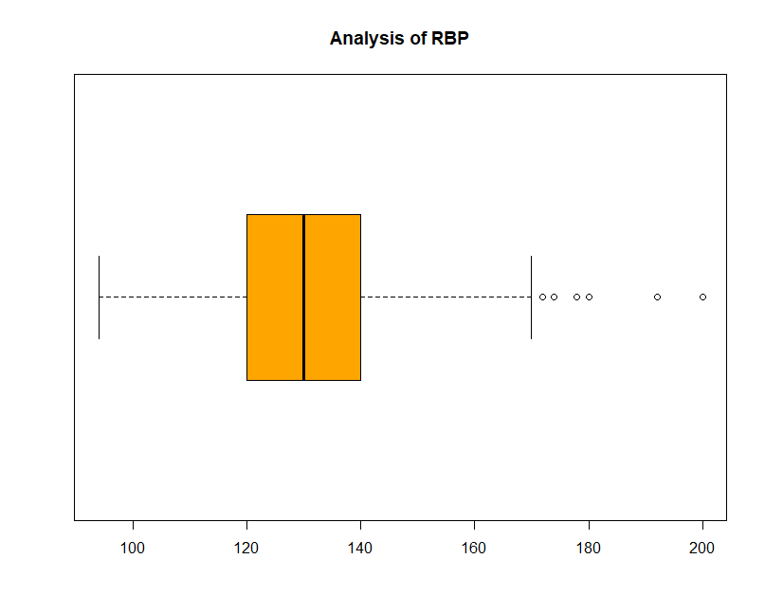

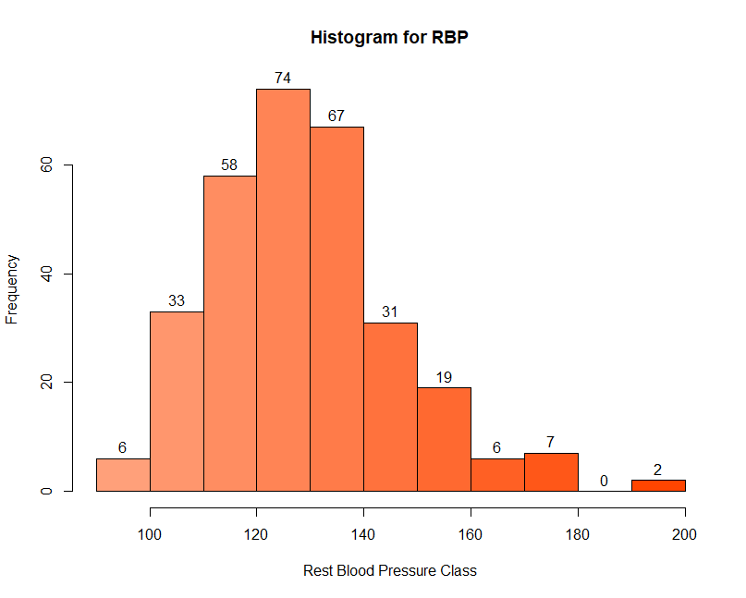

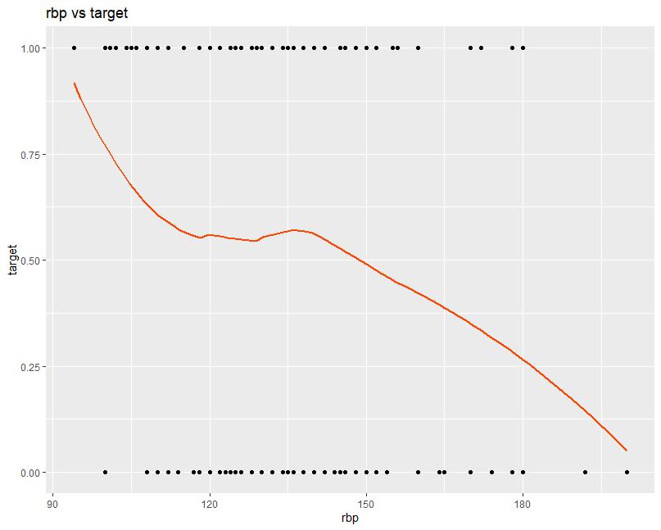

**Serum Cholesterol(chol) Analysis**

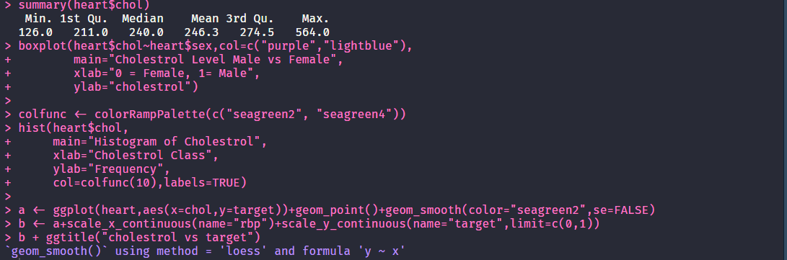

* Minimum cholesterol level is 126, maximum is 564 and average is 246.3.
* We can see Boxplot for analysis separately for males and females, and from it we can observe that males have lower cholesterol than females.
* We can observe in histogram that maximum population have cholesterol between 200 and 250.
* In smooth curve we can clearly see that probability of heart attack is increasing after cholesterol level 300.

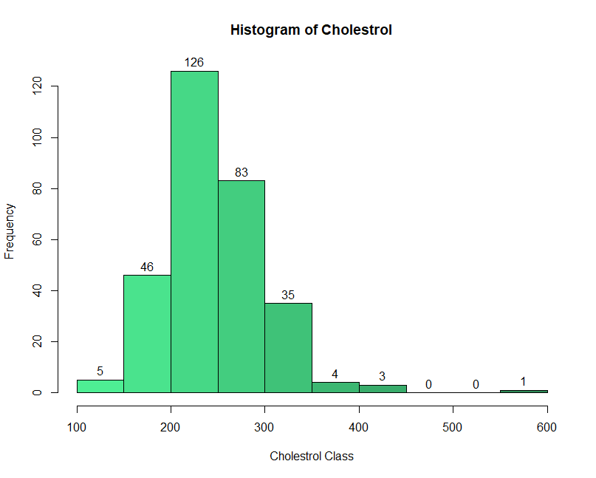

**Fasting Blood Sugar Level(fbs) Analysis**

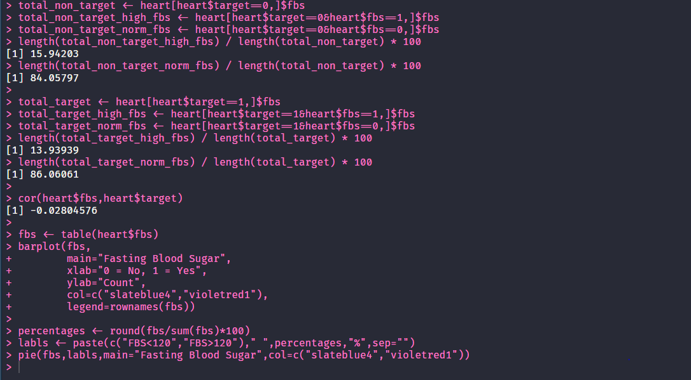

* Fasting blood sugar is a categorical variable in which 0 means level is less than 120mg/dl and 1 means it is greater than 120mg/dl.
* In bar chart and pie chart it is clearly visible that maximum (85%) people have fasting blood sugar less than 120mg/dl.
* From all heart attacks having fasting blood sugar more than 120mg/dl accounts only 13.93%, and there is very low correlation between fasting blood sugar level and target (-0.28)

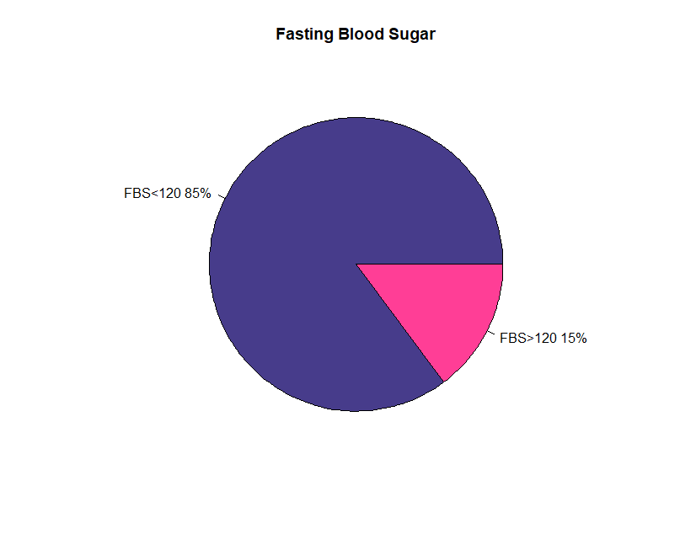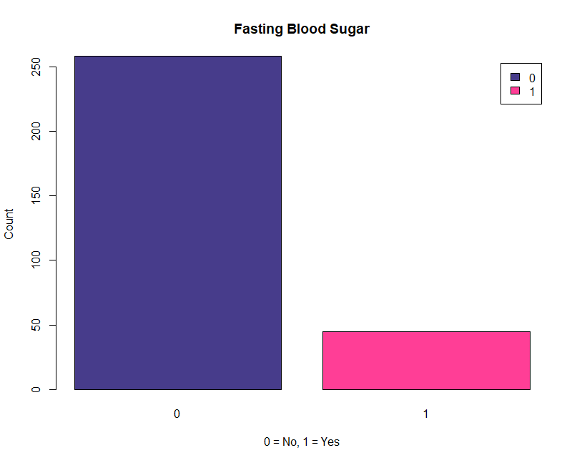

**Resting Electrocardiographic Results(restecg) Analysis**

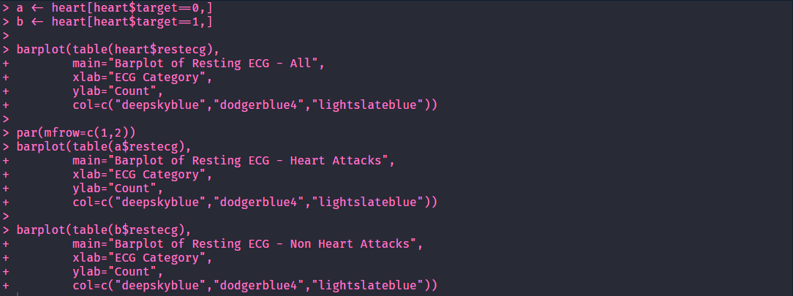

* There are 3 categories in this variable 0,1 and 2.
* Category 2 of ECG is very less and category 1 or 2 are nearly same.
* However, when looking at heart attack records and non-heart attack records, having category 2 ECG there is a higher chance of a heart attack.

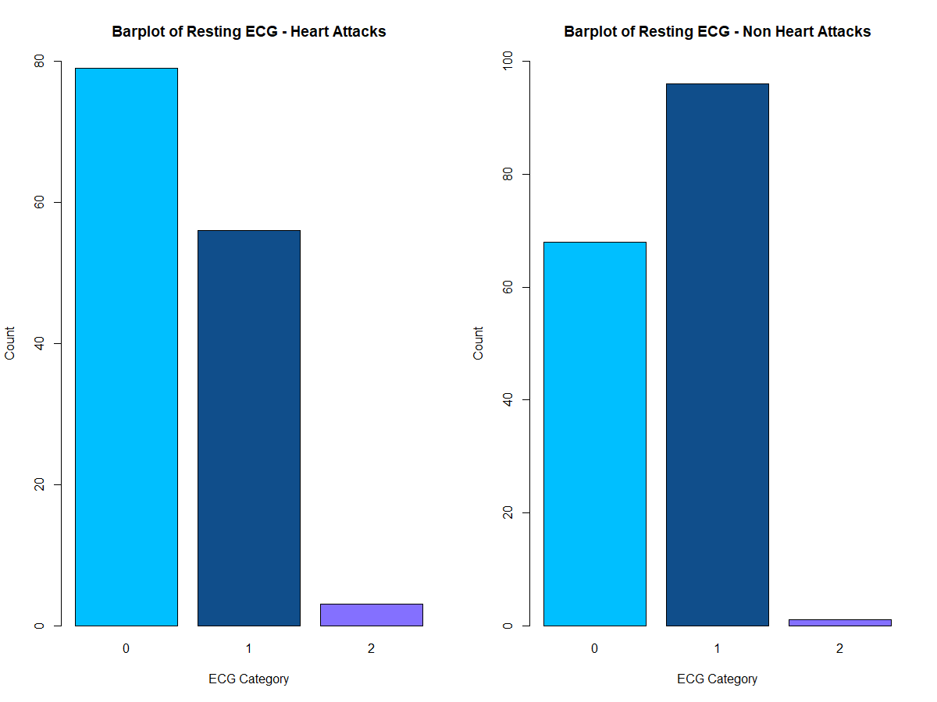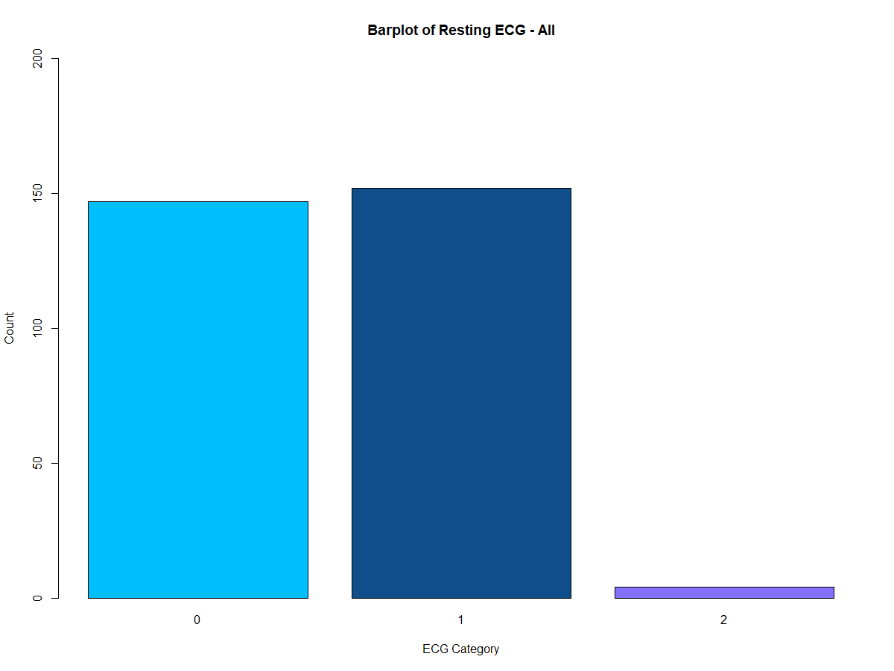

**Maximum Heart Rate(thalach) Analysis**

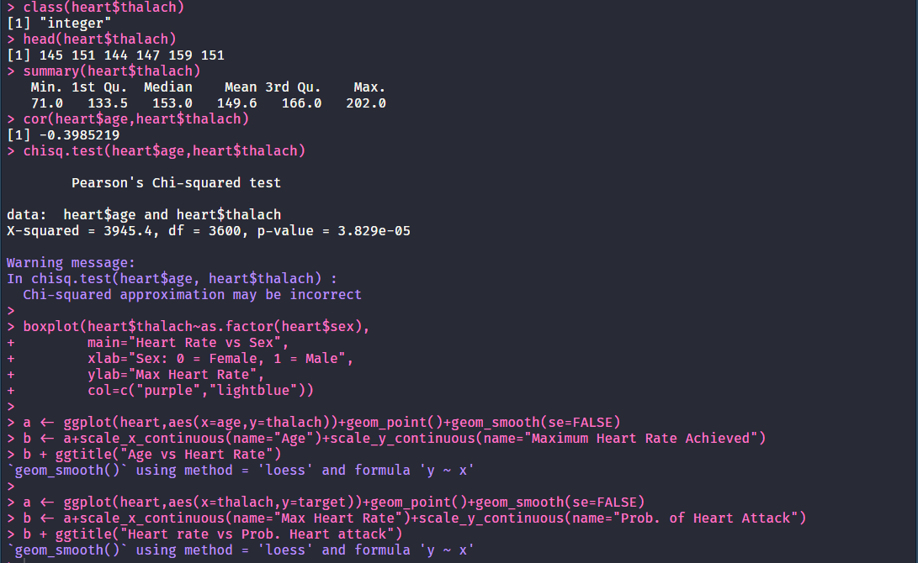

* Maximum heart rate achieved continuous data with a minimum of 71, maximum of 202 and average of 149.6.
* Females normally have a higher maximum heart Rate achieved than males, this can be seen clearly from the box plot.
* As a person get older the maximum heart Rate achieved is lower as shown by the "Age vs Heart Rate" curve, this is further backed by the negative correlation (-0.3985219) between age and maximum heart rate achieved.
* We can also observe that as the heart rate increase probability of getting Heart attack is increasing greatly as well.

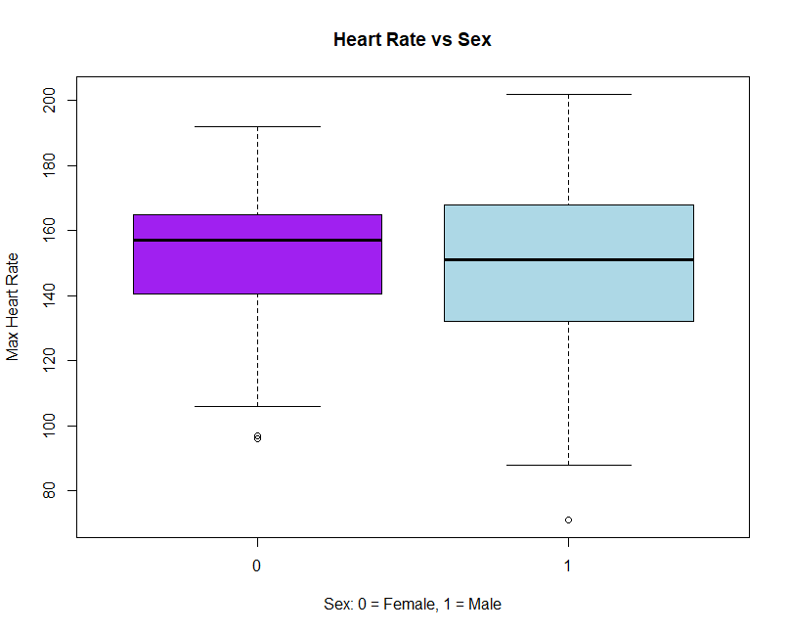

**Exercise Induced Angina(exang) Analysis**

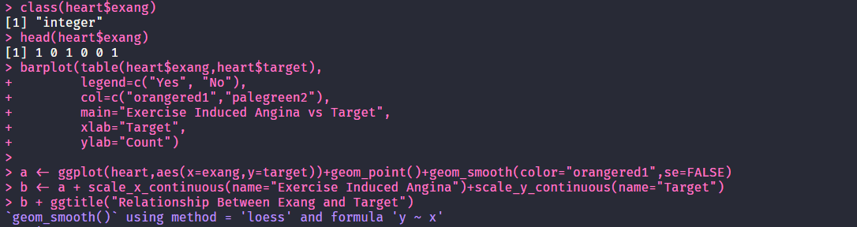

* Exercise Induced Angina is categorical variable with 0 = No exercise induced angina and 1 = Exercise induced angina
* We can clearly see in stacked bar plot that people with exercise induced angina is more likely to get heart attack.
* From relationship between exang and target curve with increase in exercise induced angina, chance of Heart attack is increasing.

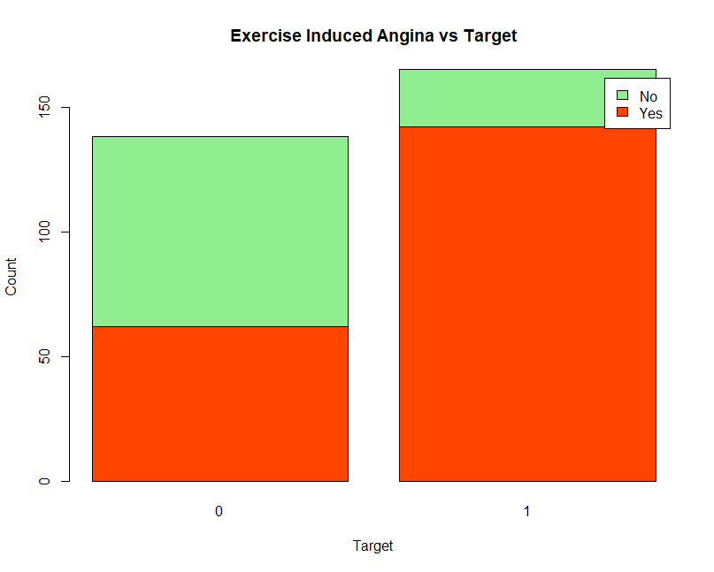

**ST Depression Induced by Exercise Relative to Rest(oldpeak) Analysis**

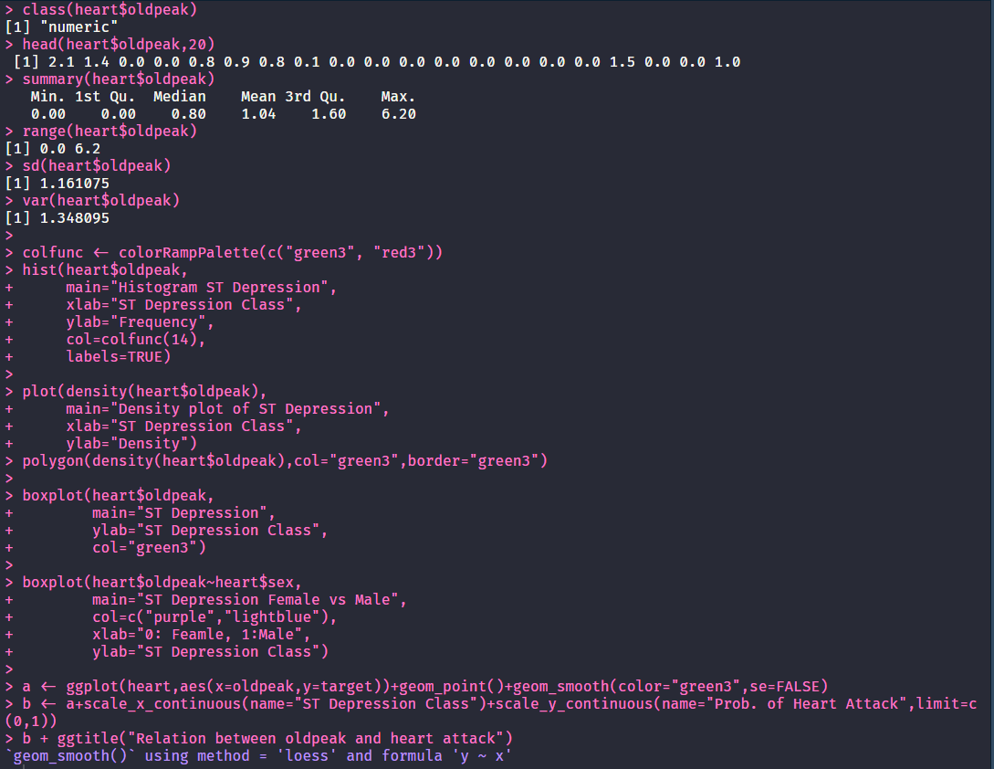

* ST depression induced by exercise relative to rest is numeric variable with a minimum of 0 and a maximum 6.20.
* Majority of the people have a ST depression of 0 to 0.5. This can be observed by the "Histogram ST depression".
* This is not normally distributed; data is skewed to the right as shown by the density plot.
* By "ST depression Female vs Male" we can observe that its higher is males than in females.
* In general, on increasing ST depression induced by exercise relative to rest, the probability of heart attack is decreasing as show by the "Relation between oldpeak and heart attack" curve.

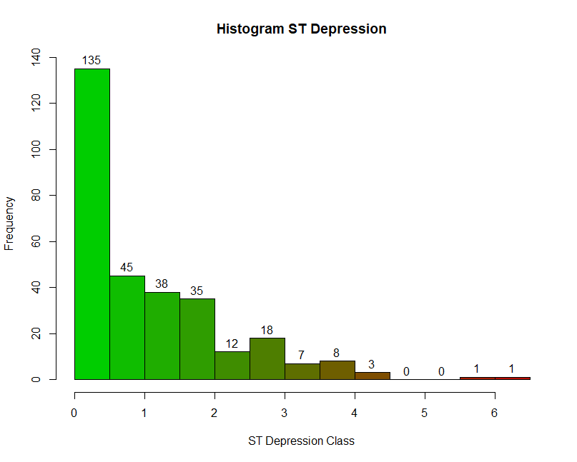

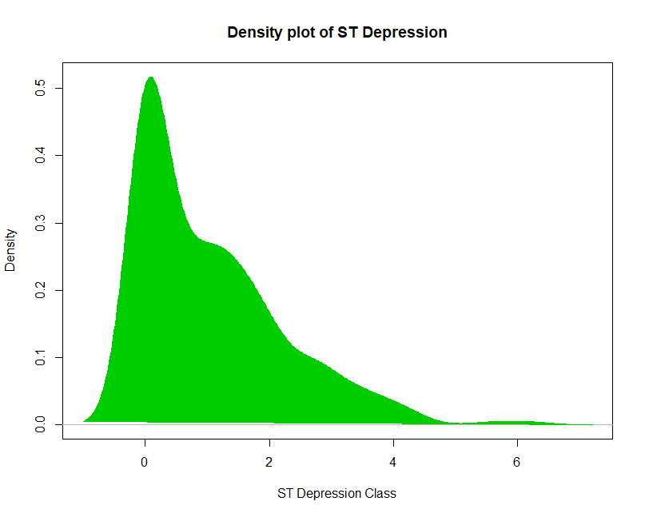

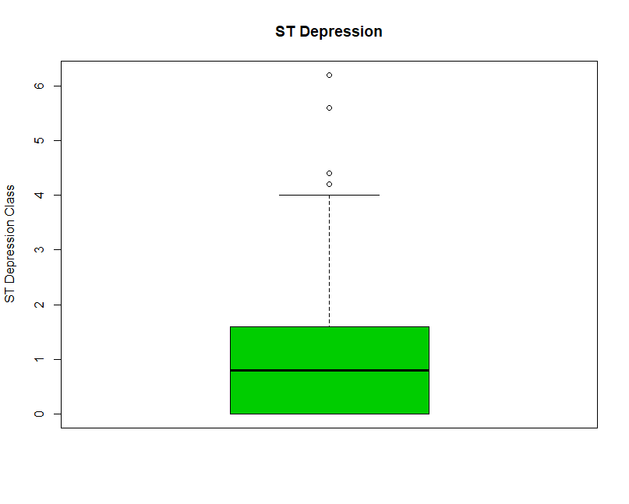

**The Slope of the Peak Exercise ST Segment(slope) Analysis**

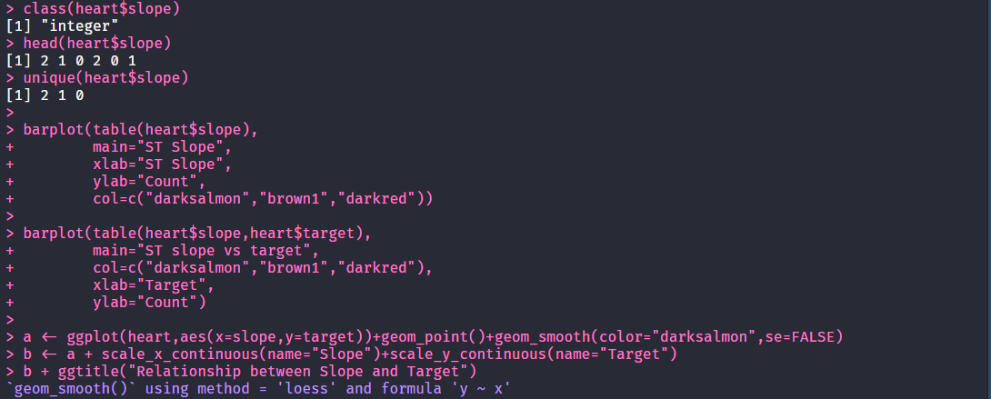

* The Slope of the Peak Exercise ST Segment categorical variable with 3 values 0,1 and 2.
* Majority of the population either has a ST slope of type 1 or 2, but type 2 has slightly higher count.
* By observing the ST slope vs target plot we can see that category 2 is more likely to get heart attack and 1 category is less likely to get heart attack.
* In curve "Relation between oldpeak and heart attack" after category 1 probability of heart attack is increasing.

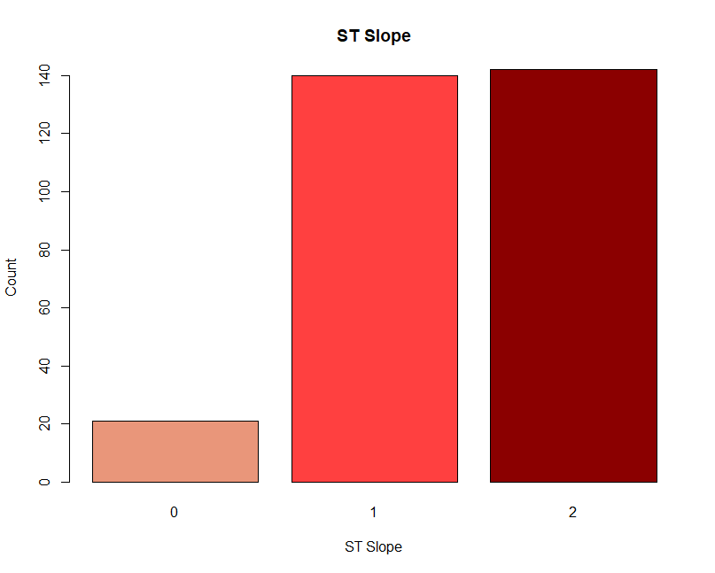

**Number of Major Vessels Colored by Fluoroscopy(ca) Analysis**

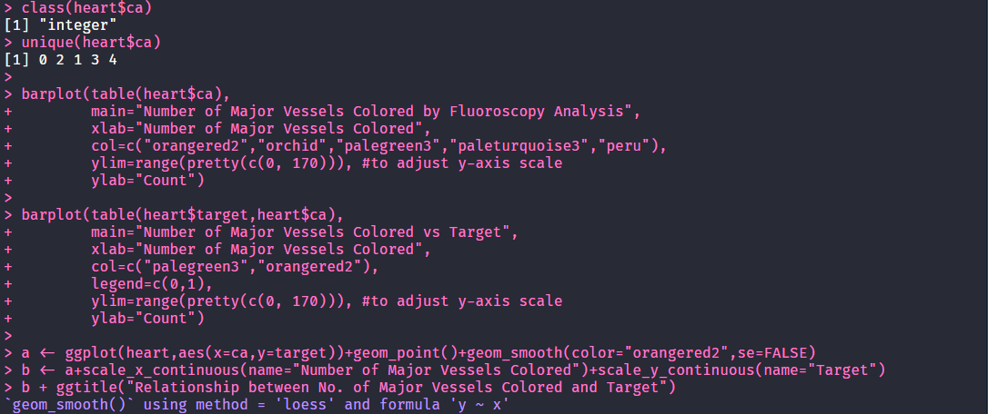

* Number of Major Vessels Colored by Fluoroscopy is a categorical variable with 5 values of 0,1,2,3 and 4
* Majority of the population is in the 0th category
* Population in 0th category is most likely to get heart attack.
* The least risk population to get heart attack is in 2nd category.

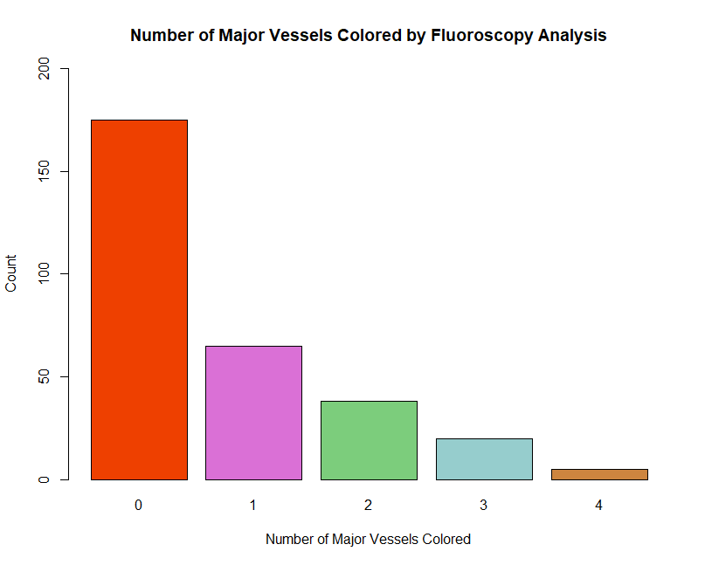

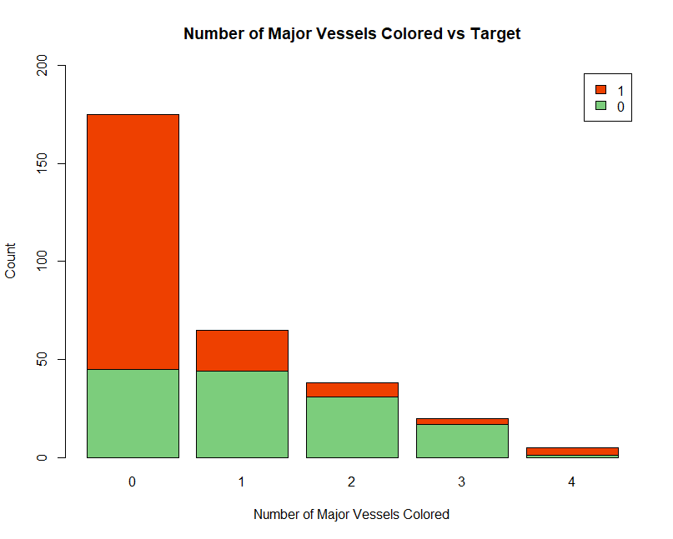

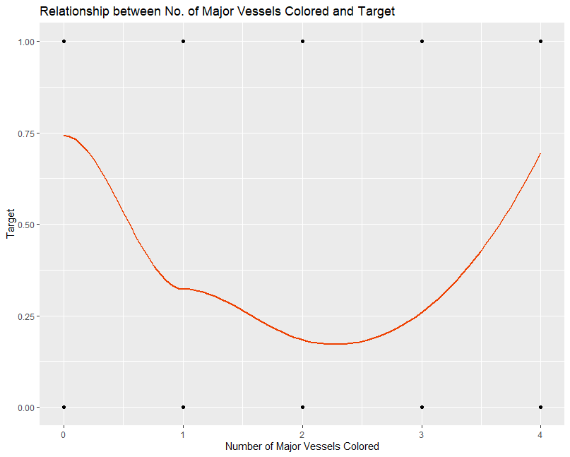

**Thalium Stress Test Result(thal) Analysis**

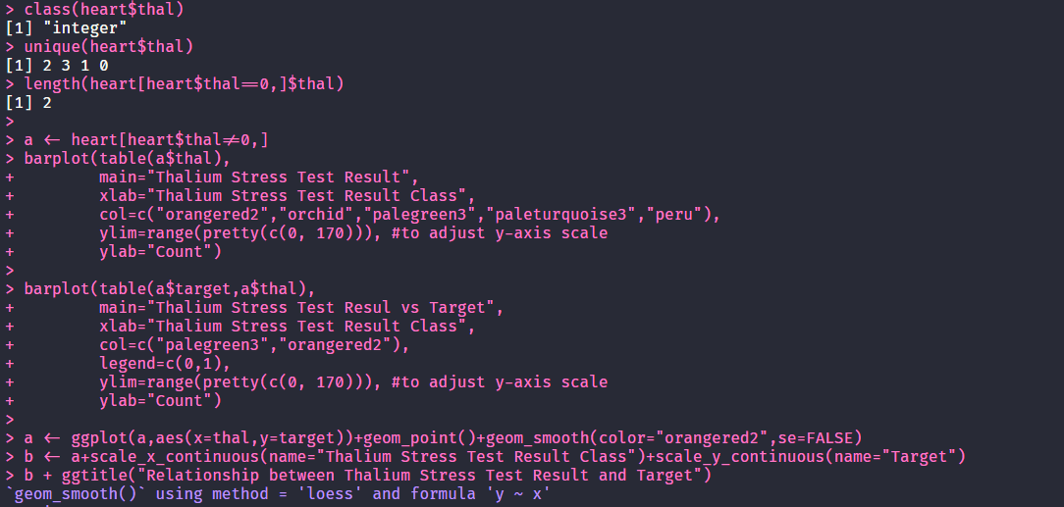

* This is a categorical variable with 3 values as 1,2 and 3.
* There are 2 data records with missing values for this and for the analysis it was removed.
* Most of the population has a normal (2) result for Thalium stress test, while most of the cases with a positive result (1 and 3) is reversable.
* Majority of the population with a heart attack has a normal result for the Thalium stress test.
* With regards to having a positive result (1 and 3) for the Thalium stress test, the probability of getting a heart is higher for fixed defect (1)

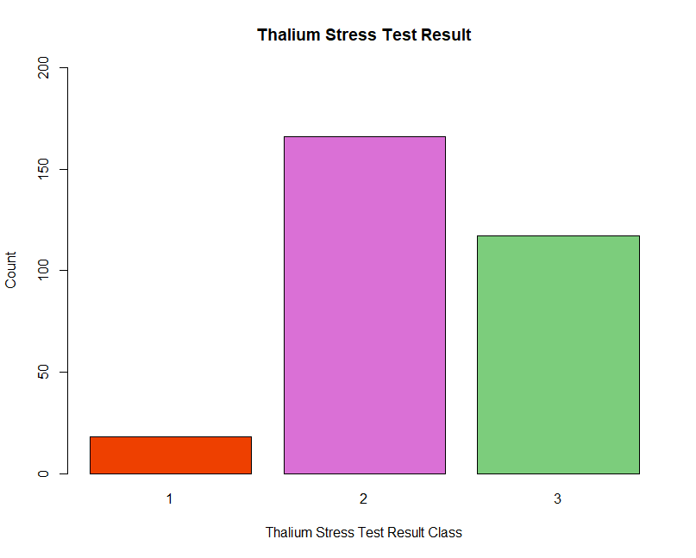

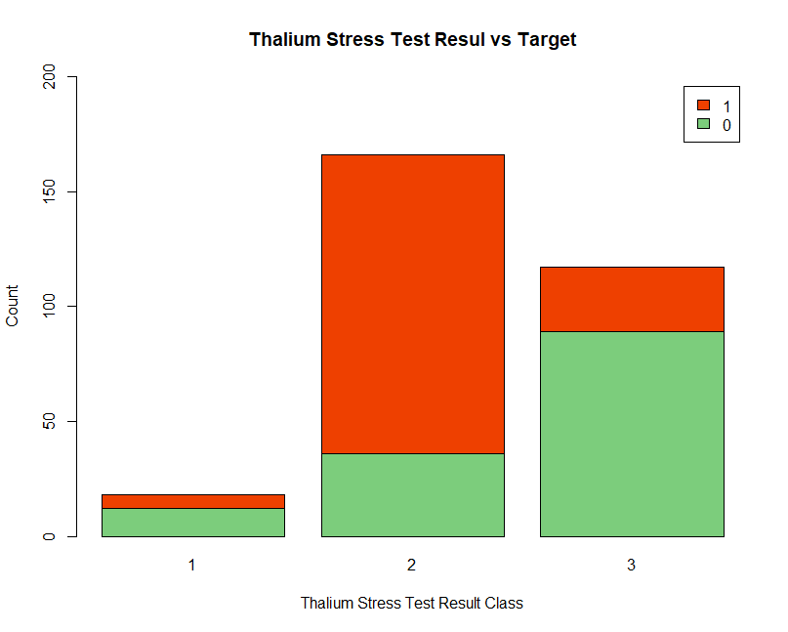

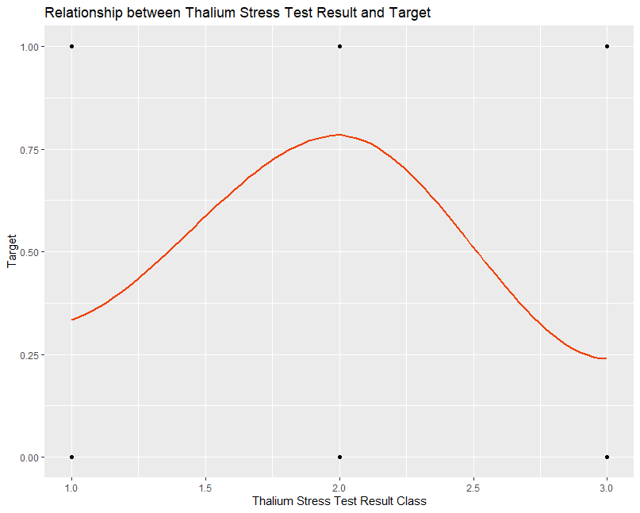

**Feature Selection**

*Correlation*

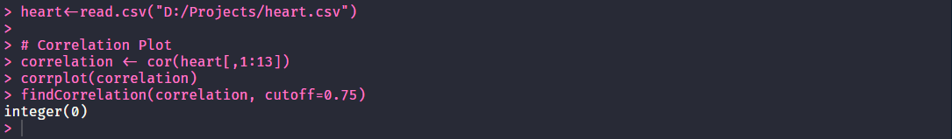

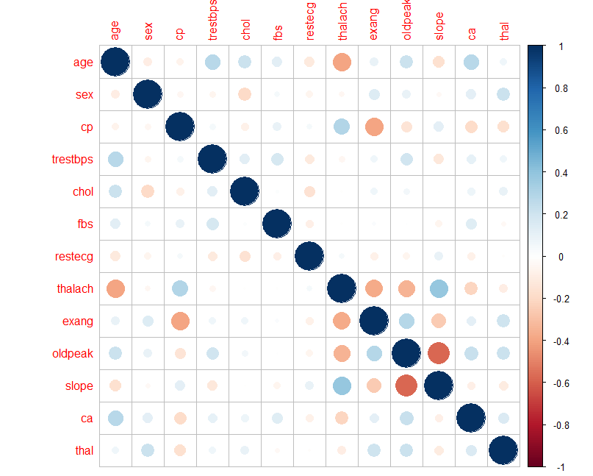

Correlation was calculated for all attributes and highest correlation is between **slope** (*The slope of the peak exercise ST segment*) and **oldpeak**(*ST depression induced by exercise relative to rest*) which is -0.578. Since the highest absolute correlation value is less than ***0.75,*** no attributes are needed to be removed due to high correlation.

*Features by importance*

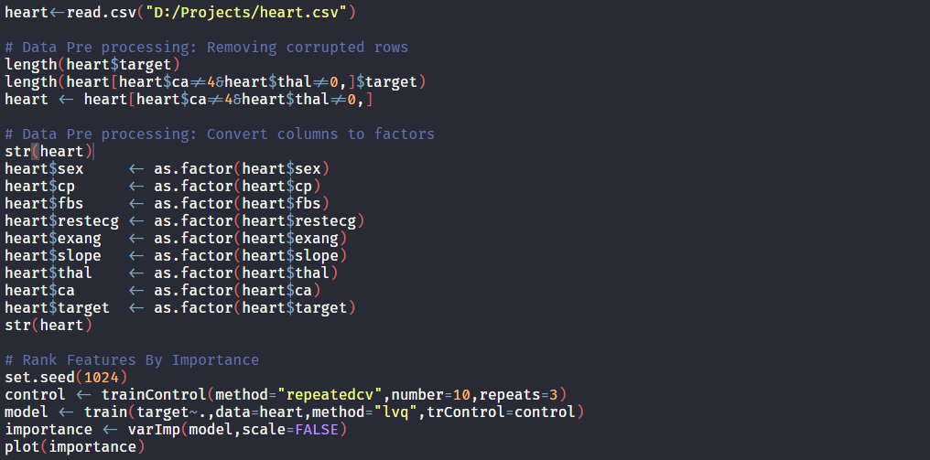

* All features except fasting blood sugar level has an importance greater than 50%.
* The top four features are
  + **ca**: Number of major vessels colored by fluoroscopy
  + **thalach**: Maximum heart rate achieved in beats per minute
  + **cp**: Chest pain type
  + **oldpeak**: ST depression induced by exercise relative to rest

We can observe that **fbs** (*Fasting blood sugar level*) has significantly less has less imports when compared to other attributes.

*Automatic feature selection*

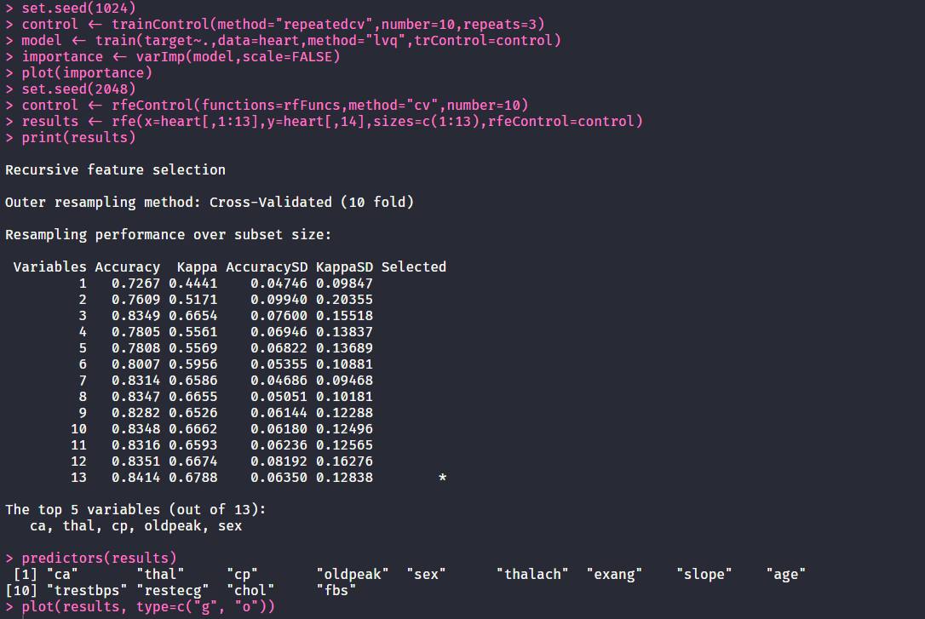

Running RFS on the attributes shows that using all 13 attributes yields the highest accuracy of 84%.

***By looking at all 3 methods of analysis I believe taking all 13 attributes into the model training will yield the best results.***

**2nd Task**: Formation of Training and Test Sets

**# Load the Data**

heart<-read.csv("D:/Projects/heart.csv")

**# Data Pre processing: Removing corrupted rows**

length(heart$target)

*[1] 303*

length(heart[heart$ca!=4&heart$thal!=0,]$target)

*[1] 296*

heart <- heart[heart$ca!=4&heart$thal!=0,]

**# Data Pre processing: Convert columns to factors**

str(heart)

*'data.frame': 296 obs. of 14 variables:*

*$ age : int 63 37 41 56 57 57 56 44 52 57 ...*

*$ sex : int 1 1 0 1 0 1 0 1 1 1 ...*

*$ cp : int 3 2 1 1 0 0 1 1 2 2 ...*

*$ trestbps: int 145 130 130 120 120 140 140 120 172 150 ...*

*$ chol : int 233 250 204 236 354 192 294 263 199 168 ...*

*$ fbs : int 1 0 0 0 0 0 0 0 1 0 ...*

*$ restecg : int 0 1 0 1 1 1 0 1 1 1 ...*

*$ thalach : int 150 187 172 178 163 148 153 173 162 174 ...*

*$ exang : int 0 0 0 0 1 0 0 0 0 0 ...*

*$ oldpeak : num 2.3 3.5 1.4 0.8 0.6 0.4 1.3 0 0.5 1.6 ...*

*$ slope : int 0 0 2 2 2 1 1 2 2 2 ...*

*$ ca : int 0 0 0 0 0 0 0 0 0 0 ...*

*$ thal : int 1 2 2 2 2 1 2 3 3 2 ...*

*$ target : int 1 1 1 1 1 1 1 1 1 1 ...*

heart$sex <- as.factor(heart$sex)

heart$cp <- as.factor(heart$cp)

heart$fbs <- as.factor(heart$fbs)

heart$restecg <- as.factor(heart$restecg)

heart$exang <- as.factor(heart$exang)

heart$slope <- as.factor(heart$slope)

heart$thal <- as.factor(heart$thal)

heart$ca <- as.factor(heart$ca)

heart$target <- as.factor(heart$target)

levels(heart$sex) <- c('F','M')

levels(heart$cp) <- c('TA','ATA','NAP','AS')

levels(heart$fbs) <- c('NO','YES')

levels(heart$restecg) <- c('NORM','ABNORM','VH')

levels(heart$exang) <- c('NO','YES')

levels(heart$slope) <- c('UP','FLT','DOWN')

levels(heart$thal) <- c('FIX','NORM','REVDEF')

levels(heart$ca) <- c('NONE','ONE','TWO','THREE')

levels(heart$target) <- c('NO', 'YES')

str(heart)

*'data.frame': 296 obs. of 14 variables:*

*$ age : int 63 37 41 56 57 57 56 44 52 57 ...*

*$ sex : Factor w/ 2 levels "F","M": 2 2 1 2 1 2 1 2 2 2 ...*

*$ cp : Factor w/ 4 levels "TA","ATA","NAP",..: 4 3 2 2 1 1 2 2 3 3 ...*

*$ trestbps: int 145 130 130 120 120 140 140 120 172 150 ...*

*$ chol : int 233 250 204 236 354 192 294 263 199 168 ...*

*$ fbs : Factor w/ 2 levels "NO","YES": 2 1 1 1 1 1 1 1 2 1 ...*

*$ restecg : Factor w/ 3 levels "NORM","ABNORM",..: 1 2 1 2 2 2 1 2 2 2 ...*

*$ thalach : int 150 187 172 178 163 148 153 173 162 174 ...*

*$ exang : Factor w/ 2 levels "NO","YES": 1 1 1 1 2 1 1 1 1 1 ...*

*$ oldpeak : num 2.3 3.5 1.4 0.8 0.6 0.4 1.3 0 0.5 1.6 ...*

*$ slope : Factor w/ 3 levels "UP","FLT","DOWN": 1 1 3 3 3 2 2 3 3 3 ...*

*$ ca : Factor w/ 4 levels "NONE","ONE","TWO",..: 1 1 1 1 1 1 1 1 1 1 ...*

*$ thal : Factor w/ 3 levels "FIX","NORM","REVDEF": 1 2 2 2 2 1 2 3 3 2 ...*

*$ target : Factor w/ 2 levels "NO","YES": 2 2 2 2 2 2 2 2 2 2 ...*

**# Seting up training and testing datasets**

set.seed(4096)

intrain <- createDataPartition(y=heart$target,p=0.75,list=FALSE)

training <- heart[intrain,]

testing <- heart[-intrain,]

dim(training)

*[1] 222 14*

dim(testing)

*[1] 74 14*

**# Repeated CV for Bagging type classifier**

set.seed(128)

bagging_control <- trainControl(method="repeatedcv",number=10,repeats=3)

**# Repeated CV for Stacking type classifier**

set.seed(128)

stacking_control <- trainControl(method="repeatedcv",number=10,repeats=3,savePredictions='final',classProbs=TRUE)

**Notes:**

* For data pre-processing, categorical attributes were converted to factors with meaningful values and there were 7 rows with missing values, and they were removed. Total records after cleaning is 296.
* Training data set consists of 75% of total records, which is around 222 records
* Testing data set is the remining 25% of total records, which is around 74 records
* For both bagging and stacking train control was 10 folder cross validation repeated 3 times.