**Manpreet Kaur N01304437**

**1. Register**

Narrative Description:

Firstly the staff needs to register into the Hospital website to check their schedule. But staff can’t register his/herself by own. Admin has a right to register the staff. Admin can click on the “Register” link then the registration form will be open. Then the admin fills the required information into the form and clicks on “Register” button. If admin skips any field without fill it then the error message will be displayed. Otherwise, a success message will be displayed

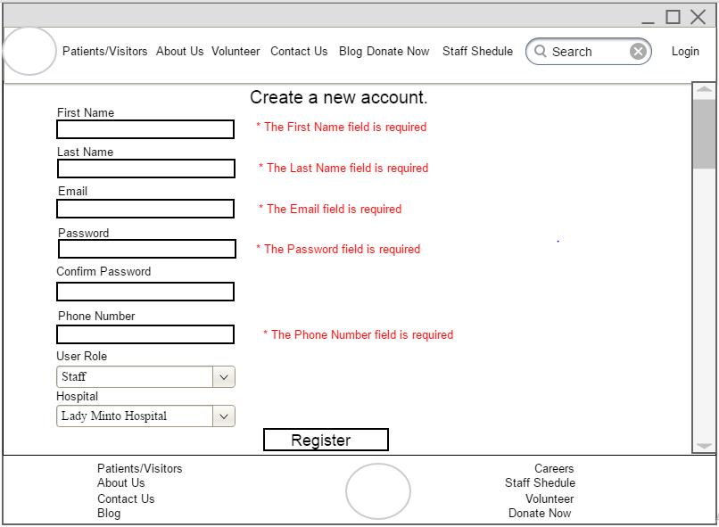

**Login**

Narrative Description:

After register into the Hospital website staff can log in by entering their email id and password then click on login button. If a staff enters valid ID and password then it shows the message “you are login successfully” otherwise shows the error message “Invalid ID or password”.

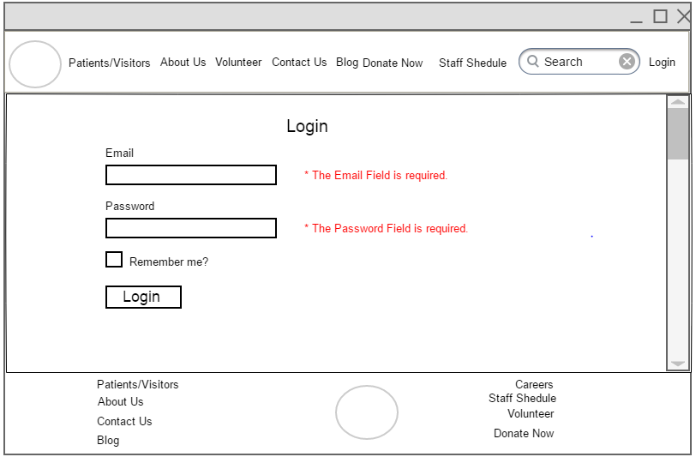

**Detail Users**

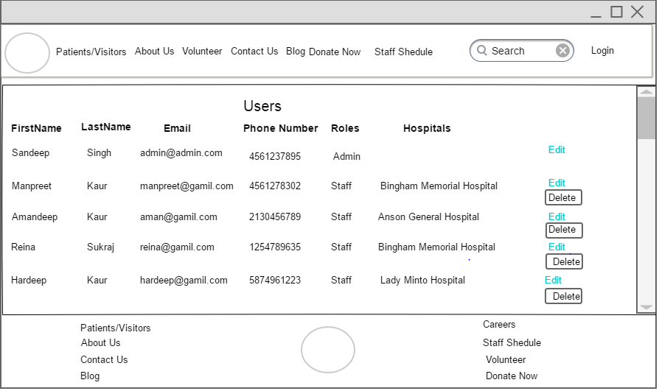

**Update Profile**

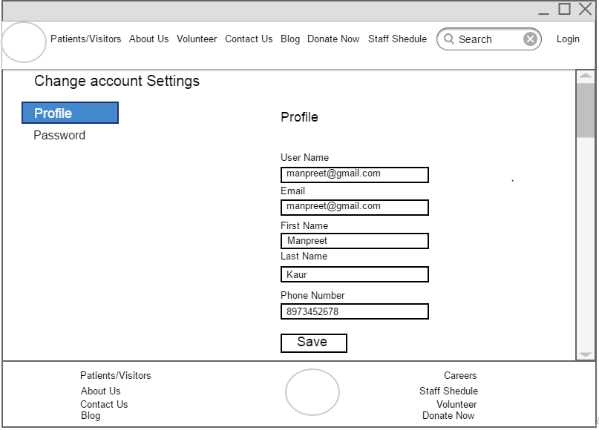

**Change Password**

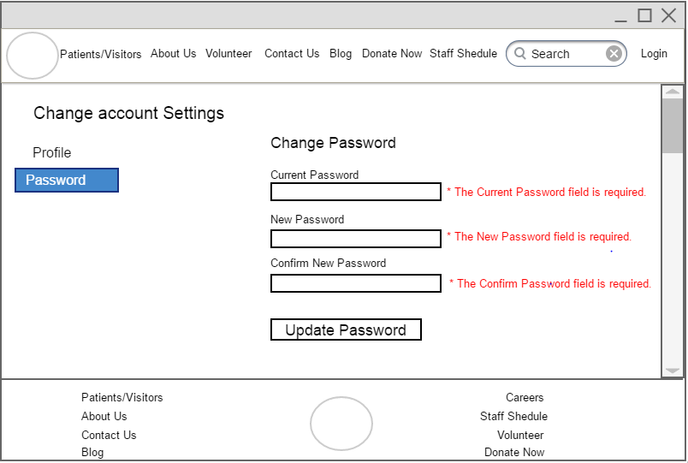

**Delete User**

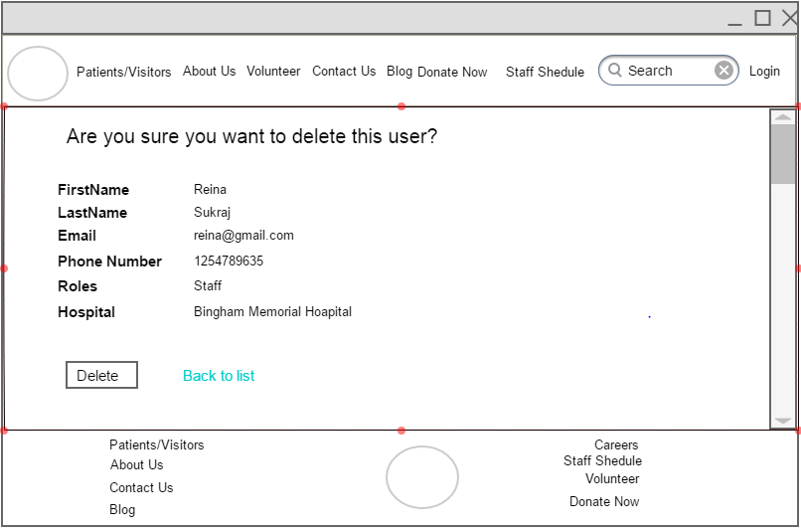

1. **Create Navigation**

Narrative Description:

As heart is the main part of human body in the same way navigation plays a part of heart in any website. Navigation gives the clear idea to user what they want to brows as it is categorized in groups and so it is easy to access.It gives better visibility to search engines.

Admin has a write to create new Navigation. Navigation is a two type Primary and Secondary. Primary Navigation is a main navigation It have no parent menu. Secondary Navigation is called sub navigation, it also have a parent menu.

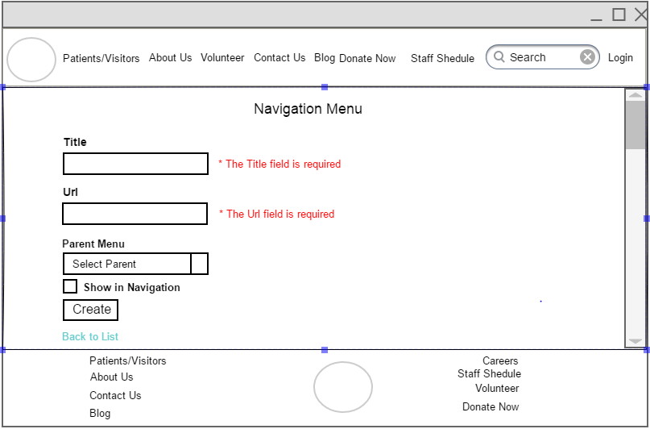

**List Navigation Menu**

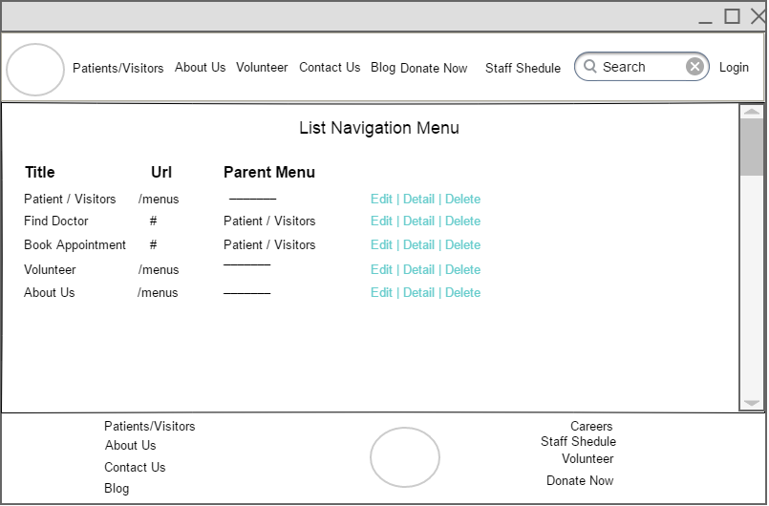

**Edit Navigation**

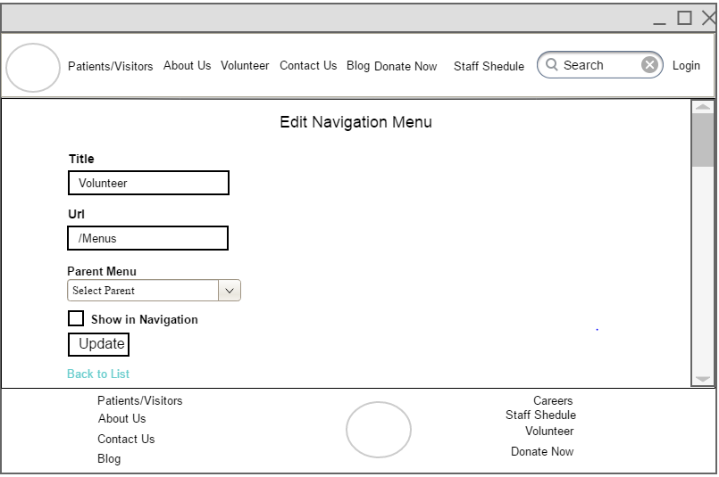

**Detail Navigation**

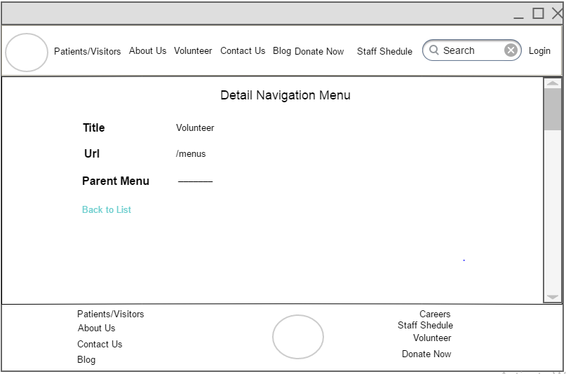

**Delete Navigation**

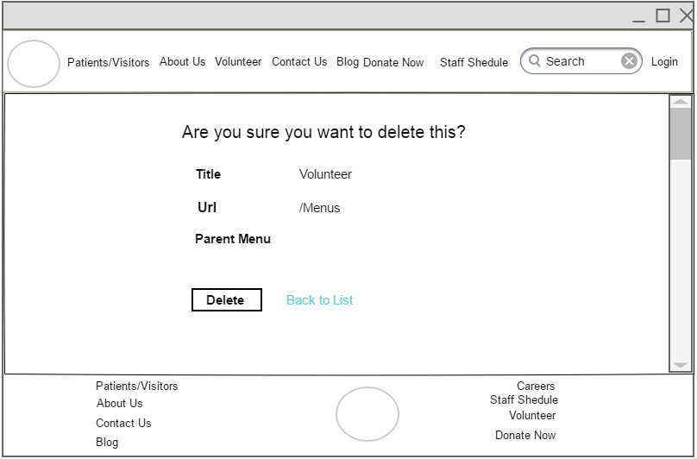

1. **Find a Doctor**

Narrative Description:

Find a doctor feature can be very helpful to the users, they don’t need to come hospital to book an appointment. The user can check online which type of doctors are available in the hospital and then he/she book an appointment with a doctor.

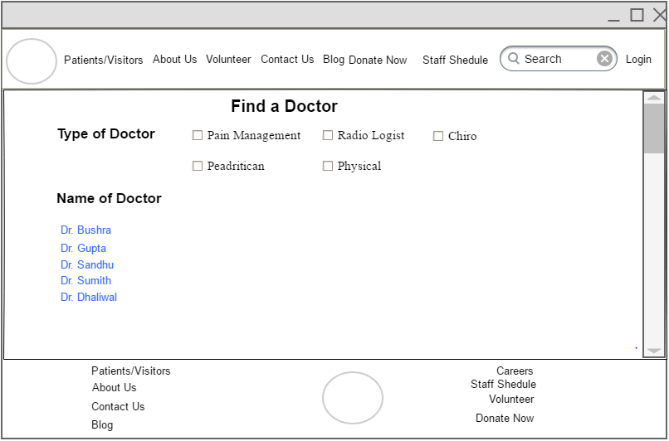

**Detail of Doctor**

