**Careers:**

**Narrative Description**

The Careers feature allows the hospital to post a list of jobs on the website and accept online applications for positions from users. It is located on the Home page in the main menu and in the footer. Visitors will follow the link to the page with a list of jobs. Visitors will see the entire list of jobs and two search fields. The first will contain a placeholder "Find jobs by keyword" with a drop-down list of categories. The second field will contain a placeholder "All locations" with a drop-down list of the hospitals. Users can type or choose. The website will display information on the vacancy or a message that “No results found.” Under the description of the position and requirements, there will be a link to submit an application. The user goes to the page with the application form, where they can upload a resume and cover letter.

The Careers feature will have an administrative backend. The administrator selects the “Career List” in the main navigation bar and can see the career list which he/she can manage. The administrator can sort by category, can select a position as well as add, edit and delete information. In addition, the admin can view all submitted applications, choose the best resumes, and delete applicants who are not suitable for the position

**Wireframes.**

Public page wireframes:

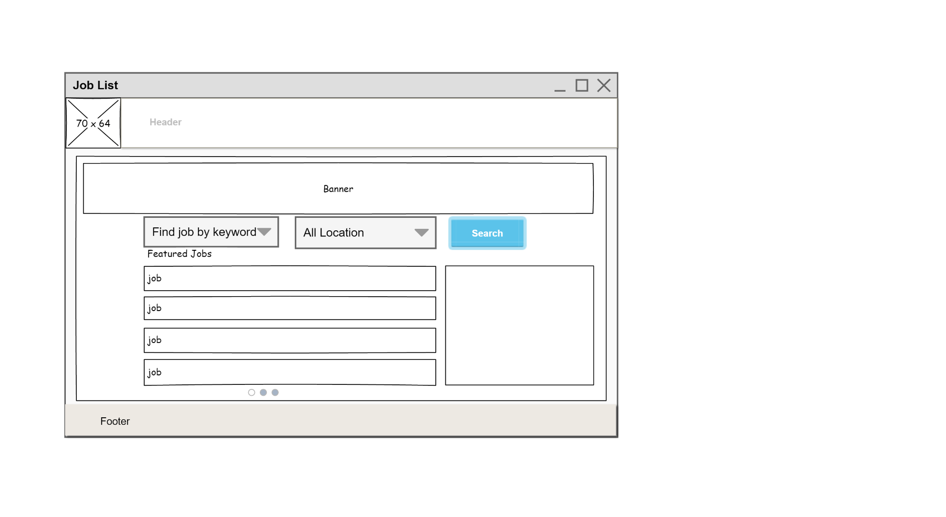

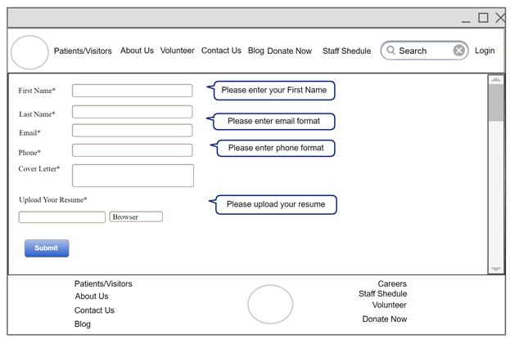

Job Application

Admin:

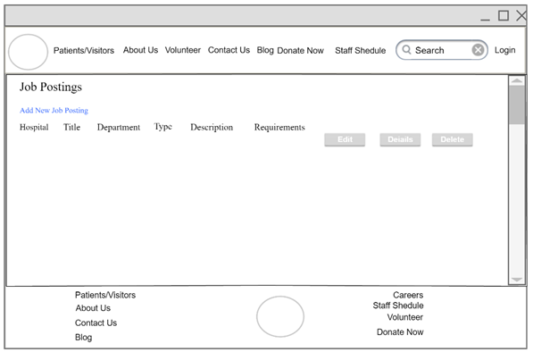

Job Posting List

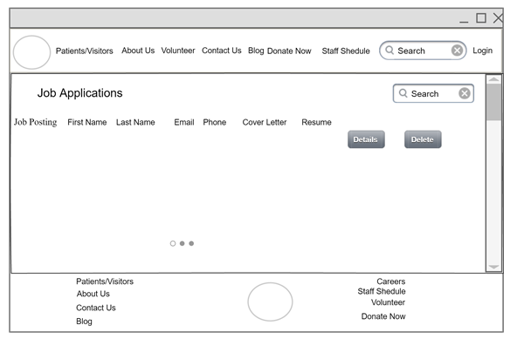

Job Applications List

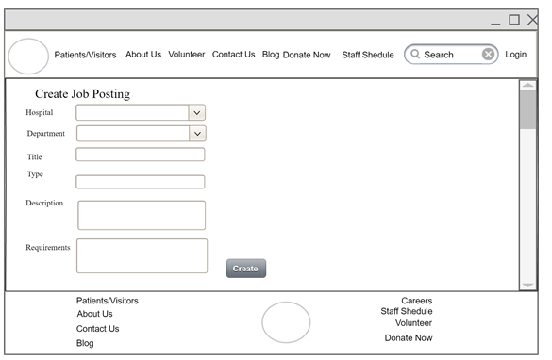

Create Job Posting

Volunteer

**Narrative Description**

The Volunteer feature allows registration for volunteering at the hospital through the simple process of filling out a form. The visitor can find a link in the main menu and in the footer. The link leads to the registration form. This form consists of contact information, demographic information, volunteer experience and availability. The form will also provide a choice of hospital location and department in which the visitor would prefer to volunteer. The form asks about the volunteer’s emergency contact and any health conditions. It will be mandatory to sign a volunteering agreement after which the visitor can send a request.

The volunteer feature will have an administrative backend that will manage submitted volunteer requests. The administrator can look at applications, contact applicants and edit incorrectly filled out forms. Also, the admin can delete inappropriate or outdated applications from inactive volunteers.

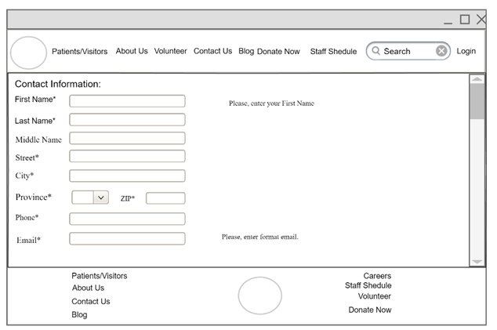

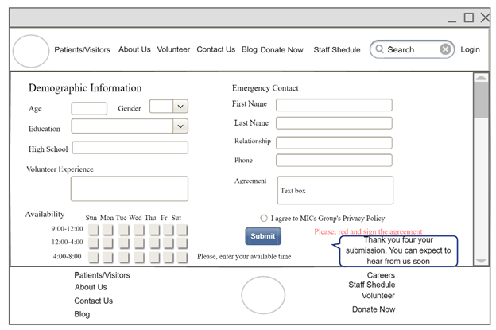

Admin:

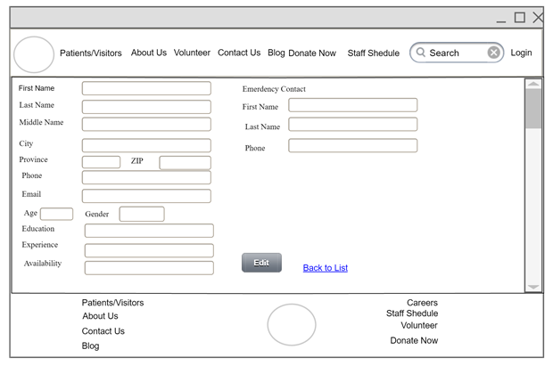

Booking Appointment

**Narrative Description**

The Booking Appointment is a feature that allows registered users to find a doctor and make an appointment online.  A visitor can find a doctor using the search field in which they will indicate their state of health, or a procedure or the name of the doctor. The visitor can choose the location of the hospital. In addition to this, there is a filter for reason for visit. After clicking the search button, a list of doctors appears with available appointment dates. The visitor can choose a doctor and find out the full information about him or her by clicking on the doctor’s name. Next to the information about the doctor is a calendar with an available date and time. After clicking on the selected date and time, an unregistered user is taken to the login page. A visitor can log in to the system in several ways. The first way is through an existing user or through Facebook or Google. The name and email fields input automatically. The second way is through registration by filling out the registration form. After completing the form, the user must become familiar with the agreement and privacy policy. The visitor sees all the information about the appointment and confirms the booking or returns back to a new choice. All information is sent to the hospital database and to the visitor's email. The visitor can cancel or change the appointment.

The administrator can see the entire list of doctors, booked time and time interval of admission. The administrator can change and delete time intervals or create a newly available time. Also, the doctor can go to page and view and manage the calendar.

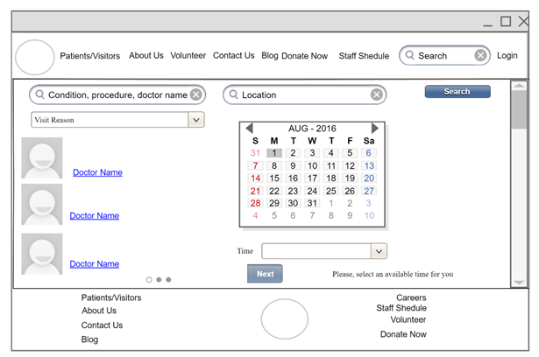

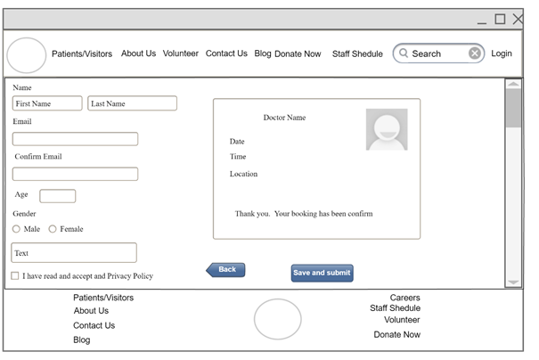

Admin

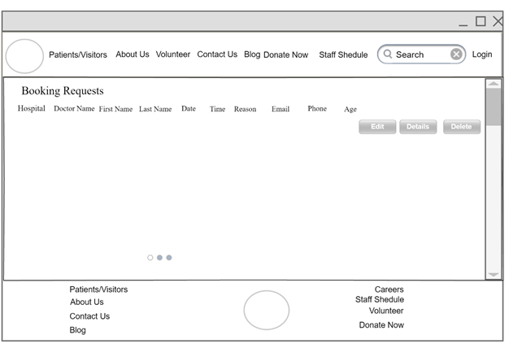

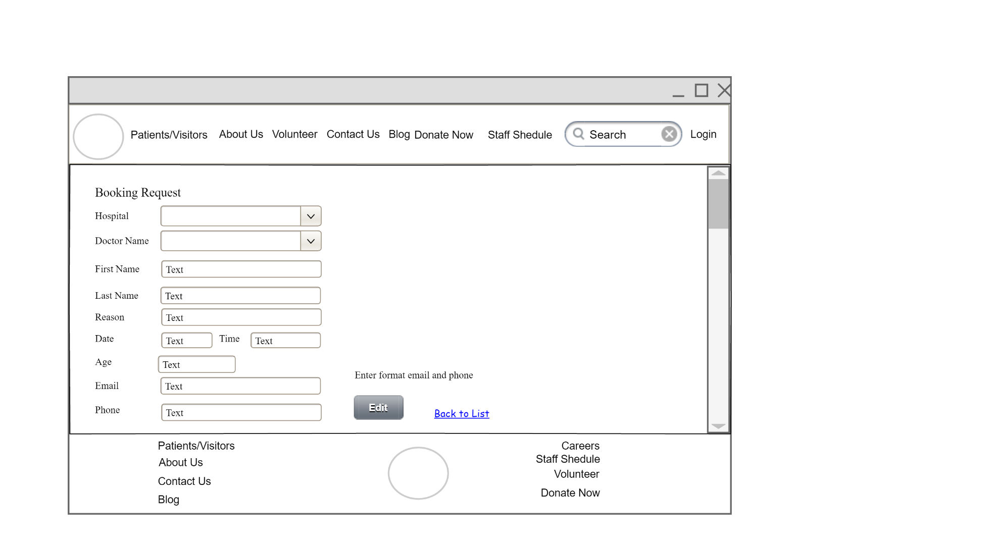

Edit Booking Request