Project µC – Part 4

# Circuit

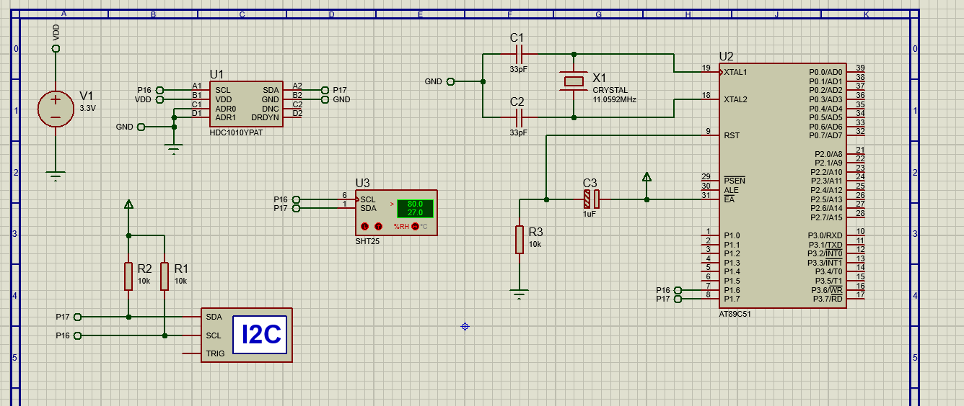

# Block Diagram

# Program Organigram

# I2C Interface

The I2C is widely used for attaching lower-speed peripherals ICs to processors and microcontrollers in short-distance, intra-board communication. It is a serial protocol (data is transferred bit by bit along the SDA) for two-wire interface to connect low-speed devices like microcontrollers, EEPROMs, A/D and D/A converters and other similar embedded systems.

I2C combines the best features of SPI and URATs, therefor, with I2C, one can connect multiple slaves to a single master (like SPI) and one can have multiple masters, controlling one/more slave(s).

Like URAT, the I2C uses two wires to transmit data: SDA (Serial Data) and SCL (Serial Clock). SDA is the line for the master and slave to send/receive data, while the SCL is the line that carries the clock signal.

With I2C, data is transferred in messages. Messages are broken up into frames of data. Each message has an address frame that contains the binary address of the slave, and one or more data frames that contain the data being transmitted. The message also includes start and stop conditions, read/write bits, and ACK/NACK bits between each data frame.

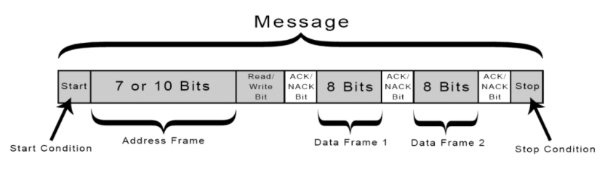

**Start Condition:** The SDA line switches from a high voltage level to a low voltage *before* the SCL line switches from high to low.

**Stop Condition:** The SDA line switches from a high voltage level to a low voltage *after* the SCL line switches from high to low.

**Address Frame:** A 7/10-bit sequence unique to each slave; it identifies the slave when the master wants to “talk” to it.

**Read/Write Bit:** A single bit specifying whether the master is sending data to the slave (low voltage) or requesting data from it (high voltage).

**ACK/NACK Bit:** Each frame in a message is followed by an acknowledge/no-acknowledge bit. If an address frame or data frame was successfully received, an ACK bit is returned to the sender from the receiving device.