µC

# Introduction

A microcontroller is a small, low cost and self-contained computer-on-a-chip that can be used as an embedded system. They usually include an 8/16-bit µP, a little measure of RAM, programmable ROM and flash memory, parallel/serial I/O, timers, ADC and DAC. [1]

The 8051 µC is a 40 pin µC with a Vcc of 5V connected to the pin 40 and the Vss of 0V connected at pin 20. There are 4 (P0->P3) input/output ports numbered as: Px.1->Px.7. [1]

# Internal Architecture [1]

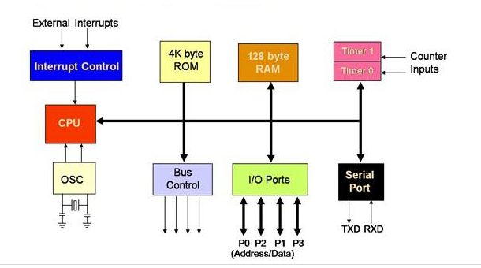

# Model comparison

|  |  |  |  |
| --- | --- | --- | --- |
| Model | CY7C68013A-56LTXC [2] | AT89C51 [3] | DS80C320-MNL+ [4] |
| Availability (market) | Yes | Yes- AT89C51CC03CA-RLTUM | Yes |
| Availability (Proteus) | *Yes | Yes | *Yes |
| I2C | Yes | With bit banging | - |
| CPU speed | 48MHz | 60MHz | 33MHz |
| Core size | 8 bits | 8 bits | - |
| ROM size | - | 64 KB | 64 KB |
| RAM size | 16 KB | 2 KB | 256 Bytes (Scratchpad) |
| Architecture | 8051 | 80C51 | 8051 |
| Price [RON] | 60.80 | 41.05 | 78.40 |

Table 1. µCs comparison

*The part is not yet complete.

# Proposed model

Based on Table 1. We can see that the AT89C51 model is the best choice for the project, out of the three options. Because, first, pricewise it is the cheapest and second, feature wise, it has far better ones, for example the core speed, which is of 60MHz compared to 48 and 33Mhz of the other two.

Another reason for which I picked it, is that it has a larger ROM and RAM size, and even though it does not have an integrated I2C interface, it can be implemented by using bit banging.

As for the availability on the market, there is no difference, but when it come to the availability in Proteus, we meet with some limitations. That being that both CY7C68013A-56LTXC and DS80C320-MNL+ are not completed parts, therefore, we can not simulate their complete real-life behavior.

A thing that I observed during the research for the µC is that the AT89C51 is widely and far more used, which means that there will be more reference material if needed.

LCD

# Introduction

Most alphanumeric LCDs are classified as 1/2/4 line. The most common type of LCDs are the Alphanumeric/Character displays. And are easier to be implemented than a graphic unit and built-in standard configurations. [5]

Alphanumeric displays give the information in the form of characters (number/letters). [5]

# Model comparison

|  |  |  |  |
| --- | --- | --- | --- |
| Model | MC22005A6WK-BNMLW-V2 [7] | FC1602N04-RNNYBW-16*E [8] | PC1601LRU-AWB-B-Q [9] |
| Availability (market) | Yes | Yes | Yes |
| LCD Type | STN | STN | STN |
| Display appearance | White on blue | Black on yellow/green | Black on yellow/green |
| Display mode | Transmissive | Reflective | Transflective |
| Character (count x line) | 20x2 | 16x2 | 16x1 |
| Interface | Parallel | - | Parallel |
| Price [RON] | 56.70 | 67.80 | 53.10 |

Table 2. LCDs comparison

**STN** = super-twisted nematic display; is a type of [monochrome](https://en.wikipedia.org/wiki/Monochrome) [passive-matrix](https://en.wikipedia.org/wiki/Passive_matrix_addressing) [liquid crystal display](https://en.wikipedia.org/wiki/Liquid_crystal_display). [6]

**Transmissive** = the mode of operation when light from the backlight passes through the LCD. The glass/panel of the liquid crystal display functions as an optical switch, where light from the backlight passes through the LCD cell, depending on the orientation of the liquid crystal molecules. [10]

The disadvantage of this type is that the backlight requires a significant amount of energy, especially now that the backlight is required to be on all the time, even if there is no content on the display. [10]

**Reflective** = a mirror is installedbehind the liquid crystal layereither inside the LCD cell or on the rear polarizer. Ambient light passes through the LCD cell from the front side and is reflected by the mirror in the back. [10]

It presents a lower power consumption and excellent visibility in direct sunlight, therefore, an excellent solution for outdoor applications/projects, but in the dark, it does require additional lighting. [10]

**Transflective** = it has both transmissive and reflective characteristics. They contain an integrated backlight unit and a semi-transparent reflector or a reflector with a hole for each pixel. Again, the reflector can be behind the rear polarizer or inside the LCD cell behind the liquid crystal layer.

Light from the backlight can pass the semi-transparent reflector and operate the display in the transmissive mode. At the same time, ambient light can be reflected so that the display is visible in direct sunlight as well.

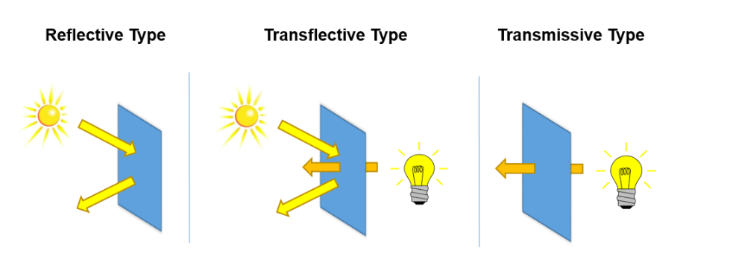

Figure.1 LCD display modes

# Proposed model

Taking into consideration Table 2. we can now make our LCD choice. All three options are available on the market and can be easily substituted with other kinds of LCDs in proteus that would keep, the original specifications.

All of them have the same type of LCD, STN which has the advantages of being low-cost and low-power consumption. Unfortunately, STN also has a narrower viewing angle and poor contrast.

Whereas for the display appearance, I think is up to the user, but for my own preference would be the white on blue, therefore, the MC2200.

Considering the display mode, perhaps the best suited for the greenhouse application would be a transmissive mode. Because there might be times when we will need to check the greenhouse during the nighttime and/or during a cloudy day. Therefore, the MC2200 wins again.

For the number of characters displayed on the line, is again a personal preference, and due to that, I will go with the 20 character and 2 lines option.

All three LCDs offer the same kind of interface, the parallel one, so, nothing to compare here.

Pricewise, I do think that the advantages I mentioned earlier, for the MC2200, make sense in justifying choosing it over the cheaper option.

The Circuit

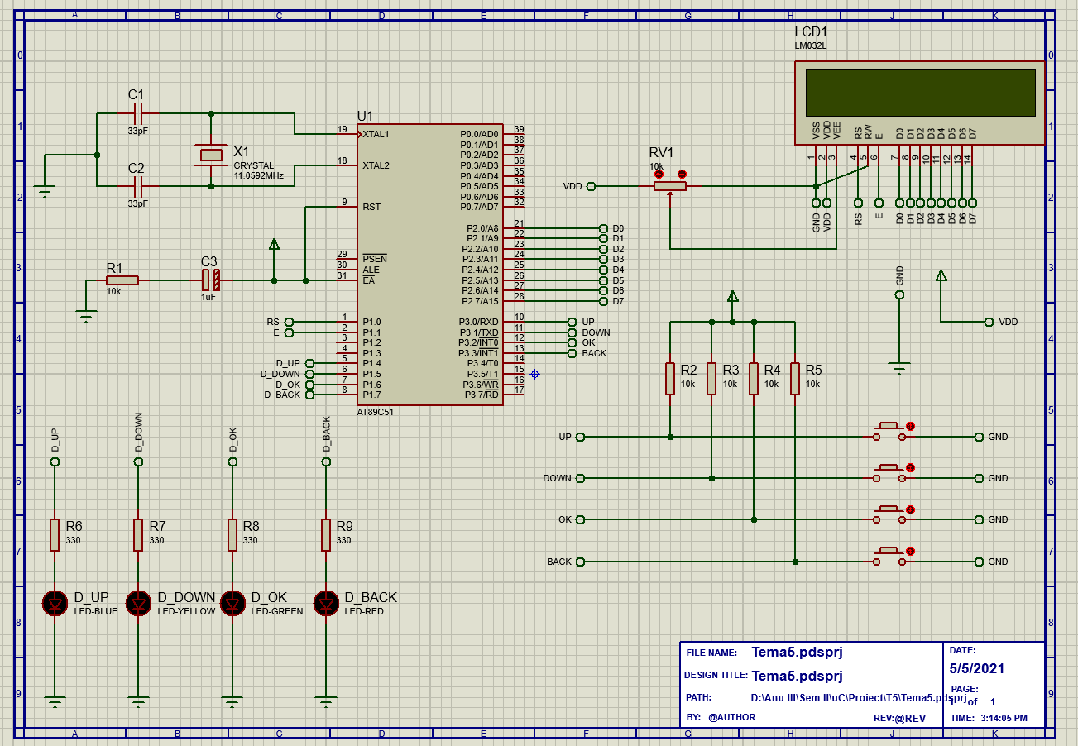

# The Code

#include<reg51.h>

#define LCD P2

//LED Pins

sbit LED_UP = P1^4;

sbit LED_DOWN = P1^5;

sbit LED_OK = P1^6;

sbit LED_BACK = P1^7;

//Button Pins

sbit UP = P3^0;

sbit DOWN = P3^1;

sbit OK = P3^2;

sbit BACK = P3^3;

sbit RS = P1^0;

sbit E = P1^1;

//Function declarations

void delay(int);

void LCD_init(void);

void cmd(char);

void dispString(char*);

void LCD_disp(char);

// Main function

void main(void)

{

OK=1; //making input

UP=1; //making input

DOWN=1; //making input

BACK=1; //making input

//Initializing the LCD

LCD_init();

while(1)

{

//up

if(UP==0) //if button UP pressed

{

LED_UP=1; //LED on

dispString("Going UP..."); //Disp message

delay(2000);

}

else

{

LED_UP=0;

LCD_init(); //reset LCD

}

//down

if(DOWN==0) //if button DOWN pressed

{

LED_DOWN=1; //LED on

dispString("Going DOWN..."); //Disp message

delay(2000);

}

else

{

LED_DOWN=0;

LCD_init(); //reset LCD

}

//ok

if(OK==0) //if button OK pressed

{

LED_OK=1; //LED on

dispString("Confirming..."); //Disp message

delay(2000);

}

else

{

LED_OK=0; //LED on

LCD_init(); //reset LCD

}

//back

if(BACK==0) //if button BACK pressed

{

LED_BACK=1; //LED on

dispString("Going BACK...");//Disp message

delay(2000);

}

else

{

LED_BACK=0;

LCD_init(); //reset LCD

}

}

}

void cmd(char t)

{

LCD = t;

RS=0;

E=1;

delay(5);

E=0;

}

void LCD_init()

{

cmd(0x38); //data init

cmd(0x0C); //LCD display on and cursor off

cmd(0x01); //clear LCD dispaly

cmd(0x80); //positioning cursor at the first line

}

void delay(int n)

{

int i,j;

for(i=0;i<n;i++)

for(j=0;j<100;j++)

{}

}

void dispString(char *p)

{

while(*p)

{

LCD_disp(*p++);

}

}

void LCD_disp(char x)

{

LCD=x;

RS=1;

E=1;

delay(5);

E=0;

}

# Bibliography

[1] <https://www.elprocus.com/microcontrollers-types-and-applications/>

[2] <https://www.cypress.com/file/138911/download>

[3] <https://4donline.ihs.com/images/VipMasterIC/IC/ATML/ATMLS04922/ATMLS04922-1.pdf?hkey=6D3A4C79FDBF58556ACFDE234799DDF0>

[4] <http://www.farnell.com/datasheets/686377.pdf>

[5] <https://focuslcds.com/journals/alphanumeric-lcd-displays/>

[6] <https://en.wikipedia.org/wiki/Super-twisted_nematic_display>

[7] <http://www.farnell.com/datasheets/2175695.pdf>

[8] <http://www.farnell.com/datasheets/3166294.pdf>

[9] <http://www.farnell.com/datasheets/1009626.pdf>

[10] <https://www.newvisiondisplay.com/lcd-modes/>