Technical University of Cluj Napoca

Data acquisition system

-Microcontroller project-

Student: Vakutz Alexandru Andrei

Coordinator: Pătărău Toma Mihai

2020-2021

Contents

1. Introduction 4

1.1 Specifications. 4

1.2 Theme description. 4

1.3 Generic list of components. 4

1.4 Block diagram 5

1.5 Final Circuit 5

2. Temperature Sensor 6

2.1 Measurement methods. 6

2.2 Proposed method. 7

2.3 Sensor comparison. 9

2.4 Proposed sensor. 10

3. Humidity Sensor 11

3.1 Measurement methods. 11

3.2 Proposed method. 12

3.3 Sensor comparison. 12

3.4 Proposed sensor. 13

4. Conditioning circuit for analog sensor 14

4.1 Introduction. 14

4.2 Block Diagram. 15

4.3 Components List. 15

4.4 ADCs measurement method. 15

4.5 ADCs proposed method. 17

4.6 ADC model comparison & proposal. 17

4.7 Calculus, circuit, and simulations. 17

5. I2C communication 22

5.1 Circuit 22

5.2 Block Diagram 22

5.3 Program Organigram 23

5.4 I2C Interface 23

6. Microcontroller 25

6.1 Introduction 25

6.2 Internal Architecture [1] 25

6.3 Model comparison 26

6.4 Proposed model. 26

7. LCD 27

7.1 Introduction 27

7.2 Model comparison 27

7.3 Proposed model. 28

The Circuit 29

Simulation 30

8. Bibliography 34

8.1 Temperature Sensor 34

8.2 Humidity Sensor 34

8.3 I2C communication 35

8.4 Microcontroller and LCD 35

# Introduction

# Specifications.

The humidity sensor must have a digital output and be affordable, first. Secondly, it must have a desirable humidity in the greenhouse would be somewhere around 80-83% RH and a temperature between 10℃ and 30℃.

# Theme description.

The aim of the project is to build an automated greenhouse system with various systems and sensors, to monitor the temperature, the air quality and humidity, the soil acidity and moisture and the CO2 levels. As well as tend to the needs of the plants.

# Generic list of components.

Sensors:

* Temperature sensor
* Humidity sensor
* Light sensor
* Moisture sensor
* Air quality/CO2
* Soil pH sensors

Processing:

* Microcontroller
* Amplifier
* ADC

Input/output:

* Keypad
* LCD display

Other:

* Humidifier
* (Drip) irrigation kit
* Light fixtures
* Vents (cooling/heating/air circulation)

# Block diagram



# Final Circuit

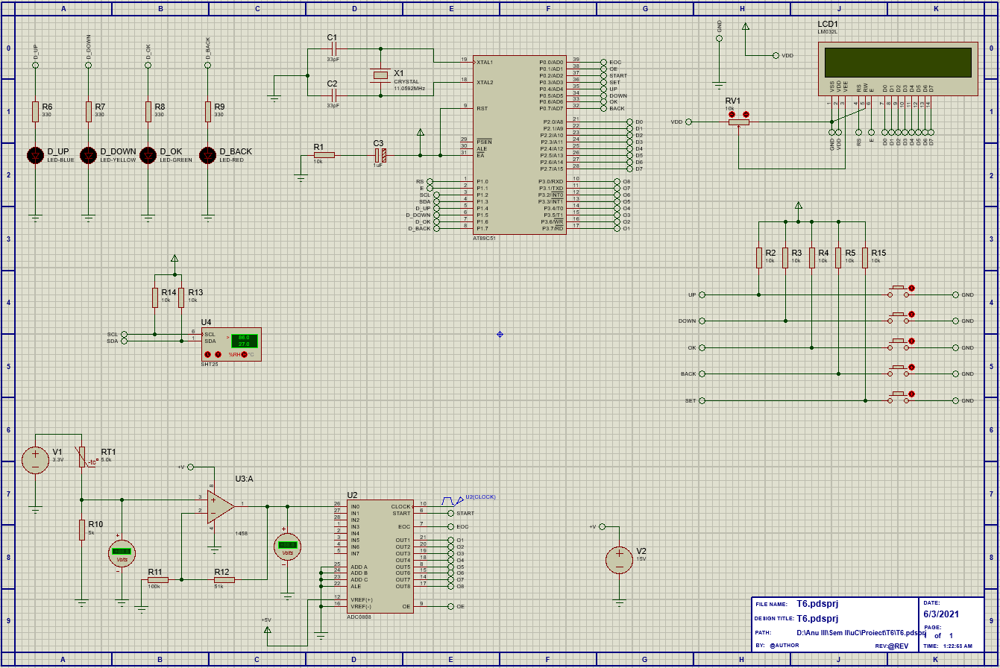

# Temperature Sensor

# Measurement methods.

Temperature measuring sensors come in a wide variety but have one thing in common: they measure temperature by sensing some change in a physical characteristic.

**Thermocouples** – voltage devices that indicate temperature measurement with a change in voltage. As temperature goes up, the output rises, not necessarily linearly.

Often, the thermocouple is located inside a metal or ceramic shield that protects it from exposure to a variety of environments.[1]

**Resistance temperature sensor (RTD)** – is a contact sensor. It uses the variation of the resistance of a metal according to the temperature. This type of sensor uses several metals that offer different measuring ranges.[2]

RTDs are in general, more linear than the thermocouples. They increase in a positive direction, with resistance going up as temperature rises.

**Thermistor** – another type of resistance sensor, that uses the variation of metal oxides according to the temperature.

There are two types of thermistor sensors: **NTC** (Negative Temperature Coefficient) which generally have a regular negative resistance and **PTC** (Positive Temperature Coefficient) which shows a sudden positive resistance variation for a narrow temperature range.

A thermistor has a fast response time and is inexpensive but, on the other hand they are quite fragile, have a much narrower temperature measurement range. It also is an extremely nonlinear semiconductive device that will decrease in resistance as temperature rises, due to its different type of construction.[1][2]

**Infrared sensor** – non-contacting sensors. It measures the radiation of a surface in the infrared range to derive the surface temperature. The main advantage of this type of a sensor is that it works remotely, without any physical contact with the targeted surface.

Very fast response time. They do not need to establish thermal equilibrium, as such these sensors can measure moving objects.

The downside to this sensor is that since they can only measure the surface temperature of the target, the measurement can be influenced by the condition of the targeted surface (dust, rust, etc.), by the cleanliness of the lenses (dust) and the optical path between the sensor and the target (dust, humidity, combustion, gas, etc.) [1][2]

**Bimetallic sensors** – take advantage of the expansion of metal when they are heated, two metals are bonded together and mechanically linked to a pointer. When heated, one side of the sensor strip will expand more than the other. When geared properly to a pointer, the temperature measurement is indicated.

The main advantages of such sensors are their portability and independence from a power supply. Unfortunately, they are not usually quite as accurate as are other sensors, and one cannot easily record the temperature value as with electrical devices, such as thermocouples or RTDs.[1]

**Thermometers** - well known liquid expansion devices also used for temperature measurement. They are organized in two main classifications: the mercury and organic types. The distinction between the two is notable, because mercury devices have certain limitations when it comes to how they can be safely transported or shipped.[1]

**Change-of-state sensors** – measure a change in the state of a material brought about by a change in temperature, as in a change from ice to water and then steam. Commercially available devices of this type are in the form of labels, pellets, crayons, or lacquers.

Limitations include a relatively slow response time, and the accuracy is not as high as with most of the other devices more commonly used. [1]

**Silicone Diode** – is a device developed specifically for the cryogenic temperature range. Essentially, they are linear devices where the conductivity of the diode increases linearly in the low cryogenic regions. [1]

# Proposed method.

Using all the information presented earlier, of all the mentioned types of temperature sensor, the silicone diode is the first one that must go, primarily because it was built for cryogenic temperatures.

Considering the temperature range, the thermocouple sensor offers the widest and highest range since those are best for working at higher temperatures [3] and so, probably, not the best for agricultural purposes. However, all the other sensors offer some quite satisfying parameters.

Considering that the sensor will be used in a greenhouse, an infrared sensor would make no sense in using because there will always be dust/humidity in the air and/or the lens.

Another sensor that would not be the most useful in a greenhouse is the bimetallic sensor, because we have no need of the advantages it offers and there are other sensors more accurate. The same could be said for the change of state sensor.

A thermometer is a poor choice as well, first, because mercury is considered an environmental contaminant, so breakage can be hazardous and second, because there are certain limitations when it comes to shipping.

We find ourselves with 2 choices left: RTD and thermistor. Which brings me to the following table:

|  |  |  |
| --- | --- | --- |
| Sensor type | Thermistor | RTD |
| Temperature range | -100 to 352℃ | -200 to 650℃ |
| Accuracy | 0.05 to 1.5℃ | 0.1 to 1℃ |
| Long-term stability@100℃ | 0.2℃/year | 0.05℃/year |
| Linearity | Exponential | Fairly linear |
| Power required | Constant voltage/current | Constant voltage/current |
| Response time | Fast (0.12 to 10s) | Slow (1 to 50s) |
| Susceptibility to electrical noise | Rarely susceptible  High resistance only | Rarely Susceptible |
| Cost | Low to moderate | High |

Table . Thermistor vs RTD

Upon taking a closer look on Table 1, the RTD would make a perfect fit, considering the temperature range, the accuracy, and the long-term stability. But considering the lower cost and the fast response time of a thermistor combined with the fact that there is not such a huge difference when it comes to accuracy between the two, the thermistor would be the natural choice. And since the NTC thermistor is mainly used for temperature control and measurements applications, I think it would make a perfect fit for our smart greenhouse.

# Sensor comparison.

|  |  |  |  |
| --- | --- | --- | --- |
| Model | B57881S [7] | NTCLE100E3 [8] | NI24MA0502H [9] |
| Accuracy | High | Over a wide temperature range | High |
| Availability | Yes | Yes | Yes |
| Price | 11.07 RON | 1.71 RON | 6.61 RON |
| Applications | Temperature measurement | Temperature measurement  Compensation | Temperature measurement  Air intake temperature  Evaporator probe |
| Operating Temperature | -55℃ to 155℃ | -40℃ to 125℃ | -55℃ to 150℃ |
| Resistance Tolerance | ±1% | ±5% | ±3% |

Table .

**Interfacing** – since microcontrollers read voltages and not resistances, the simplest circuit to convert the resistance change, generated by the thermistor, to voltage change is a voltage divider (Figure 1). So, the variation of the resistance can be measure in the middle of the two, when the resistance changes, so does the voltage. [10][11]

Figure . Voltage Divider

The output voltage will be:

The ADC equation:

Where N is the resolution of the ADC

By combining (1) and (2) we get:

To find the temperature, the system uses the Steinhart-Hart equation:

However, the Steinhart-Hart equation is rather complex and requires a lot of variables, which brings us to the simplified B/β equation:

Where, T0 is the room temperature, B is the coefficient of the thermistor, RThermistor the resistance at room temperature and T is the temperature in Kelvin.

# Proposed sensor.

Based on Table 2. we have 3 similar thermistors, with only major differences being the price and the applications.

If we are after an inexpensive sensor, the NTCLE100E3 would be the obvious choice, but it does not offer such a wide range of applications. Application wise, the same could be said about B57881S thermistor, may it have the widest temperature range of the three.

Here is where the NI24MA0502H sensor comes in. A relative cheap sensor, with a wide variety of applications that could prove useful in our greenhouse. That, combined with a temperature range that is just 5℃ smaller than the one of the B57881S and a 2% larger resistance tolerance, would make it the perfect candidate for our smart greenhouse.

# Humidity Sensor

# Measurement methods.

**Capacitive humidity sensors** – basic type of humidity sensors. Often used in applications where factors like cost, rigidity and size are of concern. In Capacitive Relative Humidity Sensors, the electrical permittivity of the dielectric material changes with change in humidity. [1][2]

It is composed of two metal plates or electrodes, separated by a thin layer of non-conductive polymer film. Capacitive sensors use these two electrodes to monitor the capacitance.[1]

This kind of sensors offer several advantages, such as low power consumption and high output signals, on the other hand, the distance from the sensor and signaling circuit is limited. They use capacitive measurement, which relies on electrical capacitance.[2]

**Resistive humidity sensors** – work on a similar principle to capacitive sensors, where electrical change is measured to produce a value for relative humidity. Although, resistive sensors, use a hygroscopic (moisture-absorbing) material. The difference to the capacitive sensors is that the resistive sensors measure the resistance change in the material, caused by the absorption of water vapor. [3]

They measure the change in electrical impedance in a hygroscopic medium such as a conductive polymer, salt, or treated substrate. [3]

Among the advantages of this sensor, are the linear output, low cost, small size, and the distance between the sensor and the signaling circuit can be large, but on the other hand they are sensitive to chemical vapors and other contaminants and the readings may shift if used with water soluble products.[3]

**Thermal humidity sensors** – also known as Absolute Humidity (AH) Sensors. They measure the thermal conductivity of both dry air as well as air with water vapor. The difference among this type of sensors stands only in the absolute humidity. [3]

Such sensors utilize two probes, one is encased in a chamber filled with dry Nitrogen while the other is exposed to open environment through small venting holes. When the circuit is powered on, the resistance of the two probes is calculated and the difference between those two values is directly proportional to the AH. [3]

They are exceptionally durable and are suitable for environments with high temperatures and for high corrosive situations. On the other hand, exposure to any gas with thermal properties different than Nitrogen, might affect the reading measurements. [3]

# Proposed method.

Considering all the information mentioned earlier, we can safely exclude the resistive humidity sensor base solely the fact that they are sensitive to chemical vapors and other contaminants, that might be used in some solutions in treating the plants. Therefore, we find ourselves, once again with just 2 choices left: capacitive and thermal humidity sensors.

Based on the information presented above, I think that the thermal humidity sensor would make a better fit because of the advantages that it brings to the table.

# Sensor comparison.

|  |  |  |  |
| --- | --- | --- | --- |
| Model | HDC1010YPAT [7] | SI7021-A20-GM [6] | SHT31-DIS-B [5] |
| Output | Digital | Digital | Digital |
| RH operating range | 0-100% | 0-100% | 0-100% |
| Stability | Excellent at high humidity | Excellent long term | High |
| Relative Humidity Accuracy | ±2% RH | ±3% RH | ±1.5% RH |
| Temperature accuracy | ±0.2 ℃ | ±0.4℃ | ±0.1 ℃ |
| Operating temperature | -40℃ to 85℃ | -40℃ to 125℃ | -40℃ to 125℃ |
| Availability | Yes | Yes | Yes |
| Interface | I2C | I2C | I2C |
| Price | 15.47 RON | 15.50 RON | 18.10 RON |

Table 3. Sensor comparison

The I2C interface is a synchronous, multi-master, multi-slave, packet switched, single-ended, serial communication bus. It is widely used for attaching lower-speed peripheral ICs to processors and microcontrollers in short-distance, intra-board communication.

I2C is a serial communication protocol, so data is transferred bit by bit along a single wire (the SDA line). Like SPI, I2C is synchronous, so the output of bits is synchronized to the sampling of bits by a clock signal shared between the master and the slave. The clock signal is always controlled by the master.

# Proposed sensor.

Base on Table 1. we can see that all the three sensors are quite similar. All of them have a digital output, and the same interface. The only differences are observed at RH and temperature accuracy, operating temperature, and price.

When comparing the three sensors we can observe that the SHT is clearly the superior sensor, but also the most expensive out of the three. Therefore, I took into consideration the other two sensors, since they were cheaper and at the same price and not so far behind the SHT.

After careful consideration I decided to go with the HDC1010YPAT because it has a better accuracy that the SI sensor and the temperature range, be it smaller, it has no importance in our case, since the greenhouse will never reach such high values.

# Conditioning circuit for analog sensor

# Introduction.

To further process an analog signal, first it must be prepared. Here intervenes the conditioning circuit. In our case, it takes the output voltage of a voltage divider, amplifies it to fit in the 0-5V range, so that the ADC could read it and send it over to the µC.

For the first sensor, which is an analog temperature sensor, I choose the temperature measurement range to be between 10℃ and 45℃ with a in between value, of 28℃.

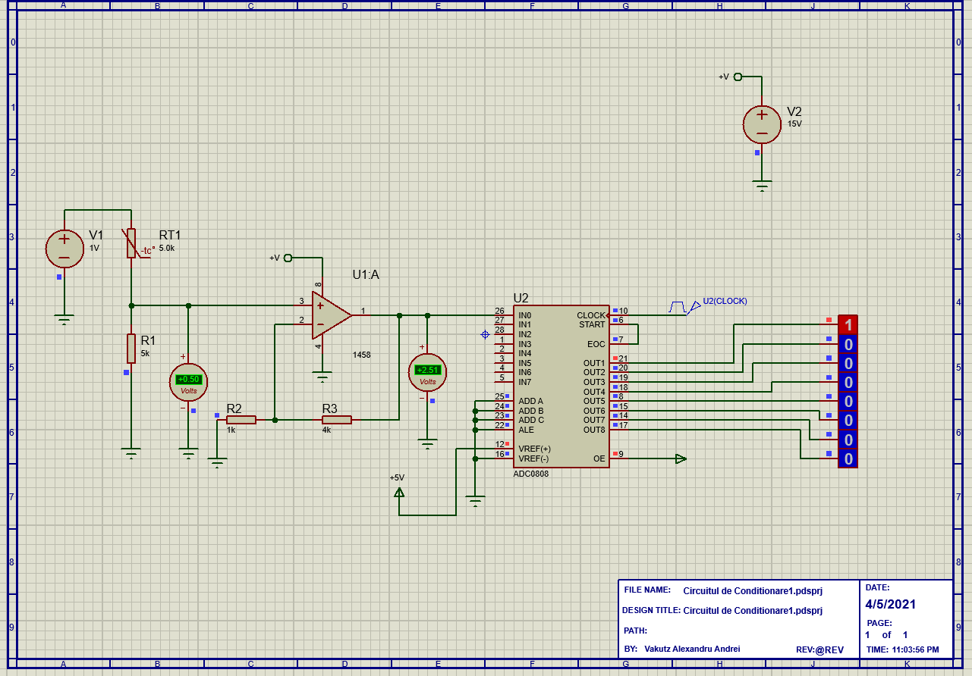

Figure . Conditioning circuit

# Block Diagram.

# Components List.

* Voltage sources x2
* Resistors x3
* NTC Thermistor x1
* 1458 Op Amp x1
* ADC 0808 x1

# ADCs measurement method.

Analog to digital converters (ADC) translate analog electrical signals into a digital signal. It may also provide an “isolated” measurement such as an electronic device that converts an input analog voltage/current into a digital number, to represent the magnitude of the said voltage/current.

**Successive-Approximation** – the most popular ADC architecture for data acquisition systems, especially when multiple channels require input multiplexing. They use a comparator and a binary search to successively narrow a range that contains the input voltage. At each step, the converter compares the input voltage to the output of an internal digital to analog converter which initially represents the midpoint of the allowed input voltage range. The approximation is stored in a successive approximation register (SAR) and the output of the digital to analog converter is updated for a comparison over a narrower range.

**Sigma-Delta** – are used for precision industrial measurement and instrumentation, for applications that require high resolution (16 to 24 bits) and effective sampling rates up to a few hundred Hz.

It oversamples the desired signal by a large factor and filters the desired signal band. Generally, a small number of bits than required are converted using a Flash ADC (uses a voltage linear ladder with a comparator at each “step”) after the filter. The resulted signal along with the error generated by the discrete levels of the Flash are fed back and subtracted from the input filler.

**Pipeline** – first, a coarse conversion is done. In a second step, the difference to the input signal is determined with a DAC. This difference is then converted more precisely, and the results combined in a last step. This can be considered a refinement of the successive-approximation ADC.

**Wilkinson ADC** – is based on the comparison of an input voltage with that produced by a charging capacitor. The capacitor is allowed to charge until a comparator determines it matches the input voltage. Then, the capacitor is discharged linearly. The time required for the discharge is proportional to the amplitude of the input voltage.

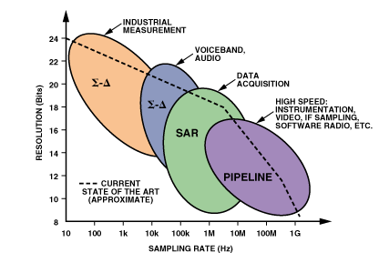

Figure .ADC applications, architectures, resolution and sampling

# ADCs proposed method.

Considering all the information displayed earlier, I decided to choose the successive-approximation ADC, because of it being the most popular ADC used for data acquisition applications, such as my project. Not only this, but the other options, as were presented earlier, would make much better choices in other kind of projects/applications.

# ADC model comparison & proposal.

|  |  |  |  |
| --- | --- | --- | --- |
| Model | ADC0804LCWMX/NOPB | ADC081C027CIMK/NOPB | ADC0808-N |
| Resolution | 8 bits | 8 bits | 8 bits |
| Analog input Voltage | 0-5V | 2.7-5.5V | 0-5V |
| Conversion time | 100µs | - | 100µs |
| Data interface | Parallel | I2C | Parallel |
| Availability | Yes | Yes | Yes |
| Price [RON] | 16.24 | 2.34 | 14.42 |

After a short research and a good look at the table above, we have three clear options. Out of which, the best one, I think would be the ADC0808-N because it has almost the same performances as the ADC0804, but a tad cheaper in price. As for the ADC081, even though, budget wise would be the logical choice, I did not choose it does not necessarily perform well in the required application.

# Calculus, circuit, and simulations.

The chosen temperature sensor is the NI24MA0502H which has a RT at 25℃ of 5kΩ. To send data to the µC, it needs to be implemented in a voltage divider. Therefore, we require a second resistance, which I chose to be equal the RT at 25℃:

Where Vo1 is the output voltage of the voltage divider and the Vcc is the input voltage which I chose to be 3.3V. Therefore, .

Since the ADC can intake a maximum of 5V I chose the Av to be 1.51:

From equation 3 we can choose .

Now we can determine the ADC input:

Where Vo2 is the output of the amplifier and the input to the ADC. Which will be:

Now we can compute the value of the ADC:

Where Vref is 5V and N represents the number of output bits of the ADC.

Which can also be verified by the following formula:



Figure . Rt@25℃

For 45℃ we will have ADC = 1010 1111b = 175. With which we can determine the value of the thermistor (which is obtained by rearranging equation 6):

In this case we will have:

Following the same logic, we can determine the value of the thermistor at 10℃ and at 28℃:



Figure . Rt@45℃



Figure . Rt@28℃



Figure . Rt@10℃

# I2C communication

# Circuit

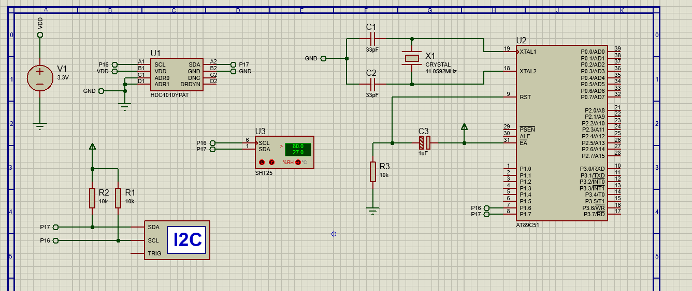

# Block Diagram

# Program Organigram

# I2C Interface

The I2C is widely used for attaching lower-speed peripherals ICs to processors and microcontrollers in short-distance, intra-board communication. It is a serial protocol (data is transferred bit by bit along the SDA) for two-wire interface to connect low-speed devices like microcontrollers, EEPROMs, A/D and D/A converters and other similar embedded systems.

I2C combines the best features of SPI and URATs, therefor, with I2C, one can connect multiple slaves to a single master (like SPI) and one can have multiple masters, controlling one/more slave(s).

Like URAT, the I2C uses two wires to transmit data: SDA (Serial Data) and SCL (Serial Clock). SDA is the line for the master and slave to send/receive data, while the SCL is the line that carries the clock signal.

With I2C, data is transferred in messages. Messages are broken up into frames of data. Each message has an address frame that contains the binary address of the slave, and one or more data frames that contain the data being transmitted. The message also includes start and stop conditions, read/write bits, and ACK/NACK bits between each data frame.

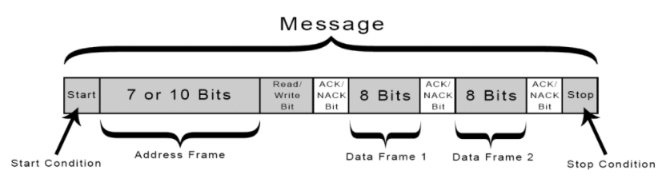

**Start Condition:** The SDA line switches from a high voltage level to a low voltage *before* the SCL line switches from high to low.

**Stop Condition:** The SDA line switches from a high voltage level to a low voltage *after* the SCL line switches from high to low.

**Address Frame:** A 7/10-bit sequence unique to each slave; it identifies the slave when the master wants to “talk” to it.

**Read/Write Bit:** A single bit specifying whether the master is sending data to the slave (low voltage) or requesting data from it (high voltage).

**ACK/NACK Bit:** Each frame in a message is followed by an acknowledge/no-acknowledge bit. If an address frame or data frame was successfully received, an ACK bit is returned to the sender from the receiving device.

# Microcontroller

# Introduction

A microcontroller is a small, low cost and self-contained computer-on-a-chip that can be used as an embedded system. They usually include an 8/16-bit µP, a little measure of RAM, programmable ROM and flash memory, parallel/serial I/O, timers, ADC and DAC. [1]

The 8051 µC is a 40 pin µC with a Vcc of 5V connected to the pin 40 and the Vss of 0V connected at pin 20. There are 4 (P0->P3) input/output ports numbered as: Px.1->Px.7. [1]

# Internal Architecture [1]

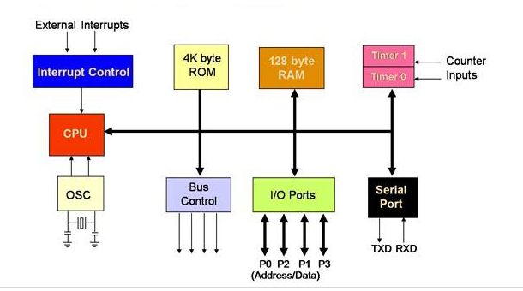

# Model comparison

|  |  |  |  |
| --- | --- | --- | --- |
| Model | CY7C68013A-56LTXC [2] | AT89C51 [3] | DS80C320-MNL+ [4] |
| Availability (market) | Yes | Yes- AT89C51CC03CA-RLTUM | Yes |
| Availability (Proteus) | *Yes | Yes | *Yes |
| I2C | Yes | With bit banging | - |
| CPU speed | 48MHz | 60MHz | 33MHz |
| Core size | 8 bits | 8 bits | - |
| ROM size | - | 64 KB | 64 KB |
| RAM size | 16 KB | 2 KB | 256 Bytes (Scratchpad) |
| Architecture | 8051 | 80C51 | 8051 |
| Price [RON] | 60.80 | 41.05 | 78.40 |

Table 4. µCs comparison

*The part is not yet complete.

# Proposed model.

Based on Table 1. We can see that the AT89C51 model is the best choice for the project, out of the three options. Because, first, pricewise it is the cheapest and second, feature wise, it has far better ones, for example the core speed, which is of 60MHz compared to 48 and 33Mhz of the other two.

Another reason for which I picked it, is that it has a larger ROM and RAM size, and even though it does not have an integrated I2C interface, it can be implemented by using bit banging.

As for the availability on the market, there is no difference, but when it come to the availability in Proteus, we meet with some limitations. That being that both CY7C68013A-56LTXC and DS80C320-MNL+ are not completed parts, therefore, we cannot simulate their complete real-life behavior.

A thing that I observed during the research for the µC is that the AT89C51 is widely and far more used, which means that there will be more reference material if needed.

# LCD

# Introduction

Most alphanumeric LCDs are classified as 1/2/4 line. The most common type of LCDs are the Alphanumeric/Character displays. And are easier to be implemented than a graphic unit and built-in standard configurations. [5]

Alphanumeric displays give the information in the form of characters (number/letters). [5]

# Model comparison

|  |  |  |  |
| --- | --- | --- | --- |
| Model | MC22005A6WK-BNMLW-V2 [7] | FC1602N04-RNNYBW-16*E [8] | PC1601LRU-AWB-B-Q [9] |
| Availability (market) | Yes | Yes | Yes |
| LCD Type | STN | STN | STN |
| Display appearance | White on blue | Black on yellow/green | Black on yellow/green |
| Display mode | Transmissive | Reflective | Transflective |
| Character (count x line) | 20x2 | 16x2 | 16x1 |
| Interface | Parallel | - | Parallel |
| Price [RON] | 56.70 | 67.80 | 53.10 |

Table 5. LCDs comparison

**STN** = super-twisted nematic display; is a type of [monochrome](https://en.wikipedia.org/wiki/Monochrome) [passive-matrix](https://en.wikipedia.org/wiki/Passive_matrix_addressing) [liquid crystal display](https://en.wikipedia.org/wiki/Liquid_crystal_display). [6]

**Transmissive** = the mode of operation when light from the backlight passes through the LCD. The glass/panel of the liquid crystal display functions as an optical switch, where light from the backlight passes through the LCD cell, depending on the orientation of the liquid crystal molecules. [10]

The disadvantage of this type is that the backlight requires a significant amount of energy, especially now that the backlight is required to be on all the time, even if there is no content on the display. [10]

**Reflective** = a mirror is installedbehind the liquid crystal layereither inside the LCD cell or on the rear polarizer. Ambient light passes through the LCD cell from the front side and is reflected by the mirror in the back. [10]

It presents a lower power consumption and excellent visibility in direct sunlight, therefore, an excellent solution for outdoor applications/projects, but in the dark, it does require additional lighting. [10]

**Transflective** = it has both transmissive and reflective characteristics. They contain an integrated backlight unit and a semi-transparent reflector or a reflector with a hole for each pixel. Again, the reflector can be behind the rear polarizer or inside the LCD cell behind the liquid crystal layer.

Light from the backlight can pass the semi-transparent reflector and operate the display in the transmissive mode. At the same time, ambient light can be reflected so that the display is visible in direct sunlight as well.

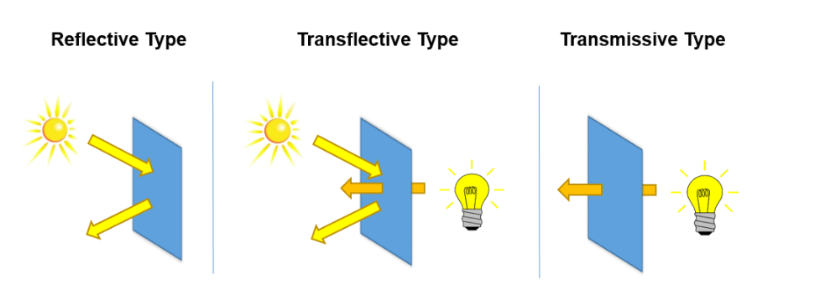

Figure.1 LCD display modes

# Proposed model.

Taking into consideration Table 2. we can now make our LCD choice. All three options are available on the market and can be easily substituted with other kinds of LCDs in proteus that would keep, the original specifications.

All of them have the same type of LCD, STN which has the advantages of being low-cost and low-power consumption. Unfortunately, STN also has a narrower viewing angle and poor contrast.

Whereas for the display appearance, I think is up to the user, but for my own preference would be the white on blue, therefore, the MC2200.

Considering the display mode, perhaps the best suited for the greenhouse application would be a transmissive mode. Because there might be times when we will need to check the greenhouse during the nighttime and/or during a cloudy day. Therefore, the MC2200 wins again.

For the number of characters displayed on the line, is again a personal preference, and due to that, I will go with the 20 character and 2 lines option.

All three LCDs offer the same kind of interface, the parallel one, so, nothing to compare here.

Pricewise, I do think that the advantages I mentioned earlier, for the MC2200, make sense in justifying choosing it over the cheaper option.

# The Circuit

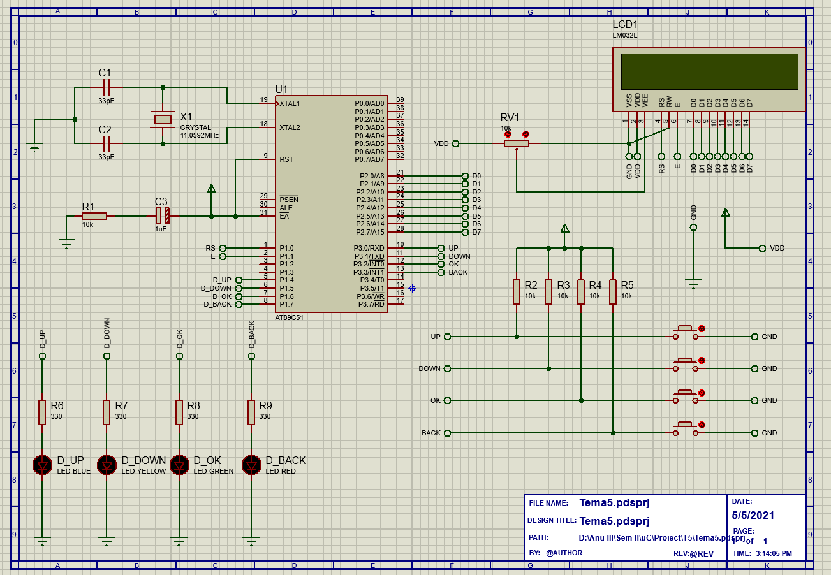

# Simulation

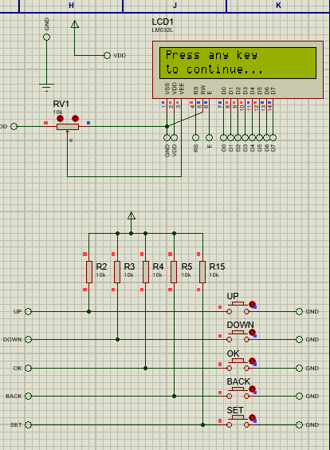

Figure . Main Menu

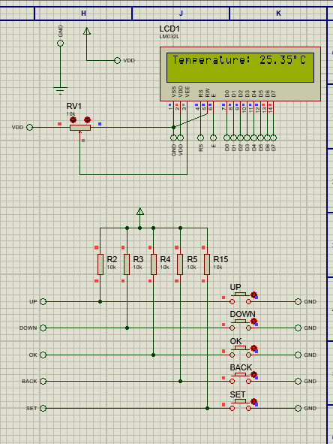

Figure .Temperature reading

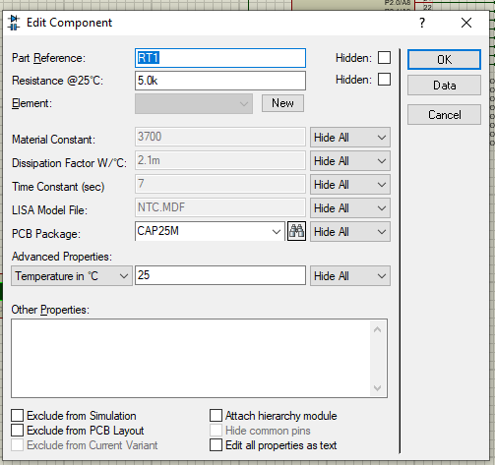

Figure .Given temperature

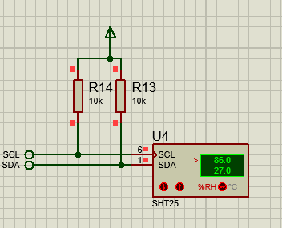

Figure .Given humidity

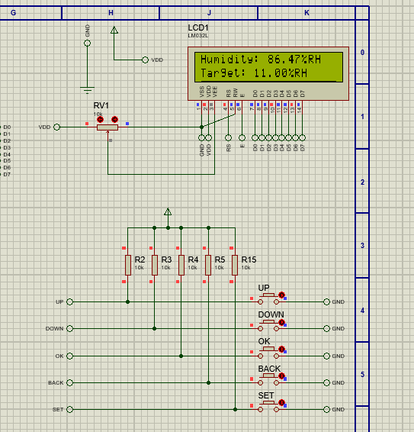

Figure .Humidity reading

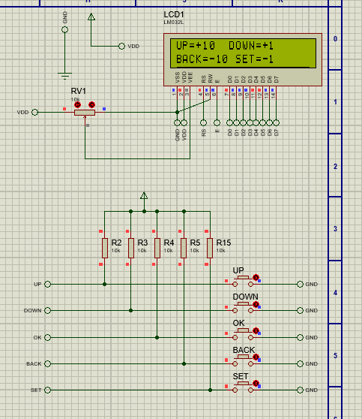

Figure .Set menu

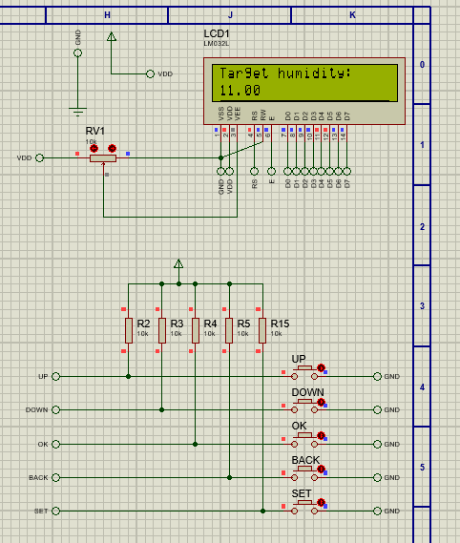

Figure . Set example

# Bibliography

# Temperature Sensor

[1] <https://www.wwdmag.com/water/7-basic-types-temperature-measuring-sensors>

[2] <http://guide.directindustry.com/choosing-the-right-temperature-sensor/>

[3] <https://www.omega.com/en-us/resources/rtd-vs-thermocouple>

[4] <https://www.omega.co.uk/temperature/z/thermocouple-rtd.html>

[5] <https://visaya.solutions/de/article/rtd-vs-thermocouple-difference-applications>

[6] <https://www.rfwireless-world.com/Terminology/NTC-thermistor-vs-PTC-thermistor.html>

[7] <http://www.farnell.com/datasheets/2330864.pdf>

[8] <http://www.farnell.com/datasheets/2792960.pdf>

[9] <http://www.farnell.com/datasheets/2198323.pdf>

[10] <https://learn.adafruit.com/thermistor/using-a-thermistor>

[11] <https://www.teachmemicro.com/how-to-interface-a-thermistor/>

# Humidity Sensor

[1] <https://www.andivi.com/humidity-sensor-what-type-should-you-choose/>

[2] <https://www.fierceelectronics.com/components/choosing-a-humidity-sensor-a-review-three-technologies>

[3] <https://www.electronicshub.org/humidity-sensor-types-working-principle/>

[4] <https://drygair.com/what-are-the-optimal-humidity-and-temperature-set-points-for-greenhouse-growing/>

[5] <http://www.farnell.com/datasheets/2901984.pdf>

[6] <http://www.farnell.com/datasheets/2245066.pdf>

[7] <https://www.ti.com/lit/ds/symlink/hdc1010.pdf?HQS=dis-mous-null-mousermode-dsf-pf-null-wwe&ts=1616427035152&ref_url=https%253A%252F%252Fro.mouser.com%252F>

# I2C communication

[1] <https://en.wikipedia.org/wiki/I%C2%B2C>

[2] <https://www.circuitbasics.com/basics-of-the-i2c-communication-protocol/>

# Microcontroller and LCD

[1] <https://www.elprocus.com/microcontrollers-types-and-applications/>

[2] <https://www.cypress.com/file/138911/download>

[3] <https://4donline.ihs.com/images/VipMasterIC/IC/ATML/ATMLS04922/ATMLS04922-1.pdf?hkey=6D3A4C79FDBF58556ACFDE234799DDF0>

[4] <http://www.farnell.com/datasheets/686377.pdf>

[5] <https://focuslcds.com/journals/alphanumeric-lcd-displays/>

[6] <https://en.wikipedia.org/wiki/Super-twisted_nematic_display>

[7] <http://www.farnell.com/datasheets/2175695.pdf>

[8] <http://www.farnell.com/datasheets/3166294.pdf>

[9] <http://www.farnell.com/datasheets/1009626.pdf>

[10] <https://www.newvisiondisplay.com/lcd-modes/>