APPENDIX**2**

══════════════════════════════════════════════════

Example of a

Formal Report

**BUD LABS-DESIGN ENGINEERING DIVISION**

|  |  |
| --- | --- |
| **Subject:** | Carbide Flex Seals for Gel Reactors |
| **Report No.:** | 227A42 |
| **Date:** | 7/20/98 |
| **Review Date:** | 7/20/98 |
| **Author(s):** | K.G. Budinski |
| **Contributors:** | R. Swartz, F. Grant |

**Abstract:**

Seal leakage problems in the support manufacturing facility prompted a study in the Materials Engineering Laboratory to determine if there are materials for face seals that will last for two years compared to the present life of about four months.

Laboratory tests were conducted to screen candidate materials for improved wear life. Cemented carbide self-mated appeared to have the best performance in the wear tests. Three prototype seals were manufactured with a solid carbide stationary member and a composite carbide/stainless steel for the rotating member. It was determined that the braze-clad carbide surface was not successful because of cracks.

A project extension is requested to investigate alternate ways of bonding carbides on the rotating flexure.

**Approved By: ________________** Date: _________________

**Edited By: ___________________** Date: __________________

________________________________________________________________________________

**Introduction**

Gel reactors in the Manufacturing Support facility had twelve shutdowns in 1997 because the face seals at the agitator feed-through (see top of Fig. A2.1) leaked. Each shutdown costs approximately $20,000 in lost production and $1800 in seal replacement costs. Nine of the twelve 1997 failures were caused by wear of the seal faces. Another cause of leakage was the sticking of the spring. The spring load is used to accommodate the waviness and wobble that exist in the system due to machinery tolerances and tolerance buildup.

Manufacturing Support requested the Materials Engineering Laboratory to investigate material improvements to increase the wear life of seals to at least two years. A department engineer then proposed a way to eliminate the spring (Fig. A2.1 bottom). The seals have the same general shape as the existing seal, but the design uses flexible web design [1] to provide the spring load on the seal. This system was put into production to solve leakage problems resulting from spring sticking and breakage, but the hardened contacting surfaces did not provide the desired service life of 500 hours. They wore significantly and leakage started at about 200 hours.

It is the purpose of this project to screen candidate seal couples and select a couple that will improve service life. The objective of this work is to eliminate the costs of frequent seal failures. This report summarizes the work. Laboratory tests are described, followed by an investigation of improved manufacturing techniques, discussion of results, and recommendations.

**Laboratory Tests**

Examination of worn seals shows that leakage occurs when the male member of the seal face wears a significant groove into the stationary member. The rotating member does not wear exactly the same as the stationary member and when the wear groove gets to a depth of about 0.5 mm leakage starts. It was decided to screen various candidate

There are a variety of standard tests used to investigate metal to metal wear characteristics [2-5]. The crossed-cylinder test of ASTM G 83 was selected, because it produces significant wear in hard materials in a relatively short test time. The test method places a rotating cylindrical pin at 90deg against a stationary pin (Fig. A2.2). A "divot" or worn area is removed from the stationary pin, and a groove is formed on the rotating pin. The wear volume on both members is measured from mass changes during the test. The test parameters were:

• speed = 0.22/sec,

• normal force = 200 N,

• test duration/sliding distance = 2h - 20,000m.

The test couples included hardened steel, ceramics, and cemented carbides. Three replicate tests were conducted on each couple and the average wear volumes were used in comparison graphics.

**Results**

The wear test results (Fig. A2.3) indicate that a number of candidate couples had lower system wear than the existing couple, self-mated type 440C stainless steel. The couples with less system wear were:

Self-mated C2 cemented carbide

440C stainless vs. C2 cemented carbide

D2 tool steel vs. C2 cemented carbide

M2 tool steel vs. C2 cemented carbide

C2 cemented carbide vs. A 11 tool steel

M4 tool steel vs. C2 cemented carbide

Any of these couples should provide a wear improvement over the present system. The lowest wear rate in the screening test occurred with type C2 cemented carbide self-mated.

**Implementation**

It was decided to implement the wear results by building three prototype seals out of C2 cemented carbide. The complication in doing this is keeping the flexure design on the rotating member of the seal. Cemented carbide is about three times as stiff as the

________________________________________________________________________________

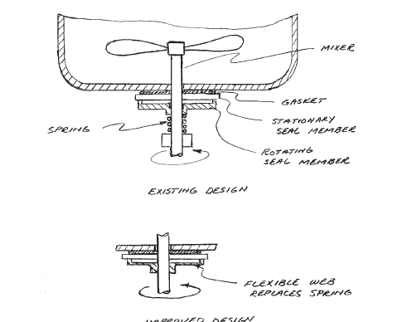

**Fig. A2.1** Proposed design improvement for face seal

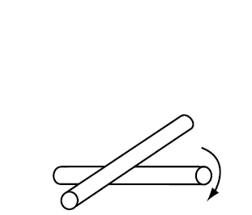

**Fig. A2.2** Cross-cylinder wear test