Nama : Hans Valerian Lenice

NIM : A11.2021.13338

Kelas : A11.4307

Project : Aplikasiku

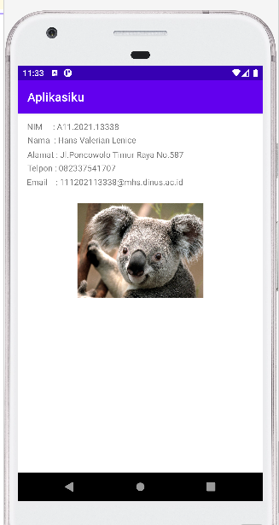

Code :

*<?***xml version="1.0" encoding="utf-8"***?>*<**androidx.constraintlayout.widget.ConstraintLayout xmlns:android="http://schemas.android.com/apk/res/android"  
 xmlns:app="http://schemas.android.com/apk/res-auto"  
 xmlns:tools="http://schemas.android.com/tools"  
 android:layout_width="match_parent"  
 android:layout_height="match_parent"  
 tools:context=".MainActivity"**>  
  
 <**TextView  
 android:layout_width="wrap_content"  
 android:layout_height="wrap_content"  
 android:text="NIM : A11.2021.13338"  
 app:layout_constraintBottom_toBottomOf="parent"  
 app:layout_constraintEnd_toEndOf="parent"  
 app:layout_constraintHorizontal_bias="0.06"  
 app:layout_constraintStart_toStartOf="parent"  
 app:layout_constraintTop_toTopOf="parent"  
 app:layout_constraintVertical_bias="0.022"** />  
  
 <**TextView  
 android:layout_width="wrap_content"  
 android:layout_height="wrap_content"  
 android:text="Nama : Hans Valerian Lenice"  
 app:layout_constraintBottom_toBottomOf="parent"  
 app:layout_constraintEnd_toEndOf="parent"  
 app:layout_constraintHorizontal_bias="0.07"  
 app:layout_constraintStart_toStartOf="parent"  
 app:layout_constraintTop_toTopOf="parent"  
 app:layout_constraintVertical_bias="0.06"** />  
  
 <**TextView  
 android:layout_width="wrap_content"  
 android:layout_height="wrap_content"  
 android:text="Alamat : Jl.Poncowolo Timur Raya No.587"  
 app:layout_constraintBottom_toBottomOf="parent"  
 app:layout_constraintEnd_toEndOf="parent"  
 app:layout_constraintHorizontal_bias="0.105"  
 app:layout_constraintStart_toStartOf="parent"  
 app:layout_constraintTop_toTopOf="parent"  
 app:layout_constraintVertical_bias="0.102"** />  
  
 <**TextView  
 android:layout_width="wrap_content"  
 android:layout_height="wrap_content"  
 android:text="Telpon : 082337541707"  
 app:layout_constraintBottom_toBottomOf="parent"  
 app:layout_constraintEnd_toEndOf="parent"  
 app:layout_constraintHorizontal_bias="0.061"  
 app:layout_constraintStart_toStartOf="parent"  
 app:layout_constraintTop_toTopOf="parent"  
 app:layout_constraintVertical_bias="0.141"** />  
  
 <**TextView  
 android:layout_width="wrap_content"  
 android:layout_height="wrap_content"  
 android:text="Email : 111202113338@mhs.dinus.ac.id"  
 app:layout_constraintBottom_toBottomOf="parent"  
 app:layout_constraintEnd_toEndOf="parent"  
 app:layout_constraintHorizontal_bias="0.1"  
 app:layout_constraintStart_toStartOf="parent"  
 app:layout_constraintTop_toTopOf="parent"  
 app:layout_constraintVertical_bias="0.181"** />  
  
 <**ImageView  
 android:layout_width="212dp"  
 android:layout_height="210dp"  
 android:src="@drawable/gambar_koala"  
 app:layout_constraintBottom_toBottomOf="parent"  
 app:layout_constraintEnd_toEndOf="parent"  
 app:layout_constraintStart_toStartOf="parent"  
 app:layout_constraintTop_toTopOf="parent"  
 app:layout_constraintVertical_bias="0.32"** />  
  
</**androidx.constraintlayout.widget.ConstraintLayout**>

MainActivity.Java

**package** com.a1113338.aplikasiku;  
  
**import** androidx.appcompat.app.AppCompatActivity;  
  
**import** android.os.Bundle;  
  
**public class** MainActivity **extends** AppCompatActivity {  
  
 @Override  
 **protected void** onCreate(Bundle savedInstanceState) {  
 **super**.onCreate(savedInstanceState);  
 setContentView(R.layout.***activity_main***);  
 }  
}