Assignment #10: Data science with database/SQL

Part 1: World Database


- How many countries became independent in the twentieth century?

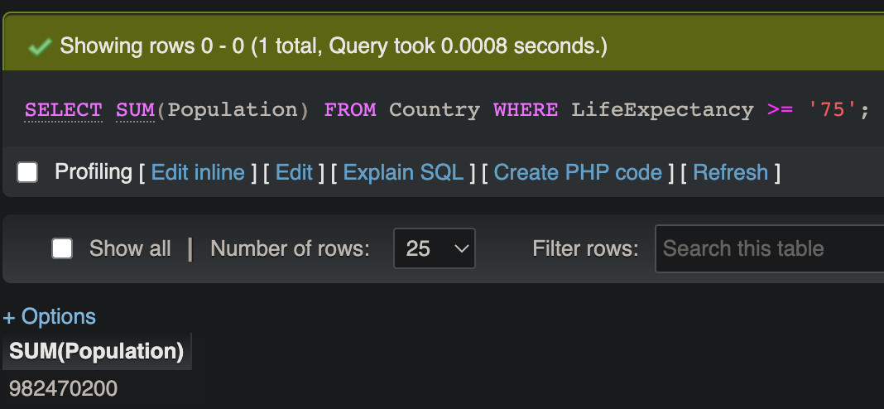
- How many people in the world are expected to live for 75 years or more?

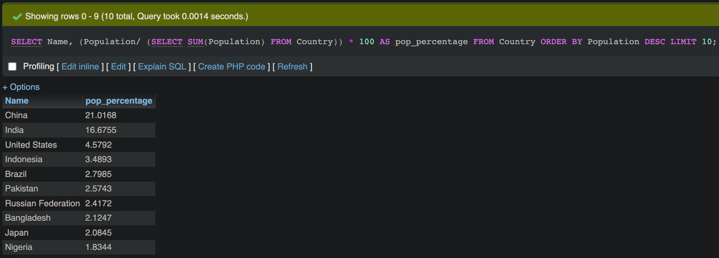
- List the 10 most populated countries in the world with their population as percentage of the world population.
Figure 1: Query
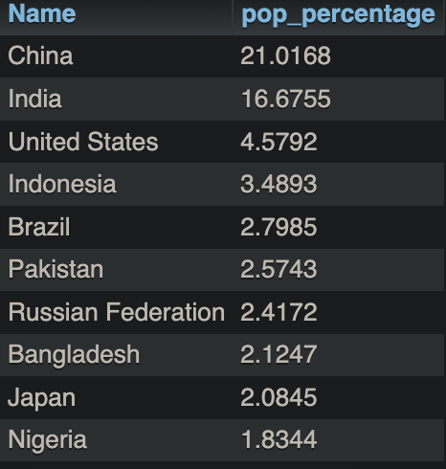

Figure 2: Result from Query in Figure 1

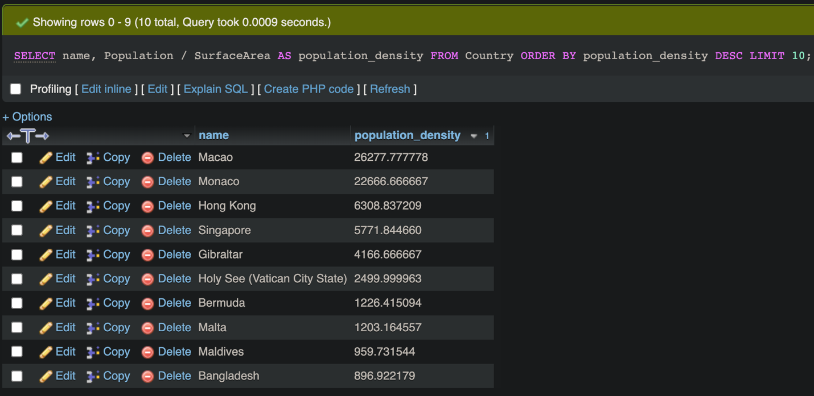
- List the top 10 countries with the highest population density.

Part 2: AIS Dynamic Data

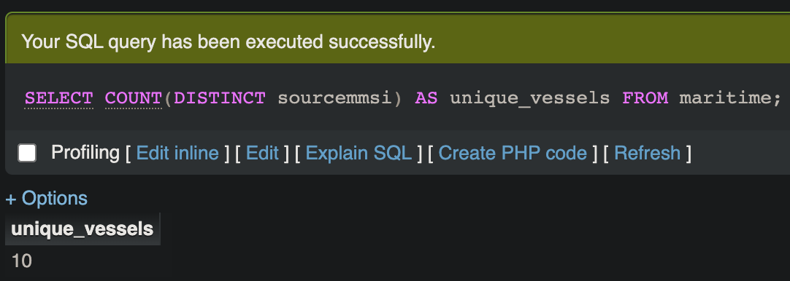
- How many unique vessels are available in the dataset?

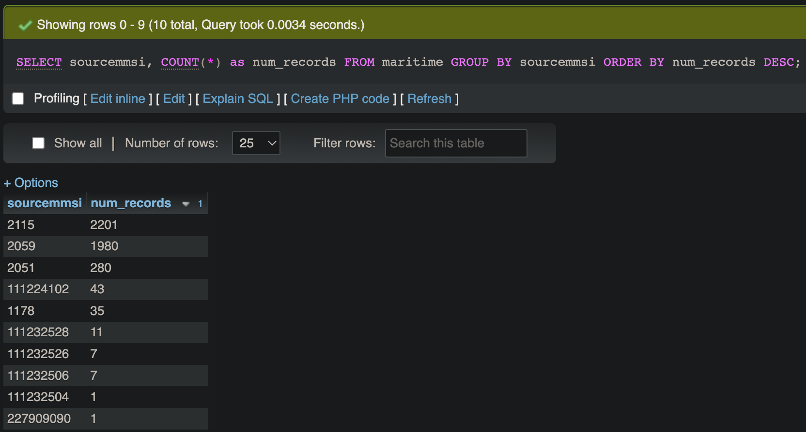
- List the number of records available for each vessel in the dataset.

- Find out the spatial (latitude and longitude) and temporal coverage of each vessel in the dataset.
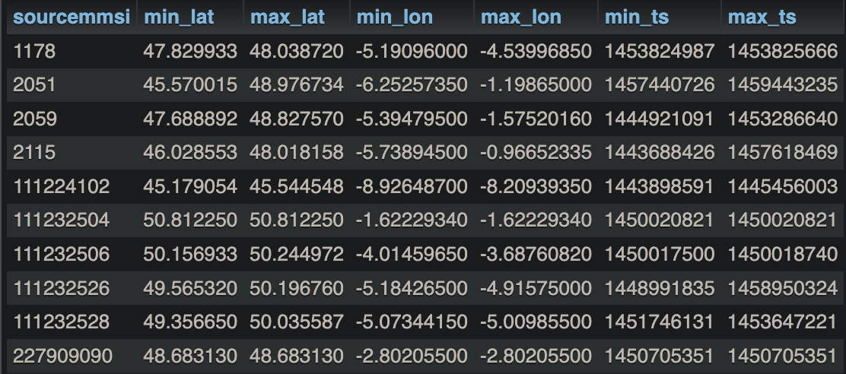
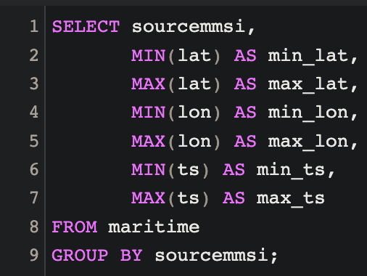
Figure 3: Query
Figure 4: Result from Query in Figure 3

