# Introduction

## Formula Student

Formula Student is an international student engineering competition. Teams from all over the world design and build a small-scale Formula-style racing car. During the competitions, the cars are judged on static events: Engineering Design, Cost & Manufacturing, Business Presentation, Lap Time Simulation and Technical Inspection. The car must comply with the rules [1] for the technical inspection. If the car passes the technical inspection, it is allowed to participate in the dynamic events: Skid pad, 1 km autocross/sprint, 75 m acceleration and 22 km endurance.

Figure 1: Formula Student endurance race

## Valais-Wallis Racing team

## The Valais-Wallis Racing team [2] is the formula student team of the HES-SO Valais Wallis. It was created in the spring of 2022 by a group of students. The first car of the team will take part in the races of summer 2023 and the telemetry system developed in this thesis will be used on the next car, for the races of summer 2024.

## Objectives

The aim of this project is to develop and test a telemetry system for the Formula Student car of the HES-SO Valais-Wallis. This thesis deals with the embedded part of the system and the communication with the PC. This project will be carried out in collaboration with a Business Information Technology student who will be working on the software that will display the data from the telemetry system.

Figure 2: Circuit

# Transmission technology

A wireless transmission must be established from the car to the computer. The range of the telemetry system must be greater than 300 meters (ideally 500 meters) with no obstacle between the transmitter and the receiver.

For this transmission, two technologies were studied. A Wi-Fi connection and a 433 MHz RF transmission.

4G/5G cellular networks were not taken into consideration, as there is no guarantee that there is network coverage in the race locations.

## 433 MHz RF

The first option is a standard RF transmission. This solution is easy to implement, the range is wide enough, and the bandwidth is sufficient for the small amount of data to be sent. Moreover, there is no need to establish a connection. The transmitter emits the data on a frequency and the receiver listens to the same frequency. If the transmission is interrupted, the data transmission will instantly work once the signal is recovered. With Wi-Fi communication, the car will need to reconnect to the hotspot, which takes a little time.

However, there will be a lot of teams during the competition, and if other teams use the same transmission method, all systems will disrupt disturb each other, and the transmission will not be guaranteed.

For an RF transmission, the RFM69HCW [3] module from HopeRF is one of the best options for this use case. It is available in 433 MHz and 868 MHz.

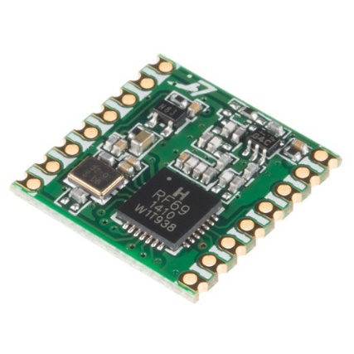

Figure 3: RFM69HCW module

This module has an output power of +20 dBm and an input sensitivity of -120 dBm at 1.2 kbps. The theoretical range can be calculated with the Friis transmission equation [4] (with omnidirectional antennas → Gantenna = 0 dbi):

For the 433 MHz module, the received power is -54 dBm at 500m, which is more than enough for the input sensitivity of -120 dBm.

## Wi-Fi

The second option is a Wi-Fi connection. It is a strong protocol that allows the transfer of large amounts of data. With a Wi-Fi connection, a classic router can be used to connect the telemetry system to the computer and directly send IP packets. Moreover, the system will not have to manage interferances from other teams because the Wi-Fi protocol uses a carrier-sense multiple access with collision avoidance (CSMA/CA). This is a method that shares the band between the stations to avoid collisions between frames.

The only disadvantage of Wi-Fi communication is the range, which will be more difficult to reach.

The best option for Wi-Fi communication is the nRF7002 [5] chip from Nordic Semiconductors. It is a dual-band Wi-Fi module that has an SPI/QSPI interface to relate to a host SoC.

Figure 4: nRF7002 chip

On the 2.4 GHz band at 1 Mbps, the maximum output power is 21 dBm and the input sensitivity is -98.6 dBm.

The theoretical range can be calculated with the Friis transmission equation [4] (with omnidirectional antennas → Gantenna = 0 dbi):

For the 2.4 GHz band, the received power is -70 dBm at 300 m, which is close to the input sensitivity of a classic router.

As these equations give theoretical results, tests must be carried out to determine whether the range will be sufficient in practice.

### Tests

## The purpose of this test is to find out if a Wi-Fi connection is suitable for the required range. The tests have been carried out in the 2.4 GHz frequency band.

The router used in this test is an Asus RT-AC68U. The router's technical specifications do not mention the output power, but it does have the CE mark, which means that the output power should not exceed 20 dBm. On the opposite side, a laptop was used. It is equipped with an Intel Wi-Fi 6 AX201 module [6], which has similar performances (in terms of range) as the nRF7002 [5]. The test was realized with the default omnidirectional antennas, so there is still room for improvement by using sector antennas if needed.

The tests were carried out with the iPerf software [7], using the UDP protocol at 1 Mbps.

The laptop and the router were able to communicate successfully at 400 meters distance.

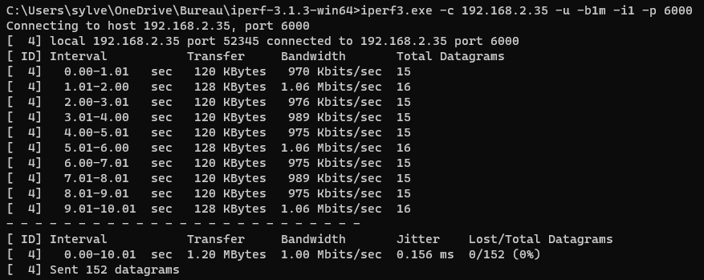

Figure 5: iPerf test - Client side

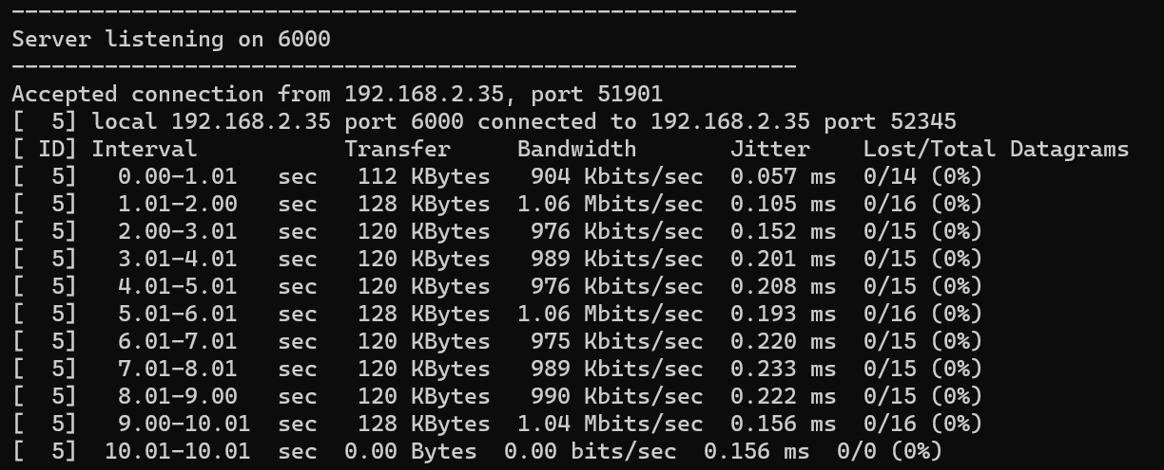

Figure 6: iPerf test - Server side

The same test was also successfully carried out on a smartphone at the same distance.

## Conclusion

The following table shows the differences between a 433 MHz RF transmission and a Wi-Fi communication:

|  |  |  |
| --- | --- | --- |
|  | **Wi-Fi** | **433 MHz RF** |
| Bandwidth | More than enough | Just enough |
| Range | enough | More than enough |
| Disturbed by interference | No (managed by CSMA/CA) | Yes |
| Connection to the computer | Wi-Fi / Ethernet | Serial port |
| Base station module | Wi-Fi Router | To be designed |
| Protocol | TCP/UDP | To be designed |

Table 1: Comparison between Wi-Fi and 433 MHz RF

The critical issues are the range and the ability to operate in an environment with a lot of interference.

The Wi-Fi solution is clearly better in terms its ability to deal with interference. The 433 MHz RF solution should be avoided because there will be many teams during the event and communication without collision avoidance is likely to fail.

For the range, the 433 MHz RF solution is better, however the tests showed that the range was reachable with a classic Wi-Fi router.

Based on these two criteria, the Wi-Fi solution can already be selected. Moreover, the other points are all better with this solution.

The system will therefore use Wi-Fi communication with Nordic Semiconductors' nRF7002 [5] module.

# Bibliography

[1] ‘FS-Rules_2023_v1.1.pdf’. Accessed: May 26, 2023. [Online]. Available: https://www.formulastudent.de/fileadmin/user_upload/all/2023/rules/FS-Rules_2023_v1.1.pdf

[2] ‘Valais Wallis Racing Team’. https://www.vrt-fs.ch/ (accessed May 26, 2023).

[3] ‘RFM69HC 20dBm Programmable 315-915Mhz RF Transceiver Module_Sub 1G Programmable 315-915Mhz RF Transceiver Module | HOPERF’. https://www.hoperf.com/modules/rf_transceiver/RFM69HCW.html (accessed May 26, 2023).

[4] ‘Friis transmission equation’, *Wikipedia*. May 25, 2023. Accessed: May 26, 2023. [Online]. Available: https://en.wikipedia.org/w/index.php?title=Friis_transmission_equation&oldid=1157035076

[5] ‘nRF7002 - Low-power, advanced security, seamless coexistence’. https://www.nordicsemi.com/Products/nRF7002 (accessed May 26, 2023).

[6] ‘Intel® Wi-Fi 6 AX201 (Gig+) - Caractéristiques du produit’, *Intel*. https://www.intel.fr/content/www/fr/fr/products/sku/130293/intel-wifi-6-ax201-gig/specifications.html (accessed May 26, 2023).

[7] ‘iPerf - The TCP, UDP and SCTP network bandwidth measurement tool’. https://iperf.fr/ (accessed May 26, 2023).