Telemetry for the Formula Student

|  |  |
| --- | --- |
|  | Graduate Sylvestre van Kappel |

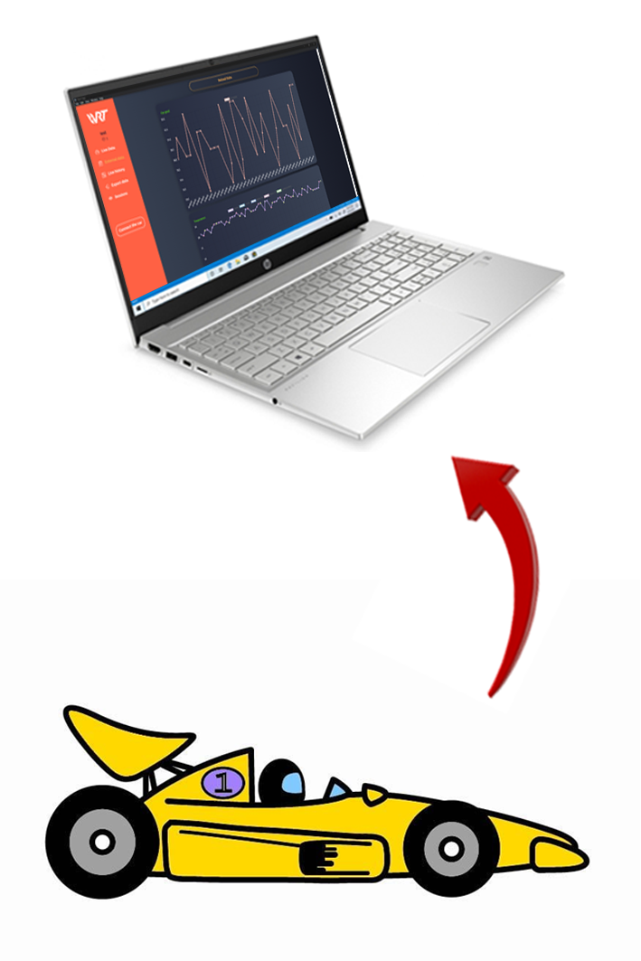

Bachelor’s Thesis   
| 2023 |



Degree programme

*Systems Engineering*

Field of application

*Infotronics*

Supervising professor

*Medard Rieder*

[*medard.rieder@hes-so.ch*](mailto:medard.rieder@hes-so.ch)

Partner

*Valais-Wallis Racing Team*

Objectives

This project aims to develop and test a telemetry system for the Formula Student car of the HES-SO Valais-Wallis. This thesis deals with the telemetry system's onboard device and the communication with the PC.

Methods | Experiences | Results

Telemetry is a technology that enables remote measurement and monitoring. This technology is interesting for a race vehicle as it allows live readings from the car's sensors to be read directly from the side of the track. With such a system, the data from all the sensors is easily accessible, and the engineers can adjust the car's parameters during the test sessions to increase the car's performance.

This project objective is to develop the telemetry onboard device's hardware and software.

The telemetry device is connected to the sensors on the car's CAN bus. The device also includes a GPS module. The CAN bus and GPS module data are transmitted to the base station via Wi-Fi. The data are also saved on an SD card. The system is designed to be generic and completely configurable. New sensors can easily be added to the system by only changing the configuration file.

The device has been successfully developed, and all the objectives have been reached. The tests showed that the system can transmit data over a 750 meters distance.

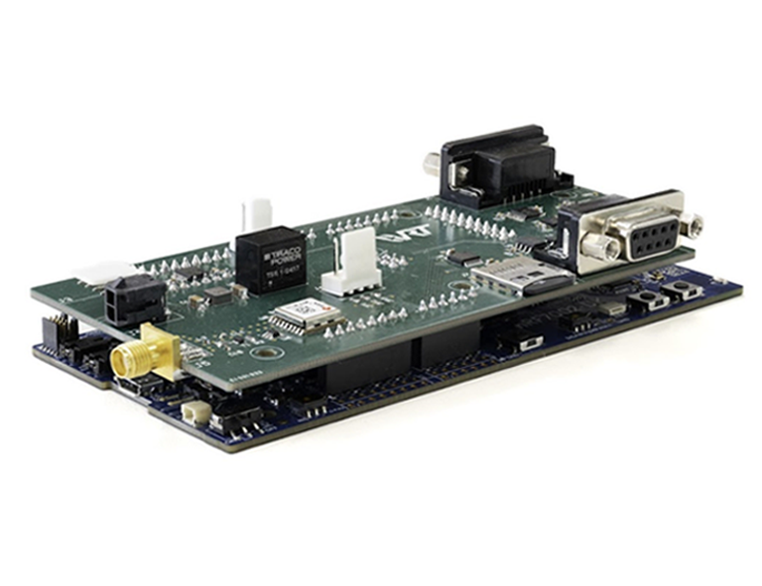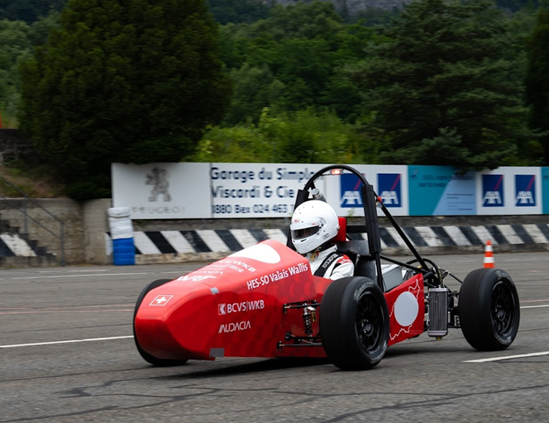

Valais-Wallis Racing Team’s Car

Telemetry onboard device