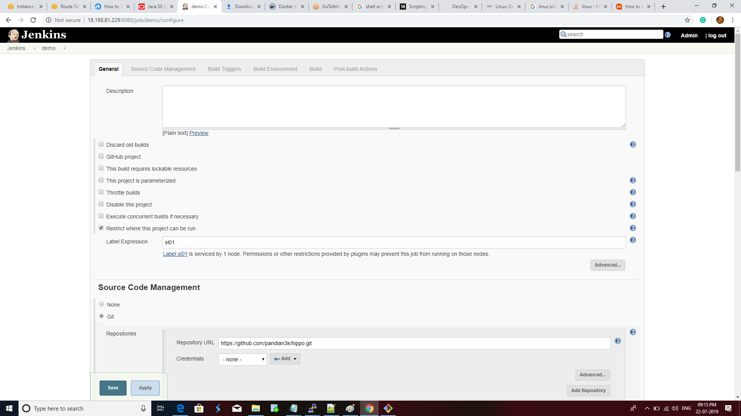

Create a Jenkins slave node and give the Slave name Sl01.

Select Git and give the url which have pom file and src file to build .war file for webapps

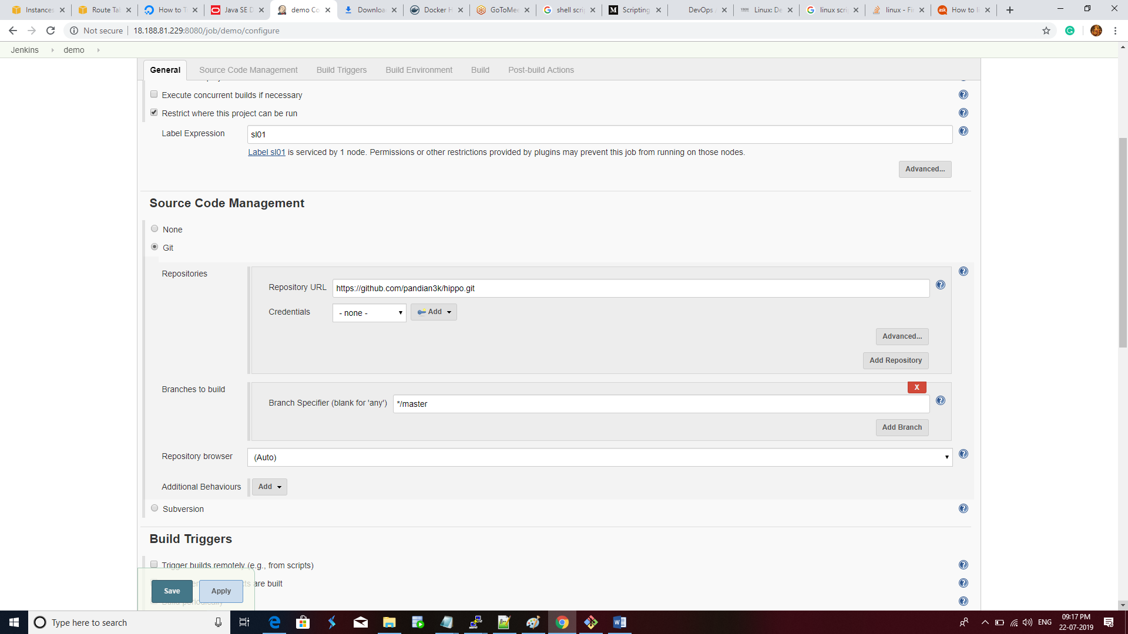

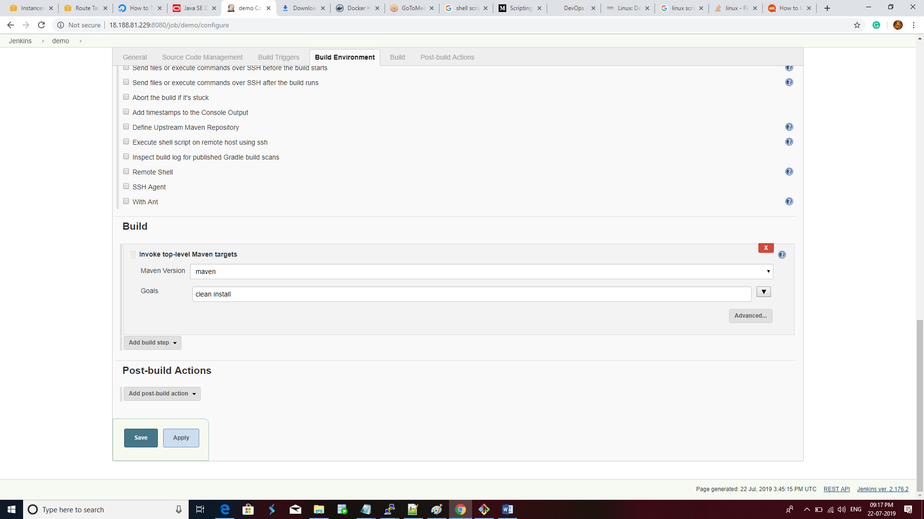

Sava and buld the demo job .

And check the output in server using tree

[root@ip-192-168-2-162 ~]# cd /var/lib/jenkins/workspace/

[root@ip-192-168-2-162 workspace]# ls

demo

[root@ip-192-168-2-162 workspace]# tree demo/

