Programming Project Report: chatroom
- Title Page
  - CS513 Computer Networks
  - A Client-Server Chat Program
  - Zhenyu Hu ID:384022697
  - 2017.6.29
  - I have reviewed WPI Academic Honest Policy and All work is implemented by myself.

- Abstract
This report outlines the design and development of a Client-Server Chat Program which implements the communication between clients and server. The program was written in Java to run under any operating system. The program make maximum use of abstract data types and of software re-use. Particular attention is paid to process the error in service may have. The report includes test cases used to verify the correct operation of the program and the entire code.

- Contents Page
Title Page: Page 1
Abstract: Page 1
Project Description: Page 1
Detailed Design: Page 1-2
Testing and Evaluation: Page 2-3
Future Development: Page 3
Conclusion: Page 3
Appendices: Page 3-23

- Project Description
This program is a chatroom based on Java. User can use client to connect the server to join in the chatroom. User need to input correct IP address and port to connect server. Each user must have a unique nickname. User can communicate with all of other users or whisper to each other. Any user joins or leaves the chatroom, the server will broadcast to every user.

- Detailed Design
In Client, using Swing widget toolkit to implement Client GUI, create a Grouplayout to set JButton, JLabel, JTextField and JScrollPane.
Use JButton to implement connect function, disconnect function, send message function and whisper function. By Implementing ActionListener interface to listen Button action.
Use JLabel and TextField to tell user where to input what, such as username, IP address, port and message.
Use JScrollPane to implement userlist and chatwindow.
The client will use the IP address and port to create socket connection to server. If user input incorrect IP address or port, the connection will fail and the client will alert user it failed. If the socket connection succeeds, the server will check the username whether it is repeated. If the username is repeated, the server will send message to tell client and refuse the client connect, user need to use a unique name to join server. Once the user join the chatroom, every user will receive the notification that which user join the chatroom and client will update the userlist. And if user click the disconnect button, the client will check whether the user is disconnected or not. If the user have disconnected, the client will alert user that the user fail to disconnect. By defining adduser, deleteuser to tell user which user joins or leaves the chatroom. And define the renewuserlist to update the client’s userlist.
After user joins the chatroom, the user can send message to all other user and receive all other users’ broadcast message. And the user can whisper to each other, only the receiver will see the message.
By Define ClientThread class to handle thread to receive message from server. According to the message type to decide run which function. And every chat message will display with the current time.
Only the client connect successfully to the server, the client can input message in the JTextField and can use send or whisper Button.
In Server, server set the socket port= 3726 and use localhost as the server IP address. According to the message type received from client, the server decide to which action to run, such as connect, broadcast, whisper and disconnect. The server uses HashMap to save the name-client key-value. If the client want to broadcast message, the server will broadcast message to each client in hashmap. And if the client want to whisper to another client, the server will use the client’ name to find the client and send the message to it.
Whenever a client is connected to the server, a thread will be started to handle communication.

- Testing and Evaluation
Test case:
The client is not connected to send message: can not input message. Successfully.
No name to connect: alert can not use empty name. Successfully.
No IP address to connect: alert can not use empty IP address. Successfully.
No port to connect: alert can not use empty port. Successfully.
Incorrect IP or port: alert fail to connect. Successfully.
Correct name, IP and port: successfully joins chatroom. Successfully.
Second client use the same name to connect: alert the name is existed.
Second client use the different name to connect: successfully joins chatroom. Successfully.
First client send the first message: successfully send to every client. Successfully.
Second client send the second message: successfully send to every client. Successfully.
First client whisper to the second client: successfully whisper to second client. Successfully.
First client disconnect: The client disconnect successfully and the second client see the notification that the first client leave the chatroom. Successfully.
First client disconnect again: alert the client has been disconnected. Successfully.
First client use the original name to connect again: connect successfully and the second client see the first join chatroom. Successfully.
Send whisper to incorrect receiver: notification the receiver is not existed. Successfully.
Use incorrect format to whisper: alert format is wrong. Successfully.
First client whisper to itself: only the first client see the message. Successfully.
Send empty message: alert can not send empty message. Successfully.

- Future Development
The program cannot select user from the userlist to whisper and it also cannot use @ to select user to whisper. And it can add a login window to implement user log in.

- Conclusion
The program has accomplished all the based requirement. And the report has described the design, details and test case.

- Appendices
  - Test Cases and Test Results
- The client is not connected to send message: can not input message. 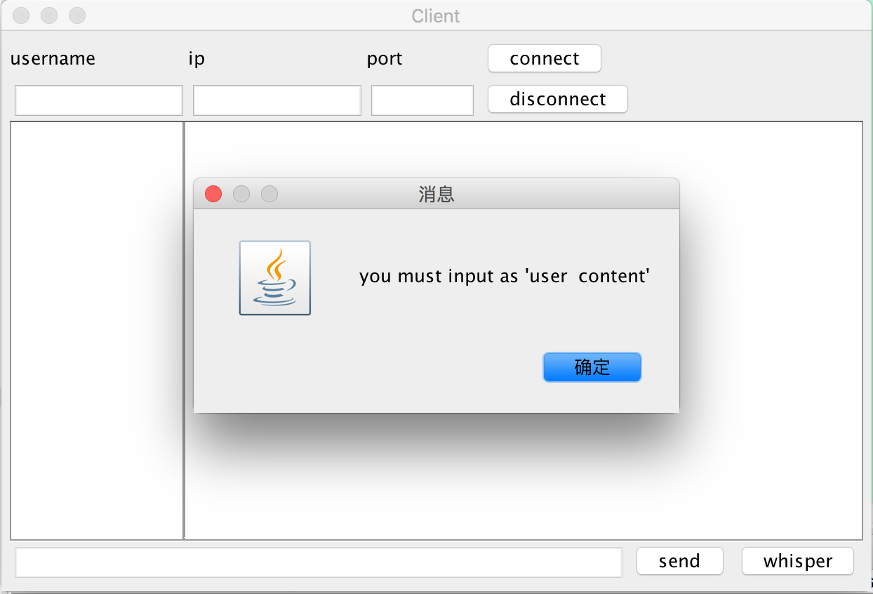
- No name to connect: alert can not use empty name. 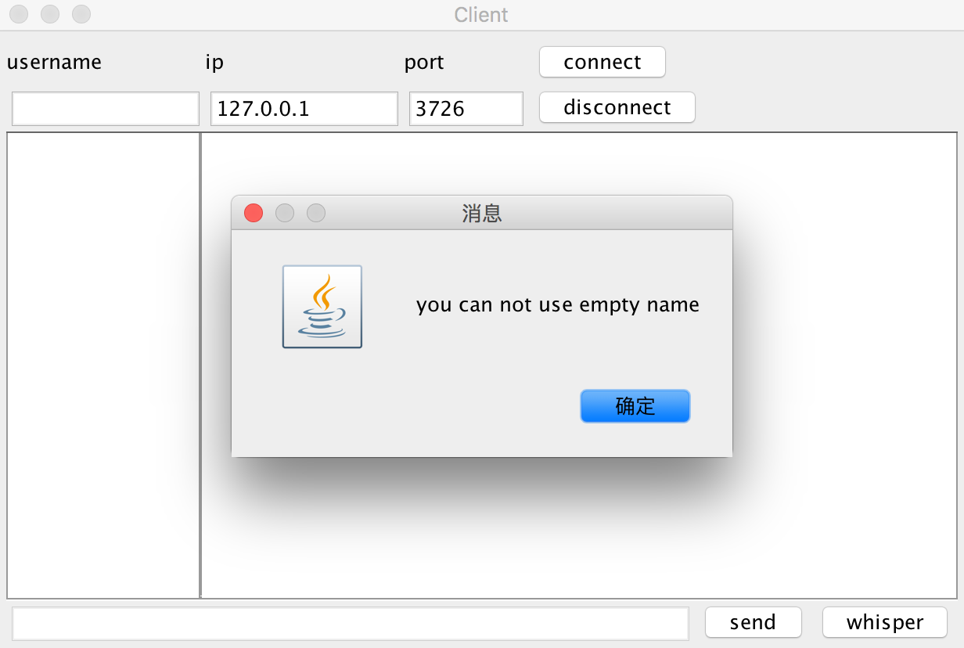
- No IP address to connect: alert can not use empty IP address. 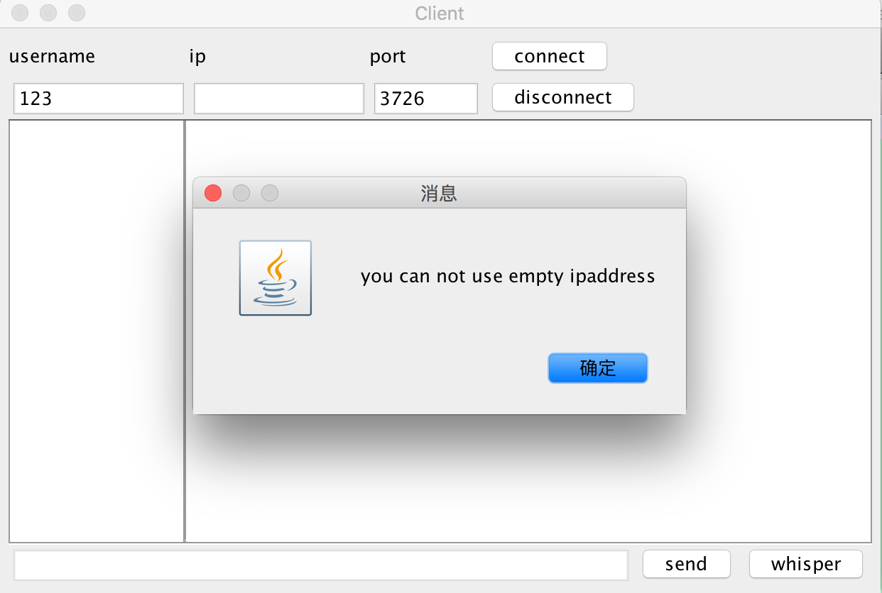
- No port to connect: alert can not use empty port. 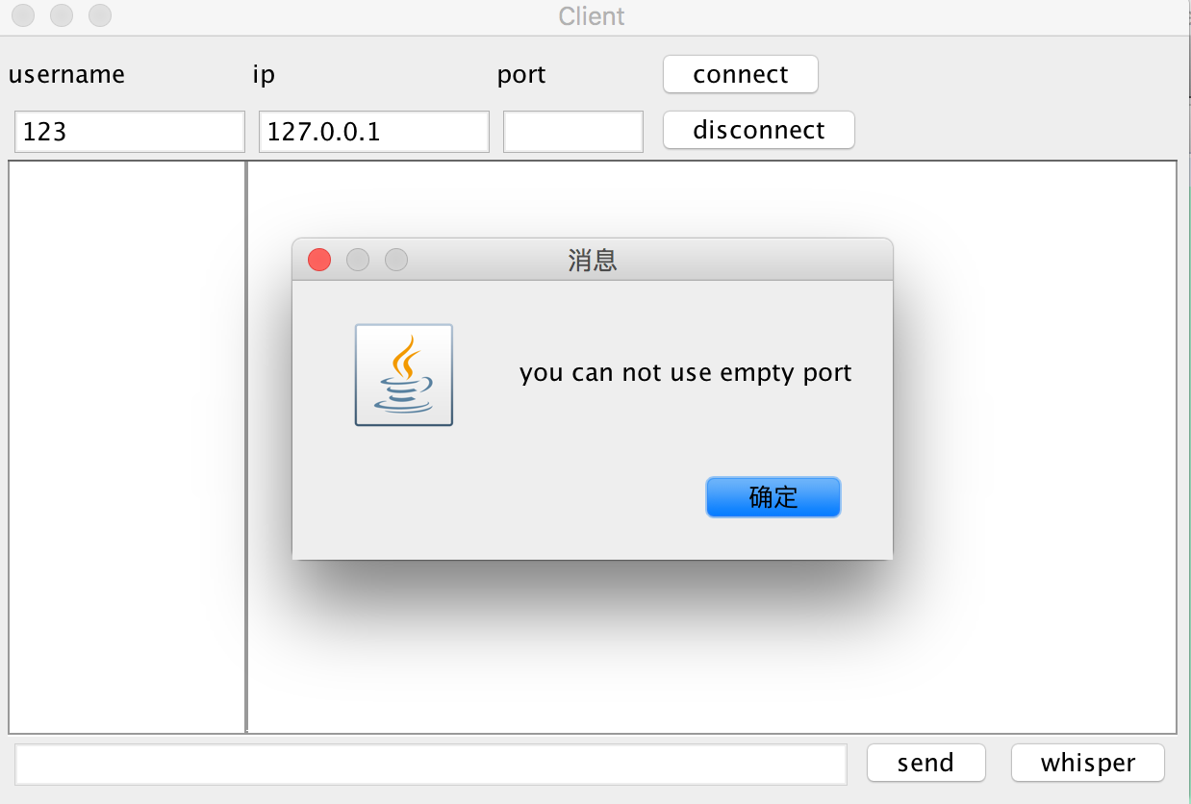
- Incorrect IP or port: alert fail to connect. 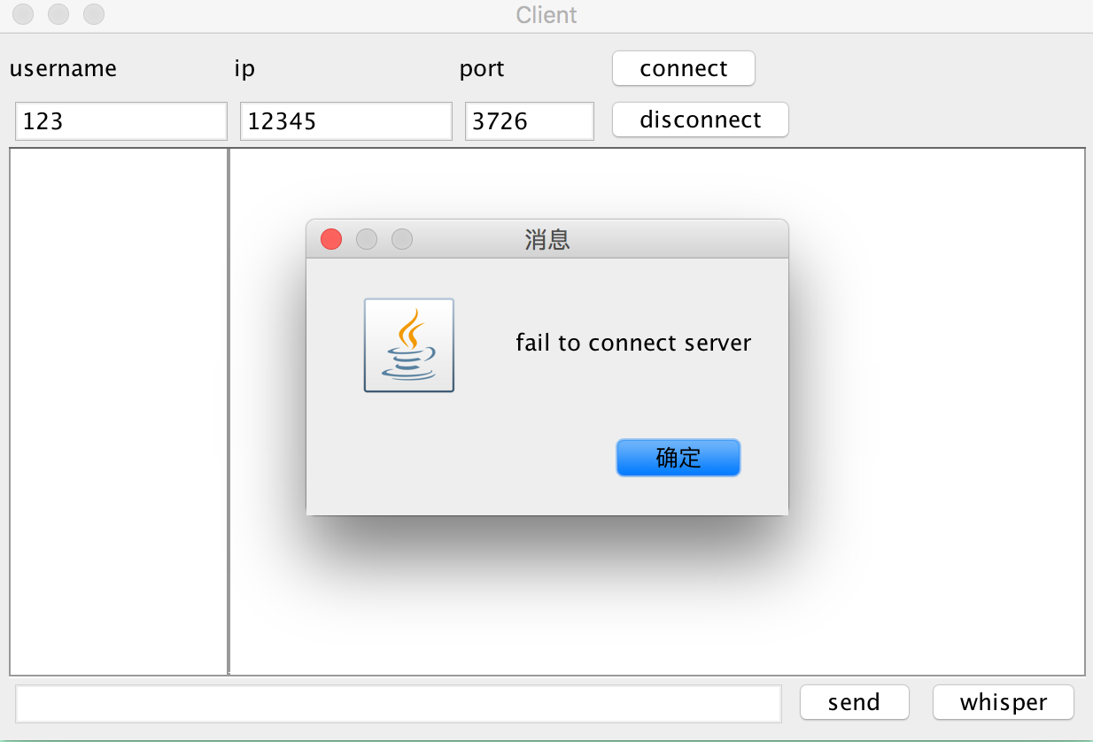
- Correct name, IP and port: successfully joins chatroom. 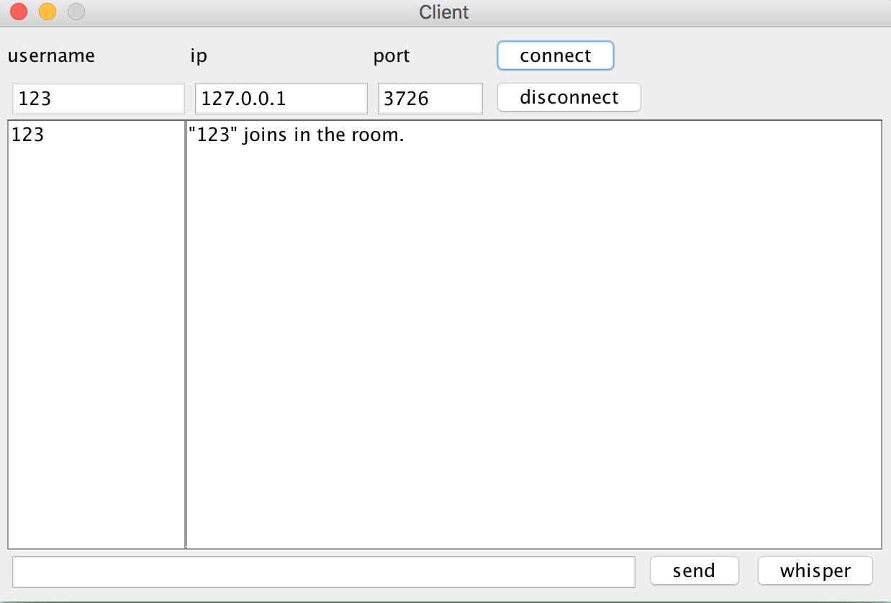
- Second client use the same name to connect: alert the name is existed. 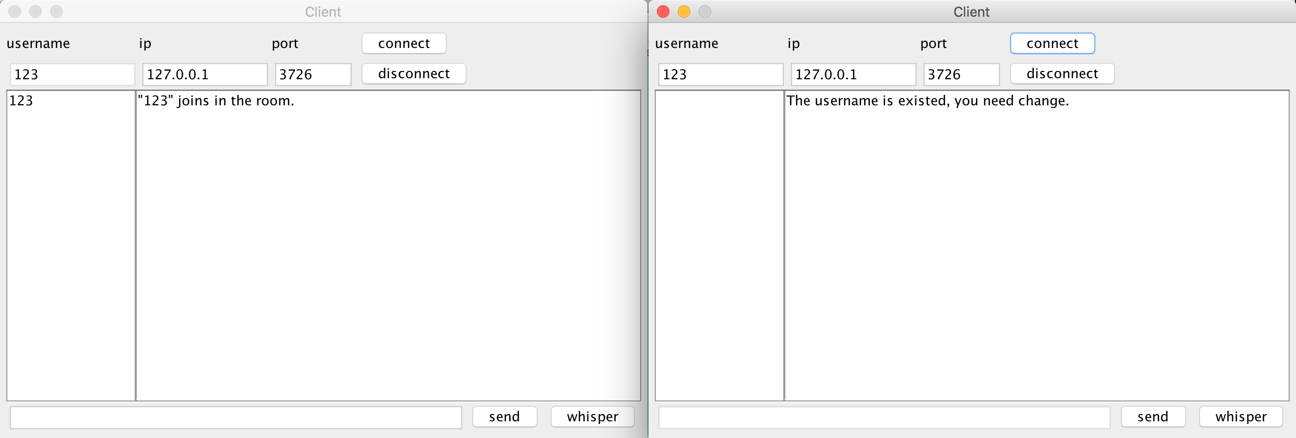
- Second client use the different name to connect: successfully joins chatroom. 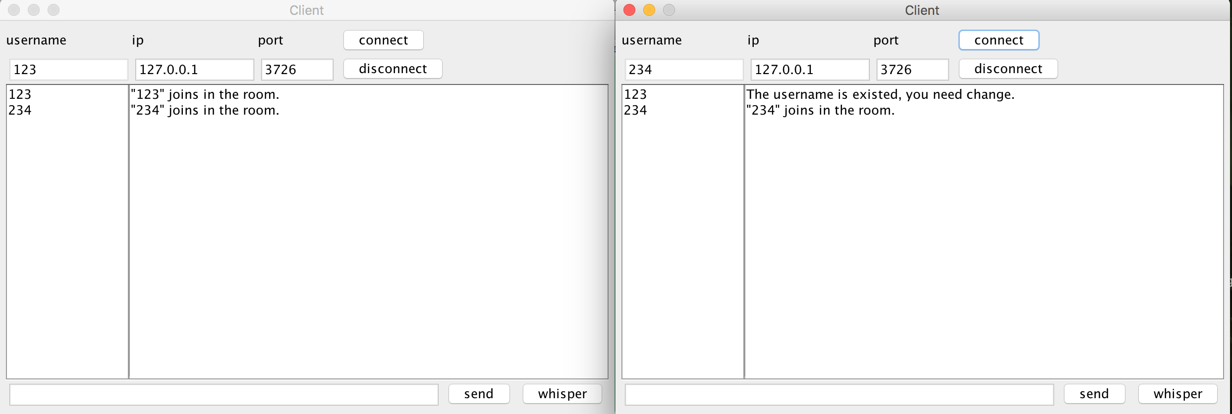
- First client send the first message: successfully send to every client. 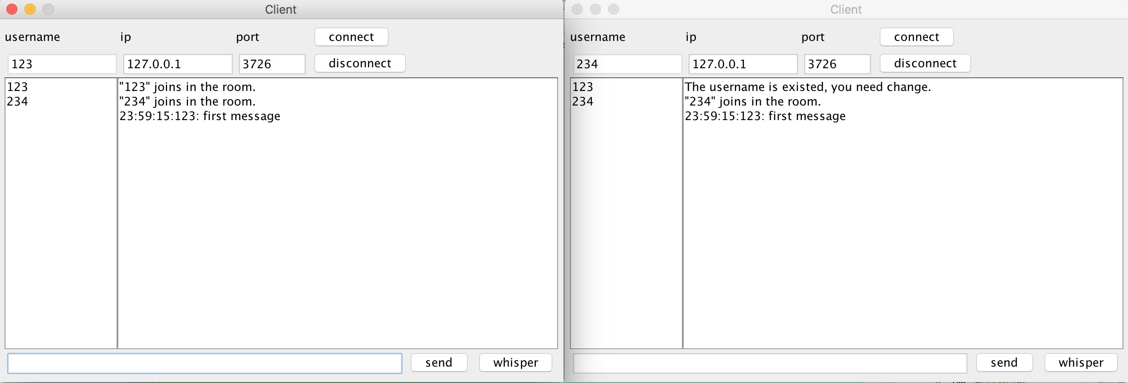
- Second client send the second message: successfully send to every client. 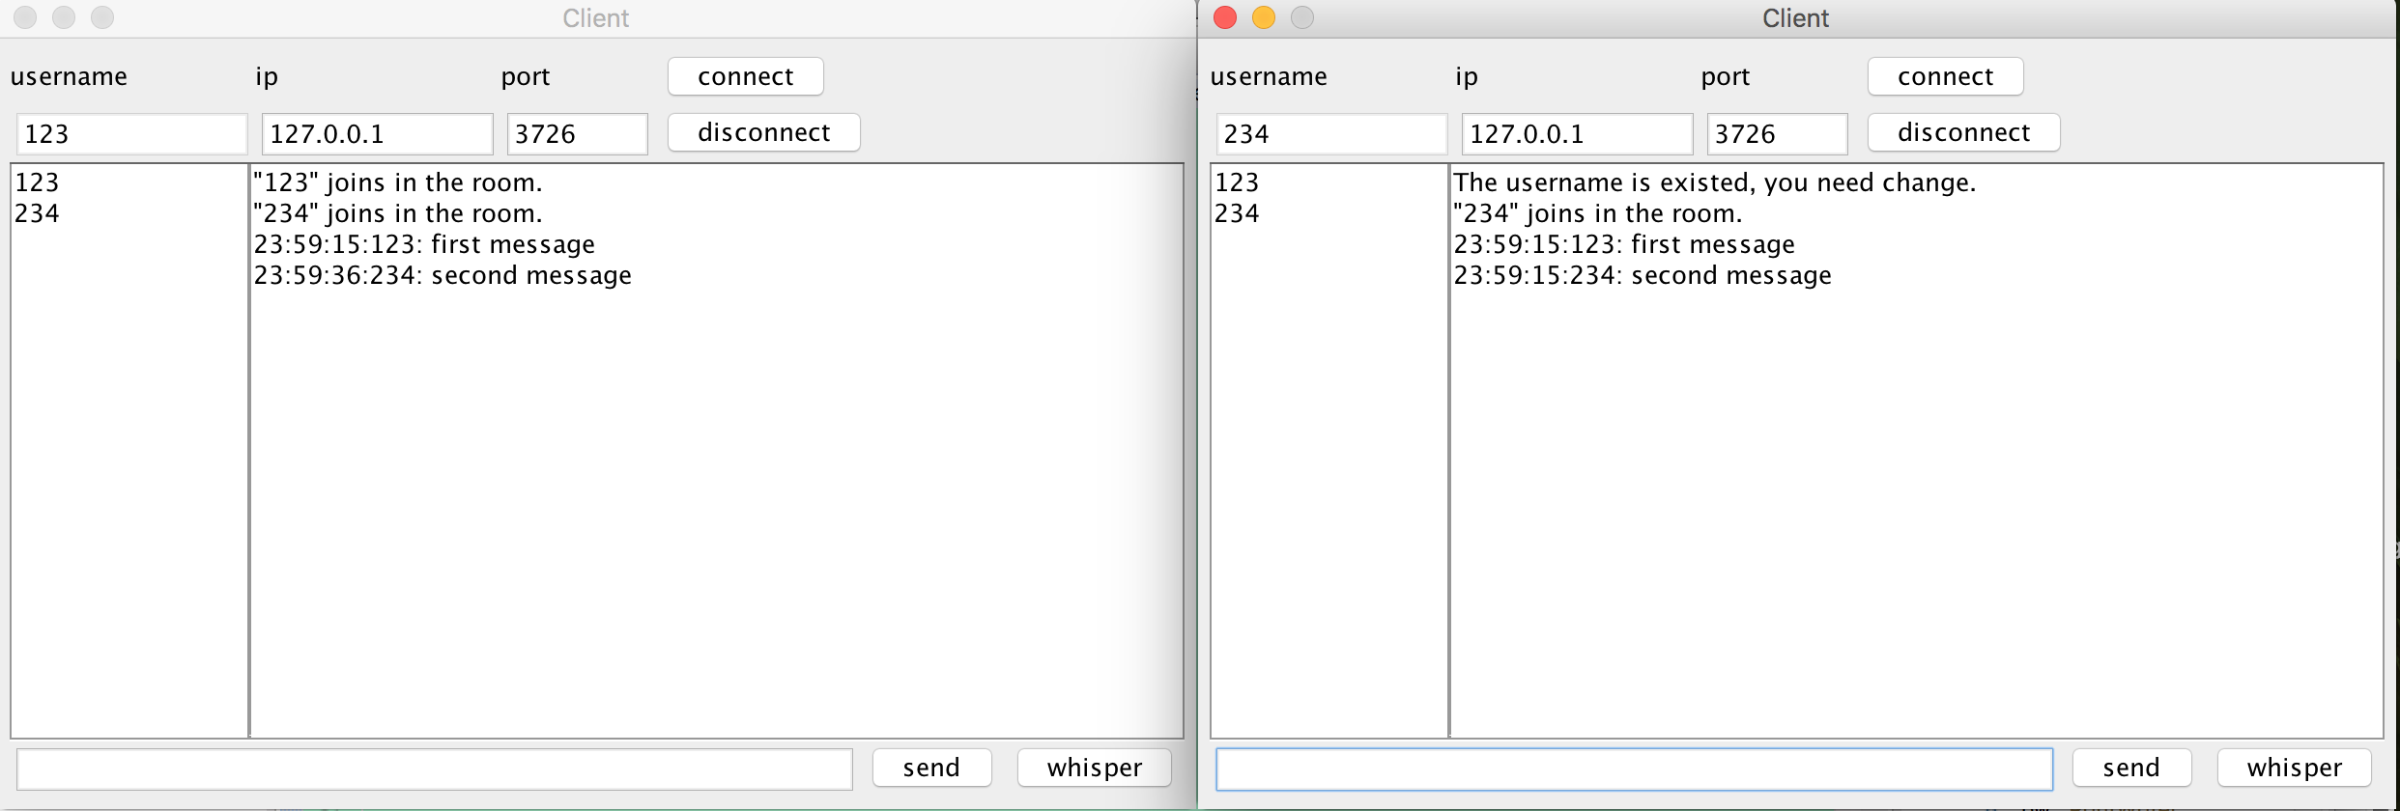
- First client whisper to the second client: successfully whisper to second client. 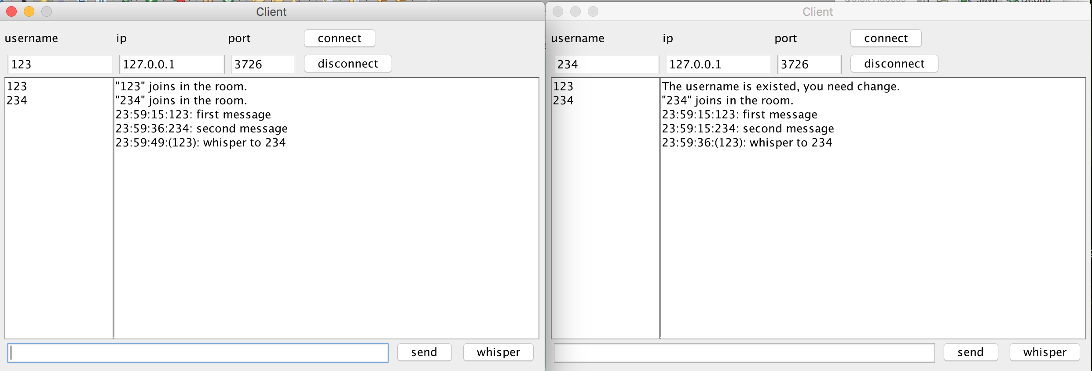
- First client disconnect: The client disconnect successfully and the second client see the notification that the first client leave the chatroom. 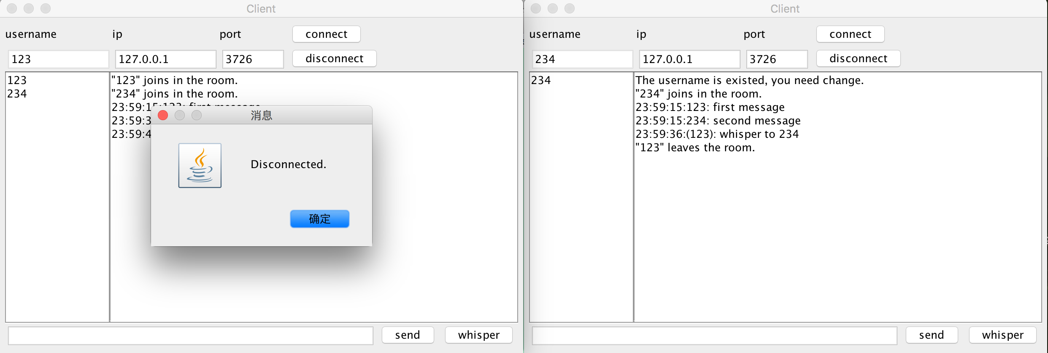
- First client disconnect again: alert the client has been disconnected. 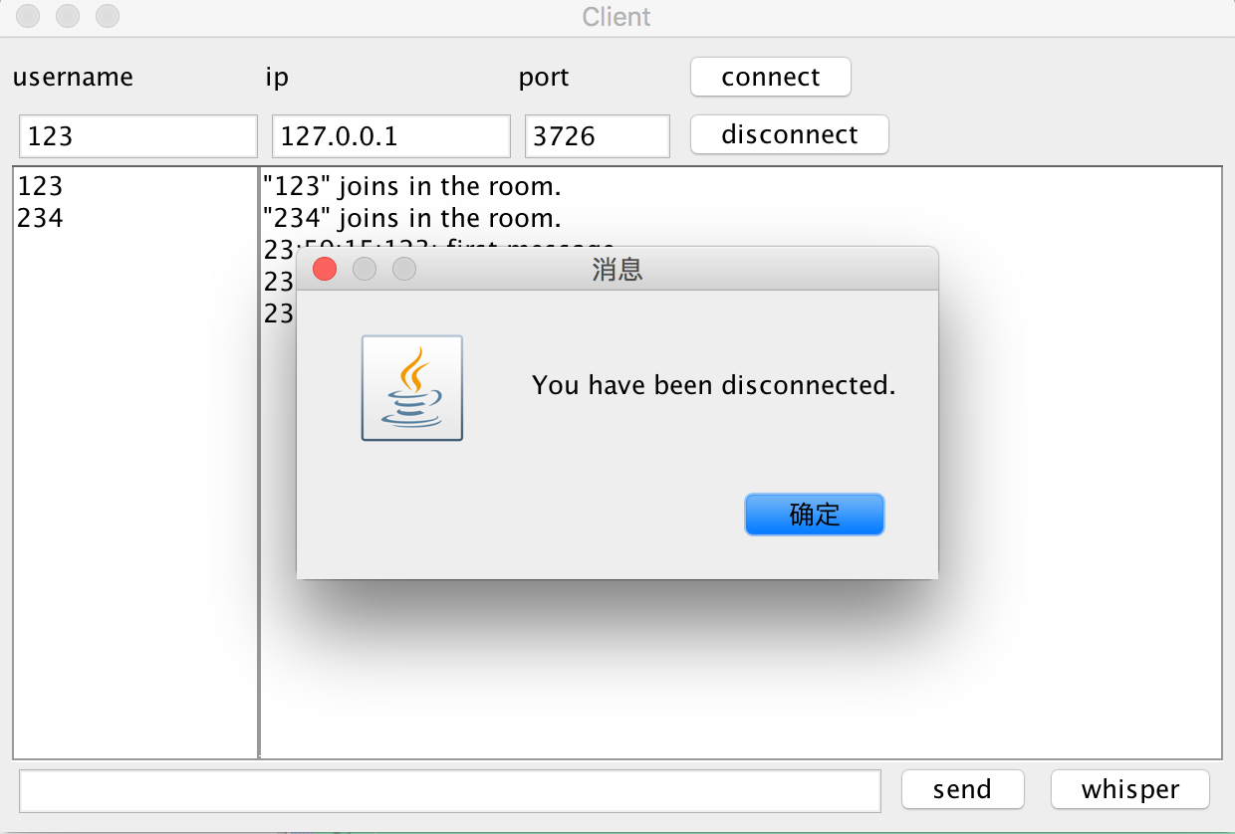
- First client use the original name to connect again: connect successfully and the second client see the first join chatroom. 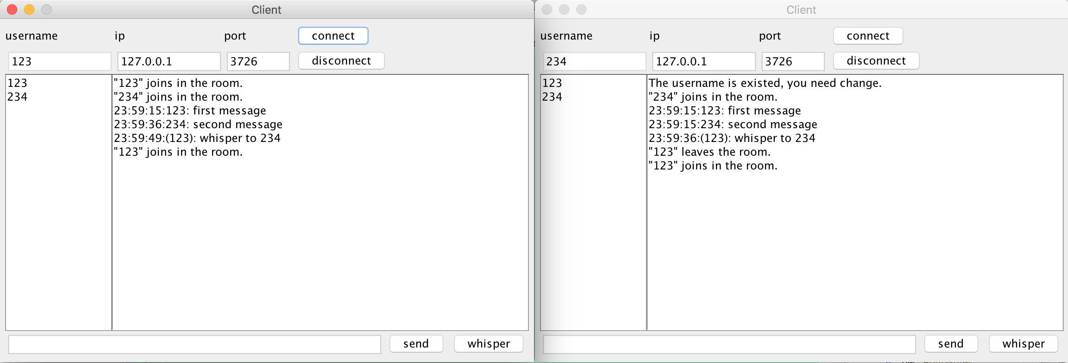
- Send whisper to incorrect receiver: notification the receiver is not existed. 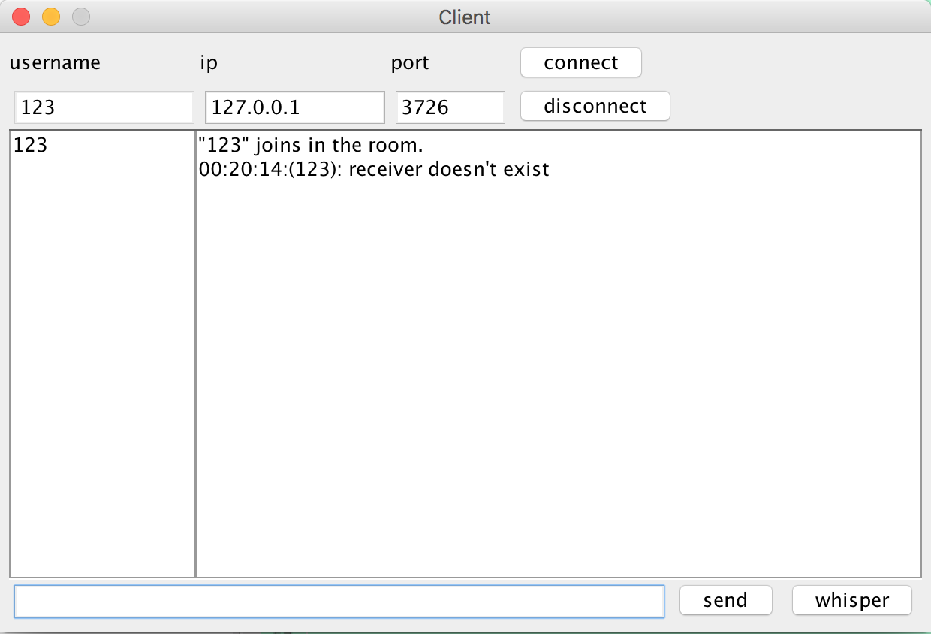
- Use incorrect format to whisper: alert format is wrong. 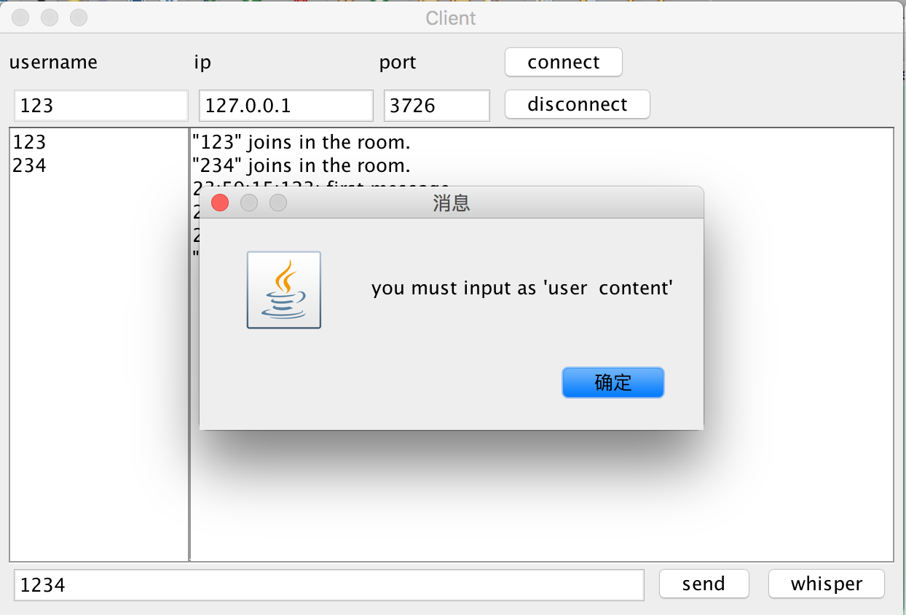
- First client whisper to itself: only the first client see the message. 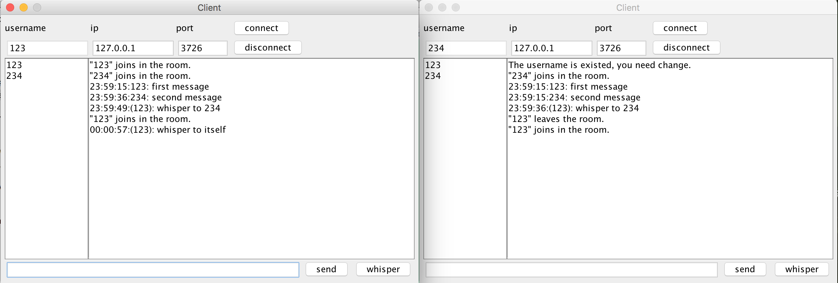
- Send empty message: alert can not send empty message. 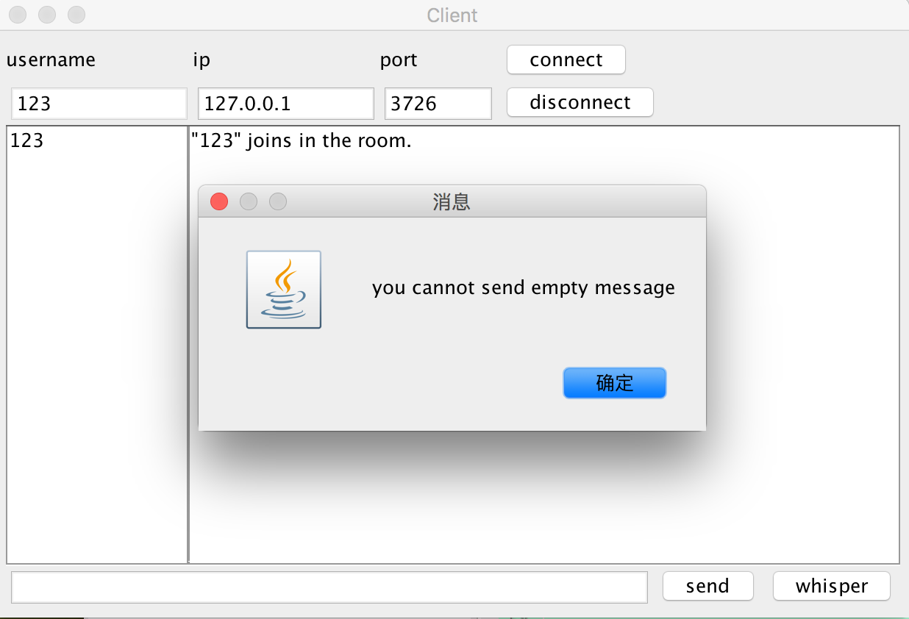

  - Code
Server:
package Server;

import java.util.*;
import java.io.*;
import java.net.*;
import java.text.SimpleDateFormat;

public class ServerThread extends Thread {

HashMap<String, PrintWriter> clientList;
ServerSocket serverSocket = null;
int serverPort = 3726;

ServerThread() {
Thread server = new Thread(new RunningServer());
server.start();
}

public class ClientHandler implements Runnable {
Socket clientSocket;
PrintWriter pw;
BufferedReader br;
String username;

ClientHandler(Socket socket, PrintWriter pw) {
try {
this.pw = pw;
username = "";
this.clientSocket = socket;
InputStreamReader clientbr = new InputStreamReader(socket.getInputStream());
br = new BufferedReader(clientbr);
} catch (Exception e) {
e.printStackTrace();
}
}

public void run() {
String message;
String[] received_data;

try {
while(!Thread.currentThread().interrupted()) {
if ((message = br.readLine()) != null) {
received_data = message.split(":");
if (received_data[2].equals("connect")) {
username = received_data[0];
if (clientList.containsKey(username)) {
pw.println(received_data[0] + ": :" + "fail");
pw.flush();
Thread.currentThread().interrupt();
} else {
addClient(received_data[0], pw);
String users = getAllClients();
broadcastClient(message + ":" + users);
}
} else if (received_data[2].equals("whisper")) {
whisperClient(username, received_data[3], message);
} else if (received_data[2].equals("broadcast")) {
broadcastClient(message);
} else if (received_data[2].equals("disconnect")) {
username = "";
deleteClient(received_data[0]);
String users = getAllClients();
broadcastClient(message + ":" + users);
Thread.currentThread().interrupt();
}
}
}
} catch (Exception e) {
deleteClient(username);
e.printStackTrace();
}
}
}

public class RunningServer implements Runnable {
public void run() {
clientList = new HashMap<String, PrintWriter>();
try {
serverSocket = new ServerSocket(serverPort);

while (!Thread.currentThread().interrupted()) {
Socket clientSock = serverSocket.accept();
PrintWriter pw = new PrintWriter(clientSock.getOutputStream(), true);

Thread clientHandler = new Thread(new ClientHandler(clientSock, pw));
clientHandler.start();

}
} catch (Exception e) {

}
}
}

public void addClient (String name, PrintWriter pw) {
clientList.put(name, pw);
}

public void deleteClient (String name) {

clientList.get(name).close();
clientList.remove(name);

}

public String getAllClients() {
StringBuffer buf = new StringBuffer();
for (String client : clientList.keySet()) {
buf.append(client + " ");
}

return buf.toString().trim();
}

public void whisperClient(String sender, String receiver, String message) {
PrintWriter pw = clientList.get(receiver);

try {
if(pw != null) {

pw.println(message);
pw.flush();
if( !sender.equals(receiver))
{
pw = clientList.get(sender);
pw.println(message);
pw.flush();
}

} else {
pw = clientList.get(sender);
message = sender + ":receiver doesn't exist:whisper";
pw.println(message);
pw.flush();

}
} catch (Exception e) {

}
}

public void broadcastClient(String message) {
for(PrintWriter pw : clientList.values()) {
try {

pw.println(message);
pw.flush();

} catch (Exception ex) {

}
}
}

public static void main(String args[]) {
ServerThread server = new ServerThread();
}
}

Client:
package Client;

import java.awt.event.ActionEvent;
import java.awt.event.ActionListener;
import java.awt.event.WindowAdapter;
import java.awt.event.WindowEvent;
import java.io.BufferedReader;
import java.io.BufferedWriter;
import java.io.IOException;
import java.io.InputStream;
import java.io.InputStreamReader;
import java.io.OutputStream;
import java.io.PrintWriter;
import java.net.Socket;
import java.text.SimpleDateFormat;
import java.util.Date;

import javax.swing.GroupLayout;
import javax.swing.JButton;
import javax.swing.JFrame;
import javax.swing.JLabel;

import javax.swing.JOptionPane;
import javax.swing.JPanel;
import javax.swing.JScrollPane;
import javax.swing.JTextArea;
import javax.swing.JTextField;
import javax.swing.WindowConstants;

public class ClientFrame extends JFrame implements ActionListener {
private static final long serialVersionUID = 1L;
Socket serverSocket;
BufferedReader br;
PrintWriter pw;
JTextField input_username;
JTextField input_ipaddress;
JTextField input_port;

JLabel iplabel;
JLabel portlabel;
JLabel usernamelabel;

String uname = "";

JScrollPane contentscroll;
JScrollPane userscroll;
JTextField input;
JButton send;
JButton disconnect;
JButton connect;
JButton whisper;

JTextArea chatWindow;
JTextArea userWindow;

static boolean isconnected = false;

ClientFrame(){
initComponents();
}

private void initComponents(){

setDefaultCloseOperation(WindowConstants.EXIT_ON_CLOSE);
setResizable(false);

iplabel = new JLabel();
portlabel = new JLabel();
usernamelabel = new JLabel();

iplabel.setText("ip");
portlabel.setText("port");
usernamelabel.setText("username");

contentscroll = new JScrollPane();
userscroll = new JScrollPane();

input_username = new JTextField();
input_ipaddress = new JTextField();
input_port = new JTextField();
input = new JTextField();

connect = new JButton();
connect.setText("connect");
disconnect = new JButton();
disconnect.setText("disconnect");
send = new JButton();
send.setText("send");
whisper = new JButton();
whisper.setText("whisper");

chatWindow = new JTextArea();
userWindow = new JTextArea();

chatWindow.setColumns(40);
chatWindow.setRows(10);
chatWindow.setEditable(false);
contentscroll.setViewportView(chatWindow);
userWindow.setColumns(10);
userWindow.setRows(5);
userWindow.setEditable(false);
userscroll.setViewportView(userWindow);
input.setEditable(false);

disconnect.addActionListener(this);
connect.addActionListener(this);
send.addActionListener(this);
whisper.addActionListener(this);

setDefaultCloseOperation(WindowConstants.EXIT_ON_CLOSE);
setTitle("Client");
setResizable(false);

GroupLayout layout = new GroupLayout(getContentPane());
getContentPane().setLayout(layout);
layout.setHorizontalGroup(layout.createParallelGroup(GroupLayout.Alignment.LEADING)
.addGroup(layout.createSequentialGroup()
.addContainerGap()
.addGroup(layout.createParallelGroup(GroupLayout.Alignment.LEADING)
.addGroup(layout.createSequentialGroup()
.addContainerGap()
.addGroup(layout.createParallelGroup(GroupLayout.Alignment.LEADING, false)
.addComponent(usernamelabel)
.addComponent(input_username, GroupLayout.DEFAULT_SIZE, 127, Short.MAX_VALUE))
.addGroup(layout.createParallelGroup(GroupLayout.Alignment.LEADING, false)
.addComponent(iplabel)
.addComponent(input_ipaddress, GroupLayout.DEFAULT_SIZE, 127, Short.MAX_VALUE))
.addGroup(layout.createParallelGroup(GroupLayout.Alignment.LEADING, false)
.addComponent(portlabel)
.addComponent(input_port, GroupLayout.DEFAULT_SIZE, 80, Short.MAX_VALUE))
.addGroup(layout.createParallelGroup(GroupLayout.Alignment.LEADING, false)
.addComponent(connect)
.addComponent(disconnect))
.addContainerGap())
.addGroup(layout.createSequentialGroup()
.addComponent(userscroll)
.addComponent(contentscroll))
.addGroup(layout.createSequentialGroup()
.addComponent(input)
.addComponent(send)
.addComponent(whisper)))
.addContainerGap())
);
layout.setVerticalGroup(layout.createParallelGroup(GroupLayout.Alignment.LEADING)
.addGroup(layout.createSequentialGroup()
.addContainerGap()
.addGroup(layout.createParallelGroup(GroupLayout.Alignment.BASELINE)
.addComponent(usernamelabel)
.addComponent(iplabel)
.addComponent(portlabel)
.addComponent(connect))
.addGroup(layout.createParallelGroup(GroupLayout.Alignment.LEADING, false)
.addComponent(input_username)
.addComponent(input_ipaddress)
.addComponent(input_port)
.addComponent(disconnect))
.addGroup(layout.createParallelGroup(GroupLayout.Alignment.BASELINE)
.addComponent(userscroll, GroupLayout.DEFAULT_SIZE, 300, Short.MAX_VALUE)
.addComponent(contentscroll, GroupLayout.PREFERRED_SIZE, 300, GroupLayout.PREFERRED_SIZE))
.addGroup(layout.createParallelGroup(GroupLayout.Alignment.LEADING)
.addComponent(input)
.addComponent(send)
.addComponent(whisper))
.addContainerGap())
);
pack();
}

public void actionPerformed(ActionEvent ae){
if (ae.getSource() == send) {
if ((input.getText()).equals("")) {
JOptionPane.showMessageDialog(this, "you cannot send empty message");
} else {
try{

String message = input.getText();
pw.println(uname + ":" + message + ":" + "broadcast");
pw.flush();
} catch (Exception e) {
chatWindow.append("send message unsuccessfully.\n");
}
input.setText("");
input.requestFocus();
}
} else if (ae.getSource() == connect) {
if(isconnected == true){
JOptionPane.showMessageDialog(this, "you have connected the server");
} else {
uname = input_username.getText();
if(uname.isEmpty()){
JOptionPane.showMessageDialog(this, "you can not use empty name");
} else {
String current_ip = input_ipaddress.getText();
String current_port = input_port.getText();

if(current_ip.isEmpty()){
JOptionPane.showMessageDialog(this, "you can not use empty ipaddress");
} else if(current_port.isEmpty()){
JOptionPane.showMessageDialog(this, "you can not use empty port");
} else {
int port = Integer.valueOf(current_port);

try{
serverSocket = new Socket(current_ip,port);
InputStreamReader is = new InputStreamReader(serverSocket.getInputStream());
br = new BufferedReader(is);
pw = new PrintWriter(serverSocket.getOutputStream());
pw.println(uname + ": :connect");
pw.flush();
isconnected = true;
input_username.setEditable(false);
input.setEditable(true);
} catch (Exception ex){
input_username.setEditable(true);
JOptionPane.showMessageDialog(this, "fail to connect server");
}
Thread clientHandler = new Thread(new ClientThread());
clientHandler.start();
}
}
}

} else if (ae.getSource() == disconnect) {

disconnect();

} else if (ae.getSource() == whisper) {
try{
String message = input.getText();
String[] arraymessage = message.split(" ", 2);
if(arraymessage.length <= 1){
JOptionPane.showMessageDialog(this, "you must input as 'user content'");
} else {
if(arraymessage[0].equals("")){
JOptionPane.showMessageDialog(this, "you must input as 'user content'");
} else{

pw.println(uname + ":" + arraymessage[1] + ":" + "whisper:" + arraymessage[0]);
pw.flush();
}
}
} catch (Exception e) {
chatWindow.append("send message unsuccessfully.\n");
}
input.setText("");
input.requestFocus();

}
}
public void disconnect()
{
try {
pw.println(uname + ": :disconnect");
pw.flush();
} catch (Exception e) {
JOptionPane.showMessageDialog(this, "Failed to send Disconnect message.\n");
}

try {
if (isconnected) {
JOptionPane.showMessageDialog(this, "Disconnected.\n");
serverSocket.close();
isconnected = false;
} else
JOptionPane.showMessageDialog(this, "You have been disconnected.\n");
} catch(Exception e) {
JOptionPane.showMessageDialog(this, "Failed to disconnect.\n");
}
isconnected = false;
input_username.setEditable(true);
}

public class ClientThread implements Runnable{
public void run(){
String[] received_data;
String message;

try{
while(!Thread.currentThread().interrupted()){
Date date = new Date();
SimpleDateFormat format = new SimpleDateFormat("HH:mm:ss");
String dateStr = format.format(date);
if (!serverSocket.isClosed() && (message = br.readLine()) != null){
received_data = message.split(":");
if (received_data[2].equals("broadcast")){
chatWindow.append(dateStr+":"+received_data[0] + ": " + received_data[1] + "\n");

} else if(received_data[2].equals("whisper")){
chatWindow.append(dateStr+":"+"(" + received_data[0] + "): " + received_data[1] + "\n");

} else if(received_data[2].equals("connect")){
chatWindow.removeAll();
AddUser(received_data[0], received_data[3]);
} else if(received_data[2].equals("disconnect")){
DeleteUser(received_data[0], received_data[3]);
if (received_data[0].equals(uname))
Thread.currentThread().interrupt();
} else if(received_data[2].equals("fail")){
chatWindow.append("The username is existed, you need change.\n");
serverSocket.close();
isconnected = false;
input_username.setEditable(true);
input.setEditable(false);
}
}
}
} catch(Exception e){

}
}
}

public void RenewUserList(String users)
{
userWindow.setText("");
for (String u : users.split(" ")) {
userWindow.append(u + "\n");
}
}

public void DeleteUser(String username, String users)
{
chatWindow.append("\"" + username + "\" leaves the room.\n");
RenewUserList(users);
}

public void AddUser(String username, String users)
{
chatWindow.append("\"" + username + "\" joins in the room.\n");
RenewUserList(users);
}

public static void main(String args[]) {
ClientFrame client = new ClientFrame();

client.addWindowListener(new WindowAdapter() {

public void windowClosing(WindowEvent e) {
if(isconnected)
{
client.disconnect();
}
e.getWindow().dispose();
}
});
client.setVisible(true);
}

}

