PROGRAM:

#include<stdio.h> #include<conio.h> #include<string.h> #include<stdlib.h> void main()
{
charch; char
key[][10]={"int","void","main","printf","scanf","isalpha","isalnum","isdigit","for","while","if","else"," else if","break","return"};
charbuff[50]; int i,j,f,k;
FILE*f1,*f2;
f1=fopen("e1.c","r");
f2=fopen("e.c","w"); clrscr();
while((ch=fgetc(f1))!=EOF)
{
i=0; f=1;
if((isalpha(ch))||ch=='_')
{
while(isalnum(ch)||ch=='_')
{
buff[i++]=ch; ch=fgetc(f1);
}
buff[i]='\0'; for(j=0;j<15;j++)
{

if(strcmp(key[j],buff)==0)
{
f=0;
break;
}
}
if(f==0)
{
printf("%s is a keyword\n",buff); fprintf(f2,"%sisakeyword\n",buff);
}
else
{
printf("%s is an identifier\n",buff); fprintf(f2,"%sisanidentifier\n",buff);
}
}
if(ch=='*'||ch=='='||ch=='+'||ch=='-'||ch=='/')
{
printf("%c is an operator\n",ch); fprintf(f2,"%cisanoperator\n",ch);
}
if(ch=='('||ch==')'||ch=='['||ch==']'||ch=='{'||ch=='}'||ch==';')
{
printf("%c is a symbol\n",ch); fprintf(f2,"%cisasymbol\n",ch);
}k=0;
if(isdigit(ch))
{
while(isdigit(ch))

{
buff[k++]=ch; ch=fgetc(f1);
}
buff[k]='\0';
printf("%d is a constant\n",ch); fprintf(f2,"%disaconstant\n",ch);
}
}
fclose(f1); fclose(f2); getch();
}

OUTPUT:

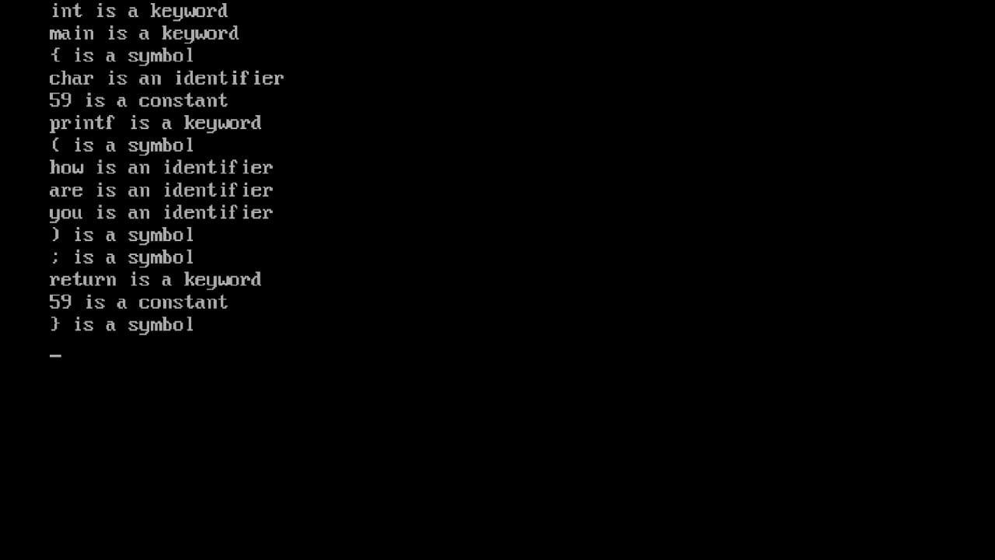

PROGRAM:
%{
#include<stdio.h>

%}

letter [A-Za-z_]
digit [0-9]
identifier ({letter})({letter}|{digit})* constant ({digit}+)([.]?)({digit}+)*
others ({digit}+)([.])({digit}+)(([.]+)|({digit}+))*
keyword
if|main|else|void|elseif|char|int|break|continue|float|while|for|do|struct|long|double
operator "+"|"-"|"="|"!"|">"|"<"|"<="|">="|"%"|"*"|"/"|"+="|"-
="|"=="|"*="|"!="|"&"|"|"|"^" literal \".*\"

%%

{keyword} {fprintf(yyout,"\nkeyword:%s",yytext);}
{identifier}{fprintf(yyout,"\nidentifier:%s",yytext);}
{constant} {fprintf(yyout,"\nconstant:%s",yytext);}
{operator} {fprintf(yyout,"\noperator:%s",yytext);}
{literal} {fprintf(yyout,"\nliteral:%s",yytext);}
{others} {fprintf(yyout,"\nnotvalid:%s",yytext);}
. {}
%%

intmain(){
externFILE*yyin,*yyout;

yyin=fopen("a1.txt","r");
yyout=fopen("b1.txt","w");

if(!yyin||!yyout){
fprintf(stderr, "Error opening files.\n"); exit(1);
}

yylex();//Callthelexer
printf("-->copiedfilesuccessfully<---\n");

fclose(yyin); fclose(yyout); return 0;
}

intyywrap(){ return 1;
}

OUTPUT:

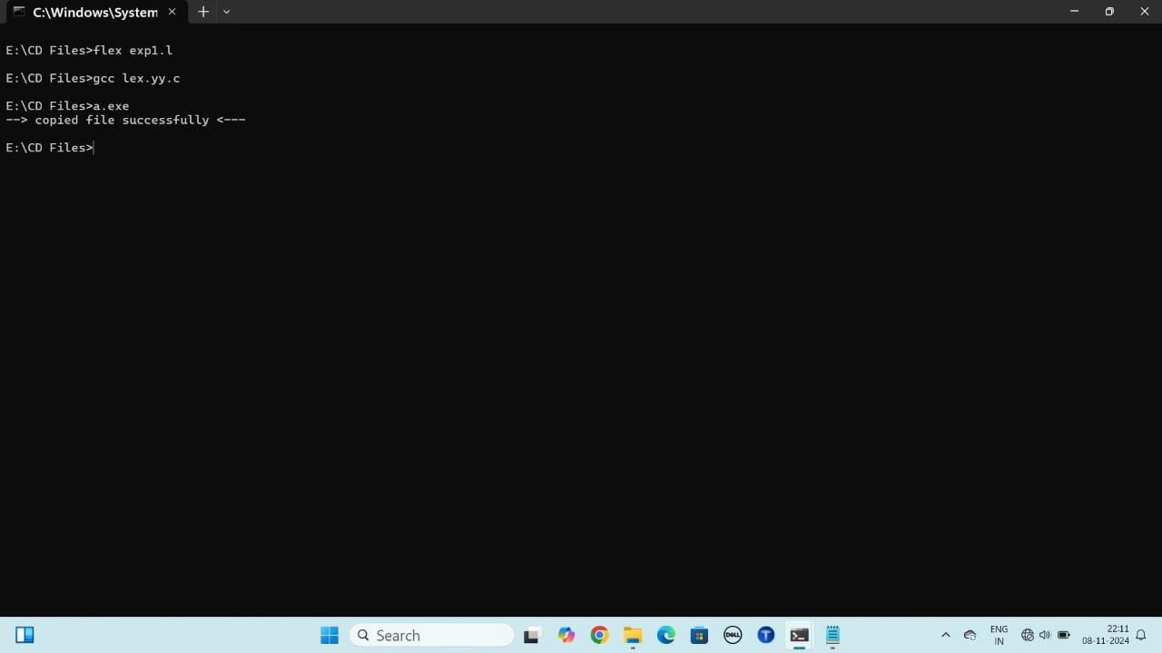

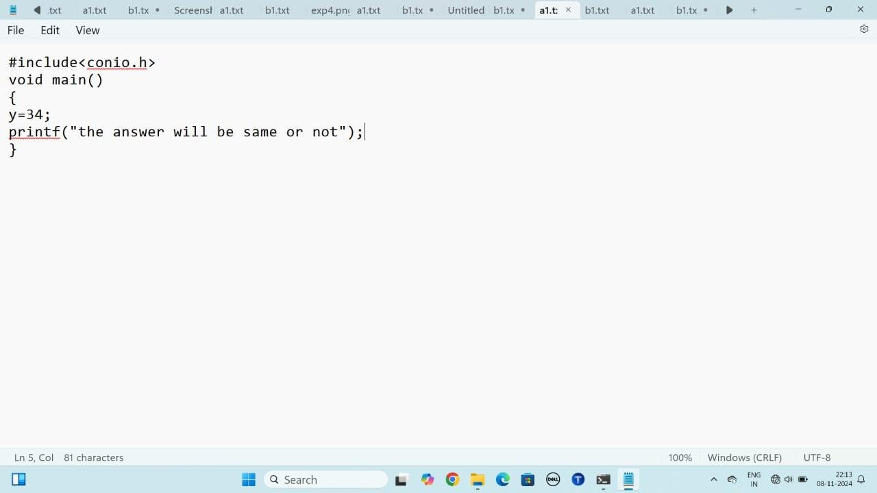

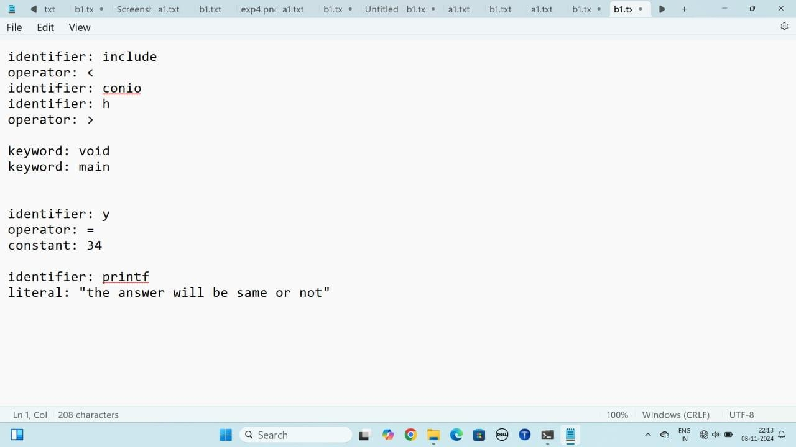

PROGRAM:
LEXPROGRAM
%{
#include <stdio.h> #include<stdlib.h>
#include"3rdexp.tab.h"//Includeyourheaderfile

//Functiondeclarations
intyylex();//Declarationforyylex
//voidyyerror(constchar*s);//Declarationforyyerror
%}

Num([0-9]+)

%%

{Num}{yylval=atoi(yytext);returnNum;}

[\t]{}//Ignoretabcharacters

[\n]{return0;}//Return0onnewline

. {return*yytext;}//Returnanyothercharacter

%%

//Functiontohandleerrors
//voidyyerror(constchar*s){
//fprintf(stderr,"Error:%s\n",s);//Printerrormessage
//}

intyywrap(){
return1;//Indicateendofinput
}

YACCPROGRAM
%{
#include <stdio.h> #include<stdlib.h>

//Functiondeclarations
intyylex();//Declarationforyylex
voidyyerror(constchar*s);//Declarationforyyerror
%}

%left'+''-'
%left'/''*'

%tokenNum

%%

S:E{printf("ans:%d\n",$1);}
;

E:E '+' E{$$=$1+$3}
|E '-'E{$$=$1-$3 }
|E'/'E{$$=$1/ $3 }
|E'*'E{$$=$1*$3 }
|Num{$$=$1}

;

%%

//Mainfunction
intmain(){//Changevoidmain()tointmain() printf("Enter expression: ");
yyparse();
return0;//Return0toindicatesuccessfulcompletion
}

voidyyerror(constchar*s){//Updatesignaturetomatchdeclaration fprintf(stderr, "Error: %s\n", s); // Print error message
}

OUTPUT:

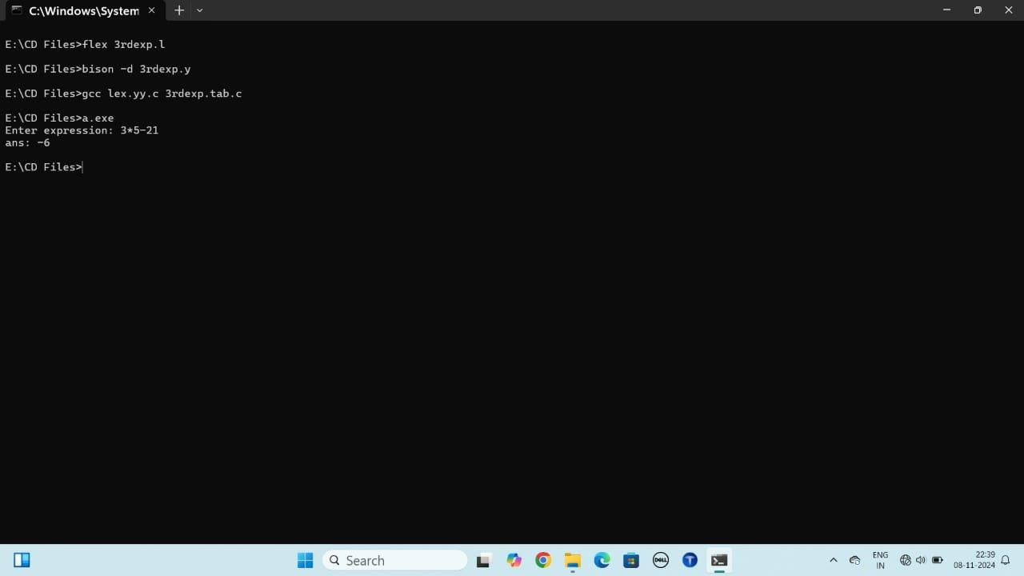

PROGRAM:
LEXPROGRAM
%{
#include"exp2.tab.h"

%}

letter([a-zA-Z_])
number([0-9])

%%

{letter}{returnLET;}
{number}{returnNUM;}

%%

intyywrap(){ return 1;
}

YACCPROGRAM

%{
#include<stdio.h>

#include "lex.yy.c" intyyerror(char*s);
%}
%tokenLETNUM
%%
S :LETE{printf("identifier");}
;
E :LETE
| NUME
|
;
%%
voidmain(){
printf("\nEnterthestring\n"); yyparse();
}
intyyerror(char*msg)
{
returnfprintf(stderr,"\n%s\n",msg);
}

OUTPUT:

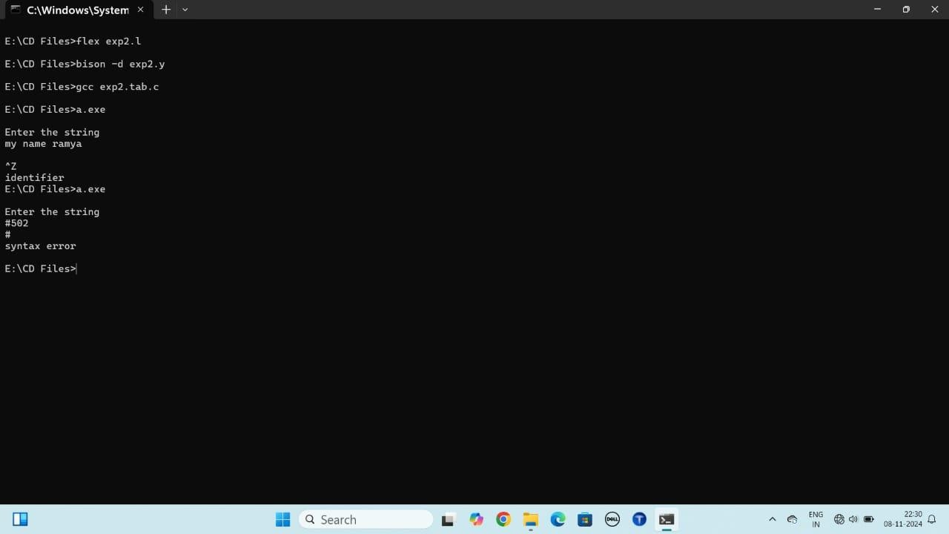

PROGRAM:

LEXPROGRAM

%{
#include"6thexp.tab.h"
%}
digit [0-9]+
id [a-zA-Z_][a-zA-Z0-9_]*
string \"([^"\\]|\\.)*\"
%%
"break" { return BREAK; } "continue"{returnCONTINUE;} "if" { return IF; }
"else" { return ELSE; } "for" { return FOR; } "do" { return DO; } "while" {returnWHILE;} "printf" {return PRINTF;}
{string}{returnSTRING;}
{digit} {returnNUM;}
{id} {returnID;}
"<=" {returnLEQ;}
">=" {returnGEQ;}
"!=" {returnNEQ;}
"==" {returnEQ;}

"||" {returnOR;}
"&&" {returnAND;}
[\t] {return0;}
. {return*yytext;}
%%

intyywrap(){ return 1;
}

YACCPROGRAM

%{
#include<stdio.h>
#include<stdlib.h>//Includethisheaderforexit() int yylex(); // Declare the lexer function
voidyyerror(char*msg);//Declaretheerrorfunction
%}

%tokenIDNUMIFELSEFORDOWHILELEQGEQEQNEQORAND PRINTF SCANF BREAK CONTINUE STRING

%right'='
%leftOR
%leftAND
%left'<''>'LEQGEQEQNEQ
%left'+''-'
%left'*''/'

%%

S:
St1{printf("dowhileloopconditionisaccepted\n");exit(0);}
|St2{printf("whileloopconditionisaccepted\n");exit(0);}
|St3{printf("forloopconditionisaccepted\n");exit(0);}
|St4{printf("ifconditionisaccepted\n");exit(0);}
|St5{printf("ifelseconditionisaccepted\n");exit(0);}
;

St1:
DO'{' ST'}'WHILE'('E2')'';'
;

St2:
WHILE'('E2')''{'ST'}'
;

St3:
FOR'('E';'E';'E')''{'ST'}'
;

St4:
IF'('E2 ')''{'ST'}'
;

St5:
IF'('E2')''{'ST'}' ELSE'{'ST'}'
;

ST:
E';'ST
|E ';'
|PRINTF'('E')'';'ST
|PRINTF'('E')'';'
;

E:
E'+'E//Arithmeticoperations
|E '-' E
|E '*' E
|E '/' E
|E'<' E
|E'>' E
|ELEQ E
|EGEQ E
|ENEQE
|E EQE
|E OR E
|EANDE
|ID'='E//Assignment ofvalue toan ID
|NUM// Numericvalue
|ID// Identifier
|'-'ID//UnaryminusforIDs

|BREAK//Breakstatement(usedasanexpression)
|CONTINUE//Continuestatement(usedasanexpression)
|STRING//Handlestringliterals
;

E2:
E'>'E
|E'<'E
|EGEQE
|E LEQE
|ENEQE
|E OR E
|EANDE
;

%%
intmain() {
printf("Enterthecondition:\n"); yyparse();
return0;//Returnanintegerfrommain
}

void yyerror(char *msg) { printf("\nInvalidcondition\n");
}

OUTPUT:

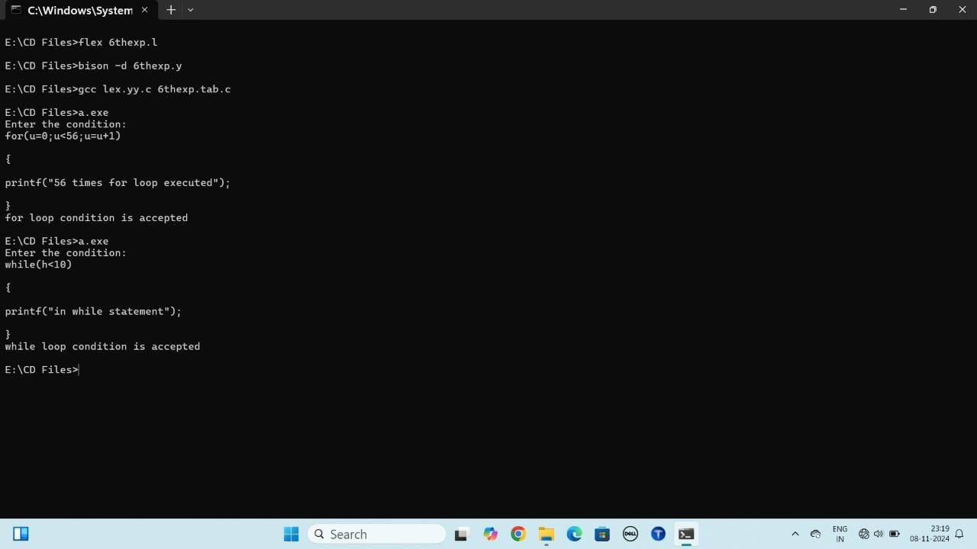

PROGRAM:
LEXPROGRAM

%{
#include<string.h> #include"4thexp.tab.h"
%}

id ([a-zA-Z])([a-zA-Z0-9_])*

%%
{id} {yylval.str=strdup(yytext);returnID;} [\t] { /* ignore tabs */ }
[\n] {return 0; }
. {return*yytext;}

%%

intyywrap(){return1;}

YACCPROGRAM

%{
#include <stdio.h> #include<string.h> #include<stdlib.h>

intyylex();//Declarethelexerfunction
intyyerror(char*msg);//Declaretheerrorhandlingfunction int temp = 1;
%}

%union { char*str;
}

%left'='
%left'+''-'
%left'*''/'
%token<str>ID
%type<str>SE

%%

//Grammarrules
S:ID'='E{printf("\n%s=%s\n",$1,$3); }
;

E: E'+'E{
charword[10]="t"; char tem[10];
sprintf(tem,"%d",temp); strcat(word, tem); temp++;

printf("\n%s=%s+%s\n",word,$1,$3);
$$=strdup(word);
}
|E'-'E{
charword[10]="t"; char tem[10];
sprintf(tem,"%d",temp); strcat(word, tem); temp++;
printf("\n%s=%s-%s\n",word,$1,$3);
$$=strdup(word);
}
|E'*'E{
charword[10]="t"; char tem[10];
sprintf(tem,"%d",temp); strcat(word, tem); temp++;
printf("\n%s=%s*%s\n",word,$1,$3);
$$=strdup(word);
}
|E'/'E{
charword[10]="t"; char tem[10];
sprintf(tem,"%d",temp); strcat(word, tem); temp++;

printf("\n%s=%s/%s\n",wo
;

%%

//Mainfunction int main() {
printf("\nEnterthestatementtoconvertTAC:"); yyparse();
return0;
}

//Errorhandlingfunction int yyerror(char *msg) {
printf("Error:%s\n",msg); rd, $1, $3);
$$=strdup(word);
}
|ID{
$$=$1;
}
return0;
}

;
E :LETE
|NUM E
|
;
%%
voidmain(){
printf("\nEnterthestring\n"); yyparse();
}
intyyerror(char*msg)
{
returnfprintf(stderr,"\n%s\n",msg);
}

OUTPUT:

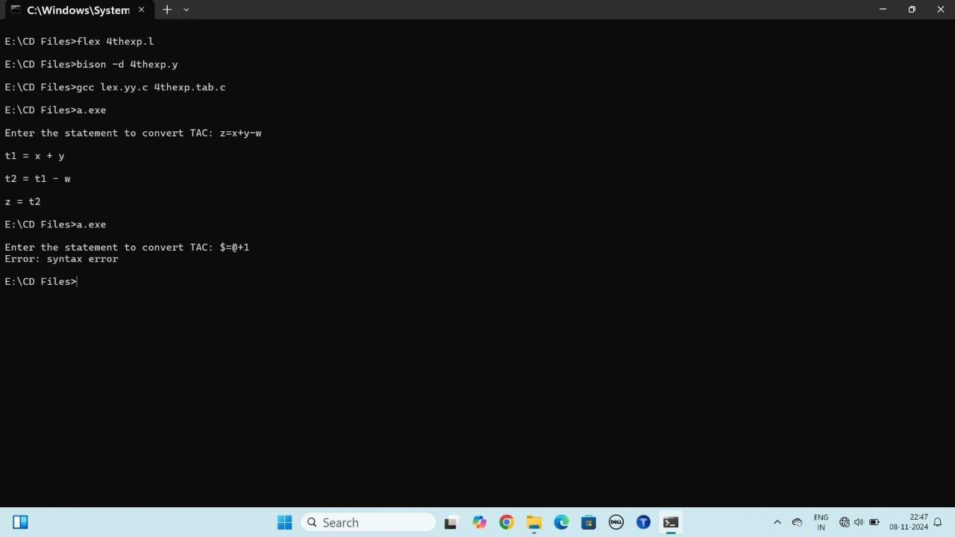

PROGRAM:
LEXPROGRAM
%{
#include"5thexp.tab.h" externintyywrap(void);
intyywrap(void){return1;}//Defineyywrapcorrectlywith`void`
%}

%%

[0-9]+ {returnINTEGER;} //Integer:asequenceofdigits
[0-9]+"."[0-9]+ { return FLOAT; } //Float:digits,adecimal,andmoredigits [a-zA-Z]+ { return STRING; } // String: only alphabetic characters
[a-zA-Z0-9]+ {returnINVALID;} //Alphanumeric(invalidtype)

[ \t\n]+ | ; | //Ignorewhitespace
. | {returnINVALID;} | //Catch-allforanyothercharacters
%%

YACCPROGRAM

%{
#include <stdio.h> #include<stdlib.h>
#include"5thexp.tab.h"//Includethegeneratedheaderfile

int yylex(); //Declareyylextoavoidimplicitdeclarationwarning int yyerror(char *s);
%}
%tokenINTEGER FLOATSTRING INVALID
%%
start:

datatype{/*Donothing*/}
;

datatype:
INTEGER{printf("Type:Integer\n");}
| FLOAT{printf("Type:Float\n"); }
|STRING{printf("Type:String\n");}
|INVALID{printf("Type:Notvalidtype\n");}
;

%%

intyyerror(char*s){
fprintf(stderr, "Error:%s\n", s); return 1;
}

intmain(){
printf("Enteravalue:\n"); yyparse();
return0;
}

OUTPUT:
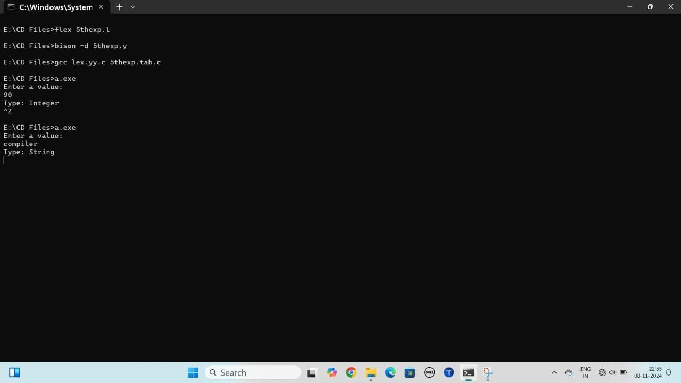

PROGRAM:

#include<conio.h> #include <stdio.h> #include<string.h>

structquad{
charresult[10],arg1[10],arg2[10],oper[3];
};

structquadtac[10]; int n;

voidinput(){ int i;
printf("\nEnterthetotalnumberofthreeaddresscode\n"); scanf("%d", &n);
for(i=0;i<n;i++){
printf("\nEnterthefirstoperand:"); scanf("%s", tac[i].arg1);
printf("\nEnterthesecondoperand:"); scanf("%s", tac[i].arg2);
printf("\nEntertheoperator:"); scanf("%s", tac[i].oper);
printf("\nEntertheresult:"); scanf("%s", tac[i].result);
}
}

voiddisplay(){ int i;

printf("\nThreeaddressstatement\n"); for(i = 0; i < n; i++) {
printf("\n%s\t=\t%s\t%s\t%s",tac[i].result,tac[i].arg1,tac[i].oper,tac[i].arg2);
}
}

voidcomsubexp(){ inti,j,t,k,temp;
for(i = 0; i < n - 1; i++) { for(j=i+1;j<n;j++){
temp=0;
//Correctedconditionandremovedextraparentheses
if((!strcmp(tac[i].arg1,tac[j].arg1))&&(!strcmp(tac[i].arg2,tac[j].arg2))&& (!strcmp(tac[i].oper, tac[j].oper))) {
for(t=i+1;t<j;t++){
if((!strcmp(tac[j].arg1,tac[t].result))||(!strcmp(tac[j].arg2,tac[t].result))){ temp = 1;
break;
}
}
if(temp==0){
for(k=j+1;k<n;k++){
if((!strcmp(tac[j].result, tac[k].arg1))) strcpy(tac[k].arg1, tac[i].result); if((!strcmp(tac[j].result, tac[k].arg2))) strcpy(tac[k].arg2, tac[i].result);
}
for(k=j;k<n -1;k++){
strcpy(tac[k].arg1,tac[k+1].arg1); strcpy(tac[k].arg2,tac[k+1].arg2); strcpy(tac[k].oper,tac[k+1].oper);

strcpy(tac[k].result,tac[k+1].result);
}
n--;//Decrementnsinceweremovedanelement
}
}
}
}
}

voiddeadcode(){ inti,j,k,temp;
for(i=0;i<n-1;i++){ temp = 0;
for(j=i+1;j<n;j++){
if((!strcmp(tac[i].result,tac[i].arg1))||(!strcmp(tac[i].result,tac[j].arg2))){ temp = 1;
break;
}
}
if(temp==0){
for(k=i;k<n-1;k++){
strcpy(tac[k].arg1,tac[k+1].arg1); strcpy(tac[k].arg2,tac[k+1].arg2); strcpy(tac[k].oper,tac[k+1].oper);
strcpy(tac[k].result,tac[k+1].result);
}
n--;//Decrementnsinceweremovedanelement
}
}
}

voidmain(){ clrscr();
input(); display(); comsubexp();
printf("\nAftercommonsubexpressionelimination\n"); display();
deadcode();
printf("\nAfterdeadcodeelimination\n"); display();
getch();
}

OUTPUT:
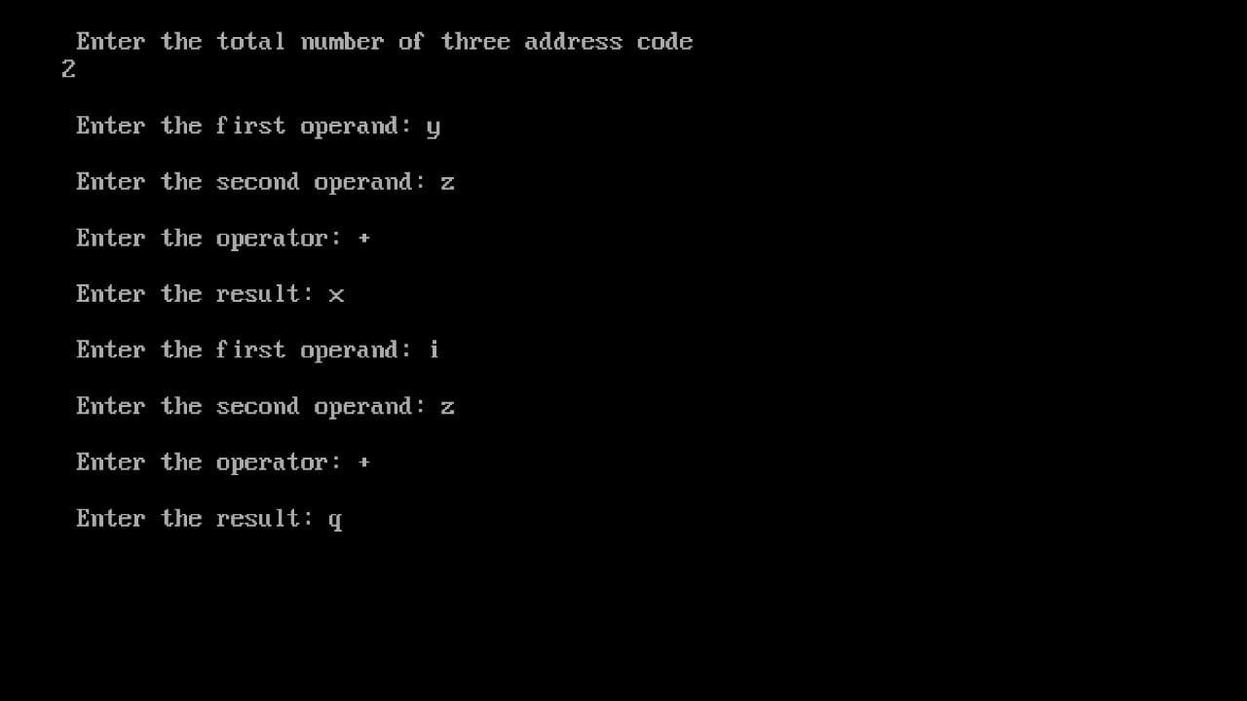

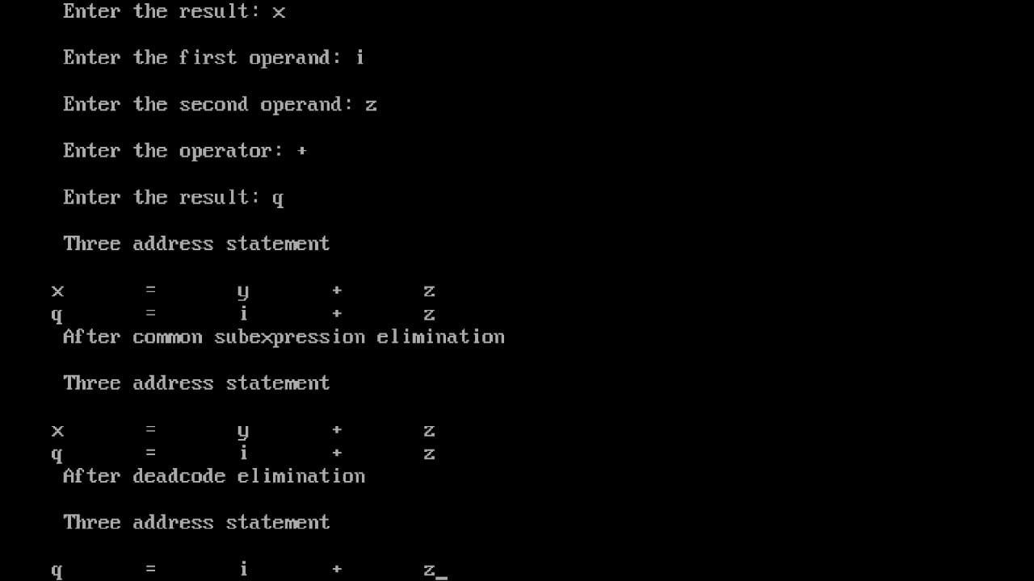

PROGRAM:

#include <stdio.h> #include<conio.h> #include<string.h>

structquad{
charresult[10],arg1[10],arg2[10],oper[3];
};

structquadtac[10]; int n;
charreg[20][10];

voidinput(){ int i;
printf("\nEnterthetotalnumberofthreeaddresscode\n"); scanf("%d", &n);

for(i =0;i<n;i++) {
printf("\nEnterthefirstoperand:"); scanf("%s", tac[i].arg1);
printf("\nEnterthesecondoperand:"); scanf("%s", tac[i].arg2);
printf("\nEntertheoperator:"); scanf("%s", tac[i].oper); printf("\n Enter the result: ");

scanf("%s",tac[i].result);//Fixedthecommaerror
}
}

voiddisplay(){ int i;
printf("\nThreeaddressstatement\n"); for(i = 0; i < n; i++) {
printf("\n%s\t=\t%s\t%s\t%s",tac[i].result,tac[i].arg1,tac[i].oper, tac[i].arg2);
}
}

char*registeralloc(charmemory[]){ int j;
staticcharword[10];//Makewordstatictoreturnitsaddress char temp[10];

for(j = 0; j < 20; j++) { if(!strcmp(memory,reg[j])){
strcpy(word,"r");
sprintf(temp,"%d",j); strcat(word, temp); return word;
}
}

for(j =0;j <20;j++) {

if(!strcmp(reg[j], "\0")) { strcpy(word, "r"); strcpy(reg[j],memory); sprintf(temp, "%d", j); strcat(word, temp);
printf("\nLD%s,%s",memory,word);//Fixedformatstring return word;
}
}

returnNULL;
}

voidassemblycode(){ int i, j, pos;
charreg1[10],reg2[10],reg3[10],temp[10];

for(i =0;i<n;i++) {
strcpy(reg1,registeralloc(tac[i].arg1)); strcpy(reg2,registeralloc(tac[i].arg2));

for(j = 0; j < 20; j++) { if(!strcmp(reg[j],"\0")){
strcpy(reg3,"r");
sprintf(temp,"%d",j); strcat(reg3, temp);pos = j;

break;
}
}

if(!strcmp(tac[i].oper,"+"))
printf("\nADD%s,%s,%s",reg3,reg1,reg2);//Fixedformatstring else if(!strcmp(tac[i].oper, "-"))
printf("\nSUB%s,%s,%s",reg3,reg1,reg2); else if(!strcmp(tac[i].oper, "*"))
printf("\nMULTI%s,%s,%s",reg3,reg1,reg2); else if(!strcmp(tac[i].oper, "/"))
printf("\nDIVIDE%s,%s,%s",reg3,reg1,reg2);

for(j = 0; j < 20; j++) { if(!strcmp(reg[j],tac[i].result))
strcpy(reg[j],"\0");
}

strcpy(reg[pos],tac[i].result);
printf("\nST%s,%s",tac[i].result,reg3);
}
}

voidmain(){ int i; clrscr();

// Initialize registers for(i=0;i<20;i++)
strcpy(reg[i],"\0");

input(); display(); assemblycode(); getch();
}

OUTPUT:

